User Presentation One-Pager: Title of Your Industrial Talk
Author Name¹ Author Name¹ Author Name²
¹Company or Department, Organization, Country, {name1,name2}@company.org
²Company, Country, name3@company.org
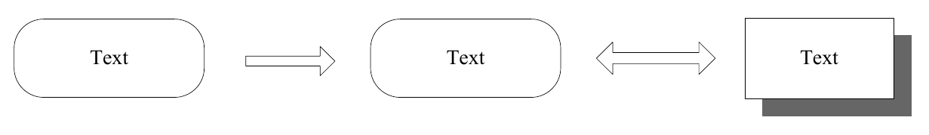
Figure 1. Recommended overview figure (replace with your own). Typical choices: application photo, system schematic, tool screenshot, or a plot of the main result discussed in the talk.
This document is the official one-page template for user presentations at a Modelica Conference. A user presentation is not a scientific publication. It is typically given by an industrial user, tool vendor, or practitioner and is announced in the conference programme. This single page is what participants read when choosing sessions: keep it informative, concrete, and easy to skim.
Layout rules (match the scientific paper template). Title, author block, fonts (Times New Roman body text at 10.5 pt), and page margins match the scientific paper template. Unlike papers, the layout is single-column over the full text width. There is no separate abstract heading: the text after the optional figure is the abstract of the presentation. Optional references may appear at the bottom; because this is not a research paper, prefer links to software, standards, product pages, or a few closely related publications rather than a full literature survey (Modelica Association 2026a; Modelica Association 2026b).
What to write. State the industrial problem or use case, the role of Modelica/FMI or related technology, what the audience will see in the talk (demo, case study, lessons learned, deployment experience), and the main conclusions or open challenges. Replace this instructional wording with your own content. Keywords are optional; if used, keep them on one short line as in the scientific template.
Keywords: user presentation, industrial application, Modelica, FMI
References
Modelica Association (2026a). Functional Mock-up Interface (FMI). URL: https://fmi-standard.org/ (visited on 2026-07-26).
Modelica Association (2026b). Modelica Association. URL: https://modelica.org/ (visited on 2026-07-26).

