

Distributed Co-Simulation Protocol (DCP)

Document Status: **Modelica Association Standard**

Document Type: **Specification document**

Version: **1.0.0**

Date: **March 4, 2019**

Ein Bild, das ClipArt enthält.

Executive summary

This document defines the Distributed Co-Simulation Protocol (DCP), version 1.0. The DCP is a platform and communication medium independent standard for the integration of models or real-time systems into simulation environments. DCP development was driven by the idea to make simulation based work flows more efficient, reduce integration effort and simplify related processes, and improve the integration of real-time systems. This standard is supported by OEMs, suppliers, tool providers, universities and research organizations.

Standardisation

This specification is developed and maintained by the newly founded Modelica Association Project (MAP) Distributed Co-Simulation Protocol (DCP). For further information see:

[www.dcp-standard.org](http://www.dcp-standard.org)

[www.modelica.org](http://www.modelica.org)

To get in touch with MAP DCP, contact us at [contact@dcp-standard.org](mailto:contact@dcp-standard.org).

History

|  |  |  |
| --- | --- | --- |
| Version | Date | Remarks |
| 1.0 | 2019-03-04 | First version of the Distributed Co-Simulation Protocol. |

Contributors

**Specification document editor:**

Martin Krammer, Kompetenzzentrum - Das Virtuelle Fahrzeug Forschungsgesellschaft mbH

**The “DCP Specification 1.0-Release Candidate 2” document** was created in scope of the ITEA3 project ACOSAR from 09/2015 to 08/2018. Essential parts thereof were contributed by the *ACOSAR Core Team*. This development group was headed by Martin Krammer (Kompetenzzentrum - Das Virtuelle Fahrzeug Forschungsgesellschaft mbH). Its members in alphabetical order were:

Khaled Alekeish, ESI-ITI Gmbh

Nicolas Amringer, dSPACE GmbH

Martin Benedikt, Kompetenzzentrum - Das Virtuelle Fahrzeug Forschungsgesellschaft mbH

Torsten Blochwitz, ESI-ITI GmbH

Isidro Corral, Robert Bosch GmbH

Micha Damm-Norwig, KS.MicroNova GmbH

Christian Kater, Leibniz Universität Hannover

Serge Klein, RWTH Aachen University

Martin Krammer, Kompetenzzentrum - Das Virtuelle Fahrzeug Forschungsgesellschaft mbH

Stefan Materne, TWT GmbH

Natarajan Nagarajan, ETAS GmbH

Roberto Ruvalcaba, TWT GmbH

Viktor Schreiber, University of Ilmenau

Klaus Schuch, AVL List GmbH

Tommy Sparber, Spath Micro Electronic Design GmbH

Andreas Thuy, ETAS GmbH

**The “DCP Specification 1.0-Release Candidate 4” document** was developed after the ACOSAR project, from 09/2018 to 02/2019. Essential parts thereof were contributed by the following people, in alphabetical order:

Khaled Alekeish, ESI-ITI GmbH

Torsten Blochwitz, ESI-ITI GmbH

Isidro Corral, Robert Bosch GmbH

Micha Damm-Norwig, KS.MicroNova GmbH

Christian Kater, Leibniz Universität Hannover

Martin Krammer, Kompetenzzentrum - Das Virtuelle Fahrzeug Forschungsgesellschaft mbH

Stefan Materne, TWT GmbH

Klaus Schuch, AVL List GmbH

Stefan Walter, dSPACE GmbH

**The following people contributed through reviews and comments**, in alphabetical order:

Leo Gall, LTX Simulation GmbH

Andreas Junghanns, QTronic GmbH

Pierre Mai, PMSF IT Consulting

License of this Document

This DCP specification document is issued under Creative Commons Attribution-ShareAlike 4.0 International (CC BY-SA 4.0).

Copyright © 2016-2018 ACOSAR consortium, 2018-2019 Modelica Association Project (MAP) Distributed Co-Simulation Protocol (DCP).

This is a human-readable summary of (and not a substitute for) the license. The legal license text and disclaimer is available at:

<https://creativecommons.org/licenses/by-sa/4.0/legalcode>

You are free to:

**Share** — copy and redistribute the material in any medium or format

**Adapt** — remix, transform, and build upon the material

for any purpose, even commercially.

Under the following terms:

**Attribution** — You must give appropriate credit, provide a link to the license, and indicate if changes were made. You may do so in any reasonable manner, but not in any way that suggests the licensor endorses you or your use.

**ShareAlike** — If you remix, transform, or build upon the material, you must distribute your contributions under the same license as the original.

**No additional restrictions** — You may not apply legal terms or technological measures that legally restrict others from doing anything the license permits.

Notices:

You do not have to comply with the license for elements of the material in the public domain or where your use is permitted by an applicable exception or limitation.

No warranties are given. The license may not give you all of the permissions necessary for your intended use. For example, other rights such as publicity, privacy, or moral rights may limit how you use the material.

Contents

1 Overview 7

2 Properties and Guiding Ideas 8

3 Protocol Specification 10

3.1 Basic Definitions 10

3.1.1 Keywords 10

3.1.2 Version Descriptor 10

3.1.3 DCP Slave 10

3.1.4 DCP File 10

3.1.5 Master-Slave Architecture 11

3.1.6 State Machine 11

3.1.7 Protocol Data Units 11

3.1.8 Number Representation 11

3.1.9 Indices 11

3.1.10 Data Types 11

3.1.11 Byte Order 12

3.1.12 Data Type Encoding 12

3.1.13 Timing 14

3.1.14 Notion of Time 14

3.1.15 Operating Modes 14

3.1.16 Time Resolution 15

3.1.17 Communication Step Size 15

3.1.18 Variables 15

3.1.19 Dependencies 19

3.1.20 Data Type Conversions 19

3.1.21 Native and Non-Native DCP Specification 19

3.1.22 Transport Protocol Numbering 19

3.1.23 Logging 20

3.2 State Machine Definitions 20

3.2.1 General 20

3.2.2 Description 20

3.2.3 Superstates 22

3.2.4 States 23

3.2.5 Transitions 29

3.3 PDU Definitions 36

3.3.1 General 36

3.3.2 Structuring 36

3.3.3 PDU Fields 37

3.3.4 PDU Type Identifier Range Distribution 40

3.3.5 Generic PDU Structure 40

3.3.6 Allowed PDUs per State 42

3.3.7 PDU Definitions 43

3.4 Protocol 52

3.4.1 Sequence Identifier 52

3.4.2 Configuration Request Pattern 52

3.4.3 State Transition Pattern 52

3.4.4 State Reporting 53

3.4.5 Data Exchange 54

3.4.6 Scope 54

3.4.7 PDU Validity 54

3.4.8 Error Reporting 62

3.4.9 Heartbeat 62

3.4.10 Error Handling 63

3.4.11 Unintended Behaviour 64

4 Transport Protocols 65

4.1 General 65

4.2 Internet Protocol (IPv4) Based Transport Protocols 65

4.2.1 General 65

4.2.2 User Datagram Protocol (UDP/IPv4) 67

4.2.3 Transmission Control Protocol (TCP/IPv4) 67

4.3 Bluetooth Radio Frequency Communication (RFCOMM) 67

4.3.1 General 67

4.3.2 Transport Protocol Specific Fields 67

4.3.3 Network Information 67

4.3.4 Port information 68

4.3.5 PDUs in RFCOMM stream 69

4.4 Universal Serial Bus (USB) 69

4.4.1 USB Version 69

4.4.2 General 69

4.4.3 Transport Protocol Specific PDU Fields 69

4.4.4 Descriptors 69

4.4.5 Network Information 71

4.4.6 DAT_input_output forwarding 72

4.5 CAN Bus Communication Systems 72

4.5.1 Procedure 72

4.5.2 DCP over CAN 72

4.5.3 Definition of KMatrix 73

4.5.4 Definition of the Scenario Configuration 77

5 DCP Slave Description 78

5.1 General 78

5.2 Use of Assertions and Constraints 78

5.3 Data Type Definitions 79

5.4 Definition of dcpSlaveDescription Element 80

5.5 Definition of OpMode Element 82

5.6 Definition of UnitDefinitions Element 83

5.7 Definition of TypeDefinitions Element 85

5.7.1 General 85

5.7.2 Definition of Data Types and Attributes 85

5.8 Definition of VendorAnnotations Element 87

5.9 Definition of TimeRes Element 87

5.10 Definition of Heartbeat Element 88

5.11 Definition of TransportProtocols Element 88

5.11.1 General 88

5.11.2 IPv4 Type 89

5.11.3 UDP/IPv4 90

5.11.4 CAN 90

5.11.5 USB 90

5.11.6 Bluetooth 91

5.11.7 TCP/IPv4 91

5.12 Definition of CapabilityFlags Element 92

5.13 Definition of Variables Element 92

5.13.1 Definition of Variable Element 92

5.13.2 Definition of Variable Element Attributes 93

5.13.3 Definition of Variable Data Types and Attributes 94

5.13.4 Definition of Output Element Attributes 96

5.13.5 Definition of Output Dependencies 96

5.13.6 Definition of Multi-Dimensional Data Types 97

5.14 Definition of Log Element 98

6 Abbreviations 100

7 Literature 101

8 Glossary 102

9 Acknowledgments 103

10 Appendix 104

A. Key Words to Indicate Requirement Levels 104

B. Default DCP Slave Integration 105

C. Example: Encoding of Variables 106

D. Example: Data Exchange 110

E. Recovery Procedure 111

F. General Guideline 112

Overview

Virtual system development is getting more and more important in a plenitude of industrial domains to reduce development times, stranded costs and time-to-market. Co-simulation is a particularly promising approach for interoperable and modular development. The Functional Mock-up Interface (FMI) defines a standardized specification for the integration of simulation models, tools and solvers. However, the coupling and integration of real-time systems into simulation environments (especially of distributed hardware-in-the-loop systems and simulations) still requires enormous effort.

The Distributed Co-Simulation Protocol (DCP) was developed in scope of the ACOSAR (Advanced Co-Simulation Open Systems Architecture) project. The DCP specifies a data model, a finite state machine, a set of protocol data units and a communication protocol. It is intended for the integration of real-time and/or non-real-time systems. It features a master-slave principle. Furthermore, it is defined independently of the underlying transport protocol and distinguishes between native and non-native DCP specifications. With this approach, support for additional transport protocols may be added in the future. The DCP specification also includes a default integration methodology.

The DCP specification document at hand can lead to a modular, considerably more flexible, as well as shorter system development process. The DCP is suitable for application in numerous industrial domains. Furthermore, it has the potential to enable new business models.

Properties and Guiding Ideas

In this section, properties are listed, and some principles are defined that guided the design of the DCP. Six central aspects drive the development: interoperability, integration, compatibility, communication, performance, and economy.

* Interoperability: The DCP defines a communication protocol intended for the exchange of simulation related information and data. It enables the interoperability of systems from different providers. This principle homogenizes the situation exposed when having a heterogeneous landscape of tools, protocols, and interfaces commonly found in today’s work environments. It further facilitates the deployment of co-simulation approaches across different computers, sites, and companies.
* Integration: The DCP enables the integration of distributed real-time systems and/or non-real-time systems into one common co-simulation scenario.   
  The DCP operation follows a master-slave architecture. This type of architecture is beneficial because it ensures the integration of multiple DCP slaves into a common co-simulation scenario. This principle supports co-simulation of mixed systems, e.g. hardware setups and digital models. The DCP master-slave approach facilitates the addition and/or removal of single components without the need to stop any DCP slave. Consequently, one can switch between digital models and real hardware setups, and therefore accelerate the development process.  
  Furthermore, a default integration methodology is provided. It demonstrates the interplay of different parts of the DCP specification. Furthermore, it also demonstrates the role of components that are not part of this DCP specification.
* Compatibility: The DCP is defined in a way such that it supports the integration of FMI based systems within DCP slaves. This applies to FMI for Model Exchange as well as FMI for Co-Simulation. The DCP state machine is designed that it matches operations defined in the state machine of the FMI. Furthermore, the DCP slave description file is aligned to the model description file of the FMI. The data types defined in the DCP slave description file may also be converted to FMI compatible data types. This principle supports FMI-based simulation models, considering the fact that FMI is one of the most common co-simulation standards today.   
  Whereas the FMI represents an application programming interface (API), the DCP represents a communication protocol. Therefore, it becomes possible to integrate various kinds of systems. The DCP specification is suitable for a broad range of computing platforms. It may be implemented on hardware as well as in software. Typical examples are middleware, runtime environments, (virtualized) operating systems, electronic control units, FPGAs, and many more.
* Communication: The DCP enables simulation data exchange by a variety of communication systems and transport protocols. The DCP specification refrains from further specification of the communication medium. This attribute underscores the underlying design principle that the choice of the communication medium must be as convenient as possible for the end-user. DCP abstracts from the most common communication systems. As of today, supported communication systems and transport protocols include UDP/IPv4, Bluetooth, USB, and CAN.   
  Modern system development processes require the exchange of many different data types. The DCP specification supports the transmission of data type primitives, vectors, binary data, and strings. Finally, the DCP specification offers a dedicated safe-state. It may be used to provide the possibility to implement mechanisms for protection of operators and the involved hardware. The safety mechanisms themselves are not inherent to the DCP specification.
* Performance: Distributed real-time and non-real-time co-simulation requires high per-formance of data exchange. For that reason, the exchanged simulation data at runtime does not contain any overhead data, like signal names or value references. The DCP supports data exchange between slaves via the co-simulation master, as well as direct slave to slave data exchange. The DCP master is free to define either a number of short data segments, or all data at once for the exchange of simulation data. This also depends on the capabilities of the communication medium.
* Economy: The DCP specification is intended to contribute to the following economic landmarks. First, it helps to reduce development time. This is achieved by independent design, development, and test of each individual subsystem. Therefore, the development process can be parallelized. Only the final integration happens collaboratively. Negotiations between system suppliers and integrators can be kept to a minimum. Second, the DCP specification is independent of any computing platform, which can decrease computing costs., Third, a shortened time-to-market can be achieved by efficiently setting up and running an increased number of test cases. Due to the open manner and free availability of the DCP specification document, a vivid and active DCP community distributes the DCP specification document into different application domains. The creation of business opportunities, especially for smaller companies, also emerges from this community. Finally, mutual support and exchange of experience will drive future development of the DCP.

Protocol Specification

Basic Definitions

The DCP is a platform-independent protocol which enables communication and data exchange for co-simulation, between a multitude of different computing platforms, operating systems and software. This section defines the data types supported by the DCP and their encodings to enable interoperability between these systems.

Keywords

Unless noted otherwise, the meaning of keywords (must, must not, should, …) as stated in Appendix A of this document applies.

Version Descriptor

This DCP specification utilizes the following version descriptor numbering scheme. See also section 5.4.

* dcpMajorVersion: First level version number. Indicates a major specification release that is relevant to compliant implementation.
* dcpMinorVersion: Second level version number. Indicates a minor specification release that is relevant to compliant implementation.
* dcpMaintenanceVersion: Third level version number. Indicates a specification release that is not relevant to compliant implementation.

DCP Slave

A DCP slave is either a simulation model or a real-time system on a ready-to-run execution platform that is accessible via DCP over a given supported communication medium.

DCP File

All static information related to a DCP slave is stored in an accompanying DCP file (file extension: .dcp). This file is a zip file. The compression method used for the zip file must be "deflate".

Any tool exporting or importing such a file must obey the following.

**Exporter for DCP files version 1.0**

Any tool creating DCP files according to this version of the specification. Its internal structure must be as follows.

|  |  |
| --- | --- |
| Structure | Description |
| / | Root of the zip file.  Note: It is not allowed to place any other files and folders at the same hierarchy level than the "v1.0" folder. |
| /v1.0 | Folder in the root of the zip file.  This is mandatory. |
| /v1.0/dcpSlaveDescription.dcpx | DCP slave description according to this specification. See section 5 for details.  This is mandatory. |
| /v1.0/documentation | Directory containing documentation for the DCP slave.  This is optional. |
| /v1.0/* | Other files and folders might be included.  This is optional. |

Table 1: Internal structure of DCP file

**Importer for DCP files version 1.0**

An importing tool must only consider the folder "/v1.0" and its subfolders. Any other files and folders at the same hierarchy level than the "v1.0" folder must be ignored.

Note: This is reserved for future versions of the DCP.

Master-Slave Architecture

Exactly one DCP master may control at least one DCP slave. The DCP master is the only one to send DCP request PDUs within a single scenario. After registration, one DCP slave shall communicate with exactly one DCP master.

This DCP specification is intended for the realization of a DCP slave. It does not explicitly specify how a DCP master must be designed. A DCP master provider needs to ensure that its DCP master is able to correctly operate with at least one DCP slave according to this DCP specification.

State Machine

Each DCP slave internally implements a state machine, where a transition refers to a change of a state. Transitions can be triggered by PDUs. Details are given in section 3.2. At any given instant of time a DCP slave is in exactly one state. This assumes that transitions are instantaneous.

Protocol Data Units

DCP slaves communicate by using Protocol Data Units, short PDU. In general, a DCP slave must be capable of sending and receiving such PDUs. Available PDUs within DCP are organized in PDU families which are named Request, Response, Notification and Data. The Request PDUs consist of configuration request (CFG), state change request (STC) and information request (INF) PDUs. The Response (RSP) PDUs together with Request PDUs represent the family of Control PDUs. See also section 3.3.

Number Representation

All numbers given in this DCP specification document must be interpreted as decimal, if no prefix is used. Hexadecimal values are always indicated with the prefix 0x. If a binary number appears outside a table, binary numbers are indicated with the prefix 0b.

Indices

All indices and positions start at 0 (“zero”) unless stated otherwise.

Data Types

The supported data types of the DCP are defined in Table 2. Each data type is assigned a unique identifier (ID).

|  |  |
| --- | --- |
| Data type | IDhex |
| uint8 | 0x0 |
| uint16 | 0x1 |
| uint32 | 0x2 |
| uint64 | 0x3 |
| int8 | 0x4 |
| int16 | 0x5 |
| int32 | 0x6 |
| int64 | 0x7 |
| float32 | 0x8 |
| float64 | 0x9 |
| string | 0xA |
| binary | 0xB |

Table 2: Supported data types of the DCP

Byte Order

The byte order considered for this entire DCP specification document is little endian, unless explicitly noted otherwise.

Data Type Encoding

Integer Numbers

* Unsigned integers (data types uint8, uint16, uint32 and uint64) are transferred as unsigned binary numbers in little endian byte order. The number of bits used to store the integer is defined by its suffix, e. g. 8 bits for uint8.
* Signed integers (data types int8, int16, int32 and int64) are transferred as binary numbers in two's complement representation in little endian byte order. The required number of bits in memory for storing the integer is defined by the suffix, e. g. 8 bits for int8.
* Table 3 illustrates both the binary and the representation of the sample number i=‑89498498 as int32 in PDUs.

|  |  |  |  |  |  |  |  |  |  |  |  |  |  |  |  |  |  |  |  |  |  |  |  |  |  |  |  |  |  |  |  |  |
| --- | --- | --- | --- | --- | --- | --- | --- | --- | --- | --- | --- | --- | --- | --- | --- | --- | --- | --- | --- | --- | --- | --- | --- | --- | --- | --- | --- | --- | --- | --- | --- | --- |
| Binary | 1 | 1 | 1 | 1 | 1 | 0 | 1 | 0 | 1 | 0 | 1 | 0 | 1 | 0 | 1 | 0 | 0 | 1 | 0 | 1 | 1 | 1 | 0 | 0 | 0 | 1 | 1 | 1 | 1 | 1 | 1 | 0 |
| Hex | 0xFA | | | | | | | | 0xAA | | | | | | | | 0x5C | | | | | | | | 0x7E | | | | | | | |
|  | MSB | | | | | | | |  | | | | | | | |  | | | | | | | | LSB | | | | | | | |
|  |  | | | | | | | | | | | | | | | | | | | | | | | | | | | | | | | |
| Position | n | | | | | | | | n + 1 | | | | | | | | n + 2 | | | | | | | | n + 3 | | | | | | | |
| DAT_input_outputBin | 0 | 1 | 1 | 1 | 1 | 1 | 1 | 0 | 0 | 1 | 0 | 1 | 1 | 1 | 0 | 0 | 1 | 0 | 1 | 0 | 1 | 0 | 1 | 0 | 1 | 1 | 1 | 1 | 1 | 0 | 1 | 0 |
| DAT_input_outputHex | 0x7E | | | | | | | | 0x5C | | | | | | | | 0xAA | | | | | | | | 0xFA | | | | | | | |
|  |  |  |  |  |  |  |  |  |  |  |  |  |  |  |  |  |  |  |  |  |  |  |  |  |  |  |  |  |  |  |  |  |
|  |  | Sign | | | |  |  |  |  | Binary Values | | | | | | | | | | | | | | | | |  |  |  |  |  |  |

Table 3: int32 representation

Floating Point Numbers

32 bit floating point numbers (data type float32) are transferred in binary32 format, as defined in [1], in little endian byte order:

* The binary value is built from MSB to LSB by the following: Sign (1 bit), Exponent (8 bit), and Mantissa (23 bit).

64 bit double values (data type float64) are transferred in binary64 format, as defined in [1], in little endian byte order:

* The binary value is built from MSB to LSB by the following: Sign (1 bit), Exponent (11 bit), and Fraction (53 bit). This binary value is transferred in little endian byte order.
* Table 4 illustrates both the binary and the representation of the sample number f=7256.2568359375 as float32 in PDUs.

|  |  |  |  |  |  |  |  |  |  |  |  |  |  |  |  |  |  |  |  |  |  |  |  |  |  |  |  |  |  |  |  |  |  |  |  |  |  |  |  |
| --- | --- | --- | --- | --- | --- | --- | --- | --- | --- | --- | --- | --- | --- | --- | --- | --- | --- | --- | --- | --- | --- | --- | --- | --- | --- | --- | --- | --- | --- | --- | --- | --- | --- | --- | --- | --- | --- | --- | --- |
| Binary | 0 | 1 | 0 | 0 | 0 | 1 | 0 | 1 | 1 | 1 | 1 | 0 | 0 | 0 | 1 | 0 | 1 | 1 | 0 | 0 | 0 | 0 | 1 | 0 | 0 | | 0 | | 0 | | | 0 | | 1 | | | 1 | 1 | 0 |
| Hex | 45 | | | | | | | | E2 | | | | | | | | C2 | | | | | | | | 0E | | | | | | | | | | | | | | |
|  | MSB | | | | | | | |  | | | | | | | |  | | | | | | | | LSB | | | | | | | | | | | | | | |
|  |  | | | | | | | | | | | | | | | | | | | | | | | | | | | | | | | | | | | | | | |
| Position | n | | | | | | | | n + 1 | | | | | | | | n + 2 | | | | | | | | n + 3 | | | | | | | | | | | | | | |
| DAT_input_outputBin | 0 | 0 | 0 | 0 | 1 | 1 | 1 | 0 | 1 | 1 | 0 | 0 | 0 | 0 | 1 | 0 | 1 | 1 | 1 | 0 | 0 | 0 | 1 | 0 | 0 | | 1 | | 0 | | | 0 | | 0 | | | 1 | 0 | 1 |
| DAT_input_outputHex | 0E | | | | | | | | C2 | | | | | | | | E2 | | | | | | | | 45 | | | | | | | | | | | | | | |
|  |  |  |  |  |  |  |  |  |  |  |  |  |  |  |  |  |  |  |  |  |  |  |  |  |  |  | |  | |  |  | |  | |  |  | | | |
|  |  | Sign | | | | |  | Exponent | | | | | | |  | Fraction | | | | | | | | | | | |  | | | | | | |

Table 4: float32 representation

See Appendix for further examples.

Binary

The DCP offers a binary data type (binary) to transmit arbitrary information. The binary representation consists of an unsigned integer (uint32) that specifies the length in bytes of the actual data, followed by the binary data itself. The data is transmitted as given without changing the order of its bits. Thus, the maximum length of data is limited to 4294967296 bytes.

Note: This general DCP specification does not define PDU fragmentation or splitting.

The example given in Table 5 and Table 6 shows the encoding of a four byte data sequence in binary data type. The actual data is given in Table 5, whereas in Table 6 the PDU representation of the payload is shown. The total length of the payload is 6 bytes, the first four bytes store an integer value (uint32) indicating the length (4 bytes) of the actual data.

|  |  |  |  |  |  |  |  |  |  |  |  |  |  |  |  |  |  |  |  |  |  |  |  |  |  |  |  |  |  |  |  |  |
| --- | --- | --- | --- | --- | --- | --- | --- | --- | --- | --- | --- | --- | --- | --- | --- | --- | --- | --- | --- | --- | --- | --- | --- | --- | --- | --- | --- | --- | --- | --- | --- | --- |
| Data Binary | 0 | 0 | 1 | 1 | 1 | 0 | 0 | 1 | 1 | 1 | 1 | 0 | 0 | 1 | 1 | 0 | 0 | 0 | 1 | 0 | 1 | 0 | 0 | 1 | 1 | 1 | 0 | 1 | 0 | 0 | 1 | 0 |
| Data Hex | 39 | | | | | | | | E6 | | | | | | | | 29 | | | | | | | | D2 | | | | | | | |
| Byte index | 0 | | | | | | | | 1 | | | | | | | | 2 | | | | | | | | 3 | | | | | | | |

Table 5: binary data type example

The payload is then encoded as shown in Table 6.

|  |  |  |  |  |  |  |  |  |  |  |  |  |  |  |  |  |  |  |  |  |  |  |  |  |  |  |  |  |  |  |  |  |
| --- | --- | --- | --- | --- | --- | --- | --- | --- | --- | --- | --- | --- | --- | --- | --- | --- | --- | --- | --- | --- | --- | --- | --- | --- | --- | --- | --- | --- | --- | --- | --- | --- |
| Position | n | | | | | | | | n+1 | | | | | | | | n+2 | | | | | | | | n+3 | | | | | | | |
| PDUBin | 0 | 0 | 0 | 0 | 0 | 1 | 0 | 0 | 0 | 0 | 0 | 0 | 0 | 0 | 0 | 0 | 0 | 0 | 0 | 0 | 0 | 0 | 0 | 0 | 0 | 0 | 0 | 0 | 0 | 0 | 0 | 0 |
| PDUHex | 0x04 | | | | | | | | 0x00 | | | | | | | | 0x00 | | | | | | | | 0x00 | | | | | | | |

|  |  |  |  |  |  |  |  |  |  |  |  |  |  |  |  |  |  |  |  |  |  |  |  |  |  |  |  |  |  |  |  |  |
| --- | --- | --- | --- | --- | --- | --- | --- | --- | --- | --- | --- | --- | --- | --- | --- | --- | --- | --- | --- | --- | --- | --- | --- | --- | --- | --- | --- | --- | --- | --- | --- | --- |
| Position | n+2 | | | | | | | | n+3 | | | | | | | | n+4 | | | | | | | | n+5 | | | | | | | |
| PDUBin | 0 | 0 | 1 | 1 | 1 | 0 | 0 | 1 | 1 | 1 | 1 | 0 | 0 | 1 | 1 | 0 | 0 | 0 | 1 | 0 | 1 | 0 | 0 | 1 | 1 | 1 | 0 | 1 | 0 | 0 | 1 | 0 |
| PDUHex | 0x39 | | | | | | | | 0xE6 | | | | | | | | 0x29 | | | | | | | | 0xD2 | | | | | | | |

Table 6: Binary data type representation.

Note: A maximum length in bytes may be specified in DCP slave description by setting the maxSize attribute.

Note: Depending on the transport protocol and its maxPduSize attribute in the DCP slave description, the full range of the length cannot be used, e.g. for USB, 1024 bytes can be transmitted. Therefore the maximum size of the binary value is limited to 1016 bytes.

Strings

In general, the string data type is encoded in the same way as the binary data type. Strings are of variable length and are not terminated in any way. However, the specified character encoding for strings is UTF-8 [2].

Note: UTF-8 strings are handled byte-wise.

Note: A maximum length in bytes may be specified in DCP slave description by setting the maxSize attribute. Also note that the length in bytes does not necessarily match the number of encoded characters in the string.

Note: Depending on the transport protocol and its maxPduSize attribute in the DCP slave description, the full range of the length cannot be used, e.g. for USB, 1024 bytes can be transmitted. Therefore the maximum size of the binary value is limited to 1016 bytes.

Note: These definitions apply to protocol data units (PDUs, as defined in section 3.3) only.

The following Table 7 illustrates the encoding of the word “beef” (0x62, 0x65, 0x65, and 0x66). The payload is then encoded as shown in Table 8.

|  |  |  |  |  |  |  |  |  |  |  |  |  |  |  |  |  |  |  |  |  |  |  |  |  |  |  |  |  |  |  |  |  |
| --- | --- | --- | --- | --- | --- | --- | --- | --- | --- | --- | --- | --- | --- | --- | --- | --- | --- | --- | --- | --- | --- | --- | --- | --- | --- | --- | --- | --- | --- | --- | --- | --- |
| Data Binary | 0 | 1 | 1 | 0 | 0 | 0 | 1 | 0 | 0 | 1 | 1 | 0 | 0 | 1 | 0 | 1 | 0 | 1 | 1 | 0 | 0 | 1 | 0 | 1 | 0 | 1 | 1 | 0 | 0 | 1 | 1 | 0 |
| Data Hex, UTF-8 | 0x62 | | | | | | | | 0x65 | | | | | | | | 0x65 | | | | | | | | 0x66 | | | | | | | |
| Byte index | 0 | | | | | | | | 1 | | | | | | | | 2 | | | | | | | | 3 | | | | | | | |

Table 7: String data type example

|  |  |  |  |  |  |  |  |  |  |  |  |  |  |  |  |  |  |  |  |  |  |  |  |  |  |  |  |  |  |  |  |  |
| --- | --- | --- | --- | --- | --- | --- | --- | --- | --- | --- | --- | --- | --- | --- | --- | --- | --- | --- | --- | --- | --- | --- | --- | --- | --- | --- | --- | --- | --- | --- | --- | --- |
| Position | n | | | | | | | | n+1 | | | | | | | | n+2 | | | | | | | | n+3 | | | | | | | |
| DAT_input_outputBin | 0 | 0 | 0 | 0 | 0 | 1 | 0 | 0 | 0 | 0 | 0 | 0 | 0 | 0 | 0 | 0 | 0 | 0 | 0 | 0 | 0 | 0 | 0 | 0 | 0 | 0 | 0 | 0 | 0 | 0 | 0 | 0 |
| DAT_input_outputHex | 0x04 | | | | | | | | 0x00 | | | | | | | | 0x00 | | | | | | | | 0x00 | | | | | | | |

|  |  |  |  |  |  |  |  |  |  |  |  |  |  |  |  |  |  |  |  |  |  |  |  |  |  |  |  |  |  |  |  |  |
| --- | --- | --- | --- | --- | --- | --- | --- | --- | --- | --- | --- | --- | --- | --- | --- | --- | --- | --- | --- | --- | --- | --- | --- | --- | --- | --- | --- | --- | --- | --- | --- | --- |
| Position | n+2 | | | | | | | | n+3 | | | | | | | | n+4 | | | | | | | | n+5 | | | | | | | |
| DAT_input_outputBin, UTF-8 | 0 | 1 | 1 | 0 | 0 | 0 | 1 | 0 | 0 | 1 | 1 | 0 | 0 | 1 | 0 | 1 | 0 | 1 | 1 | 0 | 0 | 1 | 0 | 1 | 0 | 1 | 1 | 0 | 0 | 1 | 1 | 0 |
| DAT_input_outputHex, UTF-8 | 0x62 | | | | | | | | 0x65 | | | | | | | | 0x65 | | | | | | | | 0x66 | | | | | | | |

Table 8: String data type representation

Timing

DCP does not include mechanisms for time synchronization. If such mechanisms are needed, existing mechanism for time synchronization between nodes shall be used. A typical example for such a mechanism can be found in [3].

Notion of Time

Absolute Time

The absolute time is the newtonian time represented by a UNIX time stamp in UTC format. It is defined in seconds since January 1st, 1970, 00:00:00 UTC, minus the number of leap seconds from that date till now.

Note: This is also referred as epoch.

Simulation Time

The simulation time is the time value to which simulation models inside DCP slaves refer to.

Operating Modes

General

The DCP defines three different operating modes targeting the real-time properties specified in the following sections. A DCP slave must support at least one of them. Table 9 specifies the operating modes enumeration.

|  |  |
| --- | --- |
| Operating mode | op_modehex |
| HRT | 0x00 |
| SRT | 0x01 |
| NRT | 0x02 |

Table 9: Operating modes enumeration

The DCP slave is informed by the master about the chosen operating mode (one of HRT, SRT, NRT).

Note: For native DCP (see section 3.1.21), this is achieved via STC_register PDU (see section 3.3.7.1).

Hard Real-Time (HRT)

All deadlines for all outputs must be met. Simulation time is synchronous to absolute time. In case of any deviations, the DCP slave transitions to the error state.

Note: Synchronous means that one unit of elapsed absolute time corresponds to the same unit of simulation time.

Soft Real-Time (SRT)

It depends on the application if and how SRT DCP slaves are integrated into scenarios. The DCP slave tries to meet deadlines for all outputs. If deadlines are not met, the DCP slave continues operation. Simulation time should be synchronous to absolute time. It depends on the application, if and when the DCP slave signals an error.

Non-Real-Time (NRT)

Simulation time is independent from absolute time. It can be faster or slower. Reception of PDU STC_do_step (see section 3.3.7.7) is required.

Time Resolution

One atomic time step, i.e. the resolution, is defined as a fraction of two integer values numerator and denominator. It is set by the DCP master. For native DCP it is rolled out via PDU CFG_time_res in state CONFIGURATION (see section 3.2). The unit of the fraction is seconds.

Possible values for the communication are defined in the DCP slave description, where either a valid range is specified or a list of valid values is provided.

Communication Step Size

The communication step sizeis defined as follows:

where numerator divided by denominator represents the resolution and steps represents the integer number of resolution intervals. The minimum value for steps is 1.

If the communication step size for an output should be fixed, then both the attributes resolution and steps need to be set to fixed in the DCP slave description.

For operating modes HRT and SRT, steps is configured via PDU CFG_steps (see section 3.3.7.15) by the DCP master in state CONFIGURATION.

For the operating mode NRT, steps is given in each PDU STC_do_step (see section 3.3.7.7).

Variables

All variable values (inputs, outputs, parameters, structural parameters) of a DCP slave are identified with a variable handle called *value reference* (abbreviated vr). This handle is defined in the DCP slave description file as attribute valueReference in element Variable. See section 5.13.2 for details.

Variable Naming Convention

Within the DCP slave description the attribute variableNamingConvention of element dcpDescription defines the convention how the variable names are constructed. This information may then be used by the simulation environment for structuring.

Possible options are given in Table 10.

Note: This is based on FMI 2.0.

|  |  |
| --- | --- |
| Option | Description |
| flat | name = Unicode-char { Unicode-char }  Unicode-char = any Unicode character without carriage return (0x0D), line feed (0x0A) nor tab (0x09)  This definition is identical to xs:normalizedString used in the specification of FMI.  The names shall be unique, non-empty strings are not allowed. |
| structured | Structured names are hierarchically organized and use “.” as a separator between hierarchies. A name consists of “_”, letters and digits or may consist of any characters enclosed in single apostrophes. A name may identify an array element on every hierarchical level using square brackets “[...]” to identify the respective array index.  In the following definitions, an extended Backus-Naur form (EBNF) [4] is used.  The precise syntax is:  name = identifier | "der(" identifier ["," unsignedInteger] ")"  identifier = B-name [ arrayIndices ] {"." B-name [ arrayIndices ] }  B-name = nondigit{digit|nondigit}|Q-name  nondigit = "_" | letters "a" to "z" | letters "A" to "Z"  digit = "0" | "1" | "2" | "3" | "4" | "5" | "6" | "7" | "8" | "9"  Q-name = "’" ( Q-char | escape ) { Q-char | escape } "’"  Q-char = nondigit | digit | "!" | "#" | "$" | "%" | "&" | "(" | ")" | "*" | "+" | "," | "-" | "." | "/" | ":" | ";" | "<" | ">" | "=" | "?" | "@" | "[" | "]" | "^" | "{" | "}" | "|" | "~" | " "  escape = "\’" | "\"" | "\?" | "\\" | "\a" | "\b" |  "\f" | "\n" | "\r" | "\t" | "\v"  arrayIndices = "[" unsignedInteger {"," unsignedInteger} "]"  unsignedInteger = digit { digit }  Note: This definition is identical to the syntax of an identifier in Modelica version 3.2.  The tree of names must be mapped to an ordered list of structured variable names in depth-first order.  Example:  vehicle  transmission  ratio  outputSpeed  engine  inputSpeed  temperature  is mapped to the following list of structured variable names:  vehicle.transmission.ratio vehicle.transmission.outputSpeed vehicle.engine.inputSpeed vehicle.engine.temperature  Note: No further restrictions apply (e.g., no alphabetical sort on same hierarchical level)  Variables representing array elements must be given in a consecutive sequence. Elements of multi-dimensional arrays are ordered according to row major order, that is elements of the last index are given in sequence.  For example, elements of the vector “centerOfMass” in body “arm1” of robot are mapped to the following variables:  robot.arm1.centerOfMass[1] robot.arm1.centerOfMass[2] robot.arm1.centerOfMass[3]  For example, a table T[4,3,2] (first dimension 4 entries, second dimension 3 entries, third dimension 2 entries) is mapped to the following Variables:  T[1,1,1] T[1,1,2] T[1,2,1] T[1,2,2] T[1,3,1] T[1,3,2] T[2,1,1] T[2,1,2] T[2,3,1] …  It might occur that not all elements of an array are present. If they are present, they are given in consecutive order in the DCP slave description. |

Table 10: Variable naming convention options

Outputs and Inputs

A DCP slave consumes inputs and provides outputs. Output values of a DCP slave are sent using the payload field of Data PDUs. Values of several outputs can be grouped together and sent using one Data PDU. Details are given in section 3.4.5.1.

The timing characteristics for communications are defined by the configuration of the outputs. Outputs may be sent at communication steps but must not be sent between communication steps.

Outputs with variability = “continuous” must be sent with their respective defined communication step size.

Outputs with variability =”discrete”, may be sent at every communication step size, but must be sent if the value has changed.

Discrete outputs may be mapped to continuous inputs, and vice versa.

Note: If a continuous output is mapped to a discrete input, zero-order-hold is implicitly introduced.

Note: If a discrete output is mapped to a continuous input, the exact behavior might be determined by extrapolation algorithms used within the receiving DCP slave. Using such configurations, the DCP integrator and master tool should be aware of the actual behavior and subsequent effects.

Parameters

Parameters are used to change properties of a DCP slave. They can be set by the DCP master only.

For parameters the variability shall be set to either fixed or tunable.

The values of parameters with variability = “fixed” can be set only in state CONFIGURATION (see section 3.2.4.2).

The values of parameters with variability = “tunable” can be set at any time. The received value of a tunable parameter shall come into effect during the next computational step of a DCP slave in NRT operating mode. For the operating modes HRT and SRT the values are adopted immediately. Values of several parameters can be grouped together and sent using one Data PDU. Details are given in section 3.4.5.2.

If a value for a parameter is not set at all, it stays at its start value which is contained in the DCP slave description.

Note: To ensure that multiple parameters coming into effect simultaneously, they must be sent at once.

Structural Parameters

Structural parameters may be used to indicate variable dimensions. This is used to define e.g. vectors and matrices.

Structural parameters have a start value and may be modified during simulation time.

Multidimensional Variables

An array variable is a data structure consisting of a collection of variables, each identified by an array index. A variable may have a constant number of dimensions. Each dimension has a size. A size may either be a constant or a structural parameter. Both may use a serialized start value.

The numbering of dimensions is done from left to right and from top to bottom.

Note:

For a C API: array[dim1][dim2]…[dimN], where N .

For XML: document order.

Serialization example

A = is serialized as follows:

A[0][0]=a11, memory address A,

A[0][1]=a12, memory address A+1,

A[1][0]=a21, memory address A+2,

A[1][1]=a22, memory address A+3,

A[2][0]=a31, memory address A+4,

A[2][1]=a32, memory address A+5.

Dependencies

The outputs of a DCP slave might depend on its inputs and parameters.

These dependencies can be described in the DCP slave description (see section 5.13.5). Additionally, the kind of dependency can be expressed, to allow for an optimized initialization of the DCP slave.

Note: This information can be utilized to e.g. detect the presence or absence of algebraic loops in the configured scenario.

Data Type Conversions

A DCP slave shall be able to perform data type conversions for inputs and parameters as specified in Table 11. The character “x” indicates that the given conversion is allowed and feasible.

For inputs and tunable parameters, an invalid conversion shall be detected in state CONFIGURATION. In that case, an error code shall be sent as a response to PDU CFG_input and PDU CFG_tunable_parameter.

Note: Empty cells are considered as invalid conversions.

|  |  |  |  |  |  |  |  |  |  |  |  |  |  |
| --- | --- | --- | --- | --- | --- | --- | --- | --- | --- | --- | --- | --- | --- |
|  | | DCP input data types | | | | | | | | | | | |
| uint8 | uint16 | uint32 | uint64 | int8 | int16 | int32 | int64 | float32 | float64 | binary | string |
| DCP output data types | uint8 | x | x | x | x |  | x | x | x | x | x |  |  |
| uint16 |  | x | x | x |  |  | x | x | x | x |  |  |
| uint32 |  |  | x | x |  |  |  | x |  | x |  |  |
| uint64 |  |  |  | x |  |  |  |  |  |  |  |  |
| int8 |  |  |  |  | x | x | x | x | x | x |  |  |
| int16 |  |  |  |  |  | x | x | x | x | x |  |  |
| int32 |  |  |  |  |  |  | x | x |  | x |  |  |
| int64 |  |  |  |  |  |  |  | x |  |  |  |  |
| float32 |  |  |  |  |  |  |  |  | x | x |  |  |
| float64 |  |  |  |  |  |  |  |  |  | x |  |  |
| binary |  |  |  |  |  |  |  |  |  |  | x |  |
| string |  |  |  |  |  |  |  |  |  |  |  | x |

Table 11: Data type conversions

Native and Non-Native DCP Specification

This section defines the term *native DCP specification*. Native DCP means that the mapping of PDUs to the transport protocol preserves the bit sequence. The bit sequence of PDUs is specified in section 3.3.7. All PDUs, especially the Control PDUs, must be transferable via the chosen transport protocol. No additional mechanisms for exchange of information, e.g. for configuration are needed.

Note: The DCP specification for UDP/IPv4 follows native DCP, for example.

In contrast to the native DCP specification, the non-native DCP specification uses a different mapping to associate the DCP protocol and PDUs to a transport protocol. Available mappings are specified in section 4.

Note: The DCP specification for CAN bus follows non-native DCP, for example.

Transport Protocol Numbering

The transport protocols supported by this DCP specification are numbered as follows.

|  |  |
| --- | --- |
| Transport protocol | Numberhex |
| UDP/IPv4 | 0x00 |
| rfcomm/Bluetooth | 0x01 |
| CAN based | 0x02 |
| USB (2.0) | 0x03 |
| TCP/IPv4 | 0x04 |

Table 12: Transport protocol numbering

Logging

The DCP supports the transmission of arbitrary log data from a DCP slave to its master. For that, it defines two different approaches, namely *log on request* (LoR) and *log on notification* (LoN).

For LoR, log messages are stored within the DCP slave. They are picked up by the master on request at any time. LoR supports the delivery of multiple log messages at one time.

For LoN, log messages are not stored within the DCP slave. They are transmitted to the master immediately. LoN supports the delivery of a single log message at one time.

The exact format of a log message is defined in the DCP slave description using log templates. A DCP slave only delivers argument values to fill into this template. The full log message is then generated by the master.

Note: The length of all PDUs exchanged for logging may be precalculated using the DCP slave description.

Log Mode

A log mode for specific log messages is set by the master using the PDU CFG_logging. The default value for all log messages is No logging via DCP (0). See section 3.3.3.9 for a list of valid log modes.

Log Level

A log level is assigned to a log template in the DCP slave description. See section 3.3.3.7 for a list of valid options.

Note: This corresponds to the status field of FMI.

Log Category

A log category is both defined and assigned to a log template in the DCP slave description. One byte shall be reserved to identify a log category. See section 3.3.3.6 for a valid list of ranges.

State Machine Definitions

General

The state machine defined in this section is intended for use within a DCP slave. Figure 1 shows the DCP slave state machine in UML notation.

Transitions are triggered either by PDUs of the state change family (STC) or internal signals. The PDUs that trigger a transition are indicated with a STC prefix (see section 3.3). Internal signals that trigger a transition are indicated via the SIG prefix. Signals are DCP slave internal only and are therefore not exchanged via DCP PDUs. All transitions are defined in section 3.2.5.

After a transition has been performed, the slave informs the master about its new state (using the PDU NTF_state_changed)

Description

The state machine’s entry point is labelled with entryPoint, whereas its exit point is labelled with exitPoint. If the software component implementing the DCP is not yet loaded, the DCP slave does not exist yet. After unloading the software component implementing the DCP, the DCP slave does not exist anymore.

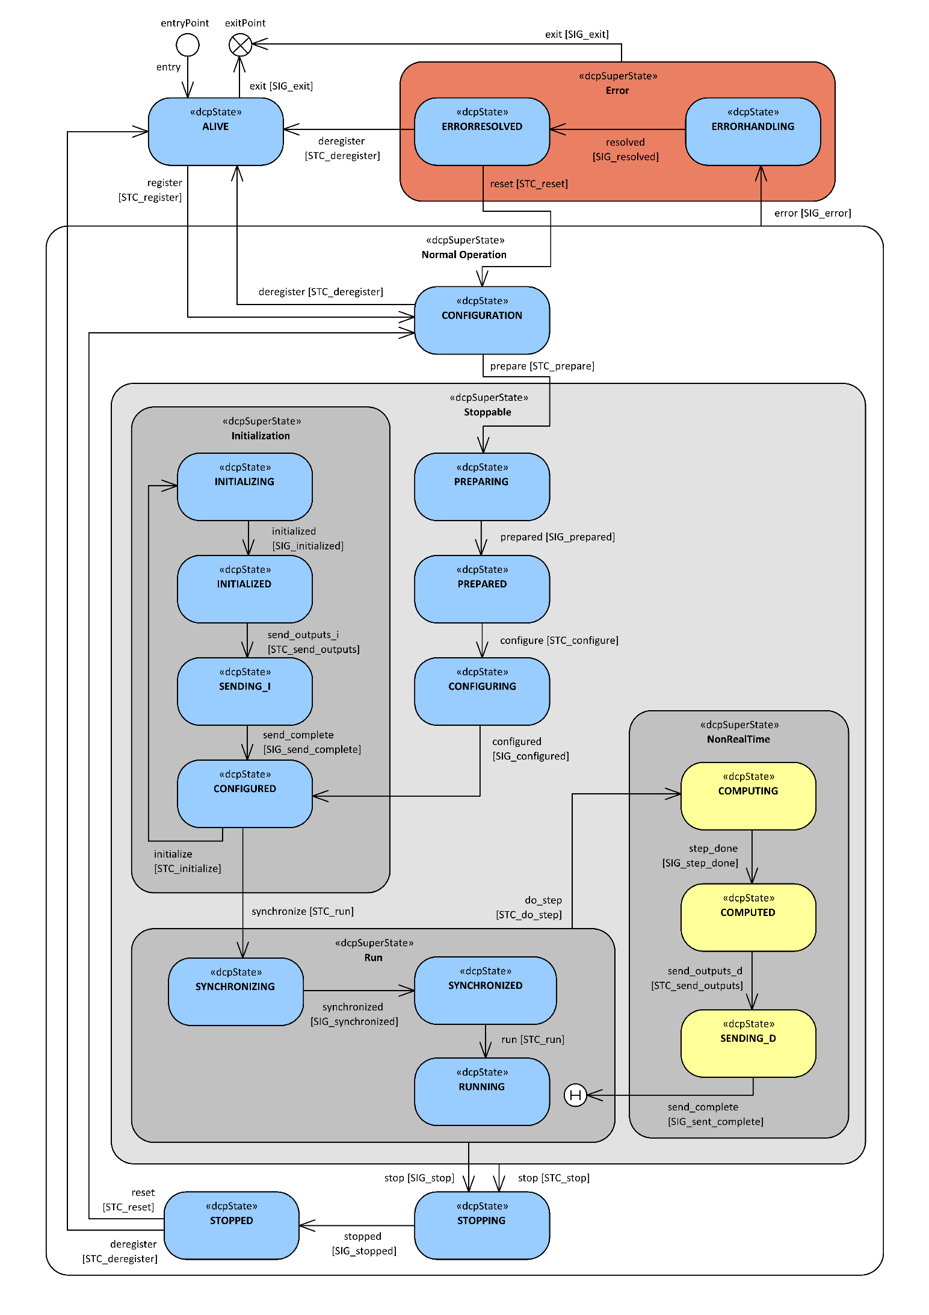

Figure 1: DCP slave state machine

Superstates

The following sections describe the general behavior of the defined superstates.

Normal Operation

The states CONFIGURATION, CONFIGURING, PREPARING, PREPARED, CONFIGURED, INITIALIZING, INITIALIZED, SENDING_I, RUNNING, COMPUTING, COMPUTED, SENDING_D, STOPPING, and STOPPED belong to a super-state called “Normal Operation”. This superstate assumes that the DCP slave operates as intended by the DCP slave provider.

Error

The states ERRORHANDLING and ERRORRESOLVED belong to a superstate Error. This superstate is used to handle exceptional conditions that are defined by the DCP slave provider.

Initialization

The DCP superstate Initialization is used by a DCP master to align multiple DCP slaves before running a simulation. The states CONFIGURED, INITIALIZING, INITIALIZED and SENDING_I together with their transitions allow the master to apply iterative algorithms to reach a consistent initial state over all slaves within a scenario. Initialization is independent from absolute time and the chosen operating mode.

Run

The states SYNCHRONIZING, SYNCHRONIZED and RUNNING belong to superstate Run. In contrast to superstate Initialization simulation time can elapse.

For real-time operating modes SRT and HRT simulation time is running and data is exchanged using the defined step size. For non-real-time operating mode NRT advance of simulation time and data exchange are handled as described in superstate NonRealTime.

The two states SYNCHRONIZING and RUNNING allow for distinction between a possible initial transient oscillation phase and the actual simulation experiment. By transitioning to state SYNCHRONIZED the slave indicates that it has finished the transient oscillation phase.

Note: For example, when the control loop between an engine test bench and a simulation model is closed, typically initial transient oscillations occur. The actual simulation experiment should only be started after this initial transient oscillation phase.

The initial transient oscillation phase takes place in state SYNCHRONIZING. As soon as this phase is finished, the slave transitions to state SYNCHRONIZED. As soon as all slaves are in state SYNCHRONIZED, the master triggers the transition to state RUNNING. This leads to a defined point in time when the actual simulation experiment starts.

For NRT operating mode, from each state of the superstate Run transition to state COMPUTING of superstate NonRealTime is possible. On reentry from state SENDING_D to superstate Run the entry state is the last state from which the superstate Run was left. This is indicated by the History element in the state chart (see Figure 1).

NonRealTime

The states COMPUTING, COMPUTED, and SENDING_D belong to superstate NonRealTime.

The states of NonRealTime are used for triggering calculation, advance of simulation time, and data exchange.

Note: Consider 1 master and 2 slaves A and B, including slave-to-slave communication.

Initially all slaves are in state RUNNING.

The master sends PDU STC_do_step to both slaves.

Slave A changes to state COMPUTING, calculates fast, moves on to COMPUTED.

If no state SENDING_D would exist, he would immediately send its outputs to slave B and changes to state RUNNING.

Slave B might receive this data before having received the STC_do_step from the master, due to network delay, latency, etc.

Thus, he would calculate with input data not consistent to current simulation time instance. The state SENDING_D prevents this.

Stoppable

The states CONFIGURING, PREPARING, PREPARED, CONFIGURED, INITIALIZING, INITIALIZED, RUNNING, COMPUTING, COMPUTED, SENDING_I, SENDING_D are grouped in a super-state “Stoppable”. This means that a slave is allowed to transit to the state Stopping from one of these states.

States

Table 13 lists the states of the state machine together with their assigned IDs.

|  |  |
| --- | --- |
| State name | State idhex |
| ALIVE | 0x00 |
| CONFIGURATION | 0x01 |
| PREPARING | 0x02 |
| PREPARED | 0x03 |
| CONFIGURING | 0x04 |
| CONFIGURED | 0x05 |
| INITIALIZING | 0x06 |
| INITIALIZED | 0x07 |
| SENDING_I | 0x08 |
| SYNCHRONIZING | 0x09 |
| SYNCHRONIZED | 0x0A |
| RUNNING | 0x0B |
| COMPUTING | 0x0C |
| COMPUTED | 0x0D |
| SENDING_D | 0x0E |
| STOPPING | 0x0F |
| STOPPED | 0x10 |
| ERRORHANDLING | 0x11 |
| ERRORRESOLVED | 0x12 |

Table 13: State IDs

State ALIVE

|  |  |
| --- | --- |
| General | The DCP slave is connected to communication media and waits for a DCP master to take ownership. While being in this state, the DCP slave is not assigned to a DCP master yet. A DCP master may take control of a DCP slave by sending the PDU STC_register.  Note: A DCP slave in this state cannot be influenced in any way, except a DCP master taking ownership. |
| Preconditions | The DCP slave is off. |
| Allowed Actions | * Exchange of DCP control and notification PDUs * Report state |

Table 14: State ALIVE

State CONFIGURATION

|  |  |
| --- | --- |
| General | A DCP master has taken ownership of the DCP slave.  In this state, the DCP slave shall accept configuration request PDUs (CFG). A configuration received in this state shall be applied before reaching the state CONFIGURED at the latest.  A DCP master may release a DCP slave by sending the PDU STC_deregister. |
| Preconditions | Any configurations necessary to load the DCP slave and connect it to a given media are set. |
| Allowed Actions | * Exchange of DCP control and notification PDUs * Report state * Configure * Instantiate model or RT system |

Table 15: State CONFIGURATION

State PREPARING

|  |  |
| --- | --- |
| General | Slave must prepare the transport protocol to allow to connect and/or to receive data. This needs to be done for every received CFG_source_network_information. |
| Preconditions | All configurations necessary for real-time and non-realtime data exchange are set by the master or in the DCP slave description. |
| Allowed Actions | * Exchange of DCP control and notification PDUs * Report state |

Table 16: State PREPARING

State PREPARED

|  |  |
| --- | --- |
| General | The slave has prepared the transport protocol and is ready to communicate or establish connections. |
| Preconditions | None. |
| Allowed Actions | * Exchange of DCP control and notification PDUs * Report state |

Table 17: State PREPARED

State CONFIGURING

|  |  |
| --- | --- |
| General | For connection oriented transport protocols a connection is established for every CFG_target_network_information. For connectionless transport protocols no specific actions are necessary.  The DCP slave realizes a start condition depending on parameters, but not on input values. |
| Preconditions | All configurations necessary for real-time and non-realtime data exchange are set by the master or in the DCP slave description. |
| Allowed Actions | * Exchange of DCP control and notification PDUs * Report state * Apply configuration settings to model or RT system |

Table 18: State CONFIGURING

State CONFIGURED

|  |  |
| --- | --- |
| General | At entry to this state coming from CONFIGURING, a start condition depending on parameters, but not on input values has been realized by the DCP slave.  The DCP slave is ready to initialize with other DCP slaves.  Note: If node time synchronization is required (e.g. for HRT operating mode), it must have been done before leaving this state via PDU STC_run because that PDU includes a time value. |
| Preconditions | Start condition is realized. |
| Allowed Actions | * Exchange of DCP Control and Notification PDUs * Report state * Receiving of Data PDUs * Maintain initialized condition of model or RT system |

Table 19: State CONFIGURED

State INITIALIZING

|  |  |
| --- | --- |
| General | In INITIALIZING an internal initial state of the DCP slave, which is consistent to its inputs, shall be established and the outputs shall be computed. The input values from the most recent data PDU are used for internal computation. If no inputs have been received, start values defined in DCP slave description shall be used.  Simulation models: Simulation time stays at start time, simulation models are not computed over time, but at start time.  When the DCP slave finished initializing, it issues SIG_initialized which triggers the transition to leave state INITIALIZING.  If the slave fails to keep the consistent internal initial state, it must perform the transition to the superstate Error.  Note: This state refers to the FMI state “initialization mode”. |
| Preconditions | None. |
| Allowed Actions | * Exchange of DCP Control and Notification PDUs * Receiving Data PDUs * Report state * Synchronize model or RT system within scenario * Indicate end of initializing |

Table 20: State INITIALIZING

State INITIALIZED

|  |  |
| --- | --- |
| General | In INITIALIZED an internal initial state of the DCP slave, which is consistent to its inputs, is established and the outputs are available.  In INITIALIZED the slave remains in its consistent internal initial state. If the slave fails to keep the consistent internal initial state, it must perform the transition to the superstate Error. |
| Preconditions | None. |
| Allowed Actions | * Exchange of DCP Control and Notification PDUs * Receiving Data PDUs * Report state * Maintain synchronized condition of model or RT system within scenario |

Table 21: State INITIALIZED

State SENDING_I

|  |  |
| --- | --- |
| General | In this state the DCP slave sends its outputs. |
| Preconditions | None |
| Allowed Actions | * Exchange of DCP Control and Notification PDUs * Sending and receiving of Data PDUs * Report state * Indicate end of sending |

Table 22: State SENDING_I

State SYNCHRONIZING

|  |  |
| --- | --- |
| General | For real-time operating modes SRT and HRT: The DCP slave is running and inputs/outputs are exchanged. Simulation time is mapped to absolute time.  For non-real-time operating mode (NRT): Simulation time is not advanced but can be increased by transitioning to the NRT-specific state COMPUTING. The DCP slave can receive inputs.  This state is used to account for initial transient oscillations. |
| Preconditions | None |
| Allowed Actions | * Exchange of DCP Control and Notification PDUs * Sending and receiving of Data PDUs * Report state * Indicate end of sending |

Table 23: State SYCHRONIZING

State SYNCHRONIZED

|  |  |
| --- | --- |
| General | For real-time operating modes SRT and HRT: The DCP slave is running and inputs/outputs are exchanged. Simulation time is mapped to absolute time.  For non-real-time operating mode (NRT): Simulation time is not advanced but can be increased by transitioning to the NRT-specific state COMPUTING. The DCP slave can receive inputs. |
| Preconditions | The observed initial transient oscillations have faded out. |
| Allowed Actions | * Exchange of DCP Control and Notification PDUs * Sending and receiving of Data PDUs * Report state * Indicate end of sending |

Table 24: State SYNCHRONIZED

State RUNNING

|  |  |
| --- | --- |
| General | For real-time operating modes SRT and HRT: The DCP slave is running and inputs/outputs are exchanged. Simulation time is mapped to absolute time.  For non-real-time operating mode (NRT): Simulation time is not advanced but can be increased by transitioning to the NRT-specific state COMPUTING. The DCP slave can receive inputs.  The actual simulation experiment is executed in this state. |
| Preconditions | None. |
| Allowed Actions | * Exchange of DCP Control and Notification PDUs * Receiving of Data PDUs in NRT operating mode * Receiving and sending Data PDUs in SRT and HRT operating modes * Report state |

Table 25: State RUNNING

State COMPUTING

|  |  |
| --- | --- |
| General | In this state one computational step is performed. The values from the most recent Data PDUs are used for internal computation. The virtual simulation time is incremented by the number of steps given in the field steps of the PDU STC_do_step multiplied by resolution.  Note: This state applies to NRT (non-real-time) operating mode only. |
| Preconditions | The DCP slave is set to NRT operating mode. |
| Allowed Actions | * Exchange of DCP Control and Notification PDUs * Report state * Indicate end of computational step |

Table 26: State COMPUTING

State COMPUTED

|  |  |
| --- | --- |
| General | In this state all computations were performed and the DCP slave is ready to send computation results. The DCP slave can receive inputs.  Note: This state applies to NRT (non-real-time) operating mode only. |
| Preconditions | The DCP slave is set to NRT operating mode. |
| Allowed Actions | * Exchange of DCP Control and Notification PDUs * Receiving of Data PDUs * Report state |

Table 27: State COMPUTED

State SENDING_D

|  |  |
| --- | --- |
| General | In this state the DCP slave sends its outputs.  Note: This state applies to NRT (non-real-time) operating mode only. |
| Preconditions | The DCP slave is set to NRT operating mode. |
| Allowed Actions | * Exchange of DCP Control and Notification PDUs * Sending and receiving of Data PDUs * Report state * Indicate end of sending |

Table 28: State SENDING_D

State STOPPING

|  |  |
| --- | --- |
| General | The simulation run has finished and is now being stopped. |
| Preconditions | None. |
| Allowed Actions | * Exchange of DCP Control and Notification PDUs * Report state * Indicate halt of model or RT system |

Table 29: State STOPPING

State STOPPED

|  |  |
| --- | --- |
| General | The DCP slave waits for further Control PDUs. |
| Preconditions | The DCP slave has come to a stop. |
| Allowed Actions | * Exchange of DCP control and notification PDUs * Report state * Maintain condition of model or RT system |

Table 30: State STOPPED

State ERRORHANDLING

|  |  |
| --- | --- |
| General | The DCP slave tries to resolve an error. |
| Preconditions | A fault is detected. |
| Allowed Actions | * Exchange of DCP control and notification PDUs * Report state * Resolve occurred error using error handling routines * Ensure safe condition of model or RT system * In case of success, transition self-reliantly to state ERRORRESOLVED.   Note: For detailed description of the DCP error handling procedure, see section 3.4.10. |

Table 31: State ERRORHANDLING

State ERRORRESOLVED

|  |  |
| --- | --- |
| General | The DCP slave has finished its error handling procedure and successfully mitigated the hazardous condition. |
| Preconditions | The DCP slave has handled the occurred error and mitigated the hazardous condition. |
| Allowed Actions | * Exchange of DCP control and notification PDUs * Report state * Maintain safe condition of model or RT system until the DCP master either resets, deregisters or terminates the DCP slave.   Note: For detailed description of the DCP error handling procedure, see section 3.4.10. |

Table 32: State ERRORRESOLVED

Transitions

The following subsections describe the valid state transitions of the DCP slave state machine.

Transition entry

|  |  |
| --- | --- |
| General | This transition marks the entry point to the state machine.  The DCP software is loaded on the execution platform, therefore it transforms into a DCP slave. |
| Preconditions | None |
| Trigger | Load the DCP software. |
| States | * entryPoint -> ALIVE |

Table 33: Transition entry

Transition exit

|  |  |
| --- | --- |
| General | This transition marks the exit point from the state machine.  The DCP software is unloaded from the execution platform.  In case of an error, the occurred error either (1) could not be handled and the DCP software is unloaded from the execution platform, or (2) another error occurred before resetting the DCP slave. |
| Preconditions | None or unrecoverable error. |
| Trigger | SIG_exit |
| States | * ALIVE -> exitPoint * ERRORHANDLING -> exitPoint * ERRORRESOLVED -> exitPoint |

Table 34: Transition exit

Transition register

|  |  |
| --- | --- |
| General | A DCP master shall register a DCP slave to integrate it into a simulation scenario and use it for a simulation task. |
| Preconditions | The DCP slave is currently deregistered.  The DCP slave received a STC_register PDU. |
| Trigger | STC_register |
| States | * ALIVE -> CONFIGURATION |

Table 35: Transition register

Transition prepare

|  |  |
| --- | --- |
| General | The transport protocol should be prepared. |
| Preconditions | All configuration information was received by the DCP slave. |
| Trigger | STC_prepare |
| States | * CONFIGURATION -> PREPARING |

Table 36: Transition prepare

Transition prepared

|  |  |
| --- | --- |
| General | The preparation of the transport protocol has finished. |
| Preconditions | None. |
| Trigger | SIG_prepared |
| States | * PREPARING -> PREPARED |

Table 37: Transition prepared

Transition deregister

|  |  |
| --- | --- |
| General | A DCP master deregisters a DCP slave to release it from a simulation scenario. |
| Preconditions | The DCP slave is registered to a DCP master. |
| Trigger | STC_deregister |
| States | * CONFIGURATION -> ALIVE * STOPPED -> ALIVE * ERRORRESOLVED -> ALIVE |

Table 38: Transition deregister

Transition configure

|  |  |
| --- | --- |
| General | The DCP slave has received configuration information and shall start to realize the configuration. |
| Preconditions | None. |
| Trigger | STC_configure |
| States | * PREPARED -> CONFIGURING |

Table 39: Transition configure

Transition configured

|  |  |
| --- | --- |
| General | The DCP slave realized a configuration. |
| Preconditions | None. |
| Trigger | SIG_configured |
| States | * CONFIGURING -> CONFIGURED |

Table 40: Transition configured

Transition initialize

|  |  |
| --- | --- |
| General | The DCP slave starts to establish a consistent initial state with all other connected DCP slaves. |
| Preconditions | None. |
| Trigger | STC_initialize |
| States | * CONFIGURED -> INITIALIZING |

Table 41: Transition initialize

Transition initialized

|  |  |
| --- | --- |
| General | The DCP slave has established a consistent initial state with other connected DCP slaves. |
| Preconditions | None. |
| Trigger | SIG_initialized |
| States | * INITIALIZING -> INITIALIZED |

Table 42: Transition initialized

Transition send_outputs_i

|  |  |
| --- | --- |
| General | The DCP slave sends its initialization results. |
| Preconditions | The DCP slave received a STC_send_outputs PDU.  The DCP slave is either in NRT (non-real-time) operating mode or in Initialization superstate. |
| Trigger | STC_send_outputs |
| States | * INITIALIZED -> SENDING_I |

Table 43: Transition send_outputs

Transition run

|  |  |
| --- | --- |
| General | This transition indicates the start of the simulation run. |
| Preconditions | The DCP master has determined that simulation shall start either now or at a given time. |
| Trigger | STC_run |
| States | * CONFIGURED -> RUNNING   Note: Even if the field time within the PDU STC_run contains a time > now, the DCP slave transitions immediately to state RUNNING. In state RUNNING, it waits for time==now and then starts the simulated time. |

Table 44: Transition run

Transition stop (STC_stop)

|  |  |
| --- | --- |
| General | The DCP master tells the DCP slave to halt the simulation or abort the configuration or initialization phase by sending PDU STC_stop. The DCP slave proceeds to STOPPING. |
| Preconditions | None. |
| Trigger | STC_stop |
| States | * PREPARING -> STOPPING * PREPARED -> STOPPING * CONFIGURING -> STOPPING * CONFIGURED -> STOPPING * SYNCHRONIZING -> STOPPING * SYNCHRONIZED -> STOPPING * RUNNING -> STOPPING * INITIALIZING -> STOPPING * INITIALIZED -> STOPPING * SENDING_I -> STOPPING * COMPUTING -> STOPPING * COMPUTED -> STOPPING * SENDING_D -> STOPPING |

Table 45: Transition stop by PDU

Transition stop (SIG_stop)

|  |  |
| --- | --- |
| General | The DCP slave wants to stop the simulation. |
| Preconditions | The DCP slave raised a SIG_stop signal.  Note: A DCP slave may request simulation stop from the DCP master by triggering SIG_stop. The master notices the state change of the DCP slave and reacts accordingly, e.g. may communicate STC_stop to other DCP slaves of the same scenario. |
| Trigger | SIG_stop |
| States | * SYNCHRONIZING -> STOPPING * SYNCHRONIZED -> STOPPING * RUNNING -> STOPPING |

Table 46: Transition stop by SIG

Transition do_step

|  |  |
| --- | --- |
| General | The DCP slave starts one computational step. |
| Preconditions | The DCP slave is in NRT (non-real-time) operating mode. |
| Trigger | STC_do_step |
| States | * SYNCHRONIZING -> COMPUTING * SYNCHRONIZED -> COMPUTING * RUNNING -> COMPUTING |

Table 47: Transition do_step

Transition step_done

|  |  |
| --- | --- |
| General | The DCP slave has finished one computational step. |
| Preconditions | The DCP slave is in NRT (non-real-time) operating mode. |
| Trigger | SIG_step_done |
| States | * COMPUTING -> COMPUTED |

Table 48: Transition step_done

Transition send_outputs_d

|  |  |
| --- | --- |
| General | The DCP slave sends its computational results. |
| Preconditions | The DCP slave received a STC_send_outputs PDU.  The DCP slave is either in NRT (non-real-time) operating mode or in Initialization superstate. |
| Trigger | STC_send_outputs |
| States | * COMPUTED -> SENDING_D |

Table 49: Transition send_outputs

Transition send_complete

|  |  |
| --- | --- |
| General | The DCP slave has finished sending its computational results. |
| Preconditions | The DCP slave is either in NRT (non-real-time) operating mode or in Initialization superstate. |
| Trigger | SIG_send_complete |
| States | SENDING_D -> RUNNING  SENDING_D -> SYNCHRONIZING  SENDING_D -> SYNCHRONIZED  SENDING_I -> CONFIGURED |

Table 50: Transition send_complete

Transition stopped

|  |  |
| --- | --- |
| General | The DCP slave and its underlying model or real-time system has come to a halt. |
| Preconditions | None. |
| Trigger | SIG_stopped |
| States | * STOPPING -> STOPPED |

Table 51: Transition stopped

Transition synchronize

|  |  |
| --- | --- |
| General | The DCP slave enters the Run superstate. |
| Preconditions | None. |
| Trigger | STC_run |
| States | * CONFIGURED -> SYNCHRONIZING |

Table 52: Transition synchronize

Transition synchronized

|  |  |
| --- | --- |
| General | The DCP slave indicates that synchronization is finished. |
| Preconditions | DCP slave internal detection of synchronization. |
| Trigger | SIG_synchronized |
| States | * SYNCHRONIZING -> SYNCHRONIZED |

Table 53: Transition synchronized

Transition reset

|  |  |
| --- | --- |
| General | The DCP slave is commanded by the DCP master to go back to state CONFIGURATION. All previously configured settings are reset, this also includes shutdown of connections configured by PDUs of the configuration family.  Note: Transport protocol specific actions might be necessary, e.g. closing connections and ports for TCP/IPv4. |
| Preconditions | None. |
| Trigger | STC_reset |
| States | * STOPPED -> CONFIGURATION * ERRORRESOLVED -> CONFIGURATION |

Table 54: Transition reset

Transition error

|  |  |
| --- | --- |
| General | This transition represents the start of an error handling routine. |
| Preconditions | The DCP slave diagnoses an error. |
| Trigger | SIG_error |
| States | * CONFIGURATION -> ERRORHANDLING * PREPARING -> ERRORHANDLING * PREPARED -> ERRORHANDLING * CONFIGURING -> ERRORHANDLING * CONFIGURED -> ERRORHANDLING * INITIALIZING -> ERRORHANDLING * INITIALIZED -> ERRORHANDLING * SENDING_I -> ERRORHANDLING * SYNCHRONIZING -> ERRORHANDLING * SYNCHRONIZED -> ERRORHANDLING * RUNNING -> ERRORHANDLING * COMPUTING -> ERRORHANDLING * COMPUTED -> ERRORHANDLING * SENDING_D -> ERRORHANDLING * STOPPING -> ERRORHANDLING * STOPPED -> ERRORHANDLING |

Table 55: Transition error

Transition resolved

|  |  |
| --- | --- |
| General | The occurred error was successfully handled. |
| Preconditions | The DCP slave received a resolved signal. |
| Trigger | SIG_resolved |
| States | * ERRORHANDLING -> ERRORRESOLVED |

Table 56: Transition resolved

PDU Definitions

General

Protocol Data Units (PDUs) are transmitted via abstract channels. In practice, a communication medium must be used. DCP PDUs are categorized in families. Configuration request (CFG), state change request (STC), and information request (INF) PDUs belong to the family of Request PDUs. Together with the family of response (RSP) PDUs they make up the family of Control PDUs. The families of Notification PDUs (NTF) and Data PDUs (DAT) complete the range of available PDU families.

Control PDUs are exchanged between DCP master and DCP slaves. PDUs of the families CFG, STC and INF are only sent from the DCP master to its DCP slaves and are acknowledged by the DCP slaves via RSP PDUs. Data PDUs are not acknowledged.

If the DCP master sets up a scenario where the master relays Data between DCP slaves, then also a DCP master may send and receive Data PDUs.

Note: Data PDUs are not acknowledged. To ensure that corruption, loss, reordering, etc. of Data PDUs is avoided, a reliable communication medium must be used. See also section 10-F.

Structuring

All PDUs are structured using fields. A field is defined by its name, a DCP compliant data type, and the position of the field within the PDU, given in bytes. Table 57 provides an overview of all specified PDU fields and their corresponding data types. Concrete PDUs are distinguished by their type (field: type_id). For all PDUs, the type_id is available at the beginning at position zero with a length of 1 byte. A specific PDU does not contain all remaining fields, but only those required for the specific use, as can be seen in Table 62. The upcoming subsections give detailed information about each PDU.

|  |  |
| --- | --- |
| Field | Data type specification |
| data_id | uint16 |
| denominator | uint32 |
| error_code | uint16 |
| exp_seq_id | uint16 |
| log_category | uint8 |
| log_level | uint8 |
| log_max_num | uint8 |
| log_mode | uint8 |
| log_template_id | uint8 |
| log_arg_val | byte[] |
| log_entries | byte[] |
| major_version | uint8 |
| minor_version | uint8 |
| numerator | uint32 |
| op_mode | uint8 |
| parameter_vr | uint64 |
| param_id | uint16 |
| payload | byte[] |
| pdu_seq_id | uint16 |
| pos | uint16 |
| receiver | uint8 |
| resp_seq_id | uint16 |
| scope | uint8 |
| sender | uint8 |
| slave_uuid | unsigned byte[16] |
| source_data_type | uint8 |
| source_vr | uint64 |
| time | int64 |
| state_id | uint8 |
| steps | uint32 |
| target_vr | uint64 |
| transport_protocol | uint8 |
| type_id | uint8 |

Table 57: Field data types

PDU Fields

Sequence Identifier

The PDU sequence id (fields: pdu_seq_id, resp_seq_id, exp_seq_id). For further information see section 3.4.1.

Slave Identifier

Each DCP slave within a given simulation scenario identifies itself uniquely by using a DCP slave id. This DCP slave id is assigned by the master. The DCP id zero (“0”) shall be reserved for the master. The two PDU fields sender and receiver use this DCP slave id.

In the sender field, the id of the slave that sends the PDU is given. In the receiver field, the id of the slave that shall receive the PDU is given.

Data Identifier

The field data_id is the unique identifier of the payload data.

Denominator

The field denominator holds the integer value for the denominator of the fraction that defines resolution.

Error Code

The error code is a unique identifier for defined DCP errors.

Log Category

The log category may be used by a DCP slave vendor to categorize log messages. Table 58 gives the possible options.

|  |  |
| --- | --- |
| Log category | Definition |
| 0 | Predefined, used to address all available log categories.  Note: CFG_logging with log category “0” will affect the configuration of all categories of a slave.  Note: A DCP slave receiving INF_log_request with log category “0” will consider all categories. |
| 1-255 | These log categories may be specified in the DCP slave description file. Subsequently they may be used in a log template. |

Table 58: Log categories

Log Level

The log level may be used in a log template in the DCP slave description file.

Note: This corresponds to the status field of FMI.

|  |  |  |
| --- | --- | --- |
| Log level | Value | Definition |
| Fatal | 0 | The simulation cannot be continued. The DCP slave will transition to the error superstate.  Note: An example for this log level are several missed heartbeats, exceeding the allowed specified time out limits. |
| Error | 1 | The current action cannot be continued.  Note: An example for this log level is a wrong UUID in STC_register. |
| Warning | 2 | The current action can be continued, but simulation results could be affected.  Note: An example for this log level is a value out of bounds. |
| Information | 3 | This log level reflects the status of a DCP slave.  Note: An example for this log level is initialization for 40% finished. |
| Debug | 4 | This log level is intended for debug information.  Note: An example for this log level is step size for data identifier 4 set to 100. |

Table 59: Log level definitions

Log Maximum Number

This field represents the maximum number of requested log entries.

Log Mode

This field defines the mode for log functionality. Table 60 gives the available options.

|  |  |
| --- | --- |
| Value | Definition |
| 0 | No logging via DCP |
| 1 | Log on request |
| 2 | Log on notification |

Table 60: Log modes

Log Argument Values

A byte array containing the argument values as specified in a template of the DCP slave description.

Log Template Identifier

An integer value representing the template identifier, referring to a template in the DCP slave description.

Log Entries

A byte array containing one or more log entries. See section 3.3.7.30, Table 95 for details.

Major Version

The field major_version gives the major version of the DCP to be used (see section 3.1.2).

Minor Version

The field minor_version gives the minor version of the DCP to be used (see section 3.1.2).

Numerator

The field numerator holds the integer value for the numerator of the fraction that defines the resolution (see section 3.1.16).

Operating Mode

The field op_mode holds the operation mode as defined in section 3.1.15 the DCP slave must use.

Parameter Value Reference

The field parameter_vr gives the value reference of the parameter (see section 3.1.18.3).

Parameter Identifier

The field param_id gives the unique identifier of the parameter referred to in the PDU (see section 3.1.18.3).

Payload

The field payload is used to hold information that is not fixed in general but must be configured using DCP mechanisms.

Position

The field pos gives the position of a data value in the PDU Data payload field in byte (see section 3.4.5).

Scope

The field scope gives the scope of validity for a configuration of a specified PDU Data payload field as defined in section 3.4.6.

Slave UUID

The field slave_uuid holds the universal unique identifier of a slave. It is defined as an unsigned byte array of length 16. The string representation of slave_uuid is defined according to RFC4122 [5]. It is not required that the content of the field slave_uuid follows RFC4122.

Source Data Type

The field source_data_type holds the data type of a value in a PDU Data as defined in section 3.1.10.

Source Value Reference

The field source_vr gives the value reference of the output (see section 3.1.18.2).

State Identifier

The field state_id gives the current state of the slave as defined in Table 13.

Steps

The content of the field steps depends on the chosen operating mode. In PDU STC_do_step it defines the number of computational steps the slave must perform in state COMPUTING. In PDU CFG_steps it defines the communication step size of an output for SRT and HRT operating modes (see section 3.1.15).

Target Value Reference

The field target_vr gives the value reference of the input (see section 3.1.18.2).

Transport Protocol

In the field transport_protocol the unique identifier of the transport protocol is given. Possible options are defined in section 3.1.22.

Type Identifier

In the field type_id the unique identifier of the PDU is given. An overview of all assigned type identifiers is given in section 3.3.5, the type identifier range distribution is given in section 3.3.4.

Time

The time field represents the absolute time (see section 3.1.14.1) as a 64-bit signed integer value.

PDU Type Identifier Range Distribution

The field type_id contains a unique number for each PDU type. For DCP, all PDU type_ids are assigned as stated in section 3.3.5. However, the following numbering scheme applies, dependent on the PDU family (also see sections 3.1.7).

|  |  |  |
| --- | --- | --- |
| PDU group | Start | End |
| (not in use) | 0x00 | 0x00 |
| State change (STC) | 0x01 | 0x1F |
| Configuration (CFG) | 0x20 | 0x7F |
| Information (INF) | 0x80 | 0xAF |
| Response (RSP) | 0xB0 | 0xDF |
| Notification (NTF) | 0xE0 | 0xEF |
| Data (DAT) | 0xF0 | 0xFF |

Table 61: PDU type identifier range distribution

Generic PDU Structure

The following Table 62 defines a generic PDU structure for native DCP.



Table 62: Generic PDU structure

Allowed PDUs per State

Table 63 defines the allowed PDUs per state. If a PDU is not allowed within a certain state, e.g. a RSP_nack PDU including an error_code may be sent. Alternatively, the DCP slave may also go to an ERROR state.

The following table specifies the permissible PDUs to be sent or received for each state.

|  |  |  |  |  |  |  |  |  |  |  |  |  |  |  |  |  |  |  |  |
| --- | --- | --- | --- | --- | --- | --- | --- | --- | --- | --- | --- | --- | --- | --- | --- | --- | --- | --- | --- |
| PDUs | States | | | | | | | | | | | | | | | | | | |
| ALIVE | CONFIGURATION | PREPARING | PREPARED | CONFIGURING | CONFIGURED | INITIALIZING | INITIALIZED | SENDING_I | SYNCHRONIZING | SYNCHRONIZED | RUNNING | COMPUTING | COMPUTED | SENDING_D | STOPPING | STOPPED | ERRORHANDLING | ERRORRESOLVED |
| STC_register | R |  |  |  |  |  |  |  |  |  |  |  |  |  |  |  |  |  |  |
| STC_deregister |  | R |  |  |  |  |  |  |  |  |  |  |  |  |  |  | R |  | R |
| STC_prepare |  | R |  |  |  |  |  |  |  |  |  |  |  |  |  |  |  |  |  |
| STC_configure |  |  |  | R |  |  |  |  |  |  |  |  |  |  |  |  |  |  |  |
| STC_initialize |  |  |  |  |  | R |  |  |  |  |  |  |  |  |  |  |  |  |  |
| STC_run |  |  |  |  |  | R |  |  |  |  |  |  |  |  |  |  |  |  |  |
| STC_do_step |  |  |  |  |  |  |  |  |  |  |  | 1 |  |  |  |  |  |  |  |
| STC_send_outputs |  |  |  |  |  |  |  | R |  |  |  |  |  | 1 |  |  |  |  |  |
| STC_stop |  |  | R | R | R | R | R | R | R | R | R | R | R | R | R |  |  |  |  |
| STC_reset |  |  |  |  |  |  |  |  |  |  |  |  |  |  |  |  | R |  | R |
| RSP_ack | S | S | S | S | S | S | S | S | S | S | S | S | S | S | S | S | S | S | S |
| RSP_nack | S | S | S | S | S | S | S | S | S | S | S | S | S | S | S | S | S | S | S |
| RSP_state_ack | S | S | S | S | S | S | S | S | S | S | S | S | S | S | S | S | S | S | S |
| RSP_error_ack |  |  |  |  |  |  |  |  |  |  |  |  |  |  |  |  |  | S | S |
| RSP_log_ack |  | S | S | S | S | S | S | S | S | S | S | S | S | S | S | S | S | S | S |
| NTF_state_changed | S | S | S | S | S | S | S | S | S | S | S | S | S | S | S | S | S | S | S |
| NTF_log |  | S | S | S | S | S | S | S | S | S | S | S | S | S | S | S | S | S | S |
| INF_state | R | R | R | R | R | R | R | R | R | R | R | R | R | R | R | R | R | R | R |
| INF_error |  |  |  |  |  |  |  |  |  |  |  |  |  |  |  |  |  | R | R |
| INF_log |  | R | R | R | R | R | R | R | R | R | R | R | R | R | R | R | R | R | R |
| CFG_steps |  | 2 |  |  |  |  |  |  |  |  |  |  |  |  |  |  |  |  |  |
| CFG_time_res |  | R |  |  |  |  |  |  |  |  |  |  |  |  |  |  |  |  |  |
| CFG_input |  | R |  |  |  |  |  |  |  |  |  |  |  |  |  |  |  |  |  |
| CFG_output |  | R |  |  |  |  |  |  |  |  |  |  |  |  |  |  |  |  |  |
| CFG_clear |  | R |  |  |  |  |  |  |  |  |  |  |  |  |  |  |  |  |  |
| CFG_target_network_information |  | R |  |  |  |  |  |  |  |  |  |  |  |  |  |  |  |  |  |
| CFG_source_network_information |  | R |  |  |  |  |  |  |  |  |  |  |  |  |  |  |  |  |  |
| CFG_tunable_parameter |  | R |  |  |  |  |  |  |  |  |  |  |  |  |  |  |  |  |  |
| CFG_parameter |  | R |  |  |  |  |  |  |  |  |  |  |  |  |  |  |  |  |  |
| CFG_param_network_information |  | R |  |  |  |  |  |  |  |  |  |  |  |  |  |  |  |  |  |
| CFG_logging |  | R |  |  |  |  |  |  |  |  |  |  |  |  |  |  |  |  |  |
| CFG_scope |  | R |  |  |  |  |  |  |  |  |  |  |  |  |  |  |  |  |  |
| DAT_input_output |  |  |  |  |  | R | 3 | R | 6 | 6 | 6 | 6 | 6 | 6 | 7 | 4 | 4 | 4 | 4 |
| DAT_parameter |  |  |  |  |  | R | R | R | 5 | 5 | 5 | 5 | 5 | 5 | 5 | 4 | 4 | 4 | 4 |

Table 63: Allowed PDUs per state

The literals in the previous table have the following meaning:

|  |  |
| --- | --- |
| Literal | Meaning |
| S | Sending of this PDU is allowed |
| R | Receiving of this PDU is allowed |
| X | Sending and receiving of this PDU is allowed |
| 1 | Receiving is only allowed in non-real time operating mode |
| 2 | Receiving is only allowed in real time and soft real time operating mode |
| 3 | A slave may receive DAT_input_output in this state, but the receiver might not consider them till it changes to INITIALIZING or RUNNING. The values from the most recent data PDU are used for internal computation. As soon as it has finished its internal computation and just before the state is left, the current output values are sent in a DAT_input_output. |
| 4 | Receiving of data PDUs is allowed, but the received data is not considered.  Note: Example: this might happen in case of slave to slave data transfer. The master might have sent STC_stop to a slave which receives DAT_input_output from a slave which is still in state RUNNING. |
| 5 | A slave may receive DAT_parameter in this state.  DAT_parameter must only contain parameters with variability tunable.   * In NRT mode, the received values must not be considered until the DCP slave changes to COMPUTING. The values from the most recent data PDU are used for internal computation. * In SRT or HRT mode the values from the most recent data PDU are used for internal computation. |
| 6 | A slave may receive DAT_input_output in this state.   * In NRT mode, the received values must not be considered until the DCP slave changes to COMPUTING. The values from the most recent data PDU are used for internal computation. * In SRT or HRT mode the values from the most recent data PDU are used for internal computation. Sending of DAT_input_output is also allowed. |
| 7 | Same as 6, excluding SRT and HRT cases.  Additionally, sending of DAT_input_output is also allowed. |

Table 64: Key for allowed PDUs per state

PDU Definitions

#### PDU STC_register

This PDU is used by a DCP master to take ownership of a given DCP slave.

The field slave_uuid follows the definition of section 3.3.3.22.

The fields major_version and minor_version follow the version descriptor numbering scheme of section 3.1.2.

In the field receiver the master sets the slave’s slave id.

|  |  |  |  |
| --- | --- | --- | --- |
| First Position [Byte] | Last Position [Byte] | Data type | Field |
| 0 | 0 | uint8 | type_id = 0x01 |
| 1 | 2 | unit16 | pdu_seq_id |
| 3 | 3 | uint8 | receiver |
| 4 | 4 | uint8 | state_id |
| 5 | 20 | byte[16] | slave_uuid |
| 21 | 21 | uint8 | op_mode |
| 22 | 22 | uint8 | major_version |
| 23 | 23 | uint8 | minor_version |

Table 65: STC_register

PDU STC_deregister

With the PDU STC_deregister, the slave is released from the ownership of the master. It triggers the transition to state ALIVE.

|  |  |  |  |
| --- | --- | --- | --- |
| First Position [Byte] | Last Position [Byte] | Data type | Field |
| 0 | 0 | uint8 | type_id = 0x02 |
| 1 | 2 | unit16 | pdu_seq_id |
| 3 | 3 | uint8 | receiver |
| 4 | 4 | uint8 | state_id |

Table 66: STC_deregister

PDU STC_prepare

This PDU is used to trigger the state transition to PREPARING.

|  |  |  |  |
| --- | --- | --- | --- |
| First Position [Byte] | Last Position [Byte] | Data type | Field |
| 0 | 0 | uint8 | type_id = 0x03 |
| 1 | 2 | unit16 | pdu_seq_id |
| 3 | 3 | uint8 | receiver |
| 4 | 4 | uint8 | state_id |

Table 67: STC_prepare

PDU STC_configure

This PDU is used to trigger the state transition to CONFIGURING.

|  |  |  |  |
| --- | --- | --- | --- |
| First Position [Byte] | Last Position [Byte] | Data type | Field |
| 0 | 0 | uint8 | type_id = 0x04 |
| 1 | 2 | unit16 | pdu_seq_id |
| 3 | 3 | uint8 | receiver |
| 4 | 4 | uint8 | state_id |

Table 68: STC_configure

PDU STC_initialize

This PDU is used to trigger the state transition to INITIALIZING.

|  |  |  |  |
| --- | --- | --- | --- |
| First Position [Byte] | Last Position [Byte] | Data type | Field |
| 0 | 0 | uint8 | type_id = 0x05 |
| 1 | 2 | unit16 | pdu_seq_id |
| 3 | 3 | uint8 | receiver |
| 4 | 4 | uint8 | state_id |

Table 69: STC_initialize

PDU STC_run

After receiving STC_run, the slave transitions immediately to state SYNCHRONIZING or RUNNING, respectively.

The field time is used to schedule the start of a simulation run in HRT or SRT operating modes. It refers to absolute time.

If time >= current absolute time, a DCP slave must wait until the point in time arrives.

If time is less than the current absolute time (time < current absolute time) the DCP slave shall respond with RSP_nack, including error_code = INVALID_START_TIME.

If the value of time equals zero (“0”), simulation shall start immediately. In case of non-real time operation mode (NRT), time must be ignored, considering that the simulation run is controlled by STC_do_step.

CONFIGURED -> SYNCHRONIZING

When time is reached, the slave starts to exchange data and the simulation time starts to advance.

SYNCHRONIZING -> RUNNING

When time is reached, the actual simulation experiment must start.

|  |  |  |  |
| --- | --- | --- | --- |
| First Position [Byte] | Last Position [Byte] | Data type | Field |
| 0 | 0 | uint8 | type_id = 0x06 |
| 1 | 2 | unit16 | pdu_seq_id |
| 3 | 3 | uint8 | receiver |
| 4 | 4 | uint8 | state_id |
| 5 | 12 | int64 | time |

Table 70: STC_run

PDU STC_do_step

This PDU triggers the transition to COMPUTING. It shall only be sent to DCP slaves in non-real-time (NRT) operating mode.

|  |  |  |  |
| --- | --- | --- | --- |
| First Position [Byte] | Last Position [Byte] | Data type | Field |
| 0 | 0 | uint8 | type_id = 0x07 |
| 1 | 2 | unit16 | pdu_seq_id |
| 3 | 3 | uint8 | receiver |
| 4 | 4 | uint8 | state_id |
| 5 | 8 | uint32 | steps |

Table 71: STC_do_step

PDU STC_send_outputs

This PDU triggers the transition to SENDING_I and SENDING_D and thus the transmission of calculated simulation outputs.

|  |  |  |  |
| --- | --- | --- | --- |
| First Position [Byte] | Last Position [Byte] | Data type | Field |
| 0 | 0 | uint8 | type_id = 0x08 |
| 1 | 2 | unit16 | pdu_seq_id |
| 3 | 3 | uint8 | receiver |
| 4 | 4 | uint8 | state_id |

Table 72: STC_send_outputs

PDU STC_stop

This PDU triggers the transition to state STOPPING.

|  |  |  |  |
| --- | --- | --- | --- |
| First Position [Byte] | Last Position [Byte] | Data type | Field |
| 0 | 0 | uint8 | type_id = 0x09 |
| 1 | 2 | unit16 | pdu_seq_id |
| 3 | 3 | uint8 | receiver |
| 4 | 4 | uint8 | state_id |

Table 73: STC_stop

PDU STC_reset

This PDU triggers the transition to state CONFIGURATION. All configuration settings received before by configuration request PDUs (CFG) are deleted.

|  |  |  |  |
| --- | --- | --- | --- |
| First Position [Byte] | Last Position [Byte] | Data type | Field |
| 0 | 0 | uint8 | type_id = 0x0A |
| 1 | 2 | unit16 | pdu_seq_id |
| 3 | 3 | uint8 | receiver |
| 4 | 4 | uint8 | state_id |

Table 74: STC_reset

PDU INF_state

This PDU requests a DCP slave’s current state.

|  |  |  |  |
| --- | --- | --- | --- |
| First Position [Byte] | Last Position [Byte] | Data type | Field |
| 0 | 0 | uint8 | type_id = 0x80 |
| 1 | 2 | unit16 | pdu_seq_id |
| 3 | 3 | uint8 | receiver |

Table 75: INF_state

PDU INF_error

This PDU requests a DCP slave’s reported error.

|  |  |  |  |
| --- | --- | --- | --- |
| First Position [Byte] | Last Position [Byte] | Data type | Field |
| 0 | 0 | uint8 | type_id = 0x81 |
| 1 | 2 | unit16 | pdu_seq_id |
| 3 | 3 | uint8 | receiver |

Table 76: INF_error

PDU INF_log

This PDU requests the slave to send it’s logging entries of the category log_category. The number of returned logging entries is limited to log_max_num.

|  |  |  |  |
| --- | --- | --- | --- |
| First Position [Byte] | Last Position [Byte] | Data type | Field |
| 0 | 0 | uint8 | type_id = 0x82 |
| 1 | 2 | unit16 | pdu_seq_id |
| 3 | 3 | uint8 | receiver |
| 4 | 4 | uint8 | log_category |
| 5 | 5 | uint8 | log_max_num |

Table 77: INF_log

PDU CFG_time_res

This PDU requests a DCP slave to set its time resolution.

|  |  |  |  |
| --- | --- | --- | --- |
| First Position [Byte] | Last Position [Byte] | Data type | Field |
| 0 | 0 | uint8 | type_id = 0x20 |
| 1 | 2 | unit16 | pdu_seq_id |
| 3 | 3 | uint8 | receiver |
| 4 | 7 | uint32 | numerator |
| 8 | 11 | uint32 | denominator |

Table 78: CFG_time_res

PDU CFG_steps

This PDU requests a DCP slave to set its communication step size.

The number of steps must be larger or equal than 1.

|  |  |  |  |
| --- | --- | --- | --- |
| First Position [Byte] | Last Position [Byte] | Datatype | Field Name |
| 0 | 0 | uint8 | type_id = 0x21 |
| 1 | 2 | unit16 | pdu_seq_id |
| 3 | 3 | uint8 | receiver |
| 4 | 7 | uint32 | steps |
| 8 | 9 | uint16 | data_id |

Table 79: CFG_steps

PDU CFG_input

In order to set up slave-to-slave DAT_input_output PDU communication, the DCP master must inform all DCP slaves that have inputs to be received in which format they may expect DAT_input_output PDUs. For that purpose, CFG_input is used.

|  |  |  |  |
| --- | --- | --- | --- |
| First Position [Byte] | Last Position [Byte] | Data type | Field |
| 0 | 0 | uint8 | type_id = 0x22 |
| 1 | 2 | unit16 | pdu_seq_id |
| 3 | 3 | uint8 | receiver |
| 4 | 5 | uint16 | data_id |
| 6 | 7 | uint16 | pos |
| 8 | 15 | uint64 | target_vr |
| 16 | 16 | uint8 | source_data_type |

Table 80: CFG_input

PDU CFG_output

In order to set up slave-to-slave DAT_input_output PDU communication, the master must inform all DCP slaves that have outputs to be sent to which input and at which DCP slave the value must be sent. For that purpose, the PDU CFG_output is used.

|  |  |  |  |
| --- | --- | --- | --- |
| First Position [Byte] | Last Position [Byte] | Data type | Field |
| 0 | 0 | uint8 | type_id = 0x23 |
| 1 | 2 | unit16 | pdu_seq_id |
| 3 | 3 | uint8 | receiver |
| 4 | 5 | uint16 | data_id |
| 6 | 7 | uint16 | pos |
| 8 | 15 | uint64 | source_vr |

Table 81: CFG_output

PDU CFG_clear

The DCP slave must reset all configurations set earlier by configuration request PDUs.

Note: The operating mode and the DCP slave’s slave_id are not reset.

|  |  |  |  |
| --- | --- | --- | --- |
| First Position [Byte] | Last Position [Byte] | Data type | Field |
| 0 | 0 | uint8 | type_id = 0x24 |
| 1 | 2 | unit16 | pdu_seq_id |
| 3 | 4 | uint8 | receiver |

Table 82: CFG_clear

PDU CFG_target_network_information

The PDU CFG_target_network_information is used to distribute network information. It is defined by the following general structure. The complete structure depends on the used communication medium.

The character *N* denotes the total length of one specific CFG_target_network_information in bytes. It depends on the used transport protocol.

|  |  |  |  |
| --- | --- | --- | --- |
| First Position [Byte] | Last Position [Byte] | Data type | Field |
| 0 | 0 | uint8 | type_id = 0x25 |
| 1 | 2 | unit16 | pdu_seq_id |
| 3 | 3 | uint8 | receiver |
| 4 | 5 | uint16 | data_id |
| 6 | 6 | uint8 | transport_protocol |
| 7 | N-1 | See section 4 – transport protocol specific | |

Table 83: CFG_target_network_information

PDU CFG_source_network_information

The message CFG_source_network_information is used to distribute network information. It is defined by the following general structure. The complete structure depends on the communication medium used.

The character *N* denotes the total length of one specific CFG_source_network_information in bytes. It depends on the used transport protocol.

|  |  |  |  |
| --- | --- | --- | --- |
| First Position [Byte] | Last Position [Byte] | Data type | Field |
| 0 | 0 | uint8 | type_id = 0x26 |
| 1 | 2 | unit16 | pdu_seq_id |
| 3 | 3 | uint8 | receiver |
| 4 | 5 | uint16 | data_id |
| 6 | 6 | uint8 | transport_protocol |
| 7 | N-1 | See section 4 – transport protocol specific | |

Table 84: CFG_source_network_information

PDU CFG_parameter

The field name payload refers to the configuration information transmitted by that PDU. The character *N* denotes the total length of one specific PDU given in bytes. It depends on the used configuration.

|  |  |  |  |
| --- | --- | --- | --- |
| First Position [Byte] | Last Position [Byte] | Data type | Field |
| 0 | 0 | uint8 | type_id = 0x27 |
| 1 | 2 | unit16 | pdu_seq_id |
| 3 | 3 | uint8 | receiver |
| 4 | 11 | uint64 | parameter_vr |
| 12 | 12 | uint8 | source_data_type |
| 13 | N-1 | byte[N-13] | payload |

Table 85: CFG_parameter

PDU CFG_tunable_parameter

This PDU is used to inform the DCP slave about the parameter format to expect.

|  |  |  |  |
| --- | --- | --- | --- |
| First Position [Byte] | Last Position [Byte] | Data type | Field |
| 0 | 0 | uint8 | type_id = 0x28 |
| 1 | 2 | unit16 | pdu_seq_id |
| 3 | 3 | uint8 | receiver |
| 4 | 5 | uint16 | param_id |
| 6 | 7 | uint16 | pos |
| 8 | 15 | uint64 | parameter_vr |
| 16 | 16 | uint8 | source_data_type |

Table 86: CFG_tunable_parameter

PDU CFG_param_network_information

The message CFG_param_network_information is used to distribute network information. It is defined by the following general structure, the complete structure depends on the used transport protocol.

The character *N* denotes the total length of one specific CFG_param_network_information in bytes, it depends on the used transport protocol.

|  |  |  |  |
| --- | --- | --- | --- |
| First Position [Byte] | Last Position [Byte] | Data type | Field |
| 0 | 0 | uint8 | type_id = 0x29 |
| 1 | 2 | unit16 | pdu_seq_id |
| 3 | 3 | uint8 | receiver |
| 4 | 5 | uint16 | param_id |
| 6 | 6 | uint8 | transport_protocol |
| 7 | N-1 | See section 4 – transport protocol specific | |

Table 87: CFG_param_network_information

PDU CFG_logging

This PDU is used to set up the DCP logging mechanisms. See section 3.1.23 for details.

|  |  |  |  |
| --- | --- | --- | --- |
| First Position [Byte] | Last Position [Byte] | Data type | Field |
| 0 | 0 | uint8 | type_id = 0x2A |
| 1 | 2 | unit16 | pdu_seq_id |
| 3 | 3 | uint8 | receiver |
| 4 | 4 | uint8 | log_category |
| 5 | 5 | uint8 | log_level |
| 6 | 6 | uint8 | log_mode |

Table 88: CFG_logging

PDU CFG_scope

This PDU is used to set the scope of the configurations of a Data PDU identified by data_id. See section 3.3.3.21 and section 3.4.6 for details.

|  |  |  |  |
| --- | --- | --- | --- |
| First Position [Byte] | Last Position [Byte] | Data type | Field |
| 0 | 0 | uint8 | type_id = 0x2B |
| 1 | 2 | unit16 | pdu_seq_id |
| 3 | 3 | uint8 | receiver |
| 4 | 5 | uint16 | data_id |
| 6 | 6 | uint8 | scope |

Table 89: CFG_scope

PDU RSP_ack

This PDU is used for general acknowledgment of any requests.

|  |  |  |  |
| --- | --- | --- | --- |
| First Position [Byte] | Last Position [Byte] | Data type | Field |
| 0 | 0 | uint8 | type_id = 0xB0 |
| 1 | 2 | uint16 | resp_seq_id |
| 3 | 3 | unit8 | sender |

Table 90: RSP_ack

PDU RSP_nack

RSP_nack shall be sent whenever a received Control PDU was not understood correctly, cannot be executed at the time, or contains an unexpected PDU sequence identifier (see section 3.4.1). Furthermore, it contains an error_code field indicating the occurred error.

|  |  |  |  |
| --- | --- | --- | --- |
| First Position [Byte] | Last Position [Byte] | Data type | Field |
| 0 | 0 | uint8 | type_id = 0xB1 |
| 1 | 2 | uint16 | resp_seq_id |
| 3 | 3 | unit8 | sender |
| 4 | 5 | uint16 | exp_seq_id |
| 6 | 7 | uint16 | error_code |

Table 91: RSP_nack

PDU RSP_state_ack

This PDU is used by a DCP master to report the current state in the field state_id. The sender field holds the slave id of the slave. In case the slave is in state ALIVE i.e. it has not been registered and thus has not been given a slave id, the slave uses the DCP slave id from the receiver field of PDU INF_state to answer with the sender field of PDU RSP_state_ack.

|  |  |  |  |
| --- | --- | --- | --- |
| First Position [Byte] | Last Position [Byte] | Data type | Field |
| 0 | 0 | uint8 | type_id = 0xB2 |
| 1 | 2 | uint16 | resp_seq_id |
| 3 | 3 | unit8 | sender |
| 4 | 4 | uint8 | state_id |

Table 92: RSP_state_ack

PDU RSP_error_ack

This PDU is used by a DCP slave to report the current error.

|  |  |  |  |
| --- | --- | --- | --- |
| First Position [Byte] | Last Position [Byte] | Data type | Field |
| 0 | 0 | uint8 | type_id = 0xB3 |
| 1 | 2 | uint16 | resp_seq_id |
| 3 | 3 | unit8 | sender |
| 4 | 5 | uint16 | error_code |

Table 93: RSP_error_ack

PDU RSP_log_ack

The character *N* denotes the total length of one specific PDU given in bytes. It depends on the used configuration.

|  |  |  |  |
| --- | --- | --- | --- |
| First Position [Byte] | Last Position [Byte] | Data type | Field |
| 0 | 0 | uint8 | type_id = 0xB4 |
| 1 | 2 | uint16 | resp_seq_id |
| 3 | 3 | unit8 | sender |
| 4 | N-1 | byte[N-4] | log_entries |

Table 94: RSP_log_ack

The log_entries field of RSP_log_ack contains an array of log entries, where one single log entry has the following structure. The character *M* denotes the total length of one single log entry given in bytes. It depends on the used configuration.

|  |  |  |  |
| --- | --- | --- | --- |
| First Position [Byte] | Last Position [Byte] | Data type | Field |
| 0 | 7 | int64 | time |
| 8 | 8 | unit8 | log_template_id |
| 9 | M-1 | byte[M-9] | log_arg_val |

Table 95: Single log entry

The log_arg_val field of a single log entry contains an array of variables.

PDU NTF_state_changed

This PDU indicates a successful state transition.

|  |  |  |  |
| --- | --- | --- | --- |
| First Position [Byte] | Last Position [Byte] | Data type | Field |
| 0 | 0 | uint8 | type_id = 0xE0 |
| 1 | 1 | unit8 | sender |
| 2 | 2 | uint8 | state_id |

Table 96: NTF_state_changed

PDU NTF_log

This PDU is used to send a single log entry. The payload field of NTF_log contains an array of argument values for the given log_template_id. The character “N” denotes the total length of one specific PDU given in bytes. It depends on the used configuration.

|  |  |  |  |
| --- | --- | --- | --- |
| First Position [Byte] | Last Position [Byte] | Data type | Field |
| 0 | 0 | uint8 | type_id = 0xE1 |
| 1 | 1 | unit8 | sender |
| 2 | 9 | int64 | time |
| 10 | 10 | uint8 | log_template_id |
| 11 | N-1 | byte[N-11] | log_arg_val |

Table 97: NTF_log

PDU DAT_input_output

The field name payload refers to the payload of that PDU. The character “N” denotes the total length of one specific PDU given in bytes. It depends on the used configuration.

|  |  |  |  |
| --- | --- | --- | --- |
| First Position [Byte] | Last Position [Byte] | Data type | Field |
| 0 | 0 | uint8 | type_id = 0xF0 |
| 1 | 2 | unit16 | pdu_seq_id |
| 3 | 4 | uint16 | data_id |
| 5 | N-1 | byte[N-5] | payload |

Table 98: DAT_input_output

PDU DAT_parameter

The field name payload refers to the payload of that PDU. The character “N” denotes the total length of one specific PDU given in bytes. It depends on the used configuration.

|  |  |  |  |
| --- | --- | --- | --- |
| First Position [Byte] | Last Position [Byte] | Data type | Field |
| 0 | 0 | uint8 | type_id = 0xF1 |
| 1 | 2 | unit16 | pdu_seq_id |
| 3 | 4 | uint16 | param_id |
| 5 | N-1 | Byte[N-5] | payload |

Table 99: DAT_parameter

Protocol

In this section the valid sequence of exchanged PDUs is defined. The following tables contain a sequence number. In this sequence number, digits define a mandatory sequence of actions, whereas letters define exclusive options.

Sequence Identifier

The sequence identifier is defined as a running counter, identifying PDUs within a certain amount of time. The master must maintain a pdu_seq_id for each slave he is connected to. The master also defines the initial value of the pdu_seq_id by sending STC_register.

Note: The slave can use the pdu_seq_id after receiving STC_register.

Note: It is not allowed to use one pdu_seq_id multiple times in a row, except at natural data type overflows. The pdu_seq_id must always be incremented by one.

All PDUs of the Request PDU family contain a PDU sequence identifier field. All PDUs of the Response PDU family contain a PDU response sequence identifier field (resp_seq_id) which contains the value of the pdu_seq_id of the corresponding Request PDU.

Control PDU Sequence ID

To check the sequence identifier of a received Control PDU, the following criterion applies:

pdu_seq_idlast valid + 1 == pdu_seq_idcurrent

The field exp_seq_id in RSP_nack shall always contain the last valid received pdu_seq_id + 1.

If the PDU sequence ID check is violated, the error code INVALID_SEQUENCE_ID applies.

Data PDU Sequence ID

The attribute maxConsecMissedPdu defines the number of consecutively missed PDUs a DCP slave can tolerate. A violation of this number will make the DCP slave proceed to the Error superstate. If no value is defined (the field does not exist), the DCP slave does not check on the PDU sequence ID and therefore never proceeds to the Error superstate because of missed PDUs.

Note: It is highly recommended to use reliable transport protocols for parameters and discrete outputs. See also section 10-F.

Configuration Request Pattern

The DCP master may request from a DCP slave that it applies certain configuration settings by sending configuration request PDUs (PDU family CFG).

|  |  |
| --- | --- |
| Sequence Number | Action |
| 1 | The DCP master requests a configuration setting by sending a configuration request PDU (CFG) to the DCP slave. |
| 2a | The slave responds to the DCP master by sending RSP_nack. In that case, the DCP slave did not receive the request properly or will not be able to fulfill the request properly. |
| 2b | The DCP slave responds by sending RSP_ack. In that case, the DCP slave will apply the desired configuration setting immediately. |
| 2c | The DCP slave responds with RSP_nack, whenever an attempt is made to modify a configuration setting fixed in the DCP slave description. If the request is consistent with the current configuration setting, RSP_ack shall be sent. |

Table 100: Configuration request pattern

State Transition Pattern

In order to operate the DCP state machine, the following state transition pattern is introduced. It is valid for the entire state machine, unless noted otherwise.

|  |  |
| --- | --- |
| Sequence Number | Action |
| 1 | The DCP master requests a state transition by sending a state change request PDU to the DCP slave. |
| 2a | The DCP slave responds to the DCP master by sending PDU RSP_nack. In that case, the DCP slave did not receive the request properly or will not be able to fulfill the request properly (see Figure 2). |
| 2b | The DCP slave responds by sending PDU RSP_ack. In that case, the DCP slave will start the transitioning process immediately. |
| 3 | If the transition is successfully finished, the DCP slave informs the DCP master by sending a PDU NTF_state_changed (see Figure 3). |

Table 101: State transition pattern procedure

|  |  |
| --- | --- |
|  |  |
| Figure **2**: State transition pattern (NAck) | Figure **3**: State transition pattern (Ack) |

State Reporting

A DCP slave must communicate its state to its master as soon as it has changed. It does so by sending the PDU NTF_state_changed whenever a DCP slave’s state change is finished.

In addition to that, the PDU INF_state can be sent at any time by the DCP master to query a DCP slave’s state. A DCP slave shall respond with PDU RSP_state_ack.

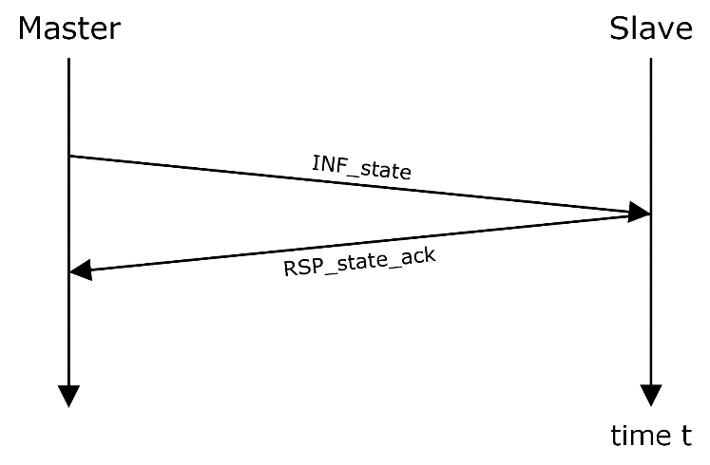

Figure 4: Positive state request

Note: The master is free to choose the DCP slave id before registering DCP slaves, to have a unique identifier for a specific DCP slave at the beginning. The slave must answer using exactly this DCP slave id.  
  
Note: A DCP slave may be identified using the pdu_seq_id only, with the risk of having collisions, depending on the underlying communication medium. Using the DCP slave id as described here, it is possible to uniquely identify a DCP slave.

Data Exchange

Inputs and Outputs

Outputs are communicated to Inputs via the payload field of PDU DAT_input_output.

The values of several outputs of one slave can be grouped in the payload field of one DAT_input_output PDU. Such a group is identified by a unique data_id. A payload field must group only values of outputs with the same configuration, i.e. sender, receiver, network configuration, scope and communication step size. The format of the payload field is defined in CONFIGURATION state using the Configuration PDUs CFG_output and CFG_input: the PDU CFG_output tells the sending slave the position of the value of an output in the payload field of a DAT_input_output.

The PDU CFG_input tells the receiving slave the position and the data type of the value in the payload field of a DAT_input_output for its input.

The communication protocol relevant information for a DAT_input_output is set in CONFIGURATION state by the PDUs CFG_set_source_network_information and CFG_set_target_network_information. For RT mode, the communication step size is set by CFG_steps.

An example of the intended sequence for the rollout of the configuration of data exchange via data objects using native DCP (UDP over IPv4) is given in the Appendix, section D.

Parameters

Parameters are set via PDU CFG_parameter.

Parameters with variability=”tunable” can additionally be set via PDU DAT_parameter. In this case the values of several parameters can be grouped in the payload field of one DAT_parameter PDU. Such a group is identified by a unique param_id. A payload field must group only values of parameters for the same configuration, i.e. receiver and network configuration. The format of the payload field is defined in CONFIGURATION state using Configuration PDUs CFG_tunable_parameter. This PDU tells the slave the position and type of the value of the parameter in the field payload of a DAT_parameter PDU.

The communication protocol relevant information for a DAT_parameter is set in CONFIGURATION state by the PDUs CFG_param_network_information.

Scope

Algorithms for computation of a consistent initial state (see section 3.2.3.3) may require exchange of inputs and outputs via the master. In superstates Run and NonRealTime slave-to-slave data exchange is advantageous, to reduce latencies and bandwidth compared to slave-master-slave communication. Therefore, a mechanism is defined which supports both. The PDUs CFG_scope contains the field scope. It defines in which states the respective configuration is active: Either in superstates Run and NonRealTime, or in Initialization, or both. Table 102 defines the enumeration of the field scope.

|  |  |
| --- | --- |
| Superstates | scopehex |
| Initialization/Run/NonRealTime | 0x0 |
| Initialization | 0x1 |
| Run/NonRealTime | 0x2 |

Table 102: Enumeration of scope

PDU Validity

If a PDU is received by a DCP slave, it shall be checked for validity. Table 104 contains a list of all currently defined error codes which are applicable to the DCP. Table 105 contains a list of all currently defined validity checks, applicable to Control and Data PDUs. Table 106 defines the permissible actions to be taken depending on the result of PDU checking. Table 107 defines the order of error checking for Control PDUs. Table 109 defines the order of error checking for Data PDUs.

As the PDUs from the family Notification (NTF) are not intended to be received by a DCP slave, they may be dropped silently.

Error Code Ranges

The following ranges for error codes are defined.

|  |  |
| --- | --- |
| Range | Group |
| 0x00 | NONE |
| 0x1001-0x1FFF | PROTOCOL_ERROR_* |
| 0x2001-0x2FFF | INVALID_* |
| 0x3001-0x3FFF | INCOMPLETE_* |
| 0x4001-0x4FFF | NOT_SUPPORTED_* |
| 0x5001-0x5FFF | [Transport protocol specific error codes] |
| 0x6001-0xFFFF | [Reserved] |

Table 103: Error code ranges

List of Error Codes

The following list of error codes applies to the field error_code of RSP_nack and RSP_error_ack.

|  |  |  |
| --- | --- | --- |
| error_codehex | Mnemonic | Description |
| 0x0000 | NONE | Indicates that no error is currently present. |
|  |  |  |
| 0x1001 | PROTOCOL_ERROR_GENERIC | Indicates that an error has occurred which is not specified in this document. |
| 0x1002 | PROTOCOL_ERROR_HEARTBEAT_MISSED | Indicates that the DCP slave did not receive a PDU INF_state within the maximum periodic interval ti_max defined in the DCP slave description. |
| 0x1003 | PROTOCOL_ERROR_ PDU_NOT_ALLOWED_IN_THIS_STATE | Indicates that a received PDU is not allowed in the current state. See section 3.3.6 for details. |
| 0x1004 | PROTOCOL_ERROR_PROPERTY_VIOLATED | Indicates that one of the following properties specified in the DCP slave description has been violated:  min, max, preEdge, postEdge, gradient, maxConsecMissedPdus.  Note: The detection and notification of a violation of these properties is optional. |
| 0x1005 | PROTOCOL_ERROR_ STATE_TRANSITION_IN_PROGRESS | Indicates that a received state change request PDU has already been acknowledged, but the current state still differs from the requested state. |
|  |  |  |
| 0x2001 | INVALID_LENGTH | Indicates that the received PDU has a valid type_id, but its length does not match. |
| 0x2002 | INVALID_LOG_CATEGORY | log_category is not log category of the slave |
| 0x2003 | INVALID_LOG_LEVEL | log_level is not a valid log level according to section 3.1.23.1 |
| 0x2004 | INVALID_LOG_MODE | log_mode is not valid log mode according to section 3.1.23 |
| 0x2005 | INVALID_MAJOR_VERSION | major_version as set by the master is not allowed according to the major version of the DCP specification defined in the DCP slave description. |
| 0x2006 | INVALID_MINOR_VERSION | minor_version as set by the master is not allowed according to the minor version of the DCP specification defined in the DCP slave description. |
| 0x2007 | INVALID_NETWORK_INFORMATION | Indicates that the network information provided through a configuration request PDU is not valid. |
| 0x2008 | INVALID_OP_MODE | Indicates that the operating mode requested through STC_register is not supported by this DCP slave. |
| 0x2009 | INVALID_PAYLOAD | Indicates that the length of a string or binary data type is larger than the defined maxSize. |
| 0x200A | INVALID_SCOPE | scope is invalid according to section 3.4.6. |
| 0x200B | INVALID_SOURCE_DATA_TYPE | source_data_type is not compatible with the inputs data type. For a list of data types see section 3.1.10, and for casting rules see section 3.1.20. |
| 0x200C | INVALID_START_TIME | Indicates that the start time provided in STC_run is invalid, e.g. in the past. |
| 0x200D | INVALID_STATE_ID | state_id is not equal to the slave’s state. |
| 0x200E | INVALID_STEPS | Indicates that the number of steps in CFG_steps or STC_do_step is not supported. |
| 0x200F | INVALID_TIME_RESOLUTION | Indicates that the time resolution expressed by numerator and denominator is not valid. |
| 0x2010 | INVALID_TRANSPORT_PROTOCOL | The given transport_protocol is not supported by the slave |
| 0x2011 | INVALID_UUID | slave_uuid is not equal to slave’s uuid. |
| 0x2012 | INVALID_VALUE_REFERENCE | Indicates that the value reference in CFG_input, CFG_output, CFG_parameter, or CFG_tunable_parameter is not available within that DCP slave. |
| 0x2013 | INVALID_SEQUENCE_ID | Violated PDU sequence ID check. See section 3.4.1. |
|  |  |  |
| 0x3001 | INCOMPLETE_CONFIG_GAP_INPUT_POS | There are gaps in the configured PDU Data payload field.  Note: No gap means if pos n is not the last pos, there exists a pos n+1. |
| 0x3002 | INCOMPLETE_CONFIG_GAP_OUTPUT_POS | There are gaps in the pos of the received CFG_output PDUs. |
| 0x3003 | INCOMPLETE_CONFIG_GAP_TUNABLE_POS | There are gaps in the pos of the received CFG_tunable_parameter PDUs. |
| 0x3004 | INCOMPLETE_CONFIG_NW_INFO_INPUT | For the PDU Data payload field identified by data_id no or no valid CFG_source_network_information has been received. |
| 0x3005 | INCOMPLETE_CONFIG_NW_INFO_OUTPUT | For the PDU Data payload field identified by data_id no or no valid CFG_target_network_information has been received. |
| 0x3006 | INCOMPLETE_CONFIG_NW_INFO_TUNABLE | Not for each param_id which occurs in the PDUs CFG_tunable_parameter a valid CFG_param_network_information with the same param_id is received. |
| 0x3007 | INCOMPLETE_CONFIG_SCOPE | At least one data_id is missing the setting of the scope. |
| 0x3008 | INCOMPLETE_CONFIG_STEPS | For every data_id which occurs in a CFG_output at least one valid CFG_steps with the same data_id must have been received. |
| 0x3009 | INCOMPLETE_CONFIG_TIME_RESOLUTION | No time resolution is specified. Neither through the DCP slave description, nor through CFG_time_res. |
| 0x300A | INCOMPLETE_CONFIGURATION | Indicates that a DCP slave cannot leave CONFIGURATION state due to missing configuration information. |
|  |  |  |
| 0x4001 | NOT_SUPPORTED_LOG_ON_NOTIFICATION | log_mode logOnNotification is not supported by the slave, i.e. in DCP slave description canProvideLogOnNotification = false |
| 0x4002 | NOT_SUPPORTED_LOG_ON_REQUEST | log_mode logOnRequest is not supported by the slave i.e. in DCP slave description canProvideLogOnRequest = false |
| 0x4003 | NOT_SUPPORTED_VARIABLE_STEPS | Steps differ from previous ones (if the slave does not support variable step sizes). |
| 0x4004 | NOT_SUPPORTED_TRANSPORT_PROTOCOL | Indicates that the transport protocol number provided through a configuration request PDU is not supported. |
| 0x4005 | NOT_SUPPORTED_PDU | Indicates that this type of PDU (identified through field type_id) is defined within this specification but is not supported by this DCP slave.  Note: This affects the current operating mode as well as DCP slave capabilities. |
| 0x4006 | NOT_SUPPORTED_PDU_SIZE | A data PDU was configured such that it exceeds the maximum allowed PDU size specified in maxPduSize in the DCP slave description. |

Table 104: List of error codes

|  |  |
| --- | --- |
| Check | Details |
| Type identifier | The type_id field of the received PDU is checked. All valid type identifiers are specified in section 3.3.  Note: This affects type_identifiers which are not specified, as well as PDUs which are not intended to be processed by this DCP slave, e.g. RSP_ack. |
| Length | The PDU length in bytes is checked.  Note: A plausibility check would include checking for PDU length smaller than 4 Bytes, resulting in an immediate drop. Detailed length checks shall be performed as defined in Table 107, Table 108, and Table 109. |
| Support | The received PDU is supported by the DCP slave, e.g. capability flag canSupportReset is set. |
| Receiver | The receiver field of the received PDU is evaluated against the assigned DCP slave id.  In state ALIVE, check if receiver is greater than zero.  Note: The DCP slave id zero is reserved for the master. Therefore no slave can be a valid receiver of a PDU which is determined for receiver zero. |
| Sequence id | The pdu_seq_id field of the received PDU is evaluated and checked for integrity. The maxConsecMissedPdus attribute from DCP slave description may influence the exact behavior. |
| data_id/param_id | The data_id or param_id field is validated. |
| State | The type_id field of the received PDU is validated against the current DCP slave state according to Table 63. |
| Semantics | All fields of the received PDU, that are specified in section 3.3 and are not explicitly covered in this section, shall be checked for validity and integrity. |

Table 105: Applicable PDU validity checks

|  |  |
| --- | --- |
| Activity | Details |
| Drop PDU | The received PDU shall be dropped silently, without any further actions. |
| Process PDU | The received PDU shall be processed further according to this specification document. |
| Handle error | The occurred error shall be communicated to the DCP master. Possible actions include transition to an Error state, and responding an error_code by using RSP_nack or RSP_error_ack.  A list of corresponding error_codes can be found in section 3.4.7.3. |

Table 106: Applicable actions related to PDU validity checks

Order of Error Checking

The following tables (Table 107, Table 108, Table 109) define the order of the checks for PDUs a DCP slave must perform. If multiple checks fail, the action from the failed check with the lowest order value must be reported first. The error codes apply to the fields error_code of RSP_nack and RSP_error_ack.

Note: This does not necessarily apply to the order of internally performed checks. This order indicates the sequence of error reporting. This is independent of the sequence of actual performed checks.

|  |  |  |
| --- | --- | --- |
| Order | Check | Action/Error code |
| 1 | Type identifier | Drop |
| Receiver |
| 2 | Sequence ID | INVALID_SEQUENCE_ID |
| 3 | Support | NOT_SUPPORTED_PDU |
| 4 | Length | INVALID_LENGTH |
| 5 | State | PDU_NOT_ALLOWED_IN_THIS_STATE |
| 6 | Semantics | See section 3.4.7.4 |

Table 107: Order of error checking for request PDUs

|  |  |  |
| --- | --- | --- |
| Order | Check | Action/Error Code |
| 1 | Type identifier | Drop |

Table 108: Order of error checking for response PDUs

|  |  |  |
| --- | --- | --- |
| Order | Check | Action |
| 1 | Type identifier | Drop |
| data_id/param_id |
| Sequence ID |
| Length |
| State |

Table 109: Order of error checking for data PDUs

Order of Error Codes

|  |  |
| --- | --- |
| Order | Error Code |
| 1 | INVALID_STATE_ID |
| 2 | INVALID_UUID |
| 3 | INVALID_OP_MODE |
| 4 | INVALID_MAJOR_VERSION |
| 5 | INVALID_MINOR_VERSION |

Table 110: Error code order for STC_register

|  |  |
| --- | --- |
| Order | Error Code |
| 1 | INVALID_STATE_ID |

Table 111: Error code order for STC_deregister

|  |  |
| --- | --- |
| Order | Error Code if condition fails |
| 1 | INVALID_STATE |
| 2 | INCOMPLETE_CONFIG_GAP_INPUT_POS |
| 3 | INCOMPLETE_CONFIG_GAP_OUTPUT_POS |
| 4 | INCOMPLETE_CONFIG_GAP_TUNABLE_POS |
| 5 | INCOMPLETE_CONFIG_NW_INFO_INPUT |
| 6 | INCOMPLETE_CONFIG_NW_INFO_OUTPUT |
| 7 | INCOMPLETE_CONFIG_NW_INFO_TUNABLE |
| 8 | INCOMPLETE_CONFIG_STEPS |
| 9 | INCOMPLETE_CONFIG_TIME_RESOLUTION |
| 10 | INCOMPLETE_CONFIG_SCOPE |
| 11 | NOT_SUPPORTED_PDU_SIZE |

Table 112: Error code order for STC_prepare

|  |  |
| --- | --- |
| Order | Error Code if condition fails |
| 1 | INVALID_STATE_ID |

Table 113: Error code order for STC_configure

|  |  |
| --- | --- |
| Order | Error Code if condition fails |
| 1 | INVALID_STATE_ID |

Table 114: Error code order for STC_initialize

|  |  |
| --- | --- |
| Order | Error Code if condition fails |
| 1 | INVALID_STATE_ID |
| 1 | INVALID_START_TIME |

Table 115: Error code order for STC_run

|  |  |
| --- | --- |
| Order | Error Code if condition fails |
| 1 | INVALID_STATE_ID |
| 2 | INVALID_STEPS |
| 3 | NOT_SUPPORTED_VARIABLE_STEPS |

Table 116: Error code order for STC_do_step

|  |  |
| --- | --- |
| Order | Error Code if condition fails |
| 1 | INVALID_STATE_ID |

Table 117: Error code order for STC_send_outputs

|  |  |
| --- | --- |
| Order | Error Code if condition fails |
| 1 | INVALID_STATE_ID |

Table 118: Error code order for STC_stop

|  |  |
| --- | --- |
| Order | Error Code if condition fails |
| 1 | INVALID_STATE_ID |

Table 119: Error code order for STC_reset

Note: A received STC_reset PDU is caught by PDU support check if canHandleReset = false (see Table 107)

|  |  |
| --- | --- |
| Order | Error Code if condition fails |
| 1 | INVALID_LOG_CATEGORY |

Table 120: Error code order for INF_log

Note: A received configuration PDU is caught by Check PDU support if canAcceptConfigPdus = false.

|  |  |
| --- | --- |
| Order | Error Code if condition fails |
| 1 | INVALID_TIME_RESOLUTION |

Table 121: Error code order for CFG_time_res

|  |  |
| --- | --- |
| Order | Error Code if condition fails |
| 1 | INVALID_STEPS |

Table 122: Error code order for CFG_steps

|  |  |
| --- | --- |
| Order | Error Code if condition fails |
| 1 | INVALID_VALUE_REFERENCE |
| 2 | INVALID_SOURCE_DATA_TYPE |

Table 123: Error code order for CFG_input

|  |  |
| --- | --- |
| Order | Error Code if condition fails |
| 1 | INVALID_VALUE_REFERENCE |
| 2 | INVALID_STEPS |

Table 124: Error code order for CFG_output

|  |  |
| --- | --- |
| Order | Error Code if condition fails |
| 1 | INVALID_TRANSPORT_PROTOCOL |
| 2 | INVALID_NETWORK_INFORMATION |

Table 125: Error code order for CFG_target_network_information

|  |  |
| --- | --- |
| Order | Error Code if condition fails |
| 1 | INVALID_TRANSPORT_PROTOCOL |
| 2 | INVALID_NETWORK_INFORMATION |

Table 126: PDU Error code order CFG_source_network_information

|  |  |
| --- | --- |
| Order | Error Code if condition fails |
| 1 | INVALID_VALUE_REFERENCE |
| 2 | INVALID_SOURCE_DATA_TYPE |
| 3 | INVALID_PAYLOAD |

Table 127: Error code order for CFG_parameter

|  |  |
| --- | --- |
| Order | Error Code if condition fails |
| 1 | INVALID_VALUE_REFERENCE |
| 2 | INVALID_SOURCE_DATA_TYPE |

Table 128: PDU Error code order CFG_tunable_parameter

|  |  |
| --- | --- |
| Order | Error Code if condition fails |
| 1 | INVALID_TRANSPORT_PROTOCOL |
| 2 | (Driver specific error handling.) |

Table 129: Error code order for CFG_param_network_information

Note: A received CFG_logging is caught by PDU support check if canProvideLogOnRequest = false and canProvideLogOnNotification = false (see Table 107).

|  |  |
| --- | --- |
| Order | Error Code if condition fails |
| 1 | NOT_SUPPORTED_LOG_ON_REQUEST |
| 2 | NOT_SUPPORTED_LOG_ON_NOTIFICATION |
| 3 | INVALID_LOG_CATEGORY |
| 4 | INVALID_LOG_LEVEL |
| 5 | INVALID_LOG_MODE |

Table 130: Error code order for CFG_logging

|  |  |
| --- | --- |
| Order | Error Code if condition fails |
| 1 | INVALID_SCOPE |

Table 131: Error code order for CFG_scope

Error Reporting

Whenever a DCP slave is in ERRORHANDLING or ERRORRESOLVED states, the DCP master may send INF_error to this DCP slave, to find out about the reason.

|  |  |
| --- | --- |
| Sequence Number | Action |
| 1 | The DCP master sends INF_error to the DCP slave. |
| 2a | The DCP slave responds by sending RSP_error_ack, which contains an error code. |
| 2b | The DCP slave responds by sending RSP_nack, if he is currently not in the Error superstate. |

Table 132: Error reporting procedure

Heartbeat

The heartbeat functionality is optional. Its availability is indicated by capability flag canMonitorHeartbeat, see section 5.12.

A slave should be able to detect that its master is still active. Therefore, the master shall send a periodic PDU INF_state at a pre-defined interval ti to each of the connected slaves. This interval is specified by the master. This enables two monitoring functions, defined as follows.

Slave Monitoring

The master receives a PDU RSP_state_ack from each slave and determines the response time. If the response time tr exceeds a given time interval tr_max, the master should take appropriate action.

Master Monitoring

Each slave must respond with a PDU RSP_state_ack immediately. A timeout defined in the DCP slave description determines the maximum waiting time ti_max between two PDUs INF_state. If the timeout expires, the slave shall go to state ERRORHANDLING and subsequently to state ERRORRESOLVED.

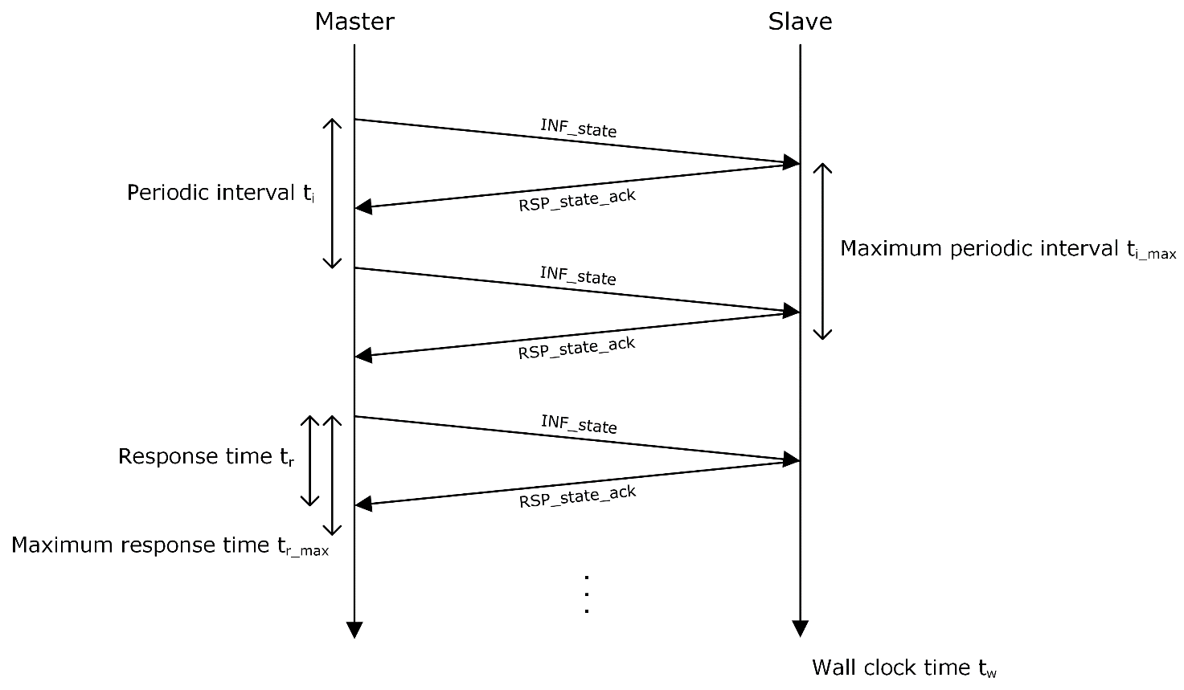

Figure 5: Heartbeat functionality

Error Handling

The DCP represents a framework to handle faults and errors to avoid failures of simulation scenarios, when running in SRT or HRT operation mode. Goal is to protect physical equipment (connected real-time systems) as well as human operators from any harm that may be caused during normal operation. The error handling procedures described here are in-line with ISO 26262 [6].

Unavailable communication medium

This description assumes that the used communication medium has become unavailable unexpectedly. The DCP slave may use mechanisms to detect these network problems, e.g. heartbeat. In case a DCP slave is unable to send or receive PDUs, it transitions to ERRORHANDLING state. In ERRORHANDLING the DCP slave shall e.g. close open connections, or perform the stopping routine. If these procedures are finished, the DCP slave proceeds to ERRORRESOLVED.

If the communication medium becomes available again, it may react to e.g. an STC_reset. Otherwise, operator intervention is required and the DCP slave must be restarted by other means.

Available communication medium

In the following the procedure of error handling is described under the assumption that it is still possible to exchange PDUs.

|  |  |
| --- | --- |
| Sequence Number | Action |
| 1 | A fault (faulty behavior or condition in model or RT system) occurs within a DCP slave (time tf). After the DCP slave detected this fault (time tfd) it transitions self-reliantly to the Error superstate.  Note: The transition to ERRORHANDLING is not requested from the master. |
| 2 | The DCP slave transitions to the ERRORHANDLING state immediately. |
| 3 | Within the ERRORHANDLING state, the DCP slave tries to send an NTF_state_changed to the master. Then it starts suitable error handling routines and tries to resolve the error.  Note: Appropriate measures of error resolving are shutdown of subsystems, potential energy dissipation in connected RT systems, etc. This may take some time. |
| 4a | If successful, the DCP slave transitions to ERRORRESOLVED state immediately.  Note: No request to do so from master.  The DCP slave either sends a PDU NTF_state_changed to its master, reporting that the state transition is finished, or reports the state change to the master on request.  Note: As defined in communication pattern. |
| 4b | If not successful, the system experiences an unrecoverable error. The transition to state ERRORRESOLVED is not performed. Signal SIG_exit to shut down in terms of an error handling procedure may be called. |
| 5 | In state ERRORRESOLVED, the DCP slave receives a PDU STC_reset (time tr). It acknowledges it by sending a PDU RSP_ack to the DCP master. |
| 6 | The transition to state CONFIGURATION, of superstate Normal operation is performed. Either a PDU NTF_state_changed is sent to the master or the state change is reported to the master on request. |

Table 133: Error handling procedure for available communication medium

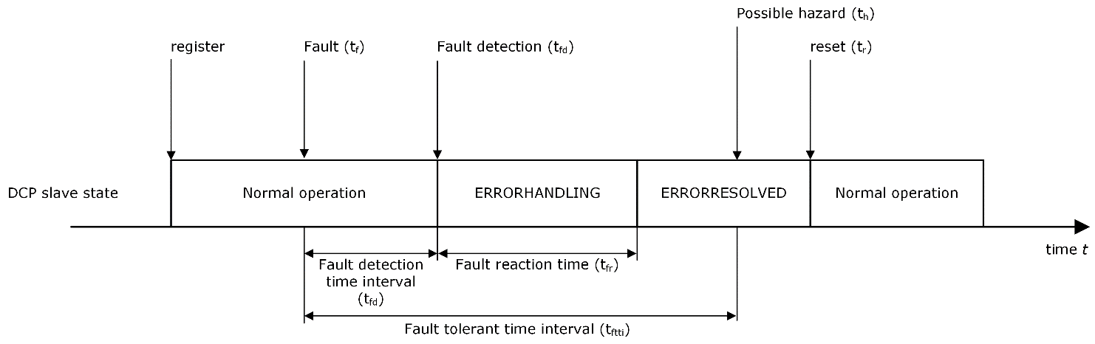

Figure 6: Procedure for error handling

Master Unavailability

If the master becomes unavailable its slaves may detect this (e.g. heartbeat) and proceed to the error superstate, as described in section 3.4.10.2.

The master needs to ensure that the previously used scenario configuration can be reproduced, including the DCP slave ID. This may be ensured by e.g. assignment of DCP slave IDs based on sorted DCP slave UUIDs.

Unintended Behaviour

If a DCP slave receives a valid, previously received PDU but with a different pdu_seq_id number, it shall acknowledge and process it as specified.

Transport Protocols

General

This section specifies the underlying transport protocols for DCP. Furthermore, this section assumes the default DCP slave integration as given in Figure 34. Therefore, the DCP integrator must know transport protocol specific information to connect the provided DCP slaves to a communication medium. For this step, the DCP slave description file may be helpful.

Internet Protocol (IPv4) Based Transport Protocols

General

A DCP slave using IPv4-based transport protocols is accessible through an IP address and a port number. This information is defined within the DCP slave description. For communication with a DCP master, the DCP slave replies to the IP address and port where the initial STC_register is coming from.

Note: A DCP master could be implemented as a IPv4-based client, whereas a DCP slave could be implemented as a IPv4-based server.

As soon as STC_register is received and positively acknowledged (RSP_ack sent by DCP slave and received by DCP master) the IP address and port for communication with the master are fixed for this simulation run.

The port information at the slave side is cleared, as soon as STC_deregister is received.

Note: The DCP slave sender port may differ from the DCP slave receiving port.

Transport Protocol Specific Fields

The field port specifies an IPv4 port number.

The field ip_address specifies an internet protocol address.

Network Information

The master distributes the communication information relevant for data exchange using the following two PDUs: CFG_target_network_information is sent to the sending DCP slave. It contains IP address and port number of the receiving DCP slave.

Implementation hint: If multiple network information with the same data_id is received by a DCP slave, the DAT_input_output PDU is to be sent to all specified targets within the CFG_target_network_information.

CFG_source_network_information is sent to the receiving DCP slave. It contains a port number. The receiving DCP slave waits for incoming data on this port number.

Implementation hint: The sending port may be chosen randomly by the IP stack implementation. It is never checked in any way on the receiver side.

The following three tables complete the PDU descriptions of sections 3.3.7.19, 3.3.7.20, and 3.3.7.23, respectively, for IPv4-based transport protocols.

The IPv4-based transport protocol specific part of CFG_target_network_information is defined by the following structure:

|  |  |  |  |
| --- | --- | --- | --- |
| First Position [Byte] | Last Position [Byte] | Data type | Field |
| 6 | 6 | uint8 | transport_protocol |
| 7 | 8 | uint16 | port |
| 9 | 12 | uint32 | ip_address |

Table 134: CFG_target_network_information

The IPv4-based transport protocol specific part of the corresponding CFG_param_network_information is defined by the following structure:

|  |  |  |  |
| --- | --- | --- | --- |
| First Position [Byte] | Last Position [Byte] | Data type | Field |
| 6 | 6 | uint8 | transport_protocol |
| 7 | 8 | uint16 | port |
| 9 | 12 | uint32 | ip_address |

Table 135: CFG_param_network_information

The IPv4-based transport protocol specific part of CFG_source_network_information is defined by the following structure:

|  |  |  |  |
| --- | --- | --- | --- |
| First Position [Byte] | Last Position [Byte] | Data type | Field |
| 6 | 6 | uint8 | transport_protocol |
| 7 | 8 | uint16 | port |
| 9 | 12 | Uint32 | ip_address |

Table 136: CFG_source_network_information

Port information

If a port is specified inside the Control element (see section 5.11.2), Control PDUs may only be received over this port.

Note: If no such port is specified, the integrator must obtain and set this information in another way, which is not specified in this document. The DCP slave provider might be consulted for clarification.

If a port or port range is specified inside the DAT_input_output (see section 5.11.2) element, PDUs DAT_input_output may only be received over these ports.

Note: If no port or port range is specified inside the DAT_input_output element, the integrator must obtain and set this information in another way, which is not specified in this document. The DCP slave provider might be consulted for clarification.

If a port or port range is specified inside the DAT_parameter element, PDUs DAT_parameter may only be received over these ports.

Note: If no port or port range is specified inside the DAT_parameter element, the integrator must obtain and set this information in another way, which is not specified in this document. The DCP slave provider might be consulted for clarification.

Some port numbers might already be used or reserved for dedicated services.

Note: Implementation hint: If the master is free to choose a IPv4 port, he should use the free user ports specified by IANA organization. Otherwise it is possible that the chosen port collides with one of the ports reserved by IANA.

<https://www.iana.org/assignments/service-names-port-numbers/service-names-port-numbers.xhtml>

Host information

If a host is specified inside the Control element (see section 5.11.2) Control PDUs may only be received on this host.

Note: If no host is specified, this can be interpreted as follows. The integrator must obtain and set this information in another way, which is not specified in this document.

If a host is specified inside the DAT_input_output element PDUs DAT_input_output may only be received on this host.

Note: If no host is specified, this can be interpreted as follows. The integrator must obtain and set this information in another way, which is not specified in this document.

If a host is specified inside the DAT_parameter element PDUs DAT_parameter may only be received on this host.

Note: If no host is specified, this can be interpreted as follows. The integrator must obtain and set this information in another way, which is not specified in this document.

User Datagram Protocol (UDP/IPv4)

For UDP over IPv4 transport protocol, all specifications of section 4.2.1 apply. No further specifications are required.

Transmission Control Protocol (TCP/IPv4)

General

For TCP over IPv4 transport protocol, all specifications of section 4.2.1 apply. Furthermore, the following is required.

Length Prefix Framing

For TCP, length-prefix-framing is applied: Each PDU in the TCP stream must be preceded by a uint32 indicating the length of the PDU, excluding the length field itself.

Bluetooth Radio Frequency Communication (RFCOMM)

General

A DCP slave using Bluetooth is accessible through an address (BD_ADDR) and a port number. This information is defined within the DCP slave description. For communication with a DCP master, the DCP slave replies to the address and port where the initial STC_register is coming from.

Note: A DCP master could be implemented as a Bluetooth client, whereas a DCP slave could be implemented as a Bluetooth server.

The BD_ADDR is a unique and permanent 48-bit address number created in accordance with section 8.2 ("Universal addresses") of the IEEE 802-2014 [7].

Transport Protocol Specific Fields

The field port specifies a port number.

The field bd_addr specifies a Bluetooth device address.

Implementation hint: The RFCOMM available ports are limited to a range between 1 and 30.

Network Information

The master distributes the communication information relevant for data exchange using the following two PDUs: CFG_target_network_information is sent to the sending DCP slave. It contains the BD_ADDR and port number of the receiving DCP slave.

Implementation hint: If multiple network information with the same data_id is received by a DCP slave, the DAT_input_output PDU is to be sent to all specified targets within the CFG_target_network_information.

CFG_source_network_information is sent to the receiving DCP slave. It contains a port number. The receiving DCP slave listens on this port number for incoming data.

The following three tables complete the PDU descriptions of sections 3.3.7.19, 3.3.7.20, and 3.3.7.23, respectively, for Bluetooth RFCOMM.

The Bluetooth specific part of CFG_target_network_information is defined by the following structure:

|  |  |  |  |
| --- | --- | --- | --- |
| First Position [Byte] | Last Position [Byte] | Data type | Field |
| 6 | 6 | uint8 | transport_protocol |
| 7 | 7 | uint8 | port |
| 8 | 15 | uint64 | bd_addr |

Table 137: CFG_target_network_information

The Bluetooth specific part of the corresponding CFG_param_network_information is defined by the following structure:

|  |  |  |  |
| --- | --- | --- | --- |
| First Position [Byte] | Last Position [Byte] | Data type | Field |
| 6 | 6 | uint8 | transport_protocol |
| 7 | 8 | uint16 | port |
| 9 | 12 | uint32 | bd_address |

Table 138: CFG_param_network_information

The Bluetooth specific part of CFG_source_network_information is defined by the following structure:

|  |  |  |  |
| --- | --- | --- | --- |
| First Position [Byte] | Last Position [Byte] | Data type | Field |
| 6 | 6 | uint8 | transport_protocol |
| 7 | 7 | uint8 | port |
| 8 | 15 | uint64 | bd_addr |

Table 139: CFG_source_network_information

Port information

If a port is specified inside the Control element (see section 5.11.2), Control PDUs may only be received over this port.

Note: If no such port is specified, this can be interpreted in two different ways. First, the integrator must obtain and set this information in another way, which is not specified in this document. Second, the DCP slave is not meant to be controlled via Bluetooth. The DCP slave provider might be consulted for clarification.

If a port or port range is specified inside the DAT_input_output (see section 5.11.2) element, PDUs DAT_input_output may only be received over these ports.

Note: If no port or port range is specified inside the DAT_input_output element, this can be interpreted in three different ways. First, the integrator must obtain and set this information in another way, which is not specified in this document. Second, the DCP master is free to choose the port numbers. The DCP slave may reject the use of requested ports using PDU RSP_nack and the corresponding error code. Third, the DCP slave is not meant to exchange PDUs DAT_input_output using Bluetooth RFCOMM. The DCP slave provider might be consulted for clarification.

If a port or port range is specified inside the DAT_parameter element, PDUs DAT_parameter may only be received over these ports.

Note: If no port or port range is specified inside the DAT_parameter element, this can be interpreted in three different ways. First, the integrator must obtain and set this information in another way, which is not specified in this document. Second, the DCP master is free to choose the port numbers. The DCP slave may reject the use of requested ports using PDU RSP_nack PDU and the corresponding error code. Third, the DCP slave is not meant to exchange PDUs DAT_parameter using Bluetooth RFCOMM. The DCP slave provider might be consulted for clarification.

Some port numbers might already be used or reserved for dedicated services.

PDUs in RFCOMM stream

For RFCOMM, length-prefix-framing is applied: Each PDU in the RFCOMM stream must be preceded by an uint32 indicating its length.

Universal Serial Bus (USB)

USB Version

The target USB version is 2.0. For simplicity the term USB is used for USB 2.0.

General

A DCP master must be implemented on the USB host side, whereas a DCP slave must be implemented as a USB device. A DCP slave using USB is accessible through the slave uuid. The USB host driver for DCP must manage the mapping between slave uuid & DCP slave id and assigned USB number.

DCP Class Device

DCP Class Driver

Control Pipe (default)

Request Pipe (Interrupt)

Response_Notification Pipe (Interrupt)

Data-Out Pipe 1 (Isochronous or Interrupt)

Data-In Pipe 1 (Isochronous or Interrupt)

Data-Out Pipe N (Isochronous or Interrupt)

Data-In Pipe N (Isochronous or Interrupt)

…

Figure 7: USB scheme

The DCP protocol for USB is defined by the DCP class. Every DCP class device consists of the following pipes:

* The Control Pipe is used for receiving and responding to requests for USB control and class data.
* The Request Pipe is used for receiving Request PDUs from the master.
* The Response_Notification Pipe is used for sending Response and Notification PDUs to the master.
* A Data-Out pipe is used to receive Data from other slaves or from the master.
* A Data-In pipe is used to send DAT_input_output to other slaves or to the master.
* A vendor can define multiple Data-Out and Data-In pipes. There must be at least one Data-In pipe if there exists at least one output variable at the DCP slave. There must be at least one Data-Out pipe if there exists at least one input variable or parameter at the DCP slave.

Transport Protocol Specific PDU Fields

Endpoint Address

The field endpoint_address is used to specify an endpoint address.

Descriptors

The following sections describe the applied USB Descriptors used for the DCP USB class. The device and configuration descriptor are vendor specific. There must be at least one Interface descriptor for the DCP containing a DCP Descriptor, as well as the endpoint descriptors used for the DCP slave.

Interface

|  |  |  |  |  |
| --- | --- | --- | --- | --- |
| First Position [Byte] | Last Position [Byte] | Data-type | Field Name | Value |
| 0 | 0 | uint8 | bLength | 9 |
| 1 | 1 | uint8 | bDescriptorType | 4 |
| 2 | 2 | uint8 | bInterfaceNumber | Vendor Specific |
| 3 | 3 | uint8 | bAlternateSetting | Vendor Specific |
| 4 | 4 | uint8 | bNumEndpoints | Vendor Specific |
| 5 | 5 | uint8 | bInterfaceClass | 255 2 |
| 6 | 6 | uint8 | bInterfaceSubClass | 205 2 |
| 7 | 7 | uint8 | bInterfaceProtocol | 205 2 |
| 8 | 8 | uint8 | iInterface | Vendor Specific |

Table 140: Interface descriptor

2 Implementation Hint: Because an official USB class for DCP does not exist at the moment, the vendor specific class is used. Therefore 205 is selected as an arbitrary number to define the subclass and protocol.

|  |  |  |  |  |
| --- | --- | --- | --- | --- |
| First Position [Byte] | Last Position [Byte] | Data-type | Field Name | Value |
| 0 | 0 | uint8 | bLength | 9 |
| 1 | 1 | uint8 | bDescriptorType | 4 |
| 2 | 18 | byte[] | slave_uuid | Vendor Specific |

Table 141: DCP descriptor

Endpoint

|  |  |  |  |  |
| --- | --- | --- | --- | --- |
| First Position [Byte] | Last Position [Byte] | Data-type | Field Name | Value |
| 0 | 0 | uint8 | bLength | 7 |
| 1 | 1 | uint8 | bDescriptorType | 5 |
| 2 | 2 | uint8 | bEndpointAddress | 16 (00010000Bin) |
| 3 | 3 | uint8 | bmAttributes | 3 (00000011Bin) |
| 4 | 5 | uint16 | wMaxPacketSize | 1024 |
| 6 | 6 | uint8 | bInterval | 16 |

Table 142: Request pipe

|  |  |  |  |  |
| --- | --- | --- | --- | --- |
| First Position [Byte] | Last Position [Byte] | Data-type | Field Name | Value |
| 0 | 0 | uint8 | bLength | 7 |
| 1 | 1 | uint8 | bDescriptorType | 5 |
| 2 | 2 | uint8 | bEndpointAddress | 33 (00100001Bin) |
| 3 | 3 | uint8 | bmAttributes | 3 (00000011Bin) |
| 4 | 5 | uint16 | wMaxPacketSize | 1024 |
| 6 | 6 | uint8 | bInterval | 16 |

Table 143: Response-notification pipe

|  |  |  |  |  |
| --- | --- | --- | --- | --- |
| First Position [Byte] | Last  Position [Byte] | Data-type | Field Name | Value |
| 0 | 0 | uint8 | bLength | 7 |
| 1 | 1 | uint8 | bDescriptorType | 5 |
| 2 | 2 | uint8 | bEndpointAddress | Vendor Specific 3 |
| 3 | 3 | uint8 | bmAttributes | Vendor Specific 4 |
| 4 | 5 | uint16 | wMaxPacketSize | 1024 |
| 6 | 6 | uint8 | bInterval | Vendor Specific |

Table 144: Data-out pipe

3 Must be constructed according to the USB standard. The endpoint number must be greater than 2. The direction must be 0 (Out).

4 Must be constructed according to the USB standard. The transfer type must be Isochronous or Interrupt.

|  |  |  |  |  |
| --- | --- | --- | --- | --- |
| First Position [Byte] | Last  Position [Byte] | Data-type | Field Name | Value |
| 0 | 0 | uint8 | bLength | 7 |
| 1 | 1 | uint8 | bDescriptorType | 5 |
| 2 | 2 | uint8 | bEndpointAddress | Vendor Specific 5 |
| 3 | 3 | uint8 | bmAttributes | Vendor Specific 6 |
| 4 | 5 | uint16 | wMaxPacketSize | 1024 |
| 6 | 6 | uint8 | bInterval | Vendor Specific |

Table 145: Data-in pipe

5 Must be constructed according to the USB standard. The endpoint number must be greater than 2. The direction must be 1 (In).

6 Must be constructed according to the USB standard. The transfer type must be Isochronous or Interrupt.

Network Information

The USB specific part of CFG_target_network_information is defined by the following structure:

|  |  |  |  |
| --- | --- | --- | --- |
| First Position [Byte] | Last Position [Byte] | Data type | Field |
| 6 | 6 | uint8 | transport_protocol = 0x5 |
| 7 | 7 | uint8 | endpoint_address |
| 8 | 23 | byte[16] | slave_uuid |

Table 146: CFG_target_network_information

The USB specific part of CFG_source_network_information is defined by the following structure:

|  |  |  |  |
| --- | --- | --- | --- |
| First Position [Byte] | Last Position [Byte] | Data type | Field |
| 6 | 6 | uint8 | transport_protocol = 0x5 |
| 7 | 7 | uint8 | endpoint_address |

Table 147: CFG_source_network_information

The USB specific part of CFG_param_network_information is defined by the following structure:

|  |  |  |  |
| --- | --- | --- | --- |
| First Position [Byte] | Last Position [Byte] | Data type | Field |
| 6 | 6 | uint8 | transport_protocol = 0x5 |
| 7 | 7 | uint8 | endpoint_address |

Table 148: CFG_param_network_information

DAT_input_output forwarding

According to the USB standard communication is only possible between USB host and USB device. The USB host driver must forward the DAT_input_output PDU to the corresponding USB device for slave-to-slave communication.

CAN Bus Communication Systems

This specification supports CAN bus communication systems. Due to the facts that

* the CAN payload is limited to 8 bytes,
* CAN does not support fragmentation,
* CAN uses its own addressing schema (arbitration)
* and thus not all Control PDUs can be sent via CAN as defined in native DCP specification

the DCP specification for CAN bus is non-native. This specification of DCP over CAN supports the KCD file format[1]

In order to map the DCP onto the CAN bus, two additional resources are provided together with this specification:

* DCP over CAN XSD schema description (DCP_over_CAN.xsd)
* DCP over CAN XSL style sheet (DCP_over_CAN_to_KCD.xsl)

Procedure

The intended procedure is to use the XSD schema to create a configuration in XML file format. An XSL style sheet is then applied to this XML file, generating a valid KCD file.

DCP over CAN

Figure 8 shows the DCP over CAN root element.

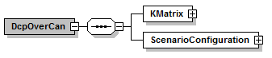

Figure 8: DcpOverCAN root element

|  |  |
| --- | --- |
| Element name | Description |
| KMatrix | Contains all elements to describe the messages & signals of the CAN bus and the participation of the bus members to the messages. |
| ScenarioConfiguration | Contains all elements to describe the co-simulation scenario, which would be distributed over configuration PDUs in a native DCP transport protocol for each DCP slave. In addition it contains the name, DCP id & uuid. Which element belongs to which DCP slave can be determined using the uuid. |

Table 149: DcpOverCan element

Definition of KMatrix

The element KMatrix is specified as follows. The KMatrix element consist optional of the CAN message description all state change, information, notification & response PDUs , as well as an arbitrary number of CAN messages for DAT_input_output & DAT_parameter PDUs. Each state change, information, notification or response PDU is defined in the following way.

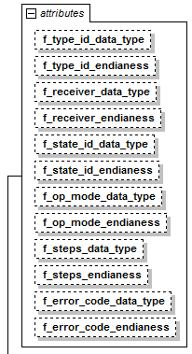

Figure 9: KMatrix element attributes

|  |  |
| --- | --- |
| Attribute name | Description |
| f_<field_name>_data_type | The data type of the field <field_name> as integer (see 3.1.10 for corresponding data type). |
| f_<field_name>_endianness | The endianness of the field <field_name>. “little” means little endian, “big” means big endian. |

Table 150: KMatrix element attributes

|  |  |
| --- | --- |
| Attribute name | Description |
| canId | The CAN identifier in the header of the CAN message |
| senderRef | The DCP id of the sending DCP slave. For state change & information PDUs this is fix, because only the master (DCP id = 0) can send this PDU. |
| length | The length of the CAN payload field. |
| f_<field_name> | The starting byte of <field_name> in the CAN payload. “H” means that this field is not contained in the CAN payload and its value can be determined by the CAN identifier in the header. |

Table 151: Attributes of every state change, information, notification & response PDU

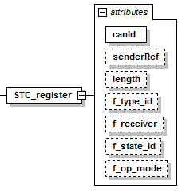

Figure 10: STC_register PDU

The element DAT_input_output consists of up to eight Payload and up to 254 Receiver elements. It is defined as follows:

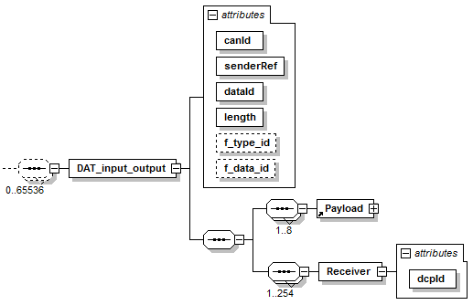

Figure 11: DAT_input_output element

|  |  |
| --- | --- |
| Attribute name | Description |
| canId | The CAN identifier in the header of the CAN message |
| senderRef | The DCP id of the sending DCP slave. |
| dataId | The data id of the DAT_input_output PDU. |
| length | The length of the CAN payload field. |
| f_<field_name> | The starting byte of <field_name> in the CAN payload. “H” means that this field is not contained in the CAN payload and its value can be determined by the CAN identifier in the header. |
| dcpId | The DCP id of the DCP slave which receives this CAN message. |

Table 152: DAT_input_output element attributes

In DAT_input_output, the Payload element contains the definition of one output from the sending DCP slave. The choice of the Payload element defines the data type of the output. Payload is defined as follows:

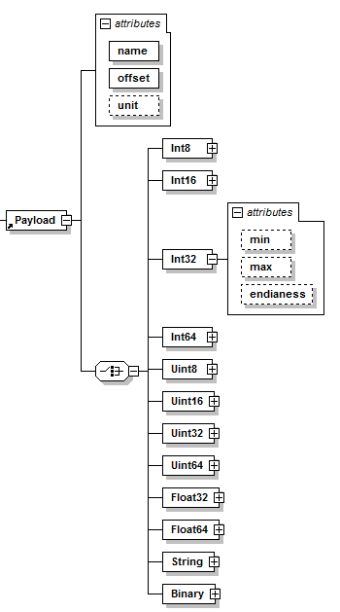

Figure 12: Payload element

|  |  |
| --- | --- |
| Attribute name | Description |
| name | The name of the output. |
| offset | The starting byte of the output in the CAN payload.  Note: This is not equal to the position in the CFG_output PDU. |
| unit | The unit of the send output. |
| min | The minimum of the output |
| max | The maximum of the output. |
| endianness | The endianness of the output. “little” means little endian, “big” means big endian. |

Figure 13: Payload element attributes

The element DAT_parameter consists of up to eight Payload and up to 254 receiver elements. It is defined as follows.

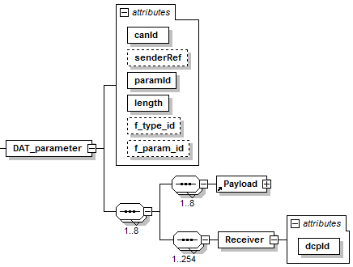

Figure 14: DAT_parameter element

|  |  |
| --- | --- |
| Attribute name | Description |
| canId | The CAN identifier in the header of the CAN message |
| senderRef | The DCP id of the sending DCP slave. |
| paramId | The parameter id of the DAT_parameter PDU. |
| length | The length of the CAN payload field. |
| f_<field_name> | The starting byte of <field_name> in the CAN payload. “H” means that this field is not contained in the CAN payload and its value can be determined by the CAN identifier in the header. |
| dcpId | The DCP id of the DCP slave which receives this CAN message. |

Table 153: Attributes of DAT_parameter

Definition of the Scenario Configuration

The element ScenarioConfiguration is defined as follows:

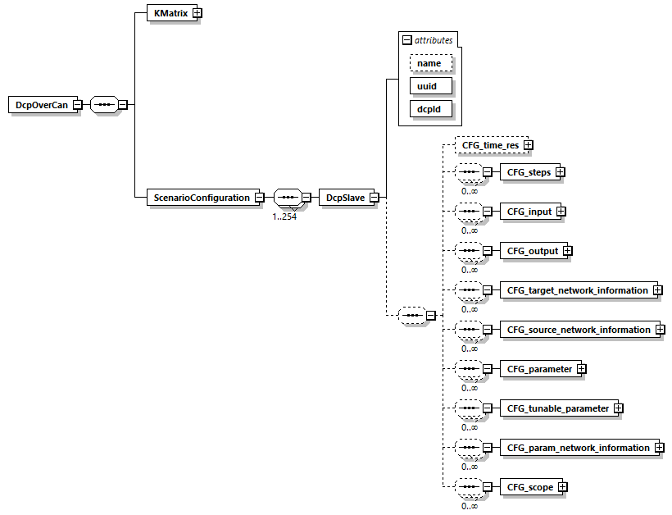

Figure 15: ScenarioConfiguration element

|  |  |
| --- | --- |
| Attribute name | Description |
| name | The name of the DCP slave. |
| uuid | The uuid of the DCP slave. |
| dcpId | The DCP id of the DCP slave. |
| All other attributes | See section 3.4 for further description. |

Table 154: Attributes of ScenarioConfiguration and subsequent elements

DCP Slave Description

General

All static information related to a DCP slave is stored in an accompanying DCP file. The requirements for this file and its internal structure are specified in section 3.1.4. The DCP file must contain at least one DCP slave description file, which is a text file in XML format. It is specified in detail in this section. The provider of a DCP slave shall ensure that the accompanying DCP file reflects the implementation of the delivered DCP slave. The DCP slave file shall be consistent with the delivered DCP slave at all times. The distribution mechanism of the DCP file is arbitrary.

The file extension of a DCP slave description file is “.dcpx”. The structure of this XML file is defined using the schema file dcpSlaveDescription.xsd. This schema file utilizes the following helper schema files:

dcpAnnotation.xsd

dcpAttributeGroups.xsd

dcpDataTypes.xsd

dcpTransportProtocolTypes.xsd

dcpType.xsd

dcpUnit.xsd

dcpVariable.xsd

These XSD schema files comply with the XSD 1.1 specification [8]. In this section these schema files are discussed. The normative definition are the above mentioned schema files[2]. Optional elements are indicated using a dashed box. The required data types (e.g. xs:normalizedString) are defined in the XML-schema standard (see <http://www.w3.org/TR/xmlschema-2> for more information).

Use of Assertions and Constraints

The schema files contain assertions and constraints to support formal verification of properties and dependencies as stated in this specification document. XSD 1.0 compliant schema files may be created by transformation using the provided XSLT file (Extensible Stylesheet Language Transformation):

dcpx_xsd11_to_xsd10.xslt

Note: This XSLT file is provided together with the XSD schema files to ensure correct transformation. It is intended to remove the assertions.

Note: The defined assertions and constraints were removed from this section’s figures to facilitate better legibility.

Data Type Definitions

The data types used in the DCP schema files are as follows:

|  |  |  |
| --- | --- | --- |
| XML | DCP equivalent | Description |
| xs:unsignedByte | uint8 | unsignedByte is derived from unsignedShort by setting the value of maxInclusive to be 255. The base type of unsignedByte is unsignedShort. |
| xs:unsignedShort | uint16 | unsignedShort is derived from unsignedInt by setting the value of maxInclusive to be 65535. The base type of unsignedShort is unsignedInt. |
| xs:unsignedInt | uint32 | unsignedInt is derived from unsignedLong by setting the value of maxInclusive to be 4294967295. The base type of unsignedInt is unsignedLong. |
| xs:unsignedLong | uint64 | unsignedLong is derived from nonNegativeInteger by setting the value of maxInclusive to be 18446744073709551615. The base type of unsignedLong is nonNegativeInteger. |
| xs:byte | int8 | int is derived from long by setting the value of maxInclusive to be 2147483647 and minInclusive to be  -2147483648. The base type of int is long. |
| xs:short | int16 | short is derived from int by setting the value of maxInclusive to be 32767 and minInclusive to be -32768. The base type of short is int. |
| xs:int | int32 | int is derived from long by setting the value of maxInclusive to be 2147483647 and minInclusive to be  -2147483648. The base type of int is long. |
| xs:long | int64 | long is derived from integer by setting the value of maxInclusive to be 9223372036854775807 and minInclusive to be  -9223372036854775808. The base type of long is integer. |
| xs:float | float32 | float is patterned after the IEEE single-precision 32-bit floating point type (see IEEE 754-1985) |
| xs:double | float64 | The double datatype is patterned after the IEEE double-precision 64-bit floating point type (see IEEE 754-1985) |
| xs:normalizedString | string | String without carriage return, line feed, and tab characters. |
| xs:dateTime | Implementation specific | Date, time and time zone  *Example: 2002-10-23T12:00:00Z*  *(noon on October 23, 2002, Greenwich Mean Time)* |

Table 155: DCP slave description data types

The first line of the DCP slave description must contain its encoding scheme. It is required that the encoding scheme is always UTF-8:

<?xml version="1.0" encoding="UTF-8"?>

The DCP schema files (*.xsd) are also stored in UTF-8.

Note: The definition of an encoding scheme is a prerequisite, in order for the XML file to contain letters outside of the 7 bit ANSI ASCII character set, such as German umlauts, or Asian characters.

The special values NAN, +INF, -INF for variables values are not allowed in the DCP XML files.

Note: Child elements, defined by sequence of elements in the DCP slave description, are ordered lists according to document order, whereas attribute information items are unordered sets (see <http://www.w3.org/TR/XML-infoset/#infoitem.element>). The DCP slave description schema is based on ordered lists in a sequence and therefore parsing must preserve this order.

Definition of dcpSlaveDescription Element

This is the root level schema file and contains the following definition (the figure below shows all elements in the schema file. Data is defined as attributes to these elements, not shown in this figure).

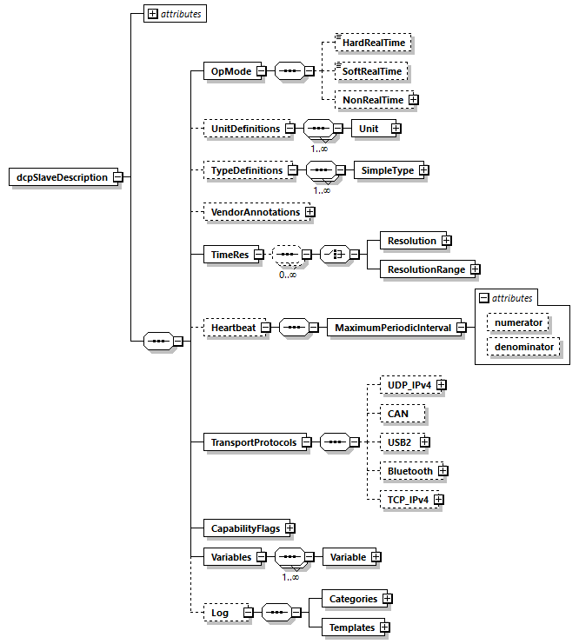

Figure 16: DCP slave description root level XSD schema

On the top level, the schema consists of the following elements.

|  |  |
| --- | --- |
| Element name | Description |
| OpMode | Valid operating modes of the described DCP slave. |
| UnitDefinitions | A global list of unit and display unit definitions (see section 5.6). |
| TypeDefinitions | A global list of type definitions. |
| VendorAnnotations | Additional vendor specific data. May be ignored. |
| TimeRes | A list of permissible single time resolutions and resolution ranges. |
| Heartbeat | If present, the DCP slave uses the given settings to monitor a heartbeat signal provided by the DCP master. |
| TransportProtocols | This element contains information for all available DCP slave DCP drivers. |
| CapabilityFlags | The attributes under this element indicate a DCP slave’s capabilities. |
| Variables | The central DCP slave data structure defining all variables of the DCP slave that are visible/accessible via DCP. |
| Log | This element contains categories and templates for logging. |

Table 156: DCP slave description root level elements

The XML attributes of dcpSlaveDescription are as follows.

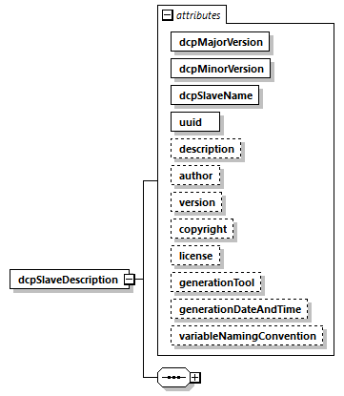

Figure 17: dcpSlaveDescription element attributes

|  |  |
| --- | --- |
| Attribute name | Description |
| dcpMajorVersion | The DCP major version that was used to generate the DCPX file and accompanying DCP slave. See section 3.1.2. |
| dcpMinorVersion | The DCP minor version that was used to generate the DCPX file and accompanying DCP slave. See section 3.1.2. |
| dcpSlaveName | The name of the complete DCP slave. |
| uuid | The *universally unique identifier* is a string that is used to uniquely identify a DCP slave in a global environment. The uuid acts as a fingerprint of relevant information. Typically, the uuid is assigned when the DCP slave description file is generated. It is used for verification during the registration process of a DCP slave. |
| description | Optional string that contains a brief description of the complete DCP slave. |
| author | Optional string that contains name and organization of the DCP slave author. |
| version | Optional development version number of the DCP slave. |
| copyright | Optional information on the intellectual property copyright for this DCP slave. |
| license | Optional information on the intellectual property licensing for this DCP slave. |
| generationTool | Optional information about the tool the DCPX file was generated with. |
| generationDateAndTime | Optional date and time when the DCPX file was generated. The format is a subset of “xs:dateTime” and should be: “YYYY-MM-DDThh:mm:ssZ" (with one “T” between date and time; “Z” characterizes the Zulu time zone, in other words Greenwich meantime). |
| variableNamingConvention | Defines whether the variable names in Variables/Variable/name and in TypeDefinitions/SimpleType/name follow a particular convention. Available options are:  flat: A string (the default).  structured: Names including “.” as hierarchy separator.  See section 3.1.18.1 for details. |

Table 157: dcpSlaveDescription element attributes

Definition of OpMode Element

|  |  |
| --- | --- |
| Element name | Description |
| HardRealTime | If present, the DCP slave is capable of operating in hard real time mode. |
| SoftRealTime | If present, the DCP slave is capable of operating in soft real time mode. |
| NonRealTime | If present, the DCP slave is capable of operating in non real time mode. |

Table 158: Operating modes

At least one of the available operating modes must be implemented. The attributes for the non-real-time operating mode are specified in Table 159.

|  |  |
| --- | --- |
| Attribute | Description |
| defaultSteps | The default number of steps. This is an optional attribute, its default value equals to 1. |
| fixedSteps | Indicate that the given number of steps is fixed. This is an optional boolean attribute, its default value is true. |
| minSteps | The minimum permissible number of steps. This is an optional attribute. |
| maxSteps | The maximum permissible number of steps. This is an optional attribute. |

Table 159: Non-real-time operating mode attributes.

Definition of UnitDefinitions Element

Note: This definition of units corresponds with the definition of units in FMI 2.0 [9]. This section recapitulates the most important definitions for completeness. For examples and the full definitions, see the FMI 2.0 specification document.

The dcpUnit type is specified as shown in Figure 18. If the UnitDefinitions element is present, it contains one or more Unit elements.

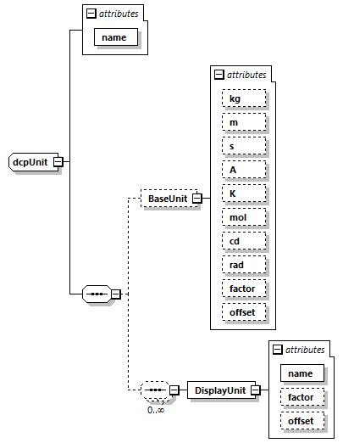

Figure 18: dcpUnit Type

|  |  |
| --- | --- |
| Element name | Description |
| name | A name of String data type. |

Table 160: dcpUnit element attributes

The Unit element contains one BaseUnit element, having the attributes defined in Table 161.

|  |  |
| --- | --- |
| Attribute name | Description |
| kg | Optional attribute of integer data type. Its default value is zero. |
| m | Optional attribute of integer data type. Its default value is zero. |
| s | Optional attribute of integer data type. Its default value is zero. |
| A | Optional attribute of integer data type. Its default value is zero. |
| K | Optional attribute of integer data type. Its default value is zero. |
| mol | Optional attribute of integer data type. Its default value is zero. |
| cd | Optional attribute of integer data type. Its default value is zero. |
| rad | Optional attribute of integer data type. Its default value is zero. |
| factor | Optional attribute of double data type. Its default value is 1.0. |
| offset | Optional attribute of double data type. Its default value is 0.0. |

Table 161: Base unit element attributes

A value with respect to Unit (abbreviated as “Unit_value”) is converted with respect to BaseUnit

(abbreviated as “BaseUnit_value”) using the equation:

BaseUnit_value = factor * Unit_value + offset

The Unit element contains an optional DisplayUnit element. It contains the attributes as defined in Table 162.

|  |  |
| --- | --- |
| Attribute name | Description |
| name | Attribute of normalizedString data type. |
| factor | Optional attribute of double data type. Its default value is 1.0. |
| offset | Optional attribute of double data type. Its default value is 0.0. |

Table 162: DisplayUnit element attributes

Definition of TypeDefinitions Element

General

The TypeDefinitions element is defined as follows.

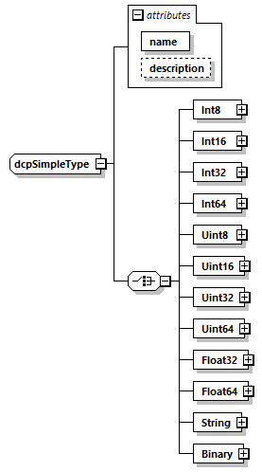

Figure 19: dcpSimpleType type

The optional TypeDefinitions element includes a list of SimpleType elements of type dcpSimpleType having the list of attributes defined in Table 163.

|  |  |
| --- | --- |
| Attribute name | Description |
| name | Name of this simple type. |
| description | An optional description. |

Table 163: dcpSimpleType element attributes

Definition of Data Types and Attributes

All unsigned integer (data type id 0 to 3), integer (data type id 4 to 7) float (data type id 8 and 9), string (data type id 10) and binary (data type id 11) data types have subsets of different attributes. For data type definitions see section 3.1.10.

|  |  |
| --- | --- |
| Attribute | Description |
| declaredType | The declared type of the variable. |
| displayUnit | The default display unit. The conversion to the “unit” is defined with the element “<dcpSlaveDescription><UnitDefinitions>”. If the corresponding “displayUnit” is not defined under “<UnitDefinitions><Unit><DisplayUnit>”, then displayUnit is ignored.  This attribute is optional.  This attribute is defined for Float32 and Float64 data types. |
| gradient | The gradient attribute indicates that the DCP slave variable is designed to change at a maximum permissible rate. Its unit is 1/s, and the data type corresponds to the variable data type.  This attribute is optional.  This attribute is defined for all integer and float data types. |
| max | The max attribute indicates that the DCP slave variable is designed to operate at or below an upper bound value (Variable value >= max).  The data type of this attribute corresponds to the parent element.  This attribute is optional.  This attribute is defined for all integer and float data types. |
| maxSize | This defines the maximum size of the data type in bytes. Its data type is unsigned integer.  This attribute is optional.  This attribute is defined for String and Binary data types. |
| mimeType | The MIME type of the data type.  This attribute is optional.  This attribute is defined for String data type. |
| min | The min attribute indicates that the DCP slave variable is designed to operate at or above a lower bound value (Variable value >= min).  The data type of this attribute corresponds to the parent element.  This attribute is optional.  This attribute is defined for all integer and float data types. |
| nominal | Nominal value of variable. If not defined and no other information about the nominal value is available, then nominal = 1 is assumed.  Note: The nominal value of a variable can be, for example used to determine the absolute tolerance for this variable as needed by numerical algorithms: absoluteTolerance = nominal * tolerance *0.01 where tolerance is, e.g., the relative tolerance.  This attribute is optional.  This attribute is defined for Float32 and Float64 data types. |
| quantity | Physical quantity of the variable, for example “Angle”, or “Energy”. The quantity names are not standardized.  This attribute is optional.  This attribute is defined for Float32 and Float64 data types. |
| unit | Unit of the variable defined with UnitDefinitions.Unit.name that is used for the model equations.  For example “N.m”: in this case a Unit.name = "N.m" must be present under UnitDefinitions.  This attribute is optional.  This attribute is defined for Float32 and Float64 data types. |

Table 164: Attributes of all defined variables.

Definition of VendorAnnotations Element

The element VendorAnnotations is of type dcpAnnotation, which is defined as shown in Figure 20.

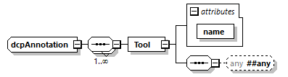

Figure 20: Annotations type

VendorAnnotations therefore consists of an ordered set of annotations that are identified by the name of the tool that can interpret additional information stored in place of the any element. The any element may be an arbitrary XML data structure. Attribute name must be unique with respect to all other elements of the VendorAnnotations list.

Definition of TimeRes Element

The element TimeRes is specified as follows.

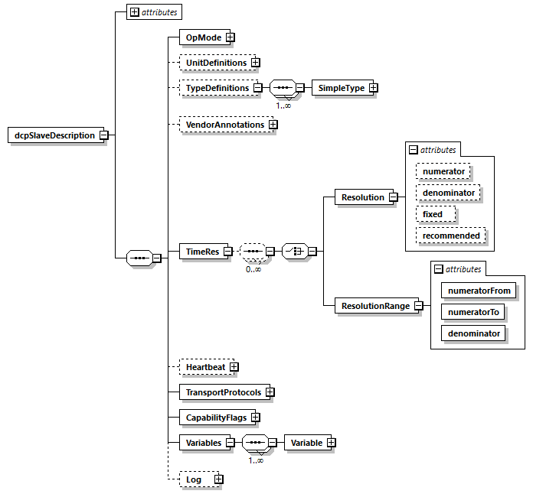

Figure 21: Time resolution element

The TimeRes element contains Resolution or ResolutionRange child elements. Their attributes are described as follows.

|  |  |
| --- | --- |
| Attribute name | Description |
| numerator | Optional numerator value specified as unsigned integer data type. Its default value is 1. |
| denominator | Optional denominator value specified as unsigned integer data type. Its default value is 1000. |
| fixed | Optional attribute of boolean data type. Its default value is true. If the fixed value is true, then there can only be one single resolution specified. |
| recommended | Optional attribute of boolean data type. If the recommended value is true, then this single resolution value is recommended for simulation. Multiple recommended single resolution values are possible. |
| numeratorFrom | This attribute specifies the begin of a numerator resolution range. Its data type is unsigned integer. |
| numeratorTo | This attribute specifies the end of a numerator resolution range. Its data type is unsigned integer. |
| denominator | This attribute specifies the denominator for one resolution range. Its data type is unsigned integer. |

Table 165: Time resolution attributes

The number of resolutions specified having the attribute fixed set to true is limited to one. In this case, it must be the only resolution specified, and the number of ResolutionRange elements must be zero. Alternatively, a number of Resolution elements having the attribute fixed set to false may be specified.

Definition of Heartbeat Element

The optional Heartbeat element is specified as follows. It contains a single MaximumPeriodicInterval element with 2 attributes.

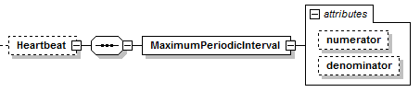

Figure 22: Heartbeat element

|  |  |
| --- | --- |
| Attribute name | Description |
| numerator | Optional attribute of unsigned integer data type. Its default value is 1. |
| denominator | Optional attribute of unsigned integer data type. Its default value is 1. |

Table 166: Heartbeat element attributes

Definition of TransportProtocols Element

General

The DCP supports multiple transport protocols. The TransportProtocols element is used to store specific settings.

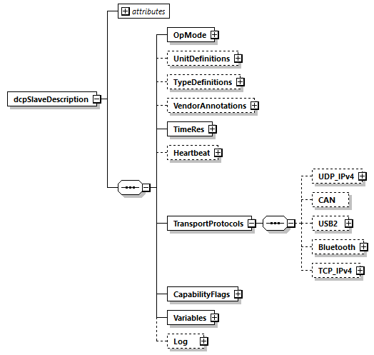

Figure 23: Transport protocols element

Each transport protocol listed under the TransportProtocols element may define a maxPduSize attribute, as required.

|  |  |
| --- | --- |
| Attribute name | Description |
| maxPduSize | Optional attribute of unsigned integer data type, specifying the maximum permissible size a transport protocol can handle. |

IPv4 Type

An element type for Internet Protocol Version 4 is defined. It is used to describe UDP and TCP transport protocols. Its sub-elements and attributes are shown in Figure 24.

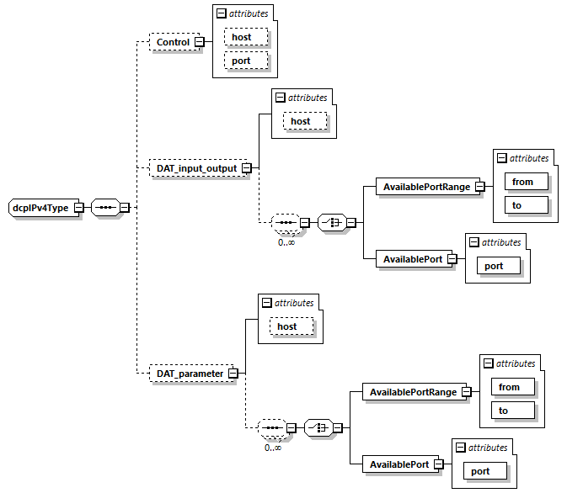

Figure 24: IPv4 type definition

The UDP via IPv4 transport protocol allows separate configurations for different PDU families.

* The optional Control element defines the host and port attributes intended for receiving PDUs of the Control PDU family.
* The optional DAT_input_output element defines a host attribute, as well as an optional list of either port ranges, indicated by from and to attributes, or single ports, indicated by the port attribute. This is intended for receiving DAT_input_output PDUs.
* The optional DAT_parameter element defines a host attribute, as well as an optional list of either port ranges, indicated by from and to attributes, or single ports, indicated by the port attribute. This is intended for receiving DAT_parameter PDUs.

These recurring attributes are specified in Table 167.

|  |  |
| --- | --- |
| Attribute name | Description |
| host | Optional attribute of normalizedString data type.  This attribute may contain one of the following:   * An IP according to RFC 791 [10] * A hostname according to RFC 952 [11] * A fully qualified domain name according to RFC 1035 [12] |
| port | Attribute of unsigned short data type. |
| from | Attribute of unsigned short data type. |
| to | Attribute of unsigned short data type. |

Table 167: Element attributes of the IPv4 type

UDP/IPv4

The elements and attributes for UDP via IPv4 are based on the IPv4 type described in section 5.11.2.

CAN

The DCP specification for CAN bus is defined in a non-native way. No entries are needed here.

USB

The elements and attributes for USB are defined in Table 168.

|  |  |
| --- | --- |
| Attribute name | Description |
| maxPower | Optional attribute of unsignedByte data type. |

Table 168: USB element attributes

The USB element contains an optional list of DataPipe elements, having the attributes defined in Table 169.

|  |  |
| --- | --- |
| Attribute name | Description |
| direction | Optional attribute of string data type, enumerated with either “In” or “Out”. |
| endpointAddress | Attribute of unsignedByte data type. Its value must be greater than 2. |
| interval | Attribute of unsignedByte data type. |

Table 169: DataPipe element attributes

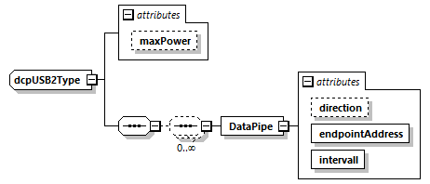

Figure 25: USB2 type definition

Bluetooth

The elements and attributes for Bluetooth are shown in Figure 26 and defined as follows.

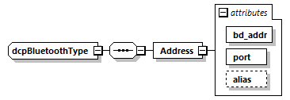

Figure 26: Bluetooth type definition

The attributes of the Address element are specified in Table 170.

|  |  |
| --- | --- |
| Attribute name | Description |
| bd_addr | Attribute of String data type. Its value must comply with the following regular expression:  ([0-9A-Fa-f]{2}[:-]){5}([0-9A-Fa-f]{2}) |
| port | Attribute of unsignedByte data type.  Its value is specified to be larger or equal to 1, and smaller or equal to 30. |
| alias | Optional attribute of type normalizedString. |

Table 170: Address element attributes

TCP/IPv4

The elements and attributes for TCP via IPv4 are based on the IPv4 type described in section 5.11.2.

Definition of CapabilityFlags Element

The element CapabilityFlags is defined as follows.

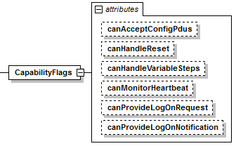

Figure 27: Capability flag element and attributes

The following capability flags are defined to indicate the availability of specific functionality. Each capability flag is of data type bool.

|  |  |
| --- | --- |
| Attribute name | Description |
| canAcceptConfigPdus | Indicates that a DCP slave is able to process CFG_input, CFG_output, CFG_target_network_information, and CFG_source_network_information PDUs properly. Otherwise, (1) the DCP slaves addressing needs to be resolved in a different way, e.g. manually, and (2) DAT_input_output PDUs need to be configured in a different way, e.g. manually. |
| canHandleReset | The DCP slave can handle a STC_reset PDU and reset the state machine from STOPPED to CONFIGURATION and from ERRORRESOLVED to CONFIGURATION. Otherwise it waits for STC_deregister to transition to ALIVE. |
| canHandleVariableSteps | Indicates that the DCP slave can handle variable steps in NRT operating mode. |
| canMonitorHeartbeat | Indicates that a DCP slave is able to monitor a periodic heartbeat signal sent by a DCP master.  If this capability flag is set to true, the element Heartbeat according to section 5.10 is required. |
| canProvideLogOnNotification | Indicates that the DCP slave supports logging using notifications. |
| canProvideLogOnRequest | Indicates that the DCP slave supports logging using the request-response mechanism. |

Table 171: Capability flags

Definition of Variables Element

The Variables element provides static information on all exposed variables. It contains Variable child elements.

Definition of Variable Element

A Variable may be either an Input, an Output, a Parameter, or a StructuralParameter. Figure 28 shows the structure of sub-elements and attributes, as defined by the dcpVariable type.

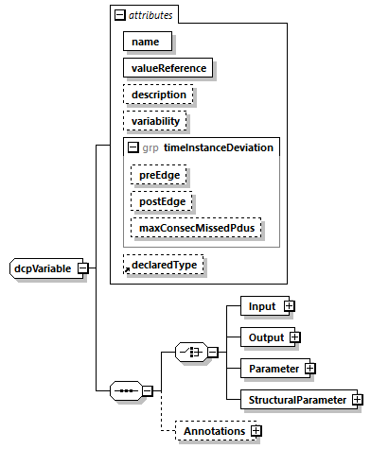

Figure 28: dcpVariable type

|  |  |
| --- | --- |
| Element | Description |
| Input | Inputs of the DCP slave. |
| Output | Outputs of the DCP slave. |
| Parameter | Parameters of the DCP slave. |
| StructuralParameter | Structural parameters of the DCP slave. |
| Annotations | dcpAnnotation type, see section 5.8. |

Table 172: Variable elements

Definition of Variable Element Attributes

The attributes of the dcpVariable type are defined as follows.

|  |  |
| --- | --- |
| Attribute | Description |
| name | The full name of the variable.  This attribute is mandatory. |
| valueReference | A unique handle per DCP slave of the variable, to efficiently identify the variable value in the DCP.  Its data type is Uint64.  This attribute is required. |
| description | An optional string describing the variable. |
| variability | Enumeration that defines the time dependency of the variable. It determines the time instants a variable is allowed to change its value.  Allowed values:   * fixed: This setting applies to parameters only. The value of the variable may only be set in state CONFIGURATION. See Table 63, CFG_parameter. * tunable: This setting applies to parameters only. The value of the variable may be set during simulation. See Table 63, DAT_parameter PDU. * discrete: This setting applies to Inputs and Outputs only. The value of the variable must at least be communicated on a change, but at periodic communication intervals. * continuous: This setting applies to Inputs and Outputs only. The value of the variable must be communicated at periodic communication intervals. |
| preEdge | The preEdge attribute defines the negative maximum deviation from the expected PDU arrival time. Its data type is float64 and its value is given in seconds.  This attribute is optional. |
| postEdge | The postEdge attribute defines the positive maximum deviation from the expected PDU arrival time. Its data type is float64 and its value is given in seconds.  This attribute is optional. |
| maxConsecMissedPdus | This attribute defines the maximum allowed number of consecutively missed PDUs for the given variable. Its data type is uint32. |
| declaredType | Identifies the name of type defined with TypeDefinitions/SimpleType providing defaults. This attribute is optional.  A variable takes values from declaredType for its attributes if they are not defined.  Note: Example  Assume a declared type: name="TestType" Uint8 min = 4, max = 6.  If a variable defines declaredType="TestType" Uint8 max = 8, then the variable would be a Uint8 with a range from 4 and 8. |

Table 173: Variable element attributes

Definition of Variable Data Types and Attributes

Inputs, Outputs, Parameters, and StructuralParameters must be assigned a data type. This is indicated by a corresponding sub-element representing a DCP data type, as defined in section 5.7.2. Table 174 shows these relationships.

|  |  |
| --- | --- |
| Element | Data type IDhex |
| Int8 | 0x4 |
| Int16 | 0x5 |
| Int32 | 0x6 |
| Int64 | 0x7 |
| Uint8 | 0x0 |
| Uint16 | 0x1 |
| Uint32 | 0x2 |
| Uint64 | 0x3 |
| Float32 | 0x8 |
| Float64 | 0x9 |
| String | 0xA |
| Binary | 0xB |

Table 174: Data type elements

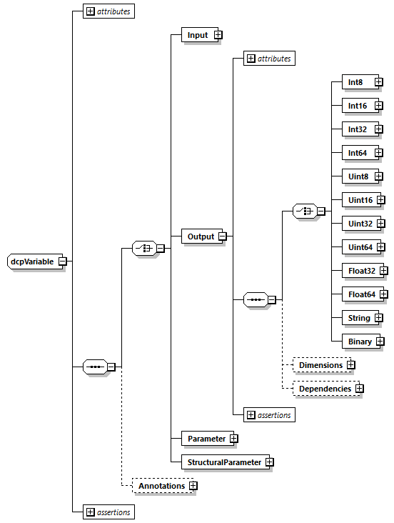

Figure 29: Data types of variables

The possible attributes of these datatypes are defined in Table 175.

|  |  |
| --- | --- |
| Attribute | Description |
| gradient | The gradient attribute indicates that the DCP slave variable is designed to change at a maximum permissible rate. Its unit is 1/s, and the data type corresponds to the variable data type.  This attribute is optional.  This attribute is defined for all integer and float data types. |
| max | The max attribute indicates that the DCP slave variable is designed to operate at or below an upper bound value (variable value >= max).  The data type of this attribute corresponds to the parent element.  This attribute is optional.  This attribute is defined for all integer and float data types. |
| maxSize | This defines the maximum size of the data type in bytes. Its data type is unsigned integer.  This attribute is optional.  This attribute is defined for String and Binary data types. |
| mimeType | The MIME type of the data type.  This attribute is optional.  This attribute is defined for String data type. |
| min | The min attribute indicates that the DCP slave variable is designed to operate at or above a lower bound value (Variable value >= min).  The data type of this attribute corresponds to the parent element.  This attribute is optional.  This attribute is defined for all integer and float data types. |
| nominal | Nominal value of variable. If not defined and no other information about the nominal value is available, then nominal = 1 is assumed.  Note: The nominal value of a variable can be, for example used to determine the absolute tolerance for this variable as needed by numerical algorithms: absoluteTolerance = nominal * tolerance *0.01 where tolerance is, e.g., the relative tolerance.  This attribute is optional.  This attribute is defined for Float32 and Float64 data types. |
| quantity | Physical quantity of the variable, for example “Angle”, or “Energy”. The quantity names are not standardized.  This attribute is optional.  This attribute is defined for Float32 and Float64 data types. |
| start | Definition of start value.  This attribute is defined for all data types.  The data type of this attribute corresponds to the parent element.  This attribute is mandatory for inputs, parameters, and structural parameters. This attribute is optional for outputs. The start value for String and Binary data types is always optional. |
| unit | Unit of the variable defined with UnitDefinitions.Unit.name that is used for the model equations.  For example “N.m”: in this case a Unit.name = "N.m" must be present under UnitDefinitions.  This attribute is optional.  This attribute is defined for Float32 and Float64 data types. |

Table 175: Data type attributes

Definition of Output Element Attributes

|  |  |
| --- | --- |
| Attribute | Description |
| defaultSteps | This optional attribute specifies the default number of steps of an output. Its data type is unsigned integer. Its default value is 1. |
| fixedSteps | This optional boolean data type attribute indicates that the number of steps is fixed and cannot be modified. Its default value is true. |
| minSteps | This optional unsigned integer data type attribute specifies the minimum number of steps. |
| maxSteps | This optional unsigned integer data type attribute specifies the maximum number of steps. |
| initialization | This optional boolean data type attribute specifies that the Output value will not change after leaving the Initialization superstate.  If true, no dependency information during Run superstate must be specified. |

Table 176: Exclusive output variable attributes

Definition of Output Dependencies

The sub-elements and attributes of the Dependencies element are shown in Figure 30.

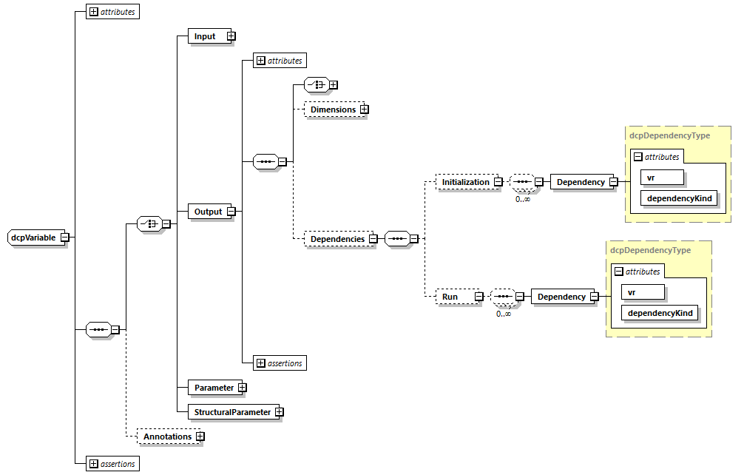

Figure 30: Dependencies element definition

The semantics specified in Table 177 is associated with the sub-elements and attributes of the Dependencies element.

|  |  |  |
| --- | --- | --- |
| Element | Condition | Semantics |
| Dependencies | Element exists | Dependency information shall be expressed. |
| Dependencies | Element does not exist | No dependency information is expressed. |
| Initialization | Element exists | In Initialization superstate, dependencies are specified. This output depends on the inputs and parameters referenced by a Dependency element.  If the Initialization element has no childs, no dependencies between this output and all inputs and parameters exist. |
| Initialization | Element does not exist | In Initialization superstate, no dependencies are specified.  Note: In that case this output may depend on all inputs and parameters. |
| Run | Element exists | In Run superstate, dependencies are specified. This output depends on the inputs and parameters referenced by a Dependency element.  If the Run element has no childs, no dependencies between this output and all inputs and parameters exist. |
| Run | Element does not exist | In Run superstate, no dependencies are specified.  Note: In that case this output may depend on all inputs and parameters. |
| Dependency | vr and dependencyKind given | The described dependency between this output and the specified input or parameter vr exists with the specified dependencyKind. |

Table 177: Dependency semantics

|  |  |
| --- | --- |
| Attribute | Description |
| vr | This is an unsigned integer data type attribute and refers to a variable, identified through its value reference. |
| dependencyKind | This is an enumerated string data type attribute. Possible options are linear and dependent. |

Table 178: Dependency element attributes

Definition of Multi-Dimensional Data Types

In order to define vector and array data types, the dimensions element is a child element of DcpVariable. It is defined using dcpDimensionsType, which must have at least one Dimension child element. The Dimension element must have one out of two attributes, either constant or linkedVR. This is shown in Figure 31.

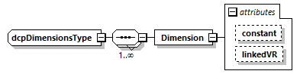

Figure 31: Dimensions type definition

Table 179 explains the attributes in detail.

|  |  |
| --- | --- |
| Attribute | Description |
| constant | This is an unsigned long data type attribute, indicating the constant dimension size of a variable. |
| linkedVR | This is an unsigned long data type attribute, referring to a variable identified through its value reference. |

Table 179: Dimensions type attributes

Figure 32 shows the structural parameter element. It defines four unsigned integer data types (data type id 0 to 3). Its attributes are given in Table 180.

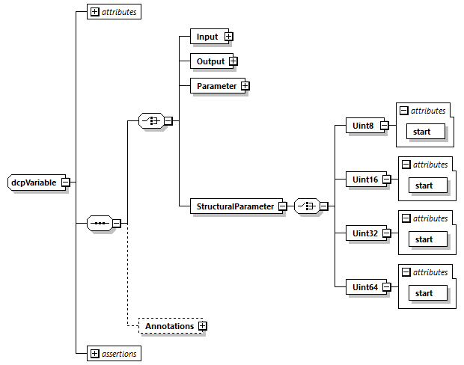

Figure 32: Structural parameter element.

|  |  |
| --- | --- |
| Attribute | Description |
| start | The start value of the structural parameter variable. |

Table 180: Structural parameter element attributes

Definition of Log Element

For a detailed description of the log mechanisms see section 3.1.23.

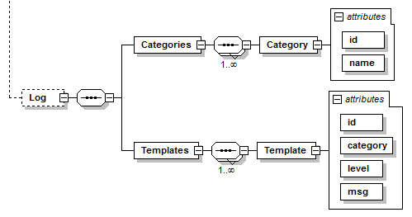

Figure 33: Log Element

|  |  |
| --- | --- |
| Attribute | Description |
| id | This defines a log category identifier. Its data type is uint8. |
| name | This defines a name for the log category. |

Table 181: Category element attributes

|  |  |
| --- | --- |
| Attribute | Description |
| id | This defines a log template identifier. Its data type is uint8. |
| category | This defines a reference to the log category identifier. Its data type is uint8. |
| level | This defines the log level. Its data type is uint8. |
| msg | This defines the log message. Its data type is a string, where placeholders starting with “%” followed by the corresponding data type descriptor are used. It is possible to escape “%” by using “%%”.  Example: Log message "Initialization at %float32 %%." will result in "Initialization at 35.5 %." |

Table 182: Template element attributes

Abbreviations

CAN – Controller area network

CFG – Prefix for Configuration PDUs

DAT – Prefix for Data PDUs

DCP – Distributed co-simulation protocol

DCPS – Distributed co-simulation protocol scenario

DCPX – Distributed co-simulation protocol XML

FMI – Functional mock-up interface

FPGA – Field programmable gate array

HRT – Hard real-time

IEEE - Institute of electrical and electronics engineers

INF – Prefix for Information request PDUs

LoN – Log on notification

LoR – Log on request

LSB – Least significant byte

MSB – Most significant byte

MTU – Maximum transmission unit

NRT – Non real-time

NTF – Prefix for Notification PDUs

PDU – Protocol data unit

RSP – Prefix for Response PDUs

SRT – Soft real-time

STC – Prefix for state change PDUs

UDP – User datagram protocol

USB – Universal serial bus

UTF-8 – Unicode transformation format

Literature

[1] “IEEE Standard for Floating-Point Arithmetic,” *IEEE Std 754-2008*, pp. 1–70, Aug. 2008.

[2] Unicode Consortium, *The Unicode Standard, Version 2.0*, no. June. 1996.

[3] “IEEE Standard for a Precision Clock Synchronization Protocol for Networked Measurement and Control Systems,” *IEEE Std 1588-2008*, pp. 1–269, Jul. 2008.

[4] R. Pattis, “EBNF : A Notation to Describe Syntax,” pp. 1–19, 2013.

[5] P. J. Leach, R. Salz, and M. H. Mealling, “A Universally Unique IDentifier (UUID) URN Namespace,” no. 4122. RFC Editor, 2005.

[6] “ISO/DIS 26262:2016 - Road Vehicles - Functional Safety.” International Organization for Standardization, 2016.

[7] WG 802.1 - Higher Layer LAN Protocols Working Group, “IEEE 802-2014 - IEEE Standard for Local and Metropolitan Area Networks: Overview and Architecture.” IEEE Standards Association, 2014.

[8] “W3C XML Schema Definition Language (XSD) 1.1 Part 1: Structures.” W3C., 2012.

[9] “Functional Mock-up Interface for Model Exchange and Co-Simulation, Version 2.0.” Modelisar Consortium and Modelica Association Project “FMI,” 2014.

[10] J. Postel, “Internet Protocol,” RFC Editor, Sep. 1981.

[11] K. Harrenstien, M. K. Stahl, and E. J. Feinler, “DoD Internet host table specification,” RFC Editor, 1985.

[12] P. Mockapetris, “Domain names - implementation and specification,” RFC Editor, Nov. 1987.

Glossary

|  |  |
| --- | --- |
| Term | Description |
| DCP master | A DCP master is defined as a black box, communicating by DCP PDUs over a given transport protocol, controlling at least one DCP slave. |
| DCP slave | A DCP slave is defined according to this specification, communicating by DCP PDUs over a given transport protocol, being controlled by exactly one DCP master. |
| Distributed Co-Simulation Protocol (DCP) | Communication protocol which enables distributed co-simulation. |
| Distributed Co-Simulation Protocol Description | Description of a DCP slave in XML file format with the file extension .dcpx according to this specification. |
| Distributed Co-Simulation Protocol File | A ZIP file having the extension .dcp designed to hold DCP description files. |
| Distributed Co-simulation Scenario (DCS) | A DCS is defined as the integration of multiple DCP slaves to perform a common simulation task. |
| Error | A DCP slave error is a discrepancy between a computed, observed or measured value or condition, and the true, specified or theoretically correct value or condition, that concerns violations of real time requirements or other DCP related functionality. |
| Failure | Termination of the ability of a DCP slave to perform as intended. |
| Hard Real-Time | Time-related criteria (deadlines) must be met at all times. Miss of a deadline is assumed to result in a total system failure. |
| Non-real time simulation | A simulation in which the simulation time is not synchronous to the absolute time. |
| Protocol Data Unit (PDU) | Information that is exchanged as a unit among DCP slaves. |
| Real-time simulation | A simulation in which the simulation time is synchronous to the absolute time. |

Acknowledgments

|  |  |
| --- | --- |
| Bildergebnis fÃ¼r itea 3 logo | Development of a DCP release candidate version was achieved in scope of the ITEA 3 project ACOSAR.  [www.itea3.org](http://www.itea3.org)  [www.acosar.eu](http://www.acosar.eu) |
| https://www.ffg.at/sites/default/files/allgemeine_downloads/Logos_2018/ffg_logo_de_2018_rgb_300.png | This project was co-funded by the Austrian Research Promotion Agency (FFG) |
| https://www.bodenkunde-projekte.hu-berlin.de/allwet/design/bilder/logo_bmbf.png | This project was co-funded by the  Federal Ministry of Education and Research (BMBF) |

**ACOSAR Project Participants**

* Kompetenzzentrum - Das virtuelle Fahrzeug, Forschungsgesellschaft mbH   
  („VIRTUAL VEHICLE“) (AT, Leader)
* AVL List Gmbh (AT)
* Spath MicroElectronicDesign (AT)
* Dr. Ing. h.c. F. Porsche AG (DE)
* Volkswagen AG (DE)
* Robert Bosch GmbH (DE)
* ETAS GmbH (DE)
* dSPACE GmbH (DE)
* ESI ITI GmbH (DE)
* TWT GmbH Science & Innovation (DE)
* RWTH Aachen University (DE)
* Technische Universität Ilmenau (DE)
* Leibniz University of Hannover (DE)
* ks.MicroNova GmbH (DE)
* Renault SAS (FR)
* Siemens Industry Software SAS (FR)

Appendix

1. Key Words to Indicate Requirement Levels

The following definitions are taken from RFC 2119.

MUST: This word, or the terms "REQUIRED" or "SHALL", mean that the definition is an absolute requirement of the specification.

MUST NOT: This phrase, or the phrase "SHALL NOT", mean that the definition is an absolute prohibition of the specification.

SHOULD: This word, or the adjective "RECOMMENDED", mean that there may exist valid reasons in particular circumstances to ignore a particular item, but the full implications must be understood and carefully weighed before choosing a different course.

SHOULD NOT: This phrase, or the phrase "NOT RECOMMENDED" mean that there may exist valid reasons in particular circumstances when the particular behavior is acceptable or even useful, but the full implications should be understood and the case carefully weighed before implementing any behavior described with this label.

MAY: This word, or the adjective "OPTIONAL", mean that an item is truly optional. One vendor may choose to include the item because a particular marketplace requires it or because the vendor feels that it enhances the product while another vendor may omit the same item. An implementation which does not include a particular option MUST be prepared to interoperate with another implementation which does include the option, though perhaps with reduced functionality. In the same vein an implementation which does include a particular option MUST be prepared to interoperate with another implementation which does not include the option (except, of course, for the feature the option provides.)

Guidance in the use of these Imperatives: Imperatives of the type defined in this memo must be used with care and sparingly. In particular, they MUST only be used where it is actually required for interoperation or to limit behavior which has potential for causing harm (e.g., limiting retransmissions). For example, they must not be used to try to impose a particular method on implementors where the method is not required for interoperability.

Security Considerations: These terms are frequently used to specify behavior with security implications. The effects on security of not implementing a MUST or SHOULD, or doing something the specification says MUST NOT or SHOULD NOT be done may be very subtle. Document authors should take the time to elaborate the security implications of not following recommendations or requirements as most implementors will not have had the benefit of the experience and discussion that produced the specification.

1. Default DCP Slave Integration

The following Figure 34 sketches the procedure for default DCP slave integration using the native DCP specification. A DCP slave provider ships a DCP slave description in DCPX file format and a DCP slave to the DCP integrator. The DCP integrator uses the DCP slave description for configuration of a scenario. This scenario description is exported to a DCP master. The DCP master is an implementation being able to control DCP slaves. It generates a configuration for simulation and rolls out this configuration to the running instances of the DCP slaves. Then the scenario may be simulated.

Note: This specification covers the intended behavior of a DCP slave and the DCP slave description. This specification does not cover the import process of DCP slave descriptions, the generation of a valid scenario configuration, the scenario description being exported to the DCP master, the exact steps necessary for DCP slave instantiation, as well as DCP slave implementation details.

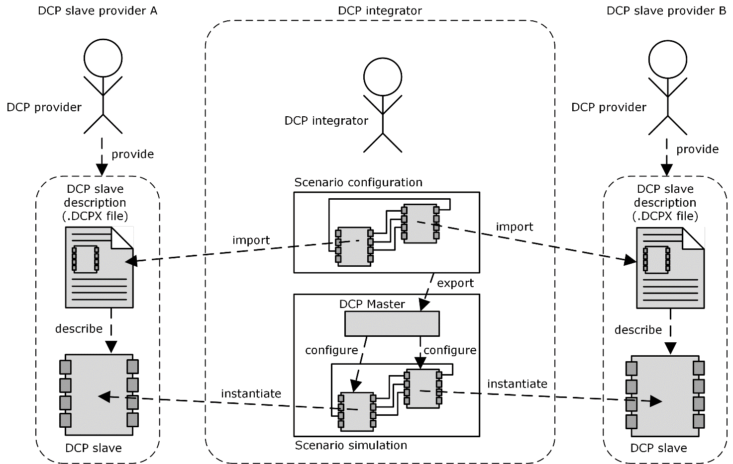

Figure 34: Default DCP slave integration

1. Example: Encoding of Variables

The following tables show the intended encoding of variables when transmitted using the DCP.

|  |  |  |
| --- | --- | --- |
| Parts of | | Coloring |
| Floating Point | Integer |
| Sign | Sign |  |
| Exponent | - |  |
| Fraction | - |  |

Table 183: Color Indicators

|  |  |  |  |  |  |  |  |  |  |
| --- | --- | --- | --- | --- | --- | --- | --- | --- | --- |
| Decimal | 42 | | | | | | | | |
| Binary | 0 | 0 | 1 | 0 | 1 | 0 | 1 | | 0 |
| Hex | 0x2A | | | | | | | | |
|  | MSB | | | | LSB | | | | |
|  |  | | | | | | | | |
| Position | n | | | | | | | | |
| DAT_input_outputBin | 0 | 0 | 1 | 0 | 1 | 0 | 1 | 0 | |
| DAT_input_outputHex | 0x2A | | | | | | | | |

Table 184: Example uint8

|  |  |  |  |  |  |  |  |  |  |  |  |  |  |  |  |  |  |
| --- | --- | --- | --- | --- | --- | --- | --- | --- | --- | --- | --- | --- | --- | --- | --- | --- | --- |
| Decimal | 7963 | | | | | | | | | | | | | | | | |
| Binary | 0 | 0 | 0 | 1 | 1 | 1 | 1 | 1 | 0 | 0 | 0 | | 1 | 1 | 0 | 1 | 1 |
| Hex | 0x1F | | | | | | | | 0x1B | | | | | | | | |
|  | MSB | | | | | | | | LSB | | | | | | | | |
|  |  | | | | | | | |  | | | | | | | | |
| Position | n | | | | | | | | n + 1 | | | | | | | | |
| DAT_input_outputBin | 0 | 0 | 0 | 1 | 1 | 0 | 1 | 1 | 0 | 0 | | 0 | 1 | 1 | 1 | 1 | 1 |
| DAT_input_outputHex | 0x1B | | | | | | | | 0x1F | | | | | | | | |

Table 185: Example uint16

|  |  |  |  |  |  |  |  |  |  |  |  |  |  |  |  |  |  |  |  |  |  |  |  |  |  |  |  |  |  |  |  |  |  |
| --- | --- | --- | --- | --- | --- | --- | --- | --- | --- | --- | --- | --- | --- | --- | --- | --- | --- | --- | --- | --- | --- | --- | --- | --- | --- | --- | --- | --- | --- | --- | --- | --- | --- |
| Decimal | 335960 | | | | | | | | | | | | | | | | | | | | | | | | | | | | | | | | |
| Binary | 0 | 0 | 0 | 0 | 0 | 0 | 0 | | 0 | 0 | 0 | 0 | 0 | 0 | 1 | 0 | 1 | 0 | 0 | 1 | 0 | 0 | 0 | 0 | 0 | 0 | 1 | 0 | 1 | 1 | 0 | 0 | 0 |
| Hex | 0x00 | | | | | | | | | 0x05 | | | | | | | | 0x20 | | | | | | | | 0x58 | | | | | | | |
|  | MSB | | | | | | | | |  | | | | | | | |  | | | | | | | | LSB | | | | | | | |
|  |  | | | | | | | | | | | | | | | | | | | | | | | | | | | | | | | | |
| Position | n | | | | | | | | | n + 1 | | | | | | | | n + 2 | | | | | | | | n + 3 | | | | | | | |
| DAT_input_outputBin | 0 | 1 | 0 | 1 | 1 | 0 | | 0 | 0 | 0 | 0 | 1 | 0 | 0 | 0 | 0 | 0 | 0 | 0 | 0 | 0 | 0 | 1 | 0 | 1 | 0 | 0 | 0 | 0 | 0 | 0 | 0 | 0 |
| DAT_input_outputHex | 0x58 | | | | | | | | | 0x20 | | | | | | | | 0x05 | | | | | | | | 0x00 | | | | | | | |

Table 186: Example uint32

|  |  |  |  |  |  |  |  |  |
| --- | --- | --- | --- | --- | --- | --- | --- | --- |
| Decimal | 622553314543962266 | | | | | | | |
| Binary | |  |  |  |  |  |  |  |  | | --- | --- | --- | --- | --- | --- | --- | --- | | 0 | 0 | 0 | 0 | 1 | 0 | 0 | 0 | | 0x08 | | | | | | | | | |  |  |  |  |  |  |  |  | | --- | --- | --- | --- | --- | --- | --- | --- | | 1 | 0 | 1 | 0 | 0 | 0 | 1 | 1 | | 0xA3 | | | | | | | | | |  |  |  |  |  |  |  |  | | --- | --- | --- | --- | --- | --- | --- | --- | | 1 | 1 | 0 | 0 | 0 | 0 | 0 | 0 | | 0xC0 | | | | | | | | | |  |  |  |  |  |  |  |  | | --- | --- | --- | --- | --- | --- | --- | --- | | 1 | 1 | 1 | 1 | 0 | 0 | 0 | 0 | | 0xF0 | | | | | | | | | |  |  |  |  |  |  |  |  | | --- | --- | --- | --- | --- | --- | --- | --- | | 1 | 1 | 1 | 0 | 1 | 1 | 1 | 1 | | 0xEF | | | | | | | | | |  |  |  |  |  |  |  |  | | --- | --- | --- | --- | --- | --- | --- | --- | | 0 | 0 | 1 | 0 | 0 | 0 | 1 | 0 | | 0x22 | | | | | | | | | |  |  |  |  |  |  |  |  | | --- | --- | --- | --- | --- | --- | --- | --- | | 1 | 0 | 0 | 0 | 1 | 0 | 0 | 0 | | 0x88 | | | | | | | | | |  |  |  |  |  |  |  |  | | --- | --- | --- | --- | --- | --- | --- | --- | | 1 | 0 | 0 | 1 | 1 | 0 | 1 | 0 | | 0x9A | | | | | | | | |
| Hex |
|  | MSB |  |  |  |  |  |  | LSB |
|  |  |  |  |  |  |  |  |  |
| Position | |  |  |  |  |  |  |  |  | | --- | --- | --- | --- | --- | --- | --- | --- | | n | | | | | | | | | 1 | 0 | 0 | 1 | 1 | 0 | 1 | 0 | | 0x9A | | | | | | | | | |  |  |  |  |  |  |  |  | | --- | --- | --- | --- | --- | --- | --- | --- | | n + 1 | | | | | | | | | 1 | 0 | 0 | 0 | 1 | 0 | 0 | 0 | | 0x88 | | | | | | | | | |  |  |  |  |  |  |  |  | | --- | --- | --- | --- | --- | --- | --- | --- | | n+ 2 | | | | | | | | | 0 | 0 | 1 | 0 | 0 | 0 | 1 | 0 | | 0x22 | | | | | | | | | |  |  |  |  |  |  |  |  | | --- | --- | --- | --- | --- | --- | --- | --- | | n + 3 | | | | | | | | | 1 | 1 | 1 | 0 | 1 | 1 | 1 | 1 | | 0xEF | | | | | | | | | |  |  |  |  |  |  |  |  | | --- | --- | --- | --- | --- | --- | --- | --- | | n + 4 | | | | | | | | | 1 | 1 | 1 | 1 | 0 | 0 | 0 | 0 | | 0xF0 | | | | | | | | | |  |  |  |  |  |  |  |  | | --- | --- | --- | --- | --- | --- | --- | --- | | n + 5 | | | | | | | | | 1 | 1 | 0 | 0 | 0 | 0 | 0 | 0 | | 0xC0 | | | | | | | | | |  |  |  |  |  |  |  |  | | --- | --- | --- | --- | --- | --- | --- | --- | | n + 6 | | | | | | | | | 1 | 0 | 1 | 0 | 0 | 0 | 1 | 1 | | 0xA3 | | | | | | | | | |  |  |  |  |  |  |  |  | | --- | --- | --- | --- | --- | --- | --- | --- | | n + 7 | | | | | | | | | 0 | 0 | 0 | 0 | 1 | 0 | 0 | 0 | | 0x08 | | | | | | | | |
| DAT_input_outputBin |
| DAT_input_outputHex |

Table 187: Example uint64

|  |  |  |  |  |  |  |  |  |  |
| --- | --- | --- | --- | --- | --- | --- | --- | --- | --- |
| Decimal | -113 | | | | | | | | |
| Binary | 1 | 0 | 0 | 0 | 1 | 1 | 1 | | 1 |
| Hex | 0x8F | | | | | | | | |
|  | MSB | | | | LSB | | | | |
|  |  | | | | | | | | |
| Position | n | | | | | | | | |
| DAT_input_outputBin | 1 | 0 | 0 | 0 | 1 | 1 | 1 | 1 | |
| DAT_input_outputHex | 0x8F | | | | | | | | |

Table 188: Example int8

|  |  |  |  |  |  |  |  |  |  |  |  |  |  |  |  |  |  |
| --- | --- | --- | --- | --- | --- | --- | --- | --- | --- | --- | --- | --- | --- | --- | --- | --- | --- |
| Decimal | -4963 | | | | | | | | | | | | | | | | |
| Binary | 1 | 1 | 1 | 0 | 1 | 1 | 0 | 0 | 1 | 0 | 0 | | 1 | 1 | 1 | 0 | 1 |
| Hex | 0xEC | | | | | | | | 0x9D | | | | | | | | |
|  | MSB | | | | | | | | LSB | | | | | | | | |
|  |  | | | | | | | |  | | | | | | | | |
| Position | n | | | | | | | | n + 1 | | | | | | | | |
| DAT_input_outputBin | 1 | 0 | 0 | 1 | 1 | 1 | 0 | 1 | 1 | 1 | | 1 | 0 | 1 | 1 | 0 | 0 |
| DAT_input_outputHex | 0x9D | | | | | | | | 0xEC | | | | | | | | |

Table 189: Example int16

|  |  |  |  |  |  |  |  |  |  |  |  |  |  |  |  |  |  |  |  |  |  |  |  |  |  |  |  |  |  |  |  |  |
| --- | --- | --- | --- | --- | --- | --- | --- | --- | --- | --- | --- | --- | --- | --- | --- | --- | --- | --- | --- | --- | --- | --- | --- | --- | --- | --- | --- | --- | --- | --- | --- | --- |
| Decimal | -89498498 | | | | | | | | | | | | | | | | | | | | | | | | | | | | | | | |
| Binary | 1 | 1 | 1 | 1 | 1 | 0 | 1 | 0 | 1 | 0 | 1 | 0 | 1 | 0 | 1 | 0 | 0 | 1 | 0 | 1 | 1 | 1 | 0 | 0 | 0 | 1 | 1 | 1 | 1 | 1 | 1 | 0 |
| Hex | 0xFA | | | | | | | | 0xAA | | | | | | | | 0x5C | | | | | | | | 0x7E | | | | | | | |
|  | MSB | | | | | | | |  | | | | | | | |  | | | | | | | | LSB | | | | | | | |
|  |  | | | | | | | | | | | | | | | | | | | | | | | | | | | | | | | |
| Position | N | | | | | | | | n + 1 | | | | | | | | n + 2 | | | | | | | | n + 3 | | | | | | | |
| DAT_input_outputBin | 0 | 1 | 1 | 1 | 1 | 1 | 1 | 0 | 0 | 1 | 0 | 1 | 1 | 1 | 0 | 0 | 1 | 0 | 1 | 0 | 1 | 0 | 1 | 0 | 1 | 1 | 1 | 1 | 1 | 0 | 1 | 0 |
| DAT_input_outputHex | 0x7E | | | | | | | | 0x5C | | | | | | | | 0xAA | | | | | | | | 0xFA | | | | | | | |

Table 190: Example int32

|  |  |  |  |  |  |  |  |  |
| --- | --- | --- | --- | --- | --- | --- | --- | --- |
| Decimal | -8789498491988154686 | | | | | | | |
| Binary | |  |  |  |  |  |  |  |  | | --- | --- | --- | --- | --- | --- | --- | --- | | 1 | 0 | 0 | 0 | 0 | 1 | 1 | 0 | | 0x86 | | | | | | | | | |  |  |  |  |  |  |  |  | | --- | --- | --- | --- | --- | --- | --- | --- | | 0 | 0 | 0 | 0 | 0 | 1 | 0 | 1 | | 0x05 | | | | | | | | | |  |  |  |  |  |  |  |  | | --- | --- | --- | --- | --- | --- | --- | --- | | 0 | 1 | 1 | 0 | 1 | 1 | 0 | 1 | | 0x6D | | | | | | | | | |  |  |  |  |  |  |  |  | | --- | --- | --- | --- | --- | --- | --- | --- | | 1 | 0 | 1 | 1 | 0 | 0 | 0 | 0 | | 0xB0 | | | | | | | | | |  |  |  |  |  |  |  |  | | --- | --- | --- | --- | --- | --- | --- | --- | | 1 | 0 | 1 | 1 | 0 | 1 | 1 | 1 | | 0xB7 | | | | | | | | | |  |  |  |  |  |  |  |  | | --- | --- | --- | --- | --- | --- | --- | --- | | 0 | 0 | 1 | 1 | 0 | 1 | 1 | 0 | | 0x36 | | | | | | | | | |  |  |  |  |  |  |  |  | | --- | --- | --- | --- | --- | --- | --- | --- | | 1 | 1 | 1 | 0 | 0 | 1 | 1 | 0 | | 0xE6 | | | | | | | | | |  |  |  |  |  |  |  |  | | --- | --- | --- | --- | --- | --- | --- | --- | | 1 | 1 | 0 | 0 | 0 | 0 | 1 | 0 | | 0xC2 | | | | | | | | |
| Hex |
|  | MSB |  |  |  |  |  |  | LSB |
|  |  |  |  |  |  |  |  |  |
| Position | |  |  |  |  |  |  |  |  | | --- | --- | --- | --- | --- | --- | --- | --- | | n | | | | | | | | | 1 | 1 | 0 | 0 | 0 | 0 | 1 | 0 | | 0xC2 | | | | | | | | | |  |  |  |  |  |  |  |  | | --- | --- | --- | --- | --- | --- | --- | --- | | n + 1 | | | | | | | | | 1 | 1 | 1 | 0 | 0 | 1 | 1 | 0 | | 0xE6 | | | | | | | | | |  |  |  |  |  |  |  |  | | --- | --- | --- | --- | --- | --- | --- | --- | | n+ 2 | | | | | | | | | 0 | 0 | 1 | 1 | 0 | 1 | 1 | 0 | | 0x36 | | | | | | | | | |  |  |  |  |  |  |  |  | | --- | --- | --- | --- | --- | --- | --- | --- | | n + 3 | | | | | | | | | 1 | 0 | 1 | 1 | 0 | 1 | 1 | 1 | | 0xB7 | | | | | | | | | |  |  |  |  |  |  |  |  | | --- | --- | --- | --- | --- | --- | --- | --- | | n + 4 | | | | | | | | | 1 | 0 | 1 | 1 | 0 | 0 | 0 | 0 | | 0xB0 | | | | | | | | | |  |  |  |  |  |  |  |  | | --- | --- | --- | --- | --- | --- | --- | --- | | n + 5 | | | | | | | | | 0 | 1 | 1 | 0 | 1 | 1 | 0 | 1 | | 0x6D | | | | | | | | | |  |  |  |  |  |  |  |  | | --- | --- | --- | --- | --- | --- | --- | --- | | n + 6 | | | | | | | | | 0 | 0 | 0 | 0 | 0 | 1 | 0 | 1 | | 0x05 | | | | | | | | | |  |  |  |  |  |  |  |  | | --- | --- | --- | --- | --- | --- | --- | --- | | n + 7 | | | | | | | | | 1 | 0 | 0 | 0 | 0 | 1 | 1 | 0 | | 0x86 | | | | | | | | |
| DAT_input_outputBin |
| DAT_input_outputHex |

Table 191: Example int64

|  |  |  |  |  |  |  |  |  |  |  |  |  |  |  |  |  |  |  |  |  |  |  |  |  |  |  |  |  |  |  |  |  |
| --- | --- | --- | --- | --- | --- | --- | --- | --- | --- | --- | --- | --- | --- | --- | --- | --- | --- | --- | --- | --- | --- | --- | --- | --- | --- | --- | --- | --- | --- | --- | --- | --- |
| Decimal | 7256.2568359375 | | | | | | | | | | | | | | | | | | | | | | | | | | | | | | | |
| Binary | 0 | 1 | 0 | 0 | 0 | 1 | 0 | 1 | 1 | 1 | 1 | 0 | 0 | 0 | 1 | 0 | 1 | 1 | 0 | 0 | 0 | 0 | 1 | 0 | 0 | 0 | 0 | 0 | 1 | 1 | 1 | 0 |
| Hex | 0x45 | | | | | | | | 0xE2 | | | | | | | | 0xC2 | | | | | | | | 0x0E | | | | | | | |
|  | MSB | | | | | | | |  | | | | | | | |  | | | | | | | | LSB | | | | | | | |
|  |  | | | | | | | | | | | | | | | | | | | | | | | | | | | | | | | |
| Position | n | | | | | | | | n + 1 | | | | | | | | n + 2 | | | | | | | | n + 3 | | | | | | | |
| DAT_input_outputBin | 0 | 0 | 0 | 0 | 1 | 1 | 1 | 0 | 1 | 1 | 0 | 0 | 0 | 0 | 1 | 0 | 1 | 1 | 1 | 0 | 0 | 0 | 1 | 0 | 0 | 1 | 0 | 0 | 0 | 1 | 0 | 1 |
| DAT_input_outputHex | 0x0E | | | | | | | | 0xC2 | | | | | | | | 0xE3 | | | | | | | | 0x45 | | | | | | | |

Table 192: Example float32

|  |  |  |  |  |  |  |  |  |
| --- | --- | --- | --- | --- | --- | --- | --- | --- |
| Decimal | 46.42829231507700882275457843206822872161865234375 | | | | | | | |
| Binary | |  |  |  |  |  |  |  |  | | --- | --- | --- | --- | --- | --- | --- | --- | | 0 | 1 | 0 | 0 | 0 | 0 | 0 | 0 | | 0x40 | | | | | | | | | |  |  |  |  |  |  |  |  | | --- | --- | --- | --- | --- | --- | --- | --- | | 0 | 1 | 0 | 0 | 0 | 1 | 1 | 1 | | 0x47 | | | | | | | | | |  |  |  |  |  |  |  |  | | --- | --- | --- | --- | --- | --- | --- | --- | | 0 | 0 | 1 | 1 | 0 | 1 | 1 | 0 | | 0x36 | | | | | | | | | |  |  |  |  |  |  |  |  | | --- | --- | --- | --- | --- | --- | --- | --- | | 1 | 1 | 0 | 1 | 0 | 0 | 1 | 0 | | 0xD2 | | | | | | | | | |  |  |  |  |  |  |  |  | | --- | --- | --- | --- | --- | --- | --- | --- | | 0 | 1 | 0 | 0 | 1 | 0 | 0 | 0 | | 0x48 | | | | | | | | | |  |  |  |  |  |  |  |  | | --- | --- | --- | --- | --- | --- | --- | --- | | 0 | 0 | 1 | 1 | 0 | 0 | 0 | 1 | | 0x57 | | | | | | | | | |  |  |  |  |  |  |  |  | | --- | --- | --- | --- | --- | --- | --- | --- | | 0 | 0 | 1 | 1 | 0 | 0 | 0 | 1 | | 0x31 | | | | | | | | | |  |  |  |  |  |  |  |  | | --- | --- | --- | --- | --- | --- | --- | --- | | 0 | 0 | 1 | 0 | 0 | 0 | 1 | 1 | | 0x23 | | | | | | | | |
| Hex |
|  | MSB |  |  |  |  |  |  | LSB |
|  |  |  |  |  |  |  |  |  |
| Position | |  |  |  |  |  |  |  |  | | --- | --- | --- | --- | --- | --- | --- | --- | | n | | | | | | | | | 0 | 0 | 1 | 0 | 0 | 0 | 1 | 1 | | 0x23 | | | | | | | | | |  |  |  |  |  |  |  |  | | --- | --- | --- | --- | --- | --- | --- | --- | | n + 1 | | | | | | | | | 0 | 0 | 1 | 1 | 0 | 0 | 0 | 1 | | 0x31 | | | | | | | | | |  |  |  |  |  |  |  |  | | --- | --- | --- | --- | --- | --- | --- | --- | | n+ 2 | | | | | | | | | 0 | 0 | 1 | 1 | 0 | 0 | 0 | 1 | | 0x57 | | | | | | | | | |  |  |  |  |  |  |  |  | | --- | --- | --- | --- | --- | --- | --- | --- | | n + 3 | | | | | | | | | 0 | 1 | 0 | 0 | 1 | 0 | 0 | 0 | | 0x48 | | | | | | | | | |  |  |  |  |  |  |  |  | | --- | --- | --- | --- | --- | --- | --- | --- | | n + 4 | | | | | | | | | 1 | 1 | 0 | 1 | 0 | 0 | 1 | 0 | | 0xD2 | | | | | | | | | |  |  |  |  |  |  |  |  | | --- | --- | --- | --- | --- | --- | --- | --- | | n + 5 | | | | | | | | | 0 | 0 | 1 | 1 | 0 | 1 | 1 | 0 | | 0x36 | | | | | | | | | |  |  |  |  |  |  |  |  | | --- | --- | --- | --- | --- | --- | --- | --- | | n + 6 | | | | | | | | | 0 | 1 | 0 | 0 | 0 | 1 | 1 | 1 | | 0x47 | | | | | | | | | |  |  |  |  |  |  |  |  | | --- | --- | --- | --- | --- | --- | --- | --- | | n + 7 | | | | | | | | | 0 | 1 | 0 | 0 | 0 | 0 | 0 | 0 | | 0x40 | | | | | | | | |
| DAT_input_outputBin |
| DAT_input_outputHex |

Table 193: Example float64

1. Example: Data Exchange

The following Figure 35 shows an example of necessary steps for configuration roll-out using native DCP (UDP over IPv4).

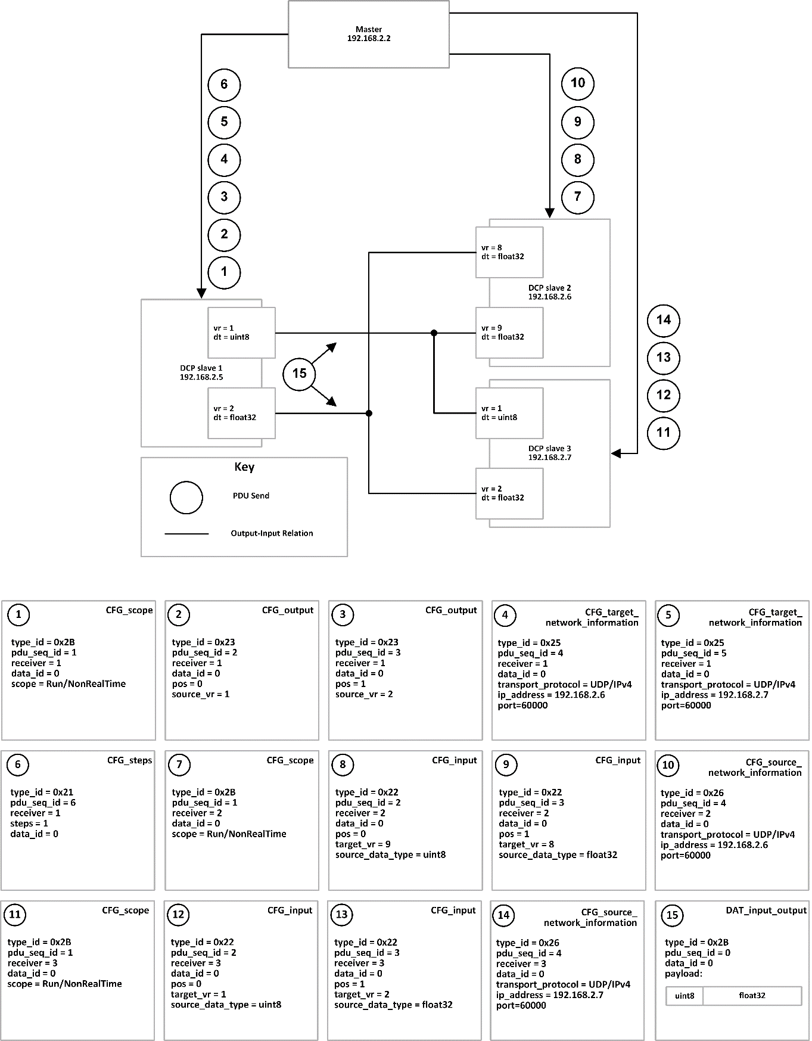

Note: For better legibility all values are in human readable format. On the communication medium these values are transported as defined in this specification.

Figure 35: Example configuration roll-out

1. Recovery Procedure

The procedure of Table 194 can be used to reach the ALIVE state, from any other state.

|  |  |
| --- | --- |
| Sequence number | Action |
| 1 | Query state using INF_state. |
| 2a | If the resulting state is within the superstate Stoppable,  1) the DCP master sends STC_stop  2) waits for the DCP slave to be in state STOPPED  3) the DCP master sends STC_deregister. |
| 2b | If the resulting state is CONFIGURATION,  1) the DCP master sends STC_deregister. |
| 2c | If the resulting state is within the superstate Error,  1) the DCP master waits for the DCP slave to be in state ERRORRESOLVED,  2) and sends STC_deregister. |

Table 194: Recovery procedure

1. General Guideline

Regarding the use of transport protocols related to Control PDUs:

It is recommended to use reliable transport protocols for Control PDUs.

Regarding the use of transport protocols related to continuous DAT_input_output PDUs:

Reliable transport protocols are considered beneficial if the time needed to transmit a PDU, including time for retransmission, is in general lower than the specified DCP communication step size.

Unreliable transport protocols are considered beneficial if e.g. higher network throughput is required, or the target platform is only capable of supporting unreliable transport protocols.

Regarding the use of transport protocols related to discrete DAT_input_output PDUs:

It is recommended to use reliable transport protocols for transmission of discrete Data PDUs.

Regarding the use of transport protocols related to DAT_parameter PDUs:

It is recommended to use reliable transport protocols for transmission of DAT_parameter PDUs.

Regarding master implementations:

Implement the suggested procedure to transition slaves to a defined state.

Define behaviour after unexpected shutdown of DCP master.

Regarding master implementations based on unreliable transport protocols:

Retransmit Request PDUs if no acknowledgement is received.

Query states of slaves at regular intervals (use heartbeat mechanism).

Use DCP slaves implementing the maxConsecMissedPdu attribute, whenever possible.

1. https://github.com/dschanoeh/Kayak
2. The screenshots of this section have been generated from the schema files with the tool “Altova XMLSpy”. Please see www.altova.com.