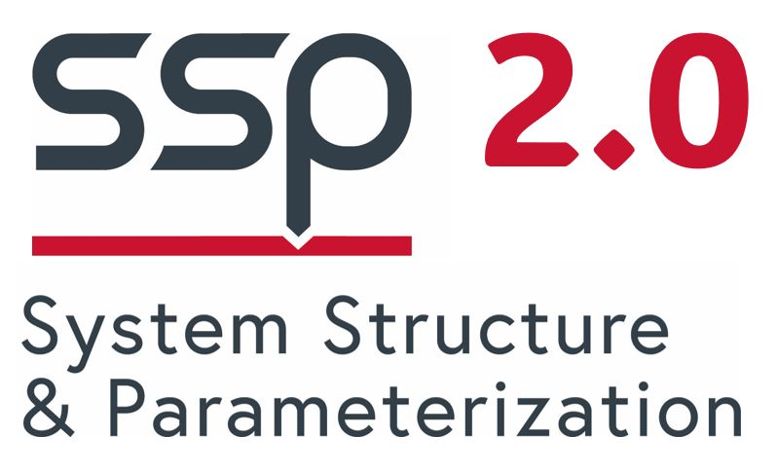

SSP Layered Standard for Traceability (SSP-LS-Traceability) v1.0.0 released

**The SSP Project is happy to announce the release of the first layered standard on top of the SSP Standard developed by the SSP Project.**

The [System Structure & Parameterization (SSP)](https://ssp-standard.org/) standard has established itself as a format for the exchange of composite system simulation models and simulation model architectures.

Layered standards are extensions to the core SSP standard for special applications. SSP-LS-Traceability defines support for the exchange of simulation traceability and credibility information alongside simulation artefacts inside SSP packages and formats.

It also defines generic formats for the exchange of keyword value pair meta data, that can be used to exchange arbitrary simulation meta data, as exemplified by the [MIC Core](https://mic-core.org/) common meta data specification.

The release [v1.0.0](https://github.com/modelica/ssp-ls-traceability/releases) is available on GitHub.

About the Modelica Association

The Modelica Association (MA) is a non-profit organization incorporated in Sweden with the mission to develop open-access, royalty-free, coordinated standards for the development and verification of cyber-physical systems. The open and royalty-free nature of the standards supports a rich eco-system of open-source and commercial solutions. The MA projects provide open-source assets, compliance checkers, and infrastructure to simplify the process of standards adoption, all publicly available under the [Modelica GitHub organization](https://github.com/modelica), and organizes regular open-access conferences, with all papers available on the [Modelica website](https://modelica.org/). The Modelica Association standards are endorsed and recommended by many professional societies in the modeling and systems engineering domain: [Prostep IVIP](http://prostep.org/), [PDES](http://pdesinc.org/), [NAFEMS](https://nafems.org/), and [INCOSE](https://incose.org/).

Contact information

Modelica Association

Website: <https://modelica.org/>



Email: [board@modelica.org](mailto:board@modelica.org)

Modelica Association Project SSP



Website: <https://ssp-standard.org/>

Email: [contact@ssp-standard.org](mailto:contact@ssp-standard.org)

SSP Project Leader: Jochen Köhler, ZF Friedrichshafen  
SSP Deputy Project Leader: Pierre R. Mai, PMSF

SSP Project Members: Altair Engineering Inc., U.S.A.; AVL List GmbH, Austria; Robert Bosch GmbH, Germany; Dassault Systèmes, France, Germany, and Sweden; dSPACE GmbH, Germany; eXXcellent solutions GmbH, Germany; PMSF, Germany; Saab AB, Sweden; ZF Friedrichshafen, Germany