

High Level Design
Prepared by: Daniel Robledo Munoz | 14 April 2026

An Post – AWS Landing Zone



Contents

1. Document overview 7
1.1. Project Background 7
1.2. Document Purpose & Drivers 7
1.3. AWS Landing Zone Drivers 8
1.3.1. Description 8
1.3.2. PAD Database Migration 8
1.3.3. PAD User Access 8
1.3.4. Eircode Open Data File Downloads 8
1.3.5. Potential Future Requirements 9
1.4. AWS Workloads Technical Overview 9
1.4.1. Description 9
1.4.2. PAD Application Overview 10
1.4.3. Public File Download & Basic Open API Facilities 11

2. Solution Overview 12
2.1. An Post Eircode AWS Landing Zone 12
2.1.1. Design Principles 12
2.1.2. Assumptions and Constraints 13
2.2. Logical architecture in An Post AWS Landing Zone 13
2.3. Organizational Units 14
2.4. AWS Landing Zone – Core Accounts 16
2.5. AWS Services by Landing Zone Account 16
2.6. Primary Services in a AWS Landing Zone 17
2.7. Multi-account Architecture 21

3. NETWORKING 24
3.1. Defense-in-depth Network 24

4. Deployment approach 26
4.1. Landing Zone Accelerator (LZA) 26
4.2. Landing Zone Accelerator – Config Files 26
4.3. Landing Zone Accelerator – Deployment 27

5. Security 29
5.1. IAM Identity Centre 29
5.1.1. SSO Login Page 30
5.1.2. Root Identities 30

6. Cost Management 32
6.1. Consolidated Billing 32
6.2. Tagging Strategy 32
6.3. Proactive FinOps and Guardrails 32
6.4. Phase 1 – Landing Zone Cost Drivers 32

Version Control
Date | Version | Changed By | Reason for Change
10/2/2026 | 0.1 | Daniel Robledo Munoz | Initial draft
2/4/2026 | 1.0 | Daniel Robledo Munoz | First version to publish to An Post
14/4/2026 | 1.1 | Daniel Robledo Munoz | Updating Suspended OU and Suspended Account to Quarantine OU and Quarantine Account

Table 1 AWS Landing Zone – Version Control

Circulation List
Name | Organisation/Title
Karl Coffey | An Post / Chief Enterprise Architect
David Cahill | An Post / Enterprise Security Architect
Michael Gleeson | An Post / Information Security Analyst
Paul Hanover | Version 1 / Delivery Manager
Gerry Whelan | Version 1 / Enterprise Architect
Daniel Robledo Munoz | Version 1 / Cloud Architect

Table 2 AWS Landing Zone – Circulation List

Reference Documents
Title | Description | Owner
AutoAddress-PAD-Requirements | Understanding of the RDS SQL Server instance requirements | Version 1
AWS PAD DB Q&A | Minutes of the Autoaddress meeting presenting their implementation solution for the RDS instance. | Version 1
PAD Hosting Queries_PAD_CapitaIT Update_190126 | Document containing technical questions for Capita about the implementation of the RDS instance. | Version 1

Table 3 AWS Landing Zone – Reference Documents

Glossary
# | Term | Definition
1 | ECAF | Eircode Address File. Simple CSV data product produced by PAD containing all (approx. 2.4 million) Irish postal addresses including their Eircodes.
2 | ECAF+ | Eircode data product specification generated from PAD extended under Open Data to include address geo-spatial co-ordinates.
3 | ECAD | Eircode Address Database data product generated from PAD.
4 | ODD | EU Open Data Directive governing High Value Datasets including ECAF+ and ECAD.
5 | PMLH | The Postcode Management Licence Holder. The responsible organisation for the management of the national Eircode service as appointed by DCCS.  Currently transitioning from CAPITA to An Post.
6 | PAD | Postcode Address Database data application and DBs used to manage Eircodes.

Table 4 AWS Landing Zone – Glossary

Document overview

Project Background

Eircode is the national postcode service in Ireland responsible for the allocation of postcodes to new and updated address locations. The Eircode service is operated by the Postcode Management Licensing Holder (PMLH) on behalf of the Department of Culture, Communications and Sport (DCCS). CAPITA technology services are the current PMLH and their 10-year contract terminates in December 2026. An Post has been nominated by DCCS as the new PMLH and will setup a new Eircode unit to operate the management of Eircodes.
A programme has commenced under the title of Project Guardian which includes the transfer, migration or re-building of key existing IT systems and services into a new An Post AWS Landing Zone to provide continuation of the Eircode management service. Improvements to existing business processes are in scope resulting in levels of improvement. The Eircode solution is subject to An Post governance and compliance to its IT, data, cyber, standards and policies and best practices.
A key enabler in the management of Eircodes is the existing PAD (Postcode Address Database) data solution. This is a custom data pipeline application consisting of numerous scripts, stored procedures, and databases used to import new or changed postal address data originating from GTS CAD, which are then processed through data pipeline stages performing quality checks, data resolutions, and any data redactions (e.g. personal business names). The primed postal address data then undergoes Eircode allocation and various data output generations in file formats.
The PAD solution uses two custom data applications to assist the Eircode management team to process Eircodes: Interactive App, which is a data viewer/editor and the Data Processing App which orchestrates ETL and other data operations.
Geo-data specialist company Autoaddress was originally sub-contracted by CAPITA to operate the Eircode Management function and they are also the developers and operators of the PAD data processing solution. An Post has re-contracted Autoaddress to continue their current roles and they will be a primary user of the An Post AWS setup where they will re-deploy and operate their PAD solution.

Document Purpose & Drivers
This document provides the high-level design and architectural view for the An Post AWS Landing Zone required to primarily support the Eircode service take-on by An Post.
Core to this service is the migration of a key RDS SQL Server workload currently deployed into another supplier’s AWS environment. This workload is termed PAD standing for Postcode Address Database. It is in fact a set of 25 databases and numerous DB scripts along with two custom .Net applications that 10 users use to process new Eircode requests, along with SQL Server Management Studio (SSMS) for DB management.
This primary requirement is to enable the Eircode Management team (contracted by An Post to Autoaddress) to deploy and operate the PAD data application used to produce and maintain national Eircodes on a monthly and quarterly release basis.
The AWS Landing Zone (LZ) first workload is to meet PAD’s needs, including operational, security, connectivity, access, and governance requirements.
In addition, the LZ design provides a scalable and governed AWS foundation that can support future Eircode-related workloads, including a separate public facing file download facility that enables public users to download full Eircode datasets in file format.
Separate to supporting the Eircode service, the LZ needs to facilitate any future non-Eircode workloads should the needs emerge. Therefore, the LZ design needs to be open, extensible, right sized and not tactical to just running the PAD workload.
The solution also needs to be aligned with An Post GTS (Global Technology Services) IT, cyber, and data policies, standards, and security controls, while also applying AWS best-practice design principles to ensure the platform is secure, supportable, and fit for long-term operation.

AWS Landing Zone Drivers

Description
This section describes the key requirements driving the need for a new AWS Organisation and an associated AWS Landing Zone.

PAD Database Migration
The existing PAD databases and associated data processing application components are hosted in CAPITA’s global AWS estate and therefore there is a need to re-host these under An Post control. A decision was taken to create a new AWS Landing Zone to host the PAD databases in preparation for An Post’s Eircode operation commencing in January 2027.
Along with the migration of approximately 25 PAD databases running within an RDS instance, custom scripts, applications and tools used by the Autoaddress team need to be setup so they can be operated by a fulltime team of up to 10.

PAD User Access
The PAD operation team require remote access to the PAD databases on RDS so they perform their regular Eircode processing work via the following applications/scripts:
- SQL Server Management Studio (SSMS)
- Two custom data applications
- Execution of various DB scripts

Eircode Open Data File Downloads
There is a requirement to host large data files containing all the Eircode data (ECAF+/ECAD files) for public consumption. This is a requirement to meet with the Open Data Directive (ODD) EU Regulation 2023/138.
These compressed files will contain approximately 2.4 million addresses with associated Eircodes. They will be accessible via a download link on the web site or via a basic Open API that will trigger a file download.
This workload will be fully segregated from the PAD workload and its solution addressed in a separate design specification.

Potential Future Requirements
The AWS Landing Zone Design should be flexible enough to potentially onboard future workloads without impacting existing. A key focus is on right-sizing the Landing Zone for the immediate Eircode AWS needs but with extensibility in mind.

Requirements Summary
The following table summarises the above AWS requirements that will drive the Landing Zone design.

# | Requirement | Description
1 | Migrate existing PAD databases and solution | Migrate existing PAD databases from the current AWS Organisation to the new An Post Organisation.  Support the deployment of SSMS, two custom applications and various custom scripts to access the databases.
2 | PAD User Access | Provide secure remote access to the PAD team to the PAD tools applications, and DB’s.
3 | Eircode Open data file downloads (TBC) | Solution to meet ODD requirements to share open data sets with public users.
4 | Potential Future Requirements | Facilitate the evolution of the Landing Zone to address future needs through a right-sized approach.
Table 5 AWS Landing Zone – Summarized Requirements

The above requirements will be described in subsequent HLD specifications and are referenced here to frame the parameters guiding the scope of the Landing Zone design.

AWS Workloads Technical Overview

Description
This section provides a short technical overview of the required workloads.

PAD Application Overview
As mentioned, PAD is the core data processing application for Eircodes and is hosted on AWS RDS SQL Server platform. The RDS instance hosts a production estate of around 25 databases, stored procedures, scripts, and supporting applications.
PAD also generates key file outputs that must be made available externally, so the new environment includes a facility to publish and store entire Eircode files generated by PAD.
The new AWS PAD environment will be designed to ensure continuity of PAD operations with minimal disruption, while improving governance, security, and operational ownership under An Post.

Core components
- Data Processing App (batch / automation):
A custom Windows-based processing application used for long-running jobs that combine C# logic and SQL Server stored procedures.
- Interactive App (operations / monthly admin):
A custom Windows-based application used by the maintenance team to perform monthly administrative updates.
- Databases:
The PAD databases store reference, static and transactional data. Operationally, the dataset currently occupies approximately 2 TB - including headroom and grows at around 40 GB per month, with archiving incorporated into the regular maintenance process.

PAD Non-Functional Requirements
- Security: The PAD platform must enforce a strong security posture based on network isolation, least-privilege access, encryption at rest, and confirmation that no PII is processed. Outbound internet access must support whitelisting specific destinations, primarily GitHub repositories.
- Port Restrictions: Inbound access to the applications requires RDP, while the databases strictly require Port 1433 inbound.
- Identity and Roles: Access requires approximately 8 IAM users divided into two distinct role levels (general users and superusers/admins).
- Database Authentication: The database will utilize internal database users for authentication rather than directory services.
- Programmatic Access: Command-line and programmatic access must be enabled to support automation tasks.
- Network placement: The solution must run in private subnets with controlled administrative access only.
- Availability: The platform must guarantee continuous application uptime, requiring a Multi-AZ deployment to eliminate single points of failure and ensure high availability. Additionally, non-production development environments must utilize a duplicated RDS instance (provisioned via snapshot) that incorporates automated stop/start controls to optimize costs and manage resources effectively during inactive periods.
- Back-up and recovery: The platform must utilize automated nightly Amazon RDS backups with a 30-day retention period, supplemented by occasional manual backups as needed. Furthermore, the system must continue to support an RTO/RPO of 24 hours, ensuring data reliability through periodic restore testing.
- Performance and capacity: Sizing and capacity planning for the RDS database storage must be engineered around a baseline of approximately 2 TB of data. The architecture must seamlessly scale over a 10-year lifecycle to accommodate regular monthly and quarterly file loads, accounting for an estimated data growth rate of 40 GB per month.
- Storage Modernization: There is a clear requirement to transition away from local attached HDDs on EC2 towards Amazon S3 for long-term storage, exports, and file handling.
- Observability and audit: The solution must provide centralized logging and full auditability using AWS CloudTrail, RDS logs, and VPC Flow Logs.
- Maintainability and change control: Maintainability must rely on version-controlled database assets and governed release processes with appropriate approvals.

Public File Download & Basic Open API Facilities
There is a need to host a service to download a limited number of zipped files containing Eircode data. The specific Eircodes files contain one of two distinct datasets; the Eircode Address File (ECAF) (300 KB) providing basic postal addresses including Eircodes, or richer and lager dataset (370 MB) containing extended information termed the Eircode Address Database (ECAD).
The solution needs to support anonymous downloads directed from a hyperlink, hosted on an external web site, or via a basic Open API endpoint.
The solution to achieving this service is outside the scope of this document and reflected in a separate specification.

Solution Overview

An Post Eircode AWS Landing Zone

For this engagement, the An Post AWS Landing Zone is the governed multi-account AWS foundation required to host the PAD platform and related Eircode services securely under An Post ownership as part of the service take-on. It provides the baseline structure, controls, and shared capabilities needed to run workloads in AWS in a consistent and supportable way, including account segregation, identity and access control, networking, logging, and security monitoring.
The Landing Zone is designed to support the immediate PAD workload requirements (including Amazon RDS for SQL Server and controlled operator access), while also providing a scalable foundation for the Open Data capability and future Eircode services.
An AWS account is the basic administrative, security, and billing boundary in AWS, used to isolate resources, permissions, and costs. In an AWS Landing Zone, multiple accounts are used to separate responsibilities and reduce operational risk.
For An Post, the Landing Zone is structured into Management, Core, and Workload account layers (Figure 1 AWS Landing Zone – Multi-account Architecture, page 14) to enforce separation of duties, centralize shared controls, and reduce the blast radius of incidents or misconfigurations. This model enables platform governance and shared security services to be managed centrally, while keeping PAD and other workloads isolated in dedicated accounts.
The AWS Landing Zone is implemented using AWS-native services such as AWS Organizations, AWS Control Tower, AWS Identity Centre, IAM, CloudTrail, and supporting logging and security services. These services provide centralized governance, account lifecycle management, guardrails, and auditability across the AWS estate, and are aligned with An Post security and operational requirements for the Eircode service take-on.

Design Principles

The An Post AWS Landing Zone design is based on a set of project-specific design principles aligned with the PAD service take-on requirements and future Eircode workloads:
- Security by design: services are deployed with private-by-default networking, least-privilege access, encryption, and centralized security monitoring.
- Separation of duties: a multi-account model is used to separate management, shared platform services, and workloads, reducing operational risk and blast radius.
- Governed access: human access is centrally managed using AWS Identity Centre and role-based IAM permissions, with MFA and auditability enabled.
- Managed services first: AWS-managed services are preferred where possible to reduce operational overhead and improve consistency.
- Centralized logging and audit: logs, API activity, and security findings are centralized to support investigations, compliance, and operational traceability.
- Scalable foundation: the Landing Zone is designed to support the initial PAD workload and Open Data capability, while allowing future expansion (e.g., Eircode.ie and other Eircode services).
- Cost-aware implementation: the initial design prioritizes proportionate controls and simplicity, with optional enhancements (e.g., CloudFront) identified for later phases if required.
- Automation and consistency: the platform is intended to be implemented and governed through repeatable configuration and infrastructure-as-code practices where feasible.

Assumptions and Constraints

The proposed Landing Zone design is based on the following assumptions and current requirements:
- PAD and also the Eircode Site are the primary workloads in scope for the initial service take-on and requires secure hosting on Amazon RDS for SQL Server.
- PAD data persistence is centralized in RDS SQL Server, which remains the single source of truth for the PAD solution.
- No PII is processed by the PAD platform, based on the information provided to date.
- The initial identity model will use AWS Identity Centre’s native identity store, without corporate directory integration in phase one.
- The Open Data capability must support public, unauthenticated access to published datasets in line with European Union’s Open Data Directive principles.
- Public Open Data access is expected to be primarily from Ireland, and the initial design is therefore optimized for simplicity and cost.
- Amazon CloudFront is not required in the initial phase for Open Data delivery, but remains a future enhancement option.
- The Landing Zone must support future Eircode-related workloads, including the Open Data Portal.
- Availability decisions such as RDS Multi-AZ must be confirmed against final business and operational requirements.

Logical architecture in An Post AWS Landing Zone

An Post Landing Zone is structured into three layers of AWS accounts: Management, Core, and Workload accounts.
The Management account centralizes governance and lifecycle controls for the Landing Zone; Core accounts host shared security, logging, and network services run by platform teams, providing centralized cross-account visibility and controls while reducing cost by reusing common platform components that would otherwise be duplicated in every workload; and Workload accounts isolate applications and environments so delivery teams can operate safely with controlled autonomy.
For An Post, this architecture improves security and audit readiness, simplifies operations through standardised guardrails and central logging, enables faster onboarding of new initiatives, and provides clearer cost ownership per workload - while maintaining high availability for critical services.

This logical architecture below is aligned to the An Post Eircode service take-on model and is intentionally operations-focused rather than product-development focused. The primary objective is to provide a governed multi-account AWS foundation for operating the PAD data platform and Open Data file delivery under An Post ownership. As no cloud-native software development capability is in scope for this phase, the model emphasizes governance, shared service support, operational monitoring, and controlled workload hosting rather than DevOps or product engineering autonomy.

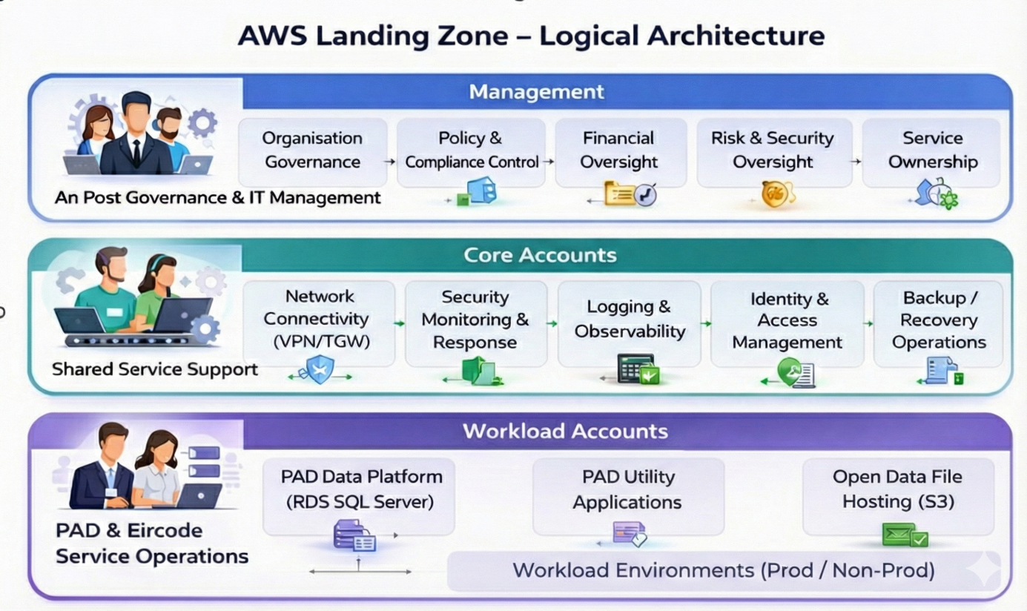

Figure 1 AWS Landing Zone – Multi-account Architecture

Organizational Units

An Organizational Unit (OU) in AWS is a logical container used to group AWS accounts within AWS Organizations and arrange them into a hierarchical structure. This hierarchy enables consistent governance at scale by allowing controls to be applied to whole groups of accounts rather than managing each account individually.

The main purpose of OUs is to simplify management and strengthen governance across the AWS environment by applying shared policies and guardrails to all accounts within a given OU. This is especially effective when combined with Service Control Policies (SCPs), which set the maximum allowable permissions for accounts in the OU providing a clear boundary for what actions are permitted regardless of the permissions assigned inside individual accounts.

The table below summarizes the OUs defined for the Landing Zone solution and identifies which are in scope for the initial Eircode release versus which are planned for potential non-Eircode use cases in future releases.

OU | Layer | Role
Root | Management | The top-level Organisational Unit, primarily containing the AWS Organisations Management account. It serves as the administrative root for the entire multi-account environment, hosting core services that manage and govern the organisation.
Quarantine | Management | Used to park AWS workload and sandbox accounts that are no longer required (e.g., completed PoCs, or orphaned accounts where the owners have left the organization). A strict SCP explicitly denies all access to these accounts except for designated Admin and Security staff, serving as an interim step before permanent account deletion after 90 days. (Note: Individual user identities accounts are managed completely separately and are never placed in this OU).
Security | Core | Dedicated to centralising security services and controls. It houses accounts for security auditing (i.e., Log Archive & Audit) and incident response, ensuring compliance monitoring and unified security posture across the organisation.
Infrastructure | Core | Designed to host shared infrastructure accounts (e.g., Network, Shared Services). This OU contains resources and services that are common dependencies for multiple workloads and are managed centrally, such as Transit Gateways, shared VPCs, or (potentially) directory services.
Sandbox | Workload | Provides a safely managed environment for experimentation. Permissive access is allowed but is strictly governed by billing alarms and budget management to prevent cost overruns.
Workloads | Workload | A logical grouping that serves as a parent container for accounts hosting application and service environments. It provides a hierarchical structure to organise various Sandbox, Test, and Production deployments.
Production | Workload | Contains AWS accounts specifically allocated for live, mission-critical application deployments. This OU is subject to the most stringent security, operational, and change management controls to ensure stability and compliance for Production workloads.
Non-Production | Workload | Houses AWS accounts designated for development, testing, staging, and quality assurance environments. Controls here are typically more relaxed than in Production, allowing for agility in development while still maintaining a secure baseline.

Table 6 AWS Landing Zone – Organizational Units in a Landing Zone

AWS Landing Zone – Core Accounts

The following table describes the primary AWS accounts deployed as part of the Landing Zone solution.

Account / ID | OU | Role
Management /  Acc. Id | Root | This is the primary account of the AWS Organisation and the central point for billing, Service Control Policies (SCPs), and overall management of other AWS accounts. This account hosts the core Landing Zone Accelerator pipeline and automation services (CodePipeline, CodeBuild, Lambda functions) responsible for vending and governing new accounts (via AWS Control Tower’s Account Factory service), as well as managing the organisational structure.
Audit /  Acc. id | Security | A highly restricted, dedicated account for centralising all security and compliance-related logs and resources. This includes consolidating AWS Config recordings, GuardDuty findings, Security Hub aggregates, and other security service outputs from all accounts across the organisation. Access to this account is limited to security and compliance personnel only.  It also integrates with AWS IAM Identity Centre (formerly SSO) for centralised access management.
Log Archive /  Acc. Id | Security | A dedicated account for long-term, immutable storage of all organisational and operational logs. This includes CloudTrail logs, S3 access logs and VPC Flow Logs. Its primary purpose is secure, centralised, and immutable log retention for compliance, auditing, and troubleshooting.
Shared Services /  Acc. Id | Infrastructure | This account centralizes shared IT infrastructure services that are consumed by multiple workloads across the organization. It includes foundational tools such as directory services (AWS Directory Service) and systems management (AWS Systems Manager). Consolidating these resources in a dedicated account prevents duplication of services in workload accounts and enables centralized administration and patching.
Network /  Acc. Id | Infrastructure | Dedicated for centralising network infrastructure that spans multiple accounts across the entire organisation. This includes AWS Transit Gateway (for inter-VPC routing), centralised egress points, and shared DNS services. Consolidating networking here simplifies management and enhances security.

Table 7 AWS Landing Zone – Landing Zone Core Accounts

AWS Services by Landing Zone Account

In the Management the organization-level controls are placed: AWS Organizations administration, account vending/provisioning, baseline guardrails, and centralized policy management, because these functions must govern all accounts and should be tightly controlled with limited access. It’s the “Command centre for the Landing Zone governance”: it defines standards, enforces them consistently, and reduces configuration drift across workloads.
The Core accounts run the shared “runway” services operated by platform teams, such as centralized logging/audit trails, security monitoring and incident response tooling, network/shared connectivity services, and shared CI/CD or tooling where applicable. These are separated into different core accounts to isolate risk and privileges: for example, a dedicated Log Archive account prevents tampering with evidence, while a Security account can monitor everything without granting broad write access elsewhere. A separate Network/Connectivity account (or equivalent) protects routing, shared egress/ingress, and connectivity constructs from application-level changes and reduces blast radius. This separation also supports segregation of duties, clearer operational ownership, and easier auditing, while allowing each core domain to scale and evolve independently without impacting others.

Primary Services in a AWS Landing Zone

The Primary AWS services selected for this Landing Zone are based on the specific requirements of the An Post Eircode service take-on, with PAD as the primary workload. The design will support the secure hosting of the PAD data platform, enable controlled operator access, supported with private network placement, centralized governance, auditability, and a scalable foundation for future Eircode-related services. For this reason, the services listed below were chosen because they provide the most appropriate balance of security, operational control, resilience, and alignment with An Post GPS policies and standards.
The selection also reflects key architectural decisions and trade-offs, including the use of managed AWS services (such as AWS Control Tower, AWS Organizations or AWS Identity Centre) where possible to reduce operational overhead, centralized shared services to avoid duplication across accounts, and strong account-level separation to reduce risk and support governance. The table below therefore describes not only the primary AWS services in the Landing Zone, but also why they are appropriate for An Post, which features are being used, and the trade-offs considered in each case.

Service | Account | Function
AWS Control Tower | Management | AWS Control Tower builds on AWS Organisations to set up and govern a secure, multi-account AWS environment i.e. the Landing Zone, according to best practices.  It automates the setup of the platform’s core accounts (Management, Log Archive and Audit accounts), configures guardrails (both preventative and detective), and provides a dashboard for continuous monitoring and compliance.  Overall, it acts as an orchestration layer for many underlying AWS services.
AWS Organizations | Management | AWS Organizations provides the structure for a governed multi-account Landing Zone by grouping accounts into OUs and enforcing guardrails with SCPs.  It centralizes billing and cost visibility across the estate. It also supports delegated administration so core teams can operate security and compliance services centrally.
AWS Identity Centre (SSO) | Management | AWS Identity Centre is selected as the central mechanism for human access to the An Post AWS Landing Zone, using the native AWS Identity Centre identity store (no corporate directory integration in scope for the initial phase).  Access will be granted through centrally managed permission sets assigned to groups, providing role-based access across Management, Core, and Workload accounts for platform, security, and PAD support users.  MFA will be enforced for interactive access, and the design avoids local IAM users in member accounts while providing a simple, auditable, and extensible access model for the service take-on.
AWS IAM | Management | AWS IAM is used to enforce least-privilege permissions across all accounts in the An Post Landing Zone, supporting the PAD service take-on and future Eircode workloads.  Human access is provided through AWS Identity Centre permission sets mapped to IAM roles (avoiding local IAM users), while IAM service roles are used for AWS service-to-service access and workload execution.  The design includes controlled cross-account role access for platform, security, audit, and PAD support teams, with customer-managed policies used for An Post-specific permissions and AWS-managed policies used only where appropriate. This provides a governed, auditable, and scalable permissions model aligned with An Post security and operational controls.
AWS Service Control Policies (SCPs) | Management | Service Control Policies (SCPs) provide centralized control over the maximum permissions available to accounts within the organization. They are managed from the Management account and applied at the Organizational Unit (OU) level.  In the specific case of the Suspended OU, a strict SCP is enforced that explicitly denies all access to the resources of the accounts placed there, except for designated Administration and Security personnel. This effectively locks down the account and serves as a secure containment measure and an intermediate step before permanently deleting the inactive account after a 90-day period.
AWS GuardDuty | Audit | AWS GuardDuty will be used as the centralized threat detection service for the An Post Landing Zone. It will be managed from the Audit account (delegated administration) and enabled across Management, Core, and Workload accounts to detect suspicious activity using AWS-native telemetry such as CloudTrail, VPC Flow Logs, and DNS logs. This provides a low-overhead, AWS-managed security monitoring capability for PAD and future Eircode workloads.
AWS Security Hub | Audit | AWS Security Hub will be used in the Audit account as the central security posture and findings dashboard for the An Post Landing Zone. It will aggregate and normalize findings across Management, Core, and Workload accounts (including PAD), and will be used to monitor misconfigurations and compliance against selected AWS security standards. This gives the An Post solution a single, governed view of security issues across the multi-account environment.
AWS CloudTrail | Log Archive | AWS CloudTrail will be enabled organization-wide to record API and console activity across the An Post Landing Zone, including Management, Core, and Workload accounts. Logs will be centralized in the Log Archive account to provide a single audit trail for PAD operations, security investigations, compliance reporting, and change tracking.  This supports An Post governance requirements and improves traceability during and after the service take-on.
AWS CloudWatch | Log Archive | AWS CloudWatch will be used to provide operational monitoring and alerting across the An Post Landing Zone, including PAD-related infrastructure. It will collect key metrics, logs, and events to support dashboards, alarms, and troubleshooting, with critical telemetry centralized for consistent operations across accounts.  This gives An Post a standard monitoring capability for day-to-day service support and incident response.
AWS Transit Gateway | Network | AWS Transit Gateway will be used to provide private connectivity between VPCs across multiple AWS accounts in the An Post Landing Zone, including PAD-related environments, through a controlled hub-and-spoke model.  This is required from the outset because PAD and its supporting services are distributed across shared services and workload accounts and need centralized, scalable routing and segmentation.  A Transit Gateway also avoids the complexity of multiple point-to-point VPC peerings.  AWS PrivateLink (which connects VPCs to AWS services such as logging and security via private IPs without traversing the public internet) is not a viable primary approach for the PAD database connectivity. Because Amazon RDS for SQL Server cannot natively integrate with PrivateLink, relying on it would require workarounds that add unnecessary complexity.
AWS Billing and Cost Management | Management | AWS Billing and Cost Management will be used in the An Post Management account to provide consolidated billing, cost allocation, and spend visibility across all Landing Zone accounts supporting PAD and future Eircode workloads. s

Table 8 AWS Landing Zone – Landing Zone Core Services

Multi-account Architecture

Based on the information and requirements provided for the Eircode service take-on, the AWS Landing Zone for An Post is designed as a hierarchical, multi-account environment aligned with AWS best practices for governance, security, networking, and workload isolation. The primary workload in scope is the PAD data solution, which is supported operationally by two data-processing utility applications, but the Landing Zone is designed as a broader foundation for PAD and future Eircode-related services. The diagram below illustrates the proposed multi-account Landing Zone architecture and account hierarchy, including the Organizational Units deployed as part of this engagement.

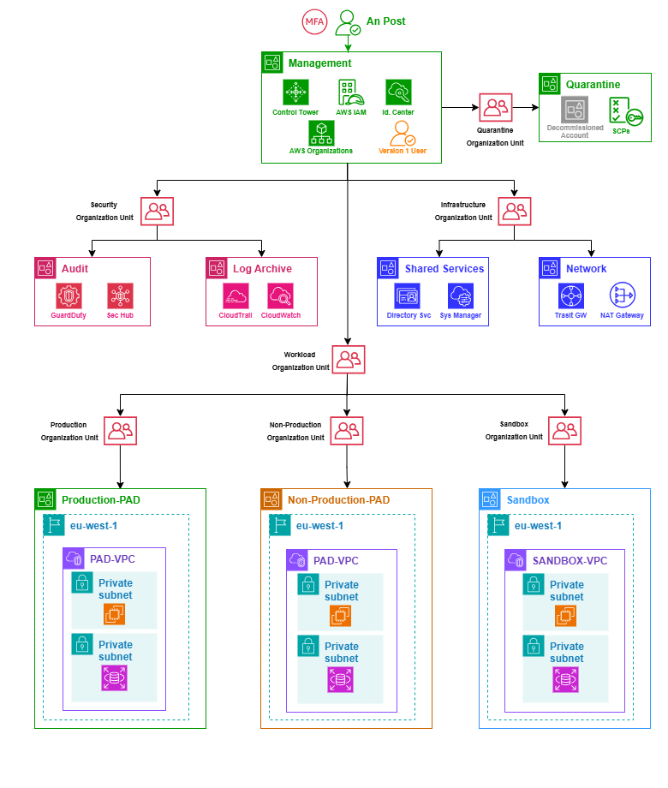
Figure 2 AWS Landing Zone - Account Hierarchy

This architecture diagram illustrates the multi-account AWS Landing Zone for An Post, structured firmly around the Security, Reliability, and Operational Excellence pillars of the AWS Well-Architected Framework. To enforce strict governance and separation of duties, the environment is organized into the following distinct hierarchical layers:

- Management Layer: The top-level Root/Management account acts as the central hub for organizational governance, hosting core services such as AWS Control Tower, AWS Organizations, and AWS IAM Identity Centre. Directly adjacent is the Quarantine OU, which serves as a secure holding area to park inactive or decommissioned workload or sandbox accounts under strict "Deny All" Service Control Policies (SCPs) prior to permanent deletion.

- Core Layer: This layer consolidates shared platform operations to reduce the blast radius and prevent duplication across workloads. It is divided into two primary Organizational Units:
  - Security OU: Houses the dedicated Audit and Log Archive accounts, centralizing immutable audit trails (CloudTrail) and security monitoring (GuardDuty, Security Hub).
  - Infrastructure OU: Contains the Network account for centralized hub-and-spoke routing (Transit Gateway, NAT Gateways) and the Shared Services account for common IT capabilities like Directory Service and Systems Manager.

- Workload Layer: The overarching Workload OU provides a hierarchical boundary for application environments. It securely segregates the core PAD data platform and potential future workloads into dedicated Production, Non-Production, and Sandbox OUs. To minimize the external attack surface, all workload resources reside exclusively within private subnets inside their respective VPCs.

To establish a strong identity foundation and ensure continuous traceability, access is centrally governed via AWS IAM with MFA, while monitoring and logging services like GuardDuty, Security Hub, and CloudTrail are isolated into dedicated Audit and Log Archive accounts to secure incident response data.
Operational Excellence is achieved through this centralized orchestration, utilizing AWS Control Tower and AWS Organizations to manage policies across all separated architectural domains consistently. Also, the design prioritizes Reliability and Defence in Depth by strictly segregating Production and Non-Production workloads into distinct accounts and Organizational Units, which limits the blast radius of any potential failure.
Finally, these application workloads reside exclusively within private subnets inside their respective VPCs, effectively removing direct public internet access and minimizing the overall attack surface.

NETWORKING

Defence-in-Depth Network Layering

As illustrated in the Network Connectivity Diagram below, the Landing Zone enforces a strict hub-and-spoke topology to eliminate direct public internet access from the workload environments. All outbound egress traffic from isolated workload accounts (spokes) will be routed centrally through the Network account (hub) via AWS Transit Gateway.
To fully realize this strong security posture, the centralized Network account utilizes the following defence-in-depth layering:
- AWS Network Firewall: Before reaching the public internet, traffic is forced through the firewall subnet for stateful packet inspection and strict domain whitelisting (e.g., restricting outbound calls to GitHub).
- Centralized NAT Gateways: Traffic then exits via NAT Gateways located exclusively in the public subnets, translating private IPs to public IPs while acting as a one-way valve that blocks all unsolicited inbound connections.
- Centralized Observability: Full auditability of network traversals is achieved by aggregating VPC Flow Logs and Transit Gateway logs centrally, ensuring all network flows are recorded for security analysis.

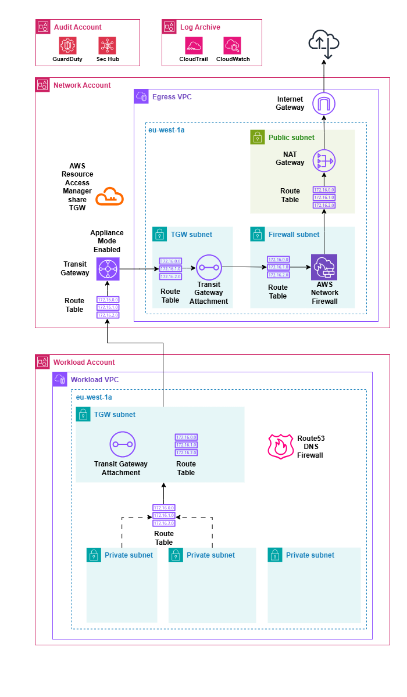
Figure 3 AWS Landing Zone - Network Connectivity Diagram

Deployment approach

Landing Zone Accelerator (LZA)

The AWS Landing Zone Accelerator (LZA) is an open-source solution designed to automate the rapid deployment of a secure, scalable, and compliant multi-account AWS environment.
By extending the foundational capabilities of AWS Control Tower, the LZA provides enhanced customisation across security controls, network topology, centralised logging, auditing, and automated account provisioning. Built upon AWS best practices and aligning with various global compliance frameworks, LZA operates entirely through Infrastructure as Code (IaC) templates. This approach eliminates the risk of human error inherent in manual console configurations, ensuring a secure, standardized, and highly predictable environment. Because the PAD scope and An Post governance requirements are already defined, leveraging these established IaC templates is expected to compress what typically requires four to six weeks of bespoke setup and validation into a deployment of just a few days. Furthermore, managing the foundation as code significantly simplifies future changes; updates to networking or security baselines can be version-controlled, audited, and rolled out programmatically without disrupting ongoing operations.
Beyond the initial implementation, the long-term benefits are equally important. Because the environment is defined and managed as code, ongoing support and operations become more consistent, easier to troubleshoot, and less dependent on manual configuration knowledge. It also simplifies future changes, onboarding of new AWS accounts, and policy updates, while improving auditability and reducing configuration drift over time. This will enable An Post to accelerate cloud adoption while maintaining a strong governance and security posture throughout the lifecycle of the platform.

Landing Zone Accelerator – Config Files

At the heart of the AWS Landing Zone Accelerator solution are six YAML configuration files: accounts-config.yaml, global-config.yaml, iam-config.yaml, network-config.yaml, organisation-config.yaml, and security-config.yaml. These declarative files serve as the primary interface for An Post to define and customise the desired multi-account AWS environment.Therefore, the solution warrants a dedicated GitHub repository to version control these configuration files. The table below captures the GitHub repo and link to same.

Repo Name | GitHub Link
ap_aws_landing_zone_configuration | TBC

Table 9 AWS Landing Zone – Repository Name

Landing Zone Accelerator – Deployment

The diagram below illustrates a high-level overview of how the An Post managed Landing Zone Configuration repository relates to the AWS components that comprise the Landing Zone solution.
- CI/CD Pipeline Integration: The Landing Zone Accelerator deploys a native AWS CodePipeline within the central Management Account. An AWS CodeStar connection will securely bridge the dedicated GitHub repository to this pipeline, ensuring a fully automated deployment mechanism.
- Code Governance & Validation: The GitHub repository will enforce strict Branch Protection Rules. Any modifications to core files (e.g., network-config.yaml or security-config.yaml) will require a Pull Request (PR) with mandatory peer reviews and approvals from a Principal Architect. Additionally, the LZA pipeline natively includes an automated validation stage to lint and check YAML syntax prior to provisioning infrastructure, ensuring erroneous code is caught before impacting the live environment.

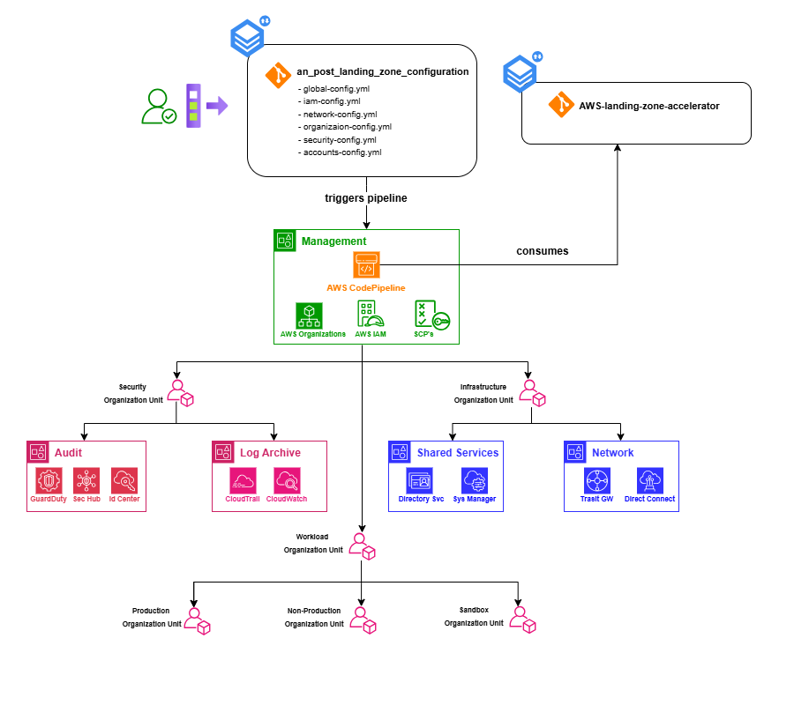
Figure 4 AWS Landing Zone – Landing Zone Accelerator Deployment

Security

IAM Identity Centre

IAM Identity Centre (formerly AWS Single Sign-On) will be leveraged to provide a streamlined and secure method for managing access across the multi-account AWS environment.
- The Landing Zone Accelerator creates an IAM Identity Centre instance in the AWS Management account. This service facilitates Single-Sign On for all AWS users which is especially pertinent when working in a multi-account structure. The introduction of this service negates the need to create and manage separate IAM users in each individual account, significantly reducing administrative overhead.
- It facilitates a seamless Single Sign-On experience for all AWS users. Users log in once to a central user portal with their credentials and can then securely access all assigned AWS accounts and roles without re-authenticating.
- When new users are created an invitation process guides them through password setup and mandatory Multi-Factor Authentication (MFA) configuration. This ensures a standardised, secure, and automated onboarding experience. Conversely, centralised management simplifies rapid offboarding and access revocation.
- Access to AWS accounts is managed through Permission Sets. These define specific AWS IAM policies and permissions (e.g., Administrator Access, Read-Only, Developer Access) that are then assigned to users or groups. IAM Identity Centre automatically provisions and manages corresponding IAM roles in each target AWS account, ensuring consistent application of the principle of least privilege across your organisation.
- The management of new identities, existing identities and associated permissions is all managed under IAM Identity Centre console.

For the initial Landing Zone implementation, AWS IAM Identity Centre will be configured to provide Single Sign-On (SSO) capabilities across member accounts within the AWS Organisation, with users managed directly within Identity Centre's own directory. The primary purpose at this stage is to centralise and streamline administrative access specifically for internal An Post personnel, allowing them to securely log into segregated accounts (such as Cost Management, Networking, or Log Archive) based on their operational roles.
While this baseline configuration does not currently include integration with external Identity Providers (IdP), the recommended future state involves integrating a third-party IdP using SCIM (System for Cross-domain Identity Management). This will automate onboarding and ensure that revoking corporate access automatically revokes AWS access. Furthermore, direct AWS Console access via this SSO directory is intended strictly for internal governance and infrastructure management. Access requirements for third-party developers (e.g., Autoaddress) will be evaluated separately and are expected to be facilitated through alternative remote access solutions such as Virtual Desktop Infrastructure (e.g., AWS WorkSpaces) or AWS Systems Manager Session Manager, rather than granting direct AWS Console access.

SSO Login Page
The table below captures the SSO login page for accessing the various AWS accounts deployed as part of the Landing Zone.

Description | Link
An Post AWS LZ SSO Landing Page | https://<TBC>
Table 10 AWS Landing Zone – SSO Landing Page

Root Identities
When a new AWS account is created, whether it's a standalone account or part of an AWS Organization, a unique Federated SSO Identity tied to an email address is a mandatory requirement to complete the process. For An Post’s AWS Landing Zone, all of the core Platform AWS accounts will leverage the "plus addressing" feature of the Management account's email address.
This strategy ensures that the root user email for every core Platform AWS account adheres to a consistent and easily identifiable naming convention:
<management_account_email>+<AWS_Account Name>@anpost.ie. For example, since the Management account's email is <TBC>@anpost.ie, the root user email associated with the Landing Zone’s Network account is <TBC>+network@anpost.ie.
Similarly, the root user email associated with the Log Archive AWS account is <TBC>+logarchive@anpost.ie.
This method offers several benefits for managing a multi-account AWS environment:
- All root user emails for various accounts route to a single, controlled inbox associated with the Management account. This simplifies monitoring and significantly reduces the administrative overhead of managing separate mailboxes for each account.
- By centralizing email reception, it becomes easier to secure the primary email inbox, thereby safeguarding the recovery mechanism for all root users across the organization. This reduces the attack surface compared to scattering root user emails across multiple, potentially less secure, individual mailboxes.
- In the event of a lost root user password or compromised credentials for any member account, the password reset emails are delivered to the designated Management account inbox, facilitating a quicker and more controlled recovery process.
- Having a consistent and predictable naming pattern for root user emails aids in auditing and tracking account ownership and communication.

For all workload AWS accounts deployed to the Landing Zone, a new Shared mailbox will be generated to mitigate against any security compromises relating to the Shared mailbox configured on the Platform level AWS accounts i.e. apaws@anpost.ie, providing a layer of demarcation between workload and Platform level AWS accounts.

For AWS accounts deployed via the Platform config repository e.g. Network account, Audit account:
- Access to the Audit and Log Archive accounts is strictly governed via IAM Identity Centre (SSO). Security Operations staff will access these environments exclusively through federated SSO roles (e.g., SecurityAuditor, LogViewer). The use of local root logins for operational access is strictly prohibited, ensuring full traceability and least-privilege compliance.

AWS Account | Federated SSO Identity | SSO Identity
Management | apaws@anpost.ie | apaws@anpost.ie
Audit | apaws+audit@anpost.ie | Federated SSO Roles (Security Team)
Log Archive | apaws+logarchive@anpost.ie | Federated SSO Roles (Audit/Security Team)
Network | apaws+networking@anpost.ie | apaws+networking@anpost.ie
Shared S. | apaws+ss@anpost.ie | apaws+ss@anpost.ie

Table 11 AWS Landing Zone – Root User Identities

Cost Management

Consolidated Billing
The consolidated billing feature in AWS Organisations consolidates billing and payment for multiple AWS accounts. The AWS Management account is responsible for paying the charges of all member accounts.

Tagging Strategy
A comprehensive Tagging Policy will be enforced from Day 1 via Service Control Policies (SCPs). No infrastructure can be provisioned unless it contains mandatory tags (e.g., CostCentre, Environment, Owner). These will be activated as Cost Allocation Tags in the Billing console to enable granular FinOps reporting.

Proactive FinOps and Guardrails
To proactively manage cloud spend, AWS Budgets will be deployed to alert the Eircode management team if forecasted spend exceeds monthly allocations. Additionally, AWS Cost Anomaly Detection will be enabled to instantly flag irregular spikes in spend via machine learning.

Phase 1 - Landing Zone Cost Drivers
During the initial phase of deploying the AWS Landing Zone, the core orchestration services (AWS Control Tower, AWS Organizations, and AWS IAM Identity Centre) are completely free. However, the foundational security baselines and logging mechanisms they provision will start generating charges from day one, even without any business applications running.

For Phase 1, the primary cost drivers fall exclusively under Centralized Governance and Security:

- Governance: AWS Config and CloudTrail log every configuration change and API call across your accounts, storing this data in your Log Archive account (using Amazon S3).
- Security: Services like Amazon GuardDuty and AWS Security Hub constantly analyse these logs and assess compliance against best practices.

Additionally, because the environment is deployed using the Landing Zone Accelerator (LZA) on AWS, the architecture relies on a CI/CD pipeline. This introduces a nominal but persistent cost in the Management account for AWS CodePipeline, AWS CodeBuild compute minutes, and AWS KMS keys used to encrypt pipeline artifacts. While highly cost-effective, these orchestration services form part of the fixed baseline.

Cost optimization for the networking phase will focus on utilizing VPC Gateway Endpoints for S3 traffic to minimize NAT Gateway data processing fees, rather than removing the central routing components.

The following table outlines the estimated daily baseline costs for running this foundational architecture including the mandatory Hub-and-Spoke networking and inspection components in an idle state, prior to any workload migration.

ESTIMATED DAILY BASELINE COSTS (PHASE 1 / IDLE ENVIRONMENT)
Organizational Unit | AWS Service | Cost Driver & Rationale | Estimated Daily Cost
Management & Governance  (Root & Log Archive Accounts) | Control Tower, Organizations, IAM Identity Centre | Core management and central identity services are provided at no additional charge. | $0.00
 | CI/CD Deployment Engine (LZA) | Orchestration costs for AWS CodePipeline, CodeBuild compute minutes, and AWS KMS keys used for pipeline artifact encryption. | ~$0.10 – $0.15
 | AWS Config | Powers detective guardrails. Charges are based on the number of configuration changes recorded and rules evaluated. | ~$1.50 – $2.00
 | CloudTrail & Amazon S3 | Storage and event processing for organizational-level trails sent to the Log Archive account. | ~$0.50
Security OU  (Audit Account) | Amazon GuardDuty | Continuous analysis of baseline network and CloudTrail events across the organization. | ~$0.50 – $1.00
 | AWS Security Hub | Execution of foundational security best practice checks. | ~$0.50 – $1.00
Infrastructure OU  (Shared Services & Network) | AWS Systems Manager | Core inventory and session management features are included at no cost. | $0.00
 | Core Network & Identity Services  (Transit Gateway, NAT Gateways, AWS Network Firewall, Directory Service) | Standing hourly charges for secure hub-and-spoke networking, egress inspection, and centralized identity management. Implemented from Day 1 to ensure full alignment with WAF Security pillars. | ~$15.00 – $18.00
Total Estimations | Daily Baseline | Expected daily cost for the foundational Landing Zone running in an idle state. | ~$18.10 – $22.65
 | Monthly Baseline | Projected 30-day cost based on the daily estimates above. | **~$543.00 – $679.50**

Table 12 AWS Landing Zone – Landing Zone Cost Drivers

For more information,
please visit version1.com

