

PAD Environment Design

Requirements Evaluation

Document Control
Version History
Prepared by | Daniel Robledo Munoz
Date Created | 19 March 2026
Last updated | 10 April 2026
Version | 0.01
Document Classification | Draft

Version | Date Released | Contributor(s) | Reviewers | Description
0.01 | 10 April 2026 |  |  | Initial Draft

Table 1 PAD Environment Design– Version Control

Document Approval
Approved by | Position | Date

Contents
Contents iii
Objective 6
Working Status 6
RDS High-level Requirements 6
Accessing PAD Environment High-level Requirements 11
PAD Deployment Environment 15
Data Processing App (Long-Running DB Processes) 17
Internet Secured Access 20
DEV-RDS INSTANCE AND DISASTER RECOVERY 22
REQUIREMENTS STATUS FOR RDS AND ACCESSING PAD ENVIRONMENT 24
Remote Access using a VDI-Centric Security Model 30
VDI Approach advantages 30
Architecture Highlights 31
Strict Separation of Concerns (AWS Accounts) 31

References

# | Title | Description | Owner
1 | An Post – AWS Landing Zone | High Level Design of the Landing Zone for the PAD project for An Post which contains the PAD Environment Design. | Version 1
2 | Autoaddress-PAD-Requirements | Understanding of the RDS SQL Server instance requirements | Version 1
3 | AWS PAD DB Q&A | Minutes of the Autoaddress meeting presenting their implementation solution for the RDS instance. | Version 1
4 | PAD Hosting Queries_PAD_CapitaIT Update_190126 | Document containing technical questions for Capita about the implementation of the RDS instance. | Version 1
5 | An Post GTS Security requirements | This document outlines a comprehensive cybersecurity framework covering identity, network, and data security. It also establishes guidelines for governance, compliance, monitoring, and security testing to ensure organizational resilience | An Post
6 | Best Practices for Deploying Amazon WorkSpaces | White Paper guide for deploying Amazon WorkSpaces.  Best Practices for Deploying WorkSpaces - AWS Whitepaper | AWS

Table 2 PAD Environment Design– References

Glossary

# | Term | Definition
1 | ECAF | Eircode Address File. A data product produced by Eircode containing all Irish postal addresses including their Eircodes.
2 | ECAF+ | The original Eircode product specification extended to include geo-spatial co-ordinates for each postal address.
3 | ECAD | Eircode Address Database.
4 | ODD | Open Data Directive
5 | PMLH | The Postcode Management Licence Holder. The responsible organisation for the management of the national Eircode service as appointed by DCCS.  Currently transitioning from CAPITA to An Post.
6 | PAD | Postcode Address Database used to manage national postal addresses.
7 | Interactive App | Custom .Net rich client application used by the PAD team to manage Eircode address processing.
8 | Data App | Custom .Net rich client application used by the PAD team to conduct Eircode DB activities relating to Eircode address processing.

Table 3 PAD Environment Design– Glossary

Objective
This document describes the AWS environment to support the operation of the Postcode Address Database (PAD) solution which consists of applications, scripts and databases used for the and management of national postcodes.
The PAD solution exists and is operated on another supplier’s AWS organisation but will need to be migrated for operation in January 2027.
The AWS PAD environment is driven by the need to enable the PAD application team to continue to run the PAD solution against its service needs.

Working Status

PAD HLD is under development and of draft status.
- Autoaddress PAD operational requirements
- An Post IT, data and cyber policies
- AWS best practices & latest innovations
- An Post’s broader / long term cloud strategies including AWS

RDS High-level Requirements

# | Requirement | Description | Proposed Solution | Requirement Source
1 | RDS SQL Server 2022 Deployment & Storage | Deploy an Amazon RDS SQL Server 2022 instance (~2TB) that is privately accessible only to the Autoaddress PAD team, strictly isolated from the public internet.  Additionally, provide secure and highly durable object storage to retain all PAD application file outputs. | Provision an RDS instance with sufficient gp3 storage (e.g., 2TB+) within a private subnet. Enable AWS KMS encryption at rest upon creation to ensure secure, isolated hosting.  Furthermore, a dedicated Amazon S3 bucket will be provisioned to securely store PAD file outputs. To maintain strict isolation, this bucket will be accessed exclusively through a private S3 VPC Gateway Endpoint, ensuring data never traverses the public internet. | Autoaddress-PAD-Requirements
2 | RDS Migration via Snapshot & Upgrade | The deployment involves migrating from a Capita account using an AWS RDS snapshot (2019 version) and performing an in-place upgrade to SQL Server 2022 directly within AWS. | Securely transfer the snapshot from the Capita account to the new account, restore it, and grant DBAs permissions to execute the database engine upgrade directly on the restored instance. | Autoaddress-PAD-Requirements
3 | High Availability & Disaster Recovery | Deploy SQL Server RDS Instance across at least two availability zones (primary/standby) to meet a 24-hour RPO/RTO SLA, with the ability for the operations team to perform annual failover testing. | Utilize Amazon RDS Multi-AZ with synchronous replication. Establish runbooks for manual failover testing outside critical windows and ensure DBA console access to guarantee the 24-hour SLA. | Autoaddress-PAD-Requirements
4 | Backup, S3 Export & Retention Strategy | Implement automated nightly RDS backups (30-day retention), enable manual backups/point-in-time recovery, and export backups and snapshots to a self-managed S3 bucket. | Configure AWS Backup policies for daily backups and point-in-time recovery. Provision a secure S3 bucket and use export tasks to route snapshots securely. | Autoaddress-PAD-Requirements
5 | SSMS User authentication | PAD DBAs need to authenticate to SSMS to make architectural and setting changes. | Configure RDS to support SQL Server Authentication. DBAs will connect via SSMS using the System Admin (sa) master account, fulfilling their requirement to be the sole Database Owners (dbo). | Autoaddress-PAD-Requirements
6 | Interactive DB Authentication | The Interactive App requires to authenticate to RDS SQL Server DBs without credential pass-through. | The Interactive App will use SQL Server Authentication via a generic Read Write User. Individual "interactive users" will be managed internally via a user table and membership provider within the database itself, not via AWS Managed AD. | Autoaddress-PAD-Requirements
7 | Application DB Authentication from EC2 instance. | The Data App needs to authenticate to RDS SQL Server DBs using the Read Write User. | The EC2 instance hosting the Data App uses an IAM Role to access AWS Secrets Manager. Secrets Manager will securely store and retrieve the SQL Server Authentication credentials (Read Write User / Read Only User) used by the app to connect. | Autoaddress-PAD-Requirements
8 | Dedicated RDS-Dev Environment | Maintain a separate, non-production duplicate RDS instance for development and QA testing, strictly isolated in a different VPC. | Arranging a distinct Dev-VPC to host the non-production RDS instance, drastically reducing the "blast radius" so dev issues or misconfigurations cannot impact Production. The database will be periodically repopulated using older production snapshots. | Autoaddress-PAD-Requirements
9 | Identity, Access Management & DBA Autonomy | Establish a centralized identity framework to control access via IAM/RBAC for the initial 8 developers (assigned to general or superuser roles), while keeping database-level authentication strictly separated. DBAs require autonomous AWS Console access for infrastructure management without compromising the native SQL database ownership. | Deploying AWS IAM Identity Centre (SSO) backed by AWS Directory Service to govern all workforce access to the AWS environment. For DBA tasks, specific IAM Permission Sets can be configured to allow RDS and S3 management. Concurrently, database internal access would be handled exclusively via native SQL Server authentication (Master User) to maintain strict DBO demarcation. | Autoaddress-PAD-Requirements
10 | SLA Demarcation & DBO Ownership | Support the AA service agreements ensuring Autoaddress are the sole Database Owners (dbo) and defining clear SLA boundaries for "Service Unavailability". | Autoaddress retains sole dbo control via the sa account and internal user tables. As a result, any application unavailability caused by database misconfigurations, internal authentication failures, failed DBA architectural changes, or OS/Application-level misconfigurations and resource exhaustion caused by Autoaddress users within the EC2 instances, internal authentication failures, or failed DBA architectural changes falls outside An Post's infrastructure control and will count against Autoaddress' 99.9% Availability Target.
11 | SLA Protection & Maintenance Windows | Maintenance windows must be mutually agreed upon in writing at least a few business days in advance to prevent masking operational downtime. Emergency maintenance must be strictly for unforeseen critical issues.  Furthermore, failures originating from Autoaddress’ internal infrastructure, facilities, or their contracted third-party services (e.g., local ISP, power) are not valid SLA exclusions. | Explicitly define in the SLA that time spent resolving active outages, or emergency maintenance resulting from deferred routine upkeep, shall be classified as downtime. Outage recovery time cannot be reclassified as 'Emergency Maintenance'.  Additionally, stipulate that Autoaddress remains fully accountable for their own operational dependencies, and any resulting unavailability will count against their SLA target. | SLA Agreement
12 | Availability | The PAD Environment Availability needs to match or exceed the PAD Application availability of 99.9%. PAD application availability exclusions are:  - Scheduled maintenance notified in advance.  - Emergency maintenance.  - Events outside the control of Autoaddress; | To support the 99.9% business availability target for the PAD application (which permits a maximum of 43.8 minutes of unplanned downtime per month at the user level), the environment will rely on the HA of AWS services supported with centralized monitoring tools defined in the architecture.  While the overarching end-user availability target is set at 99.9%, the underlying AWS infrastructure components are designed and monitored against their specific, higher-tier native Service Level Agreements (SLAs). Availability will be continuously measured using Amazon CloudWatch and RDS Enhanced Monitoring across the following primary tiers:  - Tier 1: Amazon WorkSpaces, targeting 99.9% native availability.  - Tier 2: Multi-AZ Amazon RDS deployments, targeting 99.95% native availability.  - Tier 3: Authentication Services (including SAML/IdP integrations and Directory Services), monitored against their respective provider SLAs.  - Tier 4: Amazon EC2 instances hosting the application servers, targeting 99.99% native availability.  Note: Other supporting infrastructure components, such as Amazon S3, Transit Gateways, and Network Firewalls, will similarly be governed by and monitored against their respective native AWS SLAs (e.g., 99.9% availability for S3 Standard).  Specifically, the monitoring stack will track standard EC2 Instance Status Checks, alongside RDS connectivity and system uptime metrics. These metrics will trigger automated CloudWatch Alarms upon failure or deviation from their respective component SLAs, providing an unambiguous, data-driven record to validate overall SLA compliance against the agreed exclusions.  Furthermore, disaster recovery metrics are explicitly bound to the agreed 24-hour RTO (Recovery Time Objective) and RPO (Recovery Point Objective).

Table 4 PAD Environment Design– RDS High-Level Requirements

Accessing PAD Environment High-level Requirements

# | Requirement | Description | Proposed Solution | Requirement Source
1 | Application Hosting & Internal Connectivity | Host two .NET apps (Interactive App and Data processing App) and providing secure access to these two applications. | To establish a highly secure and sealed environment, Virtual Desktop Infrastructure (VDI) workstations, pre-installed with SSMS, will be provisioned in a dedicated private subnet. From these isolated VDIs, developers will securely connect via RDP (TCP port 3389) to the EC2 instances hosting the Interactive and Data Processing applications, which are in a separate private subnet. Finally, strict Security Groups and internal routing will be configured to ensure that the Amazon RDS instance (hosted in a third, distinct private subnet) can only be accessed via TCP port 1433 from these explicitly authorized internal resources. | Autoaddress PAD Requirements
2 | Outbound Connectivity, Web Browsing & Continuous Updates | Apps and developers need outbound internet to fetch continuous updates (from external private repository), reach OSI/SharePoint, and dynamically research sites (data.gov, ) without strict whitelist blocking. | Arranging a Centralized Egress Architecture using Route 53 DNS Firewall to block malware and AWS Network Firewall inside an Inspection VPC for Layer 7 deep packet inspection. This allows dynamic, secure HTTPS research and explicit SSH port 22 access to GitHub before traffic exits via NAT Gateway and AWS Internet Gateway.
3 | Secure Remote & Developer Access | Provide secure remote access to the infrastructure and a way for developers to connect local IDEs (like Visual Studio) to the database environments. | Deploy isolated Amazon Workspaces (VDIs) equipped with local tools within private subnets. This cost-effective solution ensures data never leaves AWS.  Local IDEs (like Visual Studio) will be restricted to safely querying the non-production (DEV) RDS database only, protected by strict Security Groups.
4 | Long-Running Batch Tasks & Shared Monitoring | Support unattended intensive tasks running on the Data app such as long running DB re-builds without the underling environment session expiry. E.g. if using VDI "AutoStop" killing processes.  Also supporting the need for team members to status check running jobs. | Restricting Data Processing App access to privileged users via a secondary AD group: EC2_Batch_Admins. Authorized users will RDP into a dedicated, "Always-On" EC2 instance to execute and monitor shared batch jobs.  To ensure process continuity, OS-level patching for this specific EC2 instance should be explicitly coordinated during mutually agreed maintenance windows to prevent disruptive automated reboots.
5 | Programmatic & CLI Access | Provide secure programmatic access for background tasks, ensuring that long-term static credentials are not exposed or utilized within the developer environments. | The recommended approach is to separate programmatic access methods. Background application servers (EC2) would be assigned IAM Instance Profiles. Meanwhile, developers operating from their VDIs would be required to authenticate to the AWS CLI through IAM Identity Centre (SSO) to obtain temporary session tokens, thereby eliminating the need to generate or distribute static access keys.
6 | Identity, Access Management & DBA Autonomy | Establish a centralized identity framework using Active Directory groups to control access specifically to the Amazon WorkSpaces (VDIs) and the shared Data Processing EC2 instance for the initial 8 developers.  Meanwhile, database-level authentication will remain strictly separated.  DBAs require autonomous AWS Console access (via specific IAM roles) strictly for routine database administration tasks, such as managing backups, monitoring RDS performance, and executing daily maintenance scripts, without compromising the native SQL database ownership. | Deploying AWS IAM Identity Centre (SSO) backed by AWS Directory Service to govern all workforce access to the AWS environment.  To ensure maximum security and provide a modern, centralized authentication experience, access will require a mandatory Multi-Factor Authentication (MFA) layer natively integrated via SAML 2.0. AWS IAM Identity Centre and Directory Service will federate authentication directly to the corporate Identity Provider (IdP). Users will complete their MFA challenge via the IdP's web flow before the VDI session is granted.  For DBA tasks, specific IAM Permission Sets can be configured to allow RDS and S3 management. Concurrently, database internal access would be handled exclusively via native SQL Server authentication. | Autoaddress-PAD-Requirements
7 | Support Workflow Integration & Copy-Paste Functionality | Service Desk operators require the ability to copy and paste text (e.g., error codes, address IDs) bidirectionally between their local desktops (CRMs, emails) and the VDI environment to maintain operational agility and meet strict SLA response times. However, strict Data Loss Prevention (DLP) must be maintained to prevent the extraction of files or database dumps. | Enable bidirectional Clipboard Redirection (for text only) within the AWS WorkSpaces configuration via Group Policy Objects (GPO) or AWS directory policies. Concurrently, strictly disable Client Drive Redirection and file transfer capabilities. This ensures that while text can flow for support tasks, files and mass data cannot be moved across the environment boundary. | Autoaddress-PAD-Requirements

Table 5 PAD Environment Design– Accessing PAD Environment High-Level Requirements

PAD Deployment Environment
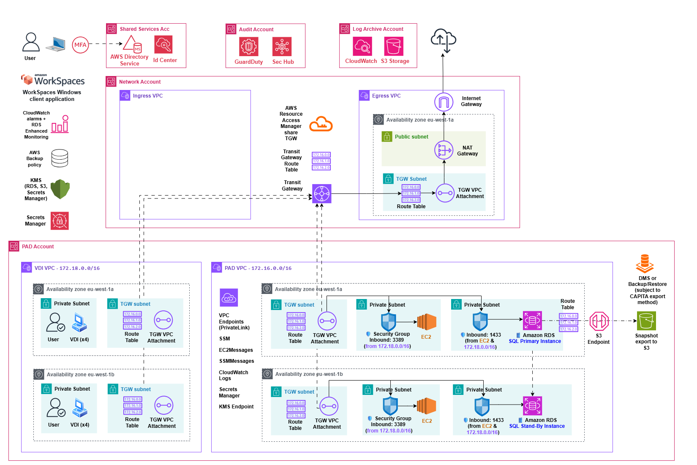
Figure 1 PAD Environment Design– PAD Deployment Environment

The High-Level Design (HLD) illustrates a secure, multi-account AWS Landing Zone centred around a Virtual Desktop Infrastructure (VDI) to give eight developers a highly isolated environment. From these VDIs, developers can use local tools like SSMS to manage backend databases, access the Interactive App, and establish secure RDP sessions to a dedicated, shared EC2 instance where the Data Processing App is hosted.
This architecture utilizes multiple specialized AWS accounts to enforce a strict separation of concerns, ensuring high availability, centralized network governance, and robust enterprise-grade security.
Central to this is the PAD AWS Account, which contains the PAD VPC. To provide true fault tolerance and disaster recovery capabilities, the infrastructure is perfectly balanced across two separate Availability Zones (eu-west-1a and eu-west-1b).
To enforce strict network segregation, the architecture utilizes two distinct VPCs within the PAD Account. As explicitly recommended by the AWS whitepaper 'Best Practices for Deploying Amazon WorkSpaces', the architecture isolates end-user compute resources from backend data processing. A dedicated WorkSpaces VPC (VDI-VPC) spans two Availability Zones, hosting four developer VDIs (pre-installed with the Interactive App and SSMS) in the first zone and the remaining four in the second. Completely separated from end-user compute, the PAD VPC houses the backend infrastructure across the same two zones: a dedicated EC2 instance hosting the Data Processing application, the Primary Amazon RDS SQL Server instance, and the synchronously replicated Standby RDS database ready for instant failover.
A critical detail in this environment is the strict internal traffic flow governed by dedicated Security Groups, which act as virtual firewalls at the instance level. Developers will use the isolated VDI machines as a secure entry point.
Because the VDIs and the backend servers reside in different VPCs, all internal cross-environment traffic is intelligently routed through the central AWS Transit Gateway. From their isolated WorkSpaces, developers connect to the application EC2 instances strictly via RDP over inbound TCP port 3389. Subsequently, both the VDIs (equipped with the Interactive App and SQL Server Management Studio) and the EC2 Data Processing application will securely query the database tier via inbound TCP port 1433. Security Groups on the PAD VPC resources are strictly configured to accept this inbound traffic exclusively from the WorkSpaces VPC CIDR block and authorized internal subnets, keeping all compute and database resources completely shielded from the public internet.
To support the dual nature of the PAD team's workflow, the Amazon RDS Security Group must securely accept incoming connections on TCP port 1433 from two distinct internal sources. First, access is granted to the internal EC2 subnets, allowing the hosted .NET applications (Interactive and Data Processing Apps) to read and write operational data automatically. Second, access is explicitly granted to the isolated WorkSpaces VPC (172.18.0.0/16). This direct VDI connection is essential for the Database Administrators (DBAs), enabling them to perform manual administrative tasks, ad-hoc queries, and architectural changes securely using SQL Server Management Studio (SSMS) without exposing the database to the internet.
Because these internal subnets lack direct internet routes, the architecture relies on highly secure, private data paths. Operations like Database Migration Service (DMS) tasks, data exports, and snapshot backups will be routed securely through a dedicated S3 VPC Gateway Endpoint directly to an external S3 bucket. Additionally, the PAD VPC will utilize AWS PrivateLink via Interface VPC Endpoints to allow the VDIs and EC2 instances to communicate natively with essential AWS managed services—such as Systems Manager (SSM, EC2Messages, SSMMessages), CloudWatch Logs, Secrets Manager, and the Key Management Service (KMS), without their traffic ever traversing the public internet.
Network connectivity and external traffic flow will be manage centrally within the Network Account using a hub-and-spoke topology built around an AWS Transit Gateway. This central router will be shared seamlessly across the organization using the AWS Resource Access Manager (RAM). To attach the PAD VPC to this hub, the design will employ dedicated "TGW subnets" in each Availability Zone. These tiny, specialized subnets will house the TGW VPC Attachments and utilize specific Route Tables to elegantly direct outbound traffic from the private compute resources up to the central hub.
Once traffic reaches the central Transit Gateway, it will be evaluated by the Transit Gateway Route Table. When the isolated VDIs or EC2 instances will require outbound internet access (such as downloading software updates or syncing code) the central TGW will route this traffic down into the Egress VPC. Upon entering the Egress VPC, the traffic will land in another dedicated TGW Subnet with its own Route Table. It will be then forwarded to a NAT Gateway located in the public subnet and finally will reach the outside world securely via an Internet Gateway. On the other hand, the Ingress VPC within this account will remain entirely empty, emphasizing that the architecture relies exclusively on secure VDI access rather than vulnerable traditional Client VPN entry points.
Developers will access this environment via Amazon WorkSpaces using their standard AD credentials.
For maximum security, a mandatory MFA layer via SAML 2.0 will be utilized. When users initiate a connection through the WorkSpaces client, users will be securely redirected to An Post Entra ID Identity Provider (IdP) to complete their primary login and MFA challenge (e.g., TOTP or push-notification). Once successfully authenticated by the IdP, the secure SAML assertion is passed to AWS, and the VDI session spins up seamlessly.
This application establishes a highly optimized, encrypted streaming protocol connection into the AWS infrastructure, ensuring low-latency rendering and seamless integration with centralized identity services while keeping the underlying network topology completely hidden from the end user.
Authentication, governance, and auditing will be handled by several specialized supporting accounts that wrap around the core infrastructure. The Shared Services Account will house the AWS Directory Service and IAM Identity Centre to seamlessly authenticate the developers and manage Role-Based Access Control inside AWS Console to manage RDS Instance access internally.
The Audit Account will continuously monitor the entire environment for vulnerabilities and threats using Amazon GuardDuty and AWS Security Hub. Simultaneously, the Log Archive Account will act as an immutable vault, centralizing all system logs via CloudWatch and S3 Storage to guarantee a tamper-proof record of operational activities.
Finally, the entire workload will be supported by global configurations, including centralized AWS Backup policies, KMS for encrypting data in transit and at rest, and Secrets Manager for automated, secure credential handling.

Data Processing App (Long-Running DB Processes)

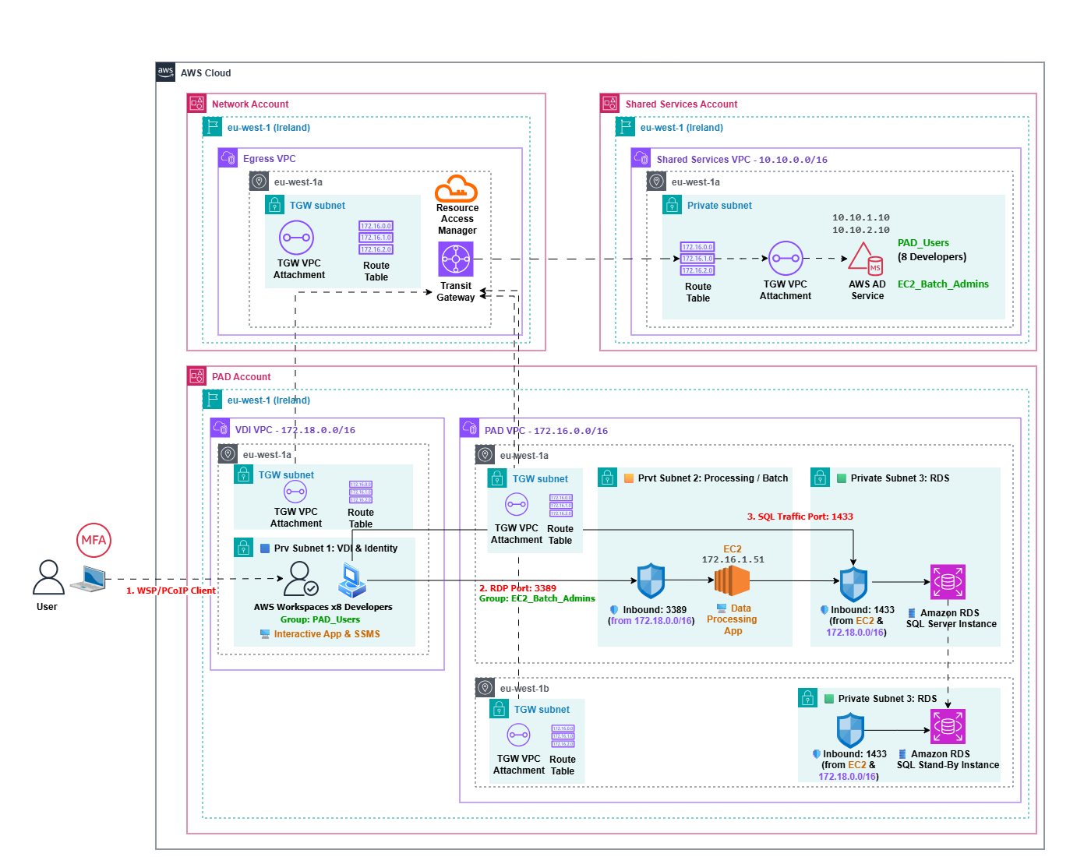
Figure 2 PAD Environment Design– Data Processing App

AWS Architecture Legend
Component / Service | Diagram Label | Architectural Function
AWS WorkSpaces | Developer VDIs (x8) | Personal virtual desktops for daily interactive tasks. Not used for executing long-running batch processes.
Amazon EC2 | Data Processing App | Windows Server 2022 instance.  The Data Processing App will be in “Always on” mode dedicated to running the heavy, long-hour legacy batch processes.
Managed Microsoft AD | AWS AD Service | Creates two user groups: PAD_Users (8 Devs) and EC2_Batch_Admins for RDP access into the Data Processing App.
Amazon RDS / SQL | Target RDS Instance (25 DBs) | Hosts the databases being queried, processed, or migrated by the Batch Server.
Security Groups | SG-RDP-Batch / SG-SQL | Virtual firewalls. Restrict inbound RDP (Port 3389) exclusively to WorkSpaces, and SQL traffic (Port 1433) exclusively from the EC2.
Amazon EBS & Amazon S3 | File Outputs Storage | Manages all application file outputs. The local Amazon EBS volumes attached to the Data Processing EC2 instance act as the "file system" for temporary processing and local saves. For long-term, highly scalable storage, files are securely pushed to an Amazon S3 bucket via the existing S3 VPC Endpoint.  Please note that this specific S3 bucket is strictly internal and private, used exclusively for securely storing generated database outputs, such as the master ECAD/ECAF files and the CSV data for the printing division. It is completely isolated from the public-facing S3 bucket (which will be hosted in a different AWS account and VPC) that is intended solely for website downloads and API integration.

Table 6 PAD Environment Design– AWS Architect Legend

The system must support intensive data processing tasks (such as long running databases scripts) that can run unattended for extended periods. However, the standard developer Virtual Desktop Infrastructure (Amazon WorkSpaces) uses an Auto‑Stop billing mode that shuts down idle sessions after a configurable period of inactivity (60 minutes by default, up to a maximum of 240 minutes). Running the .NET Data Processing application locally on an individual VDI would therefore cause long‑running batch jobs to terminate prematurely, and because the application is desktop‑based, other users would also be unable to view the status of the ongoing batch process.
To address this, the data processing will be deployed to a dedicated EC2 instance enabling session sharing. This always‑on EC2 Windows Server instance (with a fixed monthly cost) will run within the Processing/Batch Private Subnet. Access to this instance will be enforced through Role‑Based Access Control.
A dedicated Active Directory group, EC2_Batch_Admins, will be created in AWS Directory Service for this purpose. Authorized Data Admins will authenticate with their individual AD credentials to establish a Remote Desktop Protocol (RDP) connection from their VDI to the Data Processing App EC2 instance.

- Initiation: An authorized EC2_Batch_Admin developer authenticates into the EC2 instance using their individual credentials and will start the batch process within the .NET Data Processing App.

- Disconnected Sessions: Instead of signing out, the developer will simply disconnect their RDP session. The EC2 instance will remain running 24/7, allowing the application to process the long-time hour workload uninterrupted in the background.

- Secure Shared Monitoring: As the application processes data, it will continuously write its state and progress to the central Amazon RDS database. When another authorized developer needs to check the status, they RDP into the EC2 instance using their own unique credentials (creating a separate, secure Windows session). They will be able then to query the RDS database (via SSMS or the application interface) to monitor the exact progress of the ongoing job without ever sharing user profiles or passwords.

Internet Secured Access
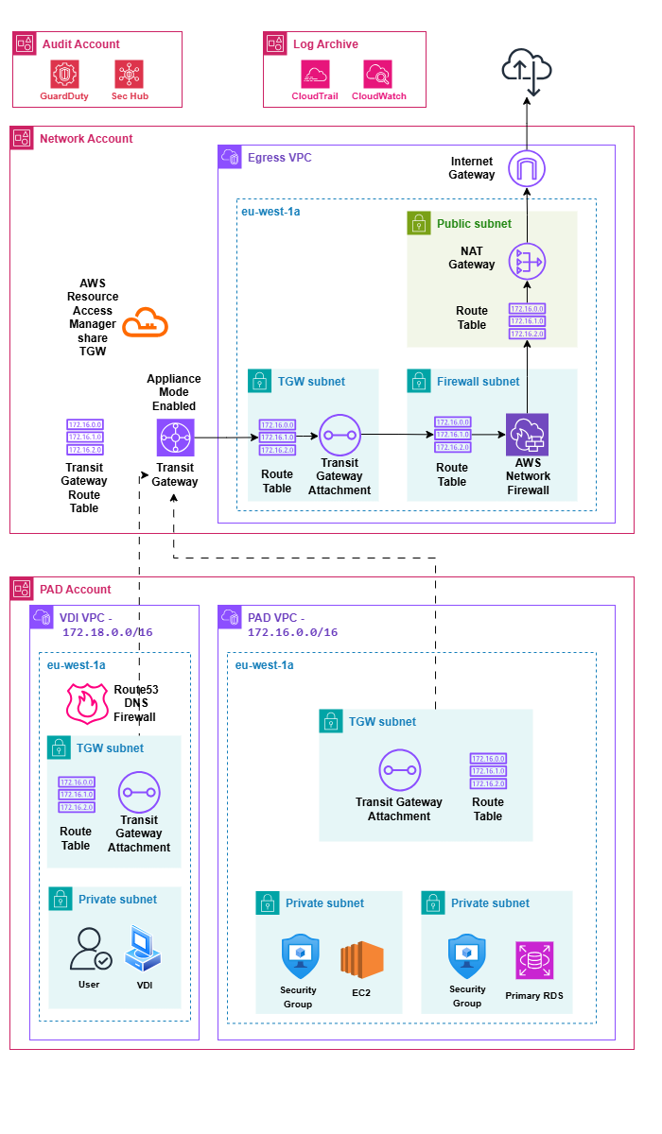
Figure 3 PAD Environment Design– Internet Secured Access

Developers require secured and controlled outbound internet access to dynamically research websites (e.g., mapping layers, check organisation names) for their day-to-day data validation tasks. Implementing a strict URL "whitelist" would severely disrupt their workflow and cause data entry errors. However, we must simultaneously protect the VDI environment from malware and inappropriate content without relying on third-party licenses like Cisco Umbrella.

To satisfy both requirements, it will be implemented the AWS-native standard pattern for large environments: a Centralized Egress Architecture utilizing AWS Network Firewall and Route 53 DNS Firewall. This provides strong malware protection while still allowing broad, dynamic internet access.

As depicted in the architecture diagram, outbound traffic follows a strict, highly secure routing path:

- WorkSpaces VPC & PAD VPC (Origins): Traffic will originate from the Private Subnets hosting the Amazon WorkSpaces (in the WorkSpaces VPC) and the shared EC2 instance (in the PAD VPC). At this stage, Route 53 DNS Firewall will provide the first layer of defence by inspecting all DNS queries originating from the WorkSpaces VPC, protecting developers from malicious domains before traffic even reaches the Transit Gateway.

- AWS Transit Gateway: All allowed outbound traffic will be routed from the Spoke VPC attachment to the central AWS Transit Gateway. To maintain session state for the AWS Network Firewall, Appliance Mode will be enabled on the Egress VPC attachment. This will ensure that the Transit Gateway maintains flow affinity, routing both request and response traffic through the same Elastic Network Interface (ENI) in the Egress VPC, regardless of the source or destination Availability Zone.

- Egress VPC: The Transit Gateway will force all internet-bound traffic into the dedicated Egress VPC for centralized inspection and control.

- AWS Network Firewall: Inside the Egress VPC, traffic will be routed to the Firewall Subnet. The AWS Network Firewall will perform deep packet, Layer 7 inspection using Suricata threat signatures to detect and block malicious traffic dynamically. In addition to threat inspection, the firewall will enforce outbound domain‑based controls; this will include allowing HTTPS traffic (Port 443) to domains such as *.sharepoint.com or data.gov and applying a specific rule that will permit SSH traffic (Port 22) exclusively to the domain bitbucket.com for the Data Processing App and Interactive App repository updates.

- Egress AWS Services (NAT Gateway & Internet Gateway): Once the traffic passes the firewall inspection, it will be routed to the NAT Gateway in the Public Subnet, and finally out to the Internet via the Internet Gateway.

This topology will guarantee that no instance can bypass the security controls, providing enterprise-grade web filtering natively within AWS.

DEV-RDS INSTANCE AND DISASTER RECOVERY

The project requires a separate, non-production duplicate RDS instance (DEV-RDS) to support development and QA testing, which must be strictly isolated within its own distinct Dev VPC. Initially, it was assumed that because traditional VPN access is being removed, the team would need to provision a separate pool of dedicated Amazon WorkSpaces ("Dev VDIs") equipped with Visual Studio just to access this isolated database. Duplicating the VDI infrastructure would introduce significant, unnecessary compute costs and management overhead.
Instead of provisioning redundant "Dev VDIs" or restoring insecure Client VPNs, the architecture leverages the centralized AWS Transit Gateway (TGW) to securely bridge the environments. Developers will continue to use their single, primary VDI within the Spoke VPC. We will establish a secure, internal network route via the TGW that allows the local IDEs (Visual Studio and SSMS) on the production VDIs to communicate directly with the DEV-RDS instance located in the Dev VPC.

- VPC Route Tables: When a developer queries the DEV-RDS endpoint from their WorkSpace, the Spoke VPC's route table will direct that specific private IP traffic (destined for the Dev VPC CIDR, 172.17.0.0/16) to the Transit Gateway attachment.

- Transit Gateway Transit: The TGW will act as a central hub, evaluating its own route tables to securely forward the internal traffic into the isolated Dev VPC.

- Security Group Enforcement: To ensure strict separation of environments, the Security Groups attached to the DEV-RDS instance will be explicitly configured to only accept incoming TCP port 1433 (SQL Server) connections originating from the specific CIDR block of the WorkSpaces VPC (172.18.0.0/16) and the internal subnets hosting the development EC2 instances.

This approach will guarantee strict environmental isolation for the DEV-RDS database while providing developers with a seamless, single-desktop experience. It maximizes the utility of the Transit Gateway and eliminates the financial and operational burden of maintaining two separate VDI fleets.

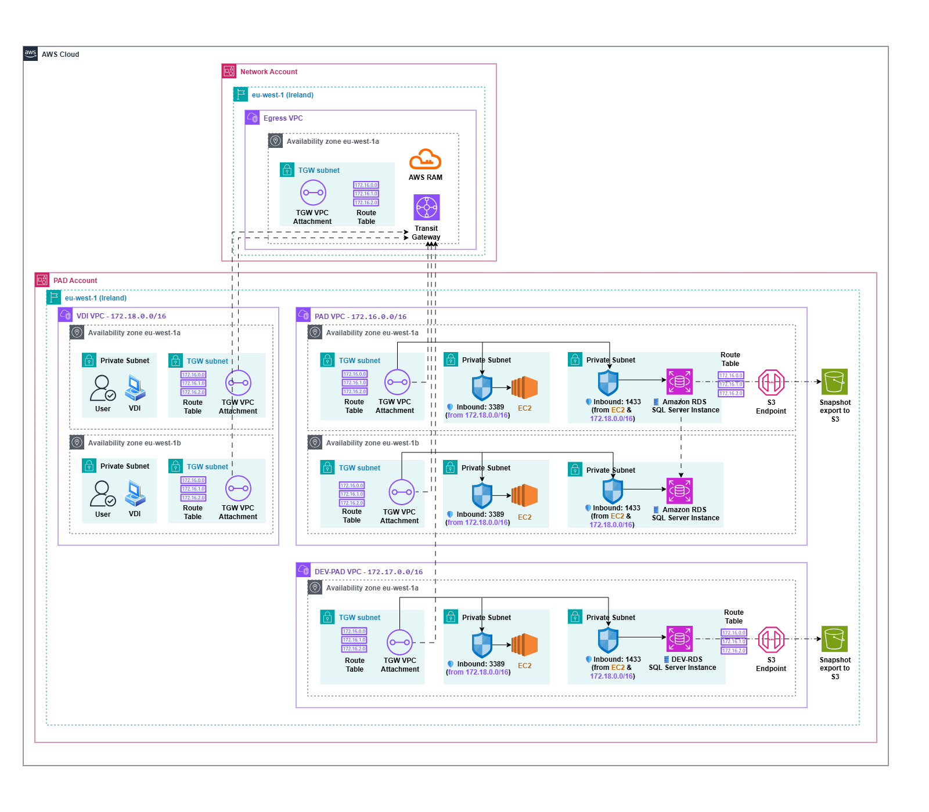
Figure 4 PAD Environment Design– DEV-RDS Instance and Disaster Recovery

The architecture represents separate Production and Development workloads into distinct Virtual Private Clouds while maintaining centralized and cost-effective network routing. At the very core of this connectivity, located at the top of the diagram within the Network Account, is the AWS Transit Gateway. Because AWS accounts are naturally isolated from one another, it will be utilized AWS RAM, or Resource Access Manager, to securely share this central routing hub with the PAD Account. The dotted lines extending downward from the central Transit Gateway illustrates a Hub-and-Spoke topology. Instead of creating complex, peer-to-peer connections between every single VPC, each VPC will simply connect back to the central hub via a dedicated Transit Gateway VPC Attachment. These attachments will be placed in isolated, dedicated subnets to allow for granular routing control and future security scalability.
The primary goal of this design is to deploy a new Amazon RDS SQL Server instance for Development in a separate network, labelled as the DEV-PAD VPC. Normally, a segregated environment like this would require developers to have a separate set of Virtual Desktop Infrastructure workstations deployed directly inside the new VPC to access the database securely. However, using a Transit Gateway, this costly duplication is entirely unnecessary. Following the visual flow in the diagram, a user will connect to their existing VDI in the Production PAD VPC. When they request access to the Development database, the traffic will be routed horizontally to the local Transit Gateway VPC Attachment. From there, it will travel up the dotted line to the central Transit Gateway in the Network Account, which will then route the traffic down the independent dotted line into the attachment of the DEV-PAD VPC. Finally, the solid black line shows the traffic will land securely on the Development Amazon RDS instance. This seamless routing allows developers to use their existing Production VDIs to reach the Development environment securely, significantly reducing compute costs and licensing overhead.
While the Production environment utilizes a multi-AZ architecture spanning two Availability Zones for high availability and fault tolerance, the DEV-PAD VPC operates strictly within a single Availability Zone. This is an intentional architectural decision to optimize costs. Development environments generally do not require the strict uptime guarantees of Production, so by omitting the redundant resources in a second Availability Zone for the Development environment, we achieve substantial savings without impacting the actual workflow.
Finally, to meet data protection and disaster recovery requirements, automated database snapshots must be taken and stored securely. On the right side of both VPCs the traffic flows through a red S3 Gateway Endpoint towards an Amazon S3 Bucket. This endpoint ensures that all backup traffic between the RDS instances and S3 remains entirely on the private AWS network, never traversing the public internet. Furthermore, there is no need to draw a second S3 bucket in another Availability Zone for redundancy because Amazon S3 is inherently a highly available, regional service. When a snapshot is pushed to the S3 bucket in the eu-west-1 region, AWS automatically replicates that data across a minimum of three distinct physical Availability Zones behind the scenes, ensuring exceptional durability against hardware failures or data corruption.
To guarantee data resilience and meet the 24-hour RTO/RPO SLAs, the architecture employs a secure, automated backup strategy. Using AWS Backup, daily automated RDS snapshots (with a 30-day retention) are routed internally (bypassing the public internet) via the dedicated S3 VPC Endpoint to a self-managed Amazon S3 bucket. Throughout this transfer and storage process, all data is encrypted at rest using AWS KMS.
In the event of database corruption or total failure, Database Administrators (DBAs) will utilize secure IAM roles to access the AWS Management Console and locate a healthy snapshot within the S3 vault. Initiating the restore process does not overwrite the corrupted database; instead, it provisions a completely new, clean Amazon RDS instance containing the historical data. Once this new instance is successfully deployed in the private subnet with the correct Security Groups and Multi-AZ configuration, the team will simply update the application connection strings to point to the new DNS Endpoint before safely decommissioning the corrupted database.

REQUIREMENTS FULFILMENT MATRIX

As detailed throughout the preceding sections, the proposed AWS architecture for the PAD solution transitions from a traditional infrastructure model to a highly secure, multi-account Landing Zone.

By implementing a VDI-centric security model via Amazon WorkSpaces, enforcing centralized egress traffic inspection, and establishing a tiered SLA monitoring strategy, the design effectively isolates critical workloads while ensuring enterprise-grade high availability.

To provide a clear, consolidated view of how these strategic architectural decisions fulfil the project's mandates, the following table summarizes the final status of all core operational requirements. It serves as a definitive mapping between the initial business needs—covering both the RDS database deployment and secure environment access—and their agreed-upon, native AWS solutions.

# | Requirement | Status | Description | Architectural Solution
1 | RDS SQL Server 2022 Deployment & Storage | ✅ | Deploy an isolated Amazon RDS SQL Server 2022 instance (~2TB) with encryption for historical and future data. | The Primary RDS SQL Server 2022 instance will be deployed strictly within a private subnet to ensure it is completely isolated from the public internet. The RDS instance will be provisioned with 2TB+ of gp3 storage to seamlessly accommodate data and future monthly/quarterly data loads. AWS Key Management Service (KMS) will be integrated via VPC Endpoints to enforce encryption at rest when configuring the new Amazon RDS instance.
2 | RDS Migration via Snapshot & Upgrade | ✅ | The deployment involves migrating from a Capita account using an AWS RDS snapshot (2019 version) and performing an in-place upgrade to SQL Server 2022 directly within AWS. | Securely transfer the snapshot from the Capita account to the new account, restore it, and grant DBAs permissions to execute the database engine upgrade directly on the restored instance.
3 | High Availability & Disaster Recovery | ✅ | Deploy SQL Server RDS Instance across at least two availability zones (primary/standby) to meet a 24-hour RPO/RTO SLA, with the ability for the operations team to perform annual failover testing. | Utilize Amazon RDS Multi-AZ with synchronous replication. Establish runbooks for manual failover testing outside critical windows and ensure DBA console access to guarantee the 24-hour SLA.
4 | Backup, S3 Export & Retention Strategy | ✅ | Implement automated nightly RDS backups (30-day retention), enable manual backups/point-in-time recovery, and export backups and snapshots to a self-managed S3 bucket. | Configure AWS Backup policies for daily backups and point-in-time recovery. Provision a secure S3 bucket and use export tasks to route snapshots securely.
5 | SSMS User authentication | ✅ | PAD DBAs need to authenticate to SSMS to make architectural and setting changes. | Configure RDS to support SQL Server Authentication. DBAs will connect via SSMS using the System Admin (sa) master account, fulfilling their requirement to be the sole Database Owners (dbo).
6 | Interactive DB Authentication | ✅ | The Interactive App requires to authenticate to RDS SQL Server DBs without credential pass-through. | The Interactive App will use SQL Server Authentication via a generic Read Write User. Individual "interactive users" will be managed internally via a user table and membership provider within the database itself, not via AWS Managed AD.
7 | Application DB Authentication from EC2 instance | ✅ | The Data App needs to authenticate to RDS SQL Server DBs using the Read Write User. | The EC2 instance hosting the Data App uses an IAM Role to access AWS Secrets Manager. Secrets Manager will securely store and retrieve the SQL Server Authentication credentials (Read Write User / Read Only User) used by the app to connect.
8 | Dedicated RDS-Dev Environment | ✅ | Maintain a separate, non-production duplicate RDS instance for development and QA testing, strictly isolated in a different VPC. | Arranging a distinct Dev-VPC to host the non-production RDS instance, drastically reducing the "blast radius" so dev issues or misconfigurations cannot impact Production. The database will be periodically repopulated using older production snapshots.
9 | Identity, Access Management & DBA Autonomy | ✅ | Control workforce access via centralized IAM/RBAC, while database-level authentication relies strictly on native SQL users. DBAs require secure, direct AWS Management Console access to manage backups and rollbacks independently. | AWS IAM Identity Centre (SSO) integrated with AWS Directory Service acts as the single source of identity. Specific Permission Sets (IAM Roles) are created to grant DBAs restricted console access strictly scoped to RDS and S3 operations. Database-level access remains entirely segregated, managed internally by DBAs using the SQL Server Master User to fulfil the exclusive Database Owner (dbo) requirement.
10 | SLA Demarcation & DBO Ownership | ✅ | Support the Autoaddress service agreements ensuring Autoaddress are the sole Database Owners (dbo) and defining clear SLA boundaries for "Service Unavailability". | Autoaddress retains sole dbo control via the sa account and internal user tables. As a result, any application unavailability caused by database misconfigurations, internal authentication failures, failed DBA architectural changes, or OS/Application-level misconfigurations and resource exhaustion caused by Autoaddress users within the EC2 instances, internal authentication failures, or failed DBA architectural changes falls outside An Post's infrastructure control and will count against Autoaddress' 99.9% Availability Target.
11 | SLA Protection & Maintenance Windows | ✅ | Maintenance windows must be mutually agreed upon in writing at least a few business days in advance to prevent masking operational downtime. Emergency maintenance must be strictly for unforeseen critical issues. Furthermore, failures originating from Autoaddress’ internal infrastructure, facilities, or their contracted third-party services (e.g., local ISP, power) are not valid SLA exclusions. | Explicitly define in the SLA that time spent resolving active outages, or emergency maintenance resulting from deferred routine upkeep, shall be classified as downtime. Outage recovery time cannot be reclassified as 'Emergency Maintenance'. Additionally, stipulate that Autoaddress remains fully accountable for their own operational dependencies, and any resulting unavailability will count against their SLA target.
12 | Availability | ✅ | The PAD AWS Environment must guarantee a minimum availability of 99.9%, aligning with the core PAD Application SLA.  The uptime calculation for this target strictly excludes downtime resulting from mutually agreed scheduled maintenance windows, legitimate emergency maintenance interventions, and force majeure events completely outside of Autoaddress' direct control. | Compliance with the overarching 99.9% business availability target (maximum 43.8 minutes of unplanned downtime per month) is enforced through a tiered monitoring strategy using native AWS tools. To ensure maximum underlying resilience, Amazon CloudWatch and RDS Enhanced Monitoring will continuously track individual infrastructure components against their specific, higher-tier native SLAs—such as EC2 (99.99%), RDS Multi-AZ (99.95%), WorkSpaces (99.9%), and Authentication services. By avoiding a blanket metric, this approach provides an immutable, data-driven audit trail to accurately measure component-level performance and validate agreed exclusions, while Disaster Recovery remains strictly governed by the 24-hour RTO/RPO.

Table 7 PAD Environment Design– Requirements Fulfilment Matrix RDS (High-Level Requirements)

# | Requirement | Status | Description | Architectural Solution
1 | Application Hosting & Internal Connectivity | ✅ | Host the .NET Data Processing App on a shared backend server and provide secure access for developers using the Interactive App directly from their isolated VDIs. | To establish a highly secure, enterprise-grade environment, Virtual Desktop Infrastructure (VDI) workstations (pre-installed with the Interactive App and SSMS) will be provisioned in a completely distinct WorkSpaces VPC (VDI-VPC).  From these isolated VDIs, developers will securely connect via RDP (TCP port 3389) through the Transit Gateway to the dedicated EC2 instance hosting the Data Processing application in the PAD VPC.  Finally, strict Security Groups and internal routing will be configured to ensure that the Amazon RDS instance can only be accessed via TCP port 1433 explicitly from the authorized CIDR blocks of the WorkSpaces VPC and the internal EC2 subnets.
2 | Outbound Connectivity, Web Browsing & Continuous Updates | ✅ | Apps and developers need outbound internet to fetch continuous updates (from external private repository), reach OSI/SharePoint, and dynamically research sites (data.gov, CRM) without strict whitelist blocking. | Arranging a Centralized Egress Architecture using Route 53 DNS Firewall to block malware and AWS Network Firewall inside an Inspection VPC for Layer 7 deep packet inspection. This allows dynamic, secure HTTPS research and explicit SSH port 22 access to GitHub before traffic exits via NAT Gateway and AWS Internet Gateway.
3 | Secure Remote & Developer Access | ✅ | Provide secure remote access to the infrastructure and a way for developers to connect local IDEs (like Visual Studio) to the database environments. | Deploy isolated Amazon WorkSpaces (VDIs) equipped with local tools within private subnets. This cost-effective solution ensures data never leaves AWS, safely querying the RDS databases protected by strict Security Groups.
4 | Long-Running Batch Tasks & Shared Monitoring | ✅ | Support unattended intensive tasks (spatial analysis up to 50 hours) without VDI "AutoStop" killing processes and allow more than one developer to log in and monitor the same batch job. | Data Processing App access is strictly restricted to privileged users via a secondary AD group: EC2_Batch_Admins. Authorized users establish secure RDP sessions into a dedicated, "Always-On" EC2 instance to execute and monitor shared batch jobs.  To guarantee uninterrupted execution, OS-level patching for the Data Processing EC2 instance must be coordinated exclusively during mutually agreed maintenance windows.
5 | Programmatic & CLI Access | ✅ | Secure programmatic and command-line (CLI) access must be provided for automation tasks across the infrastructure, strictly eliminating the risk of static credential leakage. | Programmatic access is strictly bifurcated based on the entity type. Automated Machines: EC2 instances running background applications exclusively utilize IAM Instance Profiles for secure AWS API access. Human Interaction: Developers operating within VDIs authenticate to the AWS CLI exclusively via AWS IAM Identity Centre (SSO) to generate temporary, short-lived credentials. The generation and use of static programmatic access keys (Access Keys/Secret Keys) is strictly prohibited across the environment.
6 | Identity, Access Management & DBA Autonomy | ✅ | Control workforce access via centralized IAM/RBAC, while database-level authentication relies strictly on native SQL users. DBAs require secure, direct AWS Management Console access to manage backups and rollbacks independently. | AWS IAM Identity Centre (SSO) integrated with AWS Directory Service acts as the single source of identity.  Workforce access is strictly secured by a mandatory Multi-Factor Authentication (MFA) layer seamlessly integrated via SAML 2.0 identity federation.  Specific Permission Sets (IAM Roles) are created to grant DBAs restricted console access scoped to RDS and S3 operations. Database-level access remains entirely segregated, managed internally by DBAs using the SQL Server Master User.
7 | Support Workflow Integration & Copy-Paste Functionality | ✅ | Ensure Service Desk operators can efficiently resolve customer queries by allowing text-based data transfer between the VDI and local applications, without compromising the overarching data exfiltration policies. | The architecture leverages the granular protocol controls of AWS WorkSpaces (PCoIP/WSP) to bifurcate data streams. By intentionally enabling bidirectional text clipboard syncing while explicitly enforcing a block on local drive mapping and file transfers, the design successfully balances the operational agility required by the business with the strict Data Loss Prevention (DLP) mandates of the PAD environment.

Table 8 PAD Environment Design– Requirements Fulfilment Matrix RDS (Accessing PAD Environment)

Remote Access using a VDI-Centric Security Model

The Approach: Instead of using traditional VPNs, developers connect via Amazon WorkSpaces
How it Works:
- PAD users download a special AWS workspaces client (one-off)
- PAD users log via AWS Directory Service into a cloud-hosted Virtual Desktop (VDI) that lives entirely inside the AWS VPC and interacts directly with the RDS database
- The Benefit: This creates a highly optimized, encrypted stream to the VDIs, keeping all data securely within the AWS cloud and off the physical local machines. Data never leaves the cloud.
- Mass data and files never leave the cloud: While granular protocol controls allow for bidirectional text clipboard sharing to support seamless Service Desk operations, strict restrictions explicitly block local drive redirection. This ensures that database dumps, application files, and bulk data remain entirely contained within the secure AWS boundary at all times.

VDI Approach advantages

- High Security & Data Loss Prevention: Data never leaves AWS because the VDI only sends screen updates to the laptop, making it virtually impossible to download a database dump locally. To support the agile workflows of the Service Desk without compromising this security posture, the environment implements granular protocol controls. Bidirectional text clipboard redirection is enabled to allow operators to seamlessly copy error codes and customer reference numbers between their local CRMs and the VDI (Table 5: Accessing PAD Environment High-Level Requirements, Requirement 7). However, local drive redirection and file transfer capabilities are strictly disabled at the policy level. This ensures that while day-to-day text operations remain fluid, the mass exfiltration of files, database dumps, or the introduction of local malware remains technically impossible.

- Standardized Environments: Every developer gets the exact same machine specs, OS, and pre-installed tools, eliminating “it works on my machine” issues

- Fast Database Access: Although the VDI resides in a dedicated WorkSpaces VPC for security purposes, it is securely routed to the PAD VPC via the high-performance AWS Transit Gateway backend backbone, resulting in incredibly low latency for massive queries.

- Cost optimization: It depends on the time and the number of developers operating within the PAD environment. However, in the long run, it can prove to be a more cost-effective solution than a traditional VPN. This is largely due to the AWS WorkSpaces AutoStop feature, which automatically shuts down the WorkSpace after a set period of inactivity (usually 1 hour).

Architecture Highlights

- High Availability: The system is spread across two separate physical data centres, featuring a primary RDS SQL Server database and a synchronously replicated standby database ready for instant failover

- Sealed Core Network: VDIs and databases reside entirely in private subnets with zero direct public internet access. They securely communicate with AWS services using AWS PrivateLink and S3 Endpoints

- Centralized Traffic Governance: Any required outbound internet access is routed through a centralized AWS Transit Gateway into a dedicated Network Account, monitored via NAT and Internet Gateways

- Standardized Compute & OS Security: To ensure application compatibility and adhere to strict enterprise security standards, the Amazon WorkSpaces (VDIs) will be provisioned using the Windows Server 2025 bundle, configured with the Windows 11 Desktop Experience. This explicitly guarantees that developers work within a modern, fully supported OS environment, providing a familiar end-user interface while leveraging the robust security and Long-Term Servicing Channel (LTSC) of a server-grade backend.

Strict Separation of Concerns (AWS Accounts)

- PAD Account: Hosts the core databases in the PAD VPC and the developer VDIs in a strictly isolated, dedicated WorkSpaces VPC (VDI-VPC).

- Shared Services Account: Manages developer authentication seamlessly using AWS Directory Service and Identity Centre

- Networking Account: it manages and secures all outbound internet access for the isolated Virtual Desktop Infrastructures (VDIs) and databases that reside in the "air-gapped" private subnets of the PAD Account

- Audit Account: Continuously scans for vulnerabilities using Amazon GuardDuty and AWS Security Hub

- Log Archive Account: Acts as an immutable, tamper-proof vault for all system logs using CloudWatch and S3 storage

- Data Protection: Natively integrates AWS Backup, KMS for encryption at rest, and Secrets Manager for automated credentials handling

