https://awslabs.github.io/landing-zone-accelerator-on-aws/v1.10.0/typedocs/latest/index.html

(Nota: Como en tu nueva captura veo que estás consultando la versión específica v1.12.3, si el enlace de "latest" te redirige a una versión diferente en el futuro, solo tendrías que cambiar /latest/ por /v1.12.3/ en la URL).
¿Qué es exactamente esa página que estás viendo?Lo que ves ahí es la "radiografía" técnica de cómo crear un reporte de presupuestos (IBudgetReportConfig) en AWS Landing Zone Accelerator. Te está diciendo qué variables existen para configurar tu presupuesto en el archivo YAML, por ejemplo:
- amount: La cantidad de dinero del presupuesto.
- timeUnit: Si el presupuesto es mensual, diario, etc.
- subscriptionType: Si las notificaciones llegan por EMAIL o SNS.

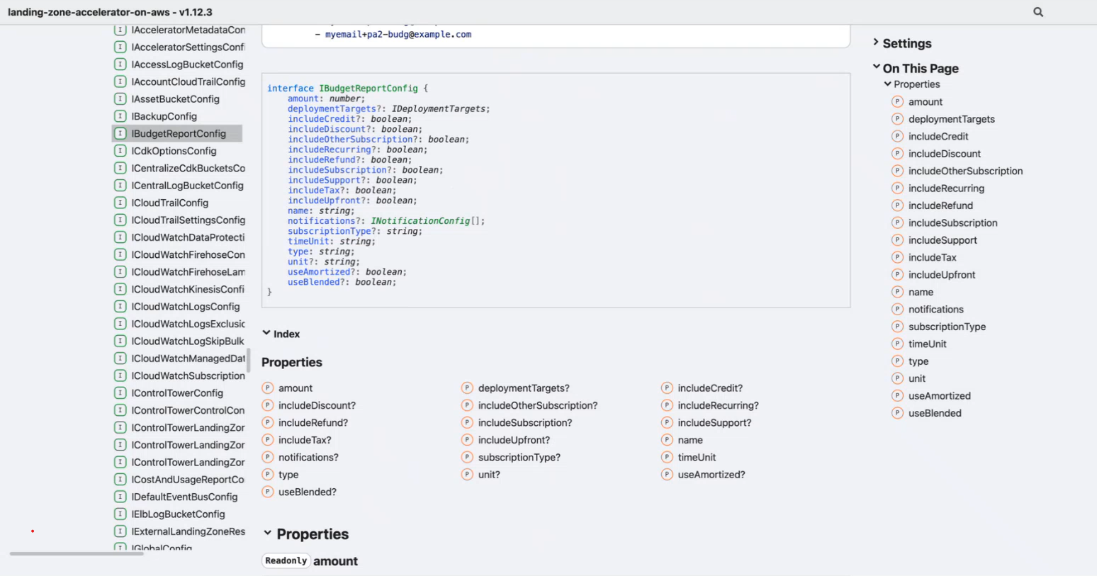

https://awslabs.github.io/landing-zone-accelerator-on-aws/v1.10.0/typedocs/latest/index.html

https://github.com/awslabs/landing-zone-accelerator-on-aws/

https://awslabs.github.io/landing-zone-accelerator-on-aws/latest/installation/

Landing Zone Accelerator on AWS | AWS Solutions | AWS Solutions Library

The Landing Zone Accelerator on AWS solution deploys a foundational set of capabilities that is designed to align with AWS best practices and multiple global compliance frameworks. With this AWS Solution, you can better manage and govern your multi-account environment that have highly-regulated workloads and complex compliance requirements. When used in coordination with other AWS services, it provides a comprehensive, low-code solution across more than 35 AWS services.

The Version 1 standard deployment of the AWS LZA conforms to CIS 1.2 standard and has the standard guardrails in place, it has GuardDuty, AWS Config and SecurityHub enabled. This provides a proven and secure base from which to build further customisations to suit the specific customer.

Use the below section to view the Deployment Guide and download the aws-accelerator-config zip file from the UKDDC Landing Zone Sharepoint Folder

Version 1's Landing Zone Accelerator code is managed and maintained here:

