Topic Topic: Integrating the military instrument to enhance societal resilience

Research Question: . Group should assess the utility and limitations of the military as an instrument of national power in addressing non-traditional national security threats in concert with other instruments available to states. Draw on case studies to illustrate both successful and problematic applications. Consider political, logistical, ethical, and strategic factors.

Length
Requirement is a 10 minute speech for me
I speak at about 110 words per minutes.
Plan for 102 words per minute
Hence 1000words.

Instructions for Analysing Presentation Content
This document consolidates relevant material from the Joint Command and Staff Course (TS_16_2022_JOINT_COMMAND_AND_STAFF_CSE.pdf) and the DSS module examination (08JCSC_DSS_Presentations). It is designed as an instruction set for analysing future presentation content, ensuring compliance with Defence Forces educational aims and Maynooth University academic standards.

Distinction Levers (68% → 72%+)
1. Frame the Argument Early and Clearly
- Open with a precise research question and your answer in one line.
- Example: “This essay argues that small states can influence outcomes conditionally, when niche expertise aligns with institutional demand.”
- Examiners reward clarity of stance more than density of sources.

2. Prioritise Critical Synthesis over Description
- Don’t just say “Bachmann argues X, Bennett argues Y.”
- Say: “Bachmann overstates disinformation’s impact; Bennett shows institutional decline is deeper. For the Defence Forces, Bennett’s reading is more persuasive because…”
- That weighing is what examiners scan for.

3. Limit → Implication Discipline
- Every section should end with:
  - Limit: one clear boundary (“Bachmann’s data is Ukraine-focused only”).
  - Implication: one DF consequence (“Implication: Ireland must adapt cautiously, given neutrality constraints”).
- This is examiner catnip: it proves you are reflective, not just descriptive.

4. Anchor Every Claim in the Defence Forces
- Even when discussing Clausewitz or RMA theory, always land on DF application.
- Example: “Metz’s claim that revolutions are social as well as technical matters. Limit: US-centric. Implication: DF must consider cultural resistance as much as drones themselves.”
- Examiners want Ireland made relevant in every paragraph.

5. Balance Optimist vs Sceptic Voices
- Always show at least two sides, then position yourself.
- E.g. “Krepinevich’s optimism clashes with Betts’ caution. By contrast, Alach bridges both. Taken together, this suggests…”
- Critical contrasts signal higher-level analysis.

6. Deliver Novel Synthesis
- Push one fresh link beyond what sources say.
- E.g. “Mission command and strategic communication both hinge on candour under uncertainty. This parallel suggests a common doctrinal challenge for the DF.”
- Even one or two such insights can push an essay into the 70s.

7. Slide/Essay Economy
- In presentations: one big claim per slide.
- In essays: one claim per paragraph. Avoid stacking.
- Dense work reads as descriptive; lean, prioritised work reads as analytical.

✅ Rule of Thumb: Every time you add evidence, ask: Am I weighing it, limiting it, and tying it back to DF? If not, cut or reframe.

1. Course Context
The Joint Command and Staff Course (JCSC) represents the cornerstone of professional military education in the Defence Forces. It prepares officers for operational and strategic appointments, and is accredited at postgraduate (MA) level through Maynooth University. The course emphasises critical thinking, leadership, defence management, strategy, and research.

2. Presentation Assessment Requirements
- The DSS presentation provides the course member with an opportunity to conduct personal research in an allocated DSS area based on the material covered during the module, personal experience and professional/academic interest. Course members will be expected to apply concepts, theories and insights gained during lectures and associated readings during their presentations.• Duration: 20–30 minutes per group (depending on size).
• Structure: Succinct summary of analysis, conclusions, and recommendations.
• Delivery: Equal speaking time among members; flexible use of aids (PowerPoint optional).
• Questions: One group-level and one individual-level Q&A session with assessors.
• Referencing: Academic integrity and Maynooth University referencing policy must be observed.

3. Marking Criteria
The marking rubric allocates 200 marks, divided as follows:

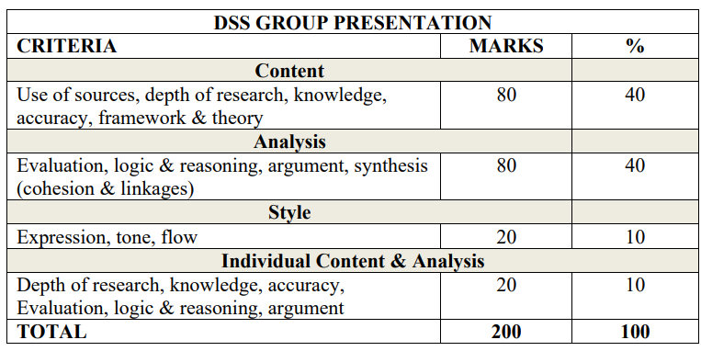4. Analytical Instructions
When analysing presentation content, apply the following criteria:
• Evaluate depth and relevance of research sources used.
• Assess the logical flow of arguments and conclusions.
• Identify evidence of critical engagement with course concepts from the DSS module.
• Consider whether content demonstrates both descriptive and critical writing.
Do the student’s sections link well together.
• Compare findings with broader Defence Forces doctrine and international perspectives.
• Note gaps in analysis, unsupported claims, or lack of engagement with counterarguments.

5. Alignment with JCSC Learning Outcomes
Presentations and analyses should align with the JCSC’s postgraduate learning outcomes, including:
- • Demonstrating advanced knowledge of command, leadership, ethics, and management.
- • Critical evaluation of defence strategy, operations, and organisational culture.
- • Effective communication and decision-making skills.
- • Ability to contextualise Irish Defence Forces perspectives within broader NATO, EU, and UN frameworks.

6. Academic and Referencing Standards
All analysis must adhere to Maynooth University Harvard Style. Students must avoid plagiarism, including unacknowledged use of AI-generated material. Sources should be relevant, credible, and properly cited.

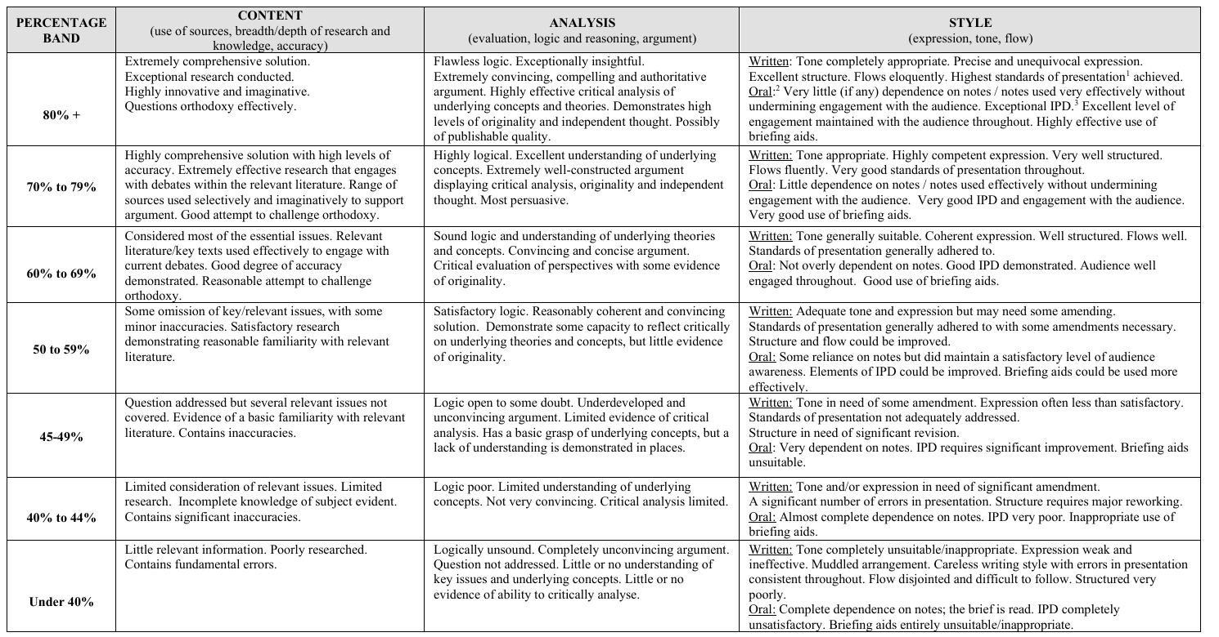
You are to consider the presentation in the context of the following questions. The speaker doesn’t have to answer them all, however these represent a robust handle on the topic. It’s not possible for the speaker to answer everything in 10 minutes.

## 1 | Organisational Culture Change and Doctrinal Inertia
1. How does the existing culture of hierarchy and caution within the Defence Forces help or hinder integration with civilian agencies during crises?
2. What mechanisms can translate mission command principles into everyday organisational behaviour that supports resilience?
3. In what ways does technological modernisation risk reinforcing rather than overcoming doctrinal inertia?
4. How can small-state context—limited resources and personnel—shape or constrain attempts at cultural reform?
5. What indicators would show that cultural change has produced genuine adaptability rather than superficial compliance?

## 2 | From Mission Command to Strategic Concordance
1. How can the philosophy of mission command be scaled up to coordinate political, civil and military actors in resilience planning?
2. What structural or psychological barriers prevent trust between Defence, the Department of Defence and other government departments?
3. How does Schiff’s concept of concordance help explain Ireland’s uneven record in interagency cooperation?
4. Which institutional reforms—planning boards, shared doctrine, joint staffing—would best embed concordance across government?
5. How can Ireland reconcile its tradition of strict civilian control with the need for rapid, delegated crisis decision-making?

## 3 | Civil–Military Trust and the Ethics of Resilience Roles
1. What ethical principles should guide military involvement in domestic resilience operations such as cyber defence or disaster relief?
2. How can Defence maintain legitimacy and public consent when operating within civilian spheres?
3. What are the risks of politicisation or dependency if the military becomes a default responder to civil shortfalls?
4. How might transparency and communication strategies sustain public trust during ethically sensitive missions?
5. Where should ethical responsibility sit—within Defence, government, or joint oversight—when resilience operations affect citizens directly?

## 4 | Integration as Practice — From Concept to Credibility
1. What concrete steps can embed Defence permanently within the Office of Emergency Planning and national cyber structures?
2. How can training, liaison roles and promotion pathways make interagency cooperation habitual rather than personality-driven?
3. What metrics can test whether integration strengthens rather than substitutes for core defence capability?
4. How do international doctrines (NATO 2022, HCSS 2023, USMC 2022) inform practical Irish adaptation?
5. What resource or legitimacy costs accompany deeper military participation in societal resilience?

## 5 | Closing Transition to [] — Linking Adaptation to Legitimacy
1. How does organisational adaptation provide the structural foundation for legitimacy and ethical leadership in resilience?
2. What happens to societal trust if integration proceeds faster than ethical safeguards develop?
3. How can Ireland measure the balance between effective coordination and democratic oversight?
4. Which lessons from Sinéad’s Irish and US case studies most clearly demonstrate the value of adaptation for legitimacy?
5. How can Defence preserve its warfighting identity while expanding roles that emphasise collaboration and public service?

