**Model Validation Report**

ML Test

Imported from a GIT repository

acdc5038-20c5-4cfb-8461-6a355eafd442

**Prepared by:** *Enter the document preparer’s name here*

**Model Developed by:** Matt

**Model Developed on:** 2022-06-08T05:23:01.433Z

**Executive Summary**

*Provide a concise summary description of the model and its proposed use(s), model results, and key conclusions from the model development process. A reader should be able to obtain a solid understanding of the model solely from reading the Executive Summary.*

**Statistical Analysis**

**Classification Metrics**

*Provide a textual analysis of the classification metrics and what they indicate*

|  |  |  |  |  |  |
| --- | --- | --- | --- | --- | --- |
| accuracy | precision | recall | f1_score | auc | confusion_matrix |
| 0.6650 | 0.4516 | 0.7241 | 0.5563 | 0.6825 | [{0=0.455, 1=0.255}, {0=0.08, 1=0.21}] |

Table 1 - Classification Metrics

**Stability Analysis**

*Provide a textual analysis of the stability analysis and what they indicate*

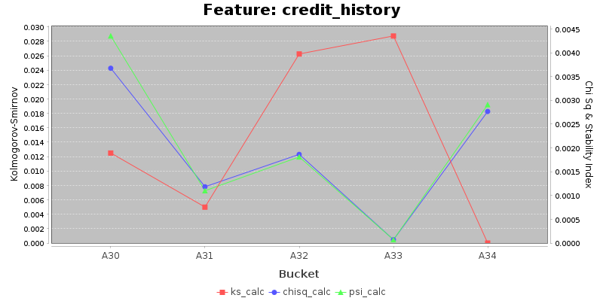

|  |  |  |  |  |  |  |  |  |  |  |  |  |
| --- | --- | --- | --- | --- | --- | --- | --- | --- | --- | --- | --- | --- |
| bucket | train_count | eval_count | train_percent | eval_percent | train_mean_score | eval_mean_score | score_mean_diff | train_cum_percent | eval_cum_percent | ks_calc | chisq_calc | psi_calc |
| A30 | 34 | 6 | 0.0425 | 0.0300 | 0.7647 | 0.8333 | 0.0686 | 0.0425 | 0.0300 | 0.0125 | 0.0037 | 0.0044 |
| A31 | 38 | 11 | 0.0475 | 0.0550 | 0.8158 | 0.7273 | -0.0885 | 0.0900 | 0.0850 | 0.0050 | 0.0012 | 0.0011 |
| A32 | 419 | 111 | 0.5238 | 0.5550 | 0.5084 | 0.5135 | 0.0052 | 0.6138 | 0.6400 | 0.0263 | 0.0019 | 0.0018 |
| A33 | 70 | 18 | 0.0875 | 0.0900 | 0.4429 | 0.5556 | 0.1127 | 0.7013 | 0.7300 | 0.0288 | 0.0001 | 0.0001 |
| A34 | 239 | 54 | 0.2988 | 0.2700 | 0.2134 | 0.2407 | 0.0274 | 1.0000 | 1.0000 | 0.0000 | 0.0028 | 0.0029 |

Table 2 - Stability for Feature credit_history

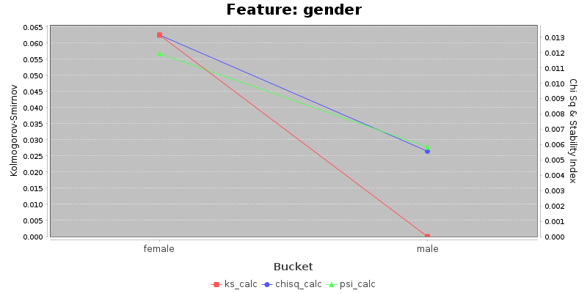

|  |  |  |  |  |  |  |  |  |  |  |  |  |
| --- | --- | --- | --- | --- | --- | --- | --- | --- | --- | --- | --- | --- |
| bucket | train_count | eval_count | train_percent | eval_percent | train_mean_score | eval_mean_score | score_mean_diff | train_cum_percent | eval_cum_percent | ks_calc | chisq_calc | psi_calc |
| female | 238 | 72 | 0.2975 | 0.3600 | 0.4958 | 0.4306 | -0.0652 | 0.2975 | 0.3600 | 0.0625 | 0.0131 | 0.0119 |
| male | 562 | 128 | 0.7025 | 0.6400 | 0.4164 | 0.4844 | 0.0680 | 1.0000 | 1.0000 | 0.0000 | 0.0056 | 0.0058 |

Table 3 - Stability for Feature gender

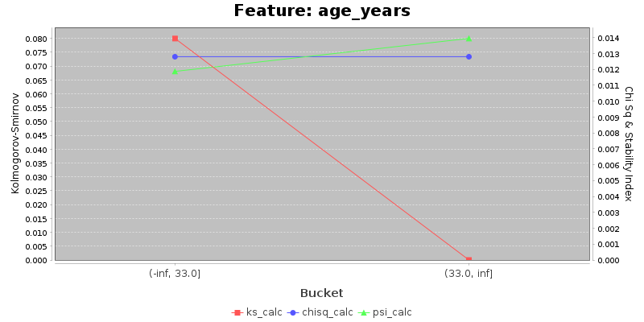

|  |  |  |  |  |  |  |  |  |  |  |  |  |
| --- | --- | --- | --- | --- | --- | --- | --- | --- | --- | --- | --- | --- |
| bucket | train_count | eval_count | train_percent | eval_percent | train_mean_score | eval_mean_score | score_mean_diff | train_cum_percent | eval_cum_percent | ks_calc | chisq_calc | psi_calc |
| (-inf, 33.0] | 400 | 116 | 0.5000 | 0.5800 | 0.4950 | 0.4914 | -0.0036 | 0.5000 | 0.5800 | 0.0800 | 0.0128 | 0.0119 |
| (33.0, inf] | 400 | 84 | 0.5000 | 0.4200 | 0.3850 | 0.4286 | 0.0436 | 1.0000 | 1.0000 | 0.0000 | 0.0128 | 0.0139 |

Table 4 - Stability for Feature age_years

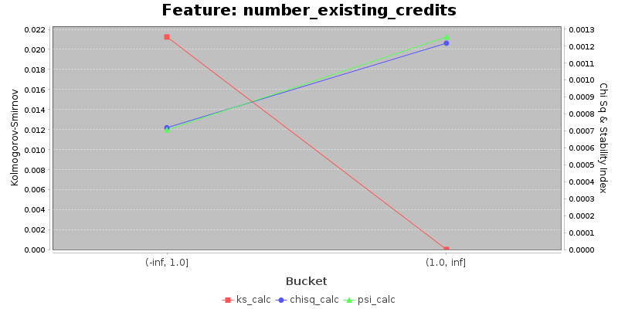

|  |  |  |  |  |  |  |  |  |  |  |  |  |
| --- | --- | --- | --- | --- | --- | --- | --- | --- | --- | --- | --- | --- |
| bucket | train_count | eval_count | train_percent | eval_percent | train_mean_score | eval_mean_score | score_mean_diff | train_cum_percent | eval_cum_percent | ks_calc | chisq_calc | psi_calc |
| (-inf, 1.0] | 503 | 130 | 0.6288 | 0.6500 | 0.5010 | 0.5385 | 0.0375 | 0.6288 | 0.6500 | 0.0213 | 0.0007 | 0.0007 |
| (1.0, inf] | 297 | 70 | 0.3713 | 0.3500 | 0.3367 | 0.3286 | -0.0081 | 1.0000 | 1.0000 | 0.0000 | 0.0012 | 0.0013 |

Table 5 - Stability for Feature number_existing_credits

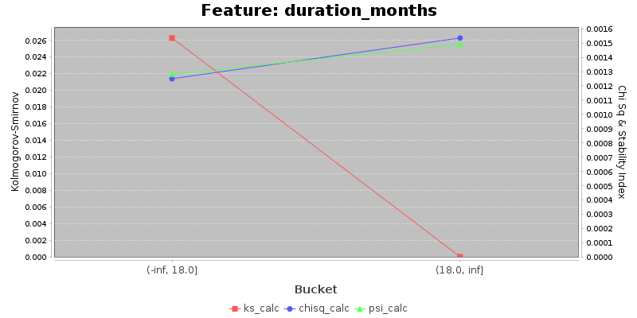

|  |  |  |  |  |  |  |  |  |  |  |  |  |
| --- | --- | --- | --- | --- | --- | --- | --- | --- | --- | --- | --- | --- |
| bucket | train_count | eval_count | train_percent | eval_percent | train_mean_score | eval_mean_score | score_mean_diff | train_cum_percent | eval_cum_percent | ks_calc | chisq_calc | psi_calc |
| (-inf, 18.0] | 441 | 105 | 0.5513 | 0.5250 | 0.4218 | 0.3905 | -0.0313 | 0.5513 | 0.5250 | 0.0263 | 0.0013 | 0.0013 |
| (18.0, inf] | 359 | 95 | 0.4488 | 0.4750 | 0.4624 | 0.5474 | 0.0850 | 1.0000 | 1.0000 | 0.0000 | 0.0015 | 0.0015 |

Table 6 - Stability for Feature duration_months

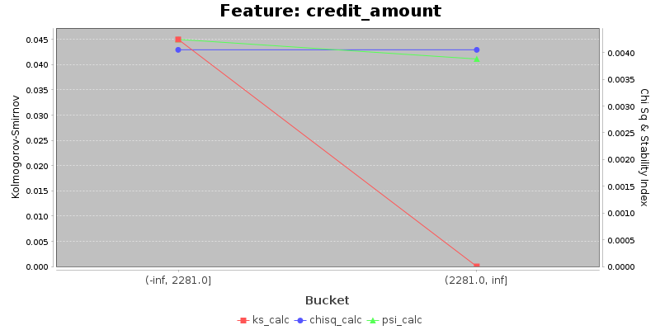

|  |  |  |  |  |  |  |  |  |  |  |  |  |
| --- | --- | --- | --- | --- | --- | --- | --- | --- | --- | --- | --- | --- |
| bucket | train_count | eval_count | train_percent | eval_percent | train_mean_score | eval_mean_score | score_mean_diff | train_cum_percent | eval_cum_percent | ks_calc | chisq_calc | psi_calc |
| (-inf, 2281.0] | 400 | 91 | 0.5000 | 0.4550 | 0.4100 | 0.4505 | 0.0405 | 0.5000 | 0.4550 | 0.0450 | 0.0041 | 0.0042 |
| (2281.0, inf] | 400 | 109 | 0.5000 | 0.5450 | 0.4700 | 0.4771 | 0.0071 | 1.0000 | 1.0000 | 0.0000 | 0.0041 | 0.0039 |

Table 7 - Stability for Feature credit_amount

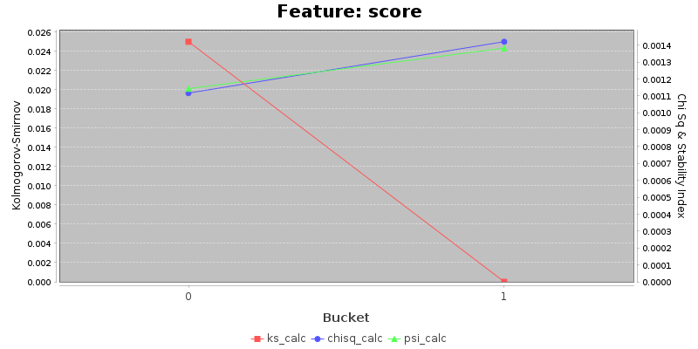

|  |  |  |  |  |  |  |  |  |  |  |  |  |
| --- | --- | --- | --- | --- | --- | --- | --- | --- | --- | --- | --- | --- |
| bucket | train_count | eval_count | train_percent | eval_percent | train_mean_score | eval_mean_score | score_mean_diff | train_cum_percent | eval_cum_percent | ks_calc | chisq_calc | psi_calc |
| 0 | 448 | 107 | 0.5600 | 0.5350 | 0.0000 | 0.0000 | 0.0000 | 0.5600 | 0.5350 | 0.0250 | 0.0011 | 0.0011 |
| 1 | 352 | 93 | 0.4400 | 0.4650 | 1.0000 | 1.0000 | 0.0000 | 1.0000 | 1.0000 | 0.0000 | 0.0014 | 0.0014 |

Table 8 - Stability for Feature score

**Analysis for Bias**

*Provide a textual analysis of bias results and control measures put in place to eliminate the bias in the provided data and results.*

**Bias Analysis for Protected Classes**

