MBSE Coffee Machine
Model-Based Systems Engineering — Knowledge Pack
From a SysML model in CATIA Magic to a graph-driven gap analysis,
a live digital twin, and requirement-vs-industry sensitivity analysis

Course: MEMKO — MBSEF-SEng (MBSE Fundamentals for Systems Engineering)
Tool: CATIA Magic / Magic Systems of Systems Architect 2026x (SysML v1)
Author: Alex Kovaceski
Date: 17 September 2026

This document embeds three working files — the SysML model, the full application, and a
standalone showcase — as attachments (see "Package Contents"). Extract them to reuse everything here.

1 Executive summary
Over the MEMKO MBSEF-SEng course we built a complete SysML model of a bean-to-cup coffee machine in CATIA Magic, then went well beyond the lab sheets: we drove the tool programmatically, exported the model to an open JSON format, and built an interactive portal on top of it. That portal let us do things the modelling tool alone cannot — use a network graph to find integration gaps in the model, run a live digital twin of the state machine and boiler physics, inject faults (including a deliberately unsafe electrical short that electrocutes the operator), compute OEE, and marry the machine's requirements with real public product data to do sensitivity analysis for decision-makers.
The headline outcome: a single, fully-integrated model (no orphan elements), a set of reusable automation patterns, and a shareable application that makes systems-engineering artefacts legible to non-modellers. This document explains what we built, how, and exactly what a colleague needs to rebuild or deploy it on a controlled network.

The model at a glance
Metric | Value
Blocks (structure) | 49
Requirements | 25
Signals | 9
Activities | 8
Graph nodes | 99
Graph relations | 165
Connected components | 1 (fully integrated — 0 orphans, 0 islands)
Requirement traceability | satisfy / refine / verify / allocate across physical & operational

2 Course & case study context
MBSEF-SEng is an introduction to Model-Based Systems Engineering. The lecture modules cover MBSE concepts; the hands-on work is four laboratories that incrementally build one model of a domestic coffee machine:
- Lab 1 — Structure: the block hierarchy (subsystems: water, brew, control, power, dispensing) and their parts, ports and interfaces.
- Lab 2 — Behaviour: a state machine (Off / On / Initialising / Idle / Brewing, with a nested heating region) and the activities behind each state (Initialise System, Check System, Select Coffee, Brew Coffee, Clean System, plus a decomposed Heat Water activity).
- Lab 3 — Requirements & use cases: ~25 requirements with IDs and text, actors and use cases, and traceability (satisfy / refine).
- Lab 4 — Parametrics / analysis: a boiler heating analysis that verifies requirement 1.1 (reach 84 °C within 90 s) using the relation T = inputWaterTemperature + √boilingFactor × t.
Everything in this pack is built on that model. The coffee machine is a training example — nothing here is confidential — which is why we can share it freely to demonstrate the approach.

3 The SysML model we built
The model follows the four SysML pillars — structure, behaviour, requirements and parametrics — and ties them together with traceability. Key diagrams:
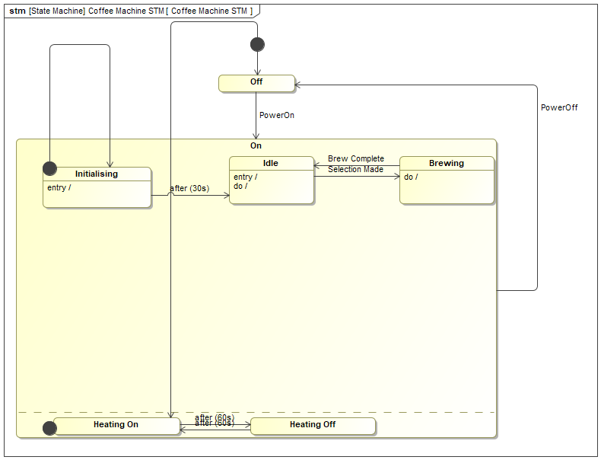
The coffee-machine state machine (Lab 2): Off / On with the Initialising → Idle → Brewing cycle and a nested heating region. Each state invokes a real activity as its entry/do behaviour.
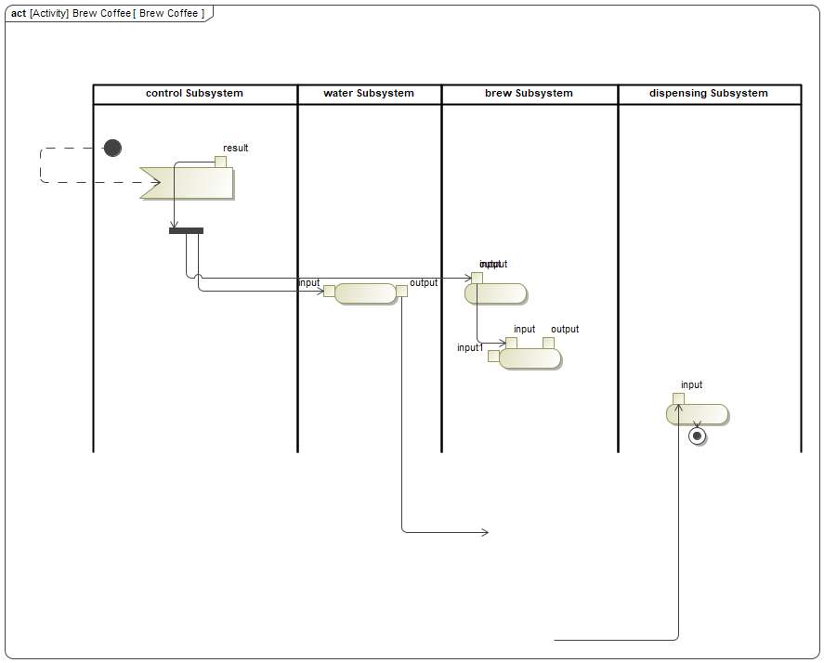
The Brew Coffee activity (Lab 2) laid out across subsystem swim-lanes: Heat Water, Grind Beans, Extract Coffee, Dispense Coffee.
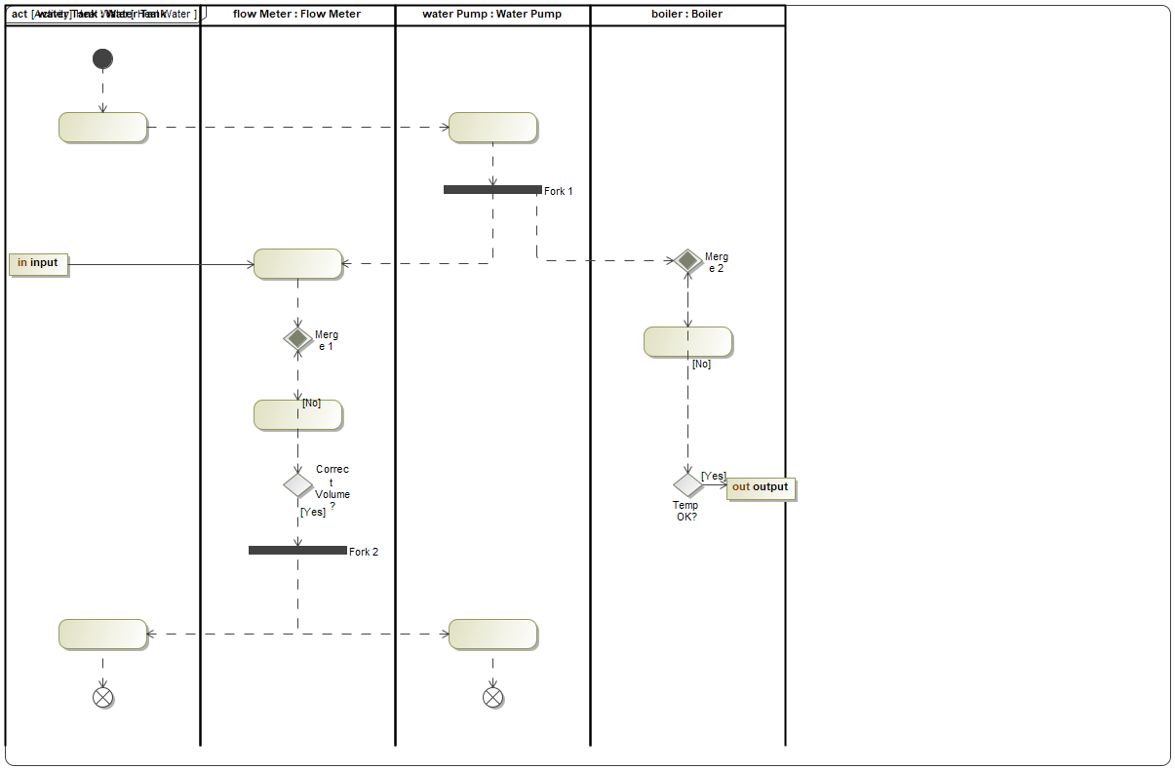
The decomposed Heat Water sub-activity (2-of-2) with decisions, forks and guards.
Requirements carry proper IDs (1.1–1.11, 2.x, 3.x) and text, and are traced to the physical parts that satisfy them and the analysis that verifies them. Lab 4 adds the Boiler and Boiler Observer analysis blocks and a constraint block for the heating relation.

4 Software integration — driving CATIA Magic programmatically
Building a model by hand in the GUI is slow and hard to repeat. Instead we drove CATIA Magic through its Groovy OpenAPI, so every change is a script we can re-run, review and version. The main API objects:
- Application / Project / ElementsFactory — the model and how to create elements.
- ModelElementsManager — add/remove elements and create diagrams.
- SessionManager — wrap every change in a create/close (or cancel) session so edits are atomic.
- PresentationElementsManager — place shapes, path elements and swim-lanes on diagrams.
- StereotypesHelper — apply SysML stereotypes (Requirement, Satisfy, …) and read/write their tags.
def app = Application.getInstance(); def p = app.getProject()
def f = p.getElementsFactory(); def mem = ModelElementsManager.getInstance()
def sm = SessionManager.getInstance()
sm.createSession(p, 'add requirement')
try {
def req = f.createClassInstance(); req.setName('Electrical Isolation On Dispense')
mem.addElement(req, internalFeatures)
StereotypesHelper.addStereotype(req, reqStereotype)
StereotypesHelper.setStereotypePropertyValue(req, reqStereotype, 'Id', '3.1.5')
sm.closeSession(p)
} catch (ex) { sm.cancelSession(p) }
Pattern: every model change runs inside a session and is written by a Groovy macro (illustrative).
Because this VDE has no scripting console open to us directly, we trigger each macro from PowerShell: focus the CATIA window, click the model tree to give it focus, and send the macro’s keyboard shortcut. Each macro writes its result to a text file, so the automation is file-verified — we always read back exactly what happened rather than assuming the GUI did it.
This gave us a reliable, repeatable pipeline: author a Groovy script → copy it into the macro slot → trigger it → read the result file → save the model. The same pipeline built the model, repaired it, and exported it.

5 Getting the data out — the model export (“OKF”)
To build anything on top of the model, we needed the model outside the tool. A Groovy exporter (export_model.groovy) walks the user packages (skipping the SysML/UML profiles) and emits a single JSON file — our open knowledge format — capturing both the model content and a graph of every relationship:
- Nodes: blocks, requirements, interfaces, signals, activities, states, the state machine, use cases, actors.
- Edges: part, reference, association, generalization, dependency (satisfy / refine / allocate / verify), transition, behavior (state → entry/do/exit activity), effect, triggers (signal → state), uses (activity → signal), contains (requirement nesting & state hierarchy), include, subject.
def out = [ project: p.getName(),
summary: [blocks:.., requirements:.., graphNodes:.., graphEdges:..],
structure: [...], requirements: [...], signals: [...],
stateMachine: {...}, activities: [...],
graph: [ nodes: [{id,kind,name}], edges: [{source,target,kind,label}] ] ]
new File('coffee_machine_model.json').setText(toJson(out), 'UTF-8')
The exporter emits a self-describing JSON. Everything downstream reads this one file.
This export is the hinge of the whole solution: the portal, the graph analysis, the digital twin and the LLM all consume this JSON. Re-exporting after any model change refreshes every view.

6 The interactive portal (application)
On top of the exported JSON we built a single-page portal — an “MBSE Model Explorer” — served locally. It has views for the model graph, structure, requirements, the state machine, activities, a digital twin, market-fit / sensitivity, OEE, an ontology explainer, and an “Ask the Model” chat. It is plain HTML/JS (vis-network for the graph) served by a tiny PowerShell HTTP server — no framework, no build step, no cloud.

The model-graph view: all 99 elements in one connected network, colour-coded by kind (block, requirement, state, activity, signal, interface, use case, actor).

7 Using the graph to identify gaps in the model
A network graph is a powerful review tool: in a properly integrated SysML model everything should be reachable from everything else. Anything that floats free is a missing relationship. We used two checks on the exported graph:
- Isolated nodes (degree 0) — elements with no relationship at all.
- Connected components (a breadth-first search) — clusters that are internally linked but detached from the main model. This is the check that matters: the first pass looked integrated because nothing was fully orphaned, yet a component analysis revealed five separate islands.
The graph surfaced genuine gaps, which fell into two categories:
(a) Export/view gaps — the exporter simply was not drawing certain relationships that existed in the model: block → its state machine (classifier behaviour), state → its entry/do/exit activity, transition → effect, signal → the transition it triggers, requirement nesting, and the state-machine hierarchy (state machine → states, composite state → substates). We enriched the exporter to emit these.
(b) Real model gaps — the state machine invoked throwaway placeholder behaviours instead of the real detailed activities (so Brew Coffee, Heat Water, etc. floated free); flow items (Water, Coffee, Coffee Beans) were never wired into any block; several requirements (the cleaning family) had no satisfy links; and the physical structure was not traced to the operational model. We fixed each in the model itself — repointing the state behaviours to the real activities, adding flow-item reference properties, a signal taxonomy, satisfy/allocate/refine relationships, and a verify link closing the analysis loop.
Result: the graph collapsed from 36 isolated nodes and 5 disconnected components down to a single connected component of 99 nodes and 165 relations — nothing left unconnected. This is exactly the kind of integration defect that is invisible in a diagram-by-diagram review but obvious in a graph.
Graph integration | Outcome
Before | 36 isolated nodes; 5 disconnected components
After | 0 isolated nodes; 1 connected component (99 nodes, 165 relations)
Fixed in the exporter | behaviour, effect, triggers, uses, contains, reference, generalization, state hierarchy
Fixed in the model | STM→real activities, flow-item props, signal taxonomy, satisfy/allocate/refine/verify

8 The digital twin
The digital twin is a live, animated simulation of the machine driven by the same model. It runs the state machine (Off → Initialising → Idle → Brewing) and the Lab 4 boiler physics — T = inputWaterTemperature + √boilingFactor × t — reading the actual parameter values from the exported model, and it evaluates requirement 1.1 (84 °C at 90 s) in real time.
Crucially, it lets you inject faults and watch the state machine react: empty water tank (REQ 1.3), beans low (REQ 1.4), overheat (REQ 1.2), dregs drawer removed (REQ 3.1.3), and a deliberately unsafe electrical short on dispense. The short energises the chassis and — because no residual-current device (RCD) is fitted — electrocutes the operator. We modelled this hazard end-to-end: a “Short Detected” signal, a new safety requirement 3.1.5 (electrical isolation / RCD on dispense), an STM safety transition On → Off triggered by that signal with an “Isolate Power (RCD trip)” effect, and satisfy links from the power-supply and dispensing subsystems. The twin dramatises it as a (cheeky) easter egg so the safety point lands.
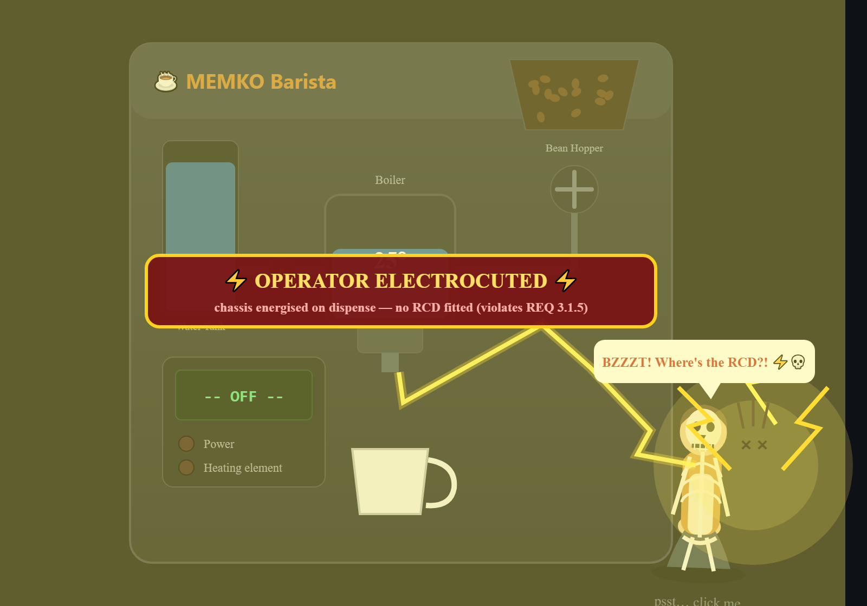
Fault injection: the unsafe short-circuit-on-dispense hazard. The operator is electrocuted (x-ray skeleton, arc from the energised chassis) because no RCD is fitted — a visual argument for requirement 3.1.5.
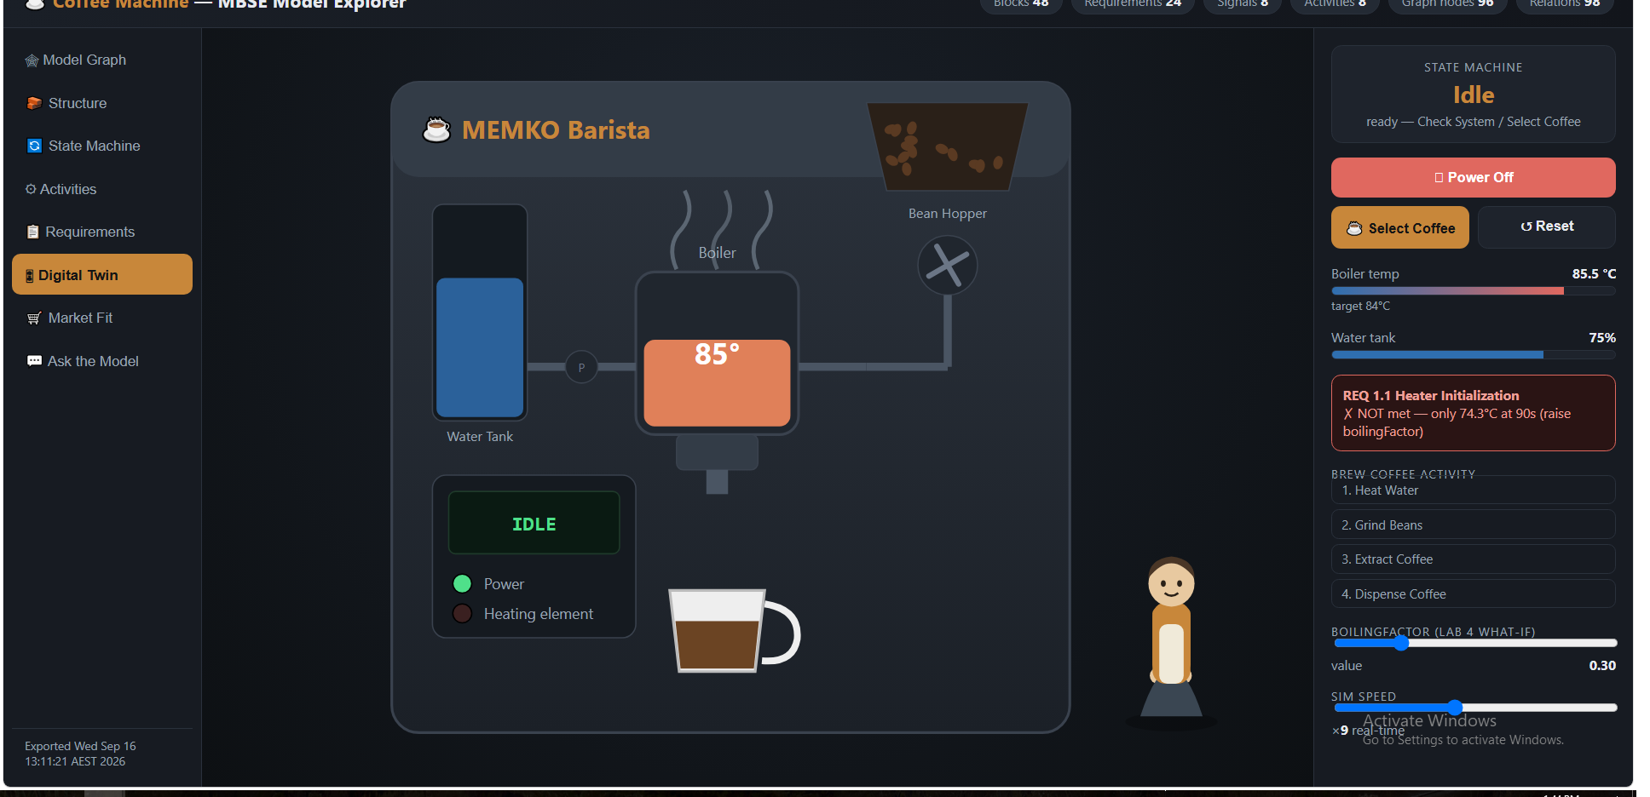
The twin in normal operation: boiler heating toward the 84 °C target, live requirement 1.1 check, the Brew Coffee activity stepping, and the clickable barista who powers it on.

9 OEE, throughput & fault Pareto
Because the twin runs continuously, we can measure it like a real production asset. The OEE view computes Overall Equipment Effectiveness = Availability × Performance × Quality from run/operating/down time and good/bad cups, tracks throughput (cups per hour), and ranks fault types on a Pareto chart so the biggest availability losses are obvious.
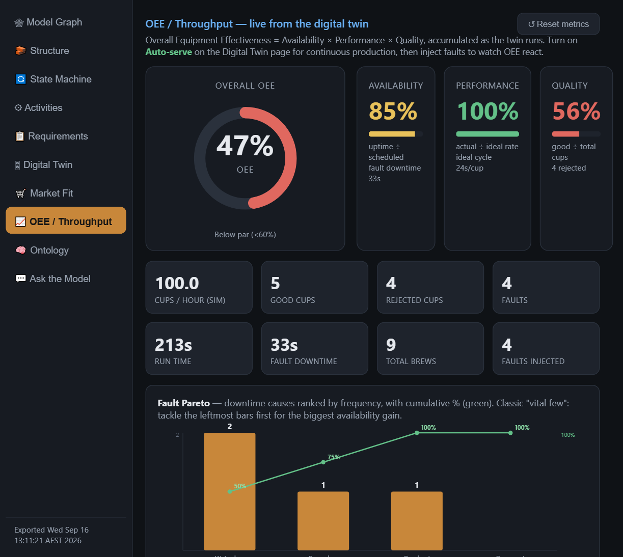
OEE / throughput dashboard with the fault Pareto — turning the behavioural model into operational KPIs.

10 Requirements × industry data → sensitivity analysis
This is where the model earns its keep for decision-makers. We extracted the machine’s quantitative requirements (heat-up time, tank capacity, bean capacity, pump pressure, price ceiling) and compared them against a table of real, currently-sold espresso machines compiled from public product data (De’Longhi, Jura, Siemens and others). The portal then answers the question a buyer or designer actually asks: which products meet all of our requirements — and if none do, which requirement is the binding constraint?
The sensitivity part is interactive: relax or tighten a requirement threshold and the candidate set updates live, so you can see, for example, that the heat-up-time requirement excludes the most machines and is the spec most worth revisiting. This demonstrates bringing open, external data into an MBSE model to support trade-off decisions — no machine on the market meets a given need, so a specification has to change, and the model shows which one and by how much.
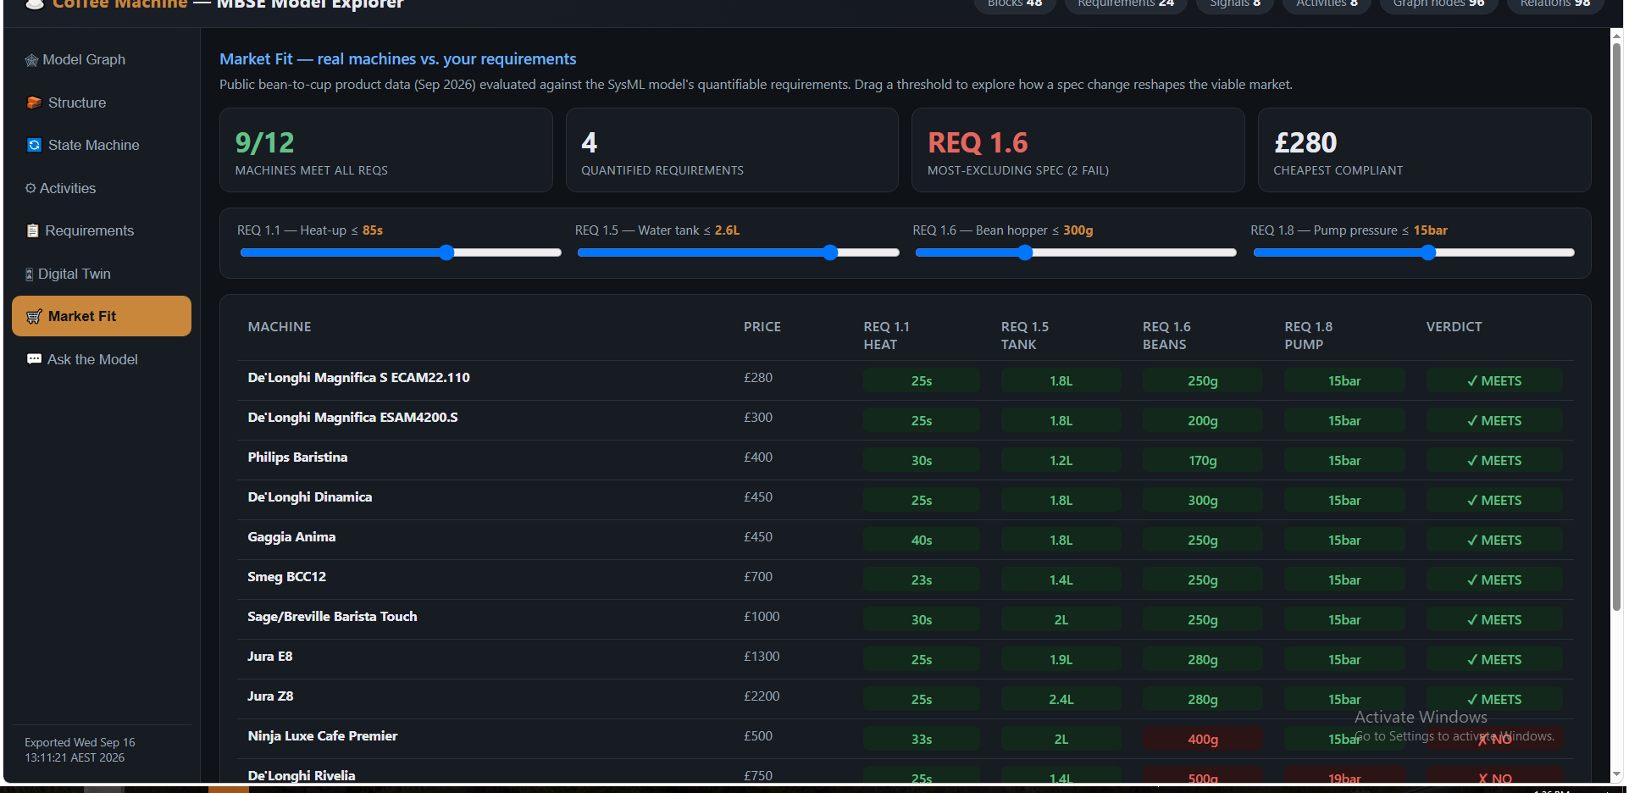
Market-fit / sensitivity view: extracted requirements vs real product data, showing which machines pass and which requirement is the binding constraint.

11 Local LLM — “Ask the Model”
To make the model approachable for non-modellers, we added a chat that answers natural-language questions grounded in the exported model. It runs entirely locally against Ollama (qwen2.5:1.5b) — no internet, no data leaving the machine — with the exported JSON provided as context. You can ask “what states can the machine be in?” or “which requirement covers water heating?” and get answers from the model itself.
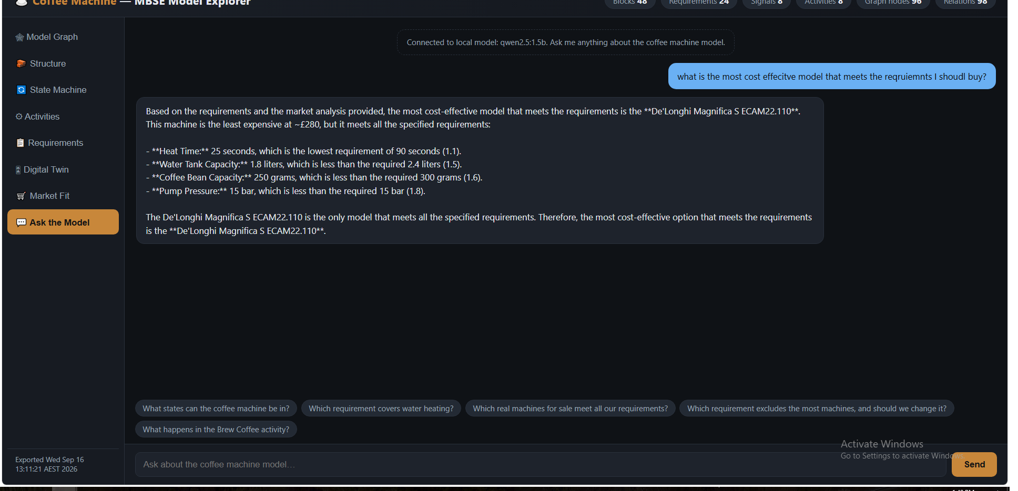
The “Ask the Model” chat: a local LLM answering questions grounded in the SysML model.

12 Ontology explainer (bonus)
A light-hearted extra: an ontology page that uses the coffee machine to show, concretely, what an ontology is (classes, instances, relationships and inferred facts) — a handy way to settle the recurring “what exactly is an ontology?” debate with a worked example rather than a definition.
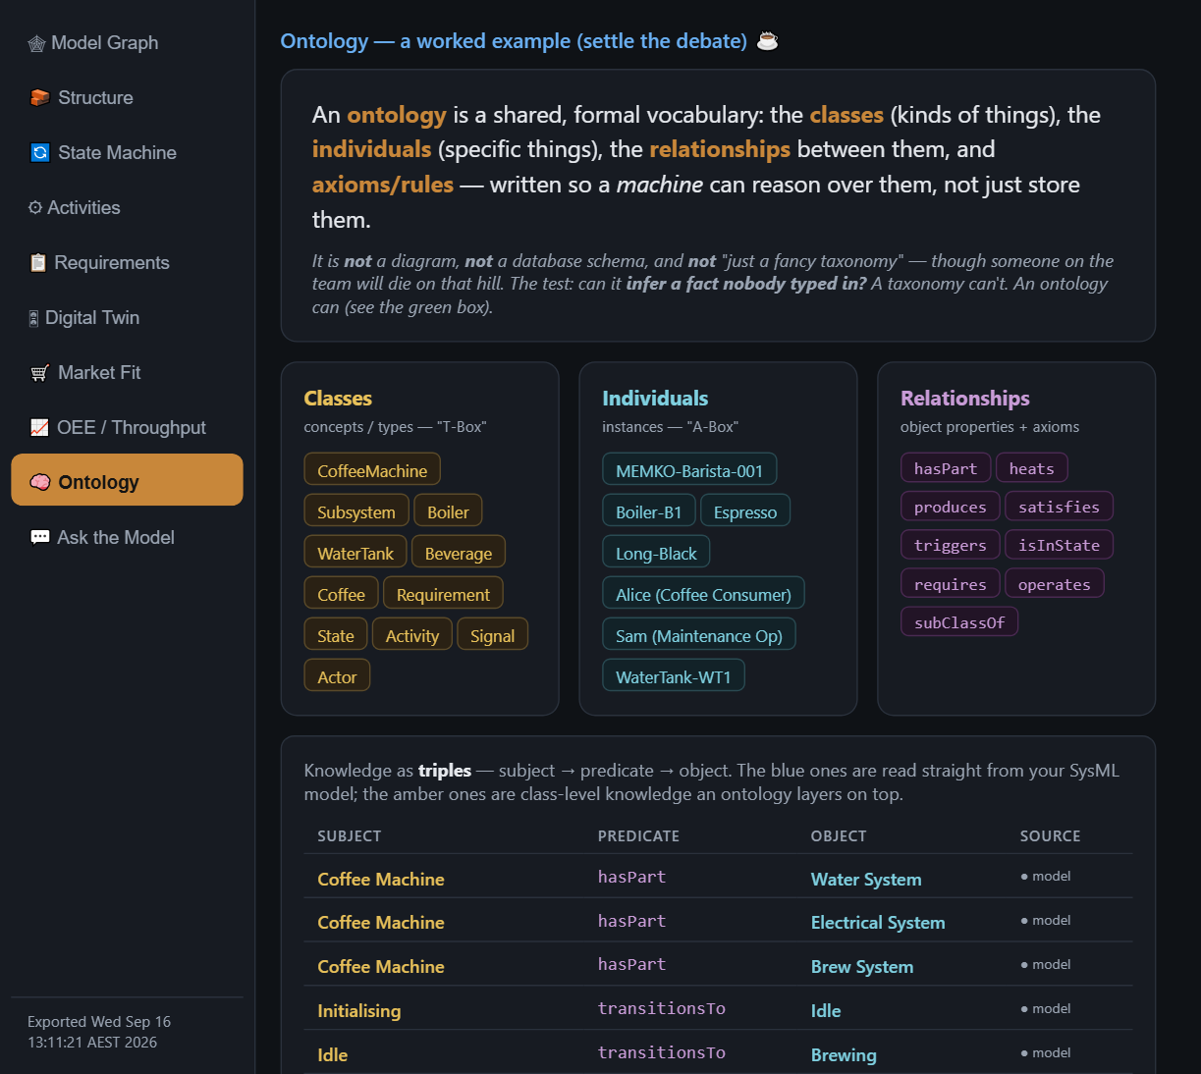
The ontology explainer built from the coffee-machine model.

13 Integration patterns & lessons learnt
Reusable patterns from this work:
- Script the modelling tool, don’t click it. Groovy OpenAPI + sessioned edits made the model repeatable and repairable; the GUI was only ever for looking.
- Export to an open format early. One self-describing JSON decoupled every downstream capability from the tool and its licence.
- Review the model as a graph. Connected-component analysis finds integration gaps that diagram reviews miss — check components, not just orphans.
- Behaviour allocation is where models silently fragment. States referencing placeholder behaviours instead of the real activities was the single biggest source of disconnection.
- A digital twin makes requirements tangible. Running the state machine + physics turned static requirements (84 °C at 90 s; RCD on dispense) into things you can watch pass or fail.
- Bring external data in for trade-offs. Requirements gain decision value when checked against real market data; sensitivity analysis then points at the spec to change.
Lessons / gotchas:
- SysML associations come with two pre-made ends — set the types on the existing ends; creating new ends corrupts the model.
- Setting a state’s entry/do behaviour re-parents that activity under the state — the exporter must recurse into state-machine internals or the activities vanish from the graph.
- Serve with no-cache headers. A cached page silently hides every update — a real source of “it’s not working” confusion.
- Keep everything local. Local server + local LLM means the whole solution runs offline, which matters for controlled networks.

14 Rebuilding & deploying on a controlled network
Everything here is designed to run offline on a locked-down machine. What a colleague needs:

Prerequisites
Component | Requirement
Modelling tool | CATIA Magic / Magic Systems of Systems Architect 2026x (to open/edit the .mdzip and run the Groovy macros)
Runtime | Windows + PowerShell 5.1 (built in) — runs the two tiny local servers
Python | Python 3.12 (only to re-generate this document / the standalone; not needed to run the app)
Local LLM (optional) | Ollama + a small model such as qwen2.5:1.5b, for the “Ask the Model” chat
Browser | Any modern browser (Edge/Chrome)

Ports used (all localhost)
Port | Purpose
8000 | static web server for the portal (serve.ps1)
8001 | optional screenshot upload endpoint (upload_server.ps1)
11434 | Ollama local LLM API (optional)

Steps to stand it up
1. Open the model (CoffeeMachine-SysML-Model.mdzip) in CATIA Magic. Re-run export_model.groovy to produce a fresh coffee_machine_model.json if you have changed the model.
2. Unzip CoffeeMachine-App.zip. In that folder run:
powershell -ExecutionPolicy Bypass -File .\serve.ps1
# then browse to http://localhost:8000
3. (Optional) Install Ollama, pull a small model, and run “ollama serve” for the chat.
4. To show someone quickly with zero setup, just open CoffeeMachine-Showcase-standalone.html by double-clicking it — the model is inlined, so it needs no server and no model file.

Controlled-network / security notes
- No external services are required at runtime. The portal, the servers and the LLM are all localhost.
- The only outbound references are the illustrative product URLs on the market-fit page; they can be removed for a fully air-gapped build without affecting any analysis.
- The local servers bind to localhost only and serve a fixed folder; the upload endpoint is optional and only needed for re-capturing screenshots.
- The LLM is a local model file — prompts and model data never leave the machine.
- No admin rights are required: Python, Ollama and the LibreOffice we used for QA all install per-user, and the servers are plain PowerShell.

15 Package contents (embedded files)
The three working artefacts below are embedded in this document as attachments. Double-click each icon to open or save it. (If your Word viewer does not show the icons, the same three files are provided alongside this document in the knowledge-pack zip.)
File | What it is / how to use it
CoffeeMachine-SysML-Model.mdzip | The complete SysML model — open in CATIA Magic. Contains the structure, state machine, activities, requirements, parametrics and all the traceability described here.
CoffeeMachine-App.zip | The full interactive portal + the two PowerShell servers + the exported model JSON + a READ-ME. Unzip and run serve.ps1.
CoffeeMachine-Showcase-standalone.html | A single self-contained file — the whole portal with the model inlined. Double-click to run offline, no server; ideal for showing people what the approach can do.


Double-click to open in CATIA Magic — CoffeeMachine-SysML-Model.mdzip

Double-click to save/unzip — CoffeeMachine-App.zip (run serve.ps1)

Double-click to save and open in a browser — CoffeeMachine-Showcase-standalone.html

