10. Below is the graph for the number of IPC and MFLOPS for both partitions. The size of the matrix used is 2000. IPC is collected by perf, and MFLOPS is calculated by taking the value of fp_arith_inst_retired.scalar_single and divide it by the time-elapsed * 10^6.
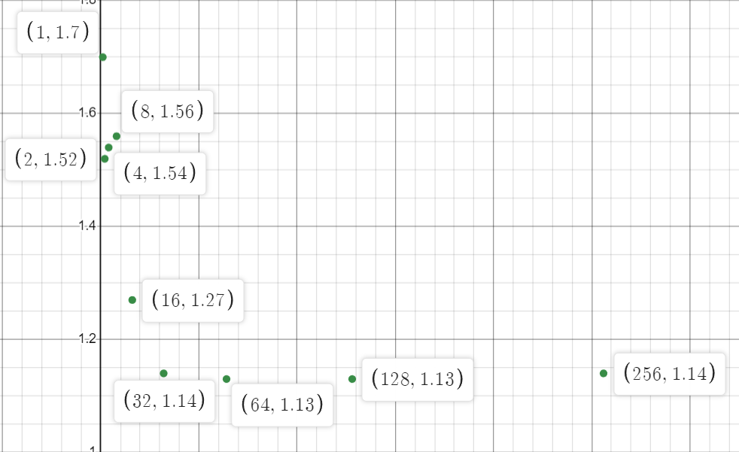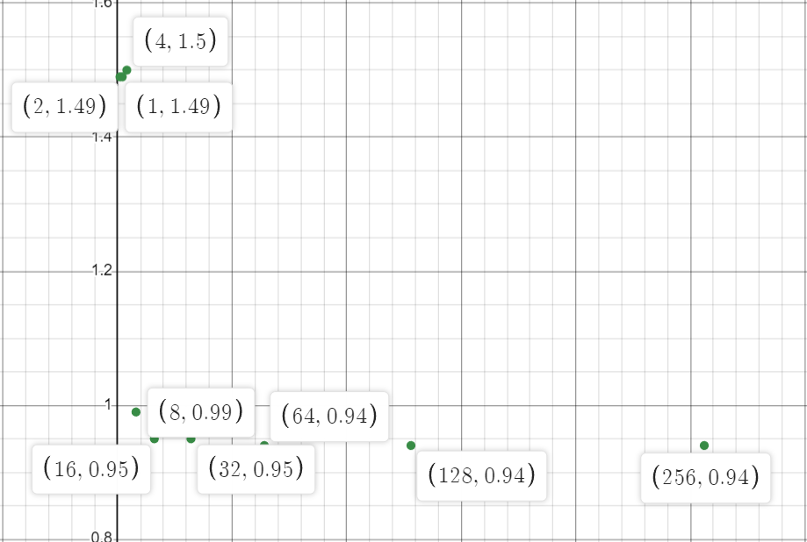
IPC (i7-7700 partition)
IPC (xs-4114 partition)

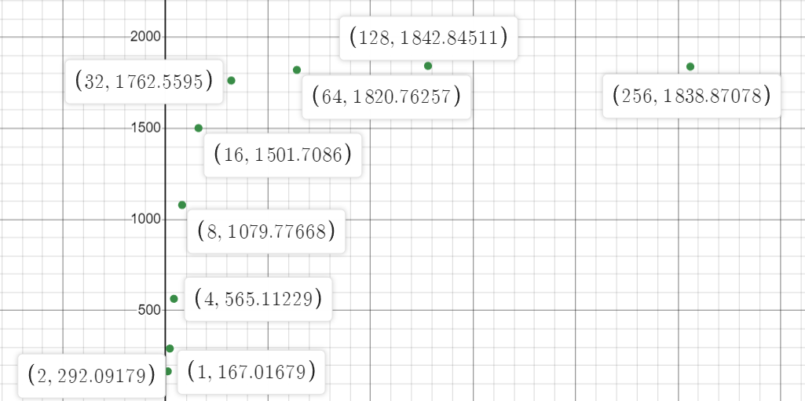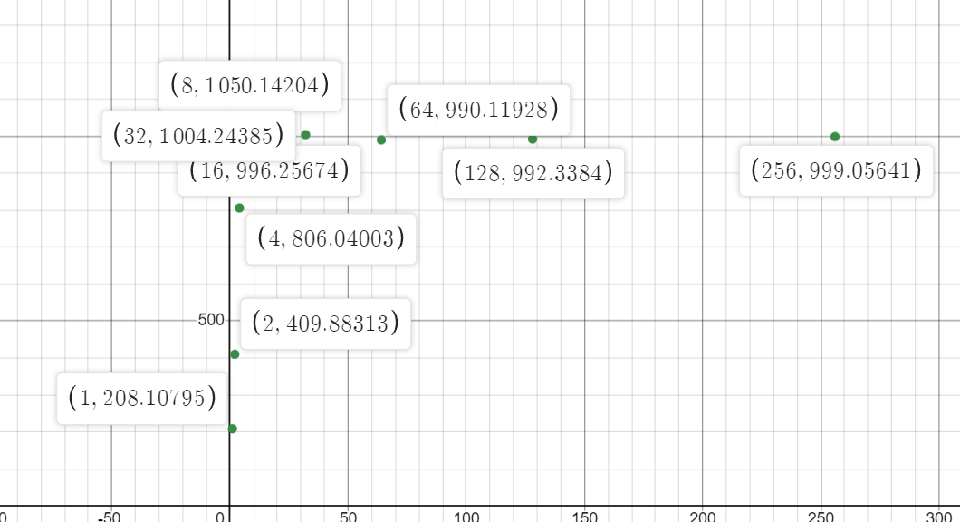
MFLOPS (i7-7700 partition)
MFLOPS (xs-4114 partition)

For IPC, both machine types yield similar results, with the i7-7700 partition having slightly less IPC across all number of threads. As the number of threads increases, the amount of IPC decreases until it plateaus after the number of threads exceed 32 for xs-4114 partition and 8 for i7-7700 partition. This might be due to some contention for cache between threads, causing memory stalls and resulting in less IPC. The reason for leveling out might be because of core saturation, as all the cores are already fully utilized and increasing the number of threads doesn’t improve the performance further.
For MFLOPS, both machine types have increasing MFLOPS with increasing number of threads, which plateaus out at the same breakpoint as IPC (for probably the same reason). The amount between the 2 machines is however very different, as the xs-4114 partition is able to execute the program almost twice as fast across all number of threads. This is expected, as the xs-4114 partition has a higher number of cores, meaning it has more computing resource to work with.

11. The idea is that we want to have A be stored in row-major order and B in column-major order. That would allow us to access the element of both A and B in the same loop and the same manner. The only difference in code from the original version is swapping the position of j and k for accessing elements of B.
for (i = 0; i < size; i++) {
for (j = 0; j < size; j++) {
result.element[i][j] = 0;
for (k = 0; k < size; k++) {
// Swap j and k for B
result.element[i][j] += a.element[i][k] * b.element[j][k];
}
}
}

12. Below is the table and graph for the time elapsed in running both version of the program on xs-4114 partition with matrix size = 1000.
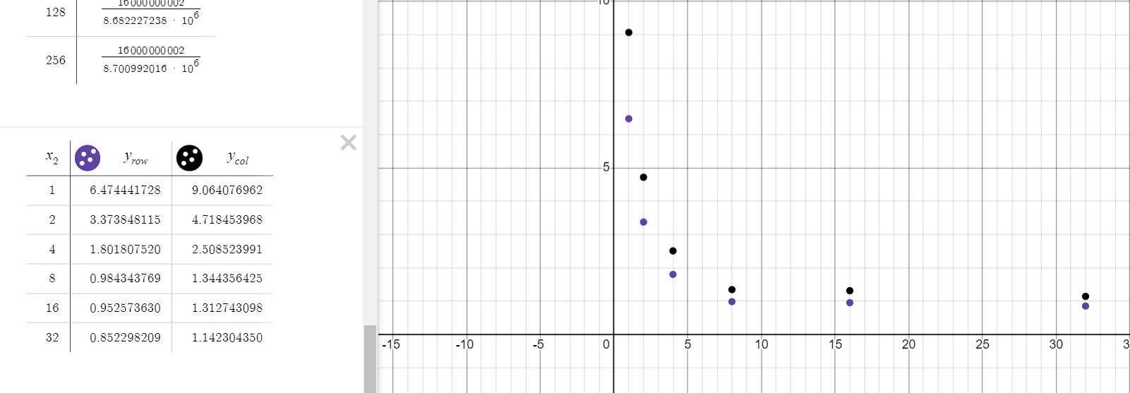
The time between the new version and the old version is quite different, with the row major version being faster across all number of threads. This is because in row-major order elements in the same row are stored consecutively. This leads to lower cache misses and thus faster execution time.

