

**NFPC JDEDBPD HEALTH CHECK REPORT**  **(24062021)**

**Tablespace storage :**

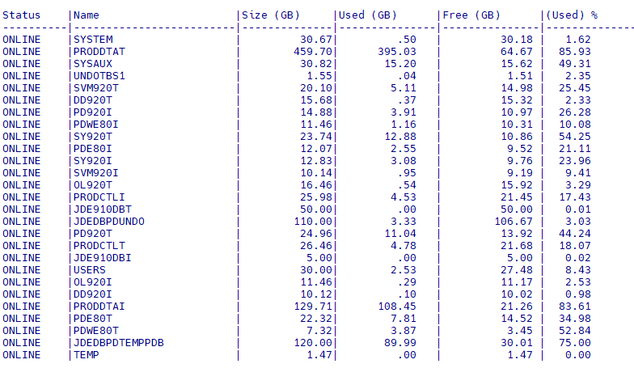.

**FAST RECOVERY AREA(FRA):**

**-**FRA storage utilized  **80%**.

- **640 GB** of FRA storage used .

-Free space available in FRA **160 GB** .

- When FRA storage reached 80 % , oracle managed the OMF files by deleting the old archive logs automatically .

fra23

**TEMP status:**

- 2.5 GB of usage in temp

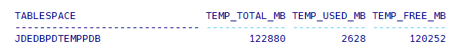

**ARCHIVE LOG GENERATION:**

- **40** **GB** of archives generated on 23-06-2021

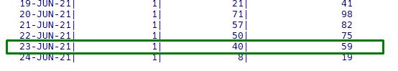

- Archives generation on hourly basis



**RMAN BACKUP STATUS :**

-Completed Incremental Level 1 Backup at **3:20 AM.**

-Time acquired to complete level 1 backup is **4 Minutes**.

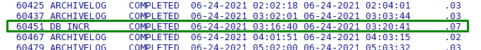

**ARCHIVE LOG BACKUP :**

-Auto backup of archive logs feature is enabled in our database .

-Oracle will take archive log backup in regular one hour intervals .

-Archive log backup completed up to 6:01 AM( GMT +4)



**DATABASE GROWTH BY TABLESPACE ( 1 DAY SPAN PERIOD):**

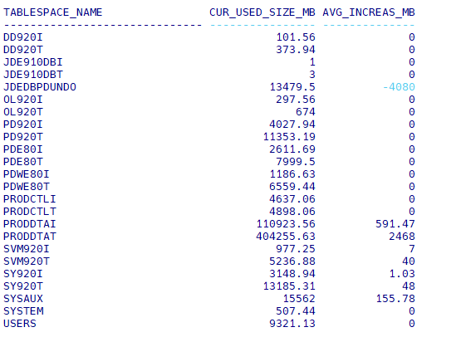

**ASM storage :**

-No changes in Diskgroup

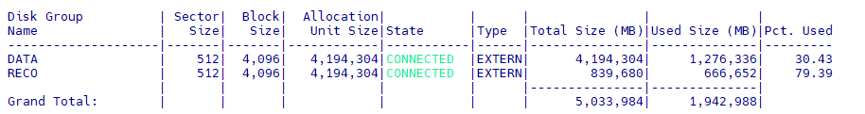

**UNDO STATUS:**

- Undo is fine.

