|  |  |
| --- | --- |
| Ex. No: 02 | **Study of Network Devices** |
| Date: 19/12/2024 |

# Objective(s):

To understand working principle of network devices Hub, Switch, Routers and configure the following using Cisco Packet Tracer

a) Building a Peer-to-Peer Network.

Design a Peer-to-peer network with minimum of 3 PC's and verify the connectivity from both the ends using Packet Tracer.

1. Design a Simple LAN Network

Create a Simple LAN deign with 1 switch, 4 PC's, 2 laptops and verify the connections from all the ends using Packet Tracer.

# Introduction:

Study of following Network Devices in Detail

* + Repeater
  + Hub
  + Switch
  + Bridge
  + Router
  + Gate Way

# Theoretical Background:

To know more about the above network devices, Refer textbook for detailed explanation.

# a) Building a Peer-to-Peer Network with at least three hosts Objective(s):

Design a Peer to peer network with minimum of 3 PC's and verify the connectivity from both the ends using Packet Tracer.

# Theoretical Background:

In Peer to Peer architecture every node is connected to other node directly for exchanging information instead of connected to central server Every computer node is referred as peer and they do the job of client as well as server both. Every peer provides services to other peers as well as uses services provided by other peers.

**Sample Diagram:**

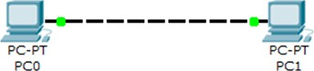

1. **Device Requirements:**
   1. PC’S -2
   2. Copper Cross Over Wire
2. **Network Diagram for your experiment (draw the diagram either hand drawing/ms paint or any other drawing tools)**

Pc 2

Pc 1

1. **Network Diagram (packet tracer diagram before configuration):**

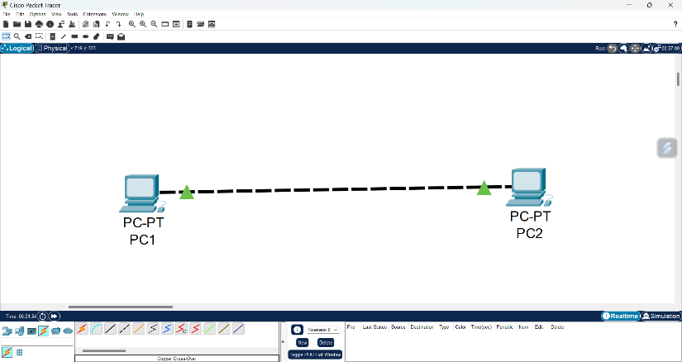

1. **Configuration details:**

|  |  |  |  |
| --- | --- | --- | --- |
| **Device Name** | **Interface Name** | **IP Address** | **Subnet mask** |
| PC1 | FA0 | 192.168.1.1 | 255.255.255.0 |
| PC2 | FA0 | 192.168.1.2 | 255.255.255.0 |
| Copper Cross Over |  |  |  |

1. **Commands used in each of the diagram (if any):**

* **Ipconfig /all**
* **ping**

1. **Output Diagram (Minimum 3 screenshot):**

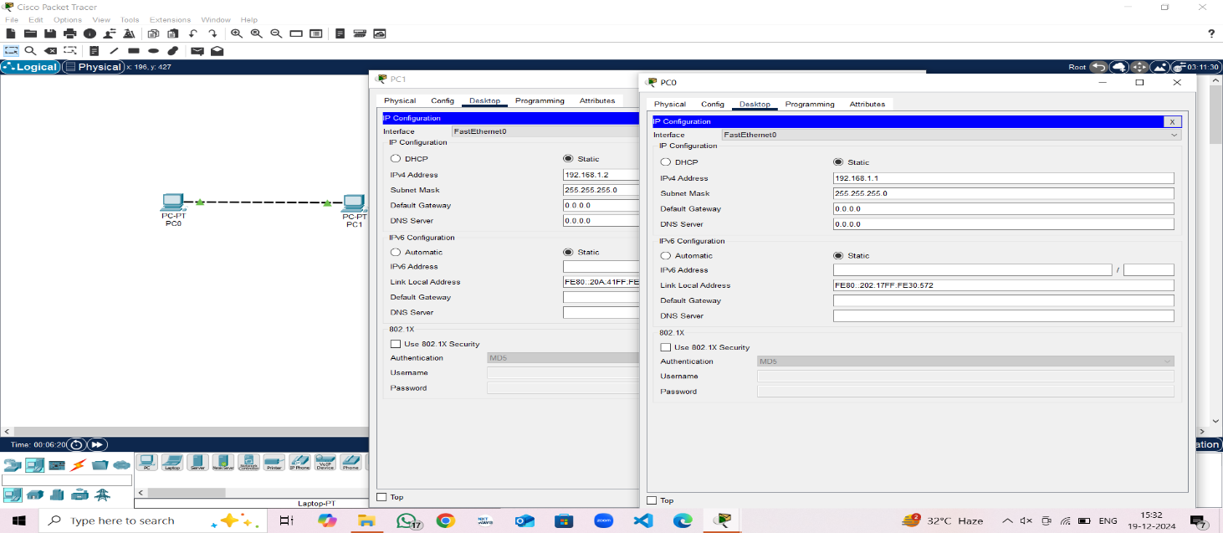

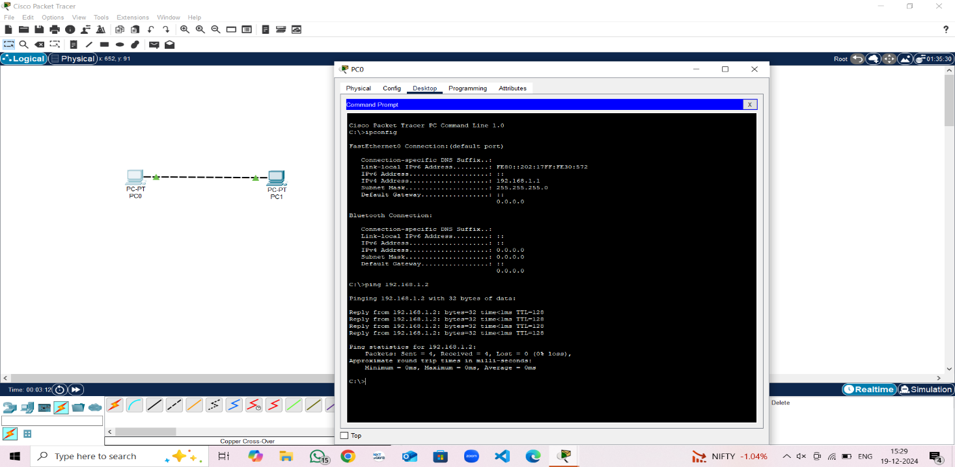

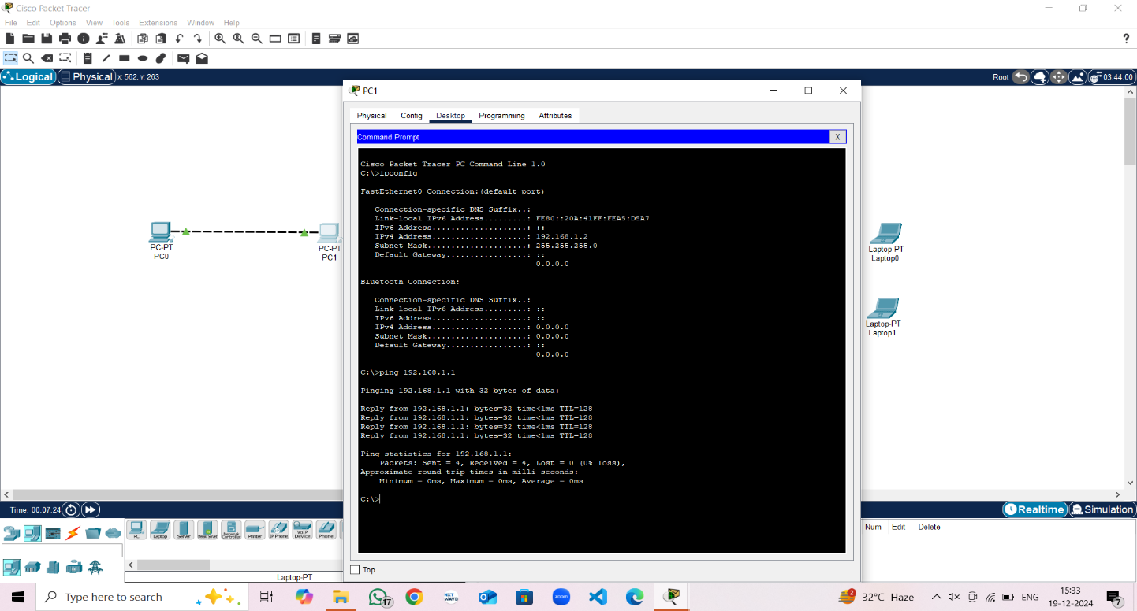

# Google Drive link of the packet tracer file (give view permission):

**Link:** <https://drive.google.com/drive/folders/1mICLKtfRjPChSrmBTMaTTVYjAdJhDwd-?usp=sharing>

**CONCLUSION (provide conclusion about this experiment):** Successfully Created a peer to peer network Using Cisco Packet Tracer

# Rubrics for Experiment Assessment:

|  |  |  |  |  |
| --- | --- | --- | --- | --- |
| **Rubrics** | **Good** | **Normal** | **Poor** | **Marks** |
| **Creation of Topology (4)** | Created the topology, Identify the proper devices  and making the connections **(4)** | Created the topology, Identify the proper devices, making the  connections but missing some features **(3)** | Created wrong topology, Failed to Identify the proper  devices and making connections **(1)** |  |
| **Verify the connectivity (4)** | Verified the connectivity in all the levels **(4)** | Verified the connectivity at some levels (only some nodes) **(2)** | Verified the  connectivity is not done. **(1)** |  |
| **Timely Completion (2)** | Completed the lab before the allotted time **(2)** | Completed the lab after the deadline **(1)** | Did not submitted before grading **(0)** |  |
| **Tota**l | | | |  |

**b). Design a Simple LAN Network. Objective(s):**

Create a Simple LAN design with minimum of 1 switch, 4 PC's, 2 laptops and verify the connections from all the ends using Packet Tracer.

**Sample Design:**

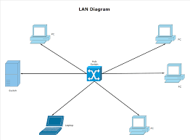

1. **Device Requirements:**
   1. Switch-1
   2. PC’s – 4
   3. Laptops - 2
   4. Copper Cross-Over
2. **Network Diagram for your experiment (draw the diagram either hand drawing/mspaint or any other drawing tools)**

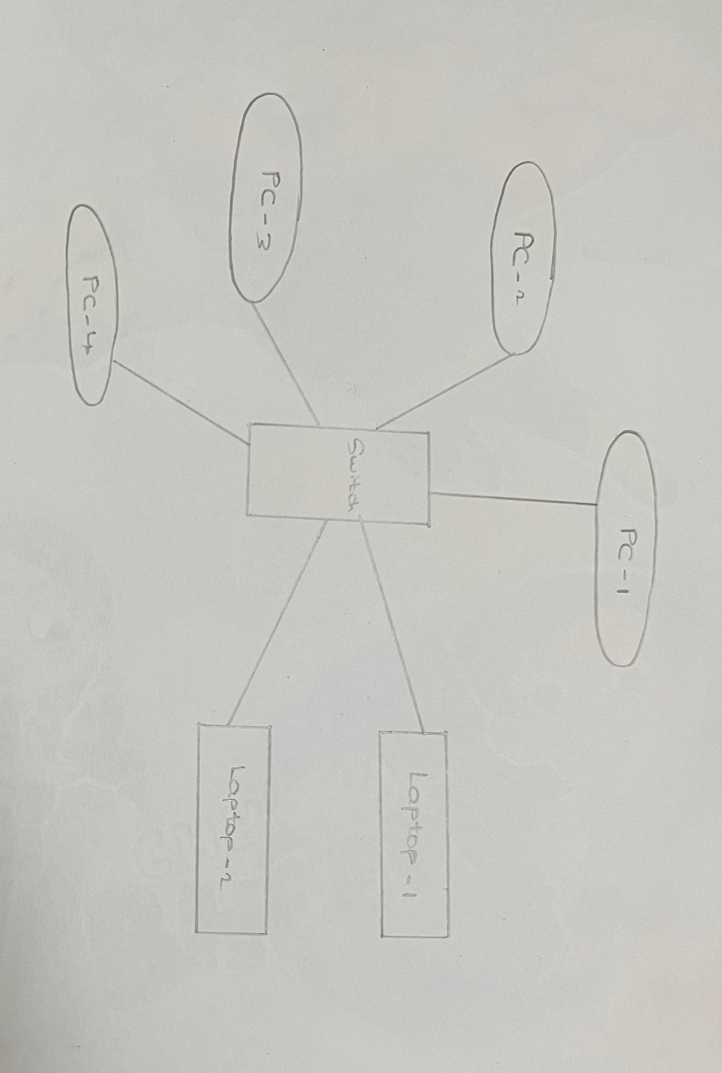

1. **Network Diagram (packet tracer diagram before configuration):**

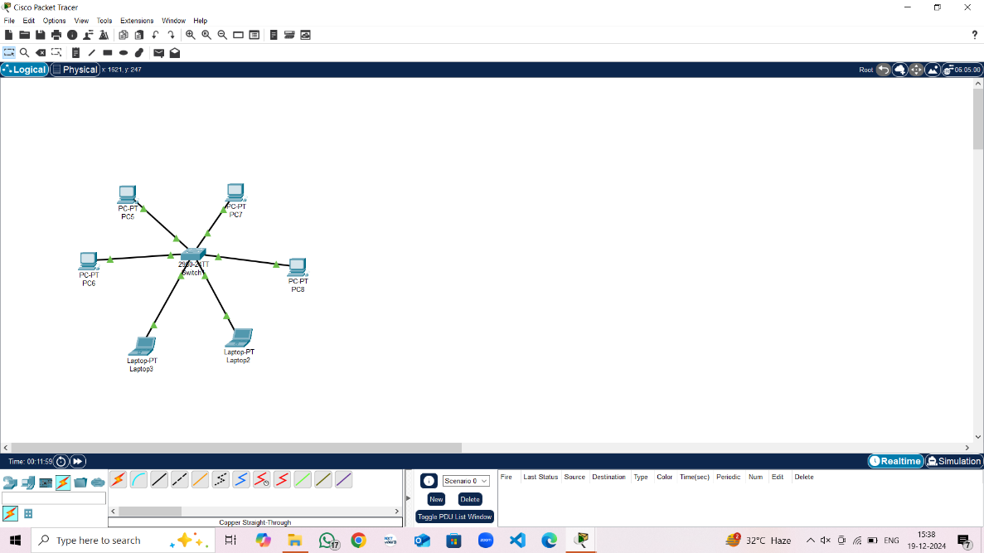

1. **Configuration details:**

|  |  |  |  |
| --- | --- | --- | --- |
| **Device Name** | **Interface Name** | **IP Address** | **Subnet mask** |
| Laptop1 | FA/4 | 192.168.1.1 | 255.255.255.0 |
| Laptop2 | FA/5 | 192.168.1.2 | 255.255.255.0 |
| PC1 | FA/0 | 192.168.1.3 | 255.255.255.0 |
| PC2 | FA/1 | 192.168.1.4 | 255.255.255.0 |
| PC3 | FA/2 | 192.168.1.5 | 255.255.255.0 |
| PC4 | FA/3 | 192.168.1.6 | 255.255.255.0 |

1. **Commands used in each of the diagram (if any):**

* **Ipconfig /all**
* **ping**

1. **Output Diagram (Minimum 3 screenshot):**

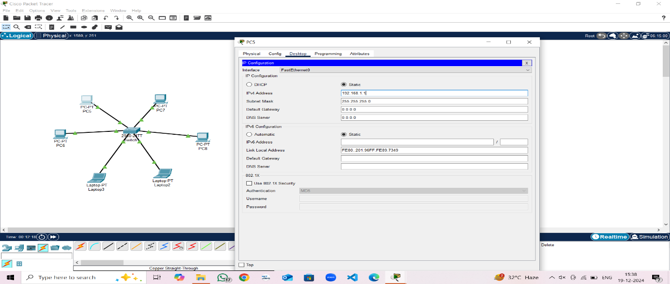

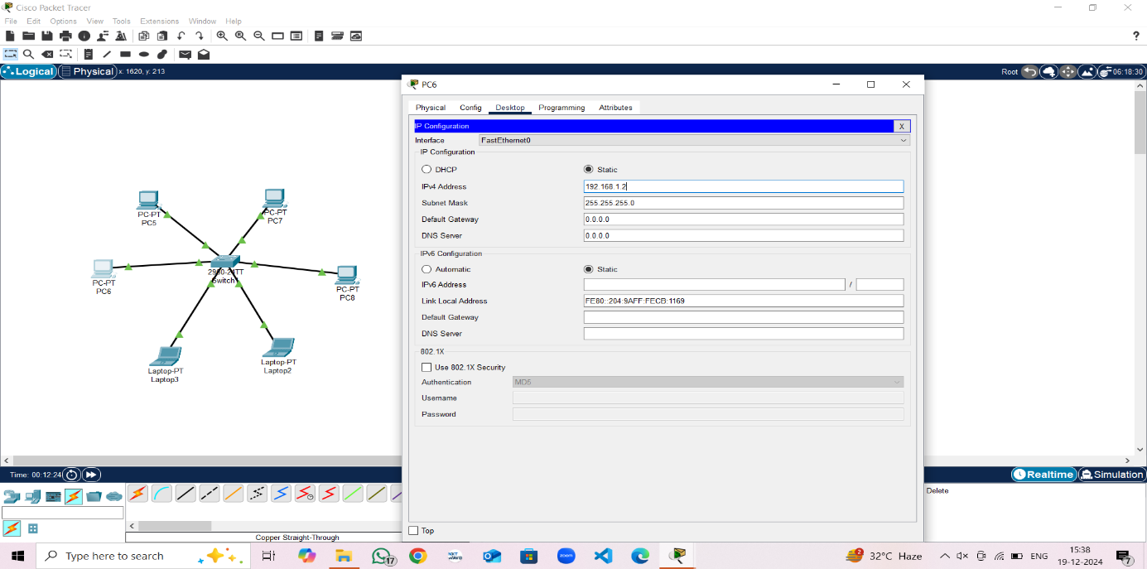

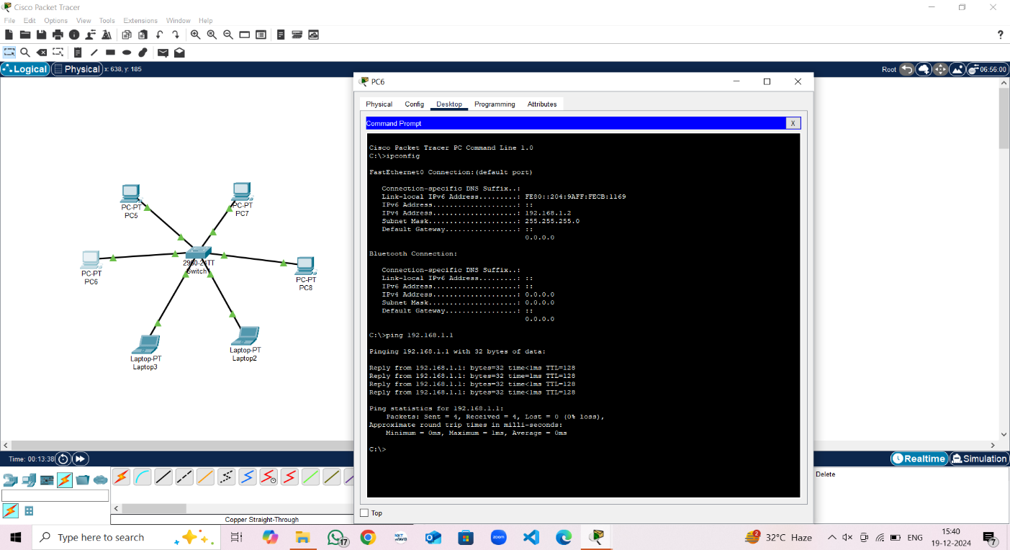

# Google Drive link of the packet tracer file (give view permission):

**Link:**<https://drive.google.com/drive/folders/1mICLKtfRjPChSrmBTMaTTVYjAdJhDwd-?usp=sharing>

**CONCLUSION (provide conclusion about this experiment):** Successfully Created and Executed a simple LAN Network using Cisco Packet Tracer

**Rubrics for Experiment Assessment:**

|  |  |  |  |  |
| --- | --- | --- | --- | --- |
| **Rubrics** | **Good** | **Normal** | **Poor** | **Marks** |
| **Creation of Topology (4)** | Created the topology, Identify the proper devices and making the  connections **(4)** | Created the topology, Identify the proper devices, making the connections But missing  some features **(3)** | Created wrong topology, Failed to Identify the proper devices and making  connections **(1)** |  |
| **Verify the connectivity (4)** | Verified the connectivity in all the levels **(4)** | Verified the connectivity at some levels (only some nodes) **(2)** | Verified the  connectivity is not done. **(1)** |  |
| **Timely Completion (2)** | Completed the lab before the allotted time **(2)** | Completed the lab after the deadline **(1)** | Did not submitted before grading **(0)** |  |
| **Tota**l | | | |  |