# Overview

Final project for JS300 is a React app that allows users to browse a library of public workouts, create a public workout, and create a private workout regimen of workouts. The app provides a collaborative platform to define workouts and a private area to tailor a specific collection of those workouts into a regimen for the user.

# Pages

## Workout Library

The index page provides and interface to browse the workout library( I am considering a carousel just for sport)

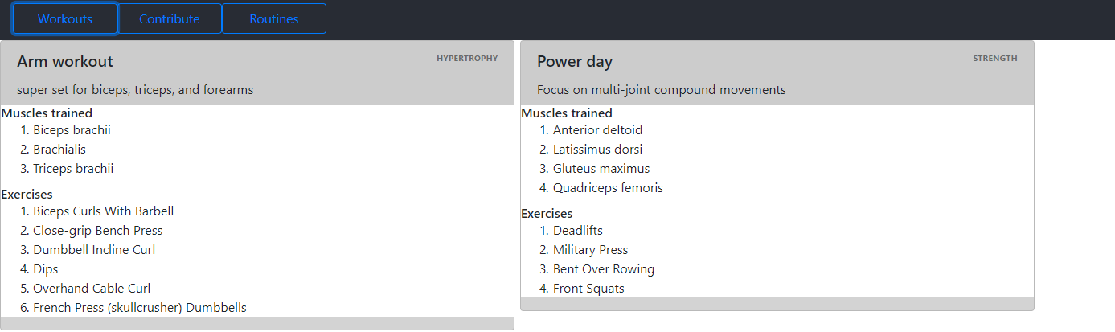

## Contribute workouts

Allows users to create a workout. The app loads available muscle groups from API into multi-select from API, then conditionally adds exercises to the exercise dropdown that apply to those muscle groups

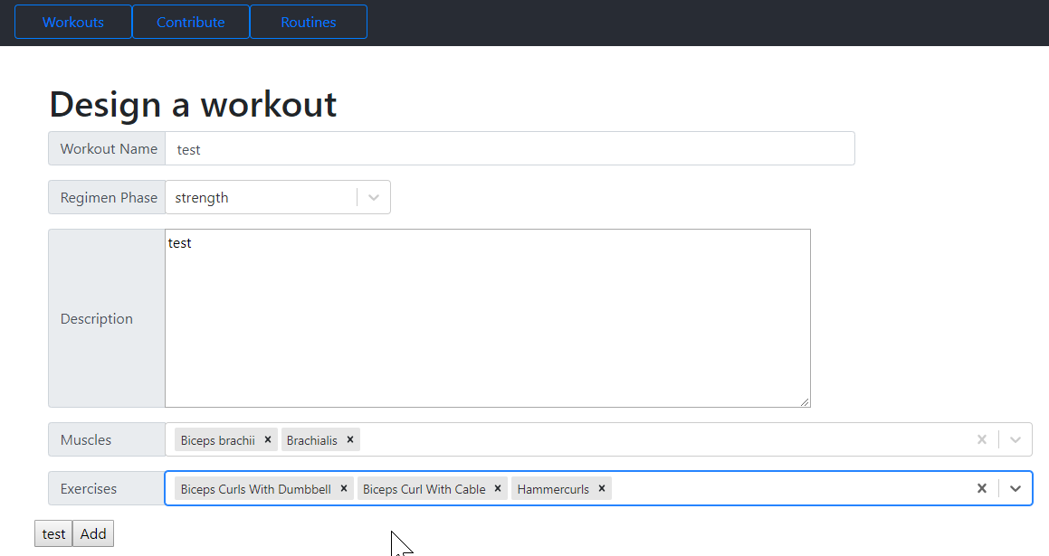

## Create a routine

Create an interface for a user to map out a schedule for a week by selecting workouts from the library. I have not yet decided how to implement this yet.



## Dependencies

"dependencies"**:** {  
 "bootstrap"**:** "^4.3.1"**,** "firebase"**:** "^6.0.2"**,** "react"**:** "^16.8.6"**,** "react-bootstrap"**:** "^1.0.0-beta.8"**,** "react-dom"**:** "^16.8.6"**,** "react-firebase"**:** "^2.2.8"**,** "react-fontawesome"**:** "^1.6.1"**,** "react-router-dom"**:** "^5.0.0"**,** "react-scripts"**:** "3.0.1"**,** "react-select"**:** "^2.4.3"**,** "prop-types"**:** "latest"

API: <https://wger.de/en/software/api>

## Tasks

* Define a workout
  + Read source data from api
  + Display form in UI
  + Capture data in state and write to firebase
* Display a workout
  + Read from firebase
  + Display in UI
* Define a regimen
  + Authenticate
  + Read workouts from firebase
  + Display in UI
  + Define regimen in UI
  + Capture regimen data
  + Write to firebase