CPSC 1181, Assignment 1

Objectives

- Obtain computer account ids and change passwords.
➢ Set up the Java computing environment.
➢ Write a small Java program.

Requirements

Part 1 - Get your ID
Using the web registration system, obtain your computer account and password. Login and change your password to something more appropriate, something you can remember but no one else can guess.

Part 2 - Set up your Java environment
For Assignment1 and Assignment2 you should use the IDE (Integrated Development Environment) that you are familiar with.

Part 3 – Write a small Java program.
- Write a Java program to accept a person’s name, his/her height (in inches), and his/her weight (in pounds); convert height to centimeters and weight to kilograms and display the result. The input should be entered in one line. The input name, height and weight must be separated by a comma.
- Please note that 1 inch = 2.5 centimeters and 1 pound = 0.45 kilograms.
- Use a procedural, structured programming style with a top-down design that breaks the problem into smaller problems. Use methods.
- Document your class and methods appropriately using the javadoc notation. You do not need to submit the documentation files resulting from having run javadoc.
- Use the methods in JOptionPane class for reading input and displaying output as follows:

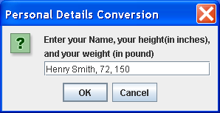

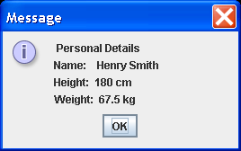

- Come up with a test plan once you have understood the simple problem. Write out specific test cases (i.e. inputs and expected outputs and the reason why you have chosen such inputs). Consider border line cases and some typical cases.
How should you treat a negative height/weight? Do not concentrate on erroneous input but write what type of input you expect, for instance, you can assume that the height and weight are numeric values. If you enter values that are not numeric by mistake, your program will cause an exception and you will have to restart your program. That would be OK for this assignment.
A test plan
- lists input values
- the reasons for choosing these input values
- has expected outputs
- has the actual results of your program.
With a test plan, you can compare and see if the results of your program match the expected outputs that you worked out by hand. You can use a test plan to debug (i.e. find errors) in your program. After you have programmed the solution, put the actual outputs produced by your program into the test plan. Explain the discrepancies between your original test plan “expected outputs” and your actual results. Also, add input cases that you might have forgotten in your original test plan and indicate why you think that they should be included even though you had not put them in originally (white box testing).
To submit with Blackboard CE:
- A text file or a Word document named using your Novell id and this assignment number with
  - your test plan
  - comments about your assignment (if needed)
- Your program Java files, source code (.java file) and the byte code (.class file).

