Kyra Samuel

CMIS 242

Assignment 1

03.29.2021

# Tests

## Case 1

1. **Selection 1: on repeat (1)[1]**

* Add two books

1. **Selection 4**

* Display Books

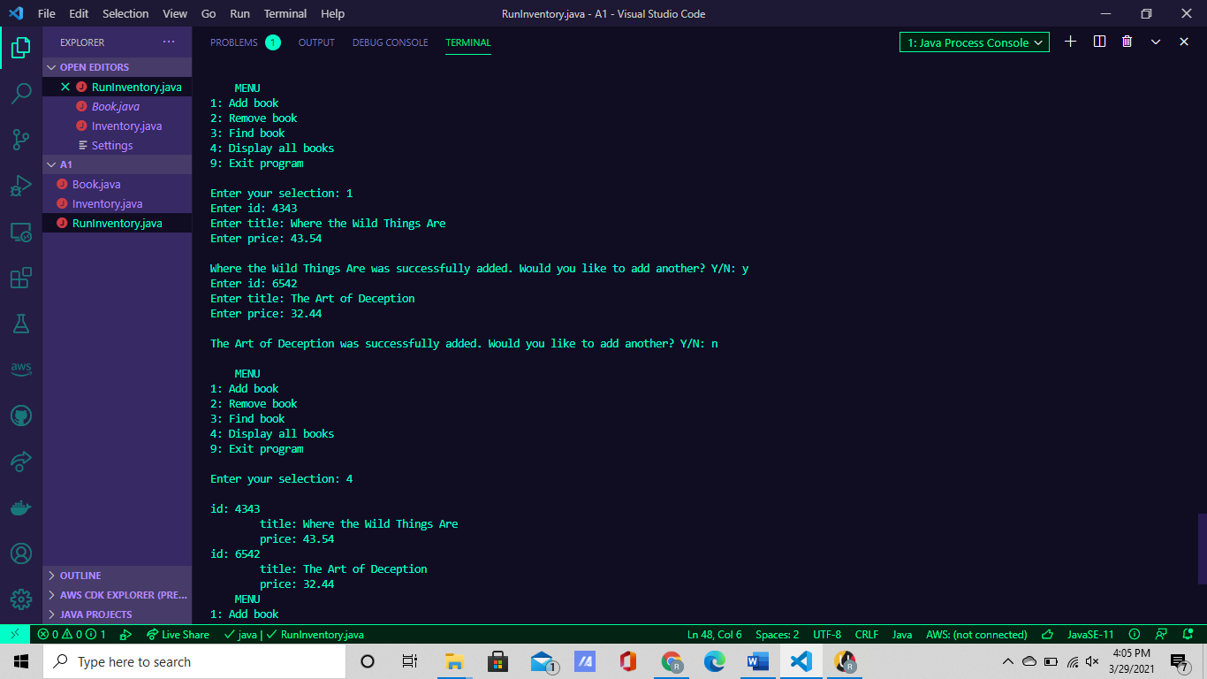

## Case 2

1. **Selection 1: on repeat (2)**

* Add three Books

1. **Selection 4**

* Display Books

1. **Selection 2**

* Remove a Book (id=1002)6

1. **Selection 4**

* Display Books

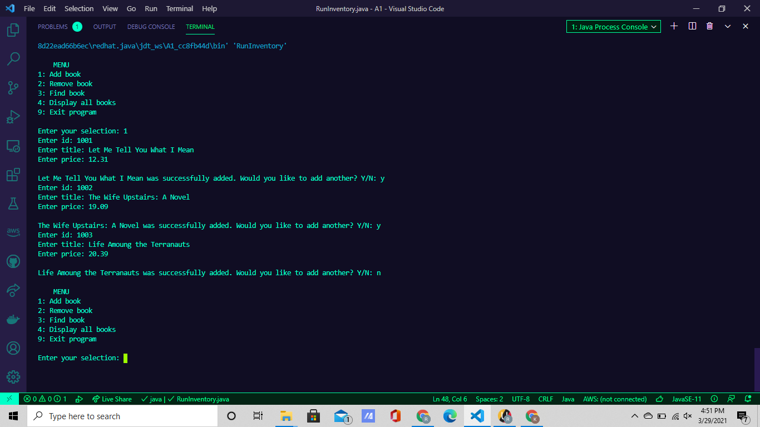

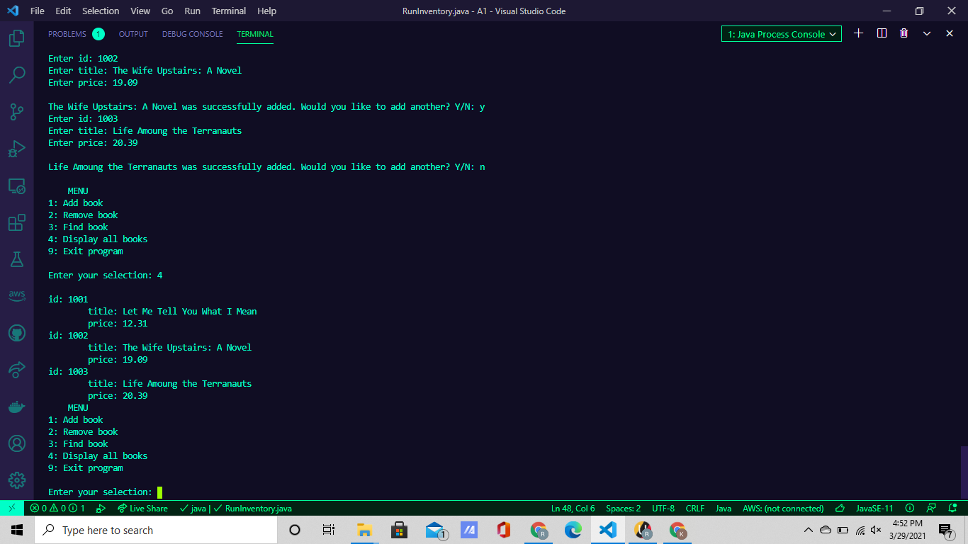

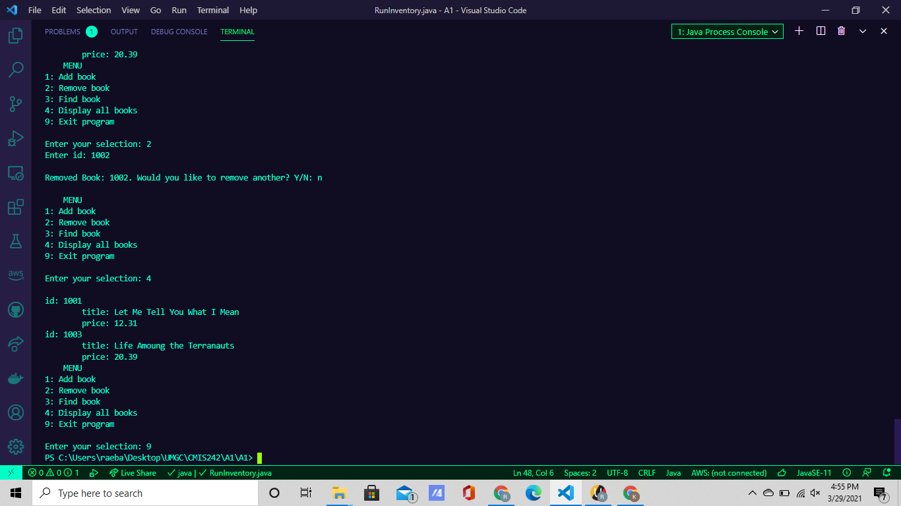

## Case 3

1. **Selection 1**

* Adding a Book

1. **Selection 3**

* Finding a Book (id=3000)

1. **Selection 9**

* Ending Program

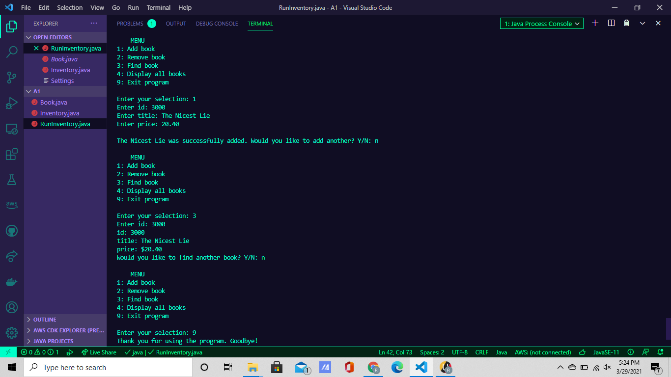

## Case 4

1. **Selection 2, Selection 3, Selection 4**

* Error Check**:** no books have been entered yet

1. **Selection 1 on repeat (3)**

* Add 3 Books with Error Check
* Error Check**:** invalid integer value for id.

1. **Selection 3 on repeat(2)**

* Finding 2 Books with Error Check
* Error Check**:** id not found

1. **Selection 4**
2. **Selection 2 on repeat(1)**

* Remove 2 Books **(id=3032, id=3031)**

1. **Selection 4**

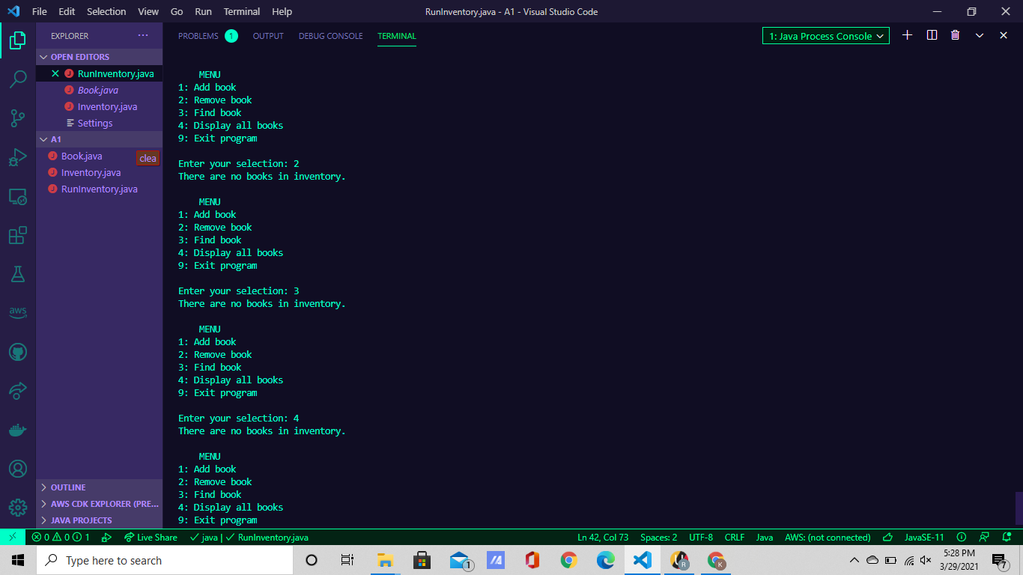

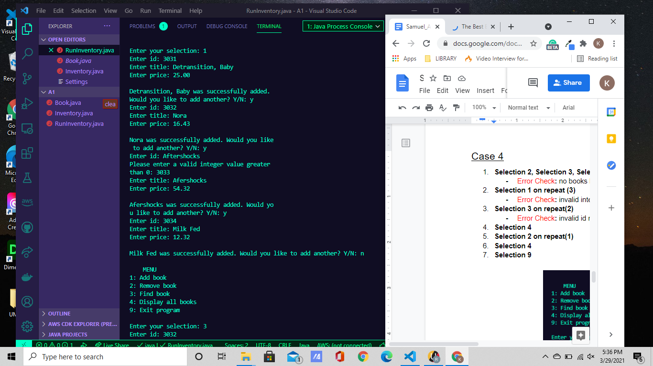

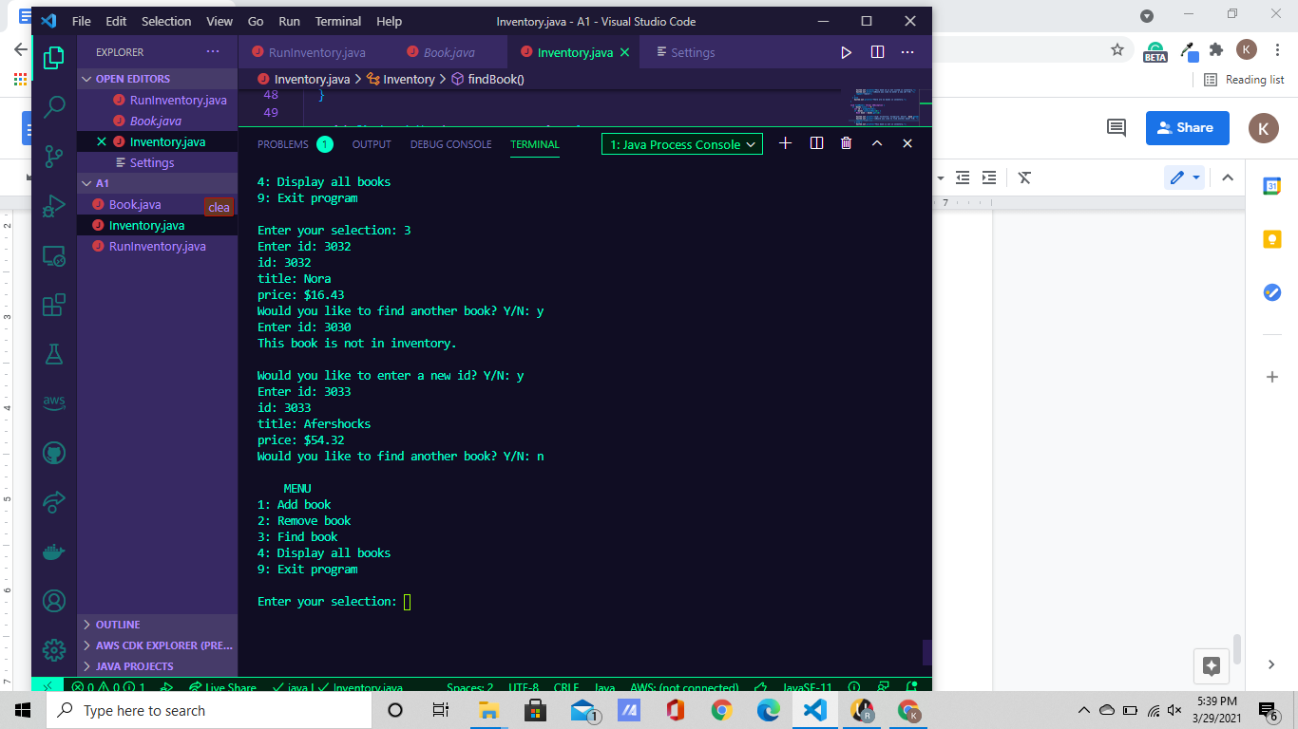

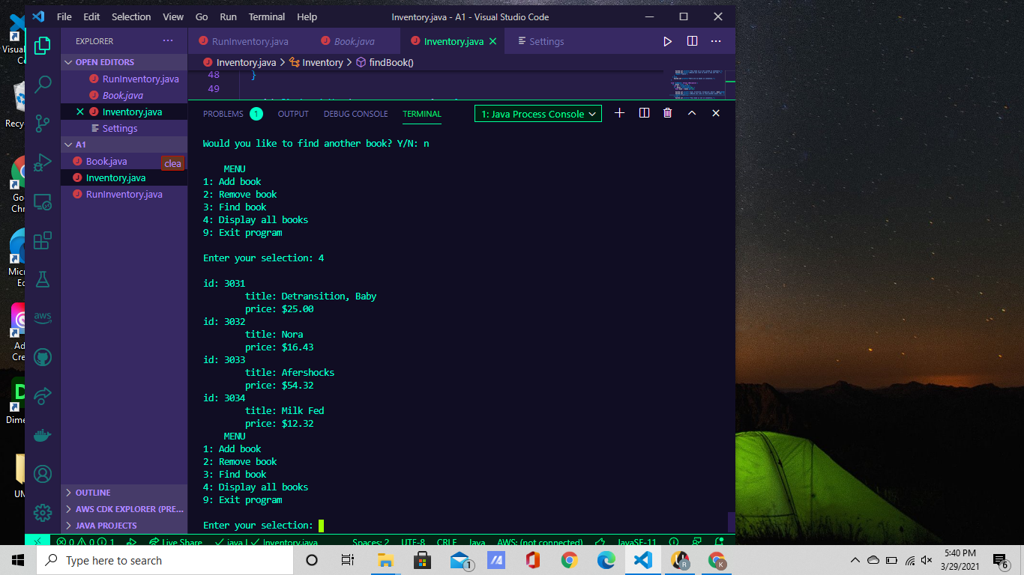

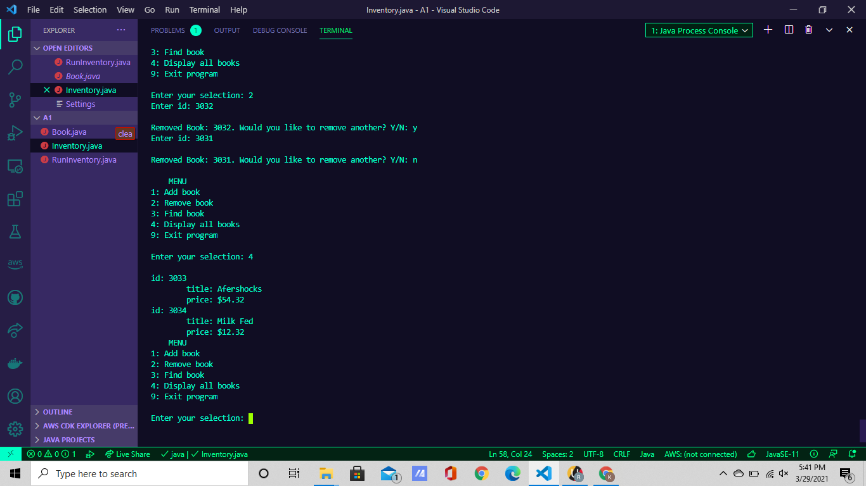

## Case 5

1. **Invalid Selection**
2. **Selection 4**
3. **Selection 9**

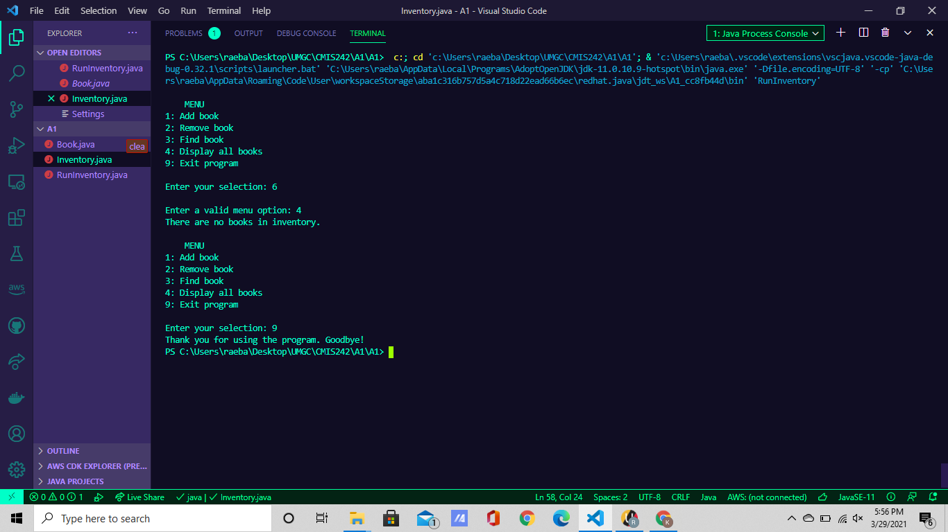

## Case 6

1. **Selection 1 on repeat (2)**

* Error Check: Invalid price input
* Error Check: same id found

1. **Selection 4**
2. **Selection 3**

* Error Check: no id found

1. **Selection 4**
2. **Selection 9**

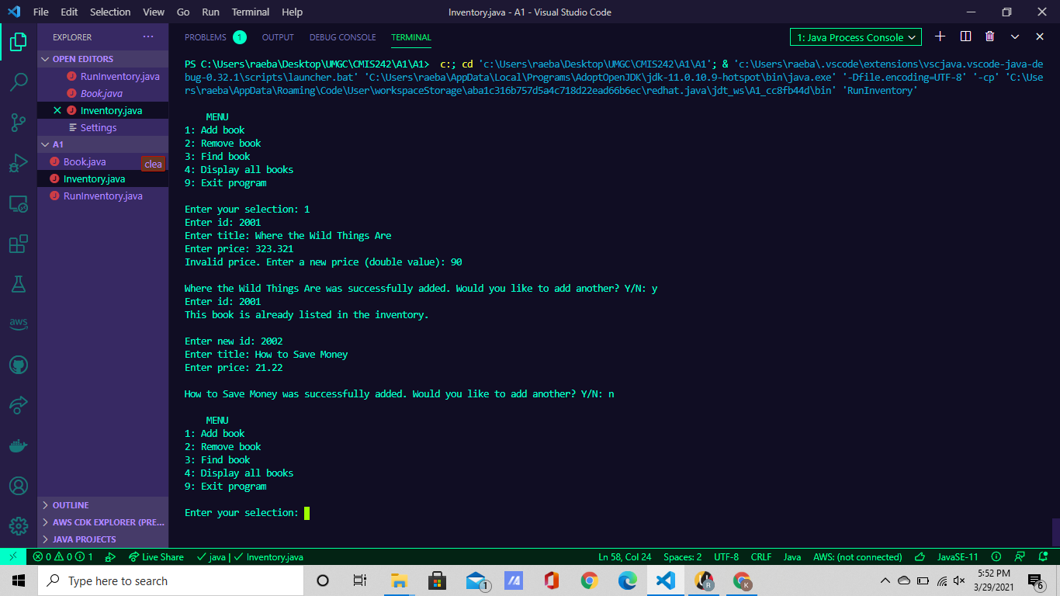

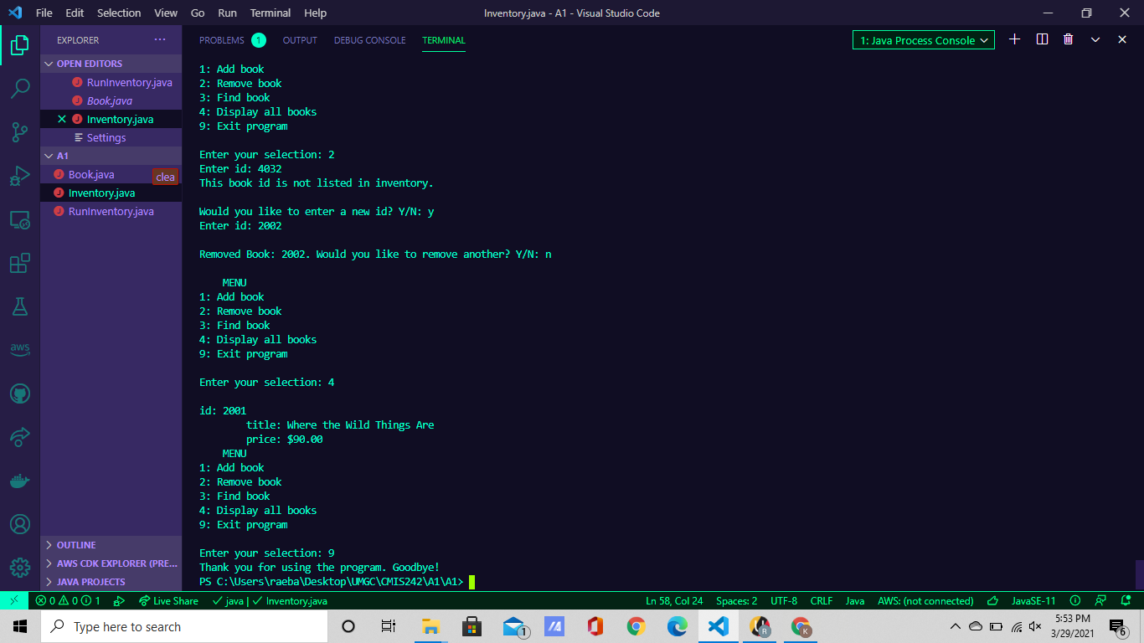

1. The user enters “y” or “Y” (x) times for adding, removing, or finding another book.