Kyra Samuel

CMIS242

05/11/2021

Homework 4

# Guide:

* View readMe.md in FP folder for correct .txt syntax.

# Tests:

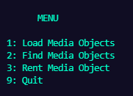

## Load Media Objects

### Initial Start-Up

* On first run, the user is prompted to select a .txt file from the provided FileExplorer panel.
* If .txt file is valid, the Media objects are printed, else, an error message is printed to the console.

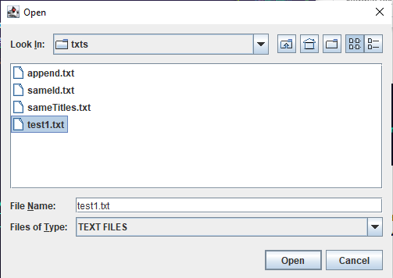

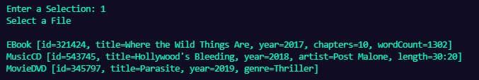

### Previous Media Objects Loaded

* If media objects have already been loaded by the Manager, the user is prompted to choose “1” or “2” to merge or overwrite the current ArrayList of Media objects.

#### Add to Medias

* Allows users to select a new .txt file to merge to the current Medias list then displays the new medias added.

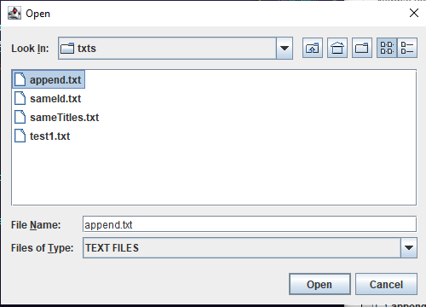

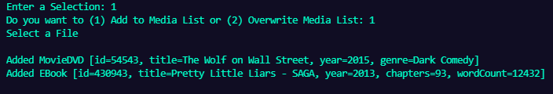

#### Overwrite Medias

* Allows users to select a new .txt file to overwrite medias list then displays the new medias list.

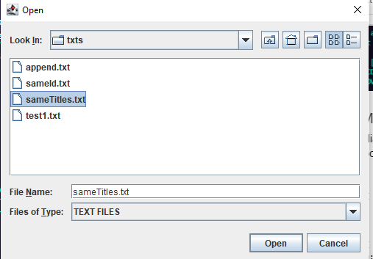

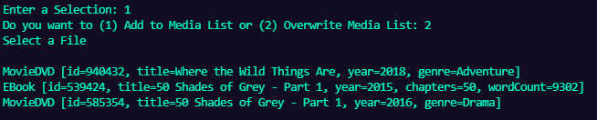

## Find Media Objects

* The user is prompted for a title then displays the results if the title is found in the medias list.
* If the title is not found, an error message is displayed.
* If the medias list is empty, an error message is displayed.

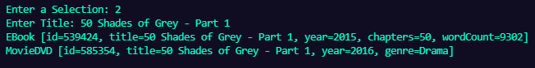

* Title found



* No title found



* No media objects in Manager

## Rent Media Objects

* Displays a list of available and out of stock Media objects (if any), the user is prompted to select an option (Media) to purchase.
* If option is a valid Media option, then the user is prompted for the quantity
* If there are enough copies of the Media object to purchase, then the price is outputted, else an error message is displayed with available copies.

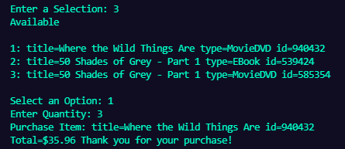

* Successful purchase example

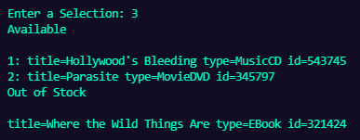

* Purchase with out of stock Media listed



* If all media is out of stock.

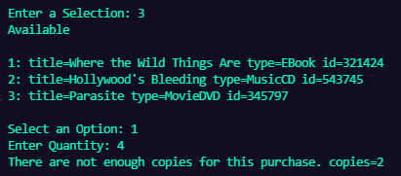

* If quantity request exceeds the number of copies

### Rent Media Objects Error Checking

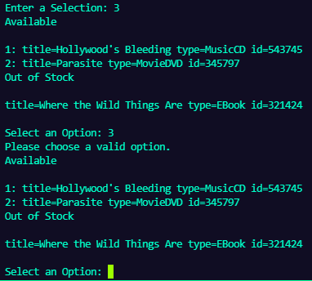

* Invalid menu option



* Invalid Quantity (only ints allowed)

## Quit



## Other Error Checks

#### Invalid .txt Syntax

#### Same ID



* Response to sameId.txt

#### Invalid Field

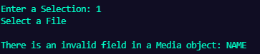

* Response to invalidFields.txt

#### Missing Fields



* Response to missingFields.txt

#### Invalid Field Data Types

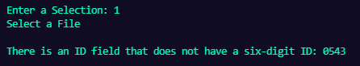

* Response to invalidId.txt

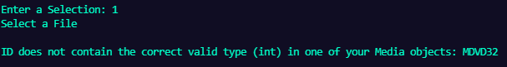

* Response to invalidId2.txt



* Response to invalidStatus.txt



* Response to invalidPrice.txt



* Response to invalidBoolean.txt

#### Invalid Brackets

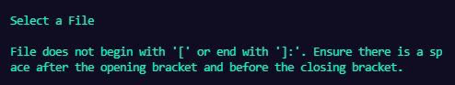

* Response to invalidBrackets.txt

#### Invalid Line Endings (no colon)

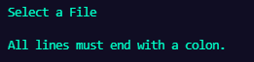

* Response to invalidColons.txt