Kyra Samuel

SDEV300

Lab One

05/17/2021

# Tests

## Successful Registration

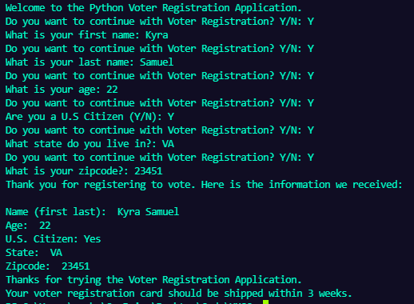

* **Zip Code 23451** - Virginia Beach, VA, USA

## Non-US Citizen Registration

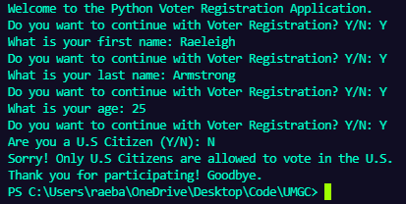

## Quitting Registration

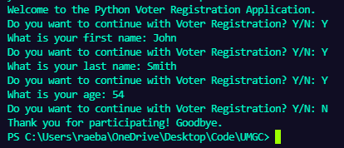

# Error Checking

## Invalid Names

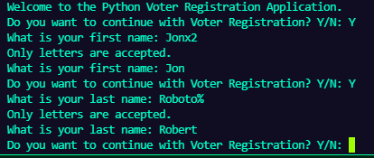

## Invalid Age

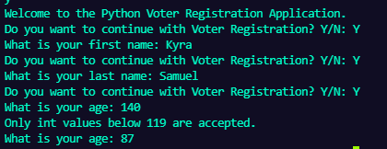

* Checks for ages below 119! [Oldest Human Alive - Google Search](https://www.google.com/search?rlz=1C1CHZN_enUS943US943&sxsrf=ALeKk01C9RuDm9wmJRVNH9YnxZK-r-ZaqQ:1621283514095&q=oldest+human+alive&spell=1&sa=X&ved=2ahUKEwjTxb_fx9HwAhVoElkFHdTNCuEQBSgAegQIARAx&biw=1366&bih=625)

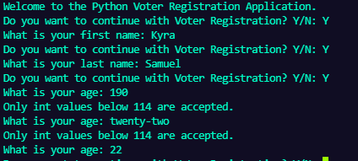

* Only int values are accepted.

## Invalid State

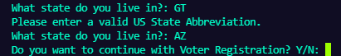

## Invalid Zip Code

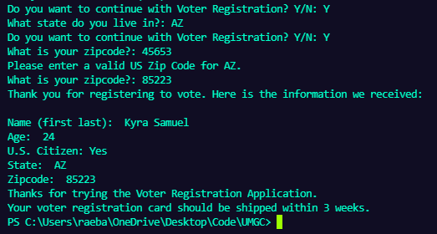

* Invalid Zip Code for State (**Zip Code 45653** - Minford, OH - Scioto County. **Zip Code 85223** - Arizona City, AZ )

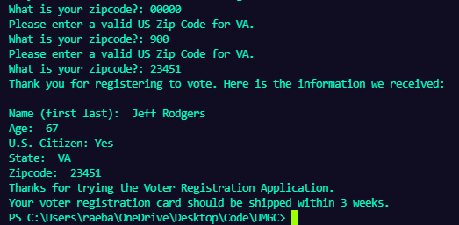

* Unidentified Zip Code



* Invalid Zip Code int type

# Pylint

## main.py

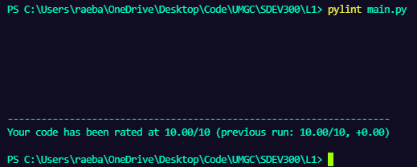

## lab_one.py

