Kyra Samuel

SDEV400

05/11/2021

Homework 4

# Guide:

* A simple ecommerce application
* The user is allowed to view and add items to cart anonymous; however, only logged in users are allowed to make purchases
* The cart is emptied after the program ends

# Test:

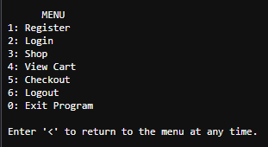

## Register

* Username must be greater or equal to 6 digits
* Password input is invisible and must be greater or equal to 8 digits!
* All usernames must be unique

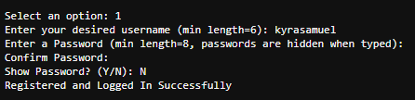

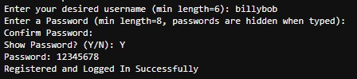

### Register - Error Checking



* User will be prompted for username if it is already in use



* User will be prompted for passwords greater than 8

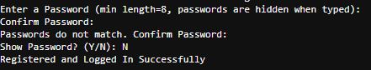

* Confirm Password must match original password

# Login

* User is prompted for username and password
* Password input is hidden!

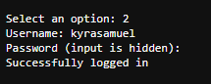

### Login Error Checking

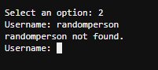

* Checks for valid usernames

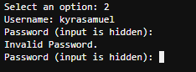

* Invalid Password Check

# Shop

* Users are prompted for a category then product. After a product is selected the user is prompted to show the product or add to cart

## Showing Products

* Displays Product Name, Price, and Link to Product Image from my public S3 Bucket
* Prompted to add to cart

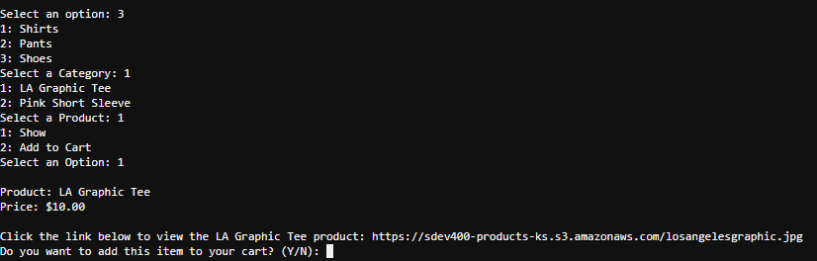



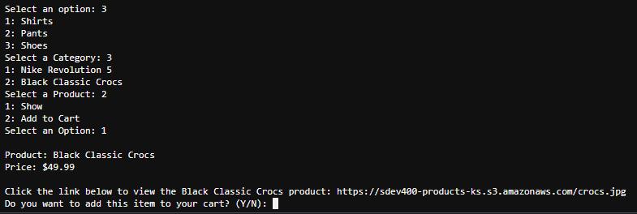



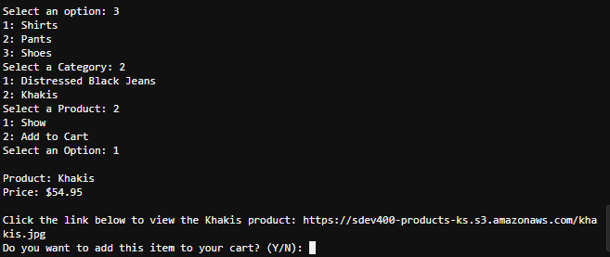



## Adding to Cart:

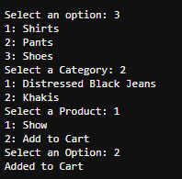

### Shop Error Checking

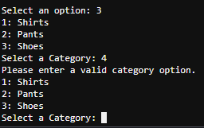

* Invalid Category Option

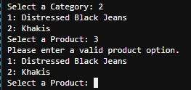

* Invalid Product Option

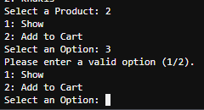

* Invalid Option for Show/Add to Cart

# View Cart

* Displays items in cart with quantity and individual prices
* Displays cart total

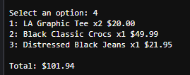

### View Cart Error Checking



* Displays message if cart is empty

# Checkout

* Displays cart total and confirms purchase

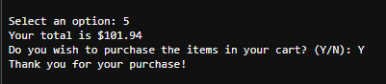

### Checkout Error Checking

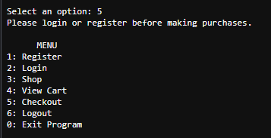

* Checking out without logging in



* Displays message is cart is empty

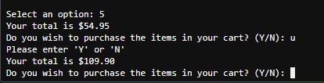

* Invalid Y/N

# Logout



# Exit Program

