Laboratory Experiment #2

Remarks: This lab exercise is made up of two parts. Please type all your data into this document. Expand space between lines as needed.

Part I: Diameter of the Sun Activity

Brief Overview of Activity: A pinhole can form an image in much the same way as a lens. Measuring the size of the Sun’s projected image and the distance between the pinhole and the image, you will be able to calculate the diameter of the Sun.

Required Items: a friend to help you, a broom handle (or mop handle or long straight piece of wood of similar dimensions), a ruler (marked in centimeters), two envelopes, a pencil, masking tape, one stick-pin.

Number of Observations needed: 1

Timing of Observations: near noon on a bright sunny day

Procedure:

Preparation: Use the stick-pin to poke a small hole near the center of one of the envelopes. Mark a location near the top of the broom handle with masking tape (this is where your friend will hold the envelope with the pin-hole). Mark another location near the end of the broom handle with masking tape (this is where you will observe and mark the image). Carefully measure the distance between your two marked locations on your broom handle. Make your measurement to the nearest 0.1 centimeter and record here: 98.75 cm.

Observation: As you read this paragraph, please see the figure shown below. Gather your friend, marked broom handle, two envelopes, pencil, and then head outside. With your friend holding the envelope with the pin-hole at the upper marked position and you holding the other envelope at the lower marked location, align the broom handle such that a small faint image of the Sun’s disk is seen on the lower envelope. You may find it convenient to actually sit on the ground for this procedure. With a pencil, carefully mark the location of opposite sides of the Sun’s disk.

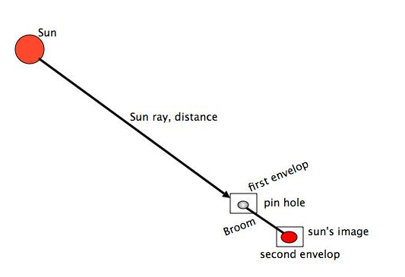

Calculation: From your marked envelope, carefully measure the size of the projected image of the Sun’s disk to the nearest 0.1 centimeter and record here: 0.96 cm.

Next, use the relationship below to calculate the Sun’s diameter in kilometers. Note that the distance to the Sun is 1.5 x 10 ⁸ km.

Sun’s diameter in kilometers image diameter in centimeters
----------------------------------------- = --------------------------------------------------
Distance to the Sun in kilometers distance between image and pin-hole in cm

X 0.96cm
----------------------------------------- = --------------------------------------------------
1.5 x 10 ⁸ km 98.75cm

0.96/98.75 * 1.5 x 10 ⁸ = x

0.00972151898 * 1.5 x 10 ⁸ = 1458227.8481cm

Record your calculated value for the diameter of the Sun 14.582278481 km

Part II – Estimate Jupiter’s Mass Using a Jovian Moon
You have learned that Kepler's third law, P² = a³, applies to any object orbiting the sun. Newton was able to derive Kepler's third law using his law of gravity. Newton's version includes the mass of both objects, P² = a³ / (M₁ + M₂), and can be used for any object that orbits any astronomical body. In this formula, the masses are measured in special units called solar mass units. The mass of the sun is equal to one solar mass unit.
If the mass of the second object is very small compared with the first mass, then, to a good approximation, P² = a³ / M₁. Solving for the mass, we get M₁ = a³ / p² . Use this mass formula to determine the mass of Jupiter using data from its moon Sinope: period of orbit is 2.075 years, average orbital distance is 0.158 astronomical units.

M = 0.158³/ 2.075²

Calculated mass of Jupiter: 0.00091608349 Solar Mass Units.

You can convert your result above into kilograms by multiplying it by the mass of the sun in kilograms: 2.00 X 10 ³⁰ kg.
Calculated mass of Jupiter: 1.832167e+27 kg

Compare your calculated mass of Jupiter (kg) to the actual value.
How close did you get? I was off 6.6833e25
Explain any difference: According to my calculations, 1.899e+27 - 1.832167e27=6.6833e25, so I supposed I am way off? I am not entirely sure, but the experiment was fun!

