**Technical Details of Recommendation to Enter the Short-Term Rental Market**

**Introduction**

I recommend that Watershed should **convert its long-term rental properties in Miami, Palo Alto, and Austin (houses only) to short term rental units using $25,000 CAPEX per property. There are 20 properties in these 3 cities totaling an initial CAPEX conversion cost of $500,000. These 20 properties potentially yield a minimum of $5,500 and maximum of $126,000 additional yearly profits per property.**

**The analysis that serves as the basis of my recommendation indicates that Watershed and its client would benefit from $915,285 of increased profits during the first year, and yearly profits of $819,285 every year thereafter if this recommendation is enacted.** This analysis is based on financial assumptions that were confirmed by company and industry experts, but sensitivity analyses indicate that Watershed should enter the short-term rental market with their client, even if these initial assumptions need to be revised. Included in this analysis are altered risk parameters based on additional research that led to these conclusions. Below, is described the analyses used to arrive at these conclusions and report the results of the sensitivity analysis that assesses how expected profits and needed capital expenditure would change if any assumptions were modified.

**EDA**

To begin this analysis, I was granted access to Watershed’s MySQL database which contained 6 tables of information on Watershed’s current long-term rental properties, and sample data from short-term rental properties with similar locations and property types. The data was first drawn into an entity relationship diagram and then a relational schema using ERDplus.com

*Figure 1: Relational Schema.*

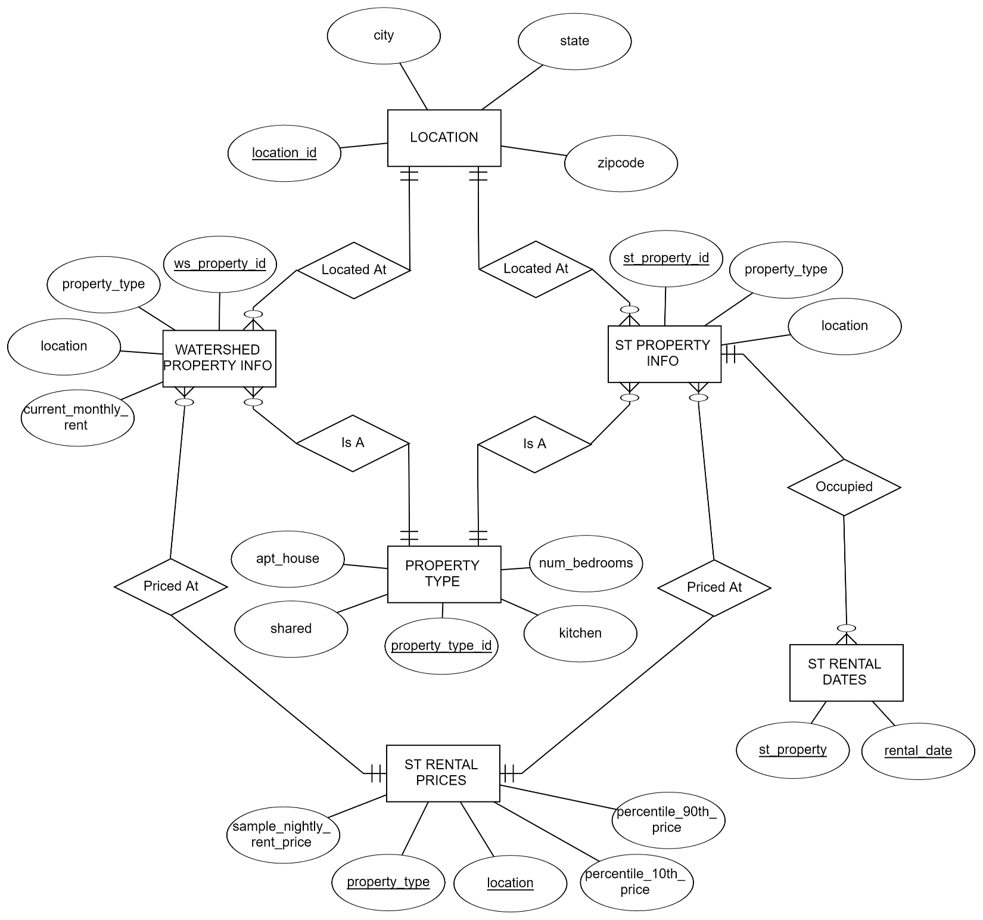

*Figure 2: Entity Relationship Diagram.*

**Gathering the Data**

The following query was built inside out by calculating the number of days occupied in the short-term rental data, converting that value to a yearly percentage occupancy rate, and joining the rest of the relevant short-term rental details for short-term properties, resulting in 245 rows of unique short-term property data. Each zip code in the short-term rental data does not include more than 1 of the 4 property types (1 bed apt., 2 bed apt., 1 bed house, 2 bed house). Watershed’s long-term data also did not include more than 1 of the 4 property types per unique zip code. Thus, the short-term and long-term rental data were joined on matching property types and zip codes.

*Figure 3: Final SQL Query used to extract data.*

|  |  |  |  |  |  |  |  |
| --- | --- | --- | --- | --- | --- | --- | --- |
| ws_ property_id | current_ monthly_rent | numDays | occupancy_ rate | location | property_ type | state | city |
| W1 | 1060 | 59 | 0.1616 | L9531 | R6 | NC | Chapel Hill |
| W10 | 1200 | 127 | 0.3479 | L9533 | R6 | NC | Chapel Hill |
| **…** | **…** | **…** | **…** | **…** | **…** | **…** | **…** |
| W101 | 1400 | 133 | 0.3644 | L15257 | R2 | TX | Austin |
| W102 | 2000 | 150 | 0.4110 | L15257 | R6 | TX | Austin |

|  |  |  |  |  |  |  |  |
| --- | --- | --- | --- | --- | --- | --- | --- |
| zipcode | sample_nightly_ rent_price | percentile_ 10th_price | percentile_ 90th_price | apt_house | num_ bedrooms | kitchen | shared |
| 27514 | 148 | 114 | 153 | apartment | 2 | Y | N |
| 27517 | 133 | 111 | 149 | apartment | 2 | Y | N |
| **…** | **…** | **…** | **…** | **…** | **…** | **…** | **…** |
| 78702 | 302 | 178 | 533 | apartment | 1 | Y | N |
| 78702 | 429 | 221 | 617 | apartment | 2 | Y | N |

*Figure 4: Table Head & Tail of 16 variables gathered.*

**Normalizing Sample Home Prices**

In our analysis of sample short-term rental nightly prices, we employed a method known as percentile normalization to standardize our data by adjusting all home price values to fall within a uniform range.

In the dataset extracted, each row contains a sample nightly rent price alongside the corresponding 10th and 90th percentile prices for that property. Unlike typical min-max normalization which uses the absolute minimum and maximum values of a dataset, we utilized the provided 10th and 90th percentile values as our lower and upper bounds in the following normalization formula:

$$0.1 + 0.8*((sample_nightly_rent_price - percentile_10th_price) / (percentile_90th_price - percentile_10th_price))$$

The output of this formula is a normalized price which essentially transforms the original sample price value into a relative scale between 0 and 1 where 0.1 signifies the 10th percentile price, 0.9 signifies the 90th percentile price, and the values in between represent the relative position of the price within this range.

The normalized values enable us to conduct a robust data analysis that is less influenced by extreme price values, ensuring our insights are both reliable and comparable across different price ranges.

**Forecasting Optimal Short-Term Nightly Rates to Maximize Occupancy**

To maximize occupancy and total annual gross revenue, we employed a simple linear regression model, using our normalized price variable to predict the occupancy rate. The results showed that these two variables have a moderate negative correlation which tells us that the occupancy rate will decrease as prices move up and occupancy rate will increase as prices decline, in the given range of its unique property type and zip code. This allows us to later calculate an optimal nightly price that will maximize occupancy and total annual gross revenue.

Regression equation from the model:

$$occupancy rate=(-0.7917* normalized_price)+0.8507$$

The coefficient of -0.7917 signifies that for each full unit increase in the normalized price, we expect the occupancy rate to decrease by approximately 0.7917 units, holding all other factors constant. Conversely, for each unit decrease in the normalized price, we expect the occupancy rate to increase by the same amount. The intercept of 0.8507 can be interpreted as the predicted occupancy rate when the normalized price equals zero. However, this is not meaningful given the context of this model.

|  |  |  |  |  |
| --- | --- | --- | --- | --- |
| sample_nightly_rent_price | percentile_10th_price | percentile_90th_price | normalized_price | occupancy_rate |
| 380 | 202 | 646 | 0.420720721 | 0.411 |
| 969 | 239 | 1431 | 0.589932886 | 0.1096 |
| … | … | … | … | … |
| 389 | 130 | 821 | 0.399855282 | 0.5123 |
| 444 | 252 | 547 | 0.620677966 | 0.4301 |

*Figure 5: Table Head & Tail of model data.*

*Figure 6: Linear Regression Model (Occupancy Rate ~ Normalized Price)*

**Using Regression Coefficients to Calculate Optimal Nightly Short-Term Rental Prices**

Now that we have a linear regression equation to forecast occupancy rates using normalized prices, we can use our regression coefficients to estimate the maximum annual gross revenue for short-term properties. To calculate annual gross revenue, we used the following formula:

$$Annual Gross Revenue = Nominal Nightly Rate * Occupancy Rate * 365$$

We know that Nominal Nightly Rate and Occupancy can be calculated with the following formulas:

Nominal Nightly Rate =

$$((Normalized_price – 0.1) / 0.8) * (percentile_90th_price – percentile_10th_price) + percentile_10th_price$$

Occupancy Rate =

$$(-0.7917*normalized_price)+0.8507$$

Combining these two formulas with a bit of calculus gives us a method to calculate the Optimal Nightly Price that maximizes the occupancy rate and annual gross revenue:

$$(β*((10th - ((90th– 10th)/8)))/(1.25*(90th – 10th)) – α)*[(1.25*(90th – 10th))/(2*Beta)$$

We should note that this formula accounts for the 20% of missing price range values (0-10th & 90-100th). Any predicted optimal nightly prices that resulted in a normalized price less than 0.1 were manually defaulted to a normalized price of 0.1. This method could also be achieved using MS Solver Add-In for Excel with annual gross revenue as the objective cell and optimal nightly price as the variable cell.

**Forecasting Variable Costs per Stay**

Watershed’s Financial Department has recommended that $100 be expensed for each guest stay (no matter the duration of stay) for hospitality fees (variable costs). We have raised the estimate of this expense to $125 to better reflect the current service inflation in 2023. To estimate the total annual hospitality fees, we use the following formula to predict the number of stays a property will endure during a year using an average of 3 nights per stay and the forecasted optimal occupancy rate.

$$Est. Stays per Year=\frac{Occupancy Rate*365}{Average Nights per Stay}$$

**Forecasting Cash Flow with Optimized Nightly Rents & Occupancy Rates**

The following spreadsheet is a demonstration of the detailed net change in cash flow for one individual property. Year 1 represents Watershed’s current long-term rental cash flow at a 97.3% occupancy rate. Year 2 represents cash flow during the initial year of conversion if conversion were to take place at the beginning of fiscal year 2. During Year 2 (conversion year), net change in cash in is calculated from **short-term annual revenue after transaction fees minus long-term annual revenue**. An initial CAPEX of $25,000 is spent to convert the property, and fixed and variable expenses begin in year 2. The CAPEX is to depreciate over the following 5 years.

Years 3 and 4 are identical in cash flow with the exception of no additional CAPEX being spent and the commencement of repair cost expenses at $400 monthly or $4,800 annually.

*Figure 7: Individual Property Cash Flow Spreadsheet.*

**Forecasting Profits with Optimized Nightly Rents & Occupancy Rates**

The following spreadsheet is a demonstration of the detailed net change in profits for one individual property. Year 1 represents Watershed’s current long-term rental profits at a 97.3% occupancy rate. Year 2 represents profits during the initial year of conversion, if conversion were to take place at the beginning of the fiscal year. During Year 2 (conversion year), net change in profit is calculated from **short-term annual revenue after transaction fees minus long-term annual revenue**. The initial CAPEX of $25,000 spent in year 2 will begin to depreciate in year 2 at $5,000 annually for 5 years (until the end of year 6).

Years 3 and 4 are identical in profits with the exception of the commencement of repair cost expenses at $400 monthly or $4,800 annually.

*Figure 8: Individual Property Profits Spreadsheet.*

**Aggegated Changes to Cash Flow & Profits**

To apply the calculations and values to all properties in a similar fashion to the spreadsheets above, we created 4 new calculated variables to further assist this task.

* New Cash Out, Conversion Year: *Initial CAPEX* + *Utility Costs (fixed)* + *Variable Costs*
* New Cash Out - Years Thereafter: *Utility Costs (fixed)* + *Replacement Costs (fixed)* + *Variable Costs*
* New Change in Profits, Conversion Year: *Utility Costs (fixed)* + *Replacement Costs (fixed)* + *Variable Costs*
* New Change in Profits, Years Thereafter: *Utility Costs (fixed)* + *Replacement Costs (fixed)* + *Variable Costs* + *Depreciation*

Next, we subtract each of these values from *Net_Rev_Change* (**short-term annual revenue after transaction fees minus long-term annual revenue**) to give us the following 4 final financial figures for each property:

* Net Change in Cash Flow, Conversion Year: *Net_Rev_Change - New Cash Out, Conversion Year*
* Net Change in Cash Flow, Years After: *Net_Rev_Change - New Cash Out - Years Thereafter*
* Net Change in Profits, Conversion Year: *Net_Rev_Change - New Change in Profits, Conversion Year*
* Net Change in Profits, Years After: *Net_Rev_Change - New Change in Profits, Years Thereafter*

The final figure here, Net Change in Profits, Years After was the figure used to determine the minimum profitability threshold for a property to be included in the risk adjusted conversion model assessment.

**Risks & Sensitivity**

The metrics reported on are based on the sum of the forecasted profits that would be gained and the forecasted capital investment that would be needed if my recommendation is followed, after the following are taken into account: (1) minimum profitability threshold per property, (2) initial capital requirements, (3) years to depreciate CAPEX, (4) repair costs, (5) hospitality online service fees, (6) regulatory fees, (7) hospitality fees (including key service and cleaning), (8) average duration of stay, and (9) utilities.

The details of the assumptions used are provided below (Figure 9), with a description of the ranges of risk adjusted in the sensitivity analysis.

|  |  |  |  |  |  |
| --- | --- | --- | --- | --- | --- |
| **Consideration** | **Assumed Value** | **Source of Original Assumed Value** | **Min Value Tested** | **Max Value Tested** | **Rationale for Range of Values Tested** |
| Minimum profitability threshold - profit needed for a property to be considered “more profitable as a short-term rental” | $6,000 | Watershed Financial Department | $1,000 | $10,000 | Profits should not be assumed less than $1,000 per year due to variables and all properties over $10,000 should be included for same reasons. |
| Cost to convert property to short-term rental (includes furnishing and decorating) | $30,000 | Watershed Marketing Department | $10,000 | $50,000 | $10,000 should be the minimum for property conversions to be effective and no more than $50,000 because it eats too far into profits during depreciation. |
| Years to depreciate capital expenditures | 5 | Watershed Financial Department | 1 | 10 | 1 year is the minimum time the CAPEX depreciation could flow out on a yearly statement. 10 years is the longest the CAPEX could depreciation before going sub $200/month. |
| Yearly upkeep (repairs) | $6,000 | Watershed Marketing Department | $1,200 | $12,500 | Values were tested from ranges of $100 to $1,000 per month. |
| Service fees to short-term stay website (e.g. Airbnb) | 20% | Watershed Marketing Department | 10% | 30% | Service fees are not generously sub 10% and any fees approaching %30 should involve negotiations. |
| Regulatory fees (taxes and potential legal fees) | 10% | Watershed Financial Department | 5% | 15% | Regulators/taxes should charge a minimum of 5% and anything approach 15% should require negotiations and/or lobbying and/or relocation. |
| Hospitality charges (key service, cleaning, re-stocking) | $100 | Watershed Financial Department | $100 | $200 | $100 to $200 is a good range for cleaning fees depending on the size of the property. |
| Typical stay duration (days) | 3 | Watershed Marketing Department | 2 | 7 | An average should not be less than 2 due to the statistical nature of averages. While a typical stay may be one week, similarly in nature this average would be pulled down by shorter stays so maxing it at 7 days would still allow the risk to be assessed at one week. |
| Monthly utilities per property | $300 | Watershed Financial Department | $150 | $400 | This is a wide range for typical utilities in the US. I recommend gathering sample utility prices for each of Watershed’s cities and averaging them over property type and number of rooms. |

*Figure 9: Risk Parameters with Assumed Defaults & Ranges Tested.*

At the beginning of the project, I was instructed that some issues were NOT to be incorporated into the analysis, but could be incorporated in the future to help optimize short-term rental rates or to further refine projected profits (Figure 10):

|  |  |
| --- | --- |
| **Factor not included in analysis** | **Reason for exclusion from analysis** |
| Weekly or seasonal changes in rental prices/occupancy rates | Instructions from Project Manager |
| Promotions, coupons, or special events | Instructions from Project Manager |
| Loss in rental income while property is converted | Instructions from Project Manager |
| Differences in utility rates across properties | Instructions from Watershed Financial Department |

*Figure 10: Excluded Risk Factors.*

I have [**created a dashboard (here)**](https://public.tableau.com/app/profile/michael2144/viz/WatershedDashboard2/Dashboard2?publish=yes) that illustrates the effects of changing these assumptions on predicted profits and required capital investment that is available to anybody on the team by request. **The minimum additional profits Watershed could earn when the assumptions were modified within the ranges described above was $12,882,** if all the properties that are “more profitable” as a short-term rental are converted. **The maximum additional profits Watershed could earn when the assumptions were modified within the ranges described above was $5,180,843** if all the properties that are “more profitable” as a short-term rental are converted. The modified set of parameters associated with this minimum and maximum value are provided below (Figure 11). Overall, the parameter that affected profits most was **Transaction Fees**.

|  |  |  |
| --- | --- | --- |
| **Consideration** | **Value in Assumption Set that led to Minimum Profits** | **Value in Assumption Set that led to Maximum Profits** |
| Minimum profitability threshold per property | $10,000 | $1,000 |
| Cost to convert property to short-term rental | $50,000 | $10,000 |
| Years to depreciate capital expenditures | 10 | 1 |
| Yearly upkeep (repairs) | $1,200 | $12,000 |
| Service fees to short-term stay website (e.g. Airbnb) | 30% | 10% |
| Regulatory fees (taxes and potential legal fees) | 15% | 5% |
| Hospitality charges (key service, cleaning, re-stocking) | $200 | $100 |
| Typical stay duration (days) | 2 | 7 |
| Monthly utilities | $400 | $150 |

*Figure 11: Risk Factor Directional Influence.*

Based on additional research and current market conditions (in 2023), **I recommend the following values for each of the 9 risk parameters associated with this short-term rental conversion analysis.**

|  |  |
| --- | --- |
| **Recommended Consideration** | **Recommended Values** |
| Minimum profitability threshold per property | $5,500 |
| Cost to convert property to short-term rental | $25,000 |
| Years to depreciate capital expenditures | 5 |
| Yearly upkeep (repairs) | $4,800 |
| Service fees to short-term stay website (e.g. Airbnb) | 20% |
| Regulatory fees (taxes and potential legal fees) | 10% |
| Hospitality charges (key service, cleaning, re-stocking) | $125 |
| Typical stay duration (days) | 3 |
| Monthly utilities | $250 |

*Figure 12: Recommended Risk Parameter Values.*

**Conclusion**

This analysis combined Watershed’s current long-term rental property details with third-party short-term rental property data of the same property types and zip codes to forecast net changes to Watershed’s annual revenue, cash flow, and profits for the conversion of long-term rentals to short-term rentals.

After the correlation of short-term rental pricing and occupancy rates was established, the coefficients of the linear regression model were applied to derive optimal short-term nightly rental prices that would maximize annual revenue. These annual property revenues were tested among 9 variable risk factors to achieve the most realistic yet conservative forecasts.

For Watershed’s current market locale of 14 cities, the most profitable 3 cities have been recommended to convert to short-term rental properties. This recommendation not only takes advantage of the most highly profitable short-term rental regions, but also enables Watershed to optimize its conversions into the most profitable property types within these regions. These 3 cities also contain a total of 20 properties, which at $25,000 CAPEX per property, puts the total conversion cost right at the allotted $500,000 Watershed is willing to spend for these conversions.