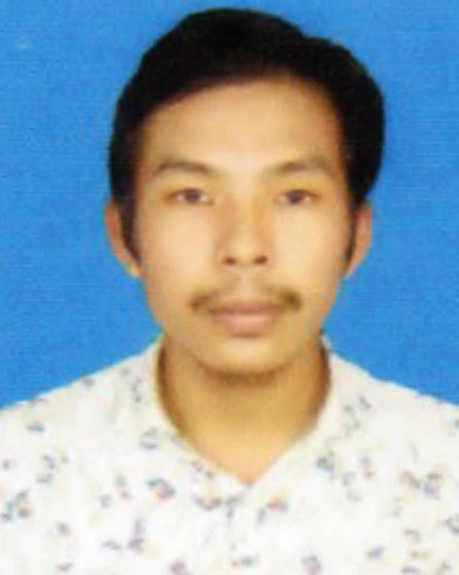
MADESH CHAKMA
Dinajpur, 5200, Bangladesh | +88 01612022729 | madeshchakma@gmail.com

SUMMARY
Innovative geospatial analyst with expertise in data modeling using ArcGIS, QGIS, and Google Earth Engine. Specialized in enhancing agricultural technologies and sustainable practices through effective ICT integration. Delivers strategic solutions to improve project efficiency and drive innovation.
EXPERIENCE
11/2025 to Current | Founder & Lead Developer  www.cropsdoctor.com  - Optimizes agricultural yields through automated, precision-based fertilizer and pesticide recommendations aligned with BARC standards.  - Scales the platform’s infrastructure to support autonomous AI agents capable of providing end-to-end assistance for precision farming.
01/2021 to Current | Executive member  IAAS Bangladesh – Dinajpur, Bangladesh
05/2026 to 12/2026 | Web Developer  www.substorebd.com – Bangladesh  - Built and launched SubStoreBD, a digital subscription marketplace using Next.js, Handled UI design, SEO, and Cloudflare deployment.
SKILLS
Geospatial Analysis & Remote Sensing
Software Engineering & Development

REFERENCES
Jashim Verma, CEO, NBCT Lab, +88 0 1723 – 34 67 87,
jashim.verma@yahoo.com
TRAINING
- Non-IT Python, EDGE Bangladesh, 1 month, 2023-01-01
- Microsoft Office Application, NBCT Lab, 6 months, 2023-01-01
- ArcGIS from Beginning to Pro, Udemy, 2023-01-01
DISCLAIMER
I hereby declare that the above information is true to the best of my knowledge and belief.
PERSONAL INFORMATION
- Height: 5.6
- Father’s Name: Kabirson Chakma
- Mother’s Name: Nabonita Chakma
- Blood Group: O+
EDUCATION
01/2025 | B.SC. AGRICULTURAL ENGINEERING (HONS.)  Hajee Mohammad Danesh Science and Technology University – Dinajpur - 5200  GPA: 3.20
01/2020 | H.S.C. Science  Rangamati Govt. College – Rangamati  GPA: 5.00
01/2017 | S.S.C. Science  Armed Police Battalion Ideal School and College – Mahalchari, Khagrachari
LANGUAGE PROFICIENCY
 | English  Upper Intermediate | Bengali  Proficient
CERTIFICATIONS
- Microsoft Office Applications (Computer Basic)
Issuing Organization: Nurul Islam Jubo Unnayan Society (NJUS), Rangpur
Date: December 2024
Details: Completed a 6-month course covering MS Word, MS Excel, MS PowerPoint, and Internet & Win 10 with an A+ grade.
- Basic Programming with Python
Issuing Organization: Bangladesh Computer Council (BCC), ICT Division (EDGE Project) in collaboration with the Faculty of Computer Science & Engineering, HSTU
Date: January 2025
Details: Completed 60 hours of professional training focused on Python programming fundamentals.
- Gemini CLI: Code & Create with an Open-Source Agent
Issuing Organization: DeepLearning.AI
Date: Issued Jan 2026
Credential ID: 876be797-b639-4757-8872-aeb970e5e214
Key Skills: Artificial Intelligence (AI) and task automation.
- Gemini Certified University Student
Issuing Organization: United Latino Students Association
Date: Issued Dec 2025 · Expires Dec 2026
Credential ID: 17091560
PROJECTS | UAV-Based Detection of Potato Leaf Diseases Using Deep Learning Techniques  - Role: Lead Researcher / Project Member / Final Year Thesis  - Institution: Hajee Mohammad Danesh Science and Technology University  - Focus: Developed a system using Unmanned Aerial Vehicles (UAVs) and deep learning models to identify and classify diseases in potato crops through aerial imagery.  CropDoctorAI (cropdoctor.com)  - Developed and managed an AI-driven agricultural platform designed to assist farmers in crop disease detection and precision farming.  - Integrated Vision-based models to provide automated pesticide and fertilizer recommendations based on regional BARC standards.  - Implemented full-stack architecture using serverless Postgres database and automated deployment via Vercel to ensure high availability.  - Engineered agricultural monitoring solutions focusing on bridging the gap between advanced technology and practical farming.
CAREER GOALS | Data-oriented agricultural engineer with a strong interest in smart agriculture and GIS software web development. Aiming to apply technical skills in Python, AI, and precision agriculture to optimize farming systems and digital infrastructure.
SOCIAL NETWORKS | - linkedin.com/in/madeshchakma/

