Infosys Springboard Virtual Internship 6.0 Completion Report

1. Team Details
Batch Number: Batch 13

Start Date: 13/02/2026

Name: Modhaka Priya

Internship Duration: 8 Weeks

Project Title: InsurAI - Corporate Policy Automation and Intelligence System

2. Project Objective
The objective of InsurAI is to develop an intelligent insurance management platform that simplifies and improves core insurance operations such as policy management, claims processing, document handling, risk assessment, fraud detection, and AI-assisted decision support. The project is designed to reduce fragmented workflows and bring policies, claims, and operational decisions into one connected platform so that processes become faster, more transparent, and easier to manage.

3. Project Description in Detail
InsurAI is a full-stack insurance operations platform built to modernize the workflow of an insurance organization. The system provides a centralized interface where multiple modules work together through one application. The frontend is designed using React and Vite to provide an interactive dashboard experience, while the backend is implemented using Java Spring Boot to manage APIs, business logic, and database operations. The project also includes AI-powered support in different modules so that the system can generate recommendations, confidence scores, document classification, and assistant-based responses.

The platform includes important working modules such as login, dashboard, policy management, claims processing, document upload and classification, risk assessment, fraud detection, and AI assistant support. The policy module allows users to create and manage policies while generating AI recommendation and risk score. The claims module supports AI confidence generation and status tracking. The document module supports file upload, metadata storage, and AI-based categorization. The risk and fraud modules help the system analyze operational risks and suspicious activity. Together, these modules form a practical insurance management solution.

4. Technologies Used
- Frontend: React, Vite, HTML, CSS, JavaScript
- Backend: Java, Spring Boot, REST API development
- Database: H2 persistent database
- AI Features: policy recommendation, claim confidence analysis, document classification, assistant support
- Tools: Maven, Git, GitHub, Visual Studio Code, PowerShell

5. Modules Implemented
- Login Module for secure sign-in and authentication
- Dashboard Module for live overview of policies, claims, risks, and fraud indicators
- Policy Module for create, edit, delete, and AI recommendation workflows
- Claims Module for claim creation, review, AI confidence, approve, and deny actions
- Documents Module for upload, classification, download, and metadata handling
- Risk Assessment Module for portfolio-level risk review and policy-level recommendations
- Fraud Detection Module for active investigations, resolved cases, escalation, and reopening
- AI Assistant Module for assistant-style responses using project context

6. Backend and Database Functionality
The backend of InsurAI is built using Java Spring Boot. It exposes REST endpoints for authentication, policies, claims, documents, risk assessment, fraud detection, and assistant interactions. The backend is connected to an H2 database, which stores persistent project data such as policies, claims, documents, and related status information. CRUD operations are implemented for major modules, and the backend also manages the logic required for fraud review movement between active and resolved cases.

AI-related features are connected through backend routes. The system supports policy recommendation generation, claim analysis, document classification, risk calculations, and assistant responses. This backend-centered design keeps the project organized and allows the frontend to fetch and update all important business data in a structured way.

7. Key Features Achieved
- Working login flow
- Policy creation with AI recommendation and risk score
- Claim creation with AI confidence
- Document upload and AI classification
- Risk assessment with portfolio insights
- Fraud detection with approve, deny, escalate, and reopen investigation actions
- Resolved fraud cases tracking
- AI assistant support integrated into the platform

8. Project Snapshots
The following screenshots show key pages developed as part of the InsurAI project.

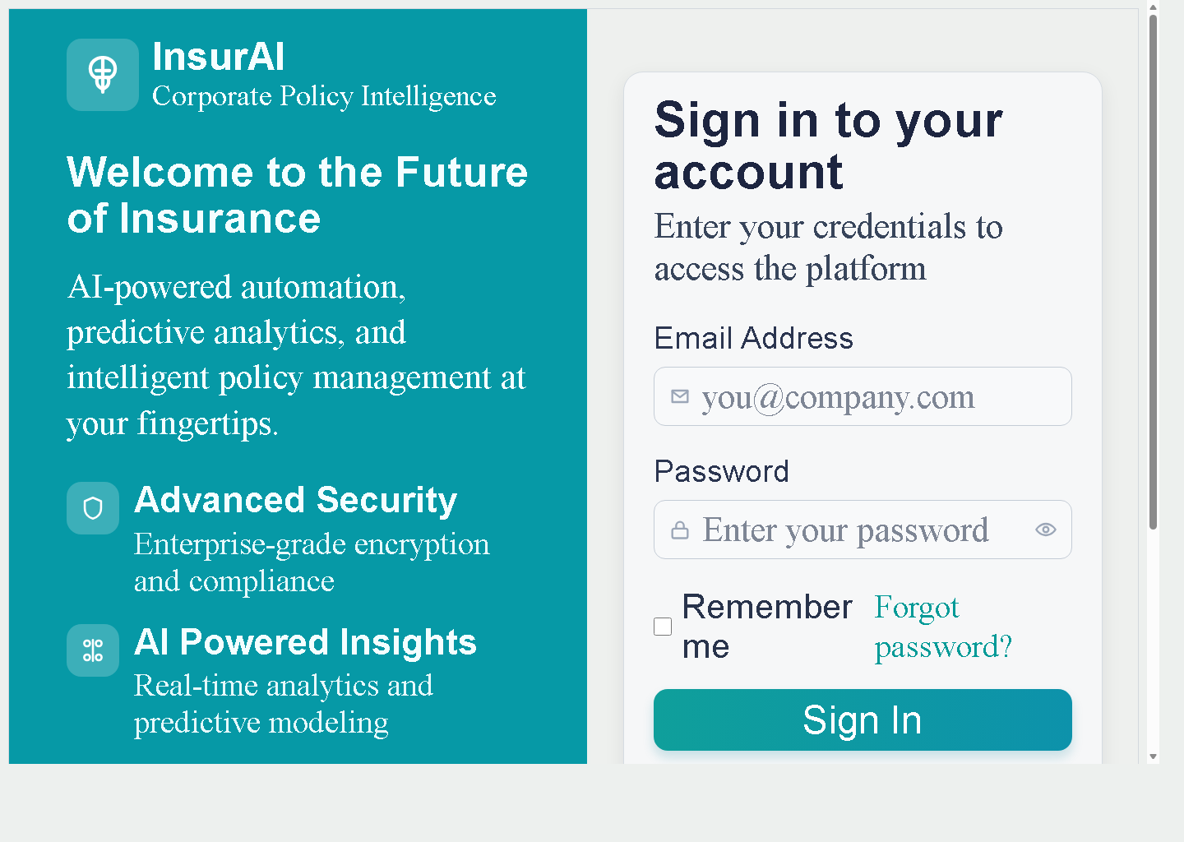
Figure 1: Login interface of the InsurAI system.


Figure 2: Project user interface snapshot showing the InsurAI application layout.

9. Learning Outcomes and Skills Acquired
The development of InsurAI provided practical experience in full-stack development, React-based UI building, Java Spring Boot backend integration, API handling, persistent database usage, authentication, and debugging. It also improved understanding of domain-specific insurance workflows such as policy lifecycle, claim review, risk assessment, and fraud investigation.

- Frontend development with React and component-based UI design
- Backend development with Java Spring Boot
- REST API integration and testing
- Database persistence using H2
- AI-assisted workflow integration
- Debugging, refinement, and iterative feature improvement

10. Conclusion
The development of InsurAI was a valuable practical learning experience. The project successfully brought together policy management, claims handling, document workflows, risk analysis, fraud review, and AI support into one connected system. It demonstrated how a real-world software solution can be planned, implemented, and improved step by step with both frontend and backend integration.

Overall, this project strengthened technical skills, problem-solving ability, and confidence in building a complete software platform with real business logic and intelligent features.

11. Acknowledgement
I would like to sincerely thank Infosys Springboard for providing this internship opportunity and for creating a platform that encourages practical learning and project development. I am also grateful to the mentors and guides who supported the completion of this project. Their guidance and encouragement helped me gain meaningful hands-on experience while developing InsurAI.

