IMS

[INSTITUTE MANAGEMENT SYSTEM]

1.INTRODUCTION

This System provides online application for the Institute Management System.The system is an online application that can be accessed throughout the organization and outside as well with proper login ID and PASSWORD.Our main motive of this system is to provide attractive environment where we can manipulate data and information about students ,staff easily. Here we manage things like Student Admission Management, Fees and Salary Management, Online Attendance management, Time Table Management etc. Here we added some additional features also, for easy communication, and easy management. Our System is available on both modes – Online as well as Offline mode.

Users will be able to see their profiles and edit them. Administrator will be able to edit an access all the data that is stored with IMS.

The Users of IMS will be as follows:

•**Administrators**

**• Handlers**

**• Students**

**• Teachers**

**• Parents/Guardians**

The Modules/Features that will be developed inside IMS are:

**• Student Information Management • Student Performance Management**

**• Classroom Management • Teacher Info. Management**

**• Student Report Generation • Library Management**

**• Attendance Management • Fees Payment Modes**

**• Admin Module • Parent Management System**

**• E-mail & SMS Notification • Enquiry Management**

PROBLEM STATEMENT

Problem 1.1: Lack of prompt updating

Today not all work but still some work at time of admission and registration of the students is done manually by ink and paper, which is very slow and consuming much efforts and time. So, it is required to design of the computerized Automation system of Institute, to speed up and make it easy to use system.

Problem 1.2: Manual calculation

At a time of Result scenario faculty check answer sheets and calculate marks of each student. Which is very slow and consuming efforts and result declaration is delayed. So, this management system is able to do this things online.

Problem 1.3: Student confusion

Some times students stayed confused that how he/she prepare for the exam/course and how to get batter material for the course. So,we provide the platform that he/she studied well and also provide online material for each course and online video lectures.

Problem 1.4: Library managing

Now days, it is not easy task to do library work on papers and manage all the functionalities of library properly within lesser time because there are higher strength of student in Institutes.

Problem 1.5: Lack of immediate retrievals

The information is very difficult to retrieve and to find particular information like – To find out about the student’s history, the user has to go through various registers. This results in inconvenience and wastages of time.

Software Requirements and

Specification(SRS)

2.1: Functional Requirement:

2.11: Student:

1. The Student shall be able to login to System.

2. The Student shall be able to view Available Courses and Materials and Online video lectures.

3. The Student shall be able to download assignments and lectures ,And also able to Upload assignment.

4. The Student shall be able to pickup books from library and also return it .

5. The Student shall be able to Solve Exams through Webpage within 1 Hours of time.

6. The Student shall be able to view and print his/her Annual Report Card.

7. The Student shall be able to pay Fees with provided Online Modes.

8. The Student shall be able to solve his/her doubts online with expert faculty within provided time.

2.12: Teacher:

1. The Teacher shall be able to login to System.

2. The Teacher shall be able to Post Student’s Assignment and Materials.

3. The Teacher shall be able to Grade Student’s Exams and Provide 1 hour online doubt session for Students.

4. The Teacher shall be able to provide Class scheduling Information.

5. The Teacher shall be able to Post Exams.

2.13: Parents/Guardians:

1. Parents should be able to Login to the System.

2. Parents should be able to see Progress report of their child.

3. Parents should be able to apply online query through Email.

4. Parents should be able to contact Managing staff or respected Faculties.

2.14: Handlers:

1. He/ She shall be able to Login to the system.

2.He/ She shall be able to Manage online queries or inquiries.

3.He/ She shall be able to Manage class schedule.

4.He/ She shall be able to contact students or parents for other issues.

5. He/ She shall be able to proceed further process of Admission.

2.15: Admin:

1.The Admin shall be able to Login to the system.

2. The Admin shall be able to Add and Delete or Edit courses.

3. The Admin shall be able to assign Teachers to courses or remove teachers from course.

4. The Admin shall be able to manage further Processes.

2.2: Non-Functional Requirement:

2.21: Availability:

The System should be available 24 hours * 7 days.

2.22: Security Requirement:

Depending upon the category of the user the access right are decided. It means if the user is an Administrator then he/ she can be able to modify the data.

2.23: Safety Requirement:

The Database may get crashed at any time due to Virus, Malware or OS failure. Therefore ,it is required to take the Database Backup.

2.24 Performance or Usability:

The System should be easy to handle.

System should give expected performance results. And Response time should be small.

System weight should be lighter, so that Every common people can use the System.

LIFE CYCLE MODEL

3.1 Model Specification :

Spiral Model:

**Spiral model** is one of the most important Software Development Life Cycle models, which provides support for **Risk Handling.** Spiral model is combination of sequential and prototype model. This model is used for large project which involve continuous enhancement.

* **Risk Handling** : Spiral model is best development model to follow due to the risk analysis and risk handling at every phase.
* **Flexiblity in Requirements**:  Change requests in the Requirements at later phase can be incorporated accurately by using this model.
* **Customer Satisfaction:** Customer can see the development of the product at the early phase of the software development and thus, they habituated with the system by using it before completion of the total product.
* **Functionality** : Additional Functionality can be added at a later date.
* **Control:** Stronger approval and documentation control.
* **Realistic:** Project estimates in terms of schedule, cost etc become more and more realistic as the project moves forward and loops in spiral get completed.

3.2 Model Documentation:

3.2.1 Diagram:

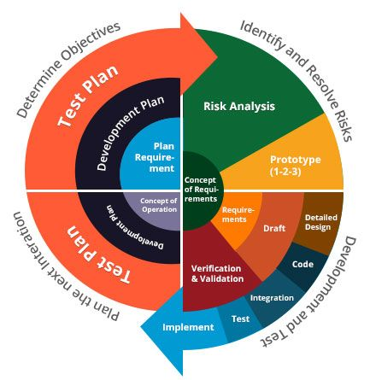

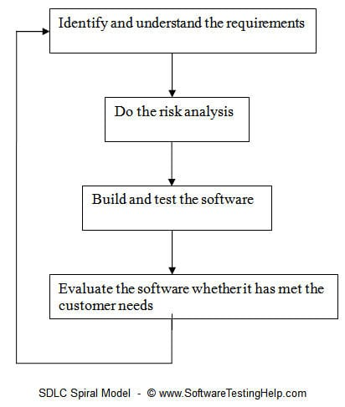

3.2.2 Phase Analysis:

| **Phase Name** | **Activities performed** | **Deliverables / Output** |
| --- | --- | --- |
| Planning | -Requirements are studied and gathered. - Feasibility study  - Reviews and walkthroughs to streamline the requirements | Requirements understanding document  Finalized list of requirements. |
| Risk Analysis | Requirements are studied and brain storming sessions are done to identify the potential risks  Once the risks are identified , risk mitigation strategy is planned and finalized | Document which highlights all the risks and its mitigation plans. |
| Engineering | Actual development and testing if the software takes place in this phase | Code Test cases and test results Test summary report and defect report. |
| Evaluation | Customers evaluate the software and provide their feedback and approval | Features implemented document |