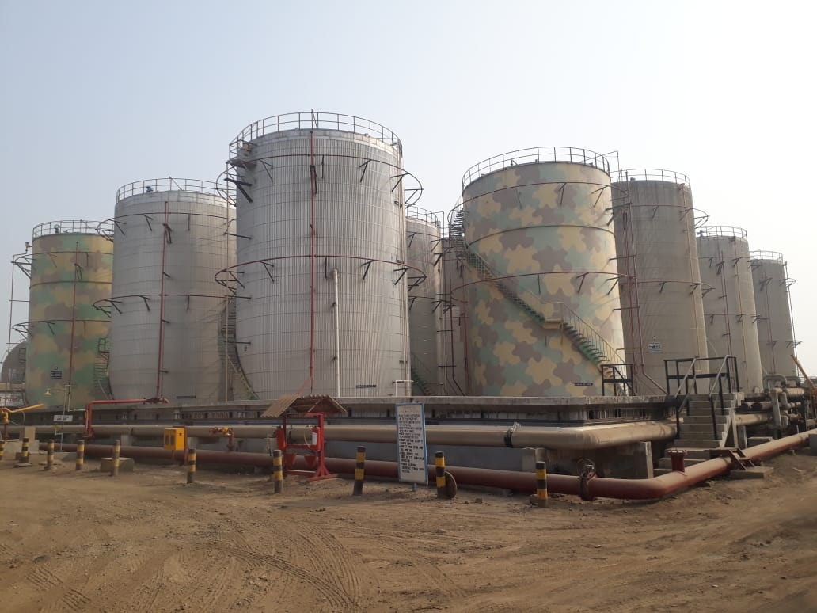

TERMINAL WAREHOUSE

INVENTORY MANAGEMENT

Company Name

Priya Modi

 Imc Limited ,kandla

Diploma Computer Engineering Sem. VI

TERMINAL WAREHOUSE INVENTORY

MANAGEMENT SYSTEM

------------------------------------------------------------------------------

Developed and Designed by

Priya Modi

Khushi Sompura

Under Guidance of

Ms. Honey Gurnani

**

**Tolani Foundation Gandhidham Polytechnic**

**Adipur ( Kutch )**

**CERTIFICATE**

Year :- 2020-2021 Semester :-

Subject : Project-I

This is certify that **Ms. Khushi Sompura, Ms. Priya Modi** having Enrollment No. 196530307064 , 196530307041 has completed IDP Project work having title Terminal Warehouse Inventory Managemant System. All the functionalities required by user with deep analysis and latest techniques.

|  |  |  |  |  |
| --- | --- | --- | --- | --- |
| |  | | --- | |  | | 3:52 PM (9 minutes ago) |  | https://mail.google.com/mail/u/0/images/cleardot.gif  https://mail.google.com/mail/u/0/images/cleardot.gif |
| |  | | --- | | Date of Submission: .  Internal External H.O.D  Examiner Examiner  https://mail.google.com/mail/u/0/images/cleardot.gif | | |  | |

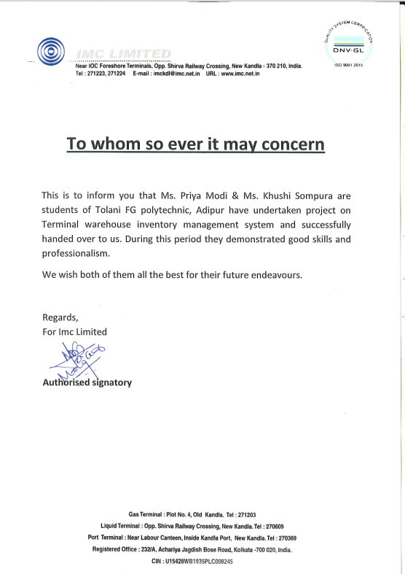

*ACKNOWLEDGEMENT*

I would like to thank to our guide of this project, Ms.Honey Gurnani For the valuable guidance and advice. She inspired us greatly to work in this project. Her willingness to motivate us contributed tremendously to our project. We also would like to thank her for showing us some example that related to the topic of the project.

Besides, we would like to thank the authority of TFGP for providing us with a good environment and facilities to complete this project. Finally, an honorable mention goes to our friends for their understanding and supports on us in completing this project. Without the above, we would have faced many difficulties doing this help of the particulars mentioned project

DEVELOPED AND DESIGNED

BY

Student : Khushi Sompura [196530307064]

Priya Modi [196530307041]

Guide Name : Mrs. Honey Gurnani

Mr. Vimal Vania

Submitted : Head , Computer Department.

Affiliated : TFGP Tolani Foundation Gandhidham

Polytechnic Adipur ( Kutch ).

**Date of Submission : __/__/____**

INDEX

**Name Page No.**

**1.Introduction…………………………………………………………………………8**

* Project Summary.

1.1 Introduction

1.2 Purpose

1.3 Features

1.4 Technology Stack

**2.Project Management..………………………………………………………………12**

2.1 Project Planning

**3.System Analysis…..………………………………………………………………....15**

3.1 System Architecture

3.2 Zero level

3.3 ER Daigram

**4.System Design…….………………………………………………………………....19**

**5.Screen Layout…….………………………………………………………………....24**

**6.Conclusion and Limitation………………………………………………………....38**

6.1 Conclusion

6.2 Limitations

6.3 Future Scope

**Chapter : 1**

**INTRODUCTION**

***PROJECT SUMMARY***

* **Abstract: *Currently IMC limited is using SAP software ..***
* ***SAP's most features are useful for Purachase Related Task..***
* ***But it is not very useful for Terminal Warehouse store's Each and Every items According to Departments And Terminal..***
* ***As our Client require to Manintain Storing Each items According to Departments And Terminal manually That's Why We creating This Software***

1. 1 Introduction :

Terminal Warehouse inventory management software has been in human requirements since all thought of managing item effectively According to ter,minal and department. It is widely used in Companies and other fields of where Storing items and manage it manually ia the main task

**Purpose :**

The Purpose of

* Terminal Warehouse inventory management software is to make work easy.
* In this Windows – Application we have added the Functionalities as per the Requirements.
* The Work which was done **Manually** can be now done **Digitally.**
* As our Client require to Manintain Storing Each items According to Departments And Terminal manually That's Why We creating This Software

**1.2 Features :**

* The Login Form for the Security Purpose.
* The Main Form.
* The Different forms for Data Entery of Department , Faculty, Subjects , Lab, Rooms etc.

**Store Facality**

* Stores Departments Terminal wise
* Stores Items Department wise

**Security**

* Only Admin can Access All things
* Other users can access only Their tasks

**Inward**

* Maintain Inward
* Purchase Inward : Maintain Supplier Wise Inward Who Suppies Products
* Terminal Inward : Maintain Terminal Wise Inward

**Outward**

* Maintain Outward
* Material Issue Department Wise
* Material Issue For Use

**Reports**

* Maintain date wise report
* Item wise And Depatment wise report
* Stock report
* Date Wise Report
* Supplier Wise Report

**1.4 Technology Stack:**

**In Context Tools & Technology**

Front End VB.Net 2019

Database Design Microsoft SQL Server

Management 2019

Design and Components VB.Net 2019

**Chapter : 2**

**PROJECT MANAGEMENT**

**2.1 Project Planning:**

The road to the successful Windows Application Development is the well-planned strategy for the best and optimal use of resources available Project management begins with a set of activities that are collectively called project planning The project planning in done in a way to get the maximum utilization of resources and on time completion of the project Project planning is concerned with identifying and measuring the activities, milestones and deliverables produced by a project

In system the first step in project planning in which we decided the title of our Terminal Warehouse Inventory Management Softwarre is the name of Windows-Application.

In project planning we decided the admin module which module will be design first and then we think about other forms.

Project planning consists of the following essential activities

* Estimating some basic attributes of the project
* Duration: How long will it take to complete the development? Effort: How much effort would be required?
* The effectiveness of the subsequent planning activities is based on the accuracy of these estimations.
* Scheduling manpower and other resources.
* Item organization and item plans.
* Risk identification, analysis, and planning.

**1.Project Organization :**

This describes the way in which the development team is organized the people involved and their roles in team.

**2. Risk Analysis :**

This describes possible project risks like likelihood of those risks arising and the risk reduction stratifies, which are proposed. The significant risk in our website development is requirement error and omissions. Therefore, cost of fixing the requirement errors at later stages in process can be very high. Experiments have shown that SDLC reduces number of problems associated with the requirement specification. Furthermore, the overall development cost may be lower if a SDLC is developed.

The risk of our system is that it will successfully run. All the Forms where perform the task in correct way, and for users it will attractive to the users so that they will easily use the Application.

**3. Hardware and Web-Application Requirements:**

Hardware Requirement

C2D Processor 4 GB RAM 4 GB free Space HDD drive

**Processor C2D Processor**

**Ram 4GB**

**HDD 4GB Free Space**

**Chapter : 3**

**SYSTEM ANALYSIS**

**3.1System Architecture:**

Insert Details info

database

Logout

Generate Reports

Add User

Enter Supplier

Login Page

(id & Password)

Add terminal

Add Item

Details

Add Department

**Use Case:-**

Admin

**3.3 ER DAIGRAM:**

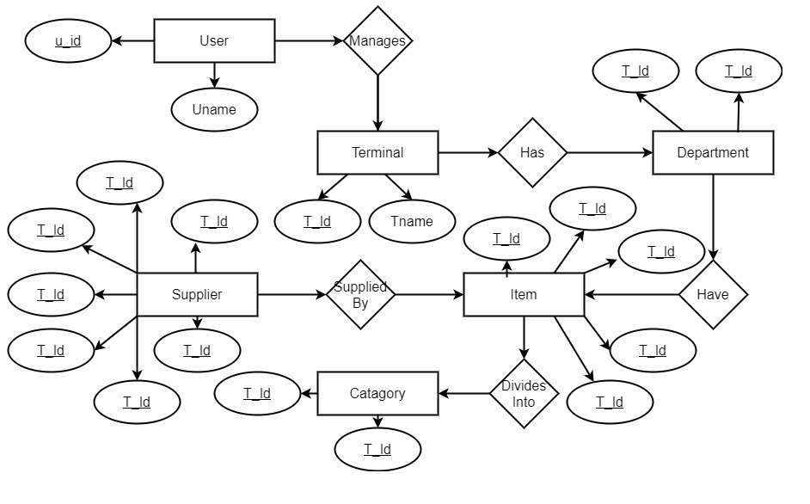

**Chapter : 4**

**SYSTEM DESIGN**

**4.1Data Dictionary :**

**Login :- login details comes in its table.**

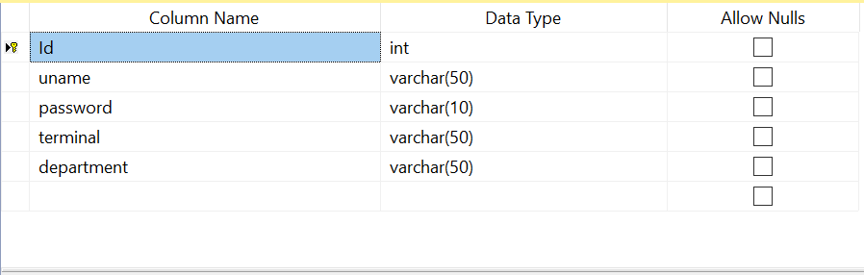

**Department :- Department details comes in this table.**

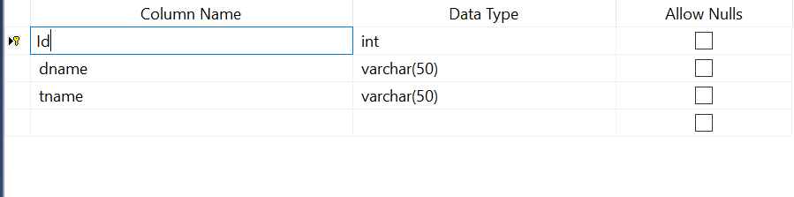

**Terminal :- Terminal details comes in this table.**

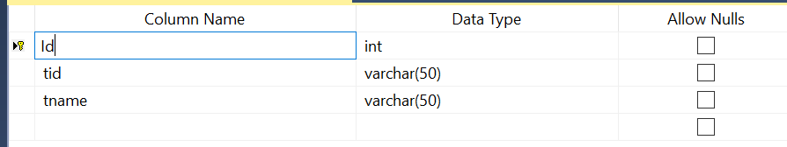

**Supplier :- Supplier details comes in this table.**

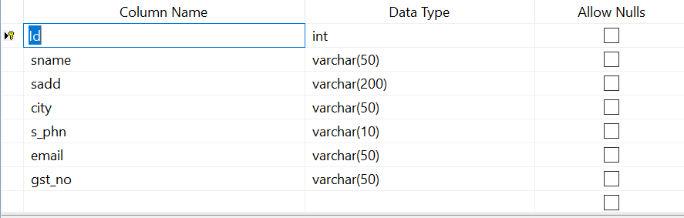

**Category :- Category details comes in this table.**

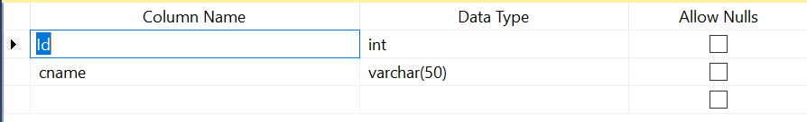

**Item :- Item details comes in this table.**

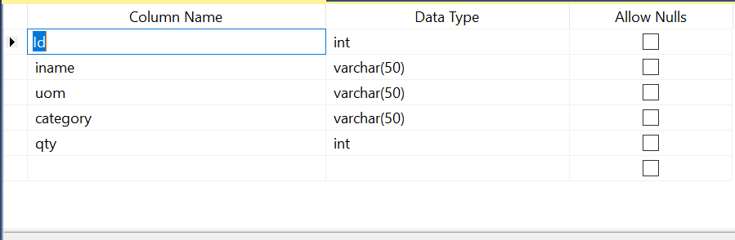

**Inward :- Inward details comes in this table.**

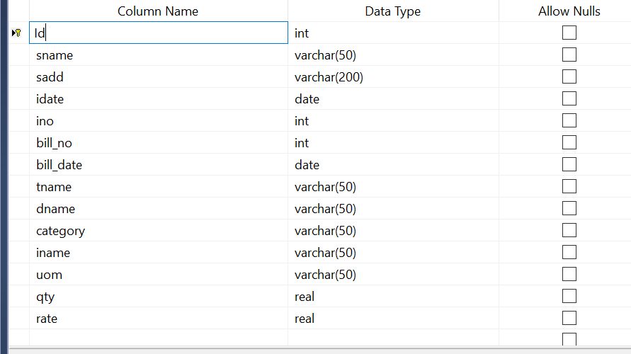

**Outward :- Outward details comes in this table.**

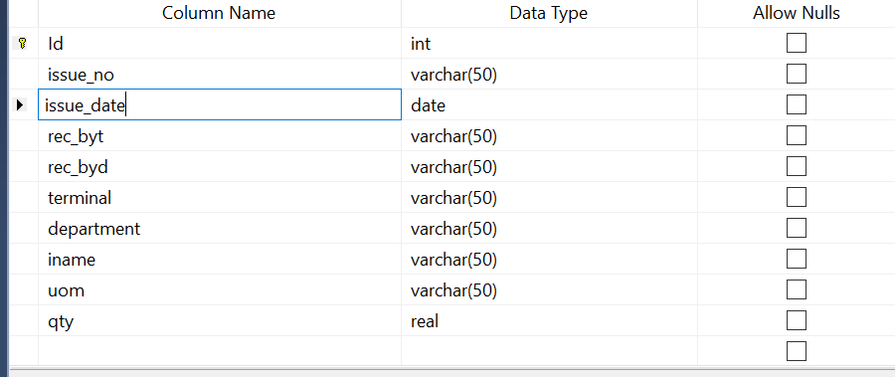

**Terminal_Inward : Terminal inward Detail Comes into this table**

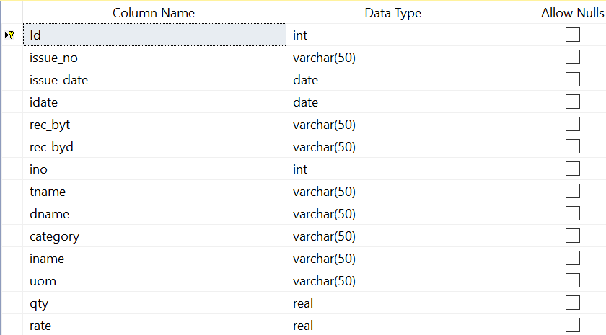

**Stock : Stock come into this table**

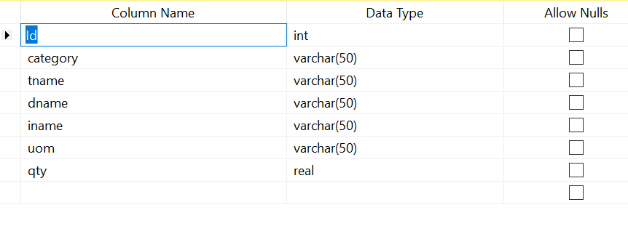

**Chapter : 5**

**Screen Layout**

**Login Form:- this form is use for login.**

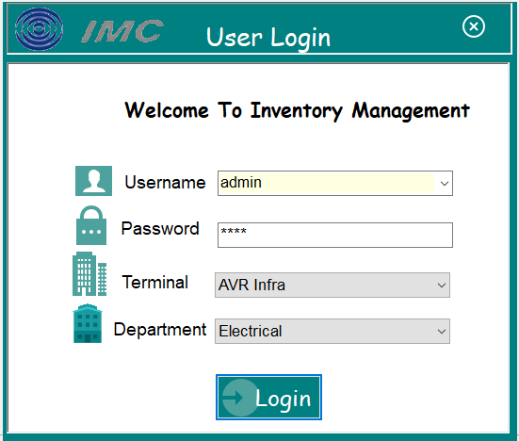**Splash Screen :**

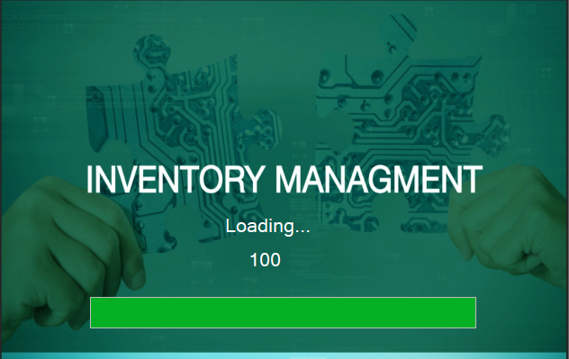

**Main Form:- main page where user can enter data.**

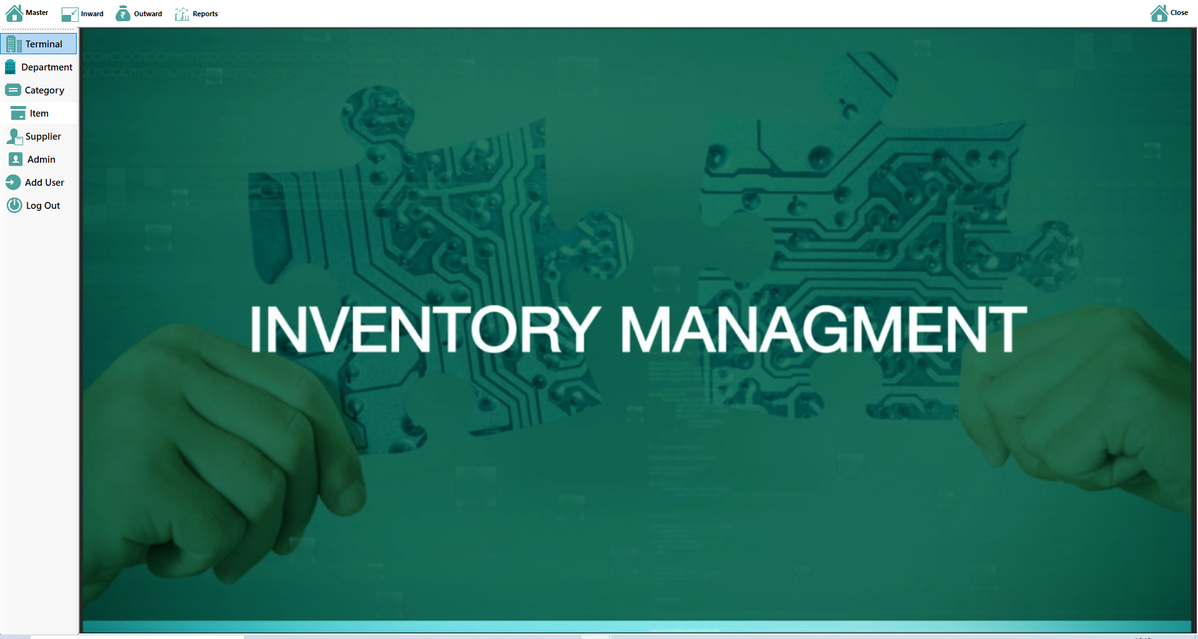

**Terminal Form :- this form is use for Terminal entry.**

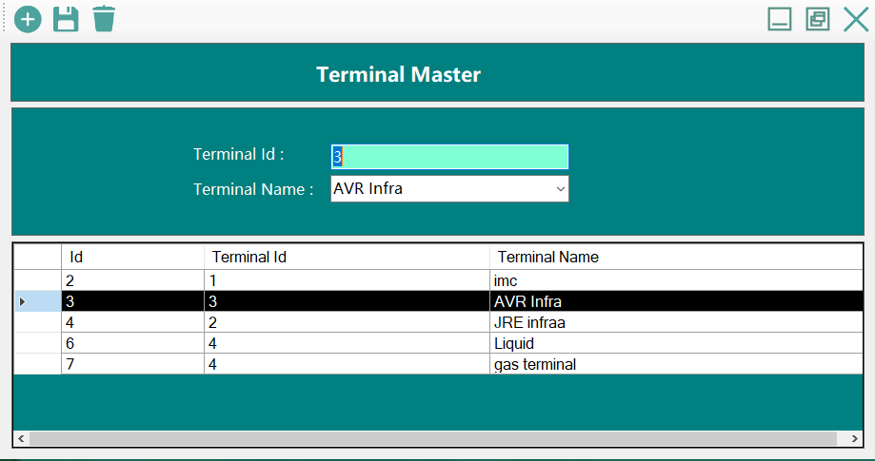

**Department From :- this form is use for Departments entry.**

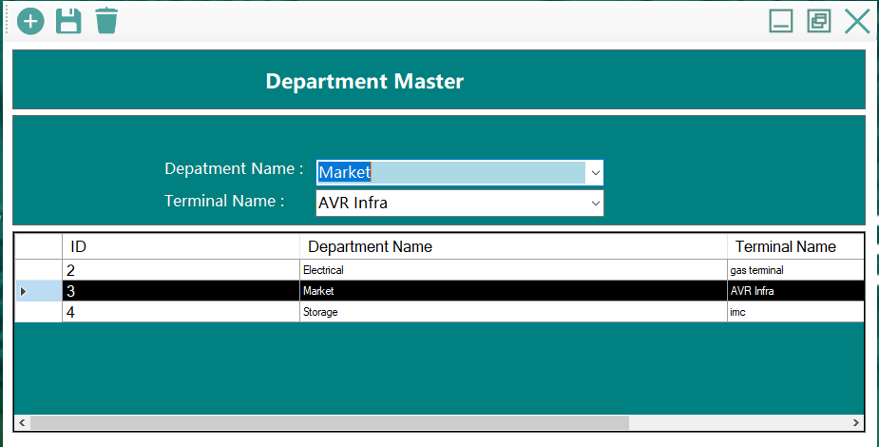

**Catagory Form :- this form is use for catagory entry.**

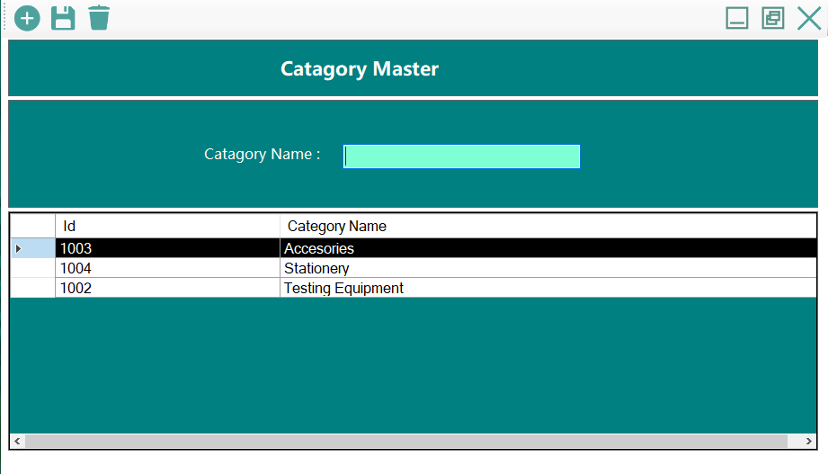

**Item Form :- this form is use for Item entry.**

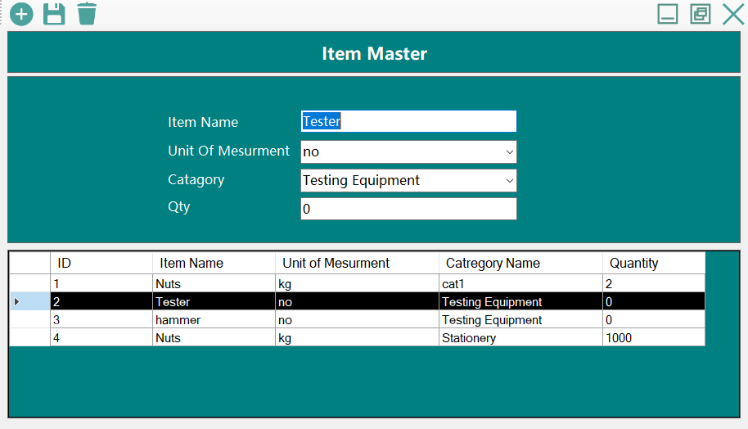

**Supplier Form :- this form is use for supplier entry.**

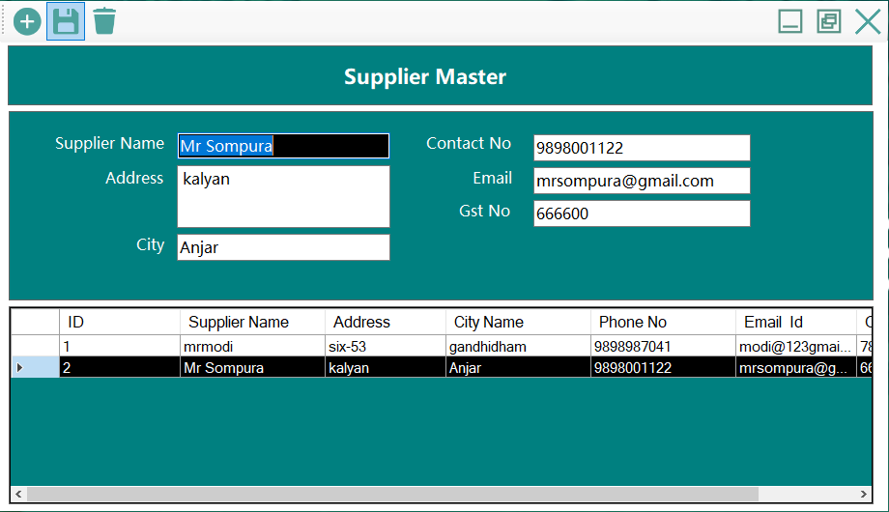

**User Form :- this form is use for User entry.**

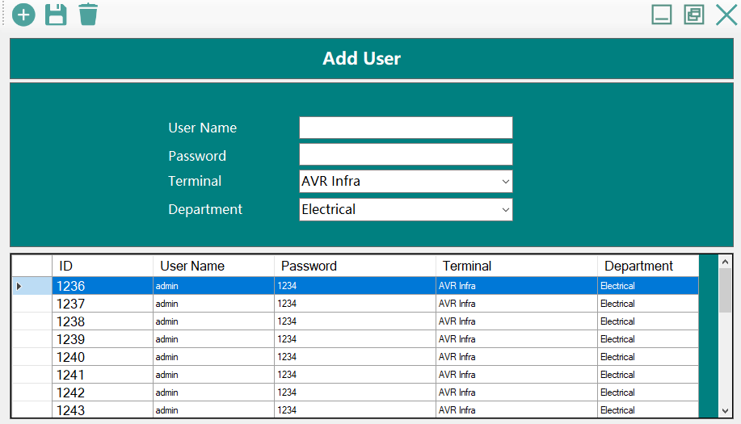

**Login History : Admin Can See Login History Here**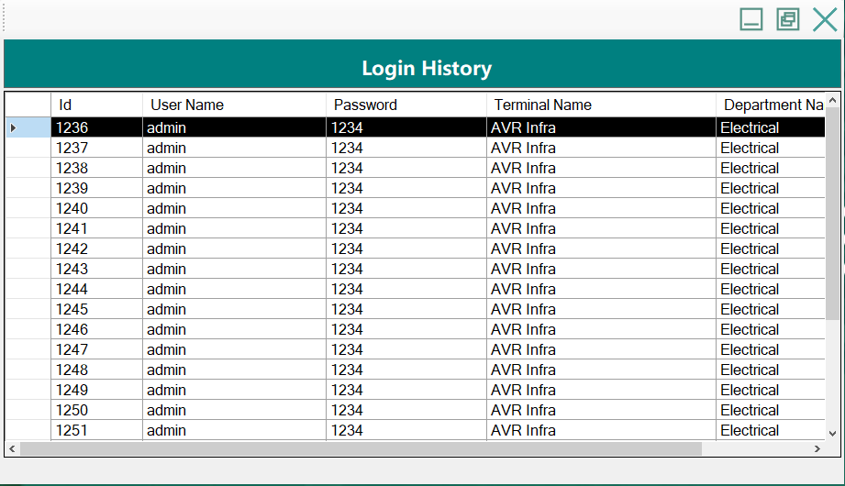

**Transaction**

**Purchase Inward Form :- this form is use for Purchase Inward entry.**

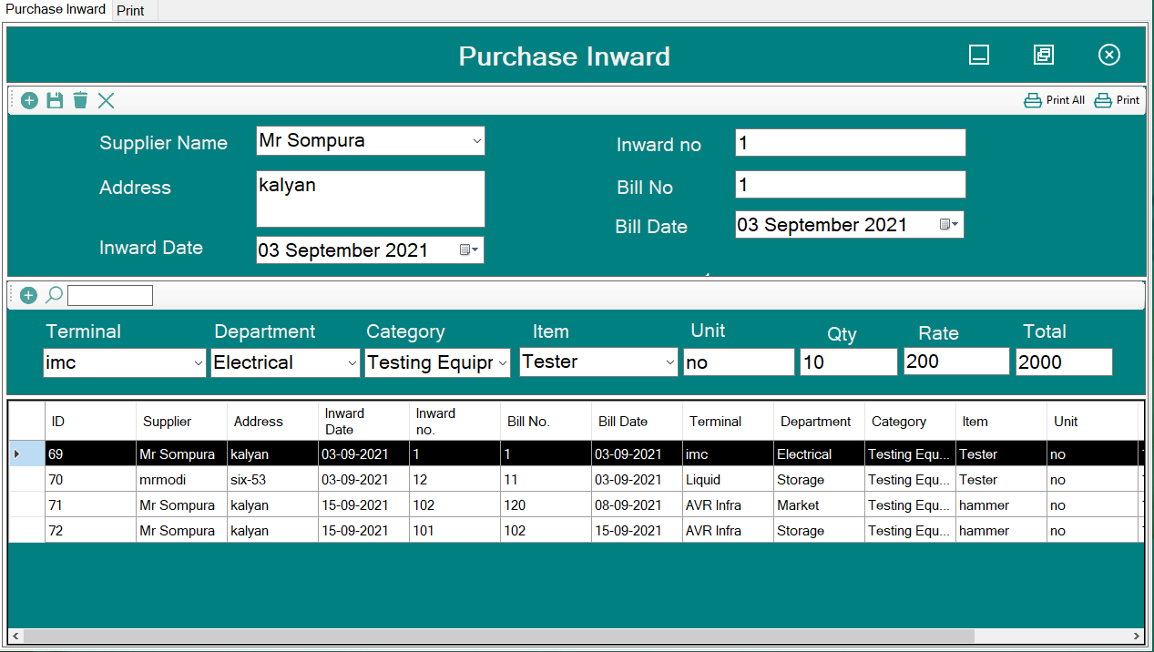

**Terminal Inward Form :- this form is use for Terminal Inward entry.**

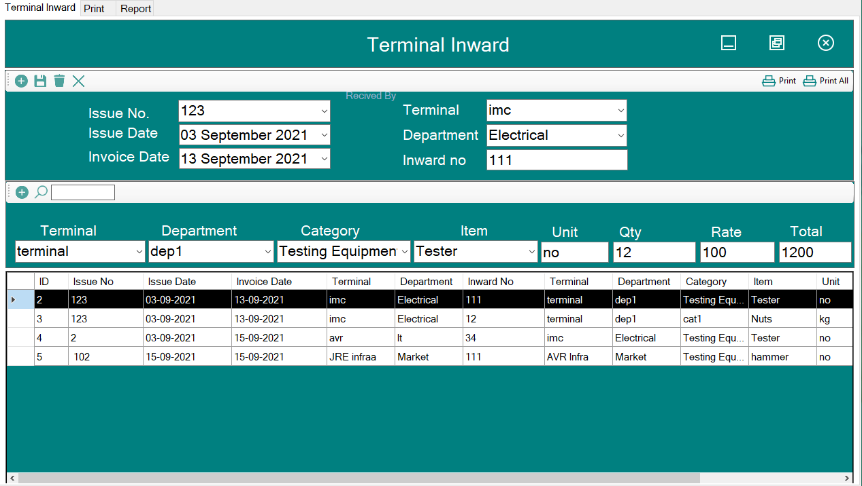

**Outward Form :- this form is use for Outward entry.**

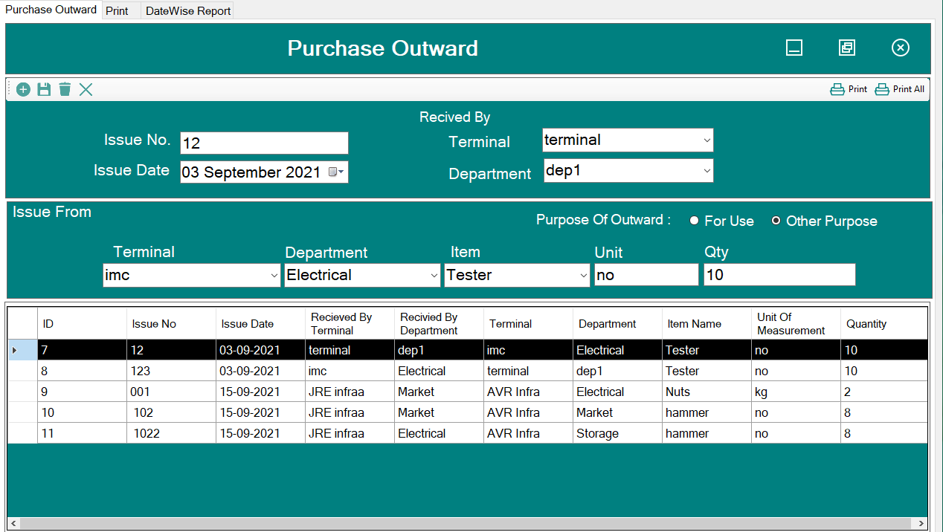

**Reports**

**Stock Report On Generate All Option**

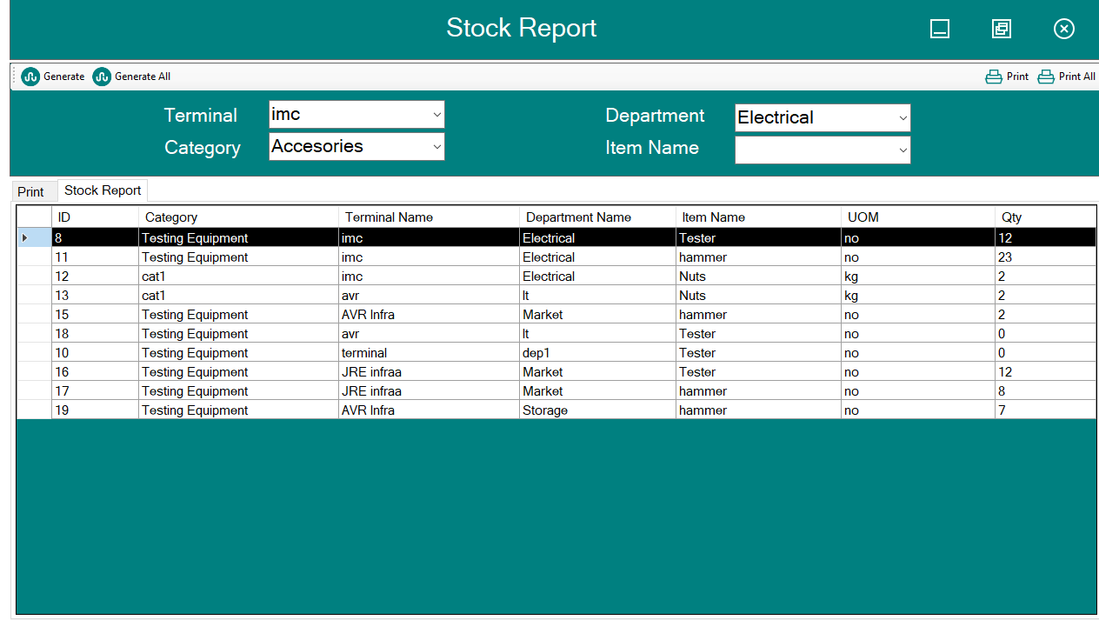

**Print of Stock Report On Print All Option**

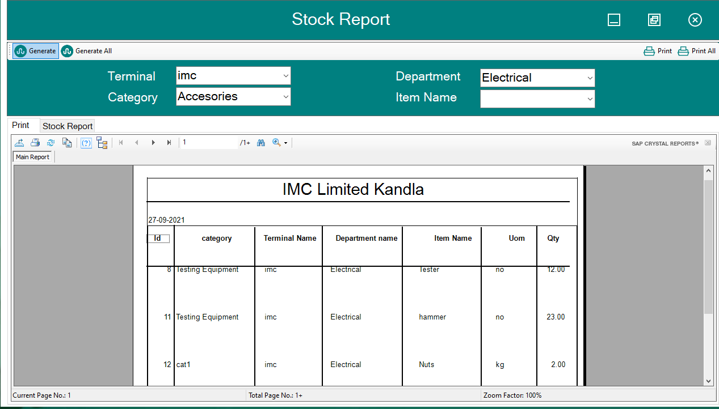

**Stock Report Of selected Field**

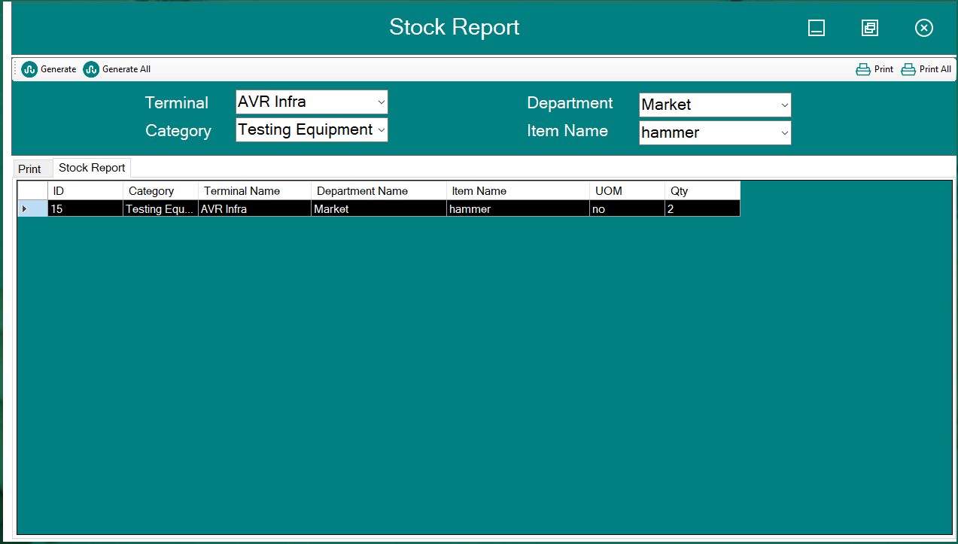

**Print Stock Report Of selected Field**

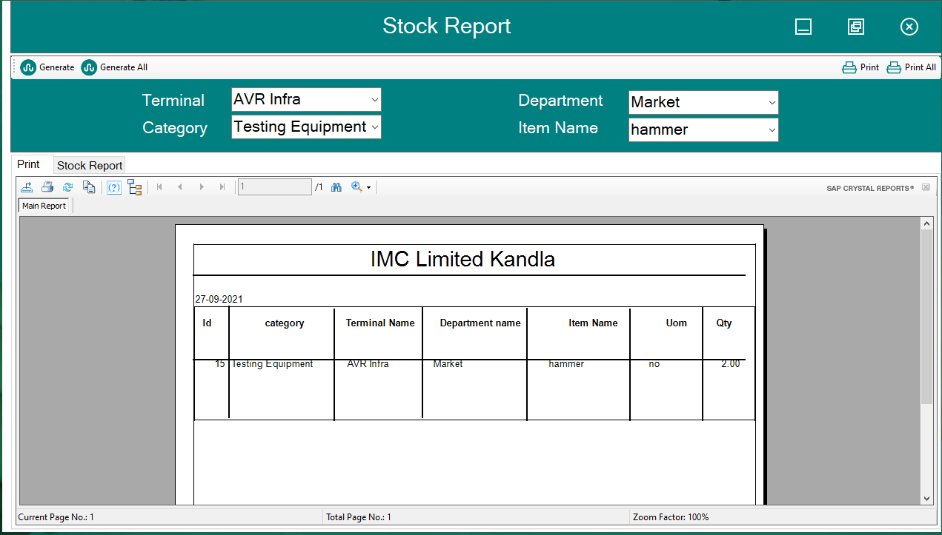

**Supplier Inward Report Date Wise**

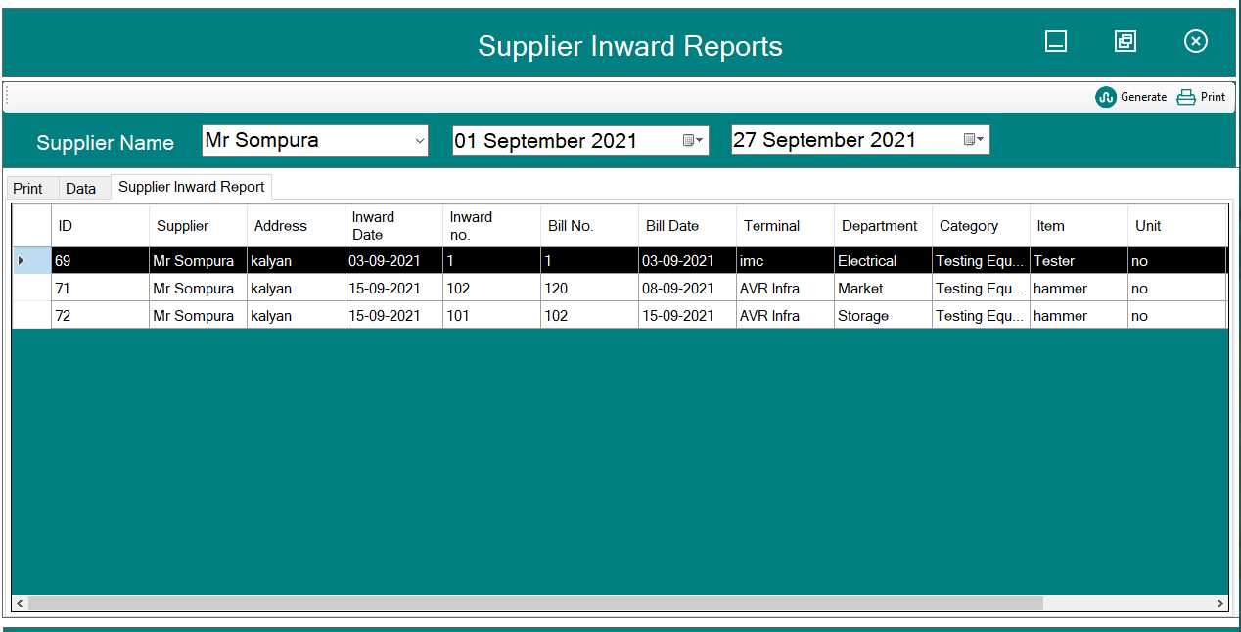

**Report Of Supplier Inward Report Date Wise**

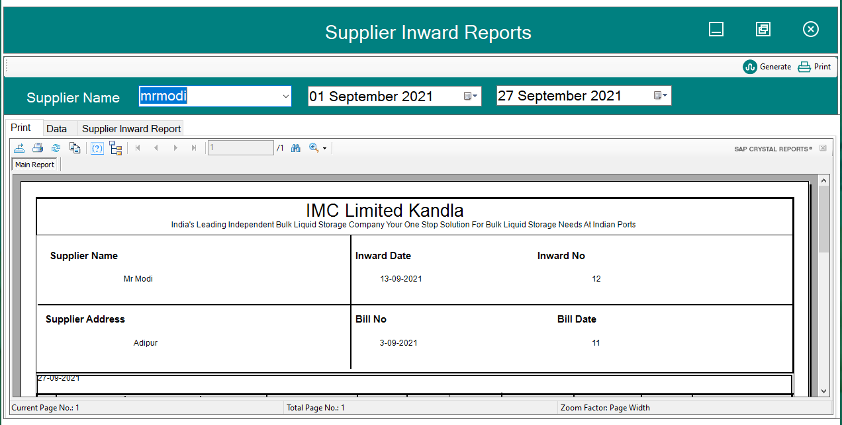

**Report Of Purchase Inward Report Date Wise**

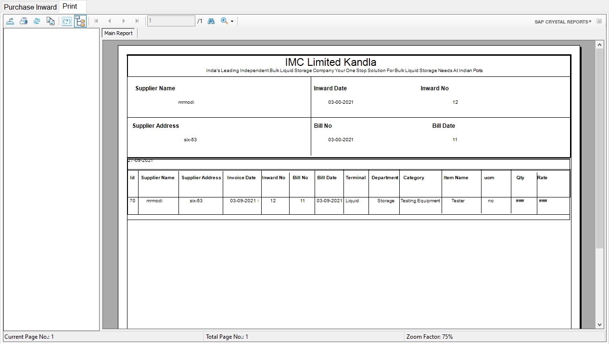

**Report Of Terminal Inward Report Wise**

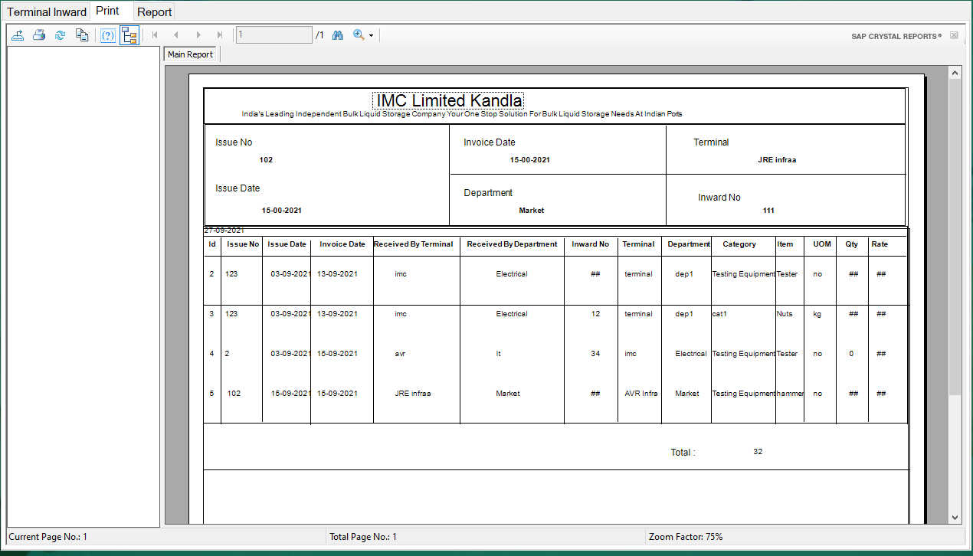

**Report Of Terminal Inward Report Date Wise**

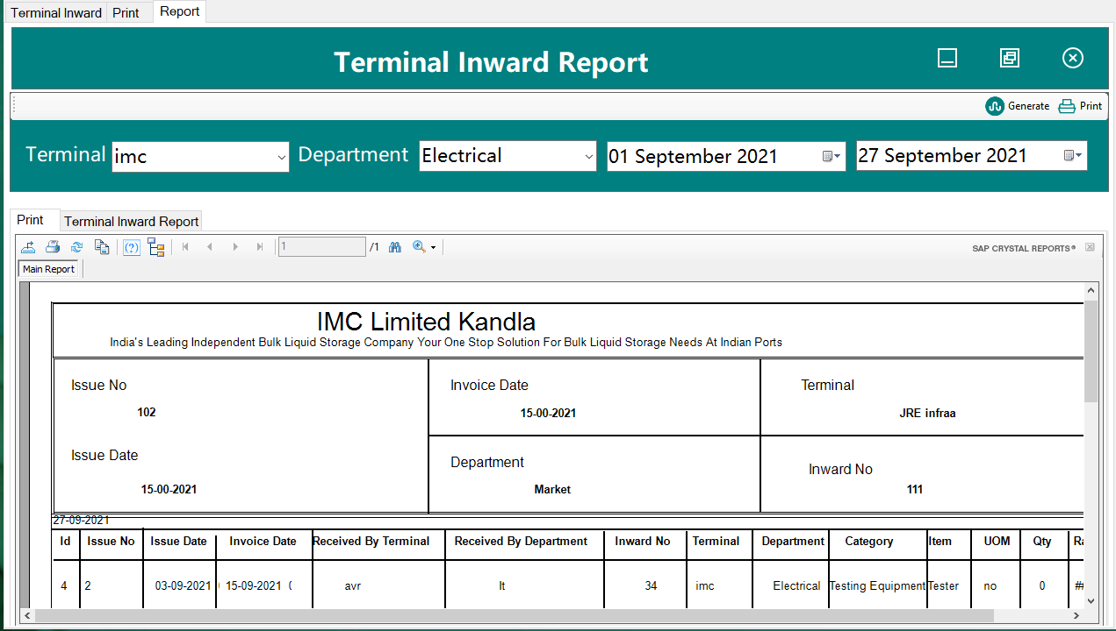

**Report Of Outward Report Print All**

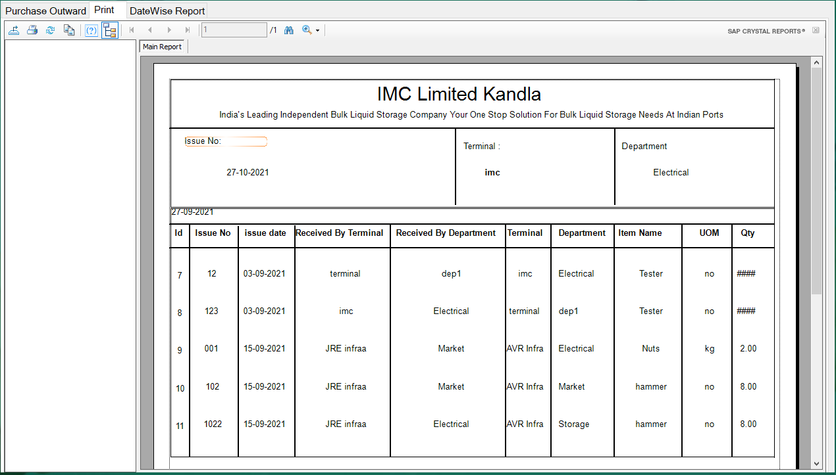

**Print Outward Report Of selected Field**

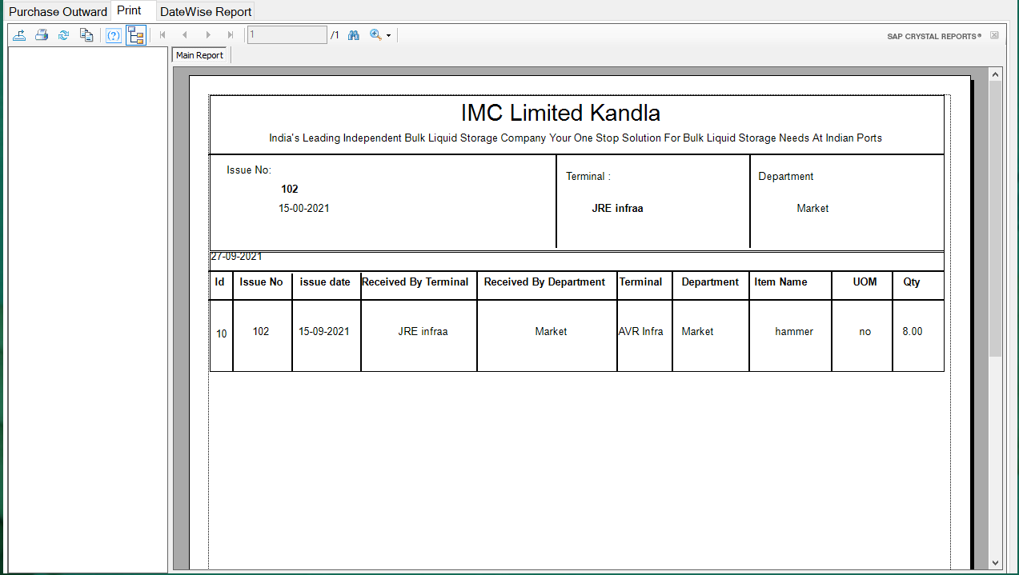

**Report Converted into PDF**

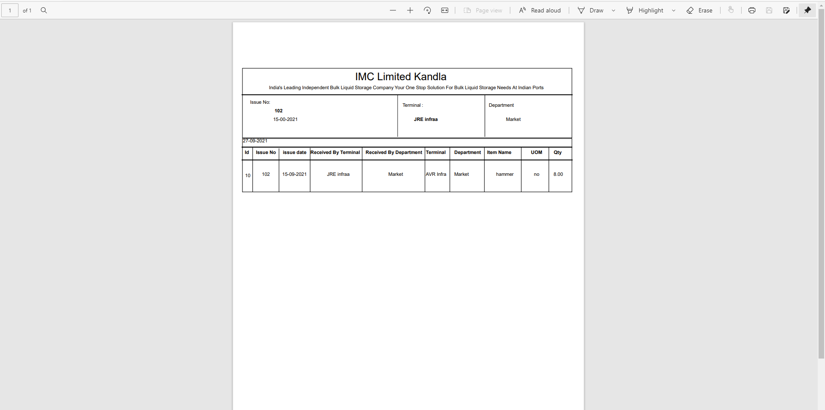

**Chapter : 6**

**CONCLUSION**

**AND**

**LIMITATION**

**6.1** **Conclusion:**

The Terminal Warehouse Inventory Management System Windows-Application Has been successfully completed by the developer within the scheduled time and all the function requirement of the project that Were set in SRS have been fully achieved. The external interface requirement and input/output formats have been implemented as Per the requirement specifications.

* 1. **Limitation:**
* Security policy is dependent on password protection.

**6.3 Future scope of the Project:**

* In future we can comeover the Limitations of the project.
* Forgot Password And Otp System.
* We can update the security Policy and can provide higher Security.

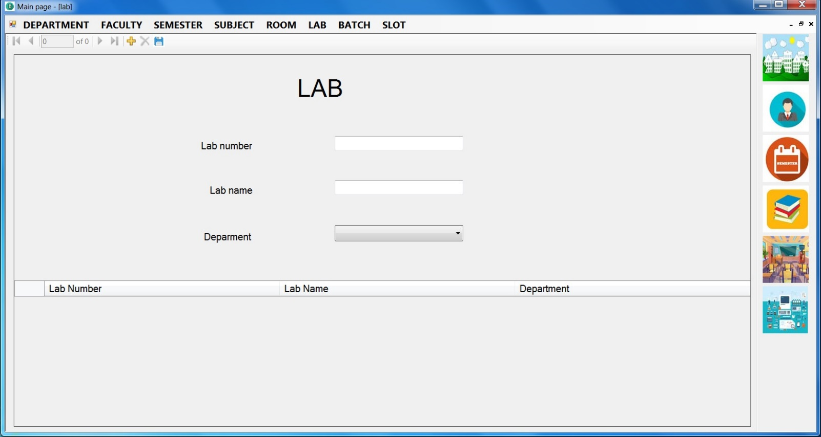Thank You