Student: HILL JIGISHKUMAR MODI (S3827516)

I certify that this is all my own original work. If I took any parts from elsewhere, then they were non-essential parts of the assignment, and they are clearly attributed in my submission. I will show I am agree to this honour code by typing "Yes": Yes.

Project – TIME SERIES ANALYSIS
Time Series Analysis to predict 10 month Waste Collection (in Tonnes) of Melbourne

Hill Jigishkumar Modi s3827516@student.rmit.edu.au
RMIT University, City Campus
Melbourne, Australia
Date: 12/06/2021
Contents
Introduction 6
AIM 6
Important Terminology 6
MA 6
AR 6
ACF 6
PACF 6
Deterministic Trend 6
Stochastic Trend 6
Stationarity / Non- Stationarity 6
Shapiro-Wilk Test 6
AIC 7
BIC 7
SARIMA(p,d,q)x(P,D,Q) 7
ADF TEST 7
EACF 7
BIC Table 7
Residuals 7
Ljung-Box Testing 7
Methodology 7
Descriptive Statistics 8
Trend 9
Changing Variance 10
Seasonality 10
Behaviour 10
Intervention Point 10
Relation between Consecutive Years 10
Box-Cox Transformation 11
Determining Set of Possible Models 12
Determining Seasonality Parameters (P,D,Q) 13
SARIMA(0,0,0)x(0,1,0) 13
SARIMA(0,0,0)x(2,1,1) 14
SARIMA(2,0,2)x(2,1,1) 15
Determining set of SARIMA(p,d,q)x(P,D,Q) Models 16
ACF & PACF 16
EACF 16
BIC Table 17
Diagnostic & Residual Analysis 18
SARIMA(0,0,0)x(2,1,1) 18
Co-efficients 18
Residual Checking 19
SARIMA(0,0,1)x(2,1,1) 20
Co-efficients 20
Residual Checking 20
SARIMA(1,0,1)x(2,1,1) 21
Co-efficients 21
Residual Checking 22
SARIMA(1,0,2)x(2,1,1) 23
Co-efficients 23
Residual Checking 23
SARIMA(1,0,3)x(2,1,1) 24
Co-efficients 24
Residual Checking 25
SARIMA(2,0,1)x(2,1,1) 26
Co-efficients 26
Residual Checking 26
SARIMA(2,0,2)x(2,1,1) 27
Co-efficients 27
Residual Checking 28
SARIMA(2,0,3)x(2,1,1) 29
Co-efficients 29
Residual Checking 29
SARIMA(3,0,3)x(2,1,1) 30
Co-efficients 30
Residual Checking 31
Determining best model 32
AIC score 32
BIC score 32
Overfitting the best model 33
SARIMA(3,0,4)x(2,1,1) 33
Co-efficients 33
Residual Checking 33
SARIMA(4,0,3)x(2,1,1) 34
SARIMA(4,0,4)x(2,1,1) 34
Co-efficients 34
Residual Checking 35
SARIMA(3,0,5)x(2,1,1) 36
Co-efficients 36
Residual Checking 36
SARIMA(3,0,6)x(2,1,1) 37
Co-efficients 37
Residual Checking 38
SARIMA(4,0,5)x(2,1,1) 39
Co-efficients 39
Residual Checking 39
SARIMA(4,0,6)x(2,1,1) 40
Co-efficients 40
Residual Checking 41
SARIMA(5,0,5)x(2,1,1) 42
Co-efficients 42
Residual Checking 42
Final SARIMA model 43
Parameter Estimation 43
Forecasting 43
Conclusion 44
References 45
Appendix 45
Abbreviation 45
Code 45

Figures
Figure 1 – Waste Collection of First 5 months 8
Figure 2 - Waste Collection of Last 5 months 8
Figure 3 - Waste collection as Time-Series Object 8
Figure 4 - Time Series Plot 9
Figure 5 - Auto-correlation of Time Series 9
Figure 6 - Scatterplot of Residential waste in consecutive months 10
Figure 7- Correlation value of Residential waste in consecutive months 10
Figure 8- Box-Cox Curve of maximum likelihood 11
Figure 9 - Confidence Interval of lambda 11
Figure 10- lambda value 11
Figure 11 – Box-Cox Transformed Time Series 12
Figure 12 - Auto-correlation of Box-Cox transformed time Series 12
Figure 13 - Residual time-series plot of SARIMA(0,0,0) x (0,1,0) 13
Figure 14- Residual auto-correlation plot of SARIMA(0,0,0) x (0,1,0) 13
Figure 15- Residual time-series plot of SARIMA(0,0,0) x (2,1,1) 14
Figure 16- Residual auto-correlation plot of SARIMA(0,0,0) x (2,1,1) 14
Figure 17- Residual time-series plot of SARIMA(2,0,2) x (2,1,1) 15
Figure 18- Residual auto-correlation plot of SARIMA(2,0,2) x (2,1,1) 16
Figure 19 - EACF Plot 17
Figure 20 - BIC Table 18
Figure 21 - Co-efficient of SARIMA(0,0,0) x (2,1,1) 19
Figure 22 - Residual Diagnostics of SARIMA(0,0,0) x (2,1,1) 19
Figure 23 - Normality Check of SARIMA(0,0,0) X (2,1,1) 20
Figure 24 - Co-efficient of SARIMA(0,0,1) x (2,1,1) 20
Figure 25 - Residual Diagnostics of SARIMA(0,0,1) x (2,1,1) 21
Figure 26 - Normality Check of SARIMA(0,0,1) X (2,1,1) 21
Figure 27 - Co-efficient of SARIMA(1,0,1) x (2,1,1) 22
Figure 28 - Residual Diagnostics of SARIMA(1,0,1) x (2,1,1) 22
Figure 29 - Normality Check of SARIMA(1,0,1) X (2,1,1) 23
Figure 30 - Co-efficient of SARIMA(1,0,2) x (2,1,1) 23
Figure 31 - Residual Diagnostics of SARIMA(1,0,2) x (2,1,1) 24
Figure 32 - Normality Check of SARIMA(1,0,2) X (2,1,1) 24
Figure 33 - Co-efficient of SARIMA (1,0,3) x (2,1,1) 25
Figure 34 - Residual Diagnostics of SARIMA(1,0,3) x (2,1,1) 25
Figure 35 - Normality Check of SARIMA(1,0,3) X (2,1,1) 26
Figure 36 - Co-efficient of SARIMA(2,0,1) x (2,1,1) 26
Figure 37 - Residual Diagnostics of SARIMA(2,0,1) x (2,1,1) 27
Figure 38 - Normality Check of SARIMA(2,0,1) X (2,1,1) 27
Figure 39 - Co-efficient of SARIMA(2,0,2) x (2,1,1) 28
Figure 40 - Residual Diagnostics of SARIMA(2,0,2) x (2,1,1) 28
Figure 41 - Normality Check of SARIMA(2,0,2) X (2,1,1) 29
Figure 42 - Co-efficient of SARIMA(2,0,3) x (2,1,1) 29
Figure 43 - Residual Diagnostics of SARIMA(2,0,3) x (2,1,1) 30
Figure 44 - Normality Check of SARIMA(2,0,3) X (2,1,1) 30
Figure 45 - Co-efficient of SARIMA(3,0,3) x (2,1,1) 31
Figure 46 - Residual Diagnostics of SARIMA(3,0,3) x (2,1,1) 31
Figure 47 - Normality Check of SARIMA(3,0,3) X (2,1,1) 32
Figure 48 - AIC Sort 32
Figure 49 - BIC Sort 32
Figure 50 - Co-efficient of SARIMA(3,0,4) x (2,1,1) 33
Figure 51 - Residual Diagnostics of SARIMA(3,0,4) x (2,1,1) 34
Figure 52 - Normality Check of SARIMA(3,0,4) X (2,1,1) 34
Figure 53 - Co-efficient of SARIMA(4,0,4) x (2,1,1) 35
Figure 54 - Residual Diagnostics of SARIMA(4,0,4) x (2,1,1) 35
Figure 55 - Normality Check of SARIMA(4,0,4) X (2,1,1) 36
Figure 56 - Co-efficient of SARIMA(3,0,5) x (2,1,1) 36
Figure 57 - Residual Diagnostics of SARIMA(3,0,5) x (2,1,1) 37
Figure 58 - Normality Check of SARIMA(3,0,5) X (2,1,1) 37
Figure 59 - Co-efficient of SARIMA(3,0,6) x (2,1,1) 38
Figure 60 - Residual Diagnostics of SARIMA(3,0,6) x (2,1,1) 38
Figure 61 - Normality Check of SARIMA(3,0,6) X (2,1,1) 39
Figure 62 - Co-efficient of SARIMA(4,0,5) x (2,1,1) 39
Figure 63 - Residual Diagnostics of SARIMA(4,0,5) x (2,1,1) 40
Figure 64 - Normality Check of SARIMA(4,0,5) X (2,1,1) 40
Figure 65 - Co-efficient of SARIMA(4,0,6) x (2,1,1) 41
Figure 66 - Residual Diagnostics of SARIMA(4,0,6) x (2,1,1) 41
Figure 67 - Normality Check of SARIMA(4,0,6) X (2,1,1) 42
Figure 68 - Co-efficient of SARIMA(5,0,5) x (2,1,1) 42
Figure 69 - Residual Diagnostics of SARIMA(5,0,5) x (2,1,1) 43
Figure 70 - Normality Check of SARIMA(5,0,5) X (2,1,1) 43
Figure 71 - Prediction Plot 44
Figure 72 - Prediction Values for next 10 months 44

Introduction
Data is taken from Assignment Section of Time Series Analysis.
Here, we have yearly dataset of Changes in Ozone Layer Thickness in Dobson Units from year 1927 to 2016. As dataset is about change, value will be respective to the previous year. If value is positive, then it represents increase in the Ozone Layer Thickness, if negative, it represents decrease in the Ozone Layer Thickness.

AIM
The Main objective/aim of report is to determine which Model is best suitable for the data, if we observe deterministic trend. For, stochastic trend, our main goal will be to identify set of Possible ARIMA(p,d,q) Models for the annual time series data of Ozone Layer Thickness.

Important Terminology

MA
MA is moving average. If time-series is fluctuates between time, then we can say, behaviour of time-series is MA.

AR
AR is Auto-Regressive. If time-series has successive time-points, then it’s behaviour is AR.

ACF
ACF is Auto-Correlation Function. We can determine q(order of MA) at the lag from the ACF plot. But, if there is pattern in ACF plot, then we can say q(order of MA) = 0. If there is wave like pattern, we can say there is seasonality in the data, if slowly decaying pattern, there is trend.

PACF
PACF is Partial Auto-Correlation Function. We can determine p(order of AR) at the lag from PACF plot.
Both, ACF and PACF tells us autocorrelation at lag.

Deterministic Trend
Deterministic Trend is the trend in which we can obtain trend by straight-forwardly looking at the equation. It only depends on the time.
y_{t} = β₀ + β₁t
Where y_{t} = current time-point value
β₀ = intercept,
β₁ = slope
t = time point
Deterministic trend (DT) : yt = βt + t Stochastic trend (ST) : yt = β + yt−1 + t ,

Stochastic Trend
Stochastic Trend is the trend in which current time-point value is also dependent on the previous time-point value.
y_{t} = β₀ + β₁t + y_{t - 1}
Where y_{t} = current time-point value
y_{t - 1} = previous time-point value
β₀ = intercept,
β₁ = slope
t = time point

Stationarity / Non- Stationarity
If mean of Time-series is same through the time points, then it is stationary.
If mean of time-series plot is changes through the time points, then series is non-stationary.

Shapiro-Wilk Test
Shapiro-Wilk test will check the normality.
Hypothesis
Null Hypothesis – data is normally distributed.
Alternate Hypothesis – data is not normally distributed.
Conclusion
if p-value is greater than 0.05, then we fail to reject null hypothesis.
Data is normally distributed.

AIC
AIC is Akaike’s Information Criterion. AIC calculates the relative quality of each model and give as output as model with lowest AIC value among them.

BIC
BIC is Bayesian Information Criterion. It gives us model with lowest BIC value.

SARIMA(p,d,q)x(P,D,Q)
ARIMA is AutoRegressive Integrated Moving Average model.
Where p = order of AR (AutoRegressive)
d = number of difference
q = order of MA (Moving Average)
SARIMA(p,d,q)x(P,D,Q)

ADF TEST
ADF Test is Augmented Dicky-Fuller Test. It is used to check the stationarity of time-series.
Hypothesis
Null Hypothesis – Series is Non-stationary
Alternate Hypothesis – Series is stationary.
Conclusion
if p-value is greater than 0.05, then we fail to reject null hypothesis.
Series is non-stationary.

EACF
EACF is Extended AutoCorrelation Function.
We will look for top-most 0s with vertex. Then we will include that order of p and q to ARIMA(p,d,q) and we will also include its neighbour orders.

BIC Table
BIC Table is Bayesian Information Criterion Table.
It compares the BIC value with significant possible ARIMA order. If respective box is darker, then it is significant.

Residuals

Ljung-Box Testing

Methodology
I will check if time-series data has changing variance and stationarity. If it is there, then I’ll deal with it with help of log or Box-Cox transformation and with taking the differences till I found stationary time-series.
Then, I’ll find set of possible ARIMA(p,d,q) model with help of ACF, PACF, EACF and BIC table.

Descriptive Statistics

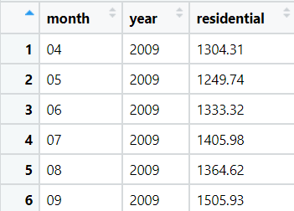
Figure 1 – Waste Collection of First 5 months

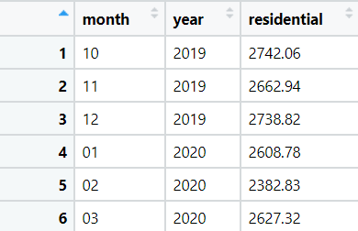
Figure 2 - Waste Collection of Last 5 months

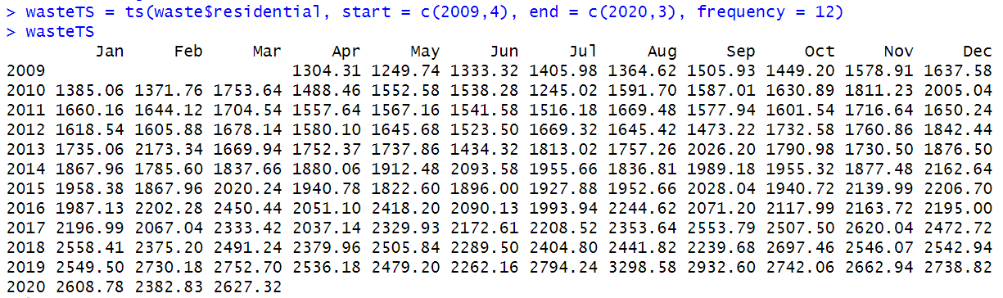
Figure 3 - Waste collection as Time-Series Object
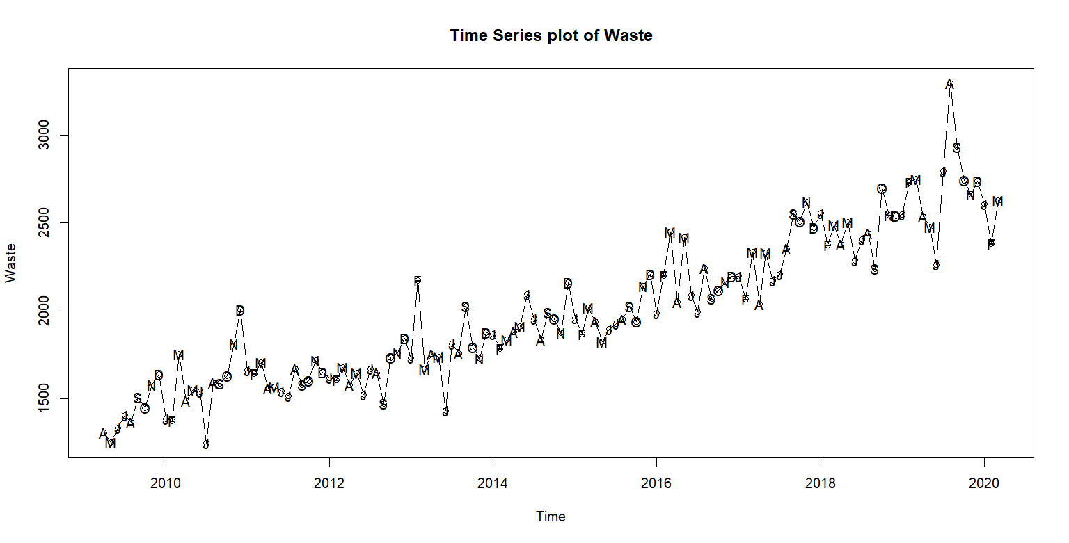
Figure 4 - Time Series Plot
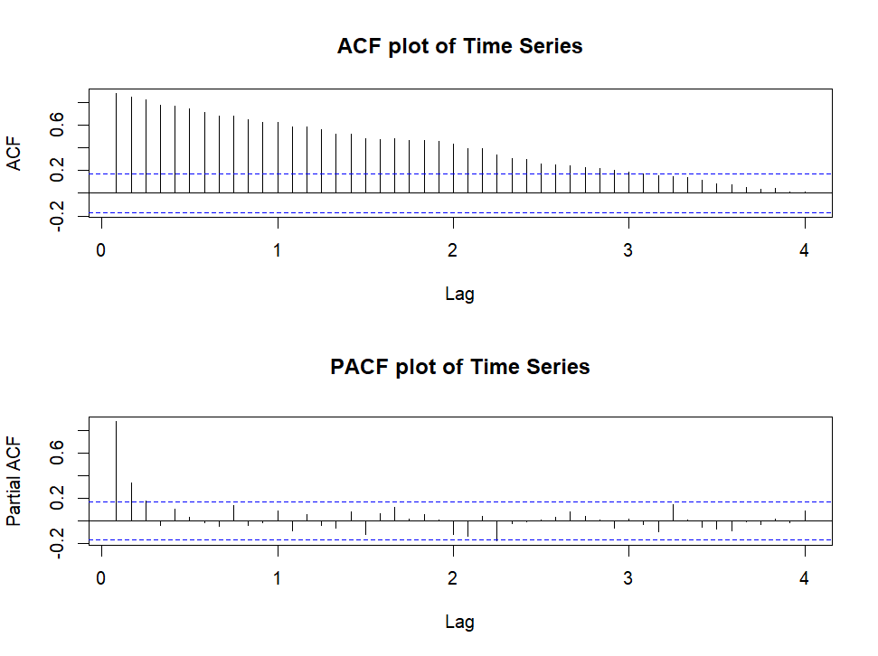
Figure 5 - Auto-correlation of Time Series

Trend
By observing the above graph it is detected that there is an upwards trend with a changing mean level. Hence, the series could be considered a non-stationary series and slowly decaying pattern from ACF plot also confirms our assumption of trend

Changing Variance

Seasonality
Seasonality refers to repeating patterns in time intervals. In this series it is not possible to identify a clear seasonality. Further analysis needs to be conducted to identify any seasonality if it exists.

Behaviour

Intervention Point

Relation between Consecutive Years

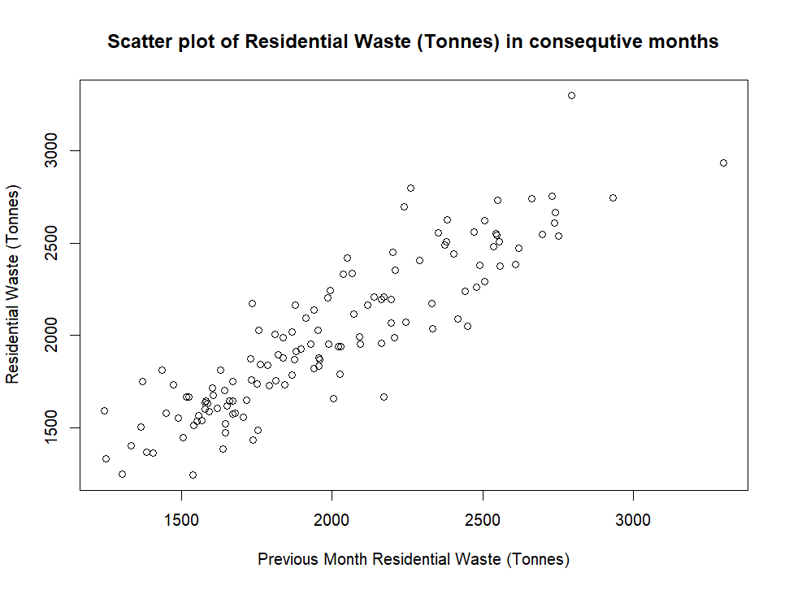
Figure 6 - Scatterplot of Residential waste in consecutive months
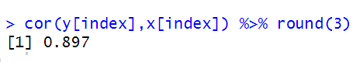
Figure 7- Correlation value of Residential waste in consecutive months

Box-Cox Transformation
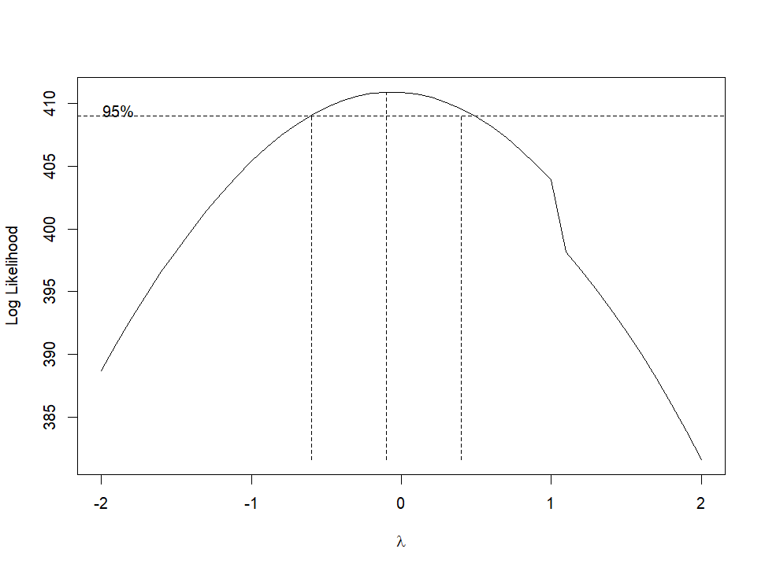
Figure 8- Box-Cox Curve of maximum likelihood

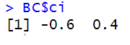
Figure 9 - Confidence Interval of lambda

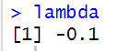
Figure 10- lambda value

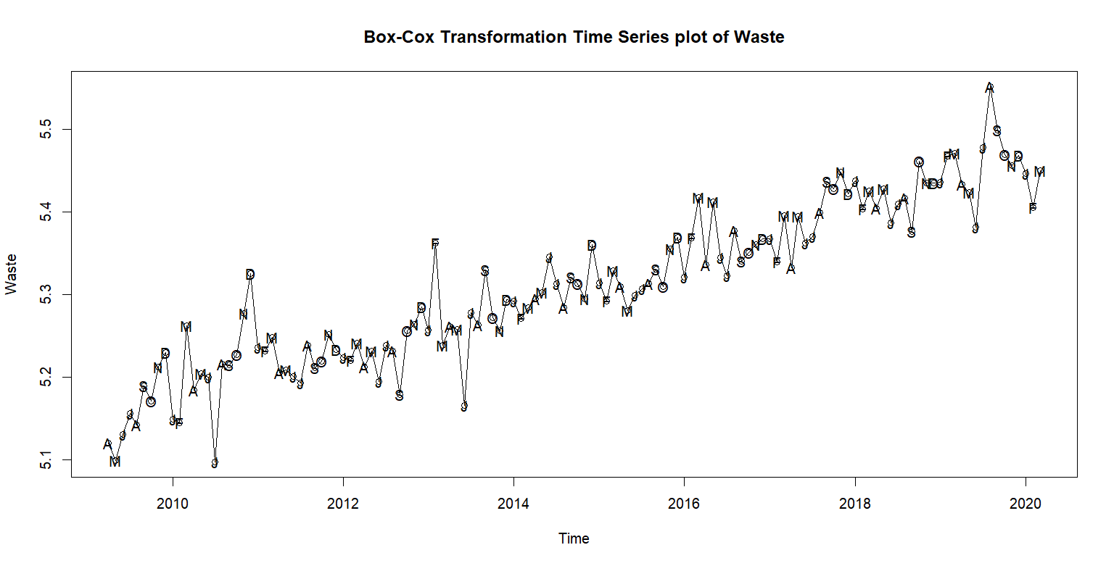
Figure 11 – Box-Cox Transformed Time Series
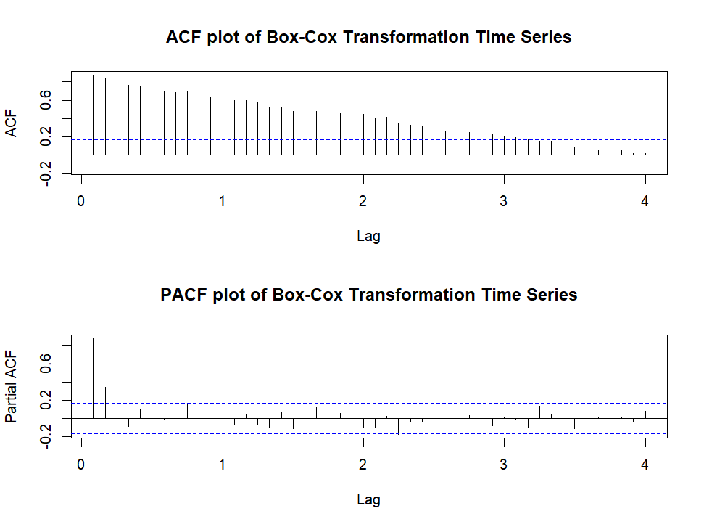
Figure 12 - Auto-correlation of Box-Cox transformed time Series

Determining Set of Possible Models

Determining Seasonality Parameters (P,D,Q)

SARIMA(0,0,0)x(0,1,0)
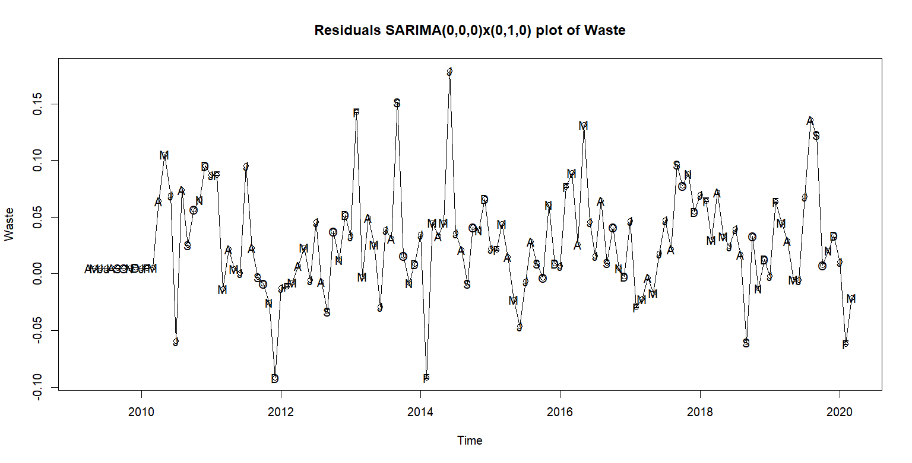
Figure 13 - Residual time-series plot of SARIMA(0,0,0) x (0,1,0)
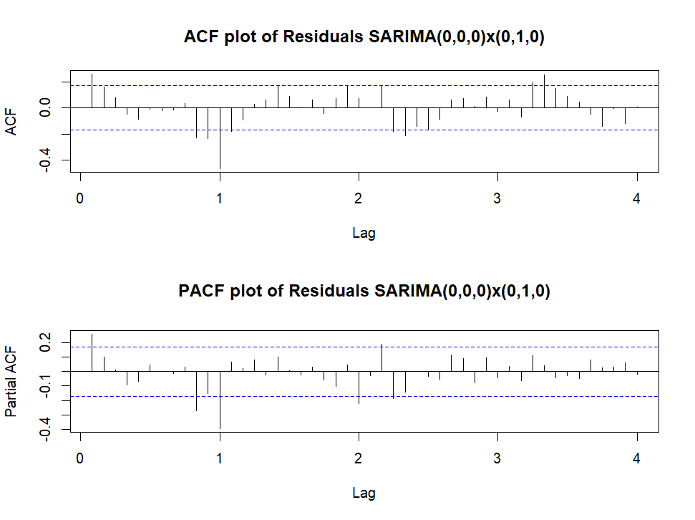
Figure 14- Residual auto-correlation plot of SARIMA(0,0,0) x (0,1,0)

ACF

PACF

SARIMA(0,0,0)x(2,1,1)

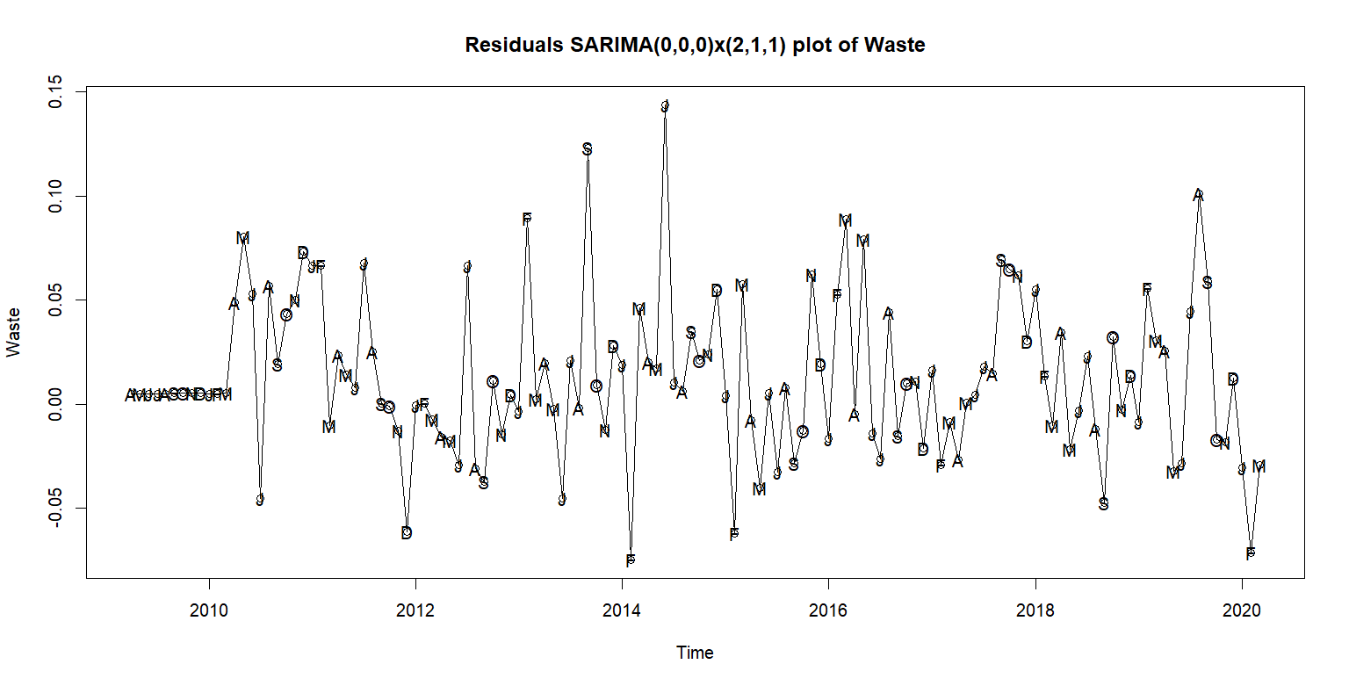
Figure 15- Residual time-series plot of SARIMA(0,0,0) x (2,1,1)
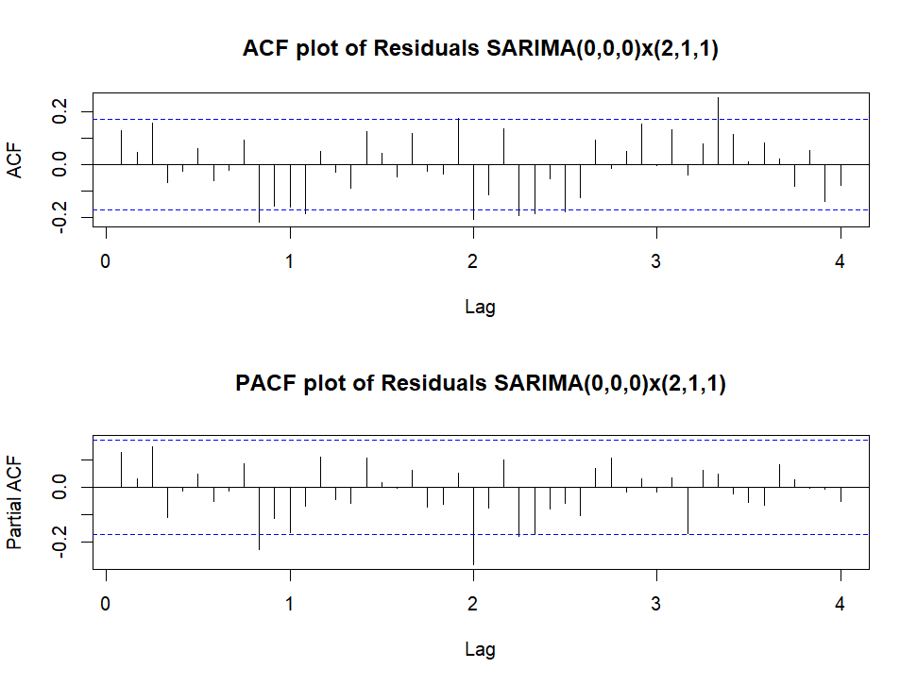
Figure 16- Residual auto-correlation plot of SARIMA(0,0,0) x (2,1,1)

ACF

PACF

SARIMA(2,0,2)x(2,1,1)

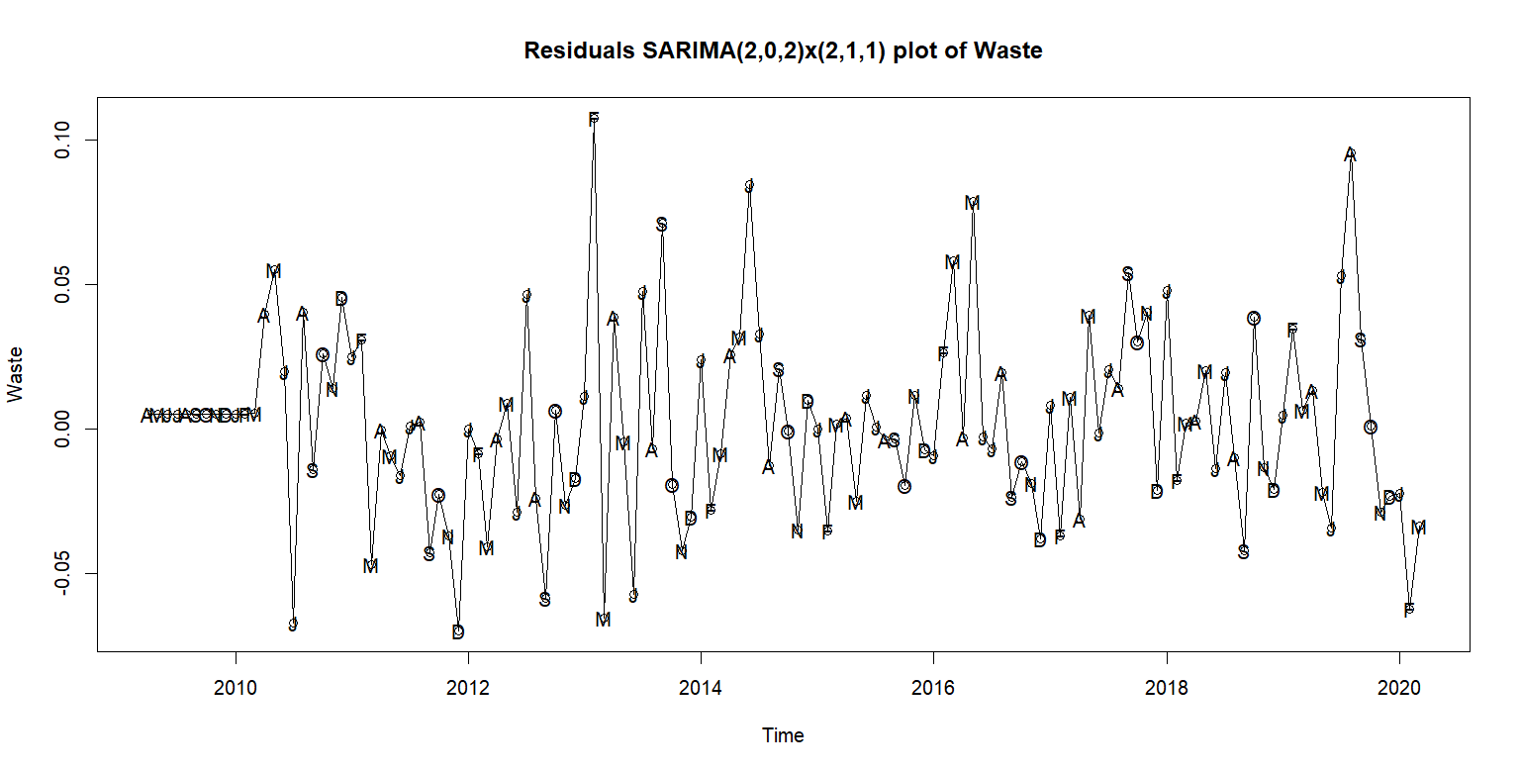
Figure 17- Residual time-series plot of SARIMA(2,0,2) x (2,1,1)
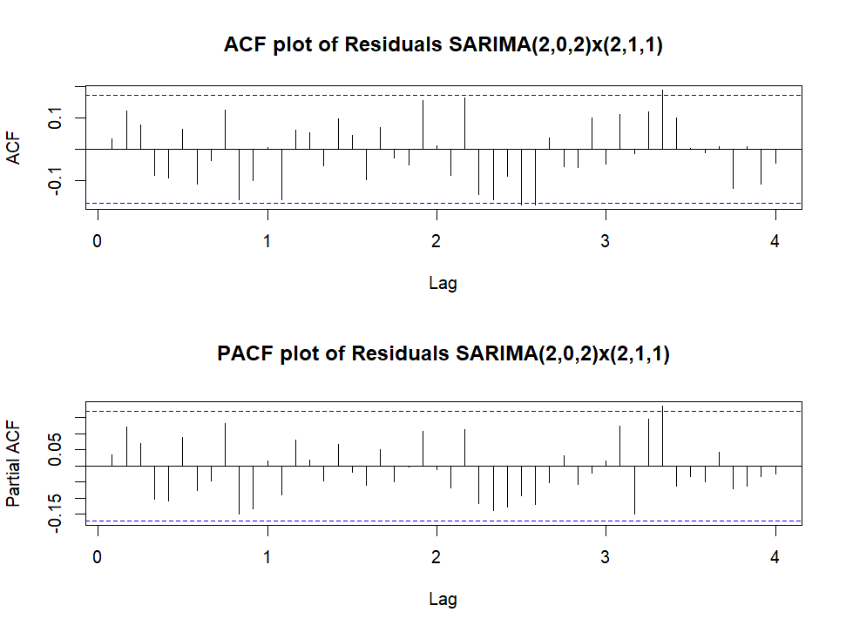
Figure 18- Residual auto-correlation plot of SARIMA(2,0,2) x (2,1,1)

ACF

PACF

Determining set of SARIMA(p,d,q)x(P,D,Q) Models

ACF & PACF

EACF

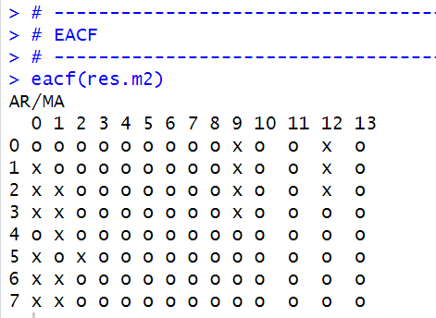
Figure 19 - EACF Plot

BIC Table
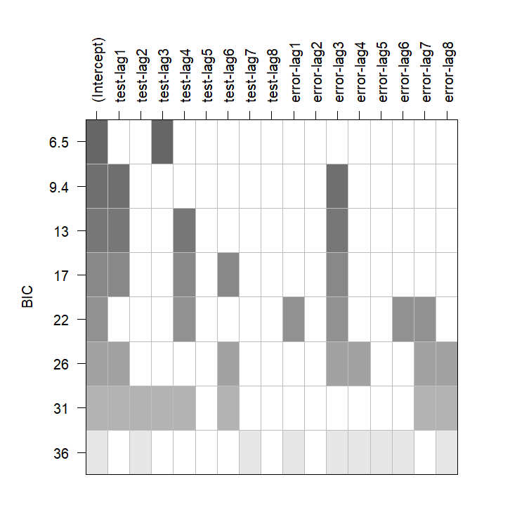
Figure 20 - BIC Table

Diagnostic & Residual Analysis

SARIMA(0,0,0)x(2,1,1)

Co-efficients

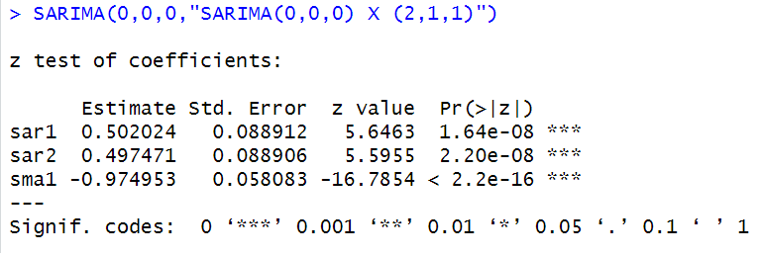
Figure 21 - Co-efficient of SARIMA(0,0,0) x (2,1,1)

Residual Checking
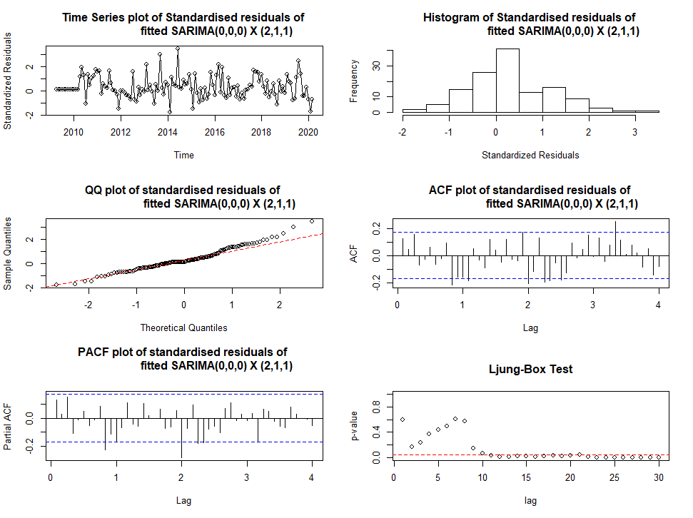
Figure 22 - Residual Diagnostics of SARIMA(0,0,0) x (2,1,1)

Time – Series

Histogram

QQ-plot

ACF

PACF

Ljung- Box

Shapiro-Wilk Test
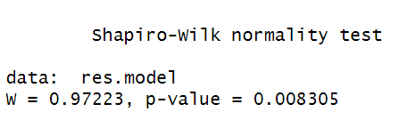
Figure 23 - Normality Check of SARIMA(0,0,0) X (2,1,1)

SARIMA(0,0,1)x(2,1,1)

Co-efficients

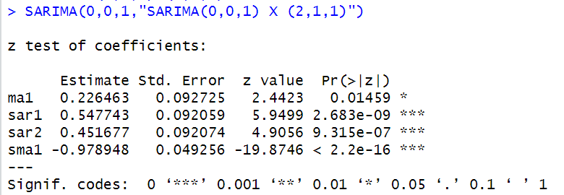
Figure 24 - Co-efficient of SARIMA(0,0,1) x (2,1,1)

Residual Checking
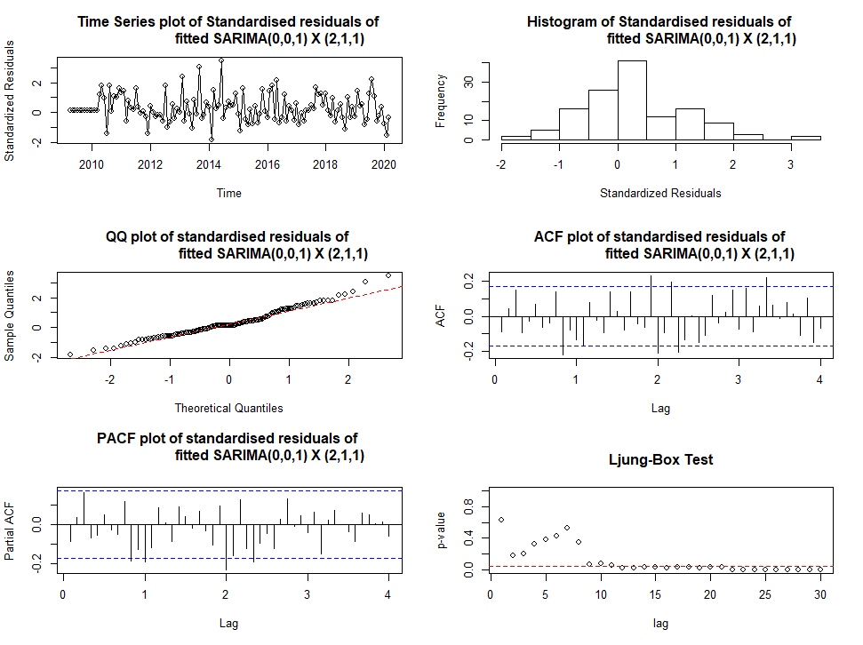
Figure 25 - Residual Diagnostics of SARIMA(0,0,1) x (2,1,1)

Time – Series

Histogram

QQ-plot

ACF

PACF

Ljung- Box

Shapiro-Wilk Test
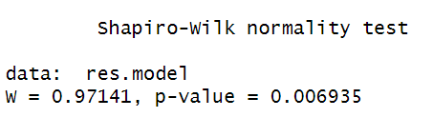
Figure 26 - Normality Check of SARIMA(0,0,1) X (2,1,1)

SARIMA(1,0,1)x(2,1,1)

Co-efficients

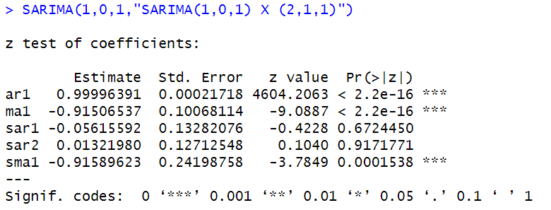
Figure 27 - Co-efficient of SARIMA(1,0,1) x (2,1,1)

Residual Checking
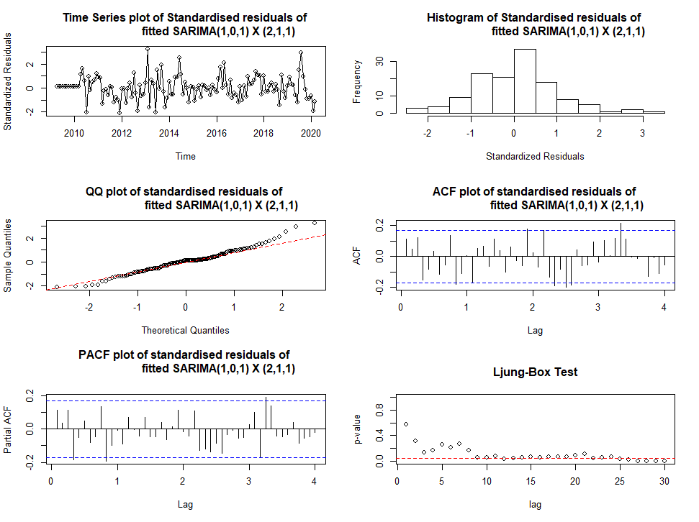
Figure 28 - Residual Diagnostics of SARIMA(1,0,1) x (2,1,1)

Time – Series

Histogram

QQ-plot

ACF

PACF

Ljung- Box

Shapiro-Wilk Test
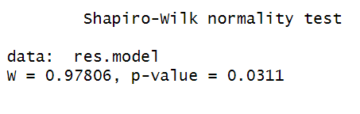
Figure 29 - Normality Check of SARIMA(1,0,1) X (2,1,1)

SARIMA(1,0,2)x(2,1,1)

Co-efficients

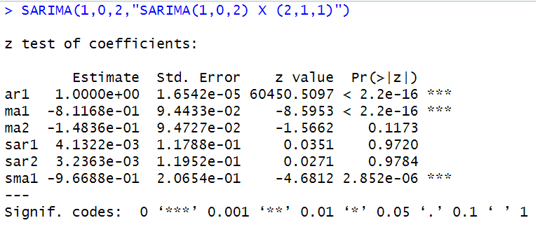
Figure 30 - Co-efficient of SARIMA(1,0,2) x (2,1,1)

Residual Checking
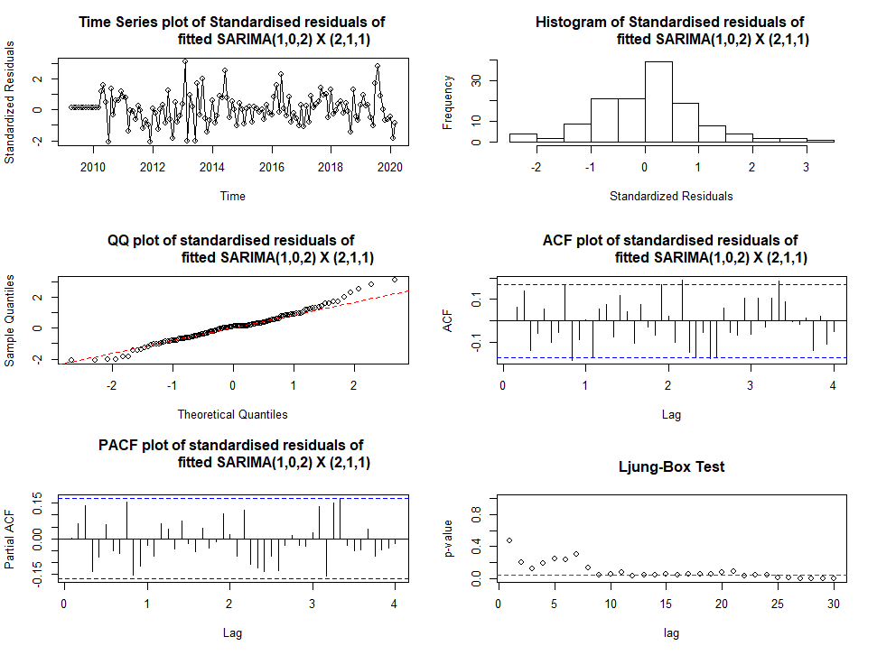
Figure 31 - Residual Diagnostics of SARIMA(1,0,2) x (2,1,1)

Time – Series

Histogram

QQ-plot

ACF

PACF

Ljung- Box

Shapiro-Wilk Test
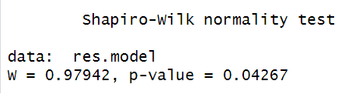
Figure 32 - Normality Check of SARIMA(1,0,2) X (2,1,1)

SARIMA(1,0,3)x(2,1,1)

Co-efficients

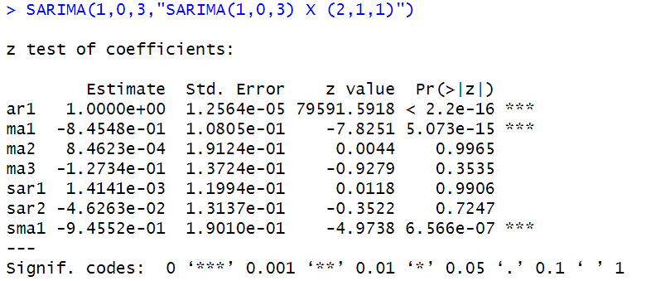
Figure 33 - Co-efficient of SARIMA (1,0,3) x (2,1,1)

Residual Checking
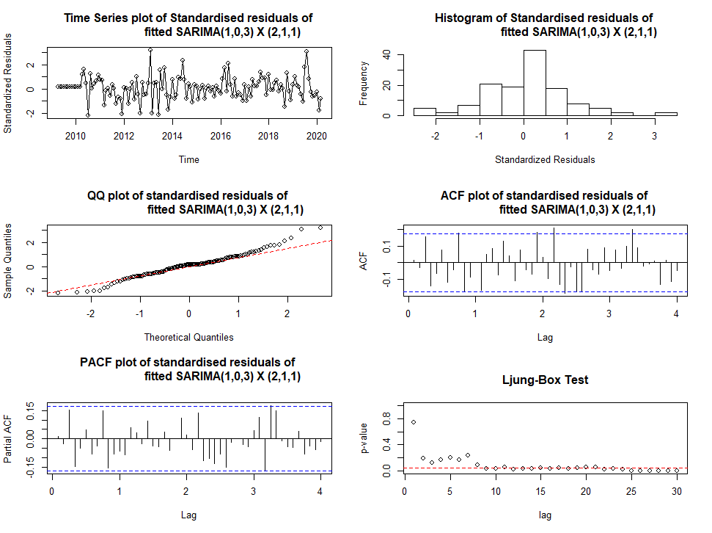
Figure 34 - Residual Diagnostics of SARIMA(1,0,3) x (2,1,1)

Time – Series

Histogram

QQ-plot

ACF

PACF

Ljung- Box

Shapiro-Wilk Test
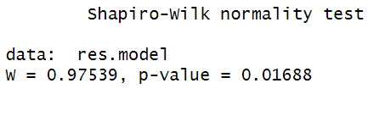
Figure 35 - Normality Check of SARIMA(1,0,3) X (2,1,1)

SARIMA(2,0,1)x(2,1,1)

Co-efficients

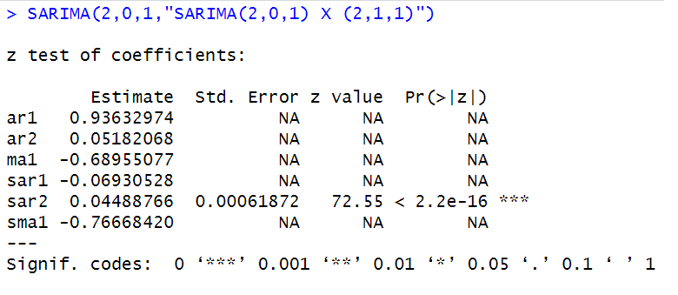
Figure 36 - Co-efficient of SARIMA(2,0,1) x (2,1,1)

Residual Checking
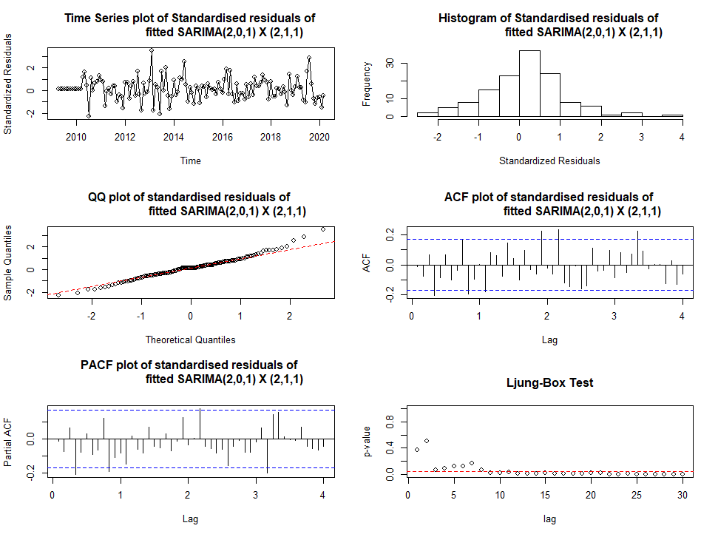
Figure 37 - Residual Diagnostics of SARIMA(2,0,1) x (2,1,1)

Time – Series

Histogram

QQ-plot

ACF

PACF

Ljung- Box

Shapiro-Wilk Test
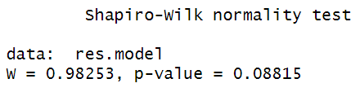
Figure 38 - Normality Check of SARIMA(2,0,1) X (2,1,1)

SARIMA(2,0,2)x(2,1,1)

Co-efficients

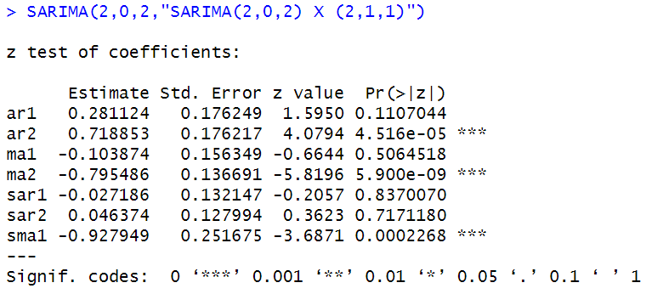
Figure 39 - Co-efficient of SARIMA(2,0,2) x (2,1,1)

Residual Checking

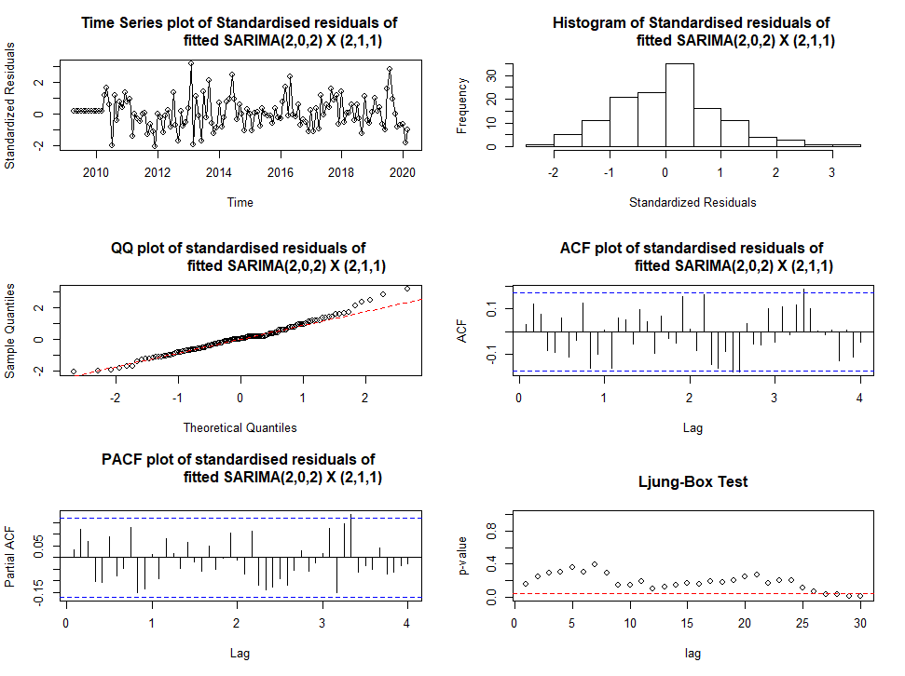
Figure 40 - Residual Diagnostics of SARIMA(2,0,2) x (2,1,1)

Time – Series

Histogram

QQ-plot

ACF

PACF

Ljung- Box

Shapiro-Wilk Test
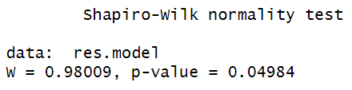
Figure 41 - Normality Check of SARIMA(2,0,2) X (2,1,1)

SARIMA(2,0,3)x(2,1,1)

Co-efficients

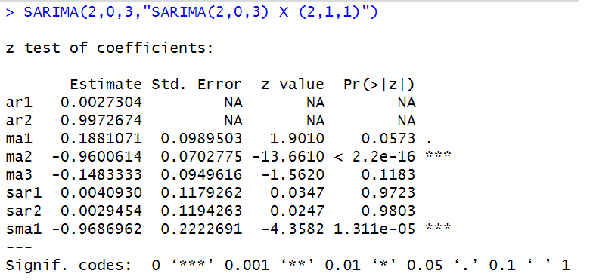
Figure 42 - Co-efficient of SARIMA(2,0,3) x (2,1,1)

Residual Checking
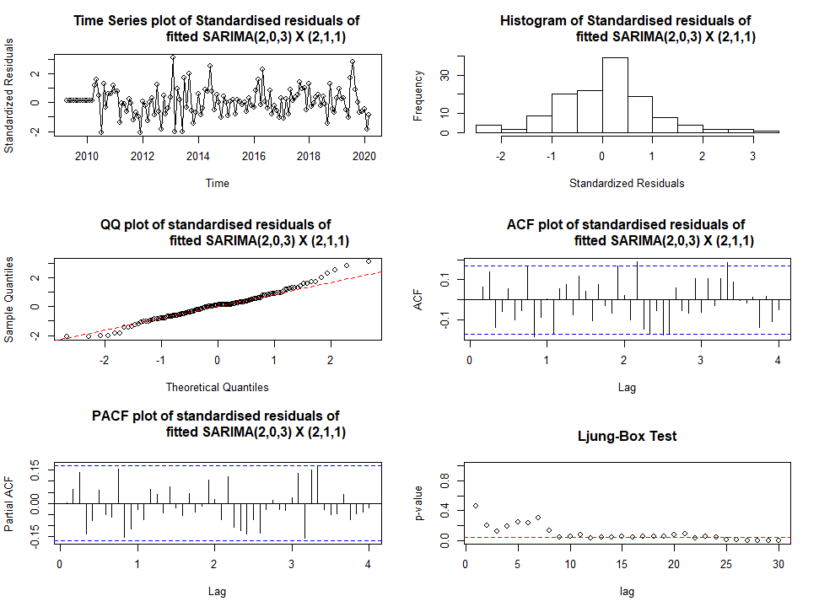
Figure 43 - Residual Diagnostics of SARIMA(2,0,3) x (2,1,1)

Time – Series

Histogram

QQ-plot

ACF

PACF

Ljung- Box

Shapiro-Wilk Test
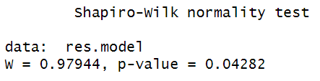
Figure 44 - Normality Check of SARIMA(2,0,3) X (2,1,1)

SARIMA(3,0,3)x(2,1,1)

Co-efficients

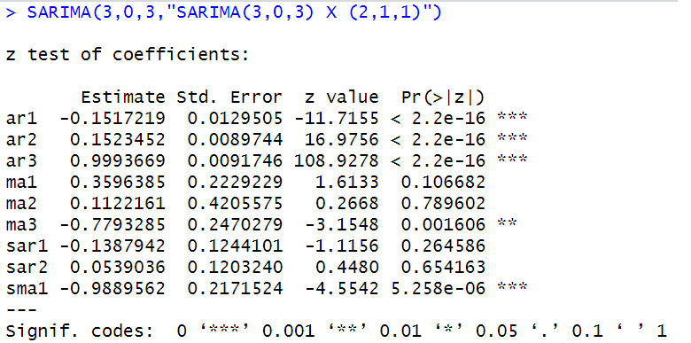
Figure 45 - Co-efficient of SARIMA(3,0,3) x (2,1,1)

Residual Checking
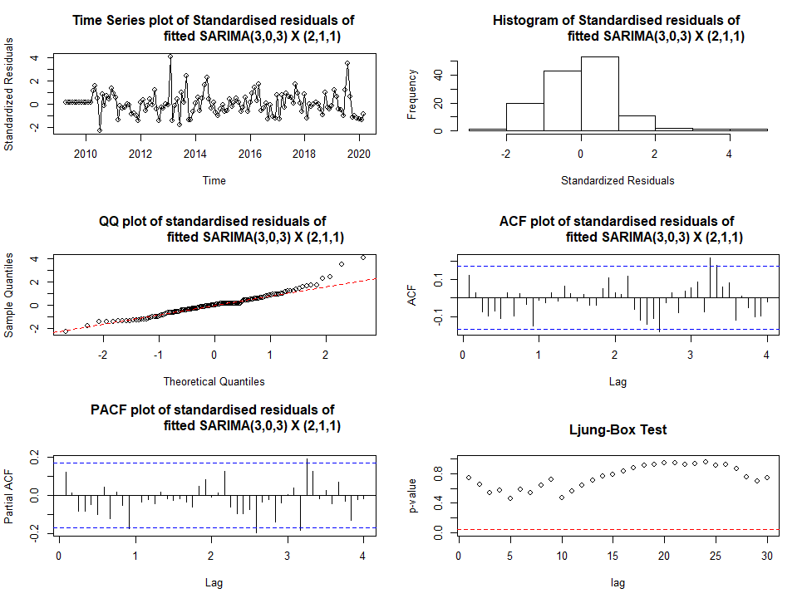
Figure 46 - Residual Diagnostics of SARIMA(3,0,3) x (2,1,1)

Time – Series

Histogram

QQ-plot

ACF

PACF

Ljung- Box

Shapiro-Wilk Test
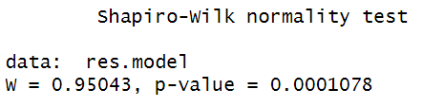
Figure 47 - Normality Check of SARIMA(3,0,3) X (2,1,1)

Determining best model

AIC score

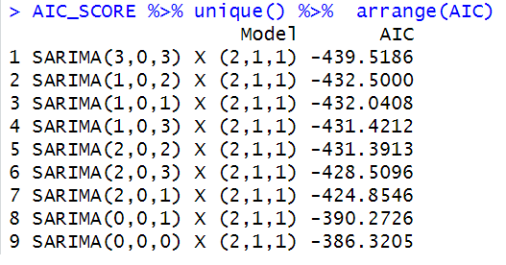
Figure 48 - AIC Sort

BIC score

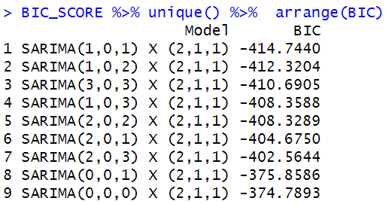
Figure 49 - BIC Sort

Table 1 – Finding the Best SARIMA model

Overfitting the best model

SARIMA(3,0,4)x(2,1,1)

Co-efficients

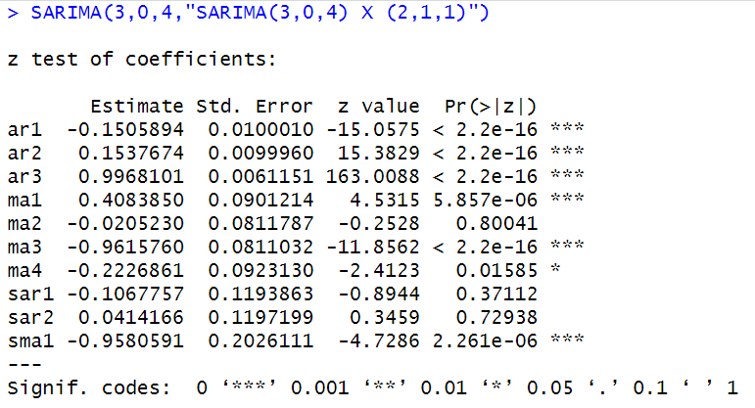
Figure 50 - Co-efficient of SARIMA(3,0,4) x (2,1,1)

Residual Checking
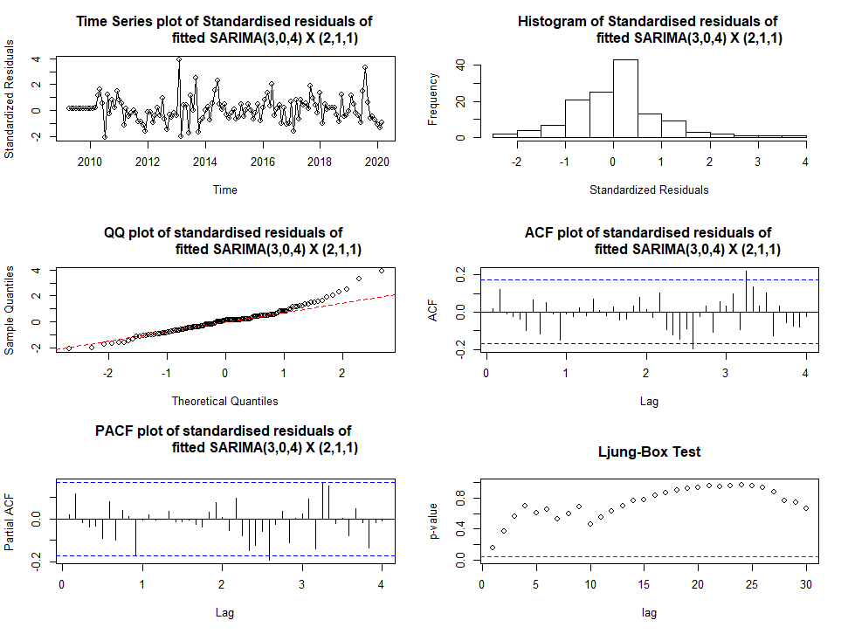
Figure 51 - Residual Diagnostics of SARIMA(3,0,4) x (2,1,1)

Time – Series

Histogram

QQ-plot

ACF

PACF

Ljung- Box

Shapiro-Wilk Test
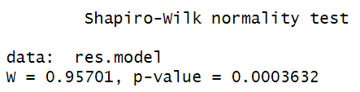
Figure 52 - Normality Check of SARIMA(3,0,4) X (2,1,1)

SARIMA(4,0,3)x(2,1,1)

SARIMA(4,0,4)x(2,1,1)

Co-efficients

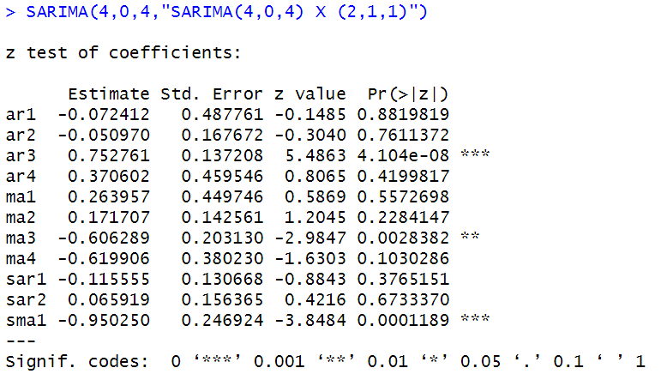
Figure 53 - Co-efficient of SARIMA(4,0,4) x (2,1,1)

Residual Checking
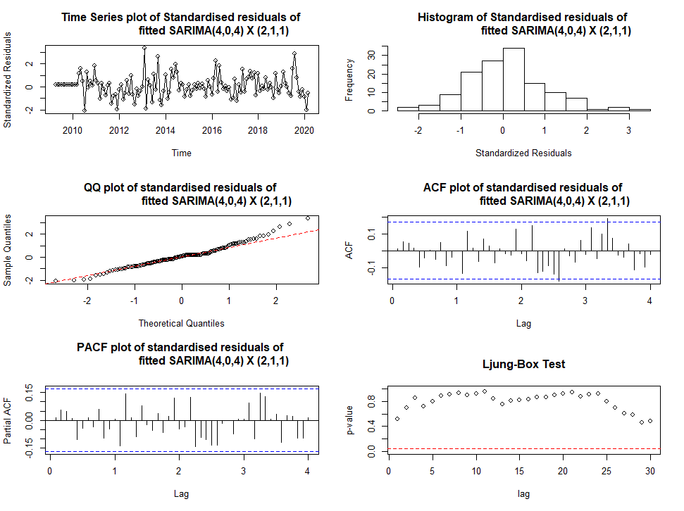
Figure 54 - Residual Diagnostics of SARIMA(4,0,4) x (2,1,1)

Time – Series

Histogram

QQ-plot

ACF

PACF

Ljung- Box

Shapiro-Wilk Test
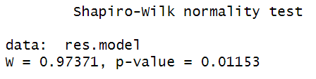
Figure 55 - Normality Check of SARIMA(4,0,4) X (2,1,1)

SARIMA(3,0,5)x(2,1,1)

Co-efficients

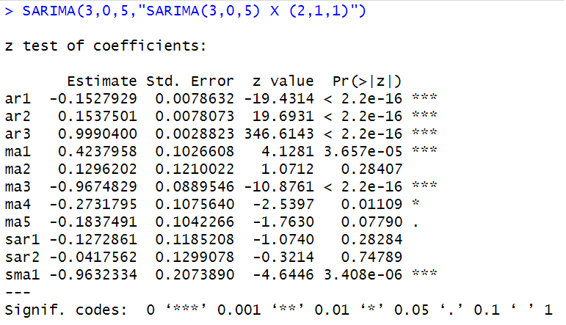
Figure 56 - Co-efficient of SARIMA(3,0,5) x (2,1,1)

Residual Checking
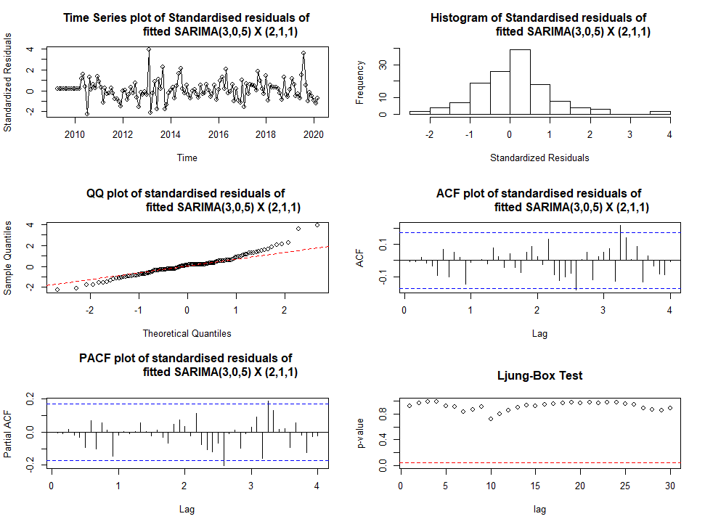
Figure 57 - Residual Diagnostics of SARIMA(3,0,5) x (2,1,1)

Time – Series

Histogram

QQ-plot

ACF

PACF

Ljung- Box

Shapiro-Wilk Test
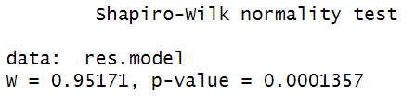
Figure 58 - Normality Check of SARIMA(3,0,5) X (2,1,1)

SARIMA(3,0,6)x(2,1,1)

Co-efficients

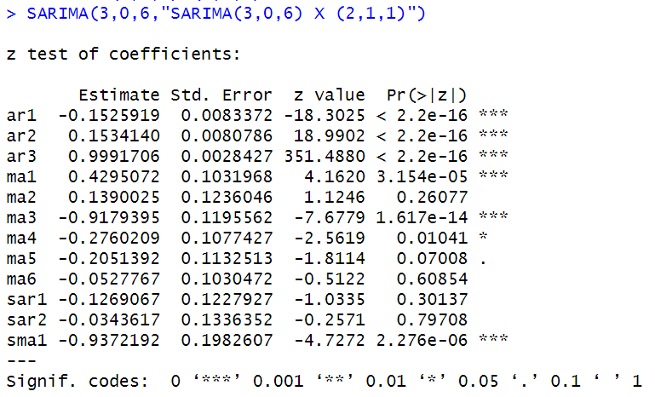
Figure 59 - Co-efficient of SARIMA(3,0,6) x (2,1,1)

Residual Checking
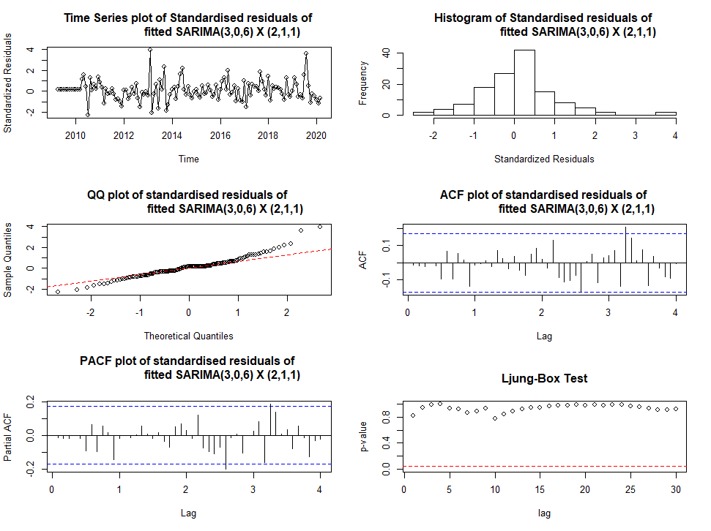
Figure 60 - Residual Diagnostics of SARIMA(3,0,6) x (2,1,1)

Time – Series

Histogram

QQ-plot

ACF

PACF

Ljung- Box

Shapiro-Wilk Test
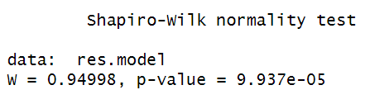
Figure 61 - Normality Check of SARIMA(3,0,6) X (2,1,1)

SARIMA(4,0,5)x(2,1,1)

Co-efficients

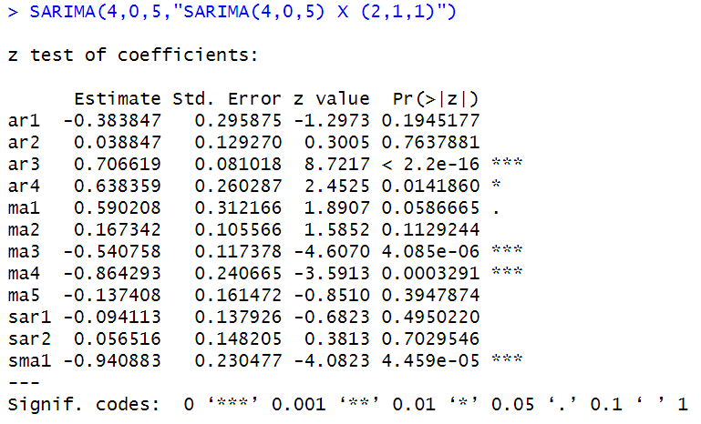
Figure 62 - Co-efficient of SARIMA(4,0,5) x (2,1,1)

Residual Checking
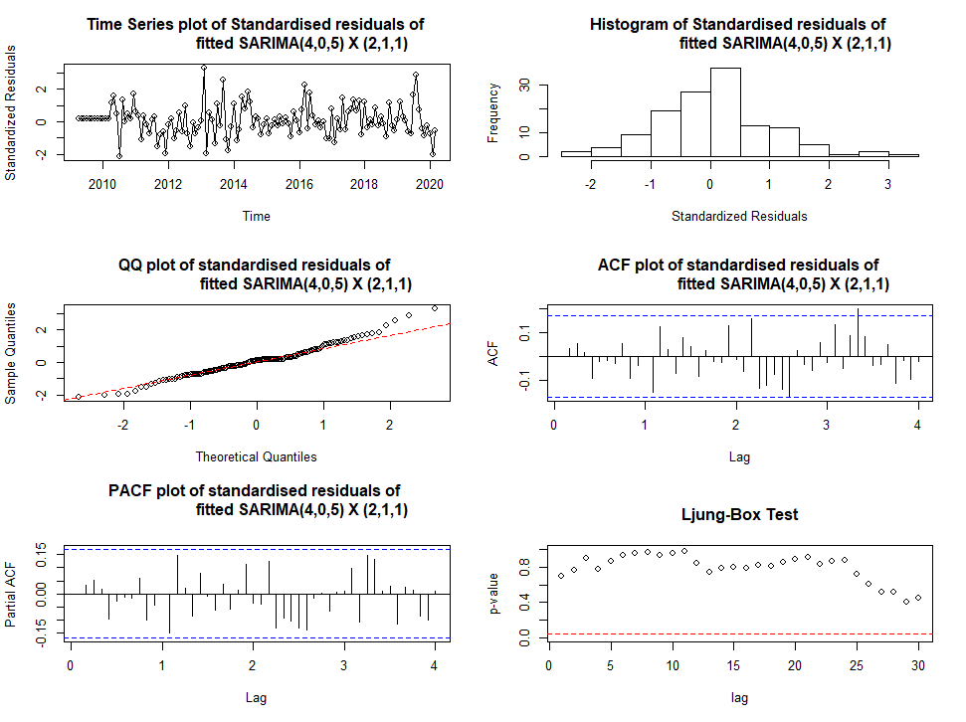
Figure 63 - Residual Diagnostics of SARIMA(4,0,5) x (2,1,1)

Time – Series

Histogram

QQ-plot

ACF

PACF

Ljung- Box

Shapiro-Wilk Test
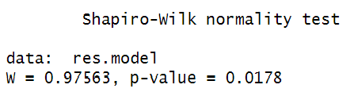
Figure 64 - Normality Check of SARIMA(4,0,5) X (2,1,1)

SARIMA(4,0,6)x(2,1,1)

Co-efficients

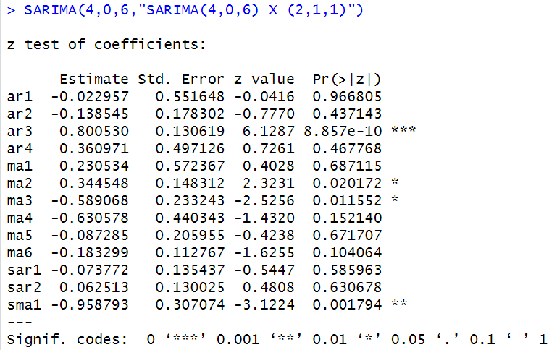
Figure 65 - Co-efficient of SARIMA(4,0,6) x (2,1,1)

Residual Checking
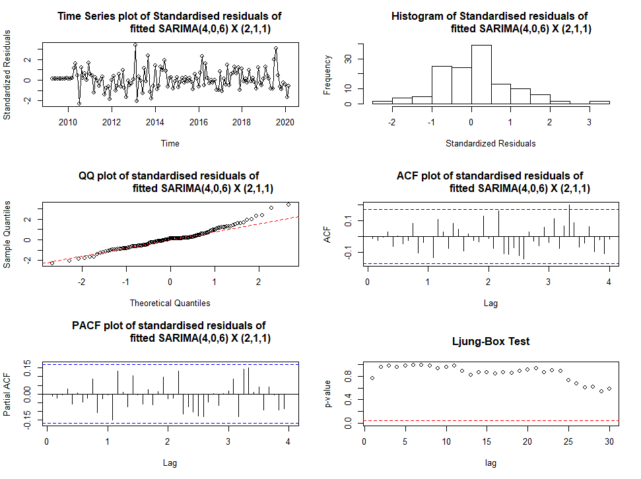
Figure 66 - Residual Diagnostics of SARIMA(4,0,6) x (2,1,1)

Time – Series

Histogram

QQ-plot

ACF

PACF

Ljung- Box

Shapiro-Wilk Test
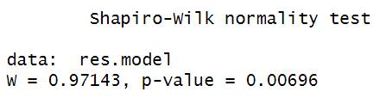
Figure 67 - Normality Check of SARIMA(4,0,6) X (2,1,1)

SARIMA(5,0,5)x(2,1,1)

Co-efficients

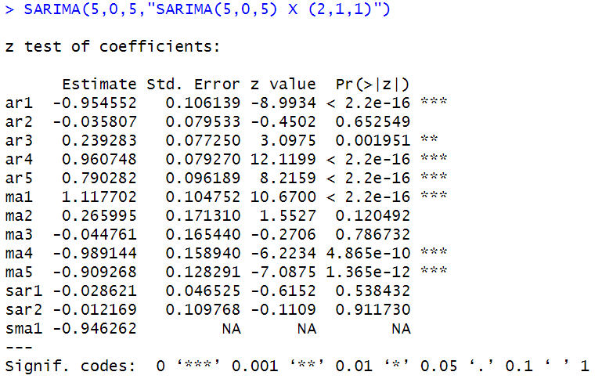
Figure 68 - Co-efficient of SARIMA(5,0,5) x (2,1,1)

Residual Checking

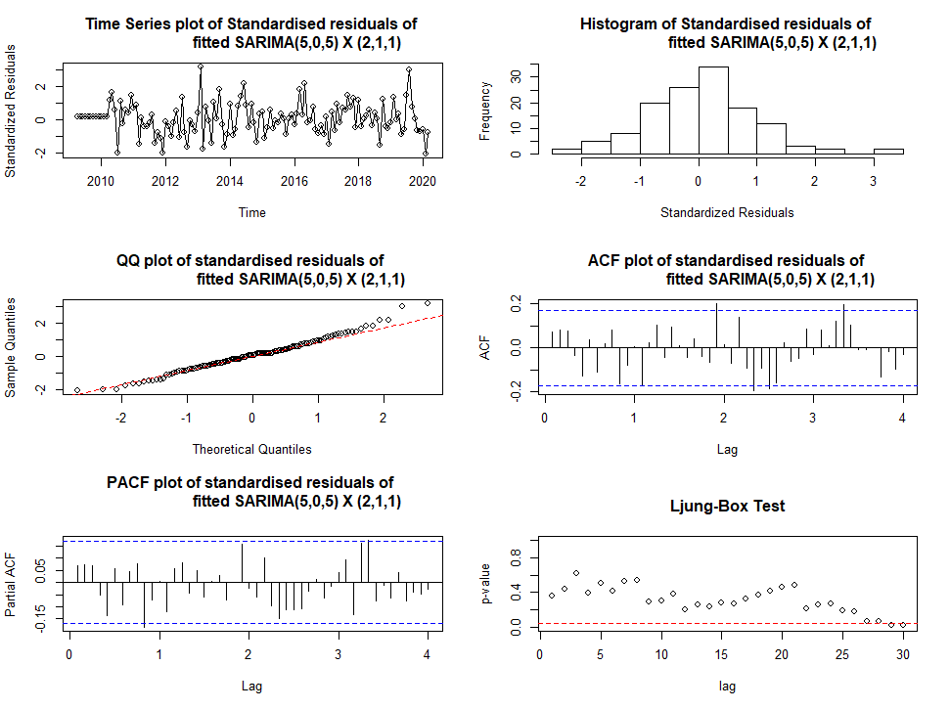
Figure 69 - Residual Diagnostics of SARIMA(5,0,5) x (2,1,1)

Time – Series

Histogram

QQ-plot

ACF

PACF

Ljung- Box

Shapiro-Wilk Test
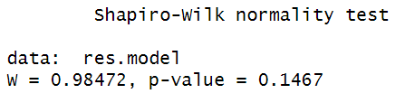
Figure 70 - Normality Check of SARIMA(5,0,5) X (2,1,1)

Final SARIMA model

Parameter Estimation

Forecasting
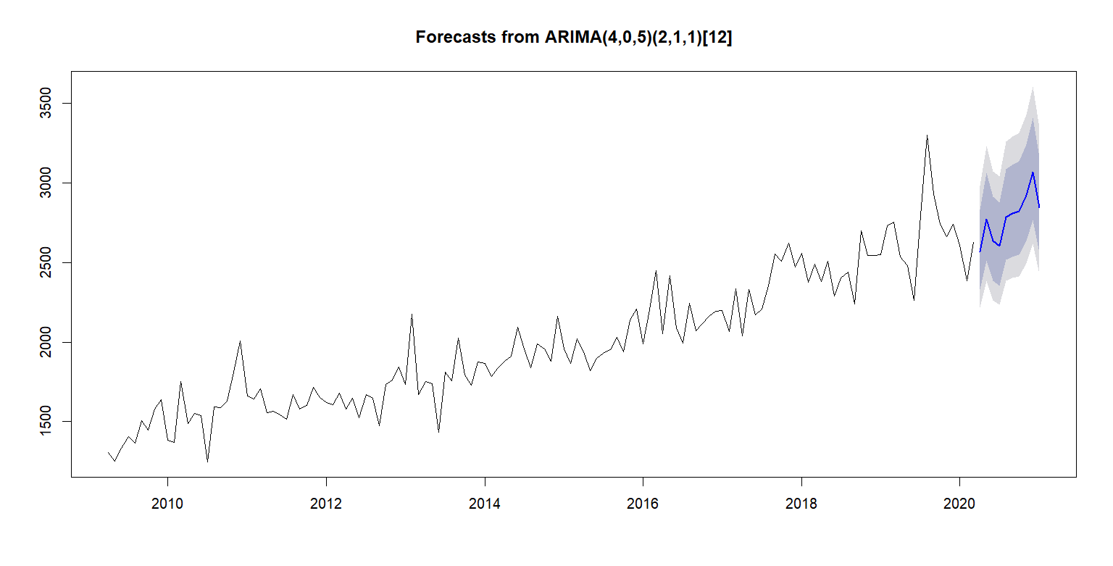
Figure 71 - Prediction Plot
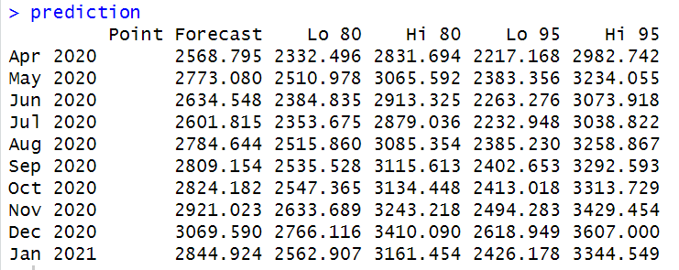
Figure 72 - Prediction Values for next 10 months

Conclusion

References
Class Presentations (1-9)
Class Lecture - Notes (1-9)
Class Recordings (1-9)

Appendix

Abbreviation
ARIMA = Auto-Regressive Integrated Moving Average
AR = Auto-Regressive,
MA = Moving Average
BC = Box-Cox
adf = Augmented Dicky-Fuller Test
pp = Phillops-Perron Test
CI = Condifence Interval
AIC = Akaike Information Criterion
BIC = Bayesian Information Criterion
ACF = AutoCorrelation Function
PACF = Partial AutoCorrelation Function
EACF = Extended AutoCorrelation Function
BIC Table = Bayesian Information Criterion
TS = Time-Series

Code
# Clearing the environment
rm(list=ls())

# libraries
library(readr)
library(dplyr)
library(tidyr)
library(TSA)
library(tseries)
library(forecast)
library(fUnitRoots)
library(lmtest)
library(fGarch)
library(CombMSC)
library(stats)
library(FitAR)

# data preparation
waste <- read_csv("C:/Users/Admin/Downloads/Waste_collected_per_month.csv")

waste <- waste %>% separate(date, into = c("month", "day","year"), sep = "/") %>%
separate(year, into = c("year", "time"), sep = " ") %>%
arrange(year, month, day) %>% select(month, year, residential)

View(head(waste))
View(tail(waste))

# converting dataframe into time series
wasteTS = ts(waste$residential, start = c(2009,4), end = c(2020,3), frequency = 12)
wasteTS

#----------------------------------------------------------------------

# Functions for Time Series
plot_ts <- function(ts, transformation)
{
win.graph(width = 45,
height = 30,
pointsize = 15)
plot(ts,
ylab = "Waste",
main = c(paste0(toString(transformation),
" plot of Waste")),
type="o")
points(y=ts,x=time(ts), pch=as.vector(season(ts)))
}

# Function for ACF and PACF
autoCorrelation <- function(ts, time_series)
{
win.graph(width = 20,
height = 15,
pointsize = 15)

par(mfrow=c(2,1))
acf(ts,
lag.max = 48,
main = c(paste0("ACF plot of ",toString(time_series))))

pacf(ts,
lag.max = 48,
main = c(paste0("PACF plot of ",toString(time_series))))
par(mfrow=c(1,1))
}

# Functions for its Residual Analysis
residual_model <- function(model, modelname)
{
res.model = rstandard(model)
win.graph(width = 20,
height = 15,
pointsize=15)

par(mfrow=c(3,2))

plot(y = res.model,
x = as.vector(time(wasteTS)),
main = c(paste0("Time Series plot of Standardised residuals of
fitted ", toString(modelname))),
xlab = 'Time',
ylab = 'Standardized Residuals',
type = 'o')

hist(res.model,
main = c(paste0("Histogram of Standardised residuals of
fitted ", toString(modelname))),
xlab='Standardized Residuals')

qqnorm(y=res.model,
main = c(paste0("QQ plot of standardised residuals of
fitted ", toString(modelname))))

qqline(y=res.model,
col = 2,
lwd = 1,
lty = 2)

print(shapiro.test(res.model))

acf(res.model,
lag.max = 48,
main = c(paste0("ACF plot of standardised residuals of
fitted ", toString(modelname))))

pacf(res.model,
lag.max = 48,
main = c(paste0("PACF plot of standardised residuals of
fitted ", toString(modelname))))

k=0
LBQPlot(res.model,lag.max = 30, StartLag = k + 1, k = 0, SquaredQ = FALSE)
par(mfrow=c(1,1))
}

# Function for SARIMA model
SARIMA <- function(p,d,q, modelname)
{
ml = arima(wasteTSBC,order=c(p,d,q),
seasonal = list(order = c(2,1,1), period = 12),
method = "ML")

print(coeftest(ml))
residual_model(ml,toString(modelname))

Model <- modelname

AIC <- AIC(ml)
aic <- cbind.data.frame(Model,AIC)
AIC_SCORE <- rbind(AIC_SCORE, aic)
AIC_SCORE <<- AIC_SCORE

BIC <- AIC(ml,k=(log(length(wasteTS))))
bic <- cbind.data.frame(Model,BIC)
BIC_SCORE <- rbind(BIC_SCORE, bic)
BIC_SCORE <<- BIC_SCORE
}

#----------------------------------------------------------------------
# Descriptive Analysis
#----------------------------------------------------------------------

# Original Time Series

par(mar=c(1,1,1,1))
plot_ts(wasteTS, "Time Series")

# ACF and PACF of original Time Series
autoCorrelation(wasteTS, "Time Series")

win.graph(width = 20,
height = 15,
pointsize=15)
# Scatter Plot of Consecutive Years
plot(y=wasteTS,
x=zlag(wasteTS),
ylab='Residential Waste (Tonnes)',
xlab='Previous Month Residential Waste (Tonnes)',
main = "Scatter plot of Residential Waste (Tonnes) in consequtive months")

# Correlation of Consecutive Years
y = wasteTS
x = zlag(wasteTS)
index = 2:length(x)
cor(y[index],x[index]) %>% round(3)

# -----------------------------------------------------------------------
# Box-cox Transformation
# -----------------------------------------------------------------------

win.graph(width = 20,
height = 15,
pointsize=15)
BC <- BoxCox.ar(wasteTS)

# box-cox confidence Interval
BC$ci

# maximum likelihood
lambda <- BC$lambda[which(max(BC$loglike) == BC$loglike)]
lambda

# box-cox transformation
wasteTSBC = ((wasteTS^lambda)-1)/lambda

plot_ts(wasteTSBC, "Box-Cox Transformation Time Series")

autoCorrelation(wasteTSBC, "Box-Cox Transformation Time Series")

# -----------------------------------------------------------------------
# Residual Approach SARIMA Models
# -----------------------------------------------------------------------

m1.temp = arima(wasteTSBC,order=c(0,0,0),
seasonal = list(order = c(0,1,0), period = 12))
res.m1 = residuals(m1.temp)
plot_ts(res.m1,"Residuals SARIMA(0,0,0)x(0,1,0)")
autoCorrelation(res.m1,"Residuals SARIMA(0,0,0)x(0,1,0)")

m2.temp = arima(wasteTSBC,order=c(0,0,0),
seasonal = list(order = c(2,1,1), period = 12))
res.m2 = residuals(m2.temp)
plot_ts(res.m2,"Residuals SARIMA(0,0,0)x(2,1,1)")
autoCorrelation(res.m2,"Residuals SARIMA(0,0,0)x(2,1,1)")

# P = 2, D = 1, Q = 1

# p = (1,2)
# q = (1,2,3)

# SARIMA(1,0,1)x(2,1,1),
# SARIMA(1,0,2)x(2,1,1),
# SARIMA(1,0,3)x(2,1,1),
# SARIMA(2,0,1)x(2,1,1),
# SARIMA(2,0,2)x(2,1,1),
# SARIMA(2,0,3)x(2,1,1),

m3.temp = arima(wasteTSBC,order=c(2,0,2),
seasonal = list(order = c(2,1,1), period = 12))
res.m3 = residuals(m3.temp)
plot_ts(res.m3,"Residuals SARIMA(2,0,2)x(2,1,1)")
autoCorrelation(res.m3,"Residuals SARIMA(2,0,2)x(2,1,1)")

# -----------------------------------------------------------------------
# EACF
# -----------------------------------------------------------------------
eacf(res.m2)
# SARIMA(0,0,0)x(2,1,1),
# SARIMA(0,0,1)x(2,1,1),

# -----------------------------------------------------------------------
# BIC
# -----------------------------------------------------------------------
win.graph(width = 10,
height = 10,
pointsize = 15)
res = armasubsets(y=res.m2,
nar=8,
nma=8,
y.name='test',
ar.method='ols')
plot(res)
# SARIMA(1,0,3)x(2,1,1),
# SARIMA(3,0,3)x(2,1,1),

# -----------------------------------------------------------------------
# set of possible SARIMA models;
# -----------------------------------------------------------------------

# SARIMA(0,0,0)x(2,1,1),
# SARIMA(0,0,1)x(2,1,1),
# SARIMA(1,0,1)x(2,1,1),
# SARIMA(1,0,2)x(2,1,1),
# SARIMA(1,0,3)x(2,1,1),
# SARIMA(2,0,1)x(2,1,1),
# SARIMA(2,0,2)x(2,1,1),
# SARIMA(2,0,3)x(2,1,1),
# SARIMA(3,0,3)x(2,1,1)

# -----------------------------------------------------------------------
# creating null data frame for AIC and BIC
# -----------------------------------------------------------------------

AIC_SCORE <- data.frame(Model = c(),
AIC = c())

BIC_SCORE <- data.frame(Model = c(),
BIC = c())

# -----------------------------------------------------------------------
# Model Fitting
# -----------------------------------------------------------------------

# SARIMA(0,0,0)x(2,1,1),
SARIMA(0,0,0,"SARIMA(0,0,0) X (2,1,1)")

# SARIMA(0,0,1)x(2,1,1)
SARIMA(0,0,1,"SARIMA(0,0,1) X (2,1,1)")

# SARIMA(1,0,1)x(2,1,1)
SARIMA(1,0,1,"SARIMA(1,0,1) X (2,1,1)")

# SARIMA(1,0,2)x(2,1,1)
SARIMA(1,0,2,"SARIMA(1,0,2) X (2,1,1)")

# SARIMA(1,0,3)x(2,1,1)
SARIMA(1,0,3,"SARIMA(1,0,3) X (2,1,1)")

# SARIMA(2,0,1)x(2,1,1)
SARIMA(2,0,1,"SARIMA(2,0,1) X (2,1,1)")

# SARIMA(2,0,2)x(2,1,1)
SARIMA(2,0,2,"SARIMA(2,0,2) X (2,1,1)")

# SARIMA(2,0,3)x(2,1,1)
SARIMA(2,0,3,"SARIMA(2,0,3) X (2,1,1)")

# SARIMA(3,0,3)x(2,1,1)
SARIMA(3,0,3,"SARIMA(3,0,3) X (2,1,1)")

# -----------------------------------------------------------------------
# Finding Best Model
# -----------------------------------------------------------------------
AIC_SCORE %>% unique() %>% arrange(AIC)
BIC_SCORE %>% unique() %>% arrange(BIC)

# -----------------------------------------------------------------------
# SARIMA(3,0,3)x(2,1,1) is best model, now, let's try overfit
# -----------------------------------------------------------------------

# SARIMA(4,0,3)x(2,1,1)
SARIMA(4,0,3,"SARIMA(4,0,3) X (2,1,1)")

# SARIMA(3,0,4)x(2,1,1)
SARIMA(3,0,4,"SARIMA(3,0,4) X (2,1,1)")

# -----------------------------------------------------------------------
# SARIMA(3,0,4)x(2,1,1) is best model, now, let's try overfit
# -----------------------------------------------------------------------

# SARIMA(3,0,5)x(2,1,1)
SARIMA(3,0,5,"SARIMA(3,0,5) X (2,1,1)")

# SARIMA(4,0,4)x(2,1,1)
SARIMA(4,0,4,"SARIMA(4,0,4) X (2,1,1)")

# -----------------------------------------------------------------------
# SARIMA(3,0,5)x(2,1,1) is best model, now, let's try overfit
# -----------------------------------------------------------------------

# SARIMA(3,0,6)x(2,1,1)
SARIMA(3,0,6,"SARIMA(3,0,6) X (2,1,1)")

# SARIMA(4,0,5)x(2,1,1)
SARIMA(4,0,5,"SARIMA(4,0,5) X (2,1,1)")

# -----------------------------------------------------------------------
# SARIMA(4,0,5)x(2,1,1) is best model, now, let's try overfit
# -----------------------------------------------------------------------

# SARIMA(4,0,6)x(2,1,1)
SARIMA(4,0,6,"SARIMA(4,0,6) X (2,1,1)")

# SARIMA(5,0,5)x(2,1,1)
SARIMA(5,0,5,"SARIMA(5,0,5) X (2,1,1)")

# -----------------------------------------------------------------------
# Forecasting
# -----------------------------------------------------------------------
forecasting = Arima(wasteTS,order=c(4,0,5),
seasonal=list(order=c(2,1,1), period=12),
lambda = -0.1,
method = "ML")
prediction = forecast(forecasting, h = 10)

win.graph(width = 10,
height = 10,
pointsize = 15)
plot(prediction)

prediction

