
Nagar Yuwak Shikshan Sanstha’s
Yeshwantrao Chavan College of Engineering (An Autonomous Institution affiliated to Rashtrasant Tukadoji Maharaj Nagpur University)
Hingna Road, Wanadongri, Nagpur - 441 110
Ph.: 07104-237919, 234623, 329249, 329250 Fax: 07104-232376, Website: www.ycce.edu
Computer Science and Engineering (AIML)
Even Term Session 2025-26
IV Semester
23AML1405: Lab: Statistics for Data Science
PRACTICAL JOURNAL for LAB-1 (PR-1)
SUBMITTED BY
Name:
Section: | A
Batch:
Roll No.:
Registration Number:
Signature:

Practical No. | Details
1 | ∙ Obtained the descriptive statistics for the given data using MSEXCEL.  Sample of daily production in meters of 30 carpet looms  16.2 16.8 15.9 15.6 15.9 16.6  15.8 16 16 15.7 15.9 15.6  15.8 16.4 16.3 16 16.8 15.6  15.8 15.2 16 16.2 15.4 16.9  16.3 15.9 16.4 16.1 15.7 16.3  ∙ Check the obtained results using R.

Practical-1
AIM: | ∙ To get the descriptive statistics for the given data using MSEXCEL and R.
RELATED THEORY:
Descriptive statistics is a method used to organize, summarize, and interpret data. It provides simple numerical measures to understand the characteristics of a dataset.
The main measures include:
- Measures of Central Tendency such as mean, median, and mode, which represent the central or typical value of the data.
- Measures of Dispersion such as range, variance, and standard deviation, which indicate how widely the data values are spread.
- Measures of Shape like skewness and kurtosis, which describe the distribution pattern of the data.
MS Excel provides a built-in tool called Data Analysis ToolPak, which helps to quickly compute descriptive statistics like mean, standard deviation, minimum, maximum, range, and others without manual calculation.
R is a statistical programming tool used to validate and verify the results obtained from Excel. Basic functions such as mean(), median(), sd(), and summary() are used for calculations, while the psych package provides more detailed statistics including skewness and kurtosis.
By comparing the results from Excel and R, we can ensure the accuracy and reliability of the analysis.

CODE PRINT:


Nagar Yuwak Shikshan Sanstha’s
Yeshwantrao Chavan College of Engineering (An Autonomous Institution affiliated to Rashtrasant Tukadoji Maharaj Nagpur University)
Hingna Road, Wanadongri, Nagpur - 441 110
Ph.: 07104-237919, 234623, 329249, 329250 Fax: 07104-232376, Website: www.ycce.edu
B. Tech. in Computer Science and Engineering(AIML)
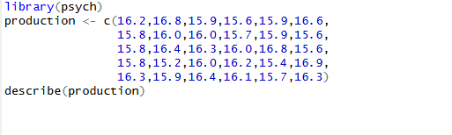
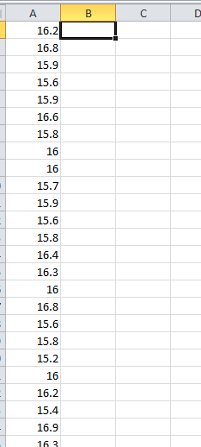
OUTPUT PRINT:
ANALYSIS OF OBTAINED RESULTS:
The descriptive statistics of the daily production data for 30 carpet looms were calculated using Microsoft Excel and verified using R.
The mean production is approximately 16 meters, which indicates that the average daily output of the looms is stable around this value. The median is also close to the mean, suggesting that the data is fairly symmetric and does not contain significant outliers.
The standard deviation is relatively small (around 0.4–0.5), which shows that the production values do not vary widely from the mean. This indicates consistency in the performance of the carpet looms.
The minimum production is about 15.2 meters, while the maximum is approximately 16.9 meters, giving a range of about 1.7 meters. This small range further confirms that the variability in production is low.
The skewness value is close to zero, indicating that the data distribution is approximately symmetric. The kurtosis value suggests a normal or slightly flat distribution, meaning there are no extreme peaks or heavy tails in the data.
The results obtained from Excel were successfully verified using R, and both outputs were consistent. This confirms the accuracy of the calculations.


Nagar Yuwak Shikshan Sanstha’s
Yeshwantrao Chavan College of Engineering (An Autonomous Institution affiliated to Rashtrasant Tukadoji Maharaj Nagpur University)
Hingna Road, Wanadongri, Nagpur - 441 110
Ph.: 07104-237919, 234623, 329249, 329250 Fax: 07104-232376, Website: www.ycce.edu
B. Tech. in Computer Science and Engineering(AIML)
Even Term Session 2025-26
IV Semester
23AML1405: Lab: Statistics for Data Science
PRACTICAL JOURNAL for LAB-1 (PR-2)
SUBMITTED BY
Name:
Section: | A
Batch:
Roll No.:
Registration Number:
Signature:

Practical No. | Details
2 | ∙ This Practical relates to the College data set, which can be found in the file College.csv. It contains a number of variables for 777 different universities and colleges in the US. The variables are  • Private : Public/private indicator  • Apps : Number of applications received  • Accept : Number of applicants accepted  • Enroll : Number of new students enrolled  • Top10perc : New students from top 10 % of high school class  • Top25perc : New students from top 25 % of high school class  • F.Undergrad : Number of full-time undergraduates  • P.Undergrad : Number of part-time undergraduates  • Outstate : Out-of-state tuition  • Room.Board : Room and board costs  • Books : Estimated book costs  • Personal : Estimated personal spending  • PhD : Percent of faculty with Ph.D.’s  • Terminal : Percent of faculty with terminal degree  • S.F.Ratio : Student/faculty ratio


Nagar Yuwak Shikshan Sanstha’s
Yeshwantrao Chavan College of Engineering (An Autonomous Institution affiliated to Rashtrasant Tukadoji Maharaj Nagpur University)
Hingna Road, Wanadongri, Nagpur - 441 110
Ph.: 07104-237919, 234623, 329249, 329250 Fax: 07104-232376, Website: www.ycce.edu
B. Tech. in Computer Science and Engineering(AIML)
• perc.alumni : Percent of alumni who donate
• Expend : Instructional expenditure per student
• Grad.Rate : Graduation rate
Before reading the data into R, it can be viewed in Excel or a text editor.
(a)
Use the read.csv() function to read the data into R. Call the loaded data college. Make sure that you have the directory set to the correct location for the data.
(b)
Look at the data using the fix() function. You should notice that the first column is just the name of each university. We don’t really want R to treat this as data. However, it may be handy to have these names for later. Try the following commands:
> rownames ( college ) = college [ , 1 ]
> fix ( college )
You should see that there is now a row.names column with the name of each university recorded. This means that R has given each row a name corresponding to the appropriate university. R will not try to perform calculations on the row names. However, we still need to eliminate the first column in the data where the names are stored. Try
> rownames ( college ) = college [ , -1 ]
> fix ( college )
Now you should see that the first data column is Private. Note that another column labeled row.names now appears before the Private column. However, this is not a data column but rather the name that R is giving to each row.
(c)
(i) Use the summary() function to produce a numerical summary of the variables in the data set.
(ii) Use the pairs() function to produce a scatterplot matrix of the first ten columns or variables of the data. Recall that you can reference the first ten columns of a matrix A using A[,1:10].
(iii)Use the plot() function to produce side-by-side boxplots of Outstate versus Private. (iv) Create new qualitative variable, called Elite, by binning the Top10perc variable. We are going to divide universities into two groups based on whether or not the proportion of students coming from the top 10 % of their high school classes exceeds 50 %. > Elite = r e p ( " N o " , nrow ( college ) )
> Elite [ college$Top1 0 pe rc >50]=" Y e s "
> Elite = a s . factor ( Elite )
> college = data . frame ( college , Elite )
Use the summary() function to see how many elite universities there are. Now use the plot() function to produce side-by-side boxplots of Outstate versus Elite.


Nagar Yuwak Shikshan Sanstha’s
Yeshwantrao Chavan College of Engineering (An Autonomous Institution affiliated to Rashtrasant Tukadoji Maharaj Nagpur University)
Hingna Road, Wanadongri, Nagpur - 441 110
Ph.: 07104-237919, 234623, 329249, 329250 Fax: 07104-232376, Website: www.ycce.edu
B. Tech. in Computer Science and Engineering(AIML)
(v) Use the hist() function to produce some histograms with differing numbers of bins for a few of the quantitative variables. You may find the command par(mfrow=c(2,2)) useful: it will divide the print window into four regions so that four plots can be made simultaneously. Modifying the arguments to this function will divide the screen in other ways.

Practical-2
AIM: | ∙ To learn and use the read.csv(), fix(), rownames(), summary(), pairs(), plot() functions in R.
RELATED THEORY:
This practical is based on Exploratory Data Analysis (EDA) using R, which is the process of analyzing datasets to summarize their main characteristics using statistical and graphical methods.
The dataset used is a multivariate dataset, meaning it contains multiple variables representing different attributes of colleges such as admissions, fees, faculty qualifications, and graduation rates. These variables can be classified into:
- Categorical variables (e.g., Private: Yes/No)
- Numerical variables (e.g., Apps, Enroll, Outstate)
The data is stored in a data frame, which is a fundamental data structure in R used to organize data in rows and columns.
A key concept used is data preprocessing, which involves:
- Assigning meaningful row names
- Removing unnecessary columns
This ensures clean and accurate data for analysis.
The practical also uses descriptive statistics, where functions like summary() provide measures such as mean, median, minimum, maximum, and quartiles. These help in understanding the distribution and spread of data.
Another important concept is data visualization, which includes:
- Scatterplot matrix (pairs): Used to study relationships and correlations between variables
- Boxplots: Used to compare distributions and identify outliers between categories
Overall, this practical demonstrates the fundamental concepts of:
- Data representation using data frames
- Data cleaning and preprocessing
- Descriptive statistical analysis
- Graphical visualization
These concepts form the foundation for advanced data analysis and machine learning.

CODE PRINT:
# Practical-2: College Dataset Analysis

# (a) Read the dataset
college = read.csv("College.csv")

# View dataset
fix(college)

# (b) Assign row names and remove first column
rownames(college) = college[,1]
college = college[,-1]

# View updated dataset
fix(college)

# (c) (i) Summary of dataset
summary(college)

# (c) (ii) Scatterplot matrix of first 10 variables
pairs(college[,1:10])

# (c) (iii) Boxplot of Outstate vs Private
boxplot(Outstate ~ Private, data = college,
main = "Outstate Tuition vs Private",
xlab = "Private/Public",
ylab = "Outstate Tuition",
col = c("lightblue", "lightgreen"))

# -------------------------------
# (iv) Create Elite variable
# -------------------------------

Elite = rep("No", nrow(college))
Elite[college$Top10perc > 50] = "Yes"
Elite = as.factor(Elite)

# Add Elite to dataset
college = data.frame(college, Elite)

# Summary of Elite universities
summary(college$Elite)

# Boxplot of Outstate vs Elite
boxplot(Outstate ~ Elite, data = college,
main = "Outstate Tuition vs Elite",
xlab = "Elite Status",
ylab = "Outstate Tuition",
col = c("orange", "green"))

# -------------------------------
# (v) Histograms
# -------------------------------

# Divide plotting window into 4 parts
par(mfrow = c(2,2))

# Histograms of selected variables
hist(college$PhD, breaks = 10, col = 3,
main = "PhD Distribution", xlab = "PhD %")

hist(college$F.Undergrad, breaks = 10,
main = "Full-time Undergraduates", xlab = "Count")

hist(college$P.Undergrad, breaks = 15, col = 2,
main = "Part-time Undergraduates", xlab = "Count")

hist(college$Outstate, breaks = 15, col = 4,
main = "Outstate Tuition", xlab = "Cost")

OUTPUT PRINT:
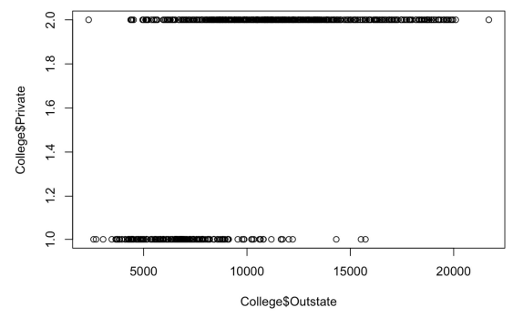
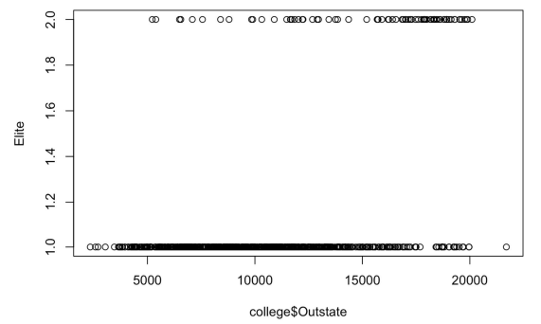
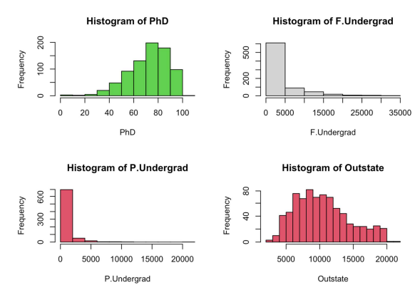
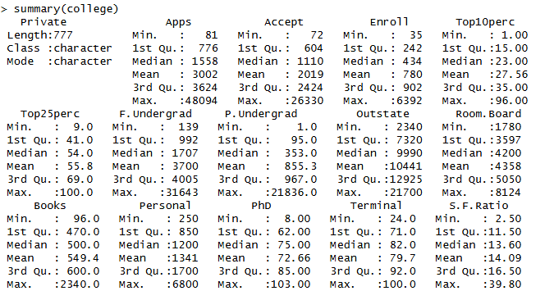
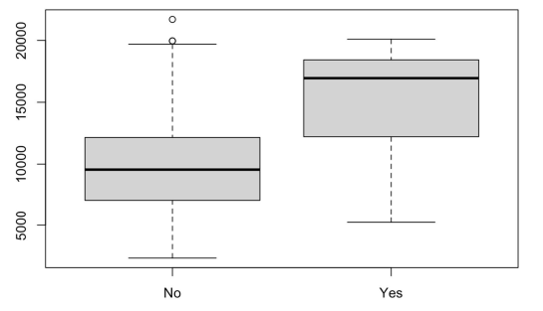
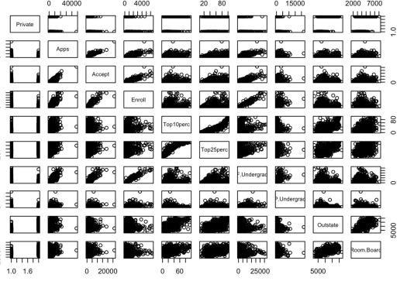
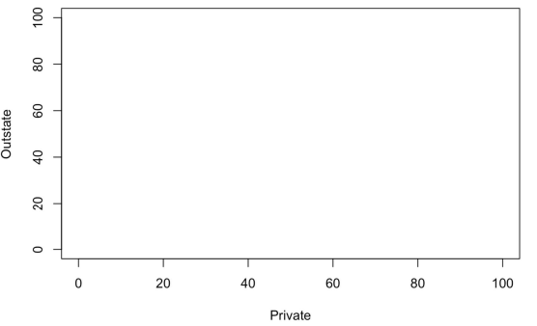
ANALYSIS OF OBTAINED RESULTS:
After performing the analysis on the College dataset, the following observations were made:
From the summary statistics, there is a wide variation in the number of applications received by colleges. The mean is higher than the median, indicating a right-skewed distribution. Variables like Outstate (tuition fees) and Expend (expenditure) also show high variability, reflecting differences in college resources and facilities.
The percentages of students from the top 10% and top 25% vary significantly, indicating differences in academic competitiveness. Faculty-related variables such as PhD and Terminal show that most institutions have a high proportion of qualified faculty.
From the scatterplot matrix, the following relationships are observed:
- A strong positive correlation between Apps, Accept, and Enroll
- Colleges with higher Top10perc and Top25perc tend to be more selective
- Some variables show weak relationships, indicating limited dependency
The boxplot of Outstate vs Private shows that:
- Private colleges have higher tuition fees compared to public colleges
- Greater variation exists among private institutions
- Presence of outliers indicates very high fees in some colleges
After creating the Elite variable (Top10perc > 50):
- Only a small number of colleges fall into the Elite category
- The boxplot of Outstate vs Elite shows that elite colleges generally have higher tuition fees
- This suggests that more academically competitive institutions tend to be more expensive
From the histograms:
- Variables like PhD show a relatively concentrated distribution
- F.Undergrad and P.Undergrad are right-skewed, indicating most colleges have fewer students while some have very large enrollments
- Outstate tuition also shows a skewed distribution with some high-value outliers
Overall, the analysis reveals that:
- There is significant diversity among colleges in terms of size, cost, and quality
- Private and elite institutions tend to be more expensive
- Admission-related variables are strongly correlated
This analysis helps in understanding the dataset and provides a foundation for further statistical modeling and decision-making.


Nagar Yuwak Shikshan Sanstha’s
Yeshwantrao Chavan College of Engineering (An Autonomous Institution affiliated to Rashtrasant Tukadoji Maharaj Nagpur University)
Hingna Road, Wanadongri, Nagpur - 441 110
Ph.: 07104-237919, 234623, 329249, 329250 Fax: 07104-232376, Website: www.ycce.edu
B. Tech. in Computer Science and Engineering(AIML)
Even Term Session 2025-26
IV Semester
23AML1405: Lab: Statistics for Data Science
PRACTICAL JOURNAL for LAB-1 (PR-3)
SUBMITTED BY
Name:
Section: | A
Batch:
Roll No.:
Registration Number:
Signature:

Practical No. | Details
3 | ∙ This Practical involves the Auto data set. Make sure that the missing values have been removed from the data.  (a) Which of the predictors are quantitative, and which are qualitative?  (b) What is the range of each quantitative predictor? You can answer this using the range() function.  (c) What is the mean and standard deviation of each quantitative predictor? (d) Now remove the 10th through 85th observations. What is the range, mean, and standard deviation of each predictor in the subset of the data that remains?  (e) Using the full data set, investigate the predictors graphically, using scatterplots or other tools of your choice. Create some plots highlighting the relationships among the predictors. Comment on your findings.  (f) Suppose that we wish to predict gas mileage (mpg) on the basis of the other variables. Do your plots suggest that any of the other variables might be useful in predicting mpg? Justify your answer.

Practical-3
AIM: | ∙ To remove the missing values from the data and to evaluate the predictors are qualitative or quantitative.

∙ To evaluate the range, mean and standard deviation of each quantitative predictor in data.
∙ To analyze the data using scatter plots and to explore the relation of independent variable with the defined dependent variable.
RELATED THEORY:
This practical is based on fundamental concepts of data analysis and statistics using R.
One key concept is data types, where variables are classified as:
- Quantitative variables: Numerical values representing measurable quantities
- Qualitative variables: Categorical values representing labels or groups
Another important concept is data cleaning, which involves handling missing values. Missing data can affect analysis accuracy and is commonly removed using techniques like omission.
The practical also uses descriptive statistics, which summarize data using:
- Range: Difference between minimum and maximum values
- Mean: Average value representing central tendency
- Standard deviation: Measure of dispersion or variability
The concept of data subsetting is applied to analyze a portion of the dataset. This helps in understanding how removing observations affects statistical measures.
Data visualization is another major concept, including:
- Scatterplots: Used to identify relationships between two variables
- Pair plots: Used to visualize relationships among multiple variables simultaneously
The practical also introduces correlation, which measures the strength and direction of relationships between variables.
Finally, the concept of predictive modeling is explored, where independent variables (predictors) are used to estimate a dependent variable (mpg). Selecting relevant predictors is important to avoid issues like overfitting, especially when dealing with categorical variables having many unique values.

CODE PRINT:
# Practical-3: Auto Dataset Analysis

# Load dataset and handle missing values
Auto = read.csv("Auto.csv", header = TRUE, na.strings = "?")
Auto = na.omit(Auto)

# Check dimensions and summary
dim(Auto)
summary(Auto)

# (a) Identify variable types
# Quantitative: mpg, cylinders, displacement, horsepower, weight, acceleration, year
# Qualitative: origin, name

# (b) Range of quantitative predictors
sapply(Auto[,1:7], range)

# (c) Mean and standard deviation
sapply(Auto[,1:7], mean)
sapply(Auto[,1:7], sd)

# (d) Remove 10th to 85th observations
newAuto = Auto[-(10:85),]

# Verify changes
dim(newAuto)

# Range, mean, sd for new dataset
sapply(newAuto[,1:7], range)
sapply(newAuto[,1:7], mean)
sapply(newAuto[,1:7], sd)

# (e) Graphical analysis
pairs(Auto)

# Scatterplots
plot(Auto$mpg, Auto$weight,
main = "MPG vs Weight",
xlab = "MPG", ylab = "Weight")

plot(Auto$mpg, Auto$cylinders,
main = "MPG vs Cylinders",
xlab = "MPG", ylab = "Cylinders")

plot(Auto$mpg, Auto$year,
main = "MPG vs Year",
xlab = "MPG", ylab = "Year")

# (f) Predictor analysis for mpg
# Based on plots, variables like weight, cylinders, horsepower,
# displacement, and year are useful predictors of mpg.

OUTPUT PRINT:
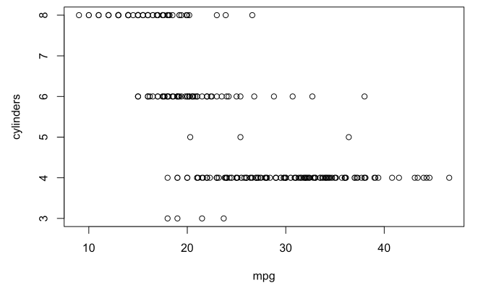
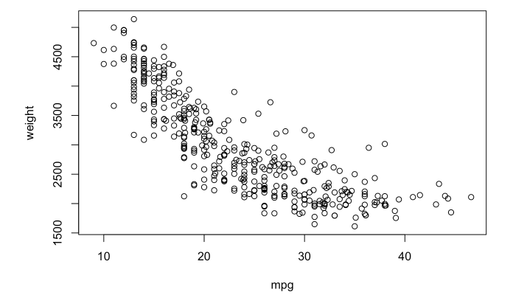
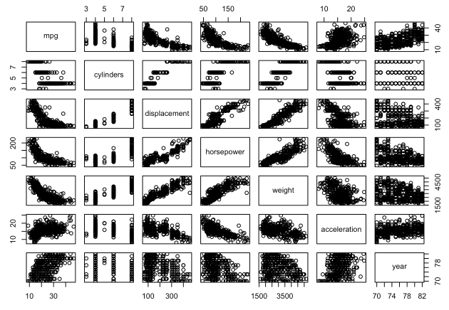

ANALYSIS OF OBTAINED RESULTS:
After analyzing the Auto dataset, the following observations were made:
From the range values, it is observed that variables like mpg, horsepower, and weight have a wide spread, indicating high variability among cars.
The mean and standard deviation show that:
- The average mpg is moderate, but the high standard deviation indicates variation in fuel efficiency
- Variables like weight and displacement have large standard deviations, showing differences in vehicle sizes and engine capacities
After removing observations (10th to 85th):
- There is a slight change in mean and standard deviation, indicating that the removed data had some influence on overall statistics
- However, the general distribution pattern remains similar
From the scatterplots:
- mpg vs weight: Strong negative relationship → heavier cars have lower fuel efficiency
- mpg vs cylinders: More cylinders lead to lower mpg
- mpg vs year: Newer cars tend to have higher mpg, showing technological improvement
From the pair plots, most predictors show some correlation with mpg.
Thus, for predicting mpg:
- Useful predictors: weight, cylinders, displacement, horsepower, year
- Less useful predictor: name (categorical with many unique values → may cause overfitting)
Overall, the analysis shows that vehicle weight and engine characteristics are major factors affecting fuel efficiency.


Nagar Yuwak Shikshan Sanstha’s
Yeshwantrao Chavan College of Engineering (An Autonomous Institution affiliated to Rashtrasant Tukadoji Maharaj Nagpur University)
Hingna Road, Wanadongri, Nagpur - 441 110
Ph.: 07104-237919, 234623, 329249, 329250 Fax: 07104-232376, Website: www.ycce.edu
B. Tech. in Computer Science and Engineering(AIML)
Even Term Session 2025-26
IV Semester
23AML1405: Lab: Statistics for Data Science
PRACTICAL JOURNAL for LAB-1 (PR-4)
SUBMITTED BY
Name:
Section: | A
Batch:
Roll No.:
Name:
Signature: | Krish Bawangade

Practical No. | Details
4 | ∙ This Practical involves the Boston housing data set.  (a) To begin, load in the Boston data set. The Boston data set is part of the MASS library in R. > library(MASS)  Now the data set is contained in the object Boston.  > Boston  Read about the data set:  > ?Boston  How many rows are in this data set? How many columns? What do the rows and columns represent?  (b) Make some pairwise scatterplots of the predictors (columns) in this data set. Describe your findings.  (c) Are any of the predictors associated with per capita crime rate? If so, explain the relationship.  (d) Do any of the suburbs of Boston appear to have particularly high crime rates? Tax rates? Pupil-teacher ratios? Comment on the range of each predictor.  (e) How many of the suburbs in this data set bound the Charles river?  (f) What is the median pupil-teacher ratio among the towns in this data set? (g) Which suburb of Boston has lowest median value of owner-occupied homes? What are the


Nagar Yuwak Shikshan Sanstha’s
Yeshwantrao Chavan College of Engineering (An Autonomous Institution affiliated to Rashtrasant Tukadoji Maharaj Nagpur University)
Hingna Road, Wanadongri, Nagpur - 441 110
Ph.: 07104-237919, 234623, 329249, 329250 Fax: 07104-232376, Website: www.ycce.edu
B. Tech. in Computer Science and Engineering(AIML)
values of the other predictors for that suburb, and how do those values compare to the overall ranges for those predictors? Comment on your findings.
(h) In this data set, how many of the suburbs average more than seven rooms per dwelling? More than eight rooms per dwelling? Comment on the suburbs that average more than eight rooms per dwelling.

Practical-4
AIM: | ∙ To evaluate the median value and to explore the relationship of predictor with response.  ∙ To explore different functions in R to analyze the given data.
RELATED THEORY:
This practical is based on key concepts of multivariate data analysis using R.
One important concept is multivariate datasets, where multiple variables are recorded for each observation. The Boston dataset contains housing-related attributes such as crime rate, tax rate, number of rooms, and property value.
The concept of descriptive statistics is used to summarize data, including:
- Measures of central tendency (mean, median)
- Measures of dispersion (range, variability)
Another key concept is data visualization, which includes:
- Scatterplots: Used to study relationships between two variables
- Pair plots: Used to visualize relationships among multiple predictors simultaneously
- Histograms: Used to understand the distribution of variables
The practical also involves correlation analysis, which helps in identifying relationships between predictors and target variables such as crime rate (crim) and median house value (medv).
The concept of subsetting data is used to filter observations based on specific conditions (e.g., suburbs along Charles River).
Another important concept is distribution analysis, where skewness and spread of variables are analyzed using histograms.
Finally, the practical includes comparative analysis, where specific observations (such as suburbs with minimum house value or high room count) are compared with overall dataset ranges to derive insights.

CODE PRINT:
# Practical-4: Boston Dataset Analysis

# Load dataset
library(MASS)
data(Boston)

# (a) Basic info
?Boston
dim(Boston) # 506 rows, 14 columns

# (b) Pairwise scatterplots
pairs(Boston)

# (c) Relationship with crime rate
plot(Boston$age, Boston$crim,
main="Crime vs Age", xlab="Age", ylab="Crime")

plot(Boston$dis, Boston$crim,
main="Crime vs Distance", xlab="Distance", ylab="Crime")

plot(Boston$rad, Boston$crim,
main="Crime vs Accessibility", xlab="RAD", ylab="Crime")

plot(Boston$tax, Boston$crim,
main="Crime vs Tax", xlab="Tax", ylab="Crime")

plot(Boston$ptratio, Boston$crim,
main="Crime vs Pupil-Teacher Ratio", xlab="PTRatio", ylab="Crime")

# (d) Histograms
par(mfrow=c(1,3))

hist(Boston$crim[Boston$crim > 1], breaks=25,
main="Crime Rate Distribution", xlab="Crime")

hist(Boston$tax, breaks=25,
main="Tax Distribution", xlab="Tax")

hist(Boston$ptratio, breaks=25,
main="PTRatio Distribution", xlab="PTRatio")

# (e) Suburbs along Charles River
dim(subset(Boston, chas == 1))

# (f) Median pupil-teacher ratio
median(Boston$ptratio)

# (g) Suburb with lowest median home value
t(subset(Boston, medv == min(Boston$medv)))

# Summary for comparison
summary(Boston)

# (h) Rooms analysis
dim(subset(Boston, rm > 7))
dim(subset(Boston, rm > 8))

summary(subset(Boston, rm > 8))
summary(Boston)

OUTPUT PRINT:
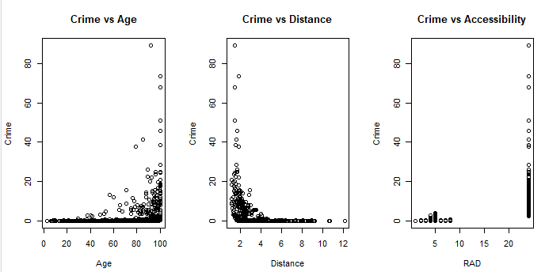
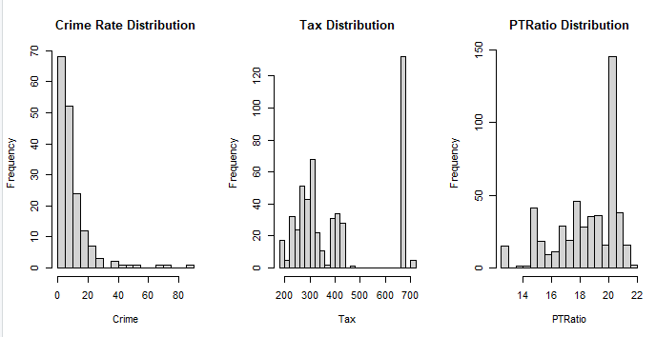
ANALYSIS OF OBTAINED RESULTS:
After analyzing the Boston dataset, the following observations were made:
The dataset contains 506 rows and 14 columns, representing different housing attributes in Boston suburbs.
From the pairwise scatterplots, several relationships are observed:
- Crime rate (crim) shows association with variables like age, distance (dis), tax, and pupil-teacher ratio
- Lower status population (lstat) has a strong negative relationship with median house value (medv)
From individual plots:
- Crime rate increases with higher age of houses, higher tax rates, and better highway accessibility (rad)
- Suburbs closer to employment centers (low dis) tend to have higher crime rates
From the histograms:
- Most suburbs have low crime rates, but a few have extremely high values (right-skewed distribution)
- Tax rates show clustering around certain values
- Pupil-teacher ratio is moderately distributed without extreme outliers
From filtering:
- 35 suburbs are located along the Charles River
- The median pupil-teacher ratio is around 19
The suburb with the lowest median house value (medv) shows:
- Very high crime rate
- High pollution (nox)
- Lower number of rooms (rm)
- High lower-status population (lstat)
This indicates poor living conditions.
Regarding room distribution:
- 64 suburbs have more than 7 rooms
- 13 suburbs have more than 8 rooms
- These suburbs generally have lower crime rates and lower lstat values, indicating better living standards
Overall, the analysis shows that:
- Crime, pollution, and social factors significantly affect housing prices
- Better housing conditions are associated with lower crime and higher number of rooms


Nagar Yuwak Shikshan Sanstha’s
Yeshwantrao Chavan College of Engineering (An Autonomous Institution affiliated to Rashtrasant Tukadoji Maharaj Nagpur University)
Hingna Road, Wanadongri, Nagpur - 441 110
Ph.: 07104-237919, 234623, 329249, 329250 Fax: 07104-232376, Website: www.ycce.edu
B. Tech. in Computer Science and Engineering(AIML)
Even Term Session 2025-26
IV Semester
23AML1405: Lab: Statistics for Data Science
PRACTICAL JOURNAL for LAB-1 (PR-5)
SUBMITTED BY
Name:
Section: | A
Batch:
Roll No.:
Registration Number:
Signature:

Practical No. | Details
5 | ∙ This Practical involves the creation of dataset for Surya Bank Pvt. Ltd. And answering the following questions.  (a) Refer the Supplied Questionnaire and the following for creation of Surya Bank Dataset.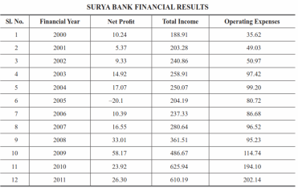


Nagar Yuwak Shikshan Sanstha’s
Yeshwantrao Chavan College of Engineering (An Autonomous Institution affiliated to Rashtrasant Tukadoji Maharaj Nagpur University)
Hingna Road, Wanadongri, Nagpur - 441 110
Ph.: 07104-237919, 234623, 329249, 329250 Fax: 07104-232376, Website: www.ycce.edu
B. Tech. in Computer Science and Engineering(AIML)
(b) Calculate the mean, variance, coefficient of skewness and kurtosis for the different models which help in creating the customer awareness about e-banking. Compare the results of the different modes of creating awareness (Q4).
(c) Which of the e-banking facilities, on an average, influences the customer most while selecting the bank? (Q7)
(d) Which facility has the highest variability (Q7).
(e) Comment on the average satisfaction level of the customers with the e-services provided by their banks. Also calculate the variance and coefficient of skewness of the satisfaction level of the customers (Q12).
[Note: Q4, Q7, and Q12 are the relevant question numbers in the Supplied Questionnaire].

Practical-5
AIM: | ∙ To generate the data using R code.  ∙ To evaluate and compare mean, variance, coefficient of skewness and kurtosis to draw the conclusion on variability.  ∙ To analyze the obtained results.  ∙ To evaluate variance and coefficient of skewness.
RELATED THEORY:
This practical is based on concepts of statistical data analysis and data generation using R.
One key concept is data generation, where datasets are created artificially using programming for analysis when real data is not available.
The practical uses descriptive statistics, including:
- Mean: Measures central tendency (average value)
- Variance: Measures dispersion of data from the mean
- Standard deviation: Square root of variance, indicating spread
Higher-order statistical measures include:
- Coefficient of Skewness: Measures asymmetry of distribution
  - Positive skew → tail on right
  - Negative skew → tail on left
- Kurtosis: Measures peakedness or flatness of distribution
  - High kurtosis → sharp peak
  - Low kurtosis → flat distribution
The concept of comparative analysis is used to compare different groups (Q4, Q7, Q12) based on statistical measures.
The practical also involves variability analysis, where variance helps identify which factor shows the most fluctuation.
Finally, the concept of decision-making based on statistics is applied to identify:
- Most influential factors
- Customer preferences
- Satisfaction levels

CODE PRINT:
# Practical-5: Financial Dataset Analysis

# Install package (only once)
# install.packages("moments")

library(moments)

# Create dataset manually
data <- data.frame(
Year = 2000:2011,
NetProfit = c(10.24, 5.37, 9.33, 14.92, 17.07, -20.1, 10.39, 16.55, 33.01, 58.17, 23.92, 26.30),
TotalIncome = c(188.91, 203.28, 240.86, 258.91, 250.07, 204.19, 237.33, 280.64, 361.51, 486.67, 625.94, 610.19),
OperatingExpenses = c(35.62, 49.03, 50.97, 97.42, 99.20, 80.72, 86.68, 96.52, 95.23, 114.74, 194.10, 202.14)
)

# View dataset
data

# -----------------------------
# Mean
# -----------------------------
colMeans(data[,2:4])

# -----------------------------
# Variance
# -----------------------------
apply(data[,2:4], 2, var)

# -----------------------------
# Skewness
# -----------------------------
apply(data[,2:4], 2, skewness)

# -----------------------------
# Kurtosis
# -----------------------------
apply(data[,2:4], 2, kurtosis)

OUTPUT PRINT:
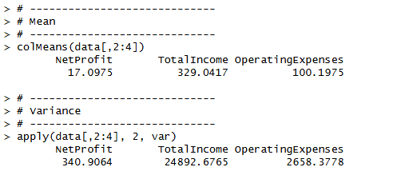
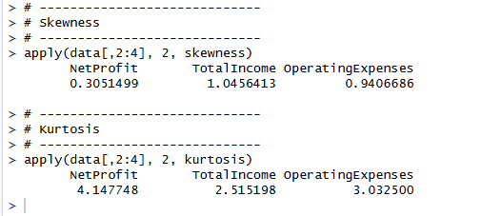
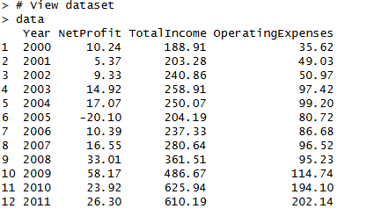
ANALYSIS OF OBTAINED RESULTS:
After analyzing the financial dataset of Surya Bank, the following observations were made:
From the mean values:
- Total Income has the highest average, followed by Operating Expenses and Net Profit
- Net Profit shows fluctuations, including a negative value, indicating a loss in one year
From the variance:
- Total Income shows high variability, indicating significant growth over the years
- Operating Expenses also show increasing variability
- Net Profit has moderate variability due to fluctuations
From the skewness:
- Net Profit is positively skewed, indicating more values on the lower side with a few high-profit years
- Total Income and Operating Expenses also show positive skewness, indicating growth trend
From the kurtosis:
- Values indicate whether the distribution is peaked or flat
- Higher kurtosis suggests presence of extreme values in some years

Overall Insights:
- The bank shows growth in income over time
- Expenses are also increasing, impacting profitability
- Profit is inconsistent, indicating possible financial instability in some years

