

ACECARD / PRODUCT OVERVIEW  Two Products.  AceCard sells two different products. The first, called the Ace Smart Card, is a digital business card individuals buy for themselves. The second, called AceCard, is a sales platform companies buy for their reps. | TWO LIVE PROFILES TO OPEN  Click either name to open the live AceCard profile in your browser.  Pratham Mittal / Founder, Tetr and Masters' Union  Shubham Rohatgi / Founder and COO, AceCard
AT A GLANCE
Two products. Same brand.
The same physical NFC card sits inside both products. The difference is the software around it and who it is sold to.
PRODUCT 01  Ace Smart Card  A digital business card you set up once and own.  WHO BUYS  An individual.  WHAT'S INCLUDED  An NFC card and a personal web page. The page can show a photo, a video, your bio, your social links, and a calendar button.  PRICE  ₹3,500 + GST. Paid once. Hosting included. |  | PRODUCT 02  AceCard  Making Your Marketing and CRM Efficient  A sales platform that uses the same NFC card.  WHO BUYS  A sales team, 10 to 1,000+ reps.  WHAT'S INCLUDED  Branded cards and profiles for every rep, voice-to-CRM that works with any CRM, a mobile app, an admin dashboard, built-in remarketing, and centralised client data.  PRICE  ₹3,000 per seat per month. Billed annually.
PRODUCT 01
Ace Smart Card
#BeUnforgettableWithAceCard
An NFC card and a personal web page. Hand the card to someone, they tap it against their phone, and the page opens. The page can include a photo, a video that plays inline, your bio, links to your work, your social handles, and a button that books a meeting on your calendar. The recipient does not need an app or a QR code, and you do not collect their email. The card is a one-time purchase, and page hosting is included after that with no recurring fee.
WHAT'S INCLUDED
01. A matte-black NFC card  Premium card with an embedded NFC chip. Tap against any iPhone or Android. Same card lasts indefinitely, no battery, no recharging. | 02. A personal web page at your own URL  Hosted page on your own AceCard URL. Photo, video, bio, links, social, 'Book a call' button. Edit from your phone any time. No AceCard branding.
HOW IT WORKS
STEP 01  Build the page  Photo, bio, links, calendar. | → | STEP 02  Give out the card  In person, at meetings or events. | → | STEP 03  They tap it  Their phone opens your page in about a second.
WHO IT'S FOR
Founders, consultants, salespeople, executives, freelancers — anyone who gives out cards often. Update the page and the change is live immediately. No reprints when your role or number changes.
PRICE  ₹3,500 + GST  One-time. Hosting included. | No subscription or renewal. Page hosting included at no extra cost, editable any time.
PRODUCT 02 / ACECARD / What's included
01. Branded NFC cards for every rep  Same NFC card. Marketing controls the page — banner, logo, colors. Link revokes the moment a rep leaves. | 02. Centrally managed profiles  Pages built from a company template. Admins audit and push updates. Access removed on offboarding.
03. Voice-to-CRM, into any CRM  Rep speaks for a minute, voice becomes structured fields. Native: Salesforce, HubSpot, Zoho, Odoo. Webhook for the rest. | 04. Mobile app for reps  Past meetings for every customer, sorted by date. Rep reads the latest notes on the phone, on the way in.
05. Dashboard for sales heads  Pipeline, taps, leads, conversion, top performers. Derived from real activity, not rep entries. | 06. Built-in remarketing audience  Every tap added to your retargeting audience. Run paid ads on Instagram, Facebook, LinkedIn, the open web.
07. Centralised client data
Every interaction stored against the company, not the rep. When a rep leaves, the client history stays.
HOW IT WORKS
STEP 01  Rep taps the card  The customer's phone opens the rep's branded page. | → | STEP 02  Rep records the meeting  Answers a few preset questions out loud, taking about a minute. | → | STEP 03  Voice becomes data  Lead name, role, deal size and next step are extracted automatically. | → | STEP 04  Lead enters the CRM  Synced into Salesforce, HubSpot, Zoho, Odoo or any other CRM in use. | → | STEP 05  Remarketing turns on  Every tap adds the customer to your retargeting audience and ads start running.
WHO IT'S FOR
Sales teams with between 10 and 1,000+ field reps. Common industries: insurance, real estate, banking, business-to-business sales, and field services.
PRICE  ₹3,000 / seat / month  Billed annually, per user. | The price covers all seven pieces above. A seat is one user (one rep). Seats can be added or removed as team size changes.
PILOT AND ROLL-OUT
AceCard ships within five business days of order confirmation. Onboarding takes one 30-minute session per rep, and voice-to-CRM goes live on day one.
STEP 01  Week 0  Sample cards shipped. 30-min walkthrough with the sales team. CRM connection set up. | → | STEP 02  Week 1  First 5 to 10 reps onboarded. Profiles published. Voice-to-CRM live in the field. | → | STEP 03  Week 2+  Roll out to the full team. Dashboard metrics start flowing. Remarketing audience builds.
WORKS WITH YOUR CRM
NATIVE INTEGRATIONS  Salesforce, HubSpot, Zoho, Odoo  Two-way sync. Leads flow into the CRM the moment voice capture is saved. | EVERYTHING ELSE  Webhook + scheduled import  Any CRM is supported. Webhooks for real-time, scheduled CSV for legacy systems.
WEB DASHBOARD / 01 of 06
Dashboard
Pipeline this month, total visits, leads captured, and tap-to-lead ratio. Every figure is derived from real card activity, not from rep entries. The chart shows pipeline value built up over the month. Below it: top performing reps ranked by activity, and a live feed of recent card taps showing who tapped, where, and when.
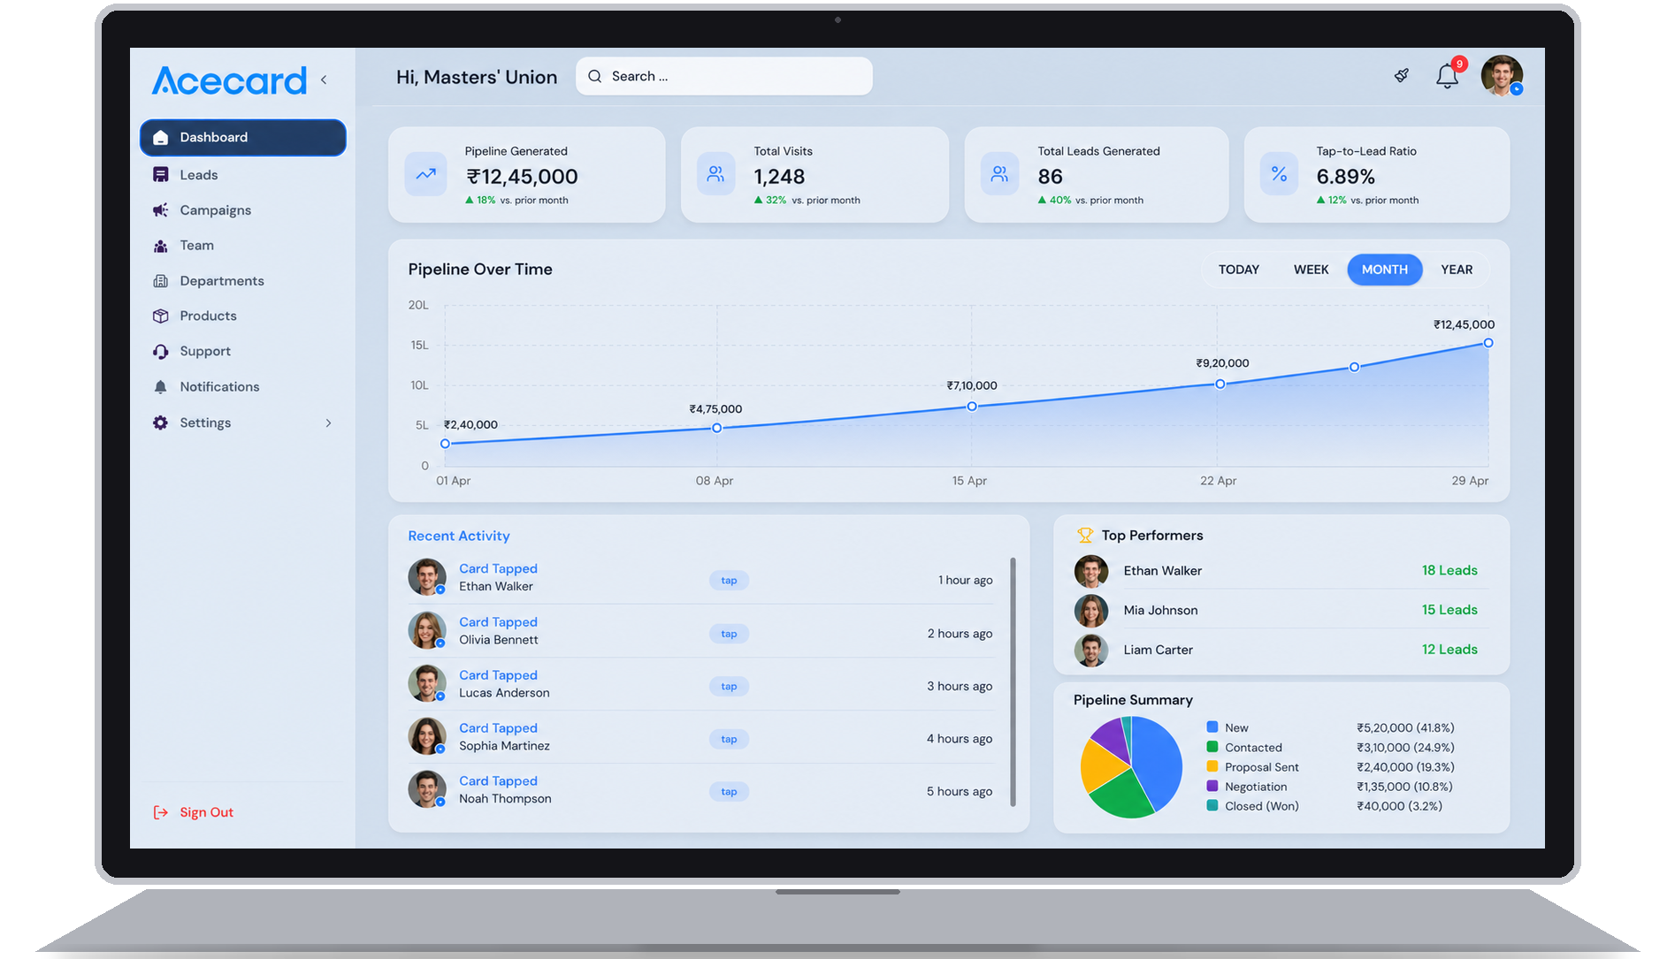
WHAT YOU ARE LOOKING AT
Pipeline value. The total deal value generated by card activity this month, calculated from CRM amounts on every saved lead.
Visits and leads. Every card tap is counted. These are confirmed in-person interactions, not numbers self-reported by reps.
Tap-to-lead ratio. Conversion rate from a card tap to a saved lead, tracked live. Tells you which markets and reps are converting.
Top performers. Reps ranked by real activity, not by self-reported numbers. The same view drills down by department.
WEB DASHBOARD / 02 of 06
Leads
Every meeting that turned into a saved lead. Sortable by stage, owner, company, deal size or date. Each row links through to the full lead record, voice transcript, and meeting history. Stage tags show where the lead is in the pipeline; deal amount and last-updated date sit alongside for quick scanning.
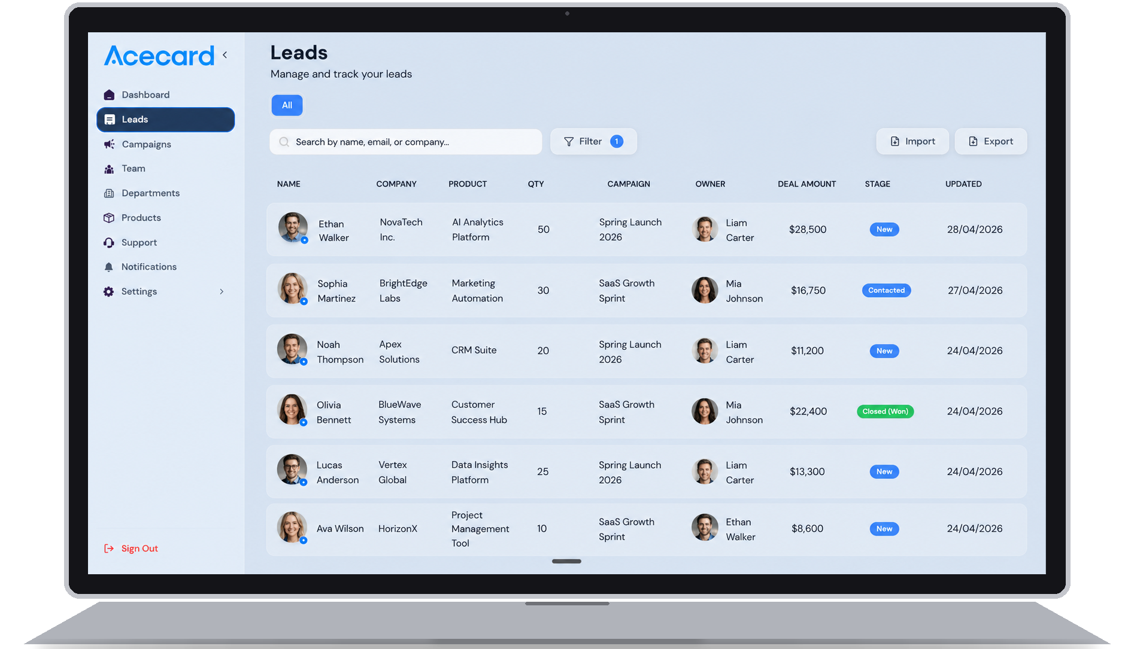
WEB DASHBOARD / 03 of 06
Campaigns
Each running campaign with its budget, leads generated, pipeline value and conversion rate. Marketing and sales finally see the same numbers in one place. Campaigns can be tied to specific cards or rep groups so the leads they produce are tracked back to their source automatically.
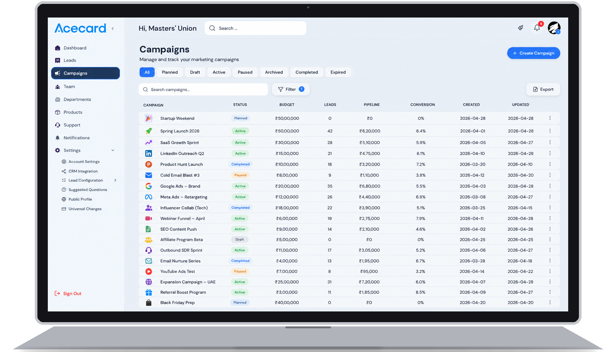
WEB DASHBOARD / 04 of 06
Team
Every rep, their manager, department, and the leads they have brought in. Per-seat licensing controls let you turn seats on and off as people join or leave. Click any rep to see their card activity, recent meetings, voice notes and current pipeline.
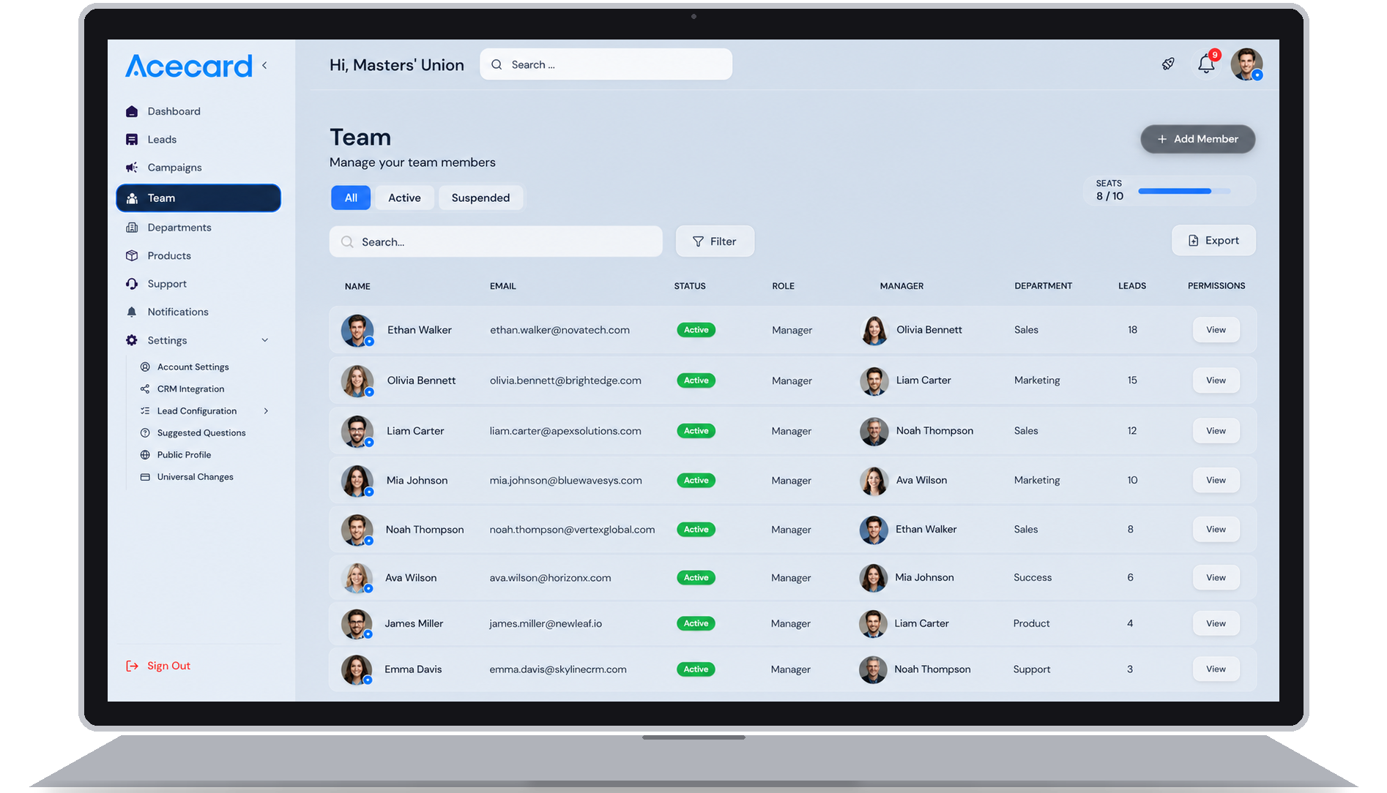
WEB DASHBOARD / 05 of 06
Departments
Group reps by team and set a department head. The dashboard breaks the numbers down by department, so you can compare insurance vs. retail vs. enterprise pipelines side by side. Department heads see their own slice of every metric across the platform.
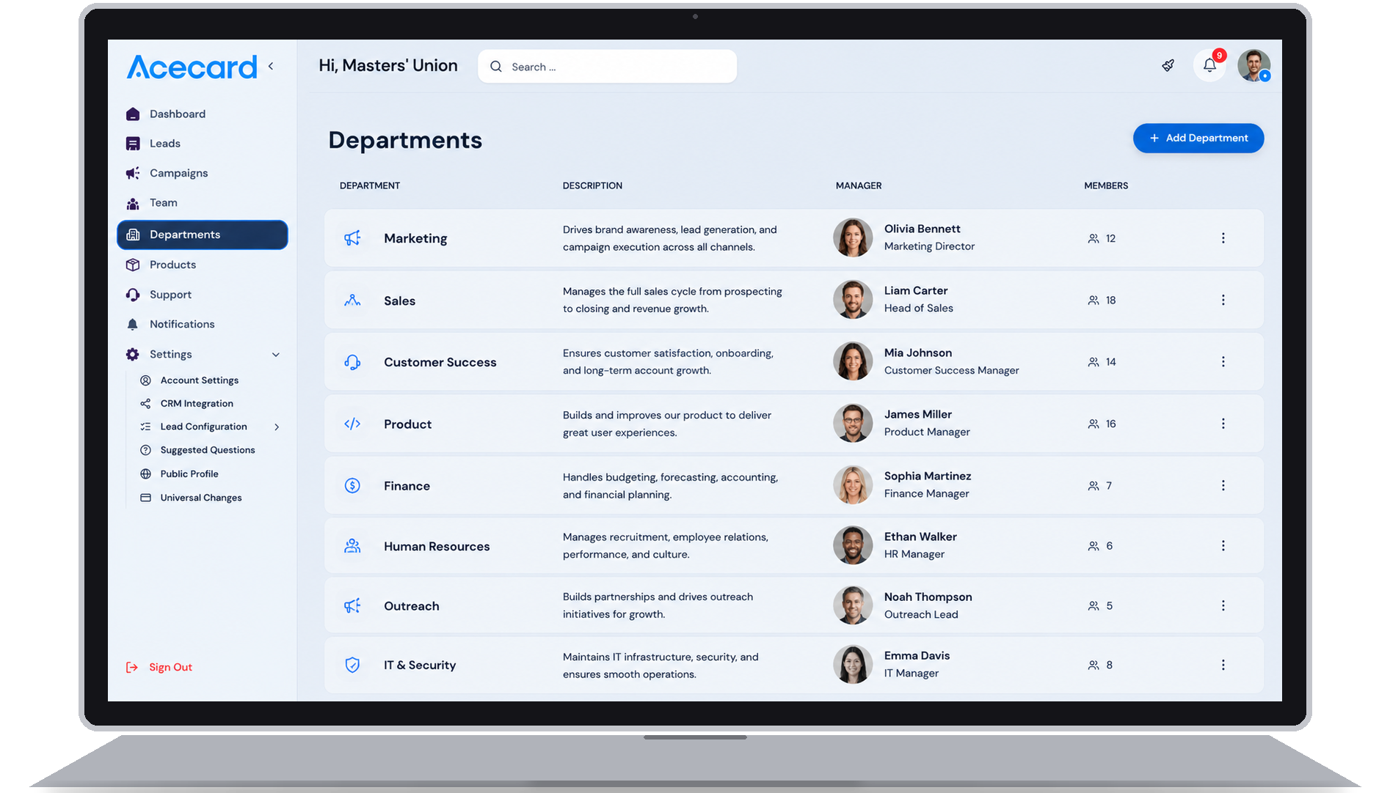
WEB DASHBOARD / 06 of 06
Products
The catalogue reps reference in meetings. The voice-to-CRM step picks the right product when the rep mentions it. Each product carries its price, description, and the assets reps can share inline. Updates here roll out to every rep's profile and voice flow instantly.
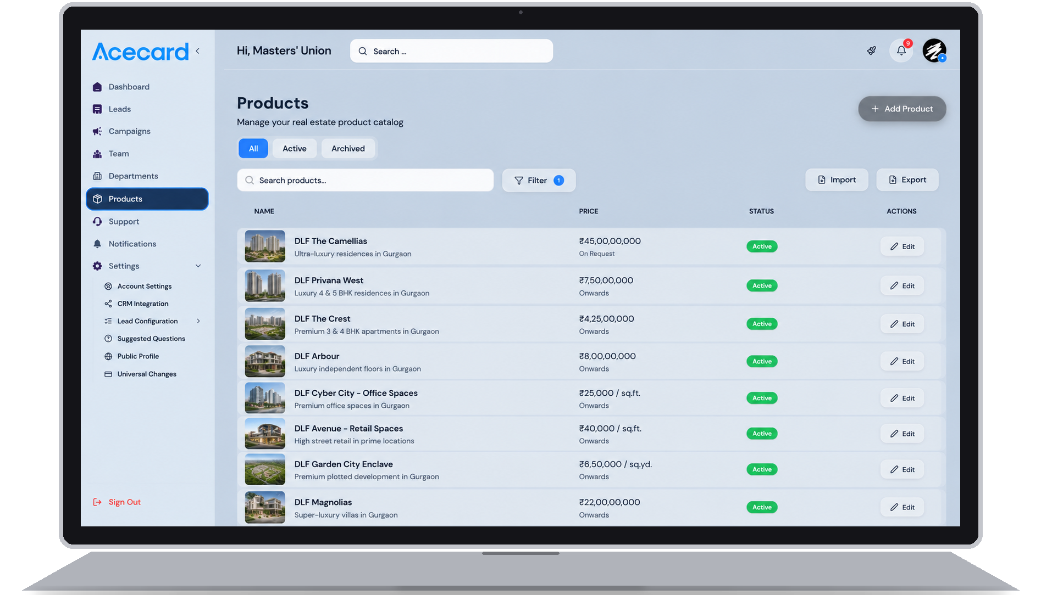
REP MOBILE APP
The phone in every rep's hand.
Three screens from the AceCard mobile app: voice capture, lead detail, and past-meeting notes.
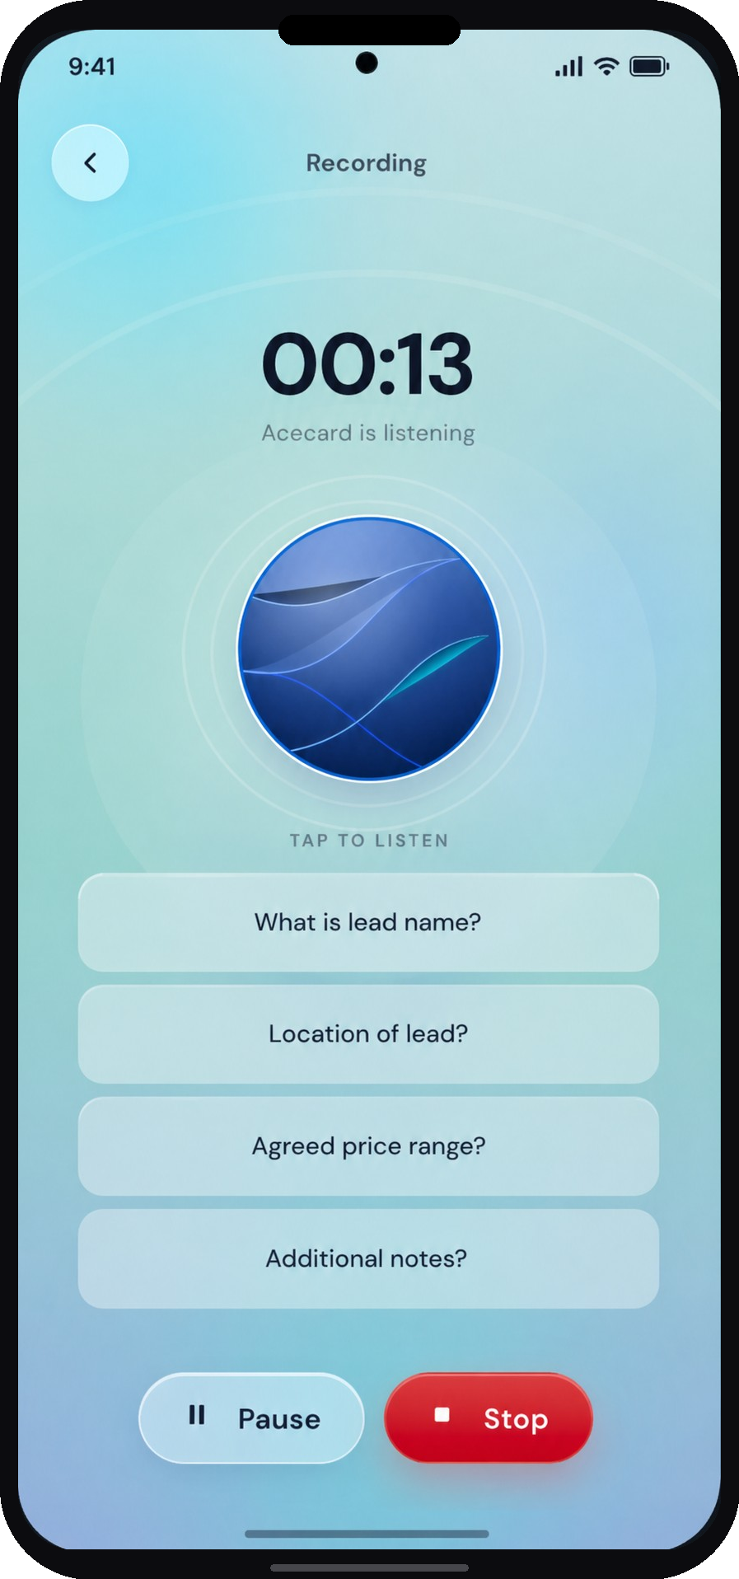  Voice capture  Rep talks for about a minute. The manager-set questions stay on screen. | 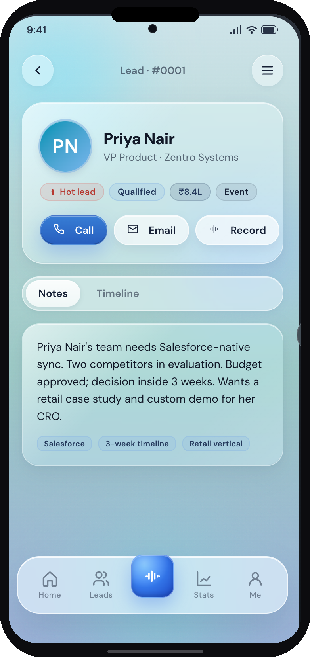  Lead detail  The lead writes itself from the voice. Rep edits any field, taps save. | 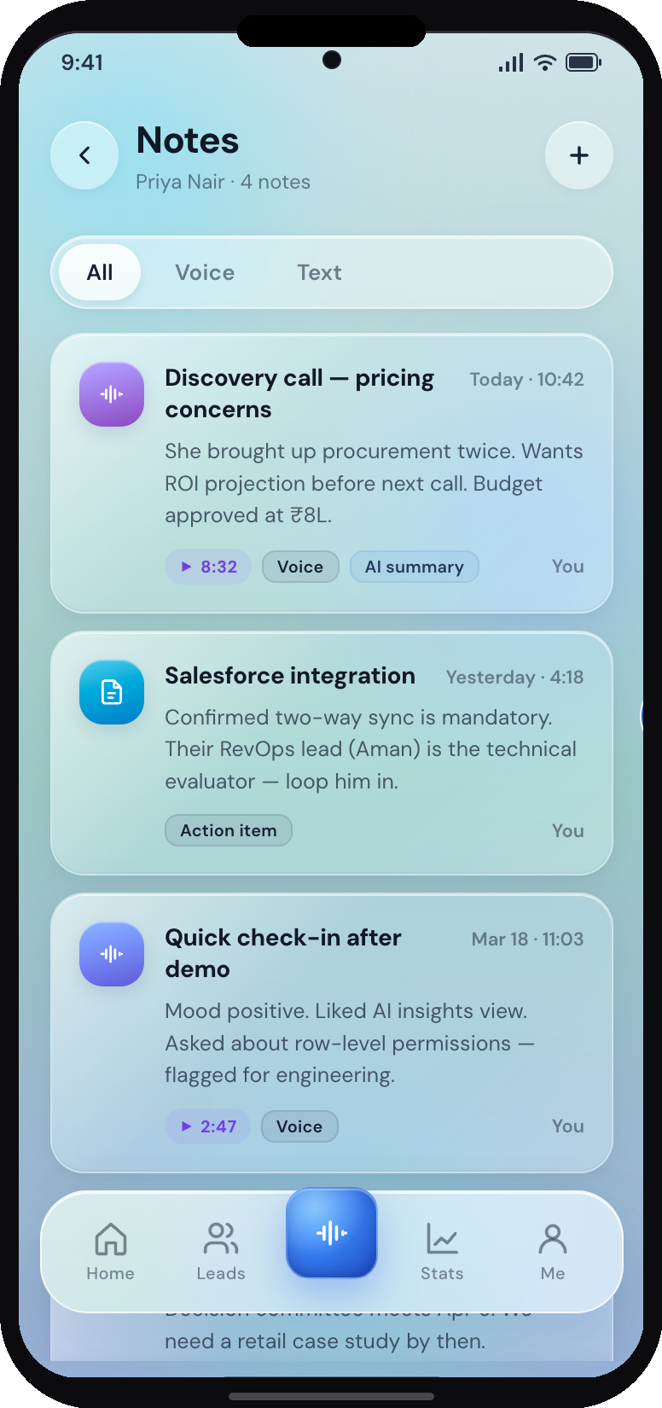  Notes timeline  Every past meeting on one page. Rep reads it before walking back in.
CONTACT
AceCard
Two products, one company. The Ace Smart Card is a digital business card individuals buy for themselves. AceCard is a sales platform companies buy for their reps.
Talk to us about which product fits your team, or to set up a pilot.
GET STARTED
From conversation to live pilot in two weeks.
STEP 01  Call us  A 30-minute call to understand your sales motion, current CRM, and team size. | → | STEP 02  Sample shipped  Sample cards and a demo workspace arrive within five business days. | → | STEP 03  Pilot live  First 5 to 10 reps live in the field, voice-to-CRM running, dashboard populating.

Shubham Rohatgi  Founder  9413615333 | Pushya Modi  7624008999
info@theacecard.co
2010: Excel
2020: Salesforce
2026: AceCard

