Report
Predicting Restaurant Revenue

1. Introduction
This report documents the process of building a regression model to predict daily outlet revenue for a national quick-service restaurant (QSR) chain. Accurate daily revenue forecasts are operationally important for this business context: restaurant managers rely on forecasts to schedule staff at appropriate levels, plan ingredient orders to avoid waste or shortfall, and time promotional activity for maximum impact. Without reliable forecasts, outlets risk either overstaffing on slow days (raising labour costs) or understaffing on busy days (reducing service quality and revenue).
The evaluation metric is Mean Squared Error (MSE) on a held-out test set. The training dataset contains 3,456 outlet-day observations across 120 unique outlets spanning April to September 2025.

1.1 Executive Summary
The key findings from this analysis are as follows. First, outlet identity alone explains 72.3% of Revenue variance, making the engineered outlet-level mean Revenue feature the single most impactful modelling decision. Second, LagHigh (a binary indicator of whether the previous month exceeded the global median Revenue) is the strongest original feature, with a mean Revenue difference of $0.5439k between its two classes (p < 0.0001). Third, all three regularised linear models (Ridge, Lasso, ElasticNet) achieved nearly identical cross-validated MSE of approximately 0.0545, confirming the revenue relationships are predominantly linear given the engineered feature set. ElasticNet (alpha = 0.005, l1_ratio = 0.3) was selected as the final model. The estimated prediction error on unseen data is approximately plus or minus $233 per outlet per day (Root Mean Squared Error (RMSE) = sqrt(0.0545) x $1,000).

2. Exploratory Data Analysis

2.1 Dataset Overview
The training dataset comprises 3,456 rows and 14 columns, forming an unbalanced panel of 120 outlets observed across approximately 180 calendar dates. Each outlet appears between 13 and 41 times (mean = 28.8, std = 5.6), with only 5 outlets observed fewer than 20 times. The panel structure, where the same outlet appears repeatedly across dates, is a key characteristic that informs both feature engineering and modelling decisions. Observations are not fully independent given this structure, as days from the same outlet share a common baseline revenue level. This observation carries forward to Section 3, where outlet-level aggregate features are motivated by the large variance explained by outlet identity.

2.2 Target Variable: Revenue
Revenue is a continuous float variable, confirmed by 3,456 unique values across 3,456 rows, measured in thousands of dollars. The distribution is right-skewed (skewness = 2.9050), with the mean ($0.9842k) sitting noticeably above the median ($0.8639k), driven by a small number of high-revenue outlet-days. Table 1 summarises the key descriptive statistics.

Statistic | Value
Mean | 0.9842
Median | 0.8639
Standard Deviation | 0.4885
Minimum | 0.0526
Maximum | 7.7753
Q1 | 0.6528
Q3 | 1.1996
IQR | 0.5468
Skewness | 2.9050
Table 1: Revenue summary statistics (n = 3,456). All values in thousands of dollars.

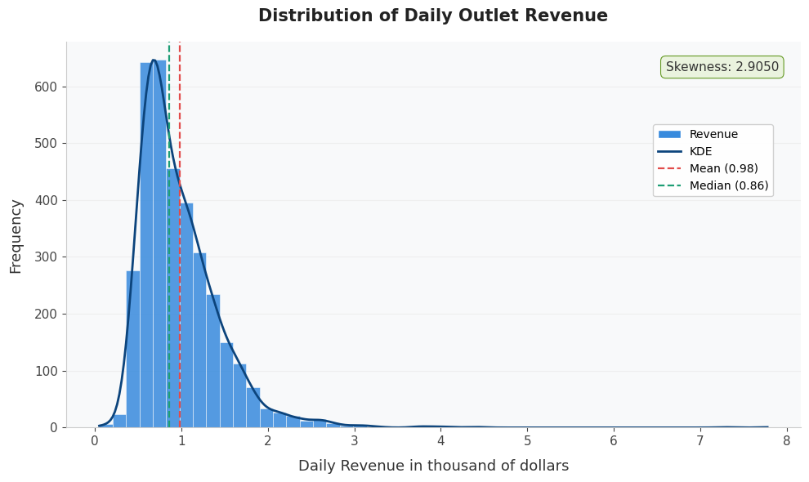
Figure 1: Distribution of daily outlet Revenue with KDE overlay. Mean (red) exceeds median (green), confirming right skew (skewness = 2.9050).
The IQR upper fence is 2.0199, above which 111 rows (3.21%) are flagged as high-revenue outliers. The maximum of 7.7753 is notably extreme relative to Q3 = 1.1996. The minimum of 0.0526 ($52.60) is suspicious for a QSR outlet and may reflect a data entry issue or an exceptionally low-traffic day. The assignment brief confirms that outliers exist; accordingly no observations were removed. Robust modelling approaches were evaluated as an alternative. These findings motivate careful outlier-aware preprocessing choices discussed in Section 4.1.

2.3 Temporal Patterns
Figure 2 shows three panels of temporal analysis. Panel 1 reveals a clear monotonic downward trend in mean daily Revenue from April 2025 (~$1.05k) to September 2025 (~$0.90k). The 14-day rolling average confirms this trend is systematic rather than noise-driven. Whether this reflects genuine seasonality or a structural shift in the data collection period cannot be confirmed with only six months of data, but the pattern is real and predictable.
Panel 2 shows outlet-demeaned monthly Revenue, where each outlet's own mean is subtracted before computing monthly averages. This removes the confounding effect of outlet quality, isolating the pure month effect. April and May are above-outlet-average months (by approximately +$0.05k), while July through September are below average (by approximately -$0.05k to -$0.06k). The month effect is real but modest, and wide error bars indicate substantial outlet-to-outlet variability within each month.
Panel 3 shows outlet-demeaned weekday versus weekend Revenue. Weekdays average +$0.054k above each outlet's baseline while weekends average -$0.144k below, a gap of approximately $0.20k that is economically meaningful for a QSR chain. These temporal findings motivate the DaysSinceStart feature in Section 3.

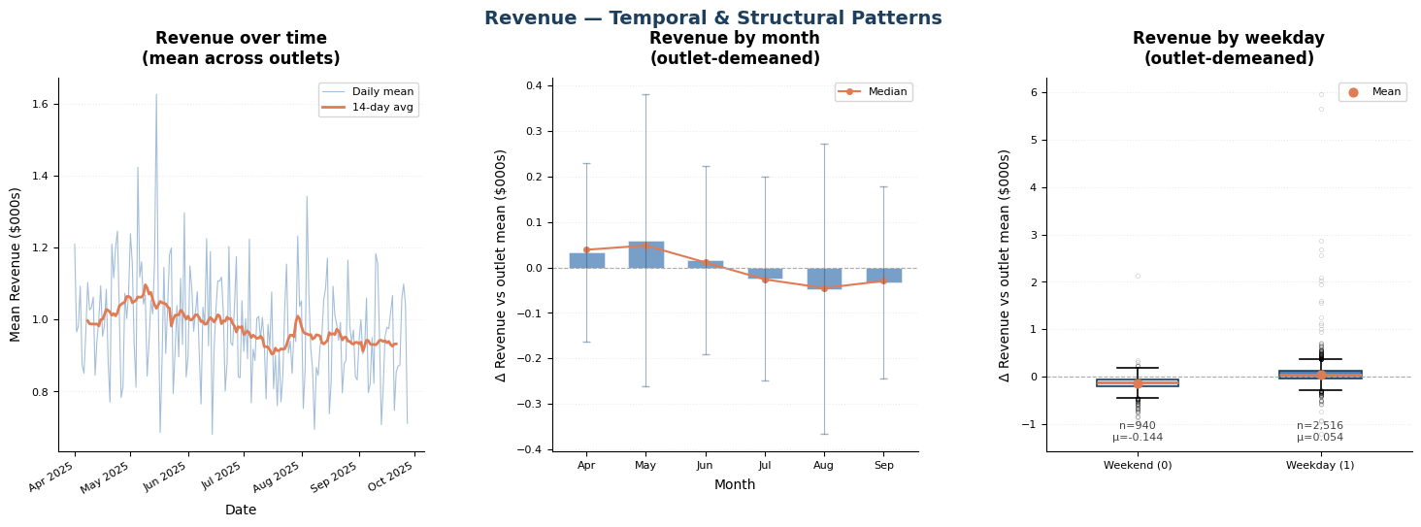
Figure 2: Revenue temporal patterns. Left: revenue over time with 14-day rolling average. Centre: outlet-demeaned monthly revenue. Right: outlet-demeaned weekday vs weekend comparison.

2.4 Missingness
Four columns contain missing values, all below the 5% threshold (Table 2). Missingness does not cluster within specific outlets or months; the top outlet (OutletID 74) has only 6 missing values and monthly missing counts are evenly spread (34 to 47 per month). However, a two-sample t-test reveals rows with any missing value have significantly higher mean Revenue (1.0830 vs 0.9769, p = 0.0012), indicating a Missing At Random (MAR) mechanism rather than Missing Completely At Random (MCAR). This finding means simple global median imputation could introduce subtle bias. Imputation is therefore deferred to the modelling pipeline and applied only to training data to prevent leakage.

Column | Missing Count | Missing %
Rain_mm | 93 | 2.69%
OfficesNearby | 63 | 1.82%
HighIncomeArea | 46 | 1.33%
CompetitorsNearby | 42 | 1.22%
Table 2: Missingness summary. All columns below the 5% flagging threshold.

2.5 Binary Features
All seven binary features (Weekday, Downtown, Mall, HighIncomeArea, Promo, EventNearby, LagHigh) were verified to contain only values 0 and 1 with no integrity issues. No column falls below the 5% minority class threshold, so none are near-constant. EventNearby has the smallest minority class at 9.26% (320 rows), which is sufficient for reliable learning. Downtown and Mall are nearly independent (Pearson r = 0.0003, overlap rate = 12.74%), confirming they carry distinct signals and can both be retained.
LagHigh is the strongest predictor among the original features (association, not causal). Outlets with LagHigh = 1 earn a mean of $1.2982k versus $0.7543k for LagHigh = 0 (difference = $0.5439k, t = -38.7043, p < 0.0001). A leakage check confirmed LagHigh is constant within each outlet-month group, encoding only the previous month's performance with no current-period information included. It is therefore safe to use as a feature. Figure 3 shows mean Revenue by binary feature and Figure 4 shows the full Revenue distribution per class.

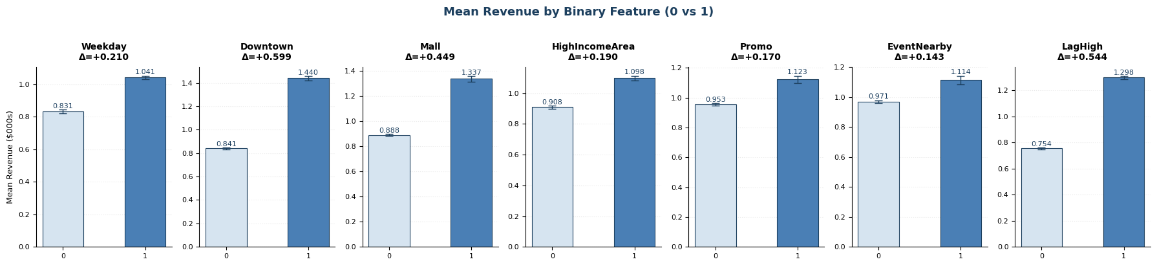
Figure 3: Mean Revenue by binary feature (0 vs 1). Delta values show mean difference. LagHigh and Downtown show the largest effects.

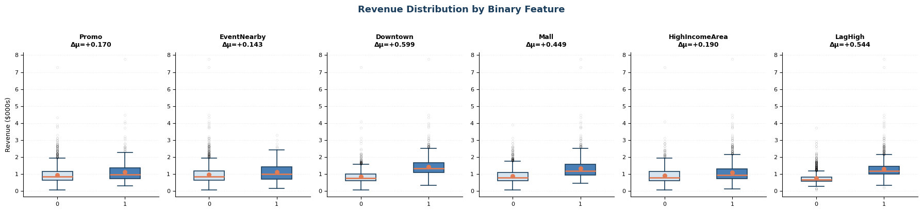
Figure 4: Revenue distribution by binary feature. Box plots confirm a distributional shift rather than just a mean shift, particularly for LagHigh and Downtown.

2.6 Numeric Features
Figure 5 shows distributions for the three numeric features: OfficesNearby, CompetitorsNearby, and Rain_mm. OfficesNearby is tightly clustered (mean 2.12, median 2.10) with skew of 3.0580 driven by a small number of outlets in very dense office areas. CompetitorsNearby shows a bimodal pattern around 5 and 12 competitors, possibly reflecting two distinct location types (urban dense vs suburban). Rain_mm exhibits severe zero-inflation: 55.3% of non-missing values are exactly zero (dry days), with the remaining 44.7% forming a right-skewed continuous distribution (skewness = 5.3372) extending to 139.7610mm. Because Rain_mm simultaneously encodes two distinct phenomena (whether it rained at all, and how much it rained on rainy days), using it directly in a model is problematic. Section 3 addresses this by replacing Rain_mm with two separate engineered features: a binary wet/dry indicator (RainToday) and a log-compressed rainfall amount (Rain_log1p).

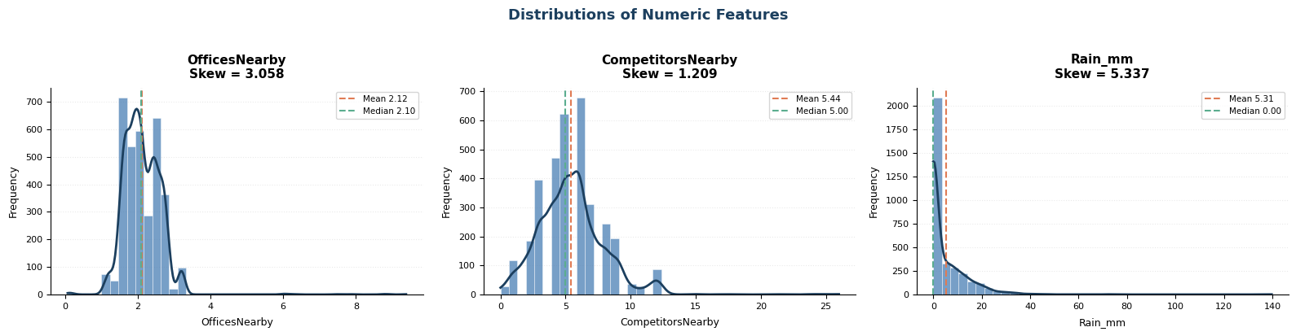
Figure 5: Distributions of numeric features with KDE overlay. Rain_mm shows severe zero-inflation and right skew. OfficesNearby skew is driven by extreme outliers only.

Figure 6 shows outlier inspection using both the IQR method (1.5 x IQR beyond Q1 or Q3) and the z-score method (|z| > 3). Revenue has 111 IQR outliers (3.21%) and 50 z-score outliers (1.45%). CompetitorsNearby has 99 IQR outliers (2.90%), which is notable at nearly 3% of the sample. Rain_mm has 196 IQR outliers (5.83%) driven by extreme rainfall events up to 139.76mm. As confirmed by the assignment brief, outliers are not removed. Instead, StandardScaler is used for numeric features and the sensitivity of linear models to outliers is noted as a limitation.

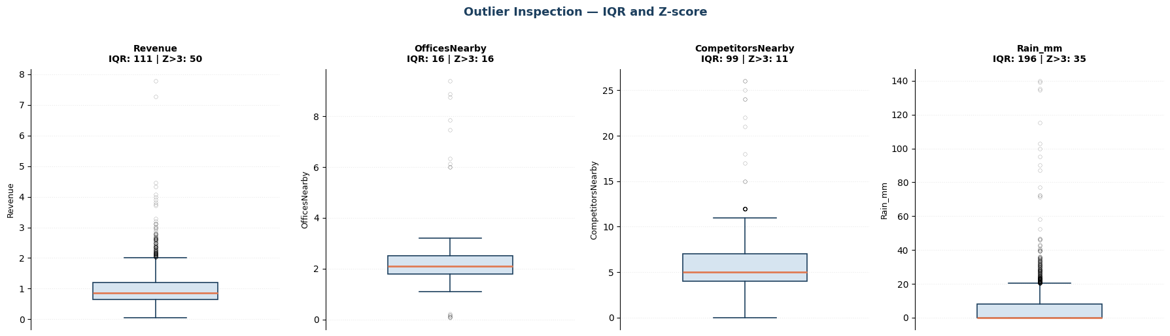
Figure 6: Outlier inspection using IQR and z-score methods. Revenue: 111 IQR outliers (3.21%). CompetitorsNearby: 99 IQR outliers (2.90%). Rain_mm: 196 IQR outliers (5.83%).

2.7 Relationships with Revenue
Figure 7 shows scatter plots of numeric features against Revenue. CompetitorsNearby has the strongest linear association with Revenue (r = -0.4383), followed by OfficesNearby (r = 0.2071). Rain_mm shows negligible linear association (r = -0.0329), though the engineered binary indicator may capture non-linear threshold effects better than the raw value. These are associations only; causality cannot be established from observational data.

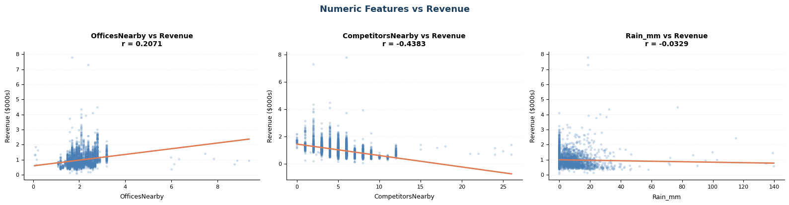
Figure 7: Scatter plots of numeric features vs Revenue with linear trend lines. CompetitorsNearby shows the strongest negative linear association (r = -0.4383).

Figure 8 shows the relationship between Month and Revenue, overlaid with linear and quadratic polynomial fits. Both fits are nearly identical, confirming the relationship is monotonically decreasing and well captured by a straight line. Month does not require polynomial or cyclic (sin/cos) encoding; it is retained as a plain numeric feature. The linear correlation is r = -0.0729, which is modest but consistent.

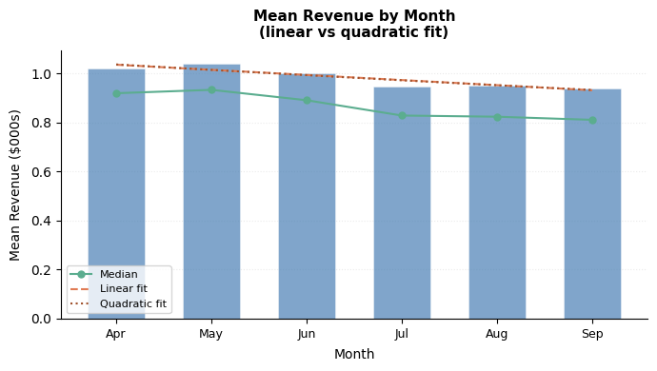
Figure 8: Mean Revenue by month with linear (dashed) and quadratic (dotted) polynomial fits. Near-identical fits confirm a monotonic relationship; cyclic encoding is unnecessary.

2.8 Feature-Feature Relationships
Figure 9 shows the lower-triangle Pearson correlation matrix across all features. No feature pair exceeds |r| > 0.8, indicating multicollinearity is not a structural concern in this dataset. Moderate correlations exist between Downtown and OfficesNearby (r = 0.16) and between LagHigh and Downtown (r = 0.43). These will be handled automatically by regularised models. Figure 10 shows interaction plots for Promo x Weekday and EventNearby x Weekday. The Promo x Weekday lines are approximately parallel (weekend effect: +0.1620, weekday effect: +0.1935), indicating no strong interaction. The EventNearby x Weekday lines are non-parallel (weekend: +0.0184, weekday: +0.1832), confirming a meaningful interaction where events boost Revenue substantially more on weekdays. This motivates the Event_x_Weekday interaction feature in Section 3.

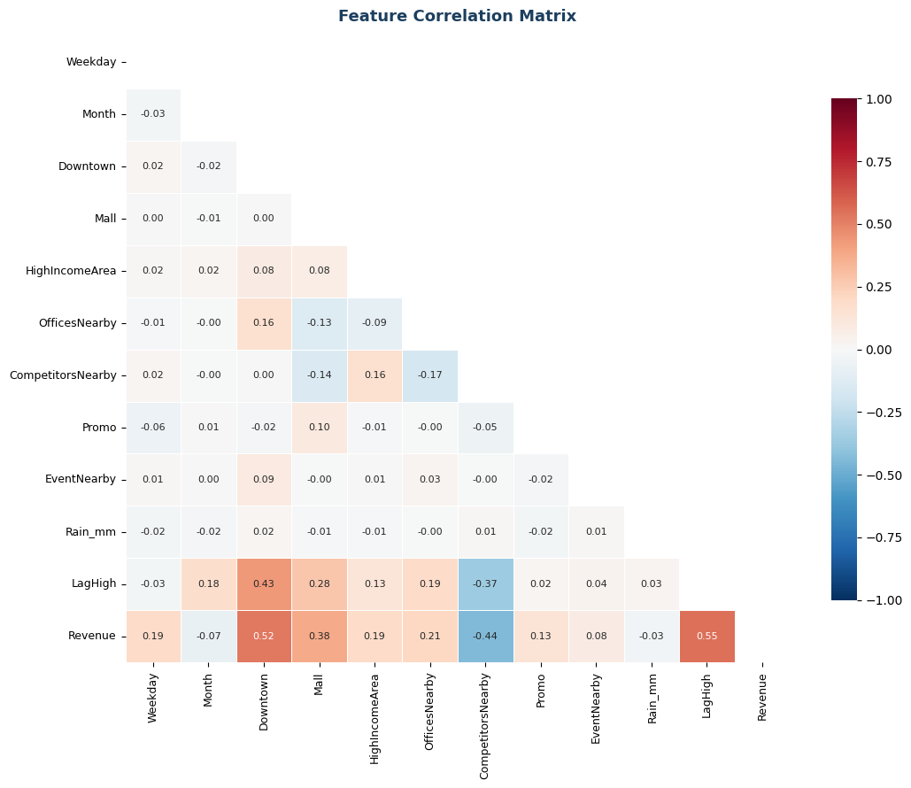
Figure 9: Feature correlation heatmap (lower triangle). LagHigh-Revenue (0.5500) and Downtown-Revenue (0.5236) are the strongest correlations. No feature pair exceeds |r| > 0.8.

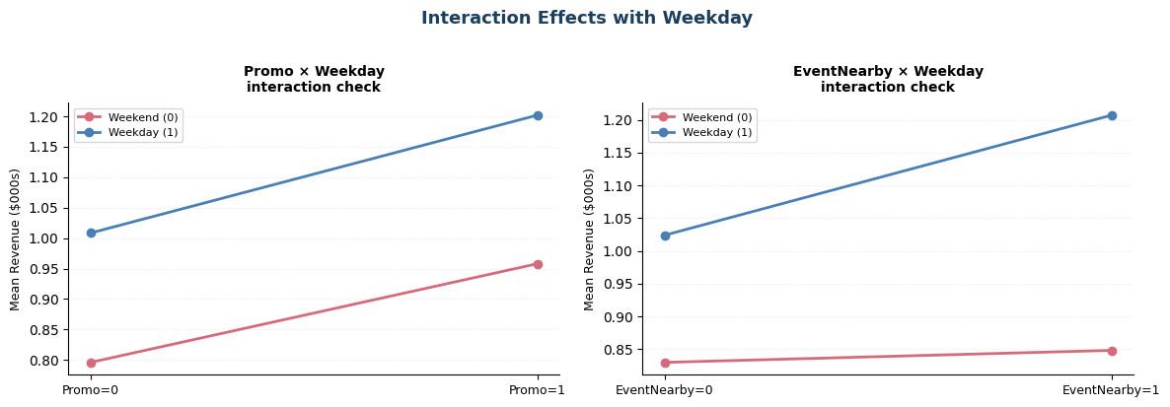
Figure 10: Interaction plots with Weekday. Left: Promo x Weekday shows roughly parallel lines (no strong interaction). Right: EventNearby x Weekday shows non-parallel lines, confirming an interaction effect.

2.9 Outlet-Level Structure
Figure 11 shows mean Revenue per outlet sorted in ascending order. The spread is substantial: the lowest-performing outlet averages approximately $0.45k while the highest averages approximately $2.74k, a sixfold difference. A variance decomposition confirms outlet identity alone explains 72.31% of total Revenue variance (R-squared = 0.7231, SS between outlets = 596.2643 of SS total = 824.6147). This is the single most important EDA finding. It directly motivates engineering outlet-level aggregate features in Section 3. Location features (Downtown, Mall, HighIncomeArea) are fully static within each outlet, confirmed by zero within-outlet variation across all 120 outlets.

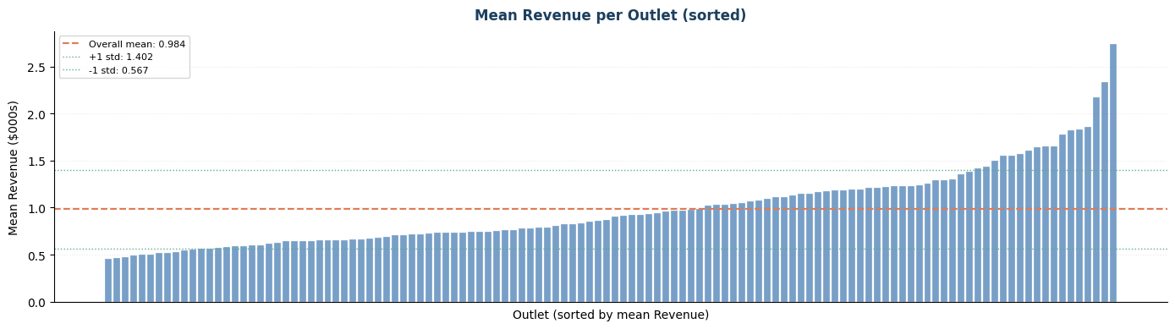
Figure 11: Mean Revenue per outlet sorted in ascending order. The wide spread (std = 0.4171) confirms that outlet identity explains 72.3% of Revenue variance, strongly motivating outlet-level feature engineering.

2.10 Train vs Test Alignment
The test set contains 864 rows across the same 120 outlets and the same date range (April 1 to September 27, 2025). All 120 test outlets appear in training, ensuring outlet-level engineered features produce no missing values for test rows. Feature distribution means between train and test are closely aligned with no flagged distribution shift. Rain_mm shows the largest mean difference (train: 5.3091, test: 4.7149) but this is within acceptable range and does not indicate a problematic shift. Preprocessing scalers are fitted on training data only and applied to both sets, preventing any leakage of test distribution statistics.

3. Feature Engineering
Seven features were engineered based on the EDA findings documented in Section 2. Raw Rain_mm was excluded from the final feature set and replaced by two purpose-built rain features. Table 3 documents each engineered feature, its derivation, and the specific EDA finding that justifies it.

Feature | Derivation | EDA Motivation
OutletMeanRevenue | Mean Revenue per outlet (train only) | Outlet identity explains R-squared = 0.7231 of variance (Section 2.9)
OutletStdRevenue | Std dev of Revenue per outlet (train only) | Captures within-outlet spread for additional model signal
RainToday | 1 if Rain_mm > 0, else 0 | 55.3% zero-inflation; binary split separates wet and dry days cleanly (Section 2.6)
Rain_log1p | log(1 + Rain_mm) | Skewness = 5.3372; compresses extreme values up to 139.76mm (Section 2.6)
DaysSinceStart | Days elapsed since April 1, 2025 | Captures monotonic downward revenue trend observed in Section 2.3
Promo_x_Weekday | Promo multiplied by Weekday | Interaction check showed similar effect sizes (Section 2.8); included for completeness
Event_x_Weekday | EventNearby multiplied by Weekday | Non-parallel lines confirmed: +0.0184 weekend vs +0.1832 weekday (Section 2.8)
Table 3: Engineered features with derivation and EDA justification.
OutletMedianRevenue was initially computed but excluded because for most outlets the mean and median are close, making the two features highly redundant. Removing it reduces dimensionality without meaningful information loss. Cyclic encoding (sin/cos) for Month was not used because only 6 consecutive months are present and the relationship is monotonically linear (Figure 8), so cyclic encoding adds complexity without benefit. The final feature set contains 17 columns: 7 numeric columns and 10 binary or indicator columns.

4. Modelling

4.1 Preprocessing Pipeline
A scikit-learn ColumnTransformer was used to apply different preprocessing steps to numeric and binary columns. Numeric columns (Month, OfficesNearby, CompetitorsNearby, OutletMeanRevenue, OutletStdRevenue, Rain_log1p, DaysSinceStart) were imputed using the median strategy and then standardised with StandardScaler. Median imputation is preferred over mean imputation because the outliers identified in Section 2.6 would inflate the mean, pulling imputed values away from the typical observation. Binary and indicator columns were imputed using the most-frequent strategy and left unscaled, as standardising 0/1 variables does not improve and may distort model performance.
Tradeoff: The MAR finding in Section 2.4 (rows with missing values skew toward higher Revenue outlets) means global median imputation may introduce subtle downward bias for those rows. A more principled approach would be outlet-level median imputation, which would better preserve the Revenue distribution for each outlet. However, this adds pipeline complexity and given that no column exceeds 2.69% missingness, the practical impact is expected to be small. The simpler approach is retained with this limitation noted.
The preprocessor was fitted exclusively on training data and applied to both training and test sets. This prevents any leakage of test distribution statistics into the preprocessing step, which would artificially improve apparent model performance.

4.2 Model Evaluation and Selection
Four regression models were evaluated using 5-fold cross-validated MSE with a fixed random seed of 42 for reproducibility. The 5-fold strategy was chosen over 3-fold (less stable estimates) or 10-fold (higher computational cost) as a practical balance given the dataset size of 3,456 rows, which ensures each fold contains approximately 690 rows for validation. The same preprocessor pipeline was embedded within each fold to prevent within-fold leakage. Tables 4 and 5 show initial untuned results and final tuned results respectively.

Model | CV MSE (untuned) | CV MSE Std
Ridge (alpha = 1.0) | 0.0547 | 0.0375
Lasso (alpha = 0.001) | 0.0545 | 0.0373
ElasticNet (alpha = 0.001, l1_ratio = 0.5) | 0.0545 | 0.0374
KNN (k = 10) | 0.0582 | 0.0361
Table 4: Initial 5-fold cross-validated MSE with default hyperparameters. CV MSE Std reflects variability across folds.

Model | Best Parameters | CV MSE
Ridge | alpha = 10.0 | 0.0546
Lasso | alpha = 0.001 | 0.0545
ElasticNet | alpha = 0.005, l1_ratio = 0.3 | 0.0545
KNN | k = 10 | 0.0582
Table 5: Tuned model comparison after GridSearchCV. ElasticNet selected as the final model.

ElasticNet (alpha = 0.005, l1_ratio = 0.3, CV MSE = 0.0545) was selected as the final model. The near-identical performance of Ridge (0.0546), Lasso (0.0545), and ElasticNet (0.0545) indicates the problem is well-suited to linear modelling, with strong linear signals coming from OutletMeanRevenue and LagHigh. Importantly, the difference between ElasticNet and Ridge of 0.0001 is well within one cross-validation standard deviation (approximately 0.0374), so the selection between these two models is not statistically meaningful. ElasticNet is preferred on theoretical grounds rather than empirical ones.
ElasticNet with l1_ratio = 0.3 is preferred over pure Lasso because the predominantly L2 penalty provides coefficient stability across correlated features, while the L1 component allows mild feature selection. Given moderate correlations between Downtown and OfficesNearby, and between OutletMeanRevenue and LagHigh, the mixed penalty is theoretically preferable to pure L1 in this setting.
KNN (MSE = 0.0582) performs noticeably worse than all linear models. This suggests the revenue relationships are predominantly linear given the engineered feature set. The monotonic improvement in KNN MSE as k increases from 3 (0.0666) to 10 (0.0582), followed by degradation beyond k = 10, confirms that the optimal neighbourhood size balances local accuracy against oversmoothing. KNN is also more sensitive to the scale of features and to imputed missing values, which may contribute to its lower performance.
Tradeoffs: Ridge retains all features and provides stable coefficient estimates, which is beneficial when features are correlated. Lasso performs automatic feature selection by shrinking weak coefficients to exactly zero, producing a sparser and more interpretable model. ElasticNet combines both properties. KNN makes no linearity assumption and can in principle capture non-linear patterns, but is sensitive to irrelevant features, scale, and imputed values. All selection decisions were based purely on cross-validated MSE as required by the assignment specification.

4.3 Prediction Summary
Statistic | Training Revenue | Test Predictions
Mean | 0.9842 | 0.9806
Std | 0.4885 | 0.4195
Min | 0.0526 | 0.2602
Max | 7.7753 | 2.8445
Table 6: Training Revenue vs test prediction distribution comparison.
The prediction mean (0.9806) closely matches the training mean (0.9842), indicating no systematic bias in the model. The lower prediction standard deviation (0.4195 vs 0.4885) is an expected property of regression models, which typically underestimate the tails of the distribution by averaging across uncertainty. The prediction minimum (0.2602) and maximum (2.8445) are within reasonable bounds. No pathological predictions (negative values or extreme extrapolations) were produced.

5. Conclusions
The most important finding from this analysis is that outlet identity explains 72.3% of Revenue variance, far exceeding the explanatory power of any individual feature. Engineering an outlet-level mean Revenue feature from training data was therefore the single most impactful modelling decision. This reflects the fundamental economics of the problem: QSR outlets differ substantially and persistently in their revenue levels based on location characteristics, customer base, and local demand, none of which change day to day.
LagHigh was the strongest original feature (r = 0.5500), confirming that prior-period outlet performance is a powerful predictor of current performance. This persistence effect is consistent with stable outlet-level demand patterns across months.
All three regularised linear models produced nearly identical cross-validated MSE of approximately 0.0545, substantially outperforming K-Nearest Neighbours (KNN) Regression at 0.0582. The convergence of linear model performance suggests the revenue prediction problem is fundamentally linear given the available features. Further gains would likely require additional outlet-level data, economic indicators, or more expressive models not covered in this course.
Key modelling decisions and their tradeoffs: (1) OutletMeanRevenue was engineered from training data only, which avoids leakage but assumes outlet performance quality is stable over the observation window; (2) Rain_mm was replaced by RainToday and Rain_log1p, which captures the zero-inflation structure but discards the raw millimetre scale; (3) Median imputation was used within the pipeline, which is simple and reproducible but does not fully address the MAR mechanism identified in Section 2.4; (4) ElasticNet was selected over Lasso despite equal CV MSE because it is theoretically preferable for datasets with correlated features, though in practice the two models are equivalent here.
For the QSR business context, the model provides a practical forecasting tool with an estimated daily revenue error of approximately plus or minus $233 per outlet (RMSE = sqrt(0.0545) x $1,000). This level of accuracy is sufficient to support staffing and inventory decisions, though the model may underperform for the small number of outlets with extreme revenue behaviour (the 111 high-revenue outliers identified in Section 2.2).

AI Acknowledgement:
- Used AI to format the document to make it look clean and organized
- AI was also used to fix grammar and sentence structure
- AI Tools used: Claude

