

**Team 2**

**int elligence;**

**Clinton Benton, David Hughes, Elizabeth Moreno,**

**Michael O’Donnell, Tommy Owens, Aaron Ulmer**

**Table of Contents**

**Overview** 3

**Customer Wish List** 4

**High Level Use Case Diagram** 5

**Summary List of Use Cases** 6

**Use Cases** 7

Sign Up 7

Login/Logout 8

View Messages 9

Send Messages 10

View Property 11

Register for Property 12

View Application 13

View Payments 14

Make Payment 15

Accept/Manage Payments 16

View Documents 17

Create/Store Documents 18

Search for Property 19

Add Property 20

Rate the Landlord 21

Manage Properties 22

View Profits and Stats 23

Rate Tenant 24

**Non-Functional Requirements** 25

# **Overview**

The goal of the project is to build an internet based program to handle property rentals and transactions between landlords and tenants, so that they could better handle the system without being so hands on or in person. This is done to simplify and quickly pass the transactions between the two. Through this, searching for properties, leasing, management, and payments can all be condensed to one web-based app where either party can handle their own responsibilities of the process.

The program needs to be able to handle basic tenant and landlord interactions. This includes searching for, applying to, leasing a property from a landlord, and payment management and communication; along with the landlord to be able to upload their properties and relevant documents, lease them and manage their fees and other matters. The program will contain a process for potential tenants to search and view available property within the system and message the landlord of that property for potential application proceedings. The applications process is sorted out by the landlord with the reviewing and signing of the legal documentation by the tenant. The landlord either keeps the documents on file within this system or external.

The addition functionality of the system needs to include the basics of a rating system for both the tenant and landlord. The purpose of the rating system is to create a validation system for landlords on tenants to avoid individuals who have a history of breaking contracts and for preventing slumlords.

The implied task of the system includes a communication system consisting of a basic instant messaging protocols, including notifications through the system and email. The customer is strongly requesting that it also be SMS compatible, aside from being through the system and notifications.

The program will contain a payment notification system and an annotation method for the tenant and landlord to validate that the payment has been made in the appropriate amount for that month. The validation system is due to tenants paying part in cash and part in the system or to check if proper amounts. The payment system will be capable of being updated to handle the current system alongside additional features to the payment system at a later date. This process needs to be intuitive so that any user can gain a quick visual status of their property’s upcoming fees.

**Project Team:**

|  |  |
| --- | --- |
| Clinton Benton | Software Engineer/Designer. Created the Overview and filled in use cases |
| David Hughes | Database Management/Software Engineer. Filled in use cases |
| Elizabeth Moreno | Lead Designer/Software Engineer. Created customer wish list and filled in use cases |
| Michael O’Donnell | Team Leader/Software Engineer. Created table of Contents, filled in uses cases and formatted/edited document |
| Tommy Owens | Software Engineer/Designer. Filled in use cases |
| Aaron Ulmer | Software Engineer/Designer. Created high level use case diagram |

# **Customer Wish List**

1. Tenants and Landlords should be able to sign-up and login into the website. Tenants have the option to register with a Landlord Property ID.
2. Tenants should be able to search Properties, Landlords and view their contact information.
3. Provided they have a Property ID, a Tenant should be able view the property and have the ability to submit an application.
4. Landlords receive incoming applications and can request payments that Tenants can choose to complete or not.
5. If the transaction is completed, the Landlord sends a lease contract for the Tenant to accept.
6. Tenants and Landlords should be able to send and receive messages through some sort of communication system.
7. Tenants receive e-mail or in-site notifications about new messages, upcoming payments, and other significant events in the lease negotiation process.
8. Tenants should be able to view and renew their current leases.
9. Tenants should be able to make payments and view their payment history. Landlords should be able to view payment history of their tenants and manage any other fees.
10. Landlords should be able to add properties with an address, description, picture, insurance information, mortgage and cost. Once it’s created, they should also be able to add forms and other documents
11. Landlords should be able to view high level information over their properties along with other information such as vacancies, status, upcoming payments and other events.
12. Landlords should have a ‘Profits View’ that displays statistics over past payments and income.
13. There should be a rating system for Tenants and Landlords

# 

# **High Level Use Case Diagram**

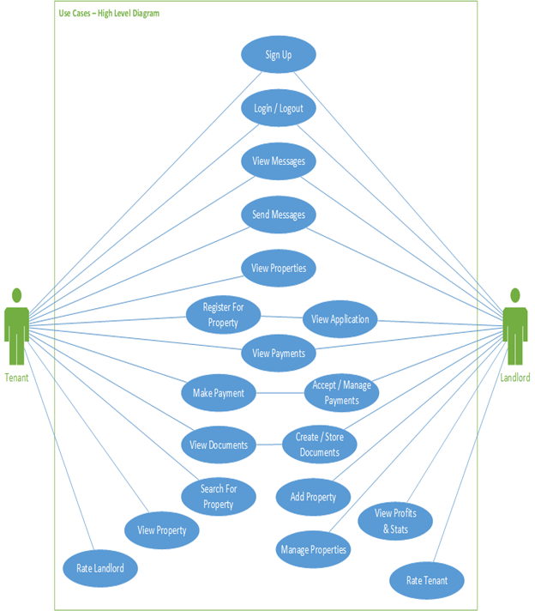

# **Summary List of Use Cases**

* **Landlord System** 
  + Be able to sign up
  + Login and logout of the system
  + View messages received from tenants in the communication system
  + Send messages to tenants in the communication system
  + View Applications that are received from tenants
  + View payments being made by tenants and payment history
  + Accept/Manage payments from tenants and edit fees on payments
  + Create/Store documents to relevant properties
  + Add property to their account along with pertinent information
  + Manage properties by adding information, documents, editing vacancies, etc.
  + View profits and stats on payments, fees, amount of leases/vacancies, etc.
  + Rate tenant on system in accordance to their payment history/treatment of property/ability to work with
* **Tenant System**
  + Be able to sign up
  + Login and logout of the system
  + View messages received from landlords in the communication system
  + Send messages to landlords in the communication system
  + View properties that they can search for/are leased under
  + Register for property and start application process to lease property
  + View payments being made to landlords and payment history
  + Make payment to landlord for property
  + View documents that are signed or pertain to the property
  + Search for potential properties in the system
  + Rate landlord on the system based on property quality/maintenance/ability to work with

# **Use Cases**

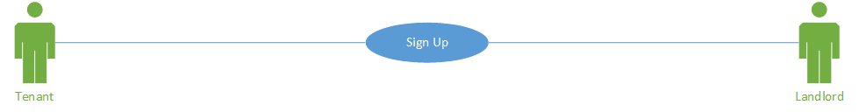

## Sign Up

|  |  |
| --- | --- |
| Use Case Name | Sign Up |
| Description | The user registers for the web service as either a tenant or landlord |
| Actors | Tenant or Landlord |
| Basic Course of Events | 1. The user navigates to the sign up area, via button with prompt 2. The user designates whether they are a tenant or landlord 3. The user fills in the form of required information 4. The user is then entered into the system under their information |
| Exceptions Paths | 1. If the user’s email is already registered onto the system, they will be informed that the email is already used. 2. If the user’s input does not pass the form’s validation, they will receive appropriate error messages and be prompted to fix their input. |
| Preconditions | None. |
| Postconditions | The user is registered into the system and can now login |

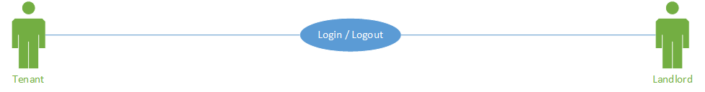

## Login/Logout

|  |  |
| --- | --- |
| Use Case Name | Login/Logout |
| Description | User signs into their account with email and password and can sign out |
| Actors | Tenant or Landlord |
| Basic Course of Events | 1. User clicks login button 2. Enter credentials and sign in 3. User is can then log out at anytime |
| Exceptions Paths | 1.Error message stating they provided incorrect information  2.If windows is closed the session is terminated |
| Preconditions | User must already be registered in the system |
| Postconditions | User signs in and gets a dashboard displaying stats, messages, and other information through the service. |

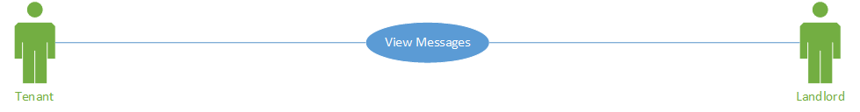

## View Messages

|  |  |
| --- | --- |
| Use Case Name | View Messages |
| Description | Tenants and landlords will have the ability to view messages that have been sent to them through the messaging system. This will display the most recent message on top and show the previous 20 messages. With the option of retrieving older messages by scrolling down. |
| Actors | Users |
| Basic Course of Events | 1. Click the messages button 2. Scroll down to view older messages 3. Click the close button or the exit button to leave. |
| Exceptions Paths | When no older messages are available, display that message. |
| Preconditions | The user has an account, and the user is signed in |
| Postconditions | The user returns to the previous screen. |

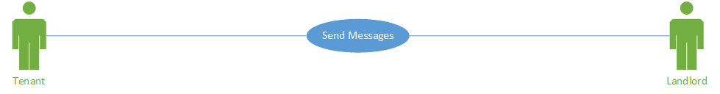

## Send Messages

|  |  |
| --- | --- |
| Use Case Name | Send Messages |
| Description | This will allow tenants and landlords to be able to send messages between them |
| Actors | 1. Landlord 2. Tenant |
| Basic Course of Events | 1. From the message action a prompt will display.   1. The prompt will automatically fill with the landlord’s information if the tenant is using the message system. 2. If the landlord is using the system a drop box of possible tenants will be used to associate the recipient of the message.   2. A blank text box will be displayed for the user to enter their message.  3. A send icon on the screen will allow this message to be sent.  4. To exist the message box a cancel button will be used or a close icon in the top right.   1. If the cancel option is used the message needs to be saved. 2. If the close option is used the draft is discarded   5. After sending the message will be sent through the system (SMS if possible/allowed) |
| Exceptions Paths | If internet connection is lost, an error message will display and the message will close and the draft will be saved as if the messenger was canceled. (message will be saved if connection allows so) |
| Preconditions | User must be signed into the system and be registered under a property to allow landlord-tenant communication |
| Postconditions | The message system will close and validate the message was sent. Return to the screen where the prompt originated. |

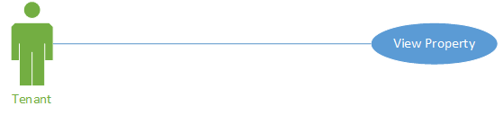

## View Property

|  |  |
| --- | --- |
| Use Case Name | View Property |
| Description | The tenant is able to search for the property and is able to view as much information as is available that the landlord allowed for or the tenant wants to view information about their current property and can switch their dashboard to view the property |
| Actors | Tenant |
| Basic Course of Events | 1. The tenant is able to search the property and view its information OR the landlord sends a unique access key to a property to the tenant 2. The tenant completes the application-lease process and is able to view the property and its information in their dashboard |
| Exceptions Paths | The landlord denies the application or access to view information. |
| Preconditions | Actor must be logged in and have searched for a property. Or the tenant must be leased under a property |
| Postconditions | Information referring to the property is available to the tenant |

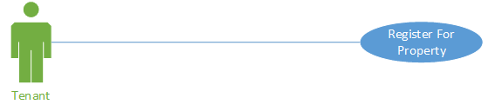

## Register for Property

|  |  |
| --- | --- |
| Use Case Name | Register for Property |
| Description | The tenant either signs the landlord's lease documents in person or over e-sign through the system. After which their profile is associated with that property. |
| Actors | 1. Landlord 2. Tenant |
| Basic Course of Events | 1. If documentation is assigned physical, the landlord manual assigns the property to the tenant. 2. If the documentation is signed virtually, once the paperwork has been sign and submitted the information will automatically be assigned to the tenants profile via system. |
| Exceptions Paths | An error will be thrown if not all the field in the e-sign was not signed,  An override case must be sure if the tenant decides not to sign the paperwork during the lease process, cancelling the process. |
| Preconditions | The potential tenant is signed in, has started the application process, and the down payment for the lease has been made |
| Postconditions | The tenant has completed the lease process and has now leased the property |

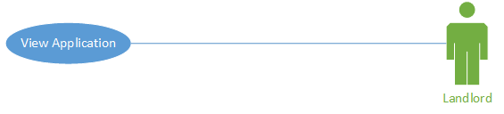

## View Application

|  |  |
| --- | --- |
| Use Case Name | View Application |
| Description | The Landlord receives a notification through the system or email and can view the application through a dashboard for application viewing and decide to accept or decline the possible-tenant’s application |
| Actors | Landlord |
| Basic Course of Events | 1. The landlord is notified through the system or email that they have received an application for a property from a possible tenant 2. The landlord navigates to the notification of the application or to the application area of the dashboard 3. Through the notification or application viewing dashboard, the landlord is able to view the application and pertinent information about the tenant and decide to whether accept or decline the application to want to lease the property. |
| Exceptions Paths | An error can occur if the application does not contain all pertinent information or if it is lost in the system and the application is received |
| Preconditions | The landlord has a property added to their account and is vacant |
| Postconditions | The landlord either declines the application along with information as to why or accepts the application and requests down payment before moving to the lease part of the process |

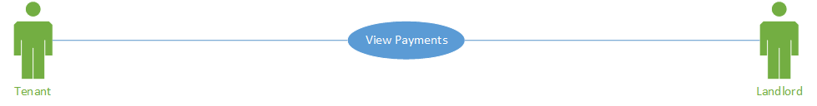

## View Payments

|  |  |
| --- | --- |
| Use Case Name | View Payments |
| Description | Both tenant and landlord can view their payment history |
| Actors | 1. Tenant 2. Landlord |
| Basic Course of Events | 1. Actor goes to their view payments page. 2. Actor can see payment history 3. Actor can see what has not been paid yet |
| Exceptions Paths | If the actor has no payment history and there is no outstanding balance, there will be nothing retrieved by the database and an error message will appear informing them |
| Preconditions | Actor must be logged in and the actor has to have a payment history |
| Postconditions | The actor will have the option to return to the other screen after their data is displayed. |

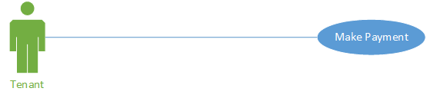

## Make Payment

|  |  |
| --- | --- |
| Use Case Name | Make Payment |
| Description | The tenant can make payments towards a registered property. |
| Actors | Tenant |
| Basic Course of Events | 1. Tenant goes to the payment page from the main dashboard 2. Tenant chooses their payment method and confirms amount to be paid and submits |
| Exceptions Paths | If any payment information is missing, the tenant is informed to fill in the missing information. |
| Preconditions | 1. The tenant is logged in. 2. The actor must be a tenant. 3. The tenant has a property assigned to them. 4. The tenant has an amount due. |
| Postconditions | Tenant’s payment will be sent to the landlord and the tenant will be redirected to their account’s page. |

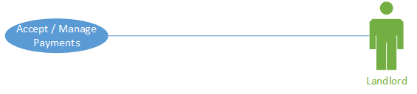

## Accept/Manage Payments

|  |  |
| --- | --- |
| Use Case Name | Accept/Manage Payments |
| Description | The main view will show the location assigned to the respective landlord or tenant with a green, yellow, or red box around an image of the properties that their profile is assigned. The box color will indicate whether a payment is upcoming, paid, late, or if the property is vacant. The landlord will be able to change the payment which is shown due in the system manual and set a new date if needed. Accept payment/validation, as well as view that tenant's payment history. |
| Actors | Landlord |
| Basic Course of Events | 1. On the main page, a display of the properties can be seen of each property with a green, yellow, or red box around them.    1. Green box will indicate that the payment has been made and the tenant is in good standing.    2. A yellow box will indicate that the payment will be due in 5 days.    3. A red box will indicate the payment is late. Box color will only change back to green until the landlord has validated payment in this case. 2. On top of the property image an icon to validate that payment has made. View payment history of that tenant. And manual change the payment schedule and amount due. |
| Exceptions Paths | If payment funds is not sufficient, a message will occur.  If the property is no longer assigned to that user only the history icon will be displayed and the image will be grayed out.  If the property is currently not being leased the image will also appear as grayed version. |
| Preconditions | The user is signed in, the user is assigned to a property and a payment plan has been established between the landlord and tenant |
| Postconditions | The landlord keeps up with the validation of payment or additional/less fees are added onto the payments |

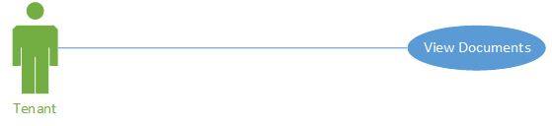

## View Documents

|  |  |
| --- | --- |
| Use Case Name | View Documents |
| Description | During the application process the tenant is given documents such as the lease to sign and other pertinent documents to view/sign. Under the lease, the tenant can view all documents signed/important for their respective property |
| Actors | Tenant |
| Basic Course of Events | 1. After having sent an application and made the down payment on a property, the tenant can receive and sign/view documents for the property from the landlord. 2. When under the lease for a property, the tenant navigates to the document area of the respective property. 3. Then tenant is able to view the documents they have signed for the property and any others that have been provided by the landlord |
| Exceptions Paths | If documents are missing or not available, the tenant and according landlord are informed of the error |
| Preconditions | The tenant is registered and has started the application process and made the initial payment. Or the tenant is leased under a property |
| Postconditions | The tenant is able to view the documents that have been signed or uploaded to the respective property |

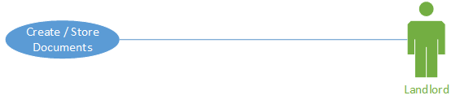

## Create/Store Documents

|  |  |
| --- | --- |
| Use Case Name | Create/Store Documents |
| Description | The landlord will be able to have the option to create their own documents through the system and have them stored to their respective property or just directly upload their own documents to the property. |
| Actors | Landlord |
| Basic Course of Events | 1. Upon logging in, the landlord can navigate to the document area 2. Once there, he can choose to create a document, allowing the landlord to edit the information that will appear on it through the system. 3. When completed, the document can be exported and saved onto the landlord’s device or immediately uploaded to a respective property(ies) 4. If the landlord chooses not to create a document and upload one they already have, they can choose to upload right away and browse and select the document they want for the property(ies) of their choosing |
| Exceptions Paths | If the document created is not complete, a message will appear informing the landlord to complete the document.  If a document is selected to be uploaded, a message will appear informing the landlord to select one to upload.  If a property(ies) is not selected to have a document uploaded to it, a message will appear to inform the landlord to select a property(ies) |
| Preconditions | Landlord is signed in and has a property added to their account |
| Postconditions | Documents are now associated to the property such as the lease document or pertaining information |

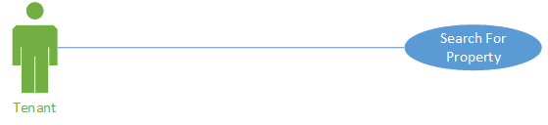

## Search for Property

|  |  |
| --- | --- |
| Use Case Name | Search Property |
| Description | The option to view other properties registered to the landlords will be available. This will allow the tenants to make queries about potential renting opportunities. The information visible will be limited to the description of the landlord. The minimal information must be displayed such as zip code, and bed/bath. Further information is provided after messaging the landlord about that property. |
| Actors | Tenant |
| Basic Course of Events | 1. On the tenant webpage the select browse properties. 2. On this new webpage they have to enter a zip code and a drop down manual distance selection that must display starting at 25 miles from zip code, or other search terms to filter which properties to view    1. Each result will display the information the landlord allows.    2. Each result will have a message landlord icon on it to request further information about that property. |
| Exceptions Paths | If no locations are found with the search area or the search prerequisites, a message will display so |
| Preconditions | User must be logged in and be a tenant |
| Postconditions | The relevant information for the respective property will be displayed to the user |

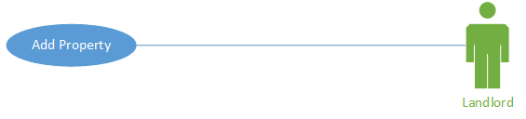

## Add Property

|  |  |
| --- | --- |
| Use Case Name | Add Property |
| Description | The landlord adds property to his home screen so that it can be managed and viewed; this can also involve bulk import of properties and information |
| Actors | Landlord |
| Basic Course of Events | 1. Landlord clicks add property from the main page 2. Fills in all the information and details about the property 3. Can add additional properties to be uploaded at once, allowing for bulk imports. The relevant information for additional properties needs to be filled out as well 4. Validates information is correct and submits |
| Exceptions Paths | If all fields are not filled in properly the landlord will not be able to proceed and a message will appear informing user to fill in the necessary property information |
| Preconditions | Landlord must be signed in as a landlord |
| Postconditions | Message displaying the information has been submitted bringing them into the property view |

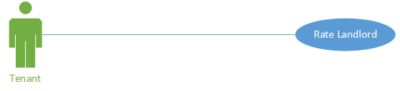

## Rate the Landlord

|  |  |
| --- | --- |
| Use Case Name | Rate Landlord |
| Description | Every 30 days the tenant will score the landlord anonymously from 1 to 5 based on how well they are doing |
| Actors | Tenant |
| Basic Course of Events | 1. Tenant, under viewing property, clicks on the landlord’s name/title to view 2. Tenant clicks the rate button on the landlord information view 3. Clicks the value they feel represents the landlord's performance 4. Clicks submit |
| Exceptions Paths | Tenant can vote only once within a 1 month time period, after which the rating can be changed or deleted by tenant  If rating is not selected and submit is clicked, an error message will appear |
| Preconditions | Tenant must be attached to a property that they are renting |
| Postconditions | Landlord score will be ranked up or down |

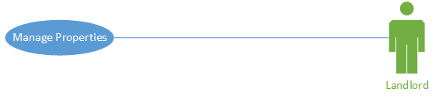

## Manage Properties

|  |  |
| --- | --- |
| Use Case Name | Manage Properties |
| Description | The manage properties will be a button on the landlord post- logon screen. This button will navigate the landlord to a new page that will allow the landlord to individual access their properties. On this page the landlords will be able to change the information in the rental property biography, what is visible publicly and when a link is sent. Additional this locations need to save the rental rate for the rental. And sale receipt for cost associated with property maintenances, to determine net profitability of the property.  This page should also be built to handle the add-on of building maintenances during future revisions. |
| Actors | landlord |
| Basic Course of Events | 1. Landlord sets manage property and navigates to a new page 2. The landlord can then select from the rentals he is associated with. 3. This page will allow the landlord to:    1. Add a picture of the property       1. Select one as property image    2. Add/edit house biography    3. Enter the rental amount    4. Enter expenses with the rental       1. Add a note with amount       2. This will be closed and a new record will start for each fiscal year.    5. Basic rental information (number of bed and bathrooms) 4. Allow for future adaptation of additional of a maintenances modular to the program. |
| Exceptions Paths | Fiscal year must be set when the property is established and can’t change. |
| Preconditions | The landlord is logged in and the landlord has properties associated with them. |
| Postconditions | If data is altered it is saved to the operate property. |

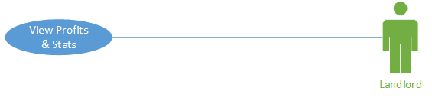

## View Profits and Stats

|  |  |
| --- | --- |
| Use Case Name | View Profits & Statistics |
| Description | Based on how much rent the landlord has collected and how much debt he has invested into the property a bar chart or other graphs will be displayed showing his net profit. Other information will be shown such as property vacancies and non-vacancies over time, late fees over time, maintenance fees and payments over time |
| Actors | Landlord |
| Basic Course of Events | 1. Landlord clicks on view stats chart from the main dashboard 2. Full display loss and gains is displayed graphically to the landlord 3. The landlord can change which information is displayed by switching option from a drop down menu and changing which stats is viewable. 4. Below the graphs, text data will be present such as averages, minimums, maximums, etc. |
| Exceptions Paths | User is not a landlord or if so has no information input.  If option selected has no data, a message will appear informing so. |
| Preconditions | Landlord must be signed in, have a net profit overtime or be leasing properties to tenants for data to be collected by the system |
| Postconditions | Visual representation of data is displayed along with text below graphs |

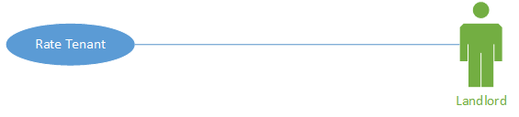

## Rate Tenant

|  |  |
| --- | --- |
| Use Case Name | Rate Tenant |
| Description | Every 30 days the landlord will score the tenant anonymously from 1 to 5 based on payments and how they abide by the lease agreement |
| Actors | Landlord |
| Basic Course of Events | 1. Landlord clicks the rate button 2. Clicks the value they feel of the tenants performance 3. Clicks submit |
| Exceptions Paths | Landlord can vote only once within a 1 month time period |
| Preconditions | Landlord must have a tenant signed up as a User |
| Postconditions | Tenant score is ranked up or down |

# **Non-Functional Requirements**

* Password must be between 8 and 40 characters
* Emails will be 254 characters long
* Simple, easy-to-access appearance
* Documents will be in pdf form through the system
* Privacy and security over properties and information
* Support Internet Explorer, Firefox, Safari and Chrome
* Accessible from a mobile device and or desktop PC
* Usability, and reusability
* Style/Elegance in design