1. 实验目的：学习UNIX的常见概念和操作命令。理解Linux的启动配置文件。

2. 实验目标：参考实验书1，完成2、3、4、5、6章的阅读，将讲解的命令实际试验一下，并思考一下每章后面的练习题。命令里，特别注意的是man命令，它可以告诉你如何“自学成材”。

自己的扩展目标： 自己编程实现某个感兴趣的命令的功能。

可供参考的内容：（1）可编制程序，实现硬链接、软链接的创建。

（2）可编制程序，尝试读或写一些Proc、设备等特殊文件。

3. 实验原理：

A command-line interface (CLI) is an operating system shell that uses alphanumeric characters typed on a keyboard to provide instructions and data to the operating system, interactively.

For example, a teletypewriter can send codes representing keystrokes to a command interpreter program running on the computer; the command interpreter parses the sequence of keystrokes and responds with an error message if it cannot recognize the sequence of characters, or it may carry out some other program action such as loading an application program, listing files, logging in a user and many others.

Operating systems such as UNIX have a large variety of shell programs with different commands, syntax and capabilities.

4. 实验方案：

ps Report process status

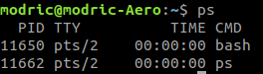

man Display system documentation

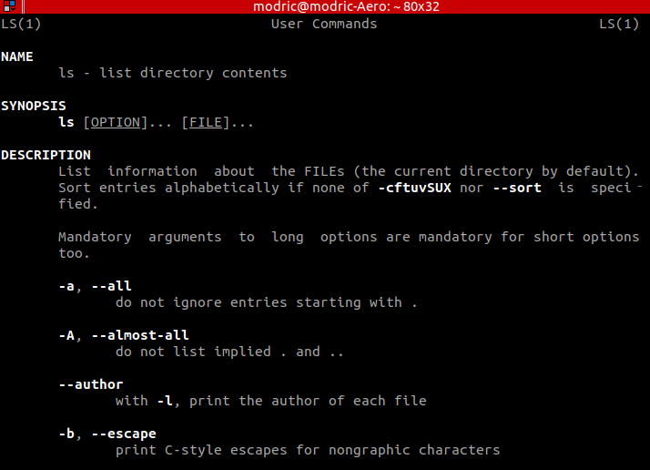

ls List directory contents

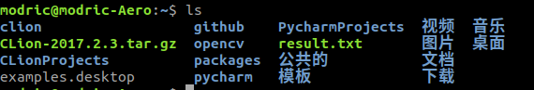

hostname show or set the system's host name



mkdir make directories



ln make links between files

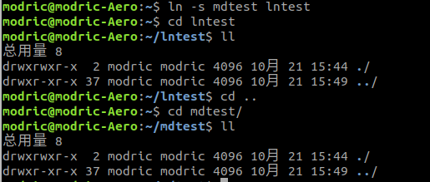

pipeline start the processes and arranges for the necessary connections between their standard streams

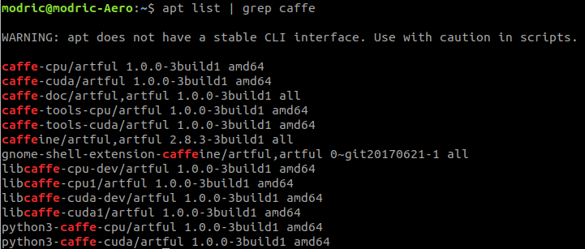

5. 实验结论：将自己的实验结果数据总结并分析一下，最好能与“实验原理”部分结合起来。

Chapter 2

1. It is a strategy meant to discourage unauthorized people from guessing names and passwords to gain access to the system.

3. No. This password is too short and usually it is a name for pets.

Chapter 3

1. who am i

2. mesg y, because by default, messages to your screen are blocked, so that you will not be able to response to others.

11. head -1 status.report; tail status.report

Chapter 4

1. absolute path name: c,d; relative path name: a,b,e; simple filename: f

2. a: cd /home

b: pwd

Chapter 5

2. sort list | lpr

4. a: ls section\*

b: ls section[1-3]

c: ls intro

d: ls section[13] ref[13a]

Chapter 6

1. i; esc

4. Exchange the current character and the next character