1. 实验目的：学习进程的概念和相关命令，理解多进程的并发和并行，并采用多进程编程实现某些功能。
2. 实验目标：

（1）学习使用与进程相关的命令ps，top，kill，管道命令 | ，more，crontab，然后完成：① 结合ps和kill命令杀死进程；② 使用crontab设置定时命令。

（2）创建一个文件，这个文件即是要写入内容的文件。在父进程中创建一个子进程。在父子进程中分别循环向文件中写入数据，每次循环时需要先给文件加锁，然后写入数据，再将锁释放。结束前关闭文件。

自己的扩展目标：

（1）自己设计一个定时任务，把指定进程的信息追加到指定文件中

（2）可以尝试多个进程（多于两个进程）同时向文件中写内容。同时也可尝试着一个进程写入数据，另一个进程读入数据。

1. 实验原理：介绍一下相关的基本概念，或者基础技术原理

ps (short for "process status") displays the currently-running processes. A related Unix utility named top provides a real-time view of the running processes.

top (table of processes) is a task manager program found in many Unix-like operating systems. It produces an ordered list of running processes selected by user-specified criteria, and updates it periodically. Default ordering is by CPU usage, and only the top CPU consumers are shown. top shows how much processing power and memory are being used, as well as other information about the running processes. Some versions of top allow extensive customization of the display, such as choice of columns or sorting method.

kill is a command that is used in several popular operating systems to send signals to running processes in order to request the termination of the process.

pipeline is a sequence of processes chained together by their standard streams, so that the output of each process (stdout) feeds directly as input (stdin) to the next one.

more is a command to view (but not modify) the contents of a text file one screen at a time. It is available on Unix and Unix-like systems, DOS, OS/2, and Microsoft Windows. Programsm of this sort are called pagers. more is a very basic pager, originally allowing only forward navigation through a file, though newer implementations do allow for limited backward movement.

Cron is a time-based job scheduler in Unix-like computer operating systems. People who set up and maintain software environments use cron to schedule jobs (commands or shell scripts) to run periodically at fixed times, dates, or intervals. It typically automates system maintenance or administration—though its general-purpose nature makes it useful for things like downloading files from the Internet and downloading email at regular intervals.

1. 实验方案：自己是如何根据“实验目标”设计实验过程的，定出自己的具体实验过程。

1）学习使用与进程相关的命令ps，top，kill，管道命令 | ，more，crontab

ps

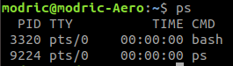

top

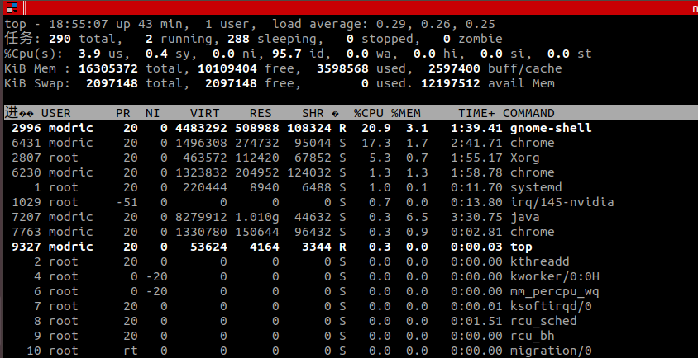

more

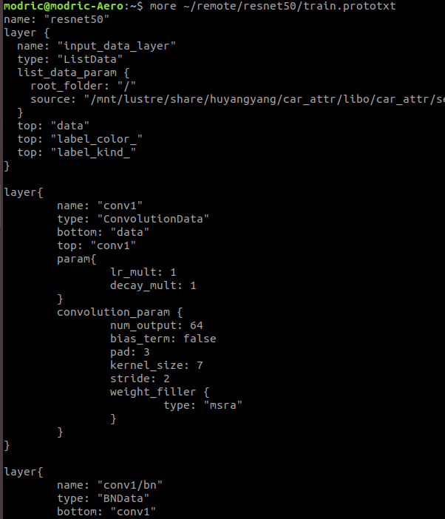

crontab

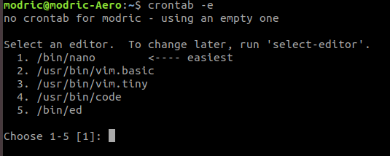

① 结合ps和kill命令杀死进程

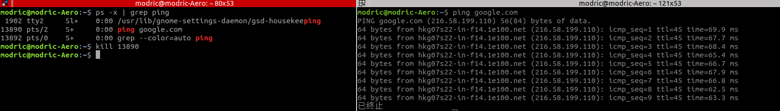

右边终端先建立一个ping进程，然后左边终端利用ps和 | 找到ping进程的pid，使用kill终止，发现右边的ping确实被终止了。

② 使用crontab设置定时命令

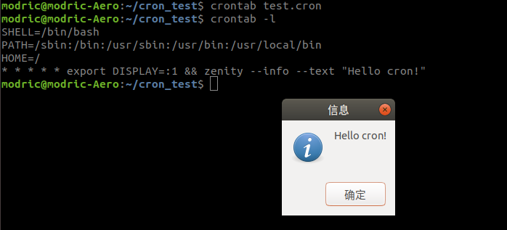

使用crontab建立一个每分钟弹出“Hello cron”对话框的定时任务（调用zenity命令）。1分钟后，确实弹出来了一个对话框。定时设置成功。

（2）创建一个文件，这个文件即是要写入内容的文件。在父进程中创建一个子进程。在父子进程中分别循环向文件中写入数据，每次循环时需要先给文件加锁，然后写入数据，再将锁释放。结束前关闭文件。

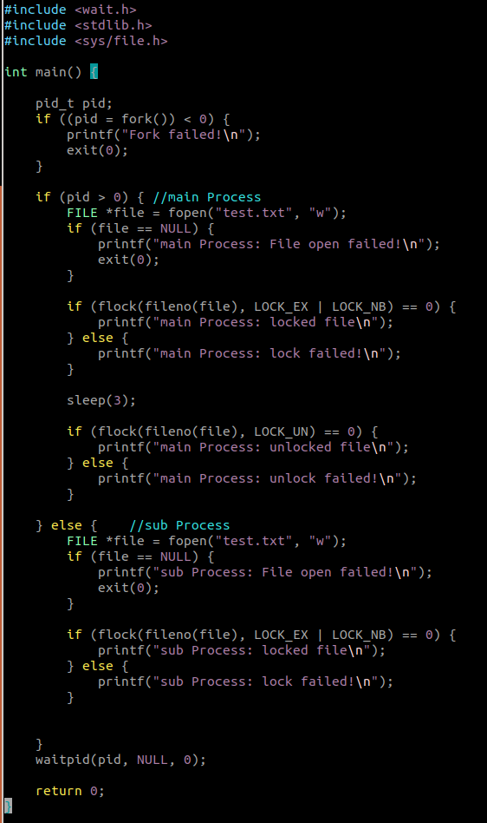

先使用这一段代码测试文件锁LOCK_EX的有效性。发现确实可以起到互斥锁的效果。

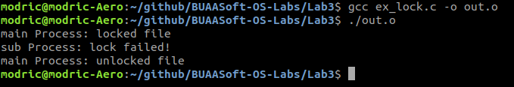

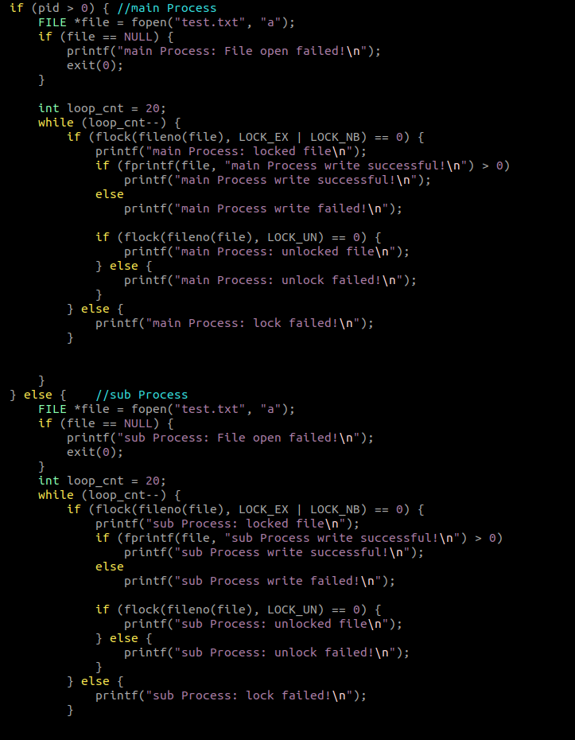

随后测试双线程抢占式写入。两个线程各写入20次，写入时加互斥锁，写入后立刻释放。

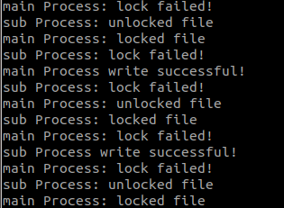

选取log的一部分，发现确实出现了抢占资源的情况，有些内容写入失败了。

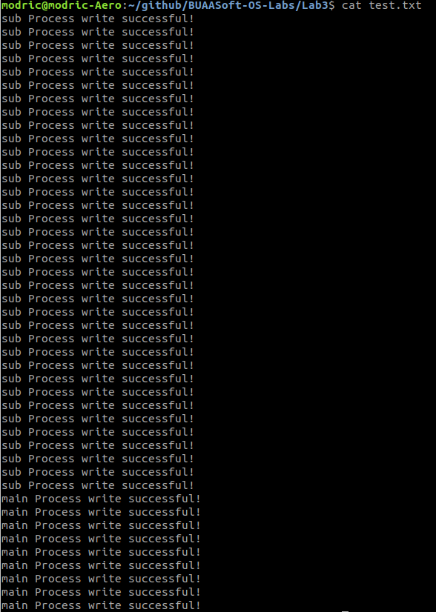

查看输出的内容，发现输出总数不到40，有些写入失败了。

1. 实验结论：

Linux拥有简单清晰的进程管理系统，用户可以直接知道进程的ID，并根据PID来查看进程的各种信息，以此来管理进程。针对多进程对统一资源的IO冲突问题，需要使用各类的锁来解决。