Quick start guide single-cell analysis ImageJ plugin

Installation of ImageJ and plugin 2

Image analysis of raw data 4

Pre-processing 4

Post-processing 7

Measurement data 11

Exemplary data sets 11

Troubleshooting 11

### Version 1.1 (2014-02-03)

* Updated *Import Sequence* screenshot: removed explicit conversion to 8-bit from pre-processing section since version 0.3.0 of the plugin is also able to process 16-bit images
* Included possibility to trigger manual chamber selection by having a ROI active before starting the Master Plugin
* Incorporated delete macro in post-processing section
* Fixed some typos

### Version 1.0 (2013-09-13)

* Initial version of this document written by Christopher Probst

# Installation of ImageJ and plugin

* Download current version of FIJI

<http://jenkins.imagej.net/job/Stable-Fiji/lastSuccessfulBuild/artifact/fiji-win64.zip>

* Unzip file
* Lunch fiji-win64.exe
* Add repository of the plugin to the ImageJ Updater as following:

|  |
| --- |
|  |
| ImageJ Updater window |

* Go to *Help->Update Fiji* and wait till the ImageJ Updater windows opens.
* Press the button “*Manager update sites*”

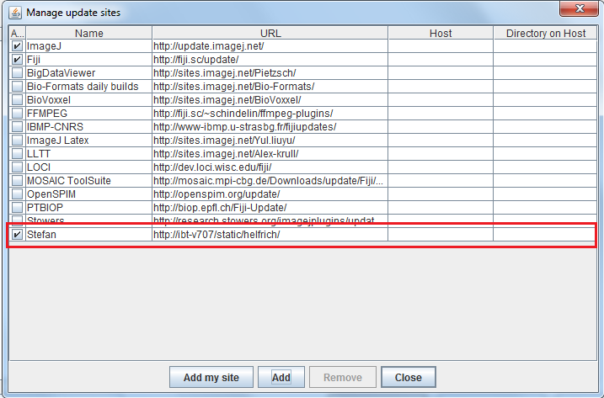

* Add the URL “http://ibt-v707/static/helfrich/“ to the update sites using *Add*
* Press Close afterwards and Fiji will install the plugin

# Image analysis of raw data

## Pre-processing

* Export selected ND file as tif image series

|  |  |  |
| --- | --- | --- |
|  |  |  |
| Export ND times series in NIS Elements |  | Select a folder for exporting the tif images |

* Lunch Fiji if not done so already
* Import tif image series *File->Import->Image Sequence*

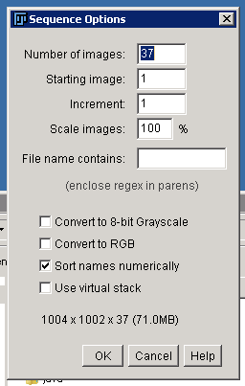

* Lunch single-cell analysis plugin *Plugins->MASTER PLUGIN*
* Select following options before running tool

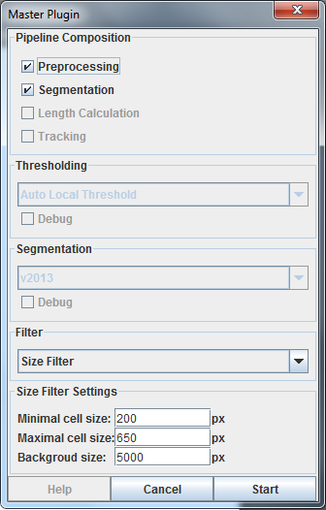

* The tool is trying to automatically detect the cultivation chamber, if it couldn’t be detected you have to select it manually when you are asked to do so (see screenshot). However, you can also force a manual selection by creating a rectangular region of interest as described below before you start the *Master Plugin*.

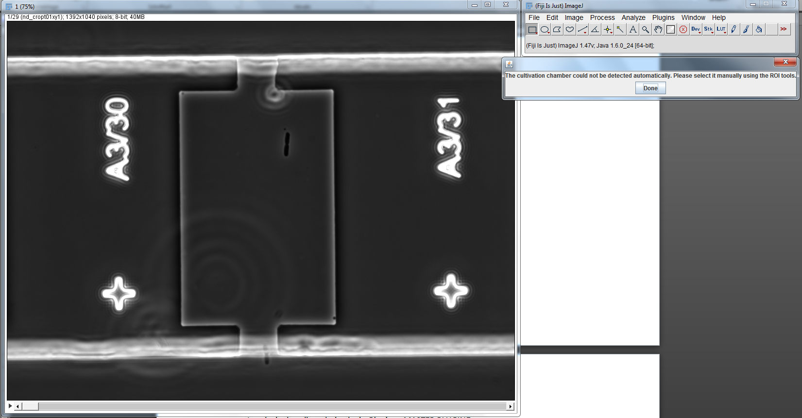

* Use the rectangular selection tool.

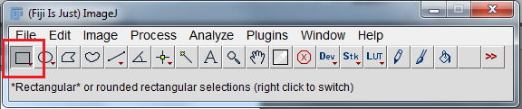

* To select the cultivation chamber as such:

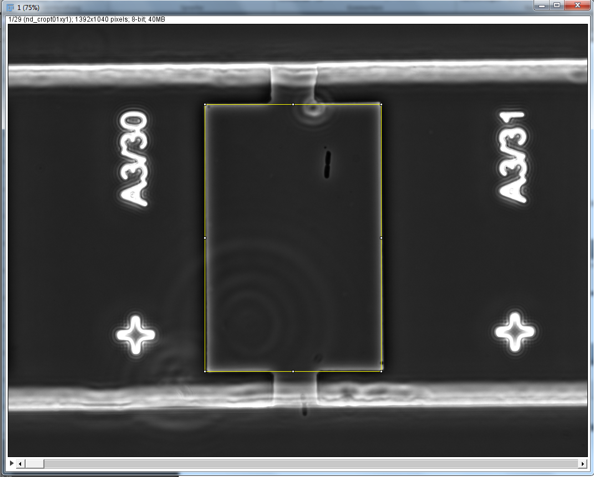

* Afterwards click done and the plugin is going to detect and analysis the single cells in the frames

## Post-processing

After a couple of seconds the tool has detected various objects, not always cells, in each of the given frames. The detected objects are highlighted by yellowish curves and are listed in the *ROI (region of interest) Manager*. Furthermore, the number of cells and overall size of each frame is shown in the *General Results* windows.

|  |  |  |
| --- | --- | --- |
|  |  |  |
| Imported images series |  | ROI Manager and General Results windows |

Go through each of the frames and check if:

* only cells are detected and no other objects

|  |  |  |
| --- | --- | --- |
|  |  |  |
| Wrong detected object |  | Delete wrongly detected object via user interface. Alternatively use shortcut ***d***. |

* that the cell was recognized entirely

|  |  |  |
| --- | --- | --- |
|  |  |  |
| Cell was detected entirely, yellowish curve surround it completely. |  | Cell was not detected entirely, yellowish curve doesn’t surrounds it completely. |

Use the *Selection Brush Tool* for altering the ROI, use the shortcut *shift + left mouse click* to enlarge the ROI to fit the entire cell shape. Merge ROI by pressing ***m***on the keyboard.

By double clicking on the *Selection Brush Tool* let you change the size of the brush in pixels.

|  |  |  |
| --- | --- | --- |
|  |  |  |
| Selection of brush tool for manual alteration of ROI area |  | After altering the ROI area with the brush tool press m to make the change permanent |

* cells were separated correctly:

Use again the *Selection Brush Tool* and the key combination *control + left mouse* click to split the ROI in two separate ones. Split ROIs by pressing ***s***on the keyboard*.*

|  |  |  |
| --- | --- | --- |
|  |  |  |
| Not proper separated cells |  | Separated ROIs using the *Selection Brush Tool.* Press s on the keyboard to make the change permanent. |

|  |  |  |
| --- | --- | --- |
|  |  |  |
| Cell was wrogly seperated in two |  | By selecting both ROIs in the ROI Manger both can be rejoined by pressing m on the keyboard |

* Select both ROIs in the ROI Manager and press ***m*** to merge them

# Measurement data

Save analysed images and ROIs first

* Save the tif image series as zip file using *File->Save as->ZIP…*
* Select all ROIs in the ROI Manger using the key combination *ctrl + a* and save them *More -> Save …*

Measure ROIs and export results

* Click on  to create a new *General Results* table.
* Save data using *File->Save as …*

# Exemplary data sets

You can find exemplary data sets containing pre-processed and segmented image series of *Corynebacterium glutamicum* and *Escherichia coli* here:

# Troubleshooting

Please report any issues regarding the plugin here: <http://ibtmodsimhub/trac/ij-plugin/>

You can use you Windows user and password to log in and issue a new ticket. Please describe your problem as detailed as possible while keeping the title short and concise.