Open Mission Systems (OMS)
Definition And Documentation (D&D)
Critical Abstraction Layer (CAL) Specification

22 January 2026
Prepared By:
Open Architecture Collaborative Working Group (OACWG)

This page is intentionally left blank.

Abstract
Open Mission Systems (OMS) is a non-proprietary, open architecture standard for integrating subsystems and services into mission packages.
This document defines the required attributes and behaviors for implementations of the Open Mission Systems (OMS) Critical Abstraction Layer (CAL) Application Programming Interface (API). A provider of an OMS Platform is responsible for delivering a CAL Implementation for each programming language with a defined CAL API. The required attributes and behaviors defined by this document provide commonality between disparate CAL Implementations, regardless of the messaging technology stack selected by the implementer. This document makes no restriction on the tools, libraries, or products that may be used to meet the requirements and fully implement the CAL API.

This page is intentionally left blank.
Revision Record
REVISION | DATE | DESCRIPTION
L | 22 January 2026 | Initial public release

This page is intentionally left blank.

Table of Contents
1 Introduction 1
2 Scope 2
3 References 3
3.1 Related Standards 3
3.2 OMS D&D Documents 3
4 CAL Terms and Definitions 4
4.1 OMS Message 5
4.2 CAL Application Programming Interface (API) 5
4.3 CAL Messages 5
4.4 CAL Client 6
4.5 CAL Implementation 6
4.6 CAL Instance 7
4.7 Network Configuration 7
4.8 Publish and Subscribe 7
4.9 CAL Messages, Readers, Writers, and Factories 7
4.10 Service Identifier 8
4.11 Topics and Connections 8
4.12 Abstract Service Bus 9
5 CAL Requirements 10
5.1 General CAL Requirements 10
5.1.1 Execution Models 10
5.1.2 Error Handling 11
5.1.3 Schemas Compatibility 11
5.2 CAL Interface 12
5.2.1 Integer Type 12
5.2.2 Time Types 13
5.2.3 UUID Type 13
5.3 CAL Initialization 14
5.4 Topics 15
5.5 CAL Messages 16
5.5.1 CAL Message Contents 16
5.5.1.1 Optional Fields 16
5.5.1.2 Required Fields 16
5.5.1.3 Bounded Lists 17
5.5.1.4 Choices 17
5.5.1.5 Sequences 17
5.5.1.6 Enumerations 17
5.5.1.7 Validation 17
5.5.2 CAL Message Construction 18
5.5.2.1 Optional Fields 18
5.5.2.2 Required Fields 18
5.5.2.3 Bounded Lists 19
5.5.2.4 Choices 19
5.5.2.5 Enumeration 19
5.5.3 Message Destruction 19
5.5.4 Accessing Message Values 19
5.5.4.1 Optional Fields 20
5.5.4.2 Required Fields 20
5.5.4.3 Bounded Lists 21
5.5.4.4 Choices 21
5.5.4.5 Sequences 21
5.6 Writers 22
5.7 Readers 23
5.7.1 Callback Interface 24
5.7.2 Polling Interface 25
5.8 CAL QoS Settings 25
5.8.1 Time Based Filter 26
5.8.2 Reliability 26
5.8.3 Expiration 27
5.8.4 Message Buffer 28
5.9 Abstract Service Bus Connection Status 29
6 CAL CERT Verification 34
7 Acronyms and Symbols 35
8 Glossary 36

List of Figures
Figure 1.0-1 CAL API Message Generation Process 1
Figure 4.0-1 CAL Client Stack 4
Figure 4.11-1 CAL and Client Topics 8
Figure 5.9-1 CAL Abstract Service Bus Connection Status State Diagram 31
Figure 5.9-2 CAL Abstract Service Bus Connection Status State Transitions 32

This page is intentionally left blank.

List of Tables
Table 3.1-1 Reference Standards 3
Table 3.2-1 OMS D&D Documents 3
Table 5.8-1 CAL Reliability Definitions 26
Table 5.9-1 CAL Abstract Service Bus Connection Status State Definition 30
Table 5.9-2 CAL Abstract Service Bus Connection Status State Behaviors 33

This page is intentionally left blank.

Introduction
The CAL API is defined by the translation of the OMS Message Schema, an XML Schema Definition (XSD) file, to software message types called CAL Message containers or simply CAL Messages (see Figure 1.0-1, CAL API Message Generation Process). The CAL API provides the means for the creation of these CAL Messages as well as the setting and accessing of their fields. The CAL API also defines the interface through which applications send and receive CAL Messages. This interface decouples the technical implementations from the interface to enable future technology upgrades and provide flexibility that allows Platform, Subsystem, and Service providers to offer innovative and competitive solutions to future problems. This document defines the requirements that ensure the disparate implementations, each developed to solve unique performance requirements, all behave in a common manner. The over-arching goal is that a software application developed and tested against a specific CAL Implementation, can be compiled against any given CAL Implementation and execute properly. The requirements levied in this document provide common CAL behavior and Quality of Service (QoS) attributes available for topics (see Section 4.11, Topics and Connections). Good systems engineering will still be required to ensure that when a software application moves between CAL Implementations the application still meets its functional mission requirements.
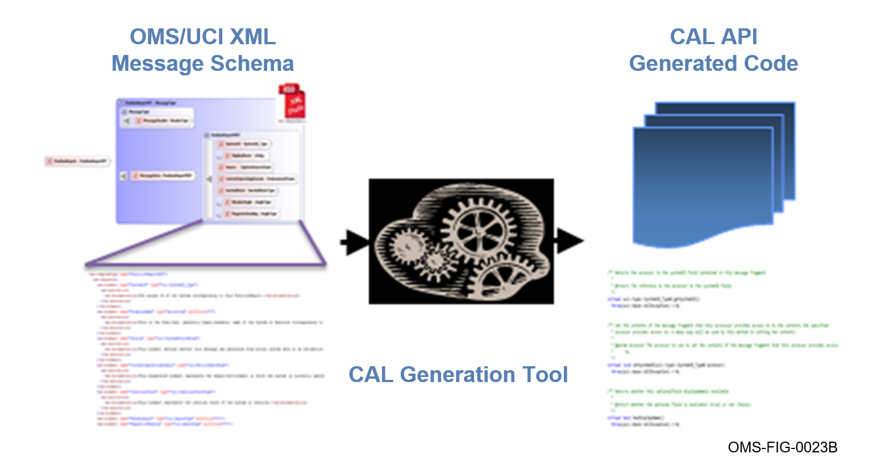
Figure 1.0-1 CAL API Message Generation Process

Scope
In the following sections, the CAL Specification requirements for a compliant OMS CAL Implementation are described and enumerated as certification requirements (CERTs). Guidance and descriptive text have been added to assist the developer in achieving the goals of this specification and to help verification engineers fully understand the intention of the requirements and how they should be tested.

References

Related Standards
The documents listed in Table 3.1-1, Reference Standards, are cited throughout this document. For dated references, only the edition cited applies. For undated references, the latest edition of the referenced document (including any amendments or corrigenda) applies.
Table 3.1-1 Reference Standards
Document Number | Document Title | Revision | Date
IETF RFC 4122 | A Universally Unique IDentifier (UUID) URN Namespace |  | July 2005
N/A | Extensible Markup Language (XML) 1.0 (Fifth Edition) | 1.0 | 26 November 2008
N/A | XML Schema Part 1: Structures Second Edition | 1.0 | 28 October 2004
N/A | XML Schema Part 2: Datatypes Second Edition | 1.0 | 28 October 2004

OMS D&D Documents
The documents listed in Table 3.2-1, OMS D&D Documents, are the documents that assist in the understanding and implementation of OMS.
Table 3.2-1 OMS D&D Documents
Document Number | Document Title | Revision | Date
OMSC-SPC-007 | Java Critical Abstraction Layer (CAL) Interface Generation Specification | K | 22 January 2026
OMSC-SPC-008 | C++ Critical Abstraction Layer (CAL) Interface Generation Specification | K | 22 January 2026
OMSC-STD-001 | OMS Standard Version 2.5 | M | 22 January 2026
OMSC-STD-002 | Abbreviations and Glossary | M | 22 January 2026

CAL Terms and Definitions
The Critical Abstraction Layer (CAL) is an OMS architecture concept and approach supporting the standardized OMS Messaging between the OMS Platform and the OMS Subsystems, Services, and Isolators that are part of an OMS Mission Package. A CAL is realized by a CAL Implementation that supports the CAL Application Programming Interface (API) through which Subsystems, Services, and Isolators interact with the CAL messaging library as shown in Figure 4.0-1, CAL Client Stack. The API includes interfaces to CAL Messages as well as the methods for publishing and receiving those messages. OMS Messaging interactions between OMS participants must use the CAL-provided publish and subscribe interface. CAL Messages provided by the messaging library may be used within services for any purpose desired by the service implementers. CAL APIs are designed to guarantee commonality of the CAL API across CALs for the same OMS version for that language.
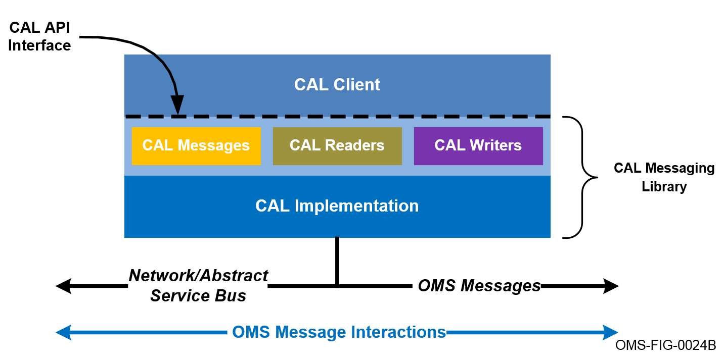
Figure 4.0-1 CAL Client Stack

OMS Message
OMS Messages are primarily command-and-control-oriented exchanges used inside of a Mission Package to coordinate key mission functionality, technical capabilities, and operational behaviors of the interaction between the Architecture Elements (Platforms, Subsystems, Services, and Isolators).
An OMS Message is a unit of information exchanged sent or received using an OMS CAL. The content and structure of OMS Messages are defined using an eXtensible Markup Language (XML) Schema Definition (XSD) specification that conforms to the UCI Schema Style and Design Specification (OAC-SPC-001) message schema. The XSD is translated in accordance with the OMSC-SPC-008, C++ CAL Interface Generation Specification, or OMSC-SPC-007, Java CAL Interface Generation Specification (see Table 3.2-1, OMS D&D Documents) to create the CAL API.

CAL Application Programming Interface (API)
The CAL API is the interface that Subsystems, Services, and Isolators use to access the capabilities supported by a CAL (e.g., the exchanges of OMS Messages). CAL APIs are designed to guarantee commonality of the CAL API across CALs for the same OMS version for that language.

CAL Messages
CAL Messages are representations of OMS Messages (see Section 4.1, OMS Messages) as defined by the CAL API. The CAL and its API provide the means to create, destroy, manipulate, send, and receive CAL Messages. A CAL Implementation (see Section 4.5, CAL Implementation) converts back and forth between OMS Messages and CAL Messages; a process sometimes called de-serialization/serialization. When the message is being manipulated by the CAL API or CAL Client it is an OMS Message. When the message is in its serialized form it is a CAL Message.

CAL Client
A CAL Client (see Figure 4.0-1, CAL Client Stack) exclusively uses the CAL API to create access, set, publish, and receive CAL Messages. Each CAL Client is uniquely identified by an argument passed to the CAL when getting the handle to the CAL instance (see Section 4.6 CAL Instance). Throughout this document the term “CAL Client” is used to indicate the software that is using or invoking the CAL Implementation through the CAL API. One type of CAL Client is an OMS Service; however, CALs may be used by applications that are not fully compliant OMS Services.
CAL Clients are responsible for obtaining access to and initializing an instance of a CAL Implementation (see Section 4.5, CAL Implementation). Under special circumstances, a CAL Client may obtain access to and initialize multiple instances of one or more CAL Implementations. CAL Clients are only allowed to utilize a single instance of a CAL Implementation for a given network configuration. In effect, this means that when a CAL Client chooses to create multiple instances of a CAL Implementation, the set of communication links created for each of those instances will be unique as a whole. This will prevent the scenario of a single CAL Client sending a single message multiple times over essentially the same communications link. Special circumstances for having multiple instances of one or more CAL Implementations might include: a “bridging” application for translating OMS Messages between two different CAL Implementations; or bridging two instances of the same CAL Implementation configured for different networks.

CAL Implementation
A CAL Implementation is a manifestation and fulfillment of the CAL API that adheres to the requirements defined in this CAL Specification. One or more CAL Implementations serve as an integral component of an OMS Platform Abstract Service Bus (ASB) (see Section 4.12, Abstract Service Bus) and are provided by the OMS Platform. A Platform must make available an appropriate CAL Implementation that satisfies the CAL API in all languages with OMS Standard-defined XSD-to-API translations. Currently, only the C++ (specified by OMSC-SPC-008, C++ CAL Interface Generation Specification) and Java (specified by OMSC-SPC-007, Java CAL Interface Generation Specification) languages are supported in OMS. CAL Implementations do not have to be fully implemented in the same language as the interface. For example, a C++ CAL Implementation may satisfy the C++ CAL interface while being partially implemented in C or Java. Developers of Encoders/Decoders in both C++ and Java must be sensitive to the fact that there are unsigned data types in the schema and handle appropriately.

CAL Instance
CAL instance refers to the specific instantiation of a Platform’s CAL Implementation used by a particular CAL Client. Each CAL instance will maintain a unique set of resources related to its network configuration (see Section 4.6, Network Configuration) and the memory management provided to the CAL Client through CAL API factories (note that memory management only applies to C++ CALs).

Network Configuration
The CAL instance is configured at runtime to connect with underlying middleware technologies, network resources, and transport layers. The Network Configuration identifies valid CAL Topics, their associated network connections, and how these network connections are actually implemented across the available network resources. A CAL instance can only have one network configuration, but CAL Clients may create multiple CAL instances that each have distinct network configurations.

Publish and Subscribe
The CAL Implementation presents a publish/subscribe architecture to the CAL Client. A publish/subscribe architecture is a messaging pattern consisting of message publishers and subscribers. A publisher is a client that creates and sends messages. A subscriber is a client that receives messages. A client may be both a publisher and a subscriber. Publishers do not send messages directly to specific subscribers but publish without knowledge of what, if any, subscribers may receive the message. Similarly, subscribers express interest in one or more messages without knowledge of what, if any, publishers may generate those messages. The CAL Implementation may achieve this publish/subscribe architecture through many different approaches, including direct connections between message generators and receivers. The programming model from the CAL Client’s perspective is always publish/subscribe.

CAL Messages, Readers, Writers, and Factories
CAL Implementations consist of several components including CAL Messages, Readers, Writers, and Factories. CAL Readers are entities used by CAL Clients to receive incoming CAL Messages and CAL Writers are entities used by CAL Clients to send CAL Messages. CAL Factories are entities used by CAL Clients to create CAL Readers and CAL Writers. C++ CAL Clients also use Factories to create CAL Messages, while Java CAL Clients use the “new” operator (or an implicit new operation) to create CAL Messages. The behaviors of the CAL and each of these components are defined in Section 5.0, CAL Requirements.

Service Identifier
A Service Identifier is a string name given to a Service that is used to associate it with a globally unique identifier called a Universally Unique Identifier (UUID) (Internet Engineering Task Force (IETF) Request for Comments (RFC) 4122) specific to an instance of that Service on a single specific system. By system, it is meant an element that could be represented as: a vehicle; a node acting as a collection of vehicles; a node on the ground control system; etc. The Service Identifier is a key argument used to initialize a CAL instance by the CAL Client.

Topics and Connections
A Connection is a communication link established between a CAL Reader and a CAL Writer through the Abstract Service Bus (see Section 4.12, Abstract Service Bus). A CAL Topic is a CAL Implementation’s internal identifier for a communications link between CAL Readers and CAL Writers. Multiple Connections may be associated with a single CAL Topic: CAL Writers can have Connections to multiple CAL Readers over a given CAL Topic; and CAL Readers can have Connections to multiple CAL Writers over a given CAL Topic. A Client Topic is the logical topic name used by a CAL Client to identify the communications between CAL Readers and CAL Writers. A CAL Implementation maps internal CAL Topics to Client Topics. Figure 4.11-1, CAL and Client Topics, depicts these interactions.
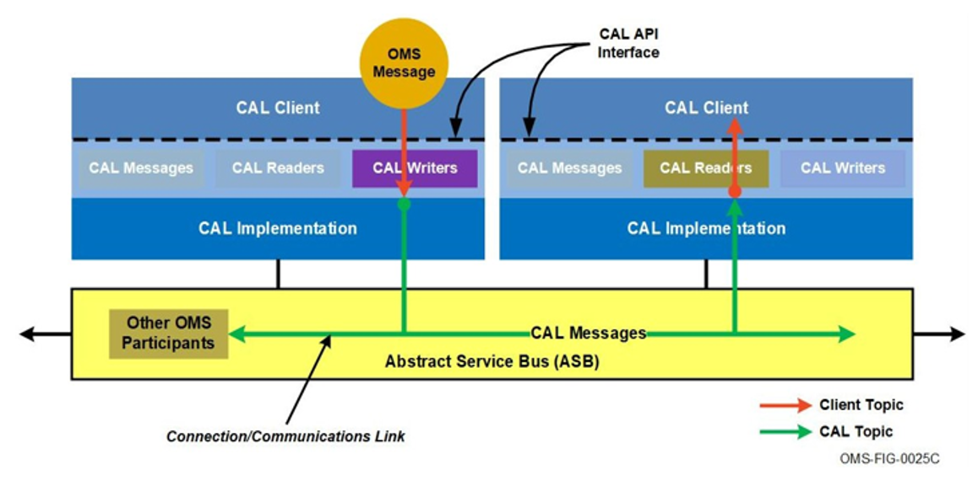
Figure 4.11-1 CAL and Client Topics

Abstract Service Bus
The Abstract Service Bus (ASB) is the collection of resources that at a minimum allow IP based network traffic, in the form of OMS Messages; from one CAL instance to another given that they are of the same CAL Implementation. An ASB may also contain other network traffic that a CAL instance is not aware of. The network related resources of an ASB are defined in part by the aggregation of network configurations (see Section 4.7, Network Configuration) of all active CAL Clients. In general, a CAL Client is completely unaware of how the ASB performs its responsibilities and of the resources it uses.

CAL Requirements

General CAL Requirements
These requirements apply to the CAL Implementation in general. CAL Clients have a general expectation that CAL Implementations have thread-safe readers, writers, and message factories. Those methods that are required to be thread-safe are identified explicitly in the OMSC-SPC-008, C++ CAL Interface Generation Specification, and OMSC-SPC-007, Java CAL Interface Generation Specification. However, thread-safety is not a required attribute across an entire CAL Implementation.
CERT CAL-005179 [A C++ CAL Implementation shall implement the methods defined by the C++ CAL Interface Generation Specification (document OMSC-SPC-008).]
CERT CAL-005180 [A Java CAL Implementation shall implement the methods defined by the Java CAL Interface Generation Specification (document OMSC-SPC-007).]

Execution Models
CAL Clients may operate within various execution models: there may be multiple services within a single address space (e.g., one service per thread/task); only one service in a single address space; or one service distributed across multiple address spaces. CAL Implementations must support the execution model of multiple services within a single address space. The other execution models are considered to be subsets of this model because once multiple services within a single address space are handled; a single service in an address space is well handled. In the case of one OMS Service distributed across multiple address spaces, it is assumed that inter-process communication (IPC) to/from the single CAL instance will be utilized to distribute CAL Messages throughout the service. Any deviation from this assumption of IPC utilization must be coordinated with the CAL provider and may not be fully supported. Note that this implies CAL implementers may assume their CAL will execute within a single address space.
Under certain circumstances, there may be multiple CAL instances within a single address space. As previously discussed, each CAL instance maintains a unique set of resources related to its network configuration and memory management. Each instance of a CAL Client will have one and only one instance of a given CAL Implementation for a network configuration. A CAL Client may act as a “bridge” by translating OMS Messages between two different CAL Implementations, or between two instances of the same CAL Implementation configured for different networks. This means that two instances of the same CAL Implementation within a single service will not communicate with each other over their shared ASB.
CERT CAL-016015 [A CAL Implementation shall provide multiple CAL Clients operating in a single address space with the same behavior as if each CAL Client were executing in separate address spaces.]
Testing criteria for this requirement is to instantiate two services (two CAL Clients) within a single address space and to show that (a) each is provided its own Service UUID and (b) when one service publishes a message and the other subscribes to that same topic, the CAL appropriately provides the message to the receiving service.

Error Handling
A CAL Implementation is responsible for detecting, handling, and reporting error conditions within the CAL Implementation and dependent software components. When an unrecoverable error condition is detected, the CAL Implementation will respond by reporting the error to the CAL Client. The method by which the error is reported is defined in OMSC-SPC-008, C++ CAL Interface Generation Specification, for C++ implementations and OMSC-SPC-007, Java CAL Interface Generation Specification for Java implementations (see Section 3, References, for document details). Certain general error conditions are identified within this CAL Specification and must be handled in accordance with the aforementioned C++ and Java CAL Interface Generation Specifications. The possible error conditions that may be detected and reported by a CAL Implementation are not limited to those defined in this document.

Schemas Compatibility
A CAL Implementation is created against a specific version of the OMS Message Schema. Over time, the OMS Message Schema will be updated and new versions will be released. There may also be cases where extensions are made to the schema in order to support new capabilities or service interactions before the schema modifications are officially adopted in the standard. In both cases there is a change in the OMS Message Schema and the compatibility of CAL Implementations built against different schemas must be addressed.
In the case where changes to the schema are limited to the addition of new OMS Messages and types, it may be possible to generate and build an extended CAL Implementation that need only be used by services requiring the new OMS Messages. OMS Services and OMS Subsystems that do not use the schema additions can continue to use the baseline CAL Implementation. However, there are commonly used middleware solutions that do not support instances of CAL Implementations built against different schemas. In order to not rule out a broad category of middleware solutions, there is no requirement that a CAL Implementation support interoperability between instances built against different message schema versions.
CAL Implementations should gracefully ignore messages they cannot de-serialize. In order to not burden CAL Clients with corrupted data, errors are not generated when bad messages are received. A CAL Implementation may log bad message events or report them as auditable events. A requirement to perform with this specific behavior is not practical because, depending on the technologies used, a CAL Implementation may never see messages itself that it cannot de-serialize in order to drop them or report errors to the CAL Client.
Note: Extending an existing message to include new fields or sub-message types (see Section 5.5.1, CAL Message Contents) creates a unique message type. CAL Implementations are based on the association of one message type to one or many Client Topics (see additional discussion in Section 5.4, Topics). Client Topics may not be associated with more than one message type. Each instance of a CAL Implementation enforces this association for its CAL Clients. However, systems engineering or other enforcement policies are needed to ensure every instance of a CAL Implementation consistently associates the same message types to connected Client Topics.
An OMS Message that was generated with a different schema version than that expected by a CAL Implementation may be rejected. In cases where an extension schema is used, the CAL Implementation may still be able to handle the OMS Message. For instances of a CAL Implementation to be completely compatible they will also be based on the same messaging schema, including any applicable extensions.
A CAL Implementation may be built specifically for a Client, including limiting the scope of the message model provided to the Client. The message model supported by a particular CAL Implementation may be the full schema or a subset of the schema, provided that interoperability when exchanging the common elements of the subset-schemas is maintained. When the CAL Implementation receives a message that falls outside its restricted message model, the implementation will cleanly ignore that message.

CAL Interface
The CAL API is defined by either OMSC-SPC-008, C++ CAL Interface Generation Specification, or OMSC-SPC-007, Java CAL Interface Generation Specification depending on whether the implementation language is C++ or Java respectively. The translation between the OMS Message Schema and the software APIs plus the required behaviors associated with each method can be found in the CAL Interface Specifications. However, some elements of the API are consistent across languages to ensure interoperability between CALs written in different languages. Those elements are documented in this section.

Integer Type
The CAL presents the W3C XML Schema built-in integer datatype as a 64-bit integer in order to provide a performant representation for the CAL Client.
CERT CAL-016024 [A CAL Implementation shall represent the xs:integer built-in datatype as a signed 64-bit integer.]

Time Types
Several W3C XML Schema built-in datatypes are used to represent time. In order to allow for compatibility in resolution and a performant representation for the CAL Client, the CAL API deviates from the W3C definition in its representation of time datatypes. Because of this decision, there are facets allowed by the XSD that are not accessible through the CAL API. CAL Clients may not depend on manipulating those facets for proper execution.
CERT CAL-016027 [A CAL Implementation shall represent the xs:duration built-in datatype as a signed 64-bit integer.]
CERT CAL-016028 [A CAL Implementation shall represent the xs:dateTime built-in datatype as a signed 64-bit integer.]
CERT CAL-016029 [A CAL Implementation shall represent the xs:time built-in datatype as a signed 64-bit integer.]
OMS is choosing to interpret these time types as 64-bit integers to avoid frequent inefficient translations between string and numerical representations of time. In order to support CAL Clients moving between various CAL Implementations, there is a need to have a common definition and precision of the numeric time value represented by the 64-bit integer. Fields of type xs:duration should be interpreted as a number of nanoseconds. Fields of type xs:time should be interpreted as number of nanoseconds since 00:00z of the current day. Fields of type xs:dateTime should be interpreted as nanoseconds since 00:00z of 1/1/1970 (POSIX Epoch). How CAL Clients interpret the time integers is not enforced by the CAL. The CAL itself has no responsibility for enforcing that the CAL Client interpret and set the time values in a consistent manner.

UUID Type
UUIDs are a fundamental structure in OMS. UUIDs are used to identify objects, link messages together, and allow for Service and Subsystem tasking among other uses. Having well formed UUIDs is critical to the success of a Mission Package. The following requirements (CERTs) are levied on CALs to promote consistent behavior and good practices among CAL users.
CERT CAL-016477 [A CAL Implementation shall enforce UUID conformance to RFC 4122.]
CALs are responsible for promoting good UUID usages. CALs should at a minimum check the version and variant bits of UUIDs provided through the CAL API for conformance to RFC 4122. CALs should also make efforts in their configuration mechanism to promote responsible UUID usage.
CERT CAL-016479 [A CAL Implementation shall generate variant 1 (Leach–Salz) UUIDs in accordance with the RFC 4122.]
CERT CAL-005181 [A CAL Implementation shall generate UUIDs in accordance with the RFC 4122, UUID version 1, 3, and 4.]
The CAL will generate UUIDs using RFC 4122. CALs may choose to implement version 1 and/or 4. Version 1 is based on the MAC address of the associated network interface and the current time. If a MAC address is not assigned to the associated network interface, MAC addresses will be purchased to ensure collisions do not occur. Version 4 is based on using a pseudorandom number generator that is well seeded and has negligible chance of collision. A cryptographically secure pseudorandom number generator that is properly implemented and seeded is suitable for version 4 generation. Version 3 UUIDs are provided when deterministic time invariant (a priori) UUIDs are needed. Version 3 UUIDs are created by taking the 128 bit MD5 hash of the concatenation of the namespace and name, then setting the version and variant bits by overwriting them. The namespace used in creating a version 3 UUID is itself a UUID. The name should be unique in order to reduce the probability of collisions.

CAL Initialization
A CAL Client will initialize each CAL instance using a Service Identifier (see Section 4.9, Service Identifier) the first time they access each CAL instance through the CAL API. Subsequent calls to retrieve a specific CAL instance from the CAL API will use the same Service Identifier used to access it the first time. The Service Identifiers used to initialize a CAL Implementation will be coordinated between the OMS Service provider and the CAL provider.
Each CAL instance will be successfully initialized prior to the CAL Client invoking any CAL operations (e.g., creating CAL Messages, CAL Readers, or CAL Writers). A given CAL instance is to be initialized by the CAL Client that obtained access to that CAL instance. Each CAL instance should be accessed by one and only one CAL Client.
CERT CAL-005201 [A CAL Implementation shall have a mechanism for the CAL Client to obtain a fully initialized instance of the CAL associated with a Service Identifier.]
A fully initialized CAL instance is ready to provide CAL Messages, CAL Readers, and CAL Writers to the CAL Client. The Service Identifier is a string name that is interpreted within the context of an OMS Platform. See Section 4.10, Service Identifier, for more information on the Service Identifier.
CERT CAL-005202 [A CAL Implementation shall associate a single CAL instance with each unique combination of Service Identifier and ASB Identifier.]
The definition of an instance of a CAL is clarified in Section 4.6, CAL Instance.
Instances of different CAL Implementations will not return the same reference given the same service identifier.
CERT CAL-005203 [A CAL Implementation shall have a mechanism for retrieving the UUIDs that identify the System, Service, Subsystem, Components, and Capabilities associated with the initializing Service.]
CERT CAL-005204 [A CAL Implementation shall report an error to the CAL Client in the event the initialization of the CAL instance fails.]

Topics
In a topic-based publish/subscribe system; messages are published to “topics”. A topic is a distribution mechanism for publishing messages that are to be delivered to one or more subscribers. A topic is associated with one and only one message type. Publishers send instances of a message on the topic and any subscribers on the topic receive those message instances. Note that schema extensions to an existing message type create a new unique message type. Exchanging extended messages over a topic associated with the un-extended base message type results in undefined behavior.
CAL Clients can name their topics as desired. A Client Topic, as described in Section 4.11, Topics and Connections, is a logical identifier for a connection between CAL Reader(s) and CAL Writer(s). Each Client Topic name, message type, and topic specific required Quality of Service (QoS) settings tuple is exposed in the CAL Clients’ Service Contracts. The CAL Implementation defines and names topics for internal use. These internal CAL Topics will be mapped to the applicable Client Topics. QoS Settings are applied to each topic. Only one group of QoS settings can be applied to a topic within a single CAL Client. For example, two readers of a given topic within a CAL Client will apply compatible QoS settings for the topic.
CERT CAL-005208 [A CAL Implementation shall associate a topic with one and only one CAL Message type.]
CERT CAL-005209 [A CAL Implementation shall map Client Topics to the applicable CAL Topics.]
CERT CAL-005210 [A CAL Implementation shall support the configuration of independent Quality of Service settings for each Client Topic.]
Note: In this case, Client Topic includes the Topic name plus its QoS settings. If a single Client (which could be multiple services) needs different QoS settings, then it will need to have multiple Client Topics – one per set of QoS settings. QoS settings are defined in the CAL QoS Settings section.

CAL Messages
CAL Messages are in the CAL Implementation that satisfy the language specific message API described in OMSC-SPC-008, C++ CAL Interface Generation Specification, for C++ implementations and OMSC-SPC-007, Java CAL Interface Generation Specification, for Java implementations. All interactions between CAL Clients and OMS Messages take place via CAL Message containers (also referred to simply as CAL Messages). OMS specifies standard C++ and Java interfaces for CAL Messages in the language-specific CAL Interface Generation Specifications. The CAL interface to the CAL Message containers defines methods for getting and setting message data member values.
Only CAL Message types may be associated with a topic and published by the CAL Client. CAL Sub-message types cannot be sent or received outside of the context of an encapsulating CAL Message.

CAL Message Contents
CAL Messages contain one or more data members. Data members may be categorized as either optional or required. A data member may be a primitive or an encapsulated type. Primitive types are the most basic data types available in a specific language and serve as the building blocks for more complex encapsulated types.
Primitive types cannot be decomposed any further. In the context of OMS, primitive types are defined in the W3C XML Schema 1.0 specification and include built-in XML types like integers, doubles, Booleans, and strings. See Section 5.2, CAL Interface, for OMS-specific interpretations of the simple types. Encapsulated types are constructed using primitive types and other encapsulated types. Encapsulated types also include special data constructs like choices, lists, and enumerations.
A data member of a CAL Message that is a complex type is known as a CAL Sub-message type. Abstract CAL Message types may not be instantiated as CAL Message types or CAL Sub-message types. An Abstract CAL Message type is an OMS Message type defined in the OMS Message Schema with an attribute named “abstract” set to a value of “true”. A non-abstract extension of an abstract type may be instantiated and then represent a parent abstract type.

Optional Fields
An optional field is a data member that is optionally populated. Optional fields are considered to be disabled if the field has not been populated. Optional fields are considered to be enabled when populated.

Required Fields
A required field is a data member that must be populated.

Bounded Lists
A bounded list is a data construct that is a list of elements whose size can be set. The elements may be either primitive or encapsulated types. All elements within the bounded list must be of the same base type, including types derived from the base type. The reason being that many languages could have difficulty maintaining a list with elements of different fundamental size (e.g., a list containing 32-bit integers and 64-bit doubles) or might have difficulty fully copying the contents of an element with different type specializations (a term known as object slicing). A bounded list is considered to be empty when it contains no elements.

Choices
A choice is a data construct that may have one of several data representations. A choice field is considered to be uninitialized when no type has been selected for the current data representation.

Sequences
A sequence is a data construct consisting of one or more primitive or complex types. Each contained type may be categorized as either optional or required. Sequences are also known as structures.

Enumerations
An Enumeration is a data construct consisting of a set of enumerated items. Data members that are defined as enumerations have a value corresponding to one of the enumerated values from the associated enumeration definition.

Validation
CAL Implementations are not responsible for ensuring the validity of CAL Messages either at object creation time or at publication time.

CAL Message Construction
CAL Clients use the mechanisms defined by the CAL API for creating instances of CAL Messages/Sub-messages and populating them. A CAL Implementation is responsible for realizing those mechanism defined by the CAL API. These mechanisms include: the selection between choices; the population of list elements; and the population of data members. As described previously, creation and destruction of CAL Messages and Sub-messages is generally language specific. C++ uses CAL Factories, while Java uses the “new” operation to create CAL Messages and CAL Sub-messages. A CAL Sub-message is the lower level complexType and simpleTypes that are defined and used to build up the definition of CAL Messages. Most of the other constructs for populating a CAL Message/Sub-message are fairly language agnostic. The CAL API defines the mechanism for selecting/activating a specific data member from a choice of data types and likewise there are means defined for enabling and disabling optional data members.
CERT CAL-016033 [A CAL Implementation shall support the creation of non-abstract CAL Messages and Sub-messages.]
CERT CAL-016035 [A CAL Implementation shall prevent the creation of abstract CAL Messages and Sub-messages.]

Optional Fields
Optional fields are considered to be disabled if the field has not been populated. Optional fields are considered to be enabled when populated. When CAL Clients create a CAL Message or Sub-message, all contained optional fields will be placed in a “disabled” state. No guarantee is made of pre-allocation of memory or other resources for optional fields. Developers should check the state of an optional field prior to use to ensure that it is enabled.
CERT CAL-005254 [A CAL Implementation shall create optional fields in a disabled state.]

Required Fields
When CAL Clients create a CAL Message or Sub-message, the memory management approach required of the CAL Implementation is language specific. Refer to OMSC-SPC-008, C++ CAL Interface Generation Specification, for C++ implementations and OMSC-SPC-007, Java CAL Interface Generation Specification, for Java implementations for additional requirements and common behaviors in each language.

Bounded Lists
When CAL Clients create a CAL Message or Sub-message, all contained lists are created in an empty state. No elements exist in the list. No guarantee is made of pre-allocation of memory or other resources for elements within a bounded list.
CERT CAL-005264 [CAL Implementation shall create bounded lists in an empty state.]

Choices
When CAL Clients create a CAL Message or Sub-message, all choices contained therein will be created in an uninitialized state. No guarantee is made of pre-allocation of memory or other resources for choice fields.
CERT CAL-005267 [A CAL Implementation shall create choice fields in an uninitialized state.]

Enumeration
When CAL Clients create a CAL Message or Sub-message, all enumerations contained therein will be created in an uninitialized state.
CERT CAL-016038 [A CAL Implementation shall create enumerations in an uninitialized state.]

Message Destruction
The memory management approach associated with the destruction of CAL Messages and Sub-messages is language specific. Refer to OMSC-SPC-008, C++ CAL Interface Generation Specification, for C++ implementations and OMSC-SPC-007, Java CAL Interface Generation Specification, for Java implementations for additional requirements and common behaviors in each language.
CERT CAL-005275 [A CAL Implementation shall have a mechanism for destroying CAL Messages and Sub-messages.]

Accessing Message Values
CAL Messages provide a mechanism for accessing field values. The specific mechanism varies between programming languages. Refer to OMSC-SPC-008, C++ CAL Interface Generation Specification, for C++ implementations and OMSC-SPC-007, Java CAL Interface Generation Specification, for Java implementations.

Optional Fields
During the creation of CAL Messages, optional fields are created in a disabled state. No initial value for the field is set. Checking a CAL Message for a disabled optional field’s state will return a value of “false”. Optional fields are enabled once a CAL Client sets the optional value. Disabling an optional field is a language-specific operation. See the OMSC-SPC-008, C++ CAL Interface Generation Specification, for C++ implementations and OMSC-SPC-007, Java CAL Interface Generation Specification, for Java implementations referred to in Section 3, References, for details and requirements. Checking a CAL Message for an enabled optional field’s state will return a value of “true”. The standard CAL interface provides a means for Clients to retrieve and set the values of optional fields.
CERT CAL-005290 [A CAL Implementation shall have a mechanism to enable or disable optional fields.]
CERT CAL-005293 [A CAL Implementation shall have a mechanism to determine the enabled or disabled state of an optional field.]
CERT CAL-005294 [A CAL Implementation shall indicate to the CAL Client that a field is disabled when a disabled optional field is accessed.]
CERT CAL-005296 [A CAL Implementation shall provide the value of the field when the value of an enabled optional field is accessed.]

Required Fields
The CAL Client actions on required fields are language specific. See the OMSC-SPC-008, C++ CAL Interface Generation Specification, for C++ implementations and OMSC-SPC-007, Java CAL Interface Generation Specification, for Java implementations referred to in Section 3, References, for details and requirements.

Bounded Lists
CAL Clients can retrieve a reference to a bounded list attribute. The language specific list interface must then be used to access individual elements within the list. All CAL Implementations support a basic set of operations for lists. This includes operations providing the following capabilities:
Retrieve size or current number of elements in list.
Retrieve maximum bound of list as defined in OMS Message Schema.
Retrieve minimum bound of list as defined in OMS Message Schema.
Reserve resources for a specified number of elements, thus modifying current capacity of the list.
Check whether or not list is empty.
Add an element to end of the list.
Remove an element from end of list.
Clear or remove all elements from list.
- Obtain reference to an element at a specified position within the list.
CAL Clients can use references to manipulate the value of the CAL instance’s internal representation of the sub-message via the defined CAL interface. There are language-specific additions to this list that can be found in the OMSC-SPC-008, C++ CAL Interface Generation Specification, for C++ implementations and OMSC-SPC-007, Java CAL Interface Generation Specification, for Java implementations. Memory management associated with the bounded list is also language-specific and is not addressed at this level.

Choices
The CAL Client actions on choices are language-specific. See the OMSC-SPC-008, C++ CAL Interface Generation Specification, for C++ implementations and OMSC-SPC-007, Java CAL Interface Generation Specification, for Java implementations referred to in Section 3, References, for details and requirements.

Sequences
The CAL Client actions on sequences are language specific. See OMSC-SPC-008, C++ CAL Interface Generation Specification, for C++ implementations and OMSC-SPC-007, Java CAL Interface Generation Specification, for Java implementations, for details and requirements.

Writers
CAL Writers are entities used by CAL Clients to send CAL Messages. Each writer instance is associated with one and only one CAL Client Topic. CAL Writers will meet or exceed the quality of service settings specified for the associated topic. CAL Writers can only be associated with Client Topics. CAL Writers will only send CAL Messages.
The CAL Client may only obtain an instance of a CAL Writer from the CAL. The CAL Client is responsible for closing the CAL Writer instance using the standard CAL interface for the writer.
The CAL Implementation for a writer provides an operation for sending CAL Messages. This write operation takes a reference to the CAL Message to be sent. CAL Clients are free to reuse the referenced CAL Message once the write operation returns.
Note that when using certain reliable QoS settings on a Client Topic, the invocation of the write operation may return before all subscribers on the network have received the message. If the History Depth QoS is set relatively small, and additional write invocations take place, messages may be dropped before they can be delivered to the network layer without notification to the CAL Client.
CERT CAL-005364 [A CAL Implementation shall have a mechanism to create Writers associated with a Client Topic.]
CERT CAL-005368 [A CAL Writer Instance shall be associated with one and only one Client Topic.]
CERT CAL-005369 [A CAL Writer Instance shall report an error upon invocation of the write operation when the associated Client Topic is unavailable.]
There are a number of reasons why a CAL Client Topic may not be available. For instance: there may not be a legitimate mapping from Client Topic to a CAL Implementation’s internal CAL Topic (see Section 4.11, Topics and Connections) or the Client Topic may not be traceable to an entry in the CAL Implementation’s network configuration (see Section 4.7, Network Configuration).
CERT CAL-016043 [A CAL Writer Instance shall report an error upon invocation of the write operation when the required resources to complete the operation are not available.]

Readers
CAL Readers are entities used by CAL Clients to receive incoming CAL Messages. Each reader instance is associated with one and only one CAL Client Topic. CAL Readers will meet or exceed the Quality of Service (QoS) settings specified for the associated topic. CAL Readers can only be associated with Client Topics. Note that multiple CAL Readers can be created in association with a single Client Topic. Each CAL Reader will provide unique CAL Message references to a CAL Client, even when the CAL Readers are associated with the same Client Topic. Each CAL Reader will enforce the same QoS settings associated with the Client Topic, but each CAL Reader will perform their own enforcement of the QoS settings. CAL Readers will only receive CAL Messages.
The CAL Client may only obtain an instance of a CAL Reader via the CAL. The CAL Client is responsible for closing the CAL Reader instance using the language-specific CAL interface for the reader.
The CAL Implementation for a reader provides two styles of interfaces for receiving CAL Messages. The first style is a callback interface. CAL Clients register a callback routine that is invoked upon receipt of an instance of the specified CAL Message type. The second style is a polling interface. CAL Clients poll or query the CAL instance for received instances of the specified CAL Message type.
CERT CAL-005374 [A CAL Implementation shall have a mechanism to create Readers associated with a Client Topic.]
CERT CAL-005378 [A CAL Reader Instance shall be associated with one and only one Client Topic.]
CERT CAL-005379 [A CAL Reader Implementation shall provide a callback interface for receiving CAL Messages.]
CERT CAL-005380 [A CAL Reader Implementation shall provide a polling interface for receiving CAL Messages.]

Callback Interface
The CAL Reader Implementation provides an operation for a CAL Client to register instances of the listener. A CAL Client may register more than one listener. Once registered, each listener’s message handler operation will be invoked one time for each received instance of the associated CAL Message type in accordance with the Quality of Service settings associated with the topic. The invocation of the listener’s message handler operation will be from a unit of execution (i.e., thread/process/task) controlled and owned by the CAL Implementation Instance. CAL Clients will assume that the registered listeners could be called either in sequence from a single reader thread or in parallel from independent threads. This is important when determining the throughput of the reader and race-conditions between registered callbacks. The CAL Reader Implementation provides the same CAL Message reference to each registered listener’s message handler operation. The CAL Instance guarantees that the CAL Message reference is good for the CAL Client to use for the duration of the message handler operation.
The CAL Reader Implementation provides an operation for a CAL Client to unregister an instance of the listener class. Once unregistered, the listener’s message handler operation will no longer be invoked for incoming CAL Messages.
CERT CAL-005391[A CAL Reader Implementation shall allow a CAL Client to register zero or more listener instances for receiving incoming CAL Messages.]
CERT CAL-005392 [A CAL Reader Implementation shall provide a CAL Client with a single, shared CAL Message reference by invoking the message handler operation of each registered listener instance one time for each received CAL Message instance.]
CERT CAL-005394 [A CAL Reader Implementation shall establish the topic connection when the Reader is created.]
CERT CAL-016044 [A CAL Reader Implementation shall begin buffering received CAL Messages based on the topic QoS Settings when the topic connection is established.]
CERT CAL-016045 [A CAL Reader Implementation shall remove the CAL Message instance from the receive buffer once the message handler operation of each registered listener instance has been completed.]
CERT CAL-016046 [A CAL Implementation shall make available without modification the CAL Message accessed by the registered listener for the duration of an invoked registered listeners’ message handler operation.]
CERT CAL-005396 [A CAL Implementation shall provide the ability to unregister a listener instance.]

Polling Interface
The polling interface provides the ability for CAL Clients to retrieve CAL Messages. The CAL Reader Implementation provides operations for a CAL Client to read received CAL Messages. These operations execute within the unit of execution used by the CAL Client to invoke the operation.
The read operation accepts a timeout value. The timeout is the duration that the read operation will block until a CAL Message is available. A CAL Reader Implementation is expected to buffer received CAL Messages in accordance with Quality of Service Settings associated with the topic. As each CAL Message is processed, it will be removed from the buffer.
The readNoWait operation does not accept a timeout value. The readNoWait operation will not block or wait until a CAL Message is available.
CERT CAL-016049 [A CAL Reader Instance shall block within the read operation until the specified timeout value has expired, a new CAL Message arrives, or the Reader Instance is closed.]
CERT CAL-016050 [A CAL Reader Implementation shall report an error when the read operation is invoked on a Reader Instance with one or more registered listeners.]
A CAL Client is not allowed to use both the CAL Reader callback and polling mechanisms at the same time as this can create undefined behavior.
CERT CAL-016052 [A CAL Reader Implementation shall remove the CAL Message instance from the receive buffer when the CAL Message is provided to the CAL Client.]
A CAL Message will only be provided to a CAL Client through the invocation of the CAL Reader’s read or readNoWait methods on the first thread/task that arrives. If a second read invocation occurs before the first has completed, the second read will not access the CAL Message provided to the first CAL Client thread/task.

CAL QoS Settings
The CAL Implementation is required to provide a series of Quality of Service settings. These settings are configurable but cannot be modified by the CAL Client during execution. The CAL Implementer is responsible for ensuring the QoS settings are available, and creating the mechanism for configuration.

Time Based Filter
Time Based Filtering can be used by the CAL Client reader instances to indicate a desire to see a select set of values of each instance published under the Client Topic based on a periodic rate. Specifically, the reader can choose to see one change in a nominal minimum separation period. It is reasonable to expect some variability (jitter) in the actual separation period obtained during operation, so the period is only approximate. This filter applies to each reader instance separately. This provides for the case where data can be generated at a much faster rate than the application using the reader would want to accept updates. Additional guidance will be provided in this section in a future release.
CERT CAL-005431 [A CAL Reader Instance shall provide Time Based Filter Quality of Service such that the CAL Reader drops CAL Messages received on a Client Topic within a specified time period since the last CAL Message was accepted on the Client Topic.]

Reliability
Reliability can be requested of CAL Readers and CAL Writers by the CAL Client to indicate one of two levels of reliability: Best Effort and Reliable. When a CAL Client chooses a Reliable setting, the writer instance may block if there is a potential that data may be lost. When the Best Effort setting is chosen, the writer instance will not retransmit missing or dropped data. Additional guidance will be provided in this section in a future release.
The definitions of reliability in Table 5.8-1, CAL Reliability Definitions, are from the CAL perspective and captured here to clarify the text that follows.
Table 5.8-1 CAL Reliability Definitions
Term | Definition
Reliable | The CAL will try to deliver the message after failure, giving best effort. This means the reliable delivery may be built upon best effort and could introduce latency and throughput complications.
Reliability | The CAL will make the effort to ensure that any message sent by the writer will be received by all the subscribers until the expiration time has expired.
Best Effort | The CAL does not guarantee message delivery and will not retransmit missing or dropped data.
Ordering | The CAL will ensure delivery and ordering between each pair of CAL Readers and CAL Writers on a given Client Topic. When a CAL Reader does not receive a message, the CAL Writer of the message will resend the message and the CAL Reader will not delivery any newer messages to the CAL Client until the message is successfully received, or the expiration time has expired.
Connection | See Section 4.11, Topics and Connections.

CERT CAL-005434 [A CAL Implementation shall provide the Reliability Quality of Service such that the CAL Implementation resends CAL Messages on connections to CAL Readers that have not received the CAL Message while the CAL Message remains available for retransmit.]
The availability of a message for retransmit is dictated by the Expiration QoS setting as well as the History Depth QoS Setting in combination with the rate at which the CAL Client invokes the write operation. The responsibility for performing this requirement is specified deliberately as the “CAL Implementation” but may be realized by the CAL Writer or some other delegate.
CERT CAL-016076 [A CAL Implementation shall provide the Reliability Quality of Service such that the CAL Implementation preserves the order of CAL Messages on a connection.]
The responsibility for performing this requirement is specified deliberately as the “CAL Implementation” but may be realized by the CAL Writer or some other delegate.

Expiration
Expiration can be set on a Client Topic to avoid publishing or receiving “expired” messages. The expiration time of the message is computed by adding the “shelf life” identified in the setting for the Client Topic to the timestamp when the message was placed in the Message Buffer. Expired CAL Messages will be removed from the CAL Reader’s buffer.
CERT CAL-005437 [A CAL Implementation shall provide the Expiration Quality of Service such that the CAL Implementation removes expired CAL Messages from the CAL Reader’s buffer.]

Message Buffer
The Message Buffer setting on a Client Topic regulates the maximum number of messages the CAL Implementation will maintain and deliver. The minimum Message Buffer size is 1. A Message Buffer size of 1 indicates that only the most recent message received is provided. A higher Message Buffer level requires the CAL Implementation to store the specified number of unread messages until they have been provided to the CAL Client. A message is considered to be unread until the message handler operations of all registered listeners have completed or the message read operation has completed.
CERT CAL-015746 [A CAL Implementation shall provide the Message Buffer Quality of Service such that the CAL Implementation will buffer a configurable, maximum number of CAL Messages that the CAL Implementation has received but not yet delivered to the CAL Client.]
CERT CAL-005444 [A CAL Implementation shall provide the Message Buffer Quality of Service such that the CAL Implementation will buffer a configurable, maximum number of CAL Messages that the CAL Implementation has received from the CAL Client but not yet delivered to the network connection.]
CERT CAL-005445 [A CAL Implementation shall remove the oldest message in the CAL Writer’s buffer of CAL Messages when the number of CAL Messages exceeds the value configured by the Message Buffer Quality of Service.]
CERT CAL-016079 [A CAL Implementation shall remove the oldest message in the CAL Reader’s buffer of CAL Messages when number of CAL Messages exceeds the value configured by the Message Buffer Quality of Service.]
In the context of CERTs CAL-005445 and CAL-016079 the term “oldest” is intended to be measured by the time that the message was placed in the Message Buffer.

Abstract Service Bus Connection Status
Each CAL instance provides the ability to query the status of the Abstract Service Bus (ASB) connection.
The CAL Connection Status Implementation for the connection status provides two styles of interfaces for determining the status. The first style is a callback interface. CAL Clients register a callback routine that is invoked when the connection status changes. The second style is a polling interface. CAL Clients poll or query the CAL Instance for the current connection status.
The CAL Connection Status Implementation provides an operation for a CAL Client to register instances of the listener. A CAL Client may register more than one listener. Once registered, each listener’s status handler operation will immediately be invoked with the current status and then in the future each time the connection status changes. The invocation of the listener’s status handler operation will be from a unit of execution (i.e., thread/process/task) controlled and owned by the CAL Implementation Instance. CAL Clients will assume that the registered listeners could be called either in sequence from a single thread or in parallel from independent threads.
The CAL Connection Status Implementation provides an operation for a CAL Client to unregister an instance of the listener class. Once unregistered, the listener’s status handler operation will no longer be invoked for changes to the connection status.
The CAL Connection Status Implementation provides operations for a CAL Client to query the current connection status. These operations execute within the unit of execution used by the CAL Client to invoke the operation.
The following applies to the Abstract Service Bus Connection Status:
- The CAL status interface poll and callback will provide the enumeration of the current state and a CAL implementer-defined string
- Upon registering as a state listener, the state change message will be called instantly with the current state
- All other API calls should work as normal regardless of connection state
CERT CAL-016366 [Upon successful completion of a request to register as an Abstract Service Bus Connection Status listener, a CAL Implementation shall call the registered class’ API notification method with the current state of the ASB connection.]
The definitions of the states are provided in Table 5.9-1, CAL Abstract Service Bus Connection Status State Definition.
Table 5.9-1 CAL Abstract Service Bus Connection Status State Definition
State | Definition
INITIALIZING* | CAL is starting up, where initialization has begun but is not complete (e.g., still loading configuration files). Read and write methods will return an error. Blocking reads will behave as normal.
NORMAL | CAL is functioning normally, where all functions can be used. All QoS settings, as applicable, are being met. Read and write methods will behave as normal. Blocking reads will behave as normal.
DEGRADED* | CAL is not functioning normally, where functions can be used but there may be limitations. Not all QoS settings are being satisfied. The CAL can send and receive but QoS settings are not being satisfied. Read and write methods will behave as normal. Blocking reads will behave as normal.
INOPERABLE* | CAL is unusable but may return to an operational state in the future. CAL is unable to send or receive messages and is attempting to recover. Read and write methods will return an error. Blocking reads will behave as normal.
FAILED | CAL is unusable and return to an operational state is not possible. Identical to Inoperable state but recovery is not possible. Read and write methods will return an error. Blocking reads will release thread, returning a UCI exception.
where * indicates an optional state

The allowed states and transitions for the Abstract Service Bus Connection Status are illustrated in Figure 5.9-1, CAL Abstract Service Bus Connection Status State Diagram.
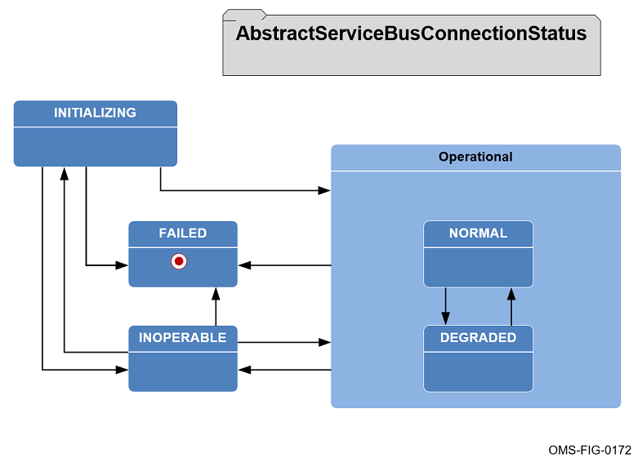
Figure 5.9-1 CAL Abstract Service Bus Connection Status State Diagram
A summary of the state transitions that are allowed and not allowed for the Abstract Service Bus Connection status is provided in Figure 5.9-2, CAL Abstract Service Bus Connection Status State Transitions. Only NORMAL and FAILED states are guaranteed to be provided by the Abstract Service Bus Connection Status API.
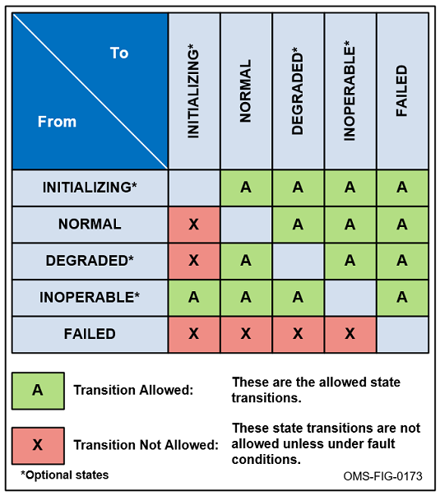
Figure 5.9-2 CAL Abstract Service Bus Connection Status State Transitions
A summary of the state definitions and behaviors of CAL Readers and Writers identified in Table 5.9-1 are shown in Table 5.9-2, CAL Abstract Service Bus Connection Status State Behaviors. The top rows indicate what a new call would return in an existing state. The bottom rows indicate what would happen to existing listeners and blocked reads of CAL Readers when transitioning into a new state.
Table 5.9-2 CAL Abstract Service Bus Connection Status State Behaviors
 | Initializing | Normal | Degraded | Inoperable | Failed
New call in current state
addListener() | OK | OK | OK | OK | E
read() (blocking) | OK | OK | OK | OK | E
readNoWait() | E | OK | OK | E | E
write() | E | OK | OK | E | E
Transition into new state
existing listener | NC | NC | NC | NC | NO/OP
existing blocking read | NC | NC | NC | NC | E
where
OK = Normal processing
E = Exception thrown
NC = No Change
NO/OP = Listener will never be called back

CAL CERT Verification
Verification is normally performed by inspection, analysis, demonstration and/or test. These CERTs are typically verified either by inspection of specific documents, analysis of test results, or demonstration of specific OMS Services or programs that prove that something has been implemented properly.
One of the goals of proving OMS compliance is to leverage existing test plan artifacts and not to generate duplicate testing.

Acronyms and Symbols
For the list of OMS acronyms, refer to the document OMSC-STD-002, Abbreviations and Glossary.

Glossary
For the glossary of terms, refer to the document OMSC-STD-002, Abbreviations and Glossary.

