Open Mission Systems (OMS)
Definition And Documentation (D&D)
Java Critical Abstraction Layer (CAL) Interface Generation Specification

22 January 2026
Prepared By:
Open Architecture Collaborative Working Group (OACWG)

This page is intentionally left blank.

Abstract
Open Mission Systems (OMS) is a non-proprietary, open architecture standard for integrating subsystems and services into mission packages.
This is the top-level OMS Schema to Java interface specification.
Java CAL Implementation requirements will adhere to the general CAL requirements listed in the CAL specification unless otherwise stated. Items listed here will either refine or clarify requirements as they apply to the Java CAL Implementation.
A Java CAL is provided as part of the Open Computing Environment (OCE). The OCE will be capable of running a Long Term Support version of Java, currently recommended as Java Standard Edition 11; therefore, Java CALs should consider an implementation that is capable of running on a Java 11 Java Virtual Machine.

This page is intentionally left blank.
Revision Record
REVISION | DATE | DESCRIPTION
K | 22 January 2026 | Initial public release

This page is intentionally left blank.

Table of Contents
1 Introduction 1
2 Scope 2
3 References 3
3.1 OMS D&D Documents 3
3.2 Other Documents 3
4 Schema to Java Compiler 4
4.1 XML Schema to Java CAL API Binding 4
5 Common Behaviors of the Generated Java CAL API Bindings 10
5.1 Setting & Getting Message Field Values 10
5.2 Required Fields 10
5.3 Optional Fields 11
5.4 List Fields 11
5.5 Choices 11
5.6 Constructors 11
5.7 Customization 11
6 Common Classes and Interfaces 12
6.1 Abstract Service Bus 15
6.2 Abstract Service Bus Factory 17
6.3 Abstract Service Bus Factory Loader 18
6.4 UCIType Interface 19
6.5 Bounded List 19
6.6 Message Listener 20
6.7 Message Reader 21
6.8 Message Writer 23
6.9 UCI Exception 24
6.10 UUID Factory 25
6.11 UUID Factory Loader 27
6.12 Version Info 28
6.13 Externalizer 29
6.14 Externalizer Loader 30
6.15 AbstractServiceBusConnection Status 32
6.15.1 AbstractServiceBusConnectionStatusListener class 32
6.15.2 AbstractServiceBusConnectionStateEnum enumeration 32
6.15.3 AbstractServiceBusConnectionStatusData class 33
7 Java CAL CERT Verification 34
8 Acronyms and Symbols 35
9 Glossary 36

This page is intentionally left blank.

List of Figures
Figure 6.0-1 UML Overview of Common CAL Classes and Interfaces (part 1) 13
Figure 6.0-2 UML Overview of Common CAL Classes and Interfaces (part 2) 14
Figure 6.1-1 UML for AbstractServiceBusConnection Interface 15
Figure 6.2-1 UML for AbstractServiceBusConnectionFactory Interface 17
Figure 6.3-1 UML for AbstractServiceBusConnectionFactoryLoader Class 18
Figure 6.5-1 UML for BoundedList Interface 19
Figure 6.6-1 UML for Message Listener Interface 20
Figure 6.7-1 UML for Message Reader Interface 21
Figure 6.8-1 UML for Message Writer Interface 23
Figure 6.9-1 UML for UCIException Class 24
Figure 6.10-1 UML for UUIDFactory Interface 25
Figure 6.11-1 UML for UUIDFactoryLoader Class 27
Figure 6.12-1 UML for Version Info Class 28
Figure 6.13-1 UML for Externalizer Interface 29
Figure 6.14-1 UML for ExternalizerLoader Class 30

This page is intentionally left blank.

List of Tables
Table 3.1-1 OMS D&D Documents 3
Table 3.2-1 Other Documents 3
Table 4.1-1 Supplementary Method Definitions 5
Table 4.1-2 Datatype Mappings 6
Table 4.1-3 Namespace to Package Mappings 6
Table 4.1-4 ChoiceType Class Definition 8
Table 6.1-1 AbstractServiceBusConnection Interface Definition 15
Table 6.2-1 AbstractServiceBusConnectionFactory Interface Definition 17
Table 6.3-1 AbstractServiceBusConnectionFactoryLoader Final Class Definition 18
Table 6.5-1 BoundedList Interface Definition 20
Table 6.5-2 BoundedList Fields 20
Table 6.6-1 Message Listener Interface Definition 20
Table 6.7-1 Message Reader Interface Definition 22
Table 6.8-1 MessageWriter Interface Definition 23
Table 6.9-1 UCIException Class Definition 25
Table 6.10-1 UUIDFactory Interface Definition 26
Table 6.11-1 UUIDFactoryLoader Final Class Definition 27
Table 6.12-1 Version Info Class Definition 28
Table 6.13-1 Externalizer Interface Definition 30
Table 6.14-1 ExternalizerLoader Final Class Definition 31
Table 6.15-1 AbstractServiceBusConnectionStatusListener Interface Definition 32
Table 6.15-2 AbstractServiceBusConnectionStateEnum Enum Definition 32
Table 6.15-3 AbstractServiceBusConnectionStatusData Class Definition 33

This page is intentionally left blank.

Introduction
This is the top-level OMS Schema to Java interface specification. The Java CAL provides an interface between the Abstract Service Bus and OMS Services, Subsystems, and Isolators. These interfaces use open and standardized non-proprietary interface definitions, but decouple the technical implementations from the interfaces. This OMS Standard enables future technology upgrades; providing flexibility that allows Platform, Subsystem and Service providers to offer innovative and competitive solutions to future problems.
This specification prefixes all schema types defined in the http://www.w3.org/2001/XMLSchema namespace with “xs:”.

Scope
In the following sections, the XML Schema Definition (XSD) to Java interface requirements (CERTs) necessary for OMS compliance are described and enumerated.

References

OMS D&D Documents
Table 3.1-1, OMS D&D Documents, lists the documents that assist in the understanding and implementation of OMS.
Table 3.1-1 OMS D&D Documents
Document Number | Document Title | Revision | Date
OMSC-STD-001 | OMS Standard Version 2.5 | M | 22 January 2026
OMSC-STD-002 | Abbreviations and Glossary | M | 22 January 2026
OMSC-SPC-001 | Critical Abstraction Layer (CAL) Specification | L | 22 January 2026

Other Documents
The documents listed in Table 3.2-1, Other Documents, are cited throughout this document. For dated references, only the edition cited applies. For undated references, the latest edition of the referenced document (including any amendments or corrigenda) applies.
Table 3.2-1 Other Documents
Document Number | Document Title | Revision | Date
JSR-000222 | Java® Architecture for XML Binding (JAXB) 2.3 (Maintenance Release 3) | 2.3 | 19 September 2017
JSR-337 | The Java® Language Specification | 8 | 15 February 2015
N/A | Extensible Markup Language (XML) 1.0 (Fifth Edition) | 1.0 | 26 November 2008
N/A | XML Schema Part 1: Structures Second Edition | 1.0 | 28 October 2004
N/A | XML Schema Part 2: Datatypes Second Edition | 1.0 | 28 October 2004
IETF RFC 4122 | A Universally Unique IDentifier (UUID) URN Namespace |  | July 2005

Schema to Java Compiler
A Schema to Java Compiler (SJC) translates a Universal Command and Control (C2) Interface (UCI) XSD to the Java code that makes up the Java CAL Interface. The necessary publish and subscribe interfaces for sending and receiving the OMS Messages using Java are described. These interfaces are implemented by compliant Java CAL Implementations.

XML Schema to Java CAL API Binding
With the exception of schema choices and some added rules below, the XML Schema is converted to the Java CAL API following the rules set forth in the JSR-000222 Java Architecture for XML Binding (JAXB) specification. SJCs are not required to implement all of the JSR-000222 specification. SJCs are only required to implement the portions called out in this specification using the customizations and addendums given in this specification. There are no requirements to support JAXB annotations or any customizations except those called out in this specification. Additional methods and/or fields may be added to non-interface classes. Interface classes may not contain additional methods or fields other than as is prescribed in this document.
When interpreting the tables in this document, “Modifier and Type” only restricts the access modifier, whether it is static or non-static, and the abstractness or finality of the class, method, or field. The “Method and Description” column of a method contains a description of the method name, parameter types, and exceptions thrown. Checked exceptions other than what are prescribed may not be thrown from these methods. Remarks provided describe the intended implementation behavior of the method.
CERT JAVA-000128 [A Java CAL API shall provide Java classes, enum constants, and methods, as specified in the “Binding XML Schema to Java Representation” section of the JAXB specification, as though only the default customizations are defined with the below addendums.]
CERT JAVA-001460 [A Java CAL API shall provide Java constructs as though the JAXB underscoreBinding global binding parameter is defined as asCharInWord.]
CERT JAVA-001461 [A Java CAL API shall provide enum constants prepended with an underscore when the first character of the xs:enumeration facet value supplied to “java.lang.Character.isJavaIdentifierStart” is false.]
CERT JAVA-001462 [A Java CAL API shall provide the <javaClassName> set<property>(<javaElementClassName>) method for each Optional or Required field.]
CERT JAVA-001463 [A Java CAL API shall provide the methods in the “Supplementary Method Definitions” table for each normal class declaration generated from the schema.]
Table 4.1-1 Supplementary Method Definitions
Applicability | Modifier and Type | Method and Description
The field is Optional | public final <javaClassName> | if<property>Present(java.util.function.Consumer<? super <javaElementClassName>>)  The if<property>Present method calls the supplied Consumer given the has<property> method returns true. No exceptions should be raised when calling this method given the has<property> method returns false.
The field is Required | public final <javaClassName> | with<property>(java.util.function.Consumer<? super <javaElementClassName>>)  The with<property> method calls the supplied Consumer with the underlying value.
The field is a List | public final <javaClassName> | forEach<property>( java.util.function.Consumer<? super <javaElementClassName>>)  The forEach<property> method calls the supplied Consumer with each underlying value.
The field is a List | public final <javaClassName> | add<property>(<javaElementClassName>…)  The add<property> method appends each <javaElementClassName> instance to the backing BoundedList. The parameter type of this method is unboxed when <javaElementClassName> is primitive.
The field is a List | public final <javaClassName> | add<property>(java.lang.Iterable<? extends <javaElementClassName>>)  The add<property> method appends each <javaElementClassName> instance to the backing BoundedList.

Table 4.1-2 Datatype Mappings
XML Schema Datatype | Java Datatype
xs:time | java.time.LocalTime
xs:dateTime | java.time.Instant
xs:duration | java.time.Duration
uci:UniversallyUniqueIdentifierType | java.util.UUID
xs:string | java.lang.String
xs:integer | java.math.BigInteger
xs:int | int
xs:long | long
xs:short | short
xs:decimal | java.math.BigDecimal
xs:float | float
xs:double | double
xs:boolean | boolean
xs:byte | byte
xs:base64Binary | byte[]
xs:hexBinary | byte[]
xs:unsignedInt | long
xs:unsignedShort | int
xs:unsignedByte | short
CERT JAVA-000151 [A Java CAL API shall provide Java types using the datatype mappings specified in the “Datatype Mappings” table.]
Table 4.1-3 Namespace to Package Mappings
XML Namespace | Java Package
https://www.vdl.afrl.af.mil/programs/oam | uci.types
CERT JAVA-000206 [A Java CAL API shall provide Java constructs using the package mappings specified in the “Namespace to Package Mappings” table.]
Appendix D.5 of the JAXB specification is to be replaced with the XML Namespace to Java Package mappings specified in the “Namespace to Package Mappings” Table 4.1-3. Extension schemas must have any new XML Namespaces mapped to a Java package. If the extensions are approved by the OMS board, extension mappings for the new XML Namespace will become part of the OMS standard.
CERT JAVA-000208 [A Java CAL shall provide a 1-to-1 mapping mechanism for XML Namespaces that are not already mapped in the XML Namespace to Java Package mapping table for Java packages during the schema to Java translation.]
The following additions are to be applied to the Java CAL API generation. A normal class declaration is defined in Section 8.1 of the Java Language Specification.
CERT JAVA-000212 [A Java CAL API shall provide a public boolean has<property>() method for each Optional Field where <property> is derived according to appendix D.2 of the JAXB specification.]
CERT JAVA-000213 [A Java CAL API shall provide an overridden public <javaClassName> clone() method for each normal class declaration generated from the schema to perform a deep copy of the object.]
CERT JAVA-000214 [A Java CAL API shall implement the java.lang.Cloneable interface for each normal class declaration generated from the schema.]
CERT JAVA-000216 [A Java CAL API shall provide ChoiceType classes that define the methods in the “ChoiceType Class Definition” table.]
Table 4.1-4 ChoiceType Class Definition
Applicability | Modifier and Type | Method and Description
All choice elements | public final <javaElementClassName> | as<property> ()  The as<property> method returns the choice value set with choose<property>. The return type of this method is unboxed when <javaElementClassName> is primitive. It is a semantic error to invoke this method when is<property> returns false, so a runtime exception is thrown.
All choice elements | public final boolean | is<property>()  The is<property> method returns true when choiceType() equals ChoiceTypeEnum.<property>.
All choice elements | public final <javaClassName> | if< property>(java.util.function.Consumer<? super <javaElementClassName>>)  The if<property> method evaluates a consumer with the choice value when is<property> returns true.  Returns this choice type instance.
Non-List choice elements | public final <javaClassName> | choose<property>(<javaElementClassName>)  The choose<property> method sets the choice value of this instance. The parameter type of this method is boxed when <javaElementClassName> is primitive. Invoking this method with a value of null clears the instance to its uninitialized state.  Returns this choice type.
List choice elements | public final <javaClassName> | choose<property>(<javaElementClassName>…)  The choose<property> method sets the choice values of this instance. The parameter type of this method is unboxed when <javaElementClassName> is primitive. Invoking this method with a value of null clears the instance to its uninitialized state.  Returns this choice type.
List choice elements | public final <javaClassName> | choose<property>(java.lang.Iterable<? extends <javaElementClassName>>)  The choose<property> method sets the choice values of this instance. Invoking this method with a value of null clears the instance to its uninitialized state.  Returns this choice type.
All choice elements | public final <javaClassName>.ChoiceTypeEnum | choiceType()  The choiceType method returns the enumeration value corresponding to the current choice value of this instance set with choose<property>. When this instance contains no choice value this method returns null.  Returns the current choice type enumeration value.
CERT JAVA-000221 [A Java CAL API shall generate the public inner enum “ChoiceTypeEnum” for each ChoiceType with the Constant Names derived according to appendix D.2 of the JAXB specification.]
CERT JAVA-000240 [A Java CAL API shall use the uci.BoundedList type in place of the java.util.List used by JAXB.]
CERT JAVA-001370 [A Java CAL API shall generate a public static final String UCI_TYPE_VERSION field for each normal class declaration generated from the schema to identify the version of the UCI type used to generate the class.]

Common Behaviors of the Generated Java CAL API Bindings
The generated Java CAL API bindings must adhere to the common behaviors described in this section.

Setting & Getting Message Field Values
The Java CAL Implementation relies on references and does not perform deep copies when setting message values.
In Java CAL Implementations, class implementations are used to represent all XSD complex types defined in the schema. XSD simple types are created via the appropriate Java language mechanism.
In Java CAL Implementations, objects are used to represent all types, both primitive and complex. OMS Message Objects are created on the heap. Sub-message objects are not initially constructed. Java CAL Clients will use the “new” operator or an implicit “new” operation (e.g., Integer myInt = 1;) to create sub-message objects before setting them within the larger message object.
To avoid requiring services to catch exceptions while creating OMS Message objects, OMS Message objects and sub-objects should avoid throwing checked exceptions in constructors and member accessor methods.
All method definitions in Table 4.1-1, Supplementary Method Definitions, and Table 4.1-4, ChoiceType Class Definition, on concrete OMS Message Objects need to be marked as final. Since each class that extends another OMS Message Object overrides the setter to return the correct type, setters should only be marked as final on classes with no OMS Message Object extensions.

Required Fields
A Required field is any xs:element whose minOccurs and maxOccurs attributes are equivalent to 1.
When setting a required field, Java Clients provide an object representing the value to be used to set the field. The Java CAL Implementation will use a reference to the provided object until the OMS Message has been sent.

Optional Fields
An Optional field is any xs:element whose minOccurs attribute is 0 and maxOccurs attribute is equivalent to 1.
If the value for an optional field is null, the field is considered to be disabled. If the value is non-null, the field is considered to be enabled. The Java CAL interface will return null to Java Clients attempting to access disabled optional fields.
When setting an optional field, Java Clients provide an object representing the value to be used to set the field. The Java CAL Implementation will use a reference to the provided object until the OMS Message has been sent.
Java CAL Clients may clear an optional field by setting the value to null. Setting the optional field to null will transition the field to a disabled state.

List Fields
A List field is any xs:element whose maxOccurs attribute is greater than 1.

Choices
A choice is a data construct that may have any of several data representations. In the OMS Message Schema, choices are defined using the “xs:choice” tag. A choice field is considered to be uninitialized when no type has been selected for the current data representation.
Java CAL Clients determine the choice value represented by a ChoiceType either the choiceType() method or the applicable is<property>() method. If choiceType() returns null then the ChoiceType contains no value. The as<property>() method may throw a runtime exception if invoked when either is<property> returns false or choiceType() does not equal the corresponding ChoiceTypeEnum.<property>.

Constructors
A public, default, no-argument constructor needs to be provided on each OMS Message Object.

Customization
Provided that all behaviors in this section are preserved, CAL implementations are allowed to do the following:
Add public, private, protected, and package protected methods, fields and classes to any OMS Message Object
Add implementation required imports to OMS Message Object
- Overload or override API prescribed non-static methods

Common Classes and Interfaces
In addition to the classes generated from the schema, the Java CAL provides a common set of classes and interfaces, shown in Figure 6.0-1, Unified Modeling Language (UML) Overview of Common CAL Classes and Interfaces used to construct the CAL and to read and write data to the Abstract Service Bus (ASB).

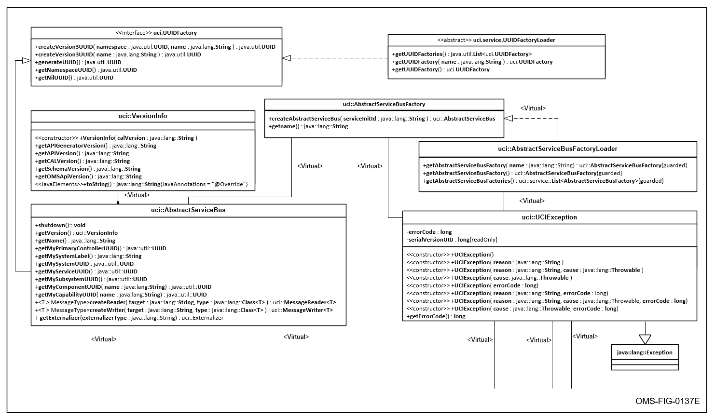
Figure 6.0-1 UML Overview of Common CAL Classes and Interfaces (part 1)
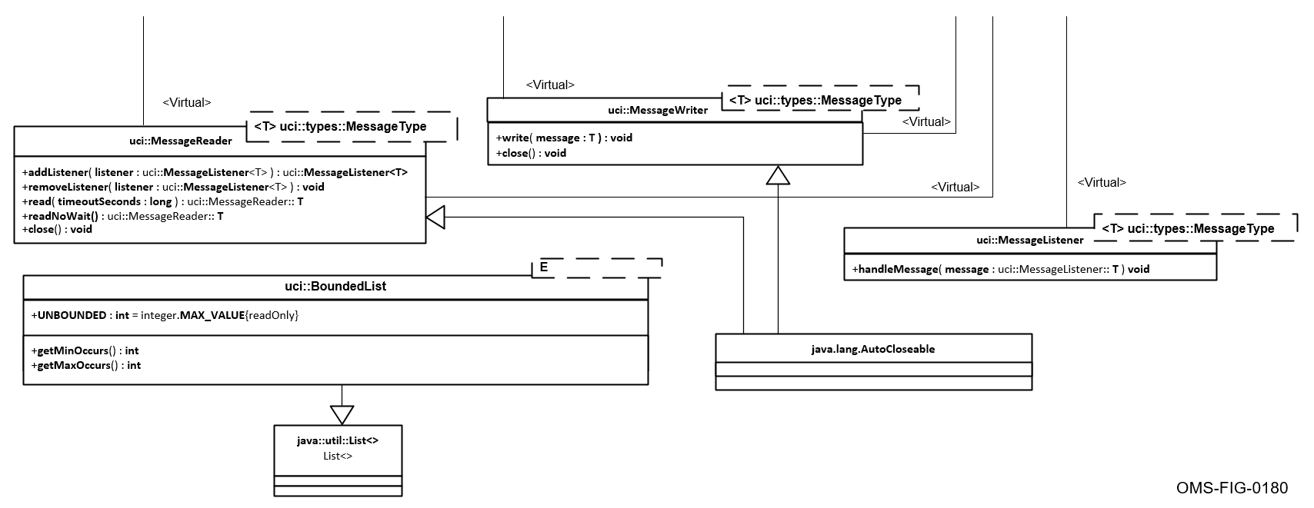
Figure 6.0-2 UML Overview of Common CAL Classes and Interfaces (part 2)

Abstract Service Bus
An instance of the AbstractServiceBusConnection is a CAL instance. It provides the fundamental support for sending and receiving messages.
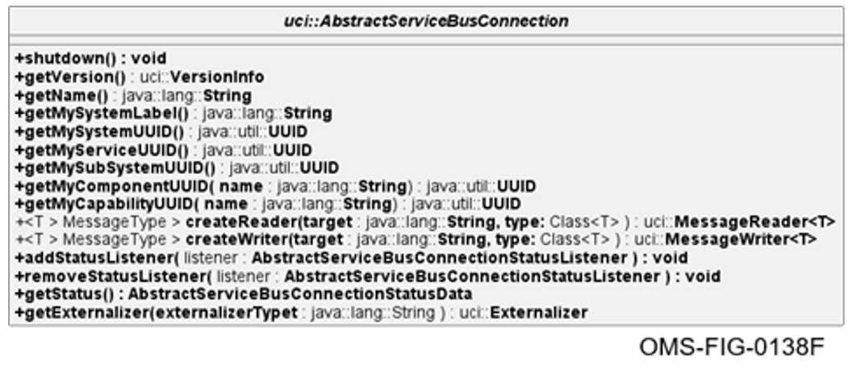
Figure 6.1-1 UML for AbstractServiceBusConnection Interface
CERT JAVA-000267 [The Java CAL shall provide the public uci.AbstractServiceBusConnection interface that extends uci.UUIDFactory with methods defined in the “AbstractServiceBusConnection Interface Definition” table.]
Table 6.1-1 AbstractServiceBusConnection Interface Definition
Modifier and Type | Method and Description
public  <T extends MessageType>  MessageReader<T> | createReader(java.lang.String target, java.lang.Class<T> type) throws UCIException  Constructs a new MessageReader that can be used to read messages of type T.
public  <T extends MessageType>  MessageWriter<T> | createWriter(java.lang.String target, java.lang.Class<T> type) throws UCIException  Constructs a new MessageWriter that can be used to write messages of type T.
public java.util.UUID | getMyCapabilityUUID(java.lang.String name) throws UCIException  Returns the UUID of the given capability name.
public java.util.UUID | getMyComponentUUID(java.lang.String name)  throws UCIException  Returns the UUID of the given component name.
public java.util.UUID | getMyServiceUUID()  Returns the UUID of the service that created the AbstractServiceBusConnection instance.
public java.util.UUID | getMySubSystemUUID()  Returns the UUID of the subsystem that create the AbstractServiceBusConnection instance.
public java.lang.String | getMySystemLabel()  Returns the system label.
public java.util.UUID | getMySystemUUID()  Returns this system’s UUID.
public java.lang.String | getName()  Returns the name of this AbstractServiceBusConnection instance.
public VersionInfo | getVersion()  Returns the version info related to this CAL/ASB implementation
public void | shutdown() throws UCIException  The shutdown method is used to shutdown this ASB. Once shutdown, this ASB can no longer be used. In addition, any factory associated with this ASB will no longer be usable.
public void | addStatusListener(AbstractServiceBusConnectionStatusListener listener) throws UCIException  Add listener for ASB service state changes
public void | removeStatusListener(AbstractServiceBusConnectionStatusListener listener) throws UCIException  Remove listener for ASB service status changes
public AbstractServiceBusConnectionStatusData | getStatus() throws UCIException  Get current ASB status
public Externalizer | getExternalizer(String externalizerType) throws UCIException  Helper function that calls getExternalizer with ASB’s Schema version and CAL API version

Abstract Service Bus Factory
The AbstractServiceBusConnectionFactory in Figure 6.2-1, UML for AbstractServiceBusConnectionFactory Interface, provides the ability to create AbstractServiceBusConnection instances for the CAL Implementation to which the factory belongs. It is used to obtain an Abstract Service Bus connection. Using the same serviceInitId will always return the same CAL instance.
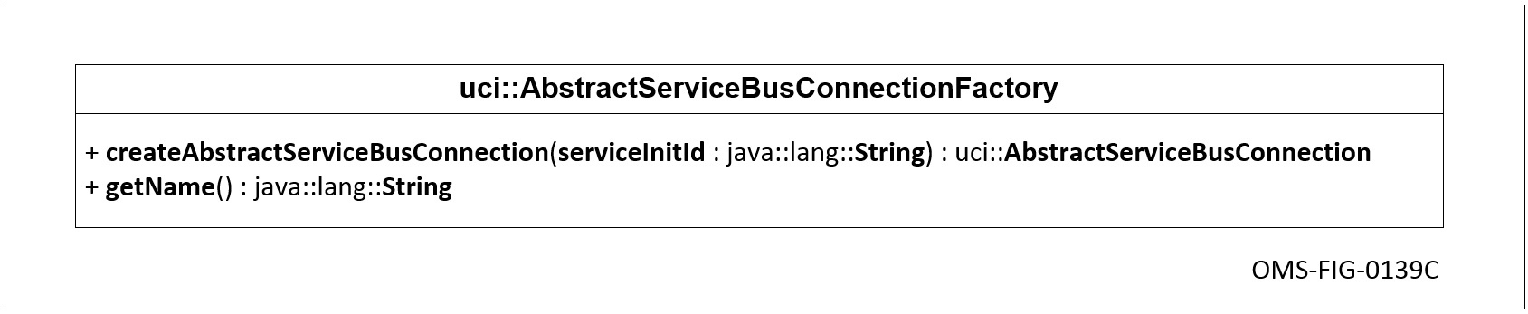
Figure 6.2-1 UML for AbstractServiceBusConnectionFactory Interface
CERT JAVA-000316 [The Java CAL shall provide the public uci.AbstractServiceBusConnectionFactory interface with methods defined in the “AbstractServiceBusConnectionFactory Interface Definition” table.]
Table 6.2-1 AbstractServiceBusConnectionFactory Interface Definition
Modifier and Type | Method and Description
public AbstractServiceBusConnection | createAbstractServiceBusConnection(java.lang.String serviceInitId) throws UCIException  This method is used to create a new ASB instance for use by the service having the specified init id. An exception is thrown if the service is not allowed to use this ASB or if one of the required initialization activities fail.
public java.lang.String | getName() throws UCIException  Returns the name of this AbstractServiceBusConnectionFactory instance.

Abstract Service Bus Factory Loader
The ASB factory loader shown in Figure 6.3-1, UML for AbstractServiceBusConnectionFactoryLoader Class, uses the Java’s service loader to load the AbstractServiceBusConnectionFactory implementation.
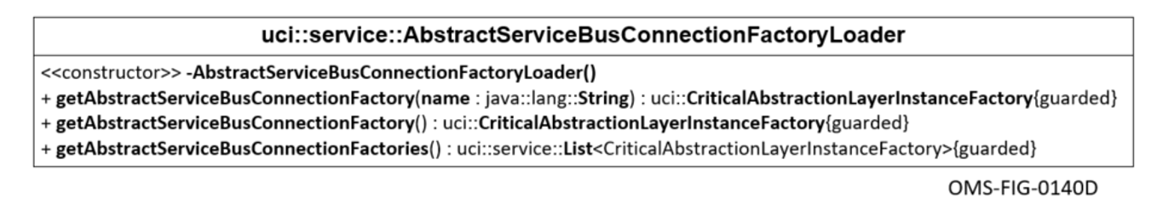
Figure 6.3-1 UML for AbstractServiceBusConnectionFactoryLoader Class
CERT JAVA-000332 [The Java CAL shall provide the public uci.service.AbstractServiceBusConnectionFactoryLoader final class with methods defined in the “AbstractServiceBusConnectionFactoryLoader Final Class Definition” table.]
Table 6.3-1 AbstractServiceBusConnectionFactoryLoader Final Class Definition
Modifier and Type | Method and Description
private Constructor | AbstractServiceBusConnectionFactoryLoader()
public static java.util.List <AbstractServiceBusConnectionFactory> | getAbstractServiceBusConnectionFactories() throws UCIException  Return a list of all AbstractServiceBusConnectionFactory instances found on the classpath.
public static AbstractServiceBusConnectionFactory | getAbstractServiceBusConnectionFactory() throws UCIException  Return the AbstractServiceBusConnectionFactory found on the classpath.
public static AbstractServiceBusConnectionFactory | getAbstractServiceBusConnectionFactory( java.lang.String name) throws UCIException  Return the  AbstractServiceBusConnectionFactory of the specified name.

UCIType Interface
The UCIType Interface is a marker interface for types generated by a Java CAL SJC from the UCI XSD.
CERT JAVA-001471 [A Java CAL API shall provide the interface uci.UCIType.]
CERT JAVA-001715 [A Java CAL API shall implement the uci.UCIType interface for each normal class declaration generated from the schema.]

Bounded List
Java CAL Implementations provide bounded list objects that implement the java.util.List interface, shown in Figure 6.5-1, UML for BoundedList Interface. In addition to the methods defined by java.util.List, the Java CAL Implementation provides the ability to obtain the “minOccurs” and “maxOccurs” values associated with the bounded list. In the context of CERT JAVA-000356, the deep copy includes performing an element by element deep copy of all elements contained in the list.
Java Clients are not able to set bounded list data members based on existing bounded list objects. Clients may obtain and modify bounded lists from OMS Message Objects.
The BoundedList is not thread-safe.
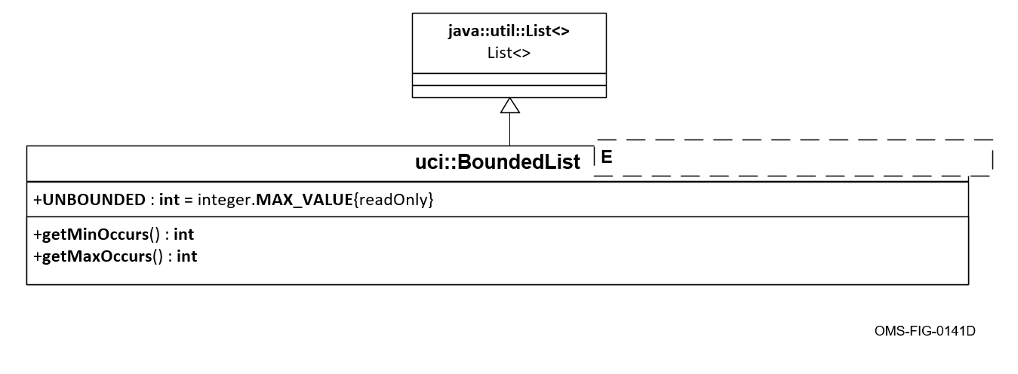
Figure 6.5-1 UML for BoundedList Interface
CERT JAVA-000356 [The Java CAL shall provide the public uci.BoundedList interface, which extends java.util.List, with methods defined in the “BoundedList Interface Definition” table and static field defined in the “BoundedList Fields” table.]
Table 6.5-1 BoundedList Interface Definition
Modifier and Type | Method and Description
public int | getMaxOccurs()  Returns this BoundedList’s maxOccurs as specified in the XML Schema specification.
public int | getMinOccurs()  Returns this BoundedList’s minOccurs as specified in the XML Schema specification.

Table 6.5-2 BoundedList Fields
Modifier and Type | Field and Description
public static final int | UNBOUNDED  The maximum size of a bounded list.

Message Listener
The MessageListener shown in Figure 6.6-1, UML for Message Listener Interface, is the interface specification of a class of objects that listen for arriving T messages.
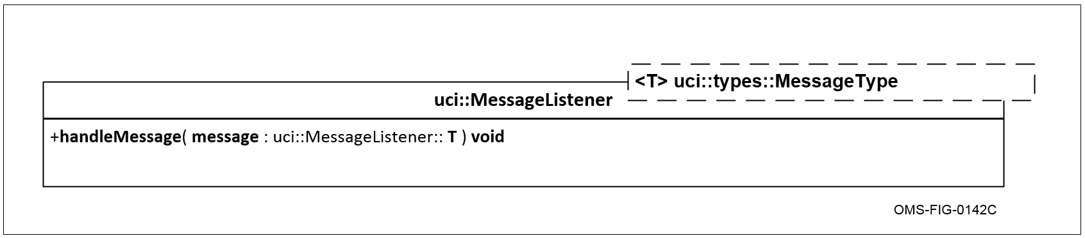
Figure 6.6-1 UML for Message Listener Interface
CERT JAVA-000395 [The Java CAL shall provide the public uci.MessageListener<T extends MessageType> interface with methods defined in the “Message Listener Interface Definition” table.]
Table 6.6-1 Message Listener Interface Definition
Modifier and Type | Method and Description
public void | handleMessage(T message) throws UCIException  The handleMessage method is used to handle incoming messages.

Message Reader
The Java CAL interface for polling shown in Figure 6.7-1, UML for Message Reader Interface, is designed to handle a single OMS Message Object per invocation. The read operation accepts a single argument specifying the timeout value. A timeout value of zero never expires, and the call blocks indefinitely. If successful, the read operation returns a reference to the OMS Message Object being read. If the operation times out, null is returned. If no timeout is desired, use the readNoWait method, which has the same behavior as the read method but returns immediately.
Java CAL Instances and Clients rely on the Java VM heap to manage the memory life cycle of OMS Message Objects. Once provided to the CAL Client, OMS Message Objects will not be modified by the Java CAL. The provided OMS Message Object references may be freely retained by the CAL Client. Since the provided OMS object reference is shared by all listeners, CAL clients should not modify the provided referenced object.
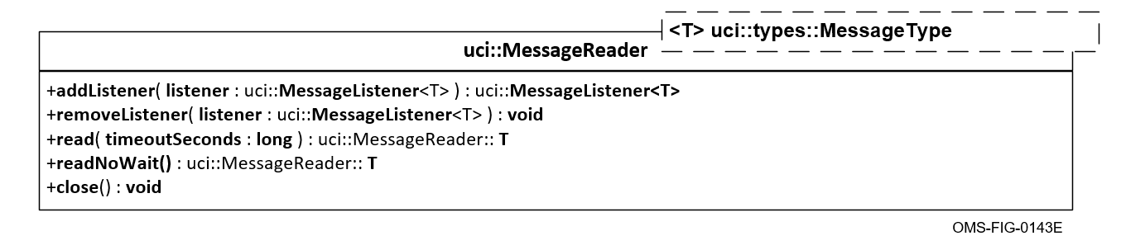
Figure 6.7-1 UML for Message Reader Interface
CERT JAVA-000409 [The Java CAL shall provide the public uci.MessageReader<T extends MessageType> interface that extends java.lang.AutoCloseable with the methods defined in the “Message Reader Interface Definition” table.]
Table 6.7-1 Message Reader Interface Definition
Modifier and Type | Method and Description
public MessageListener<T> | addListener(MessageListener<T> listener) throws UCIException  Registers a listener that will listen for new messages as they arrive.
public void | close() throws UCIException  Closes this reader.
public T | read(long timeoutSeconds) throws UCIException  Reads arriving messages. If no messages have arrived previous to the invocation of this method, then this method will block waiting for messages to arrive or until the timeout expires in which case this method will immediately return null. Once messages are available for processing, the messages will be returned in FIFO order. The timeoutSeconds argument indicates a maximum time in seconds to wait for new messages to arrive. A timeoutSeconds value of zero never expires, and the call blocks indefinitely. If no timeout is desired, use the readNoWait method.
public T | readNoWait() throws UCIException  Reads arriving messages. If no messages have arrived previous to the invocation of this method, then this method will immediately return null. If messages are available for processing, the messages will be returned in FIFO order.
public void | removeListener(MessageListener<T> listener) throws UCIException  Removes the specified listener that was previously added to listen to the arrival of new messages.

Message Writer
The MessageWriter shown in Figure 6.8-1, UML for Message Writer Interface, writes messages to specified topics. The write operation accepts a single OMS Message Object that is not modified by the Java CAL. The OMS Message Object may be freely reused by a CAL Client when the write operation returns.
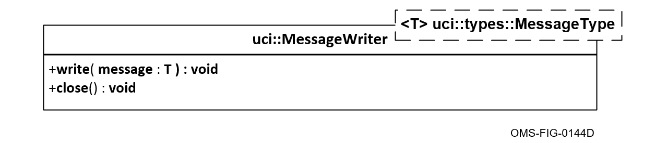
Figure 6.8-1 UML for Message Writer Interface
CERT JAVA-000431 [The Java CAL shall provide the public uci.MessageWriter<T extends MessageType> interface that extends java.lang.AutoCloseable with methods defined in the “MessageWriter Interface Definition” table.]
Table 6.8-1 MessageWriter Interface Definition
Modifier and Type | Method and Description
public void | close() throws UCIException  Closes this writer.
public void | write(T message) throws UCIException  Writes the message to the target specified when this Writer was constructed.

UCI Exception
The base class of exceptions that are thrown by UCI methods are depicted in Figure 6.9-1, UML for UCIException Class.
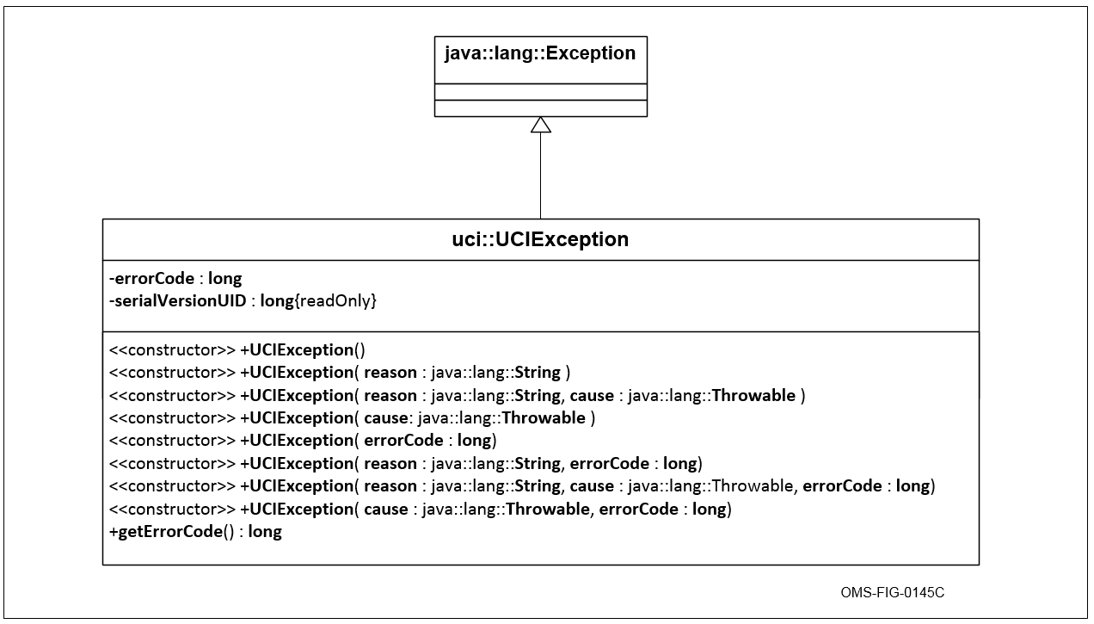
Figure 6.9-1 UML for UCIException Class
CERT JAVA-000447 [The Java CAL shall provide the public uci.UCIException class, which extends java.lang.Exception, with the methods defined in the “UCIException Class Definition” table.]
Table 6.9-1 UCIException Class Definition
Modifier and Type | Method and Description
public Constructor | UCIException()
public Constructor | UCIException(long errorCode)
public Constructor | UCIException(java.lang.String reason)
public Constructor | UCIException(java.lang.String reason, long errorCode)
public Constructor | UCIException(java.lang.String reason, java.lang.Throwable cause)
public Constructor | UCIException(java.lang.String reason, java.lang.Throwable cause, long errorCode)
public Constructor | UCIException(java.lang.Throwable cause)
public Constructor | UCIException(java.lang.Throwable cause, long errorCode)
public long | getErrorCode()  Returns this exception’s error code which was specified when the exception was created.

UUID Factory
The UUIDFactory in Figure 6.10-1, UML for UUIDFactory Interface, provides the ability to create UUIDs for creating and modifying OMS Messages.
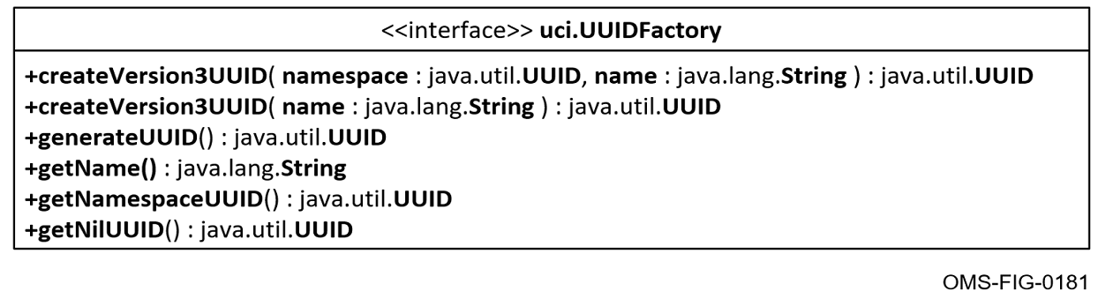
Figure 6.10-1 UML for UUIDFactory Interface
CERT JAVA-001572 [The Java CAL shall provide the public uci.UUIDFactory interface with methods defined in the “UUIDFactory Interface Definition” table.]
Table 6.10-1 UUIDFactory Interface Definition
Modifier and Type | Method and Description
public java.lang.String | getName()  Returns the name of this UUIDFactory instance.
public java.util.UUID | getNilUUID()  This method will return an RFC 4122 nil UUID. The returned value may be a consistent instance or a different instance for each call
public java.util.UUID | generateUUID()  This method will generate a new RFC 4122 Version 1 or 4 UUID
public java.util.UUID | getNamespaceUUID()  This method returns the UUID that can be used as the namespace for the createVersion3UUID(java.util.UUID namespace, java.lang.String name) method to create OMS Platform-specific, consistent UUIDs.
public java.util.UUID | createVersion3UUID(java.util.UUID namespace, java.lang.String name)  This method will create a new deterministic time-invariant RFC 4122 Version 3 UUID based on the provided namespace and name. The name is converted to UTF-8 for hashing and should be meaningful and unique. The namespace is itself a UUID and not a string representation of a UUID and is RFC 4122 conformant.
public java.util.UUID | createVersion3UUID(java.lang.String name)  This method will create a new deterministic time-invariant RFC 4122 Version 3 UUID based on the provided name using an internal namespace that is unique to each Platform. The name is converted to UTF-8 for hashing and should be meaningful and unique. The getNamespaceUUID() method will return the namespace UUID used to create the RFC 4122 Version 3 UUID.

UUID Factory Loader
The UUID factory loader shown in Figure 6.11-1, UML for UUIDFactoryLoader Class, uses the Java’s service loader to load a UUIDFactory implementation.
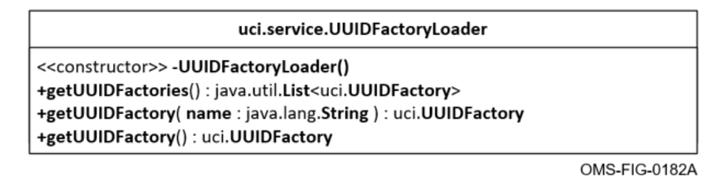
Figure 6.11-1 UML for UUIDFactoryLoader Class
CERT JAVA-001578 [The Java CAL shall provide the public uci.service.UUIDFactoryLoader final class with methods defined in the “UUIDFactoryLoader Final Class Definition” table.]
Table 6.11-1 UUIDFactoryLoader Final Class Definition
Modifier and Type | Method and Description
private Constructor | UUIDFactoryLoader()
public static java.util.List<uci.UUIDFactory> | getUUIDFactories() throws uci.UCIException  Return a list of all UUIDFactory instances found on the classpath.
public static uci.UUIDFactory | getUUIDFactory() throws uci.UCIException  Return any UUIDFactory found on the classpath
public static uci.UUIDFactory | getUUIDFactory(java.lang.String name) throws uci.UCIException  Return the UUIDFactory of the Abstract Service Bus connection factory with the specified name.

Version Info
The class encapsulating the version information for the instance of the Java CAL Implementation is depicted in Figure 6.12-1, UML for Version Info Class.
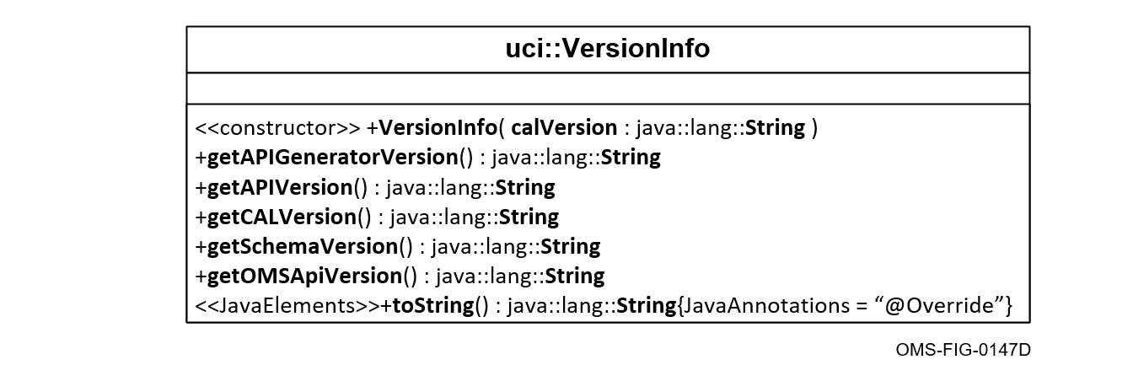
Figure 6.12-1 UML for Version Info Class
CERT JAVA-000483 [The Java CAL shall provide the public uci.VersionInfo class with the methods defined in the “Version Info Class Definition” table.]
Table 6.12-1 Version Info Class Definition
Modifier and Type | Method and Description
public Constructor | VersionInfo(java.lang.String calVersion)
public java.lang.String | getAPIGeneratorVersion()  Returns the version of the tool used to generate this CAL API
public java.lang.String | getAPIVersion()  Returns the version of this generated CAL API
public java.lang.String | getCALVersion()  Returns the version of the CAL Implementation
public java.lang.String | getSchemaVersion()  Returns the schema version as defined at the top of the schema used to generate this CAL API
public java.lang.String | getOMSApiVersion()  Returns the OMS API version
public java.lang.String | toString()

Externalizer
The Externalizer API allows an externally generated tool, built to the API, to export/import to an external format. The Externalizer API allows for the replacement of the to/from XML functionality, but also allows a method to export/import to an external format regardless of underlying CAL serialization and/or transport.
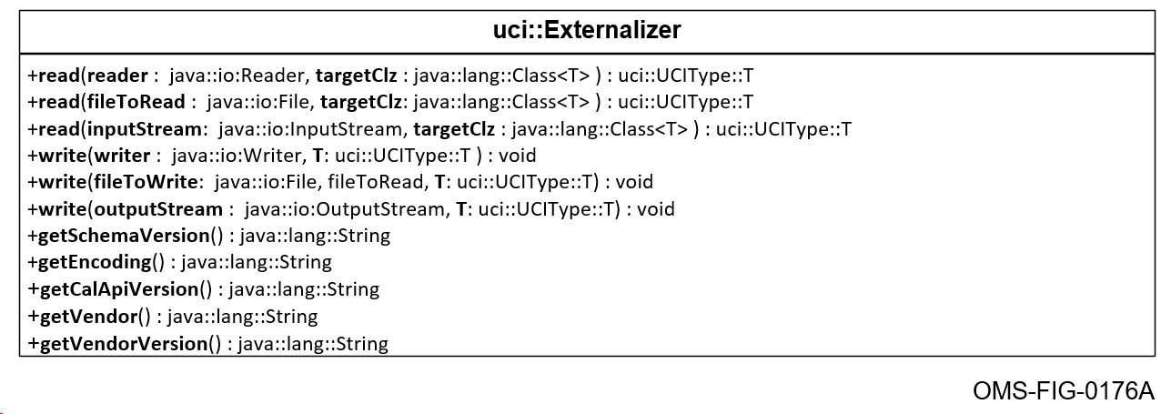
Figure 6.13-1 UML for Externalizer Interface
CERT JAVA-001380 [The Java CAL shall provide the public uci.Externalizer interface, with methods defined in the “Externalizer Interface Definition” table.]
Table 6.13-1 Externalizer Interface Definition
Modifier, Type and Method Generic Parameter | Method and Description
public <T extends UCIType> T | read(java.io.Reader, java.lang.Class<T>) throws UCIException  reads in model object with a Reader object
public <T extends UCIType> T | read(java.io.File, java.lang.Class<T>) throws UCIException  reads in model object with a File object
public <T extends UCIType> T | read(java.io.InputStream, java.lang.Class<T>) throws UCIException  reads in model object with a InputStream object
public <T extends UCIType> void | write(java.io.Writer, T) throws UCIException  writes out model object with Writer object
public <T extends UCIType> void | write(java.io.File, T) throws UCIException  writes out model object with File object
public <T extends UCIType> void | write(java.io.OutputStream, T) throws UCIException  writes out model object with OutputStream object
public String | getSchemaVersion()throws UCIException  gets schema version associated with this Externalizer
public String | getEncoding() throws UCIException  gets the Externalizer encoding type for this Externalizer
public String | getCalApiVersion() throws UCIException  gets the CAL API version for this Externalizer
public String | getVendor() throws UCIException  gets the vendor of this Externalizer
public String | getVendorVersion() throws UCIException  gets the vendor version of this Externalizer

Externalizer Loader
The Externalizer Loader API allows an externally generated tool to be loaded by the CAL.
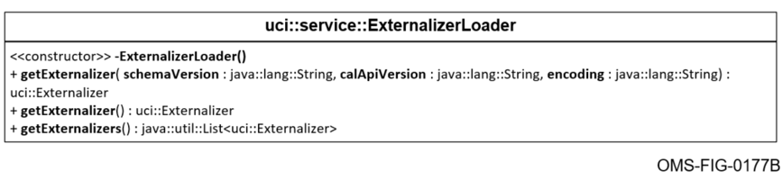
Figure 6.14-1 UML for ExternalizerLoader Class
CERT JAVA-001385 [The Java CAL shall provide the public uci.service.ExternalizerLoader final class, with methods defined in the “ExternalizerLoader Final Class Definition” table.]
Table 6.14-1 ExternalizerLoader Final Class Definition
Modifier and Type | Method and Description
private Constructor | ExternalizerLoader()
public static Externalizer | getExternalizer(String schemaVersion, String calApiVersion, String encoding) throws UCIException  get an Externalizer for a given schema version, API version, and externalizer type
public static Externalizer | getExternalizer() throws UCIException  get the only Externalizer available, throws error if 0 or >1 on the classpath
public static java.util.List<Externalizer> | getExternalizers() throws UCIException  get all service loaded externalizers

AbstractServiceBusConnection Status
The AbstractServiceBusConnection Status classes provide the Java API requirements for the AbstractServiceBusConnection status.

AbstractServiceBusConnectionStatusListener class
The AbstractServiceBusConnectionStatusListener class is responsible for providing support needed to listen for changes in the operation status of the ASB.
CERT JAVA-001307 [The Java CAL shall provide the public uci.AbstractServiceBusConnectionStatusListener interface with the methods defined in the “AbstractServiceBusConnectionStatusListener Interface Definition” table.]
Table 6.15-1 AbstractServiceBusConnectionStatusListener Interface Definition
Modifier and Type | Method and Description
public void | statusChanged(uci.AbstractServiceBusConnectionStatusData status)

AbstractServiceBusConnectionStateEnum enumeration
The AbstractServiceBusConnectionStateEnum provides all possible states of the ASB.
CERT JAVA-001310 [The Java CAL shall provide the public uci.AbstractServiceBusConnectionStateEnum enum with the enumeration constants defined in the “AbstractServiceBusConnectionStateEnum Enum Definition” table.]
Table 6.15-2 AbstractServiceBusConnectionStateEnum Enum Definition
Enum Constant Name | Description
INITIALIZING | CAL is starting up, where initialization has begun but is not complete. Read and write methods will return an error. Blocking reads will behave as normal
NORMAL | CAL is functioning normally, All QoS settings, as applicable, are being met. Read and write methods will behave as normal. Blocking reads will behave as normal
DEGRADED | Not all QoS settings are being satisfied. The CAL can send and receive but QoS settings are not being satisfied. Read and write methods will behave as normal. Blocking reads will behave as normal
INOPERABLE | CAL is unable to send or receive messages and is attempting to recover. Read and write methods will return an error. Blocking reads will behave as normal
FAILED | Identical to Inoperable state but recovery is not possible. Read and write methods will return an error. Blocking reads will release thread, returning a UCI exception

AbstractServiceBusConnectionStatusData class
The AbstractServiceBusConnectionStatusData class provides the status payload provided by the statusChanged method of the AbstractServiceBusConnectionStatusListener or returned by the getStatus method of the AbstractServiceBusConnection.
CERT JAVA-001313 [The Java CAL shall provide the public uci.AbstractServiceBusConnectionStatusData class with the methods defined in the “AbstractServiceBusConnectionStatusData Class Definition” table.]
Table 6.15-3 AbstractServiceBusConnectionStatusData Class Definition
Modifier and Type | Method and Description
public (Constructor) | AbstractServiceBusConnectionStatusData(uci.AbstractServiceBusConnectionStateEnum state, java.lang.String stateDetail)
public AbstractServiceBusConnectionStateEnum | getState() returns connection state enumeration
public java.lang.String | getStateDetail() return details string defined by CAL Implementation

Java CAL CERT Verification
Verification is normally performed by inspection, analysis, demonstration and/or test. These CERTS are typically verified either by inspection of specific documents, analysis of test results, or demonstration of specific OMS Services or programs that prove that something has been implemented properly.
One of the goals of proving OMS compliance is to leverage existing test plan artifacts and not to generate duplicate testing.

Acronyms and Symbols
For the OMS list of acronyms, refer to the document OMSC-STD-002, Abbreviations and Glossary.

Glossary
For the glossary of terms, refer to the document OMSC-STD-002, Abbreviations and Glossary.

