Open Mission Systems (OMS)
Definition And Documentation (D&D)
Mission Package Description Document (MPDD) Template

22 January 2026
Prepared By:
Open Architecture Collaborative Working Group (OACWG)

<REQUIRED: Mission Package Description Document Title>

<OPTIONAL: Organizational Logo>

<REQUIRED: Date as DD Month YYYY>

<OPTIONAL: Other labeling as appropriate>

Prepared by:

<REQUIRED: Organization>
<OPTIONAL: Address>

<OPTIONAL: Approval Signatures>

This page is intentionally left blank.

Abstract
Required: Insert program specific abstract summary details here.
Open Mission Systems (OMS) is a non-proprietary open architecture for integrating subsystems and services into mission packages.
This Mission Package Description Document (MPDD) complies with the Mission Package Description Document (MPDD) Template, OMSC-TMP-007, Revision I, dated 22 January 2026.
The template is prescribed by the OMS Standard Version 2.5, OMSC-STD-001, Revision M, dated 22 January 2026.

This page is intentionally left blank.
Revision Record
REVISION | DATE | DESCRIPTION

This page is intentionally left blank.

Table of Contents
1 Overview 1
1.1 References 1
1.2 Mission Package Worksheet 1
1.3 Mission Package Data Storage 2
1.4 Mission Package Open Computing Environment (OCE) 2
1.5 Mission Package External Interface 2
2 Cybersecurity Posture 3
2.1 Policy Overview 3
2.2 CSRC 4
2.3 Cyber Survivability Attributes (CSAs) 4
2.3.1 Prevent CSAs 4
2.3.1.1 Security Domain Definition 4
2.3.1.2 Cybersecurity Flow Description 4
2.3.1.3 Cybersecurity Confidentiality Implementation(s) 5
2.3.1.4 Cybersecurity Flow, Ports, and Protocols Restriction Policy 5
2.3.1.5 Cybersecurity Identification & Authentication Implementation(s) 6
2.3.1.6 Cybersecurity Access Controls 6
2.3.1.6.1 Non-Streaming Data Transfer Access Controls 6
2.3.1.6.2 Streaming Data Transfer Access Controls 8
2.3.1.7 Cybersecurity Integrity Implementation(s) 9
2.3.2 Mitigate CSAs 9
2.3.3 Recover CSA 9
2.3.4 Adapt CSA 9
2.4 Cyber Survivability Rationale 9
3 Security Addendum 10
A Appendix A Acronyms and Abbreviations 11
B Appendix B Glossary 13

This page is intentionally left blank.

List of Figures
Figure 2.1-1 OMS Cybersecurity Guidance in Acquisition 3
Figure 2.3-1 Security Domain Boundaries 4
Figure 2.3-2 Non-Streaming Data Transfer Information Flow Diagram 5
Figure 2.3-3 Streaming Data Transfer Information Flow Diagram 5

This page is intentionally left blank.

List of Tables
Table 1.1-1 Reference Documents 1
Table 1.2-1 Mission Package Worksheet 1
Table 1.2-2 Units of Replaceability Within the Mission Package Worksheet 1
Table 1.3-1 Data Storage Allocation 2
Table 1.4-1 Open Computing Environment 2
Table 1.5-1 External Interface 2
Table 2.2-1 Mission Package CSRC 4
Table 2.3-1 Applicable System Survivability KPP Prevent CSAs 4
Table 2.3-2 Non-Streaming Data Transfer Information Flow 5
Table 2.3-3 Streaming Data Transfer Information Flow 5
Table 2.3-4 Confidentiality Implementation 5
Table 2.3-5 Ports and Protocol Enforcement Policy 6
Table 2.3-6 Open Ports and Protocols 6
Table 2.3-7 Product/Data and Data Transfer Servers 6
Table 2.3-8 Data Transfer Protocol Identification & Authentication 6
Table 2.3-9 Non-Streaming Data Transfer Access Control Policy 7
Table 2.3-10 Streaming Data Transfer Access Control Policy 8
Table 2.3-11 Integrity Implementation 9
Table 2.3-12 Applicable System Survivability KPP Mitigate CSAs 9
Table A.0-1 List of Acronyms and Abbreviation Definitions 11
Table B.0-1 List of Term Definitions 13

This page is intentionally left blank.

Overview
Proprietary Notice: This document contains only non-proprietary information. Referenced documents conform to the Proprietary Notice statement for each major sub section. References to external documents that provide for the data in this section (i.e., Section 1) refer only to non-proprietary documents.
This section identifies the Units of Replaceability (UoRs), data storage, and Open Computing Environment (OCE) of the Mission Package.

References
Proprietary Notice: References to external documents that provide for the data in this section may refer to proprietary documents.
This section lists all the referenced documents that are required to support the integration of this Mission Package as shown in Table 1.1-1, Reference Documents.
Table 1.1-1 Reference Documents
Document Number | Document Title | Revision | Date
OMSC-GDE-003 | Cybersecurity Guide | D | 22 January 2026
OMSC-STD-001 | OMS Standard Version 2.5 | M | 22 January 2026
OMSC-TMP-007 | Mission Package Description Document (MPDD) Template | I | 22 January 2026
N/A | Cyber Survivability Endorsement Implementation Guide (CSEIG) | Version 3 | July 2022

Mission Package Worksheet
This section identifies the UoRs of the Mission Package by referencing the version of the Mission Package Worksheet (MPW) identified in Table 1.2-1, Mission Package Worksheet, and UoRs identified in Table 1.2-2, Units of Replaceability Within the Mission Package Worksheet.
Table 1.2-1 Mission Package Worksheet
Document Title | Document Number

Table 1.2-2 Units of Replaceability Within the Mission Package Worksheet
Name of UoR | Document Title | Document Number

Mission Package Data Storage
This section identifies where Subsystems, Services, and Isolators store files and subdirectories on a Platform or Subsystem and the capacities available to each Subsystem, Services, and Isolators as shown in Table 1.3-1, Data Storage Allocation.
Table 1.3-1 Data Storage Allocation
Subsystem/Service/Isolator | Data Store Label | Data Store Address | Storage Allocation | Data Transfer Protocol(s)

Mission Package Open Computing Environment (OCE)
This section identifies where Open Computing Environments exist within the Mission Package as shown in Table 1.4-1, Open Computing Environment.
Table 1.4-1 Open Computing Environment
Platform/Subsystem | H/W | Linux | Java | Virtualization
Platform

Mission Package External Interface
This section identifies the documentation for the external interface of the Mission Package as shown in Table 1.5-1, External Interface.
Table 1.5-1 External Interface
Document Number | Document Title

Cybersecurity Posture
Proprietary Notice: References to external documents that provide for the data in this section refer only to non-proprietary documents.
This section identifies the cybersecurity posture of the Mission Package.

Policy Overview
The OMS Cybersecurity Guide, OMSC-GDE-003, provides concepts and guidance to complete OMS compliance documentation. These documents can be used as part of a Program Protection and Systems Security Engineering (SSE) process and incorporate concepts provided by the Joint Chiefs of Staff (JCS) Cyber Survivability Endorsements Implementation Guide (CSEIG). OMS documentation helps fill the gap when no external cybersecurity requirements are present, and provides flexibility to reference external documents when a system-level cybersecurity process with requirements is in place. The role of OMS Cybersecurity in the SSE process is therefore to reference or provide relevant information to support the Adopting Program and system designers in addressing cybersecurity requirements as shown in Figure 2.1-1. The OMS Cybersecurity is a component of the overall cybersecurity accreditation of the weapon system.
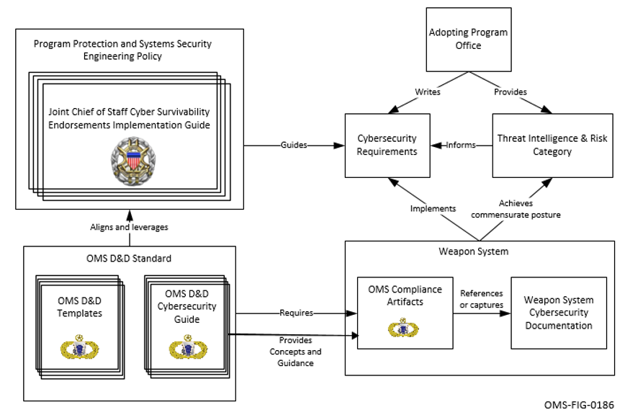
Figure 2.1-1 OMS Cybersecurity Guidance in Acquisition

CSRC
This identifies the CSRC for the Mission Package as shown in Table 2.2-1 Mission Package CSRC.
Table 2.2-1 Mission Package CSRC
CSRC 1 | CSRC 2 | CSRC 3 | CSRC 4 | CSRC 5

Cyber Survivability Attributes (CSAs)
This section identifies the CSAs applicable to the Mission Package.

Prevent CSAs
This section identifies and documents the System Survivability Key Performance Parameters (KPPs) Prevent CSAs implementation for the Mission Package. Table 2.3-1 identifies the System Survivability KPP Prevent CSAs applicable to the Mission Package.
Table 2.3-1 Applicable System Survivability KPP Prevent CSAs
CSA-01 | CSA-02 | CSA-03 | CSA-04 | CSA-05 | CSA-06

Security Domain Definition
This section describes the cybersecurity policies and configurations implemented in the Mission Package.
Figure 2.3-1, Security Domain Boundaries, is a representation of the security domains for a platform. It provides a reference for how the network described in the PDD is connected to Subsystems which may have single or multiple security domains.
<<INSERT FIGURE HERE. SEE ACCOMPANYING INSTRUCTIONS FOR AN EXAMPLE>>
Figure 2.3-1 Security Domain Boundaries

Cybersecurity Flow Description
This section describes the cybersecurity policies for flow control as implemented in this Mission Package.
Figure 2.3-2, Non-Streaming Data Transfer Information Flow Diagram, identifies the server and clients.
<<INSERT FIGURE HERE. SEE ACCOMPANYING INSTRUCTIONS FOR AN EXAMPLE>>
Figure 2.3-2 Non-Streaming Data Transfer Information Flow Diagram
Table 2.3-2, Non-Streaming Data Transfer Information Flow, identifies the actors and the information being sent in the flow described.
Table 2.3-2 Non-Streaming Data Transfer Information Flow
Ref # | Actor A (Server) | Actor B (Client) | Information Item | Security Domain(s)

Figure 2.3-3, Streaming Data Transfer Information Flow Diagram, identifies the producer and consumers.
<<INSERT FIGURE HERE. SEE ACCOMPANYING INSTRUCTIONS FOR AN EXAMPLE>>
Figure 2.3-3 Streaming Data Transfer Information Flow Diagram
Table 2.3-3, Streaming Data Transfer Information Flow, identifies the actors and the information being sent in the flow described.
Table 2.3-3 Streaming Data Transfer Information Flow
Ref # | Actor A (Producer) | Actor B (Consumer) | Information Item | Security Domain(s)

Cybersecurity Confidentiality Implementation(s)
This section describes the implemented mechanism(s) used to ensure confidentiality of information in the Mission Packages as shown in Table 2.3-4, Confidentiality Implementation.
Table 2.3-4 Confidentiality Implementation
Information Flow | Outside of Mission Package | Ports and Protocols Restriction | Restriction  Mechanism | Implementation Summary

Cybersecurity Flow, Ports, and Protocols Restriction Policy
This section documents the cybersecurity policies for restricting information flows, ports, and protocols as implemented in this Mission Package.
Table 2.3-5, Ports and Protocol Enforcement Policy, summarizes the information flow policy and restriction of ports and protocols.
Table 2.3-5 Ports and Protocol Enforcement Policy
Enforcement Component | Controlled Flows | Port and Protocol Restrictions | Restriction Method | Implementation Summary

Table 2.3-6, Open Ports and Protocols, summarizes the open ports and protocols on the Mission Package.
Table 2.3-6 Open Ports and Protocols
Port (TCP/UDP) | Protocol | Process/Service | Address | Purpose | Restriction Mechanism

Table 2.3-7, Product/Data and Data Transfer Servers, identifies the products being sent or received by the Data Transfer server.
Table 2.3-7 Product/Data and Data Transfer Servers
Client Address | Product/Data | Format | Send/Receive | Data Transfer Server

Cybersecurity Identification & Authentication Implementation(s)
This section documents the mechanism(s) used to identify Platform, Subsystems, Services, and Isolators as implemented as shown in Table 2.3-8, Data Transfer Protocol Identification & Authentication.
Table 2.3-8 Data Transfer Protocol Identification & Authentication
Data Transfer Server | Anonymous Login (Yes/No) | Client Identification | Authentication Mechanism

Cybersecurity Access Controls
This section describes the cybersecurity policies for access control as implemented in this Mission Package.

Non-Streaming Data Transfer Access Controls
This section documents the access control policy in place for the data transfer within the Mission Package as shown in Table 2.3-9, Non-Streaming Data Transfer Access Control Policy.
Table 2.3-9 Non-Streaming Data Transfer Access Control Policy
Data Flow | Server | Client | Permissions | Information Item (Product/Data) | Implementation Summary

Streaming Data Transfer Access Controls
This section describes the streaming data flows and the mechanism that is used to initiate the start of the streaming data transfer as shown in Table 2.3-10, Streaming Data Transfer Access Control Policy.
Table 2.3-10 Streaming Data Transfer Access Control Policy
Data Flow | Producer | Consumer | Permissions | Information Item (Product/Data) | Implementation Summary

Cybersecurity Integrity Implementation(s)
This section documents the implemented mechanism(s) used to ensure integrity of data in the Mission Package as shown in Table 2.3-11, Integrity Implementation.
Table 2.3-11 Integrity Implementation
Information Flow | Outside of Mission Package | Integrity Mechanism | Implementation Summary

Mitigate CSAs
This section identifies and documents the System Survivability KPP Mitigate CSAs implementation for the Mission Package. Table 2.3-12 identifies the System Survivability KPP Mitigate CSAs applicable to the Mission Package.
Table 2.3-12 Applicable System Survivability KPP Mitigate CSAs
CSA-07 | CSA-08

Recover CSA
This section identifies and documents the System Survivability KPP Recover CSA implementation for the Mission Package.

Adapt CSA
This section identifies and documents the System Survivability KPP Adapt CSA implementation for the Mission Package.

Cyber Survivability Rationale
This subsection describes Cyber Survivability rationale.

Security Addendum
Proprietary Notice: The Security Addendum reference in this section is a non-proprietary document. The Security addendum may contain references to external documents that may be proprietary.
This section identifies the Security Addendum document(s).
- Appendix A Acronyms and Abbreviations
This section lists the abbreviations and acronyms used in this document not a copy of the OMS lexicon as shown in Table A.0-1, List of Acronyms and Abbreviation Definitions.
Table A.0-1 List of Acronyms and Abbreviation Definitions
Acronym/Abbreviation | Definition
CSA | Cyber Survivability Attribute
KPP | Key Performance Parameter
OACWG | Open Architecture Collaborative Working Group
OCE | Open Computing Environment
OMS | Open Mission Systems

This page is intentionally left blank.
- Appendix B Glossary
This section lists the terms used in this document as shown in Table B.0-1, List of Term Definitions.
Table B.0-1 List of Term Definitions
Term | Definition

