Open Mission Systems (OMS)
Definition And Documentation (D&D)
Subsystem Description Document (SDD) Template Instructions

22 January 2026
Prepared By:
Open Architecture Collaborative Working Group (OACWG)

This page is intentionally left blank.

Abstract
This Subsystem Description Document (SDD) Template Instructions describes how the SDD Template is filled out. The General Template Instructions provides a description of how this Template Instructions document is used in filling out the corresponding associated SDD Template.
This Subsystem Description Document (SDD) Template Instructions is aligned with the Subsystem Description Document (SDD) Template, OMSC-TMP-002, Revision M, dated 22 January 2026.

This page is intentionally left blank.
Revision Record
REVISION | DATE | DESCRIPTION
M | 22 January 2026 | Initial public release

This page is intentionally left blank.

Table of Contents
1 Overview 4
1.1 References 6
1.2 OMS Subsystem Compliance Pattern 6
2 Service Contract 9
3 Subsystem Specification Identification and Reference 10
4 Licenses 11
5 Subsystem Libraries Not Defined In The Service Contract 12
6 Subsystem Time Synchronization 13
7 Service and Subsystem Startup 14
8 Subsystem External Interfaces 15
8.1 Open Ports and Protocols 18
9 Subsystem Data Transfer 20
9.1 Data Storage 20
9.1.1 Data Storage Access Controls 21
9.1.2 Data Storage Confidentiality Mechanisms 22
9.1.3 Data Storage Integrity Mechanisms 23
9.2 Data Transfer Confidentiality Mechanisms for Data Storage 23
9.3 Data Transfer Integrity Mechanisms for Data Storage 24
9.4 Data Transfer Configuration for Data Storage 25
10 Subsystem Internal Interfaces 26
11 Open Computing Environment (OCE) 27
11.1 OCE Processor Types, Operating Systems, and Configuration 27
11.2 General Environment 27
11.2.1 Build Environment and Tool Chain 27
11.2.2 Isolation Layer 27
11.2.3 Time 27
11.3 Java Environment 27
11.3.1 Build Environment and Tool Chain 28
11.3.2 Java Data Transfer 28
11.3.3 Time 28
11.4 Virtualization Environment 28
11.4.1 Hypervisor 28
11.4.1.1 Processor 28
11.4.1.2 Memory Virtualization 28
11.4.1.3 Network Virtualization 29
11.4.2 Time 29
11.5 Service Deployment 29
12 Test Procedures & Data 30
13 Cybersecurity Posture 31
13.1 Cyber Survivability Attributes (CSAs) 31
13.1.1 Prevent CSAs 31
13.1.2 Mitigate CSAs 32
13.1.3 Recover CSA 32
13.1.4 Adapt CSA 33
14 Security Addendum 34
A Appendix A Acronyms and Abbreviations 35
B Appendix B Glossary 36

List of Figures
Figure 1.0-1 SDD Document Tree 5
Figure 1.2-1 Standalone Subsystem 7
Figure 1.2-2 Platform-Hosted OMS Adaptation 8
Figure 8.0-1 Plug Connection Diagram 15
Figure 8.0-2 OMS Data Exchanges with a Platform-Hosted OMS Adapter 17

This page is intentionally left blank.

List of Tables
Table 0.0-1 OMS D&D Documents 2
Feedback Form Table 3
Table 1.1-1 Reference Documents 6
Table 2.0-1 Service Contract 9
Table 3.0-1 Subsystem Specifications 10
Table 4.0-1 Subsystem Licenses 11
Table 5.0-1 Additional Subsystem Libraries 12
Table 6.0-1 Time Sync 13
Table 8.1-1 OMS Subsystem Open Ports and Protocols 18
Table 8.1-2 OMS Subsystem Product/Data and Data Transfer Servers 19
Table 9.1-1 Subsystem Data Storage Details 21
Table 9.1-2 Data Storage Access Control Mechanisms 22
Table 9.1-3 Data Storage Confidentiality 23
Table 9.1-4 Data Storage Integrity 23
Table 9.2-1 Data Transfer Confidentiality Mechanisms 24
Table 9.3-1 Data Transfer Integrity Mechanisms 24
Table 9.4-1 Subsystem Data Transfer Configuration 25
Table 10.0-1 Subsystem Internal ICDs 26
Table 13.1-1 Applicable System Survivability KPP Prevent CSAs 31
Table 13.1-2 Applicable System Survivability KPP Mitigate CSAs 32
Table A.0-1 List of Acronyms and Abbreviation Definitions 35
Table B.0-1 List of Term Definitions 36

This page is intentionally left blank.

General Template Instructions
This document, Subsystem Description Document (SDD) Template Instructions, OMSC-INS-002, provides information on how to fill in required information in the SDD Template, OMSC-TMP-002. The outline of the SDD Template Instructions is one-to-one aligned with each section in the SDD Template. The green text in each section of this SDD Template Instructions document should be used as guidance to fill out the corresponding section in the SDD Template. Green text in the SDD Template is considered guidance only and should be removed to reflect your Subsystem. NOTE: The first page of the SDD Template document is for Open Mission Systems (OMS) purposes only and should be removed prior to the release of the completed Template.
A Subsystem provider should save the SDD Template using an appropriate unique filename. The Subsystem provider should add an appropriate document number, revision history and document date for configuration management of program specific information. The distribution statement should be filled out based on the program specific restrictions, and at a minimum should be Distribution Statement A. If the contents of the document require a higher restriction, the appropriate distribution statement should be updated as needed. Green text in the SDD Template represents guidance for the creation of the SDD. Green text should not remain in the completed SDD and should be replaced on the Cover page, in the Abstract, in the Revision Record and all applicable sections defined in the SDD Template.
This document contains only non-proprietary information. Referenced documents may contain proprietary information except in sections noted otherwise. Proprietary information included in referenced documents should include data transfer mechanisms and data structures, but should not include proprietary data content. Classification of the SDD should be based on the contents of the document.
Modify the sections in the template using the following guidelines:
- Existing black text is required and should not be deleted.
- If a section is not applicable, keep that section heading and add “Not Applicable” with a rationale for why that section is not applicable on a new line. For figures and tables below the not applicable section, replace figures with “Figure not applicable” and enter “N/A” in the first empty cell for tables.
The rationale behind not deleting table captions, figure captions, or sections is to preserve section references and table/figure identifiers to maintain traceability within the document and between documents. For example, the Security Control Traceability Matrix (SCTM) traces a security control to a specific document template, section and/or table identifier.
- Maintain existing table column headers.
Tables can be further modified (e.g., adding additional columns when applicable) but the original structure of existing tables should be preserved.
- Delete all green guidance text in the section, including green text added in table rows provided for exemplar purposes only.
- If additional tables or figure are added, the table/figure caption must follow the third level numbering system. Existing, default captions already in the template are numbered against headings at level 2 (e.g., Under Section 1, the first table in the section is numbered Table 1.0-1. Under Section 2.4.1, the second table in the section is numbered Table 2.4-2). Newly added tables/figures should be numbered against headings at level 3 (e.g., Under Section 1, the first newly added table in the section is numbered Table 1.0.0-1. Under Section 2.4.1, the second newly added table in the section is numbered 2.4.1-2). This results in preserving the numbering of the original tables.
Ensure correct table and figure caption styles are applied so they appear in the List of Tables and List of Figures. Use the “TableCaption” Style for table captions and “FigureCaption” Style for figure captions.
All documents referenced within the Subsystem Description Document must include a document reference number with release dates and be included in the compliance package deliverable.
The documents listed in Table 0.0-1, OMS D&D Documents, are the documents that assist in the understanding and implementation of OMS.
Table 0.0-1 OMS D&D Documents
Document Number | Document Title | Revision | Date
OMSC-STD-001 | OMS Standard Version 2.5 | M | 22 January 2026
OMSC-STD-002 | Abbreviations and Glossary | M | 22 January 2026
OMS Documentation Feedback Form
This form gives customers using the OMS documentation (Mission Package Worksheet, Mission Package Description Document, Platform Description Document, Subsystem Description Document and Service Contract) a venue to submit feedback to the OACWG. Comments should identify errors in the documentation or highlight areas of confusion.
Feedback Form Table
Name of Commenter | Contact Information (Email/Phone)
Applicable File Name | Section, Figure, Table
Comment Details (i.e., Description of Issue and Proposed Updates (if applicable))

Completed feedback forms may be submitted in one of two ways:
- Upload the completed form to the Submit Requests folder on Pydio here: https://pydio.dle.afrl.af.mil/ws-ase-group-1/OMS_UCI/%2001_Submitting%20a%20Change%20Request/Submit%20Requests
- Submit the completed form to the User Support Group at oam-cwg-usersupport@rlist.app.ray.com

Overview
This section includes a summary of key capabilities and functions of the Subsystem.
It should state if the Subsystem is a standalone Subsystem or if it uses a Platform-hosted Adapter.
Figure 1.0-1, SDD Document Tree, illustrates the document tree showing references associated to this Subsystem.
The Open Mission Systems (OMS) Subsystem Description Document (SDD) is the top-level document in the set of documents which specifies the key aspects, interfaces and capabilities [this should include all the capabilities of the Subsystem] of an OMS Subsystem.
This section may include a document tree that allows a Customer a quick reference for the documents that are referenced in this document. An example is shown in Figure 1.0-1, SDD Document Tree. An SDD is required of all OMS Subsystems to be compliant and is the primary source of documentation describing an OMS Subsystem. The SDD objectively describes the “as built” configuration and capabilities of an OMS Subsystem, but will evolve during the life-cycle of an OMS Subsystem’s development.
<< THE FOLLOWING IS AN EXAMPLE FIGURE. INCLUDE AN APPROPRIATE FIGURE IF APPLICABLE. IF NOT APPLICABLE, REPLACE THE FIGURE WITH “FIGURE NOT APPLICABLE” >>
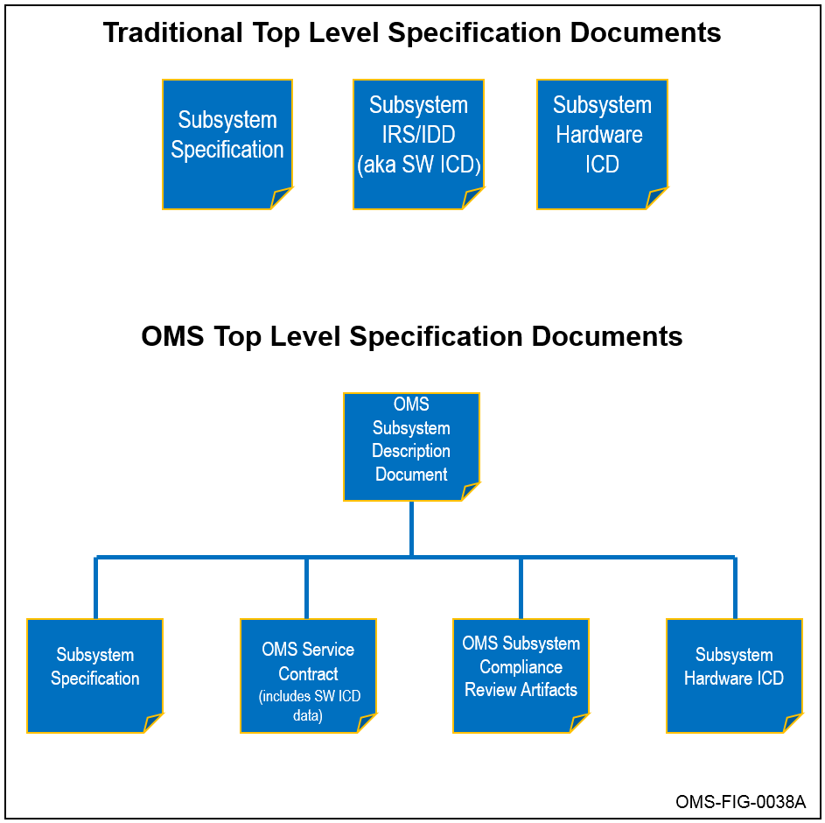
Figure 1.0-1 SDD Document Tree
This document contains only non-proprietary information. Referenced documents may contain proprietary information except in sections noted otherwise. Proprietary information included in referenced documents should include data transfer mechanisms and data structures, but should not include proprietary data content. Classification of the SDD should be based on the contents of the document.

References
Table 1.1-1, Reference Documents, lists all the referenced documents that are required to support the integration of this Subsystem.
This section should include the current OMS Standard for basis of compliance, internal and external ICDs, and other important documents or standards. Table 1.1-1, Reference Documents, lists all the required reference documents. This section should also provide overview description for each program/Subsystem specific document referenced in this section.
Table 1.1-1 Reference Documents
Document Number | Document Title | Revision | Date
OMSC-SPC-005 | Operating System Façade Specification | J | 22 January 2026
OMSC-STD-001 | OMS Standard Version 2.5 | M | 22 January 2026
OMSC-TMP-002 | Subsystem Description Document (SDD) Template | M | 22 January 2026
OMSC-TMP-003 | Service Contract Template | M | 22 January 2026
Add rows as required.

OMS Subsystem Compliance Pattern
This section identifies the compliance pattern for this Subsystem.
An OMS Subsystem, and its accompanying SDD, is unique to a Subsystem’s implementation for a specific OMS Platform or other OMS implementation. A key purpose of the SDD is to describe a Subsystem to the host Platform integrator or Platform provider. The SDD provides the information necessary to enable the Platform provider to incorporate the Subsystem into the larger architecture and design of the Platform, and to enable the Platform integrator to integrate the Subsystem into the Platform. The SDD references the Subsystem’s Service Contract that defines and describes the information required to support OMS Data Exchanges. A Subsystem's Service Contract will contain a complete description of its OMS-facing interface.
The OMS SDD references additional documents (Subsystem Spec, etc.) and, with the inclusion of those references, provides the overarching description of a Subsystem. The SDD identifies the OMS compliance pattern of the Subsystem. There are two potential OMS compliance patterns depicted in the following figures:
- Figure 1.2-1, Standalone OMS Subsystem, depicts where Subsystem implementation is OMS-compliant without requiring adaptation
- Figure 1.2-2, Platform-Hosted OMS Adaptation, depicts where a Platform-hosted Adapter provides OMS compliance.
The compliance pattern chosen for a particular Subsystem has no effect on the Subsystem’s OMS compliance tier determination. Note that if a legacy non-OMS subsystem is adapted to OMS compliance within the boundary of the Subsystem, a Platform does not see that adaptation and the Subsystem is considered a standalone Subsystem as depicted below.
This section should contain a block diagram similar to one of two figures depicted below. The block diagram should be at a high level, and does not need to go to a detailed ICD level as will be requested further in the document. At a minimum, the block diagram should call out the Subsystem, the Platform, related Services, and the connection(s) between them. If you are including a block diagram, please introduce the figure with a sentence.
<< THE FOLLOWING IS AN EXAMPLE FIGURE AND CAPTION. INCLUDE AN APPROPRIATE FIGURE AND CAPTION FOR YOUR SYSTEM >>
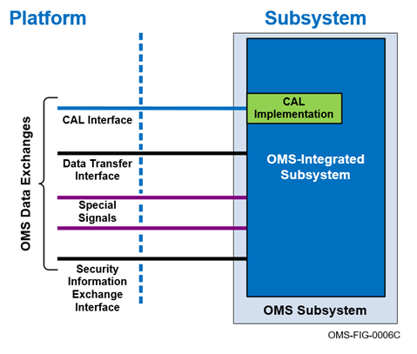
Figure 1.2-1 Standalone Subsystem
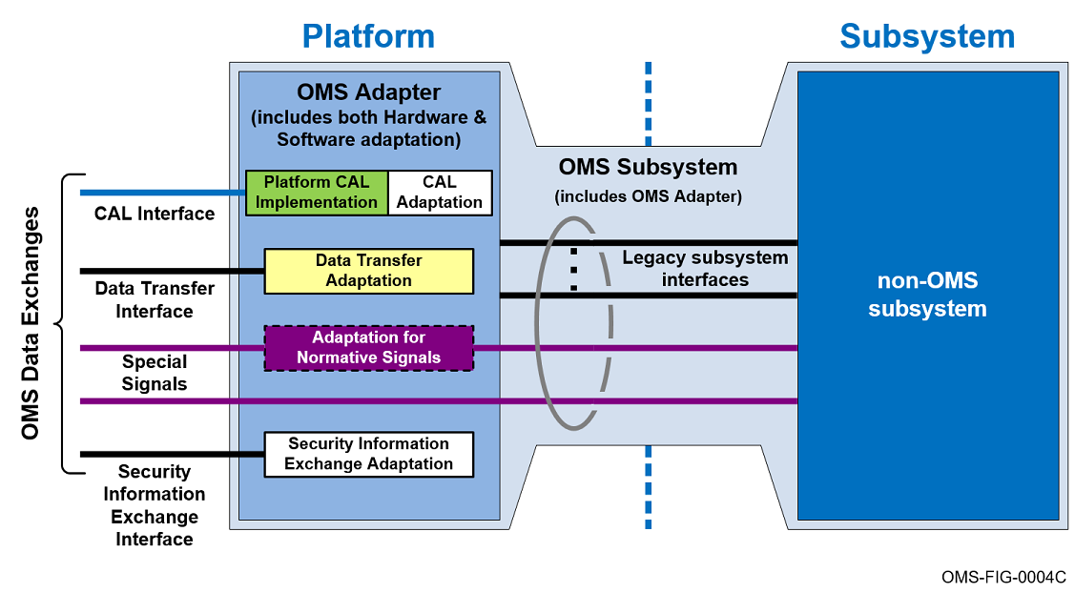
Figure 1.2-2 Platform-Hosted OMS Adaptation
The issue of adaptation inherently defines two potential elements of a Subsystem using an Adapter: the “non-OMS subsystem” which provides the mission functions and/or Capabilities and consists of the OMS Subsystem minus adaptation, and a subsystem’s OMS Adapter. The “non-OMS subsystem” and the OMS Adapter may be separately acquired. The SDD describes the non-OMS subsystem acquisition approaches, and describes any agreement(s) between parties involved in the development of OMS Adapter(s). The SDD describes the interfaces and key external physical characteristics of a non-OMS subsystem that must be known to enable the various parties to successfully design and integrate the overall Subsystem into the Platform. In addition, the SDD specifies where the CAL Implementation resides when the Subsystem is using a Platform-hosted Adapter. In this case, the Subsystem might identify the location of the CAL Implementation as the OCE or Other Mission Processing.
The SDD provides the information required to enable the Subsystem to be exchanged with a similar Subsystem, as well as supplying information that enables the Subsystem to be reused on another Platform. If the non-OMS subsystem is adapted with a Platform-hosted Adapter the SDD identifies and describes all interfaces that use Platform resources.

Service Contract
Table 2.0-1, Service Contract, identifies and refers to the Service Contract for the Subsystem.
The Service Contract includes traditional IRS/IDD (Interface Requirement Specification/Interface Design Document) information. The Service Contract must be non-proprietary, but may include proprietary annexes or references as noted in its template. See the Service Contract Template, OMSC-TMP-003, for a description of the OMS Service Contract. Please add a sentence to summarize your Service Contract and an additional sentence to introduce the table below. You may delete rows as required, but this document must be submitted with the referenced Service Contract and if desired, a separate Service Contract Appendix C spreadsheet. Do not include Service Contracts for Services hosted by this Subsystem: These Service Contracts will be listed in MPDD “Mission Package Worksheet” section, “Units of Replaceability Within the Mission Package Worksheet” table.
The columns in Table 2.0-1, Service Contract, should contain the following information:
Title – Name of the Service Contract Document
Reference – Unique identifier for the document’s configuration control
Date / Revision – Date and Revision of the Service Contract.
Table 2.0-1 Service Contract
Title | Reference | Date | Revision
Add rows as required

Subsystem Specification Identification and Reference
Table 3.0-1, Subsystem Specifications, references the associated Subsystem requirements specifications.
If none is available, then mark this section as “Not Applicable” with a rationale and the first empty cell of the table with “N/A”.
This section should list applicable Subsystem specifications that introduce, describe, and/or list any requirements documents that may be applicable for the integration of the Subsystem. This includes top-level Subsystem specifications, as well as internal interfaces that need to be exposed to an integrator, such as interfaces to an OMS Platform-hosted Adapter.
This section should also be used to identify unique tools and support software that will be needed to install, integrate, and/or run the Subsystem.
The columns in Table 3.0-1, Subsystem Specifications, should contain the following information:
Title – Name of the document
Reference – Unique identifier for the document’s configuration control
Date / Revision – Date and release version for the document.
Table 3.0-1 Subsystem Specifications
Title | Reference | Date | Revision
Add rows as required

Licenses
Table 4.0-1, Subsystem Licenses, documents the licenses required by the Subsystem to integrate with the Platform.
This section only addresses licenses used by the Subsystem that are not defined in the Service Contracts referenced in Table 2.0-1, Service Contract, such as licenses to support Data Storage, an OCE, or Security Information Exchanges not defined in a Service Contract. The intent of this disclosure is to identify licenses that a Platform integrator would be required to acquire in order to integrate the Subsystem. If this section is not applicable, mark as “Not Applicable” with a rationale and the first empty cell of the table with “N/A”.

The columns in Table 4.0-1, Subsystem Licenses, should contain the following information:
License Description – Name and Description of the required License
Provider/Product/Version – Provide the source and version of the required License
Type – Please indicate if this is a runtime or non-runtime License
Purpose – Please indicate what the general purpose of the License is used for.
Table 4.0-1 Subsystem Licenses
License Description | Provider | Product | Version | Type | Purpose
DDS License | Super Software | DDS | 1.2 | Runtime | CAL Transport
Add rows as required

Subsystem Libraries Not Defined In The Service Contract
Table 5.0-1, Additional Subsystem Libraries, documents libraries used by the Subsystem that are not defined in the Service Contracts.
To preserve document formatting, if this section is not applicable, mark as “Not Applicable” with a rationale and the first empty cell of the table with “N/A”.
Table 5.0-1 Additional Subsystem Libraries
Library Name | Provider | Version | Purpose
Add rows as required

Subsystem Time Synchronization
This section should include Special Signal references to any OMS Standard time reference signals used that are specified in OMSC-STD-001, OMS Standard, Time Reference Signals section. Table 6.0-1, Time Sync, identifies and describes the method(s) used for time synchronization.
Include optional high fidelity time synchronization. Please list the type of time synchronization your Subsystem requires, also note if it is high or low speed (1 Hz is considered low speed). To preserve document formatting, if this section is not applicable, mark as “Not Applicable” with a rationale and the first empty cell of the table with “N/A”.
The columns in Table 6.0-1, Time Sync, should contain the following information:
Method – Method of required time synchronization
Description – Please describe the method and the rate that is required.
Table 6.0-1 Time Sync
Method | Description
Add rows as required

Service and Subsystem Startup
This section documents the location, identity, and means for modifying any configuration data required for OMS startup for a Service or Subsystem.
(Note: This is not meant to include internal Subsystem configuration data.) Please describe and list out any special startup instructions in this section. Note that this section may include a sentence that simply states “Apply power to startup this Subsystem.”

Subsystem External Interfaces
This section identifies and describes the Subsystem interfaces between the Subsystem and the Platform ASB.
This figure is an example. Replace this figure with figures that represent the Subsystem.
This section should include a description of the software and physical interfaces of the Subsystem. This section should include Special Signal references to any OMS Standard discrete and voltage reference signals used that are specified in OMSC-STD-001, OMS Standard, Special Signals section. This section should also include any Subsystem usage of non-OMS special signals.
This section should include diagrams for any plugs or connections between the Subsystem and Platform. The Figure 8.0-1, Plug Connection Diagram, below depicts an example of a plug connection diagram that could be included in this section, as needed.
<< THE FOLLOWING IS AN EXAMPLE FIGURE AND CAPTION. INCLUDE AN APPROPRIATE FIGURE AND CAPTION IF APPLICABLE >>
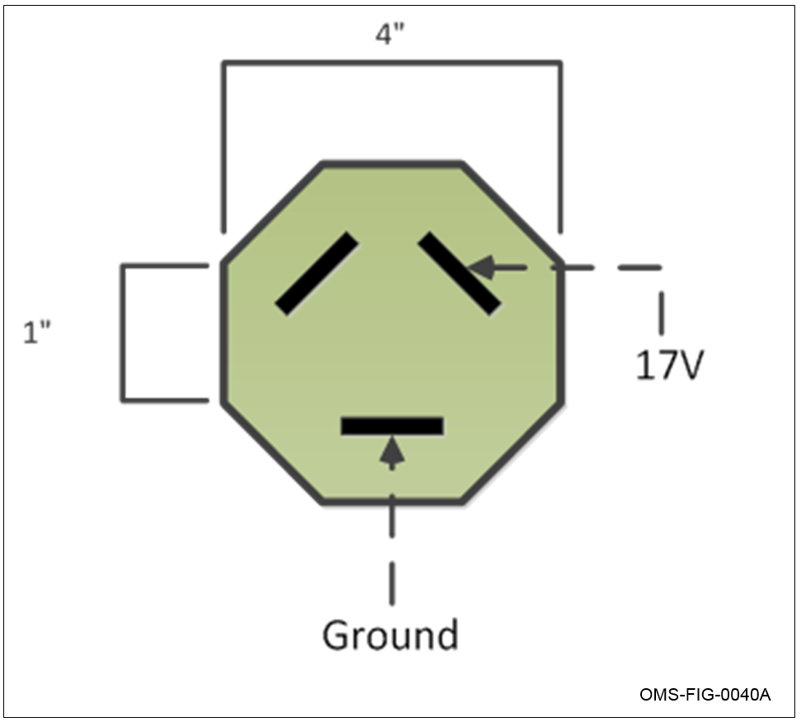
Figure 8.0-1 Plug Connection Diagram
External interface descriptions should include physical connection descriptions (cables, connectors, pin-out information) and interface transport information for each of the interfaces. In the case of a Platform-hosted Adapter, the external interfaces of a Subsystem occur within the Platform’s mission processing environment, so descriptions of physical interfaces are not required for messaging, Data Transfers and Security Information Exchanges.
This section should include a description of all protocols used by the Subsystem to transfer data to and from a file system, as well as transfer data directly from one Service/Subsystem to another. This list should be inclusive and any port not listed here is assumed to be disabled. Please provide a block diagram like the one shown in Figure 8.0-2, OMS Data Exchanges with a Platform-hosted OMS Adapter, to describe the data transfer interfaces that the Subsystem supports. At a minimum it should include the data storage types, transfer protocols, and any routing or gateways that are applicable. Please introduce this figure with a sentence if the figure is included in this section.
<< THE FOLLOWING IS AN EXAMPLE FIGURE AND CAPTION. INCLUDE AN APPROPRIATE FIGURE AND CAPTION IF APPLICABLE >>
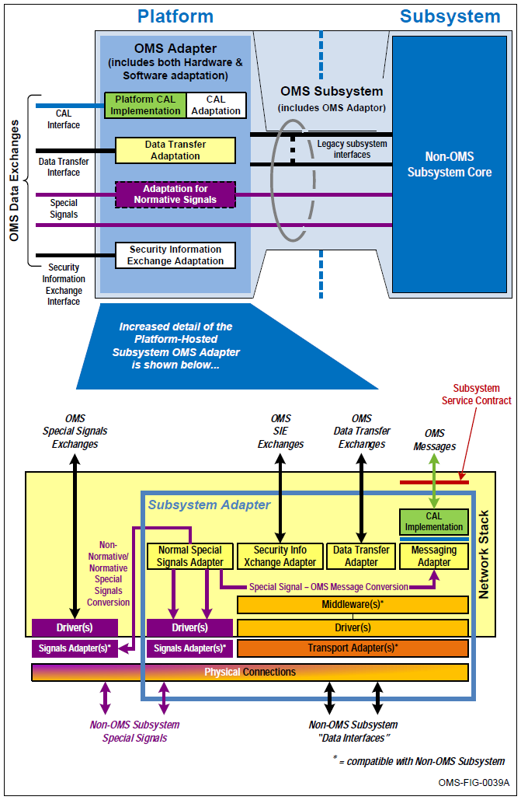
Figure 8.0-2 OMS Data Exchanges with a Platform-Hosted OMS Adapter

Open Ports and Protocols
All listening ports, specific to the Subsystem, that are open (accessible to the ASB) are listed in Table 8.1-1, OMS Subsystem Open Ports and Protocols. Ports and protocols of Services and Isolators are documented in their respective Service Contracts, not in this table. Any ports not listed are assumed closed.
The columns in Table 8.1-1, OMS Subsystem Open Ports and Protocols, should contain the following information on open ports and protocols on the Subsystem:
Port – The network port number and the TCP or UDP protocol being used
Protocol – The protocol being used on the open port
Process/Service – identify the process (e.g., on Linux, the netstat command will provide OS process names) or Service (e.g., on Linux, the nmap command will provide OS Service names) that has the port open
Purpose – The purpose of the open port
Restriction Mechanism – Identify the method(s) that are implemented or expected to constrain or restrict access to the listed port, protocol, and process. This should include identification of expected hardware, software, and algorithms associated with the mechanism. If no mechanisms are implemented or expected, input “None” in the cell.
Table 8.1-1 OMS Subsystem Open Ports and Protocols
Port  (TCP/UDP) | Protocol | Process/Service | Purpose | Restriction Mechanism
1025/TCP | NFSv3 | nfsd | NFS Server | iptables firewall
Add rows as required

Table 8.1-2, OMS Subsystem Product/Data and Data Transfer Servers, contains information on the products/data being sent or received by the Data Transfer server.
It is not used to identify products produced by Services running within the Subsystem; those products are documented within the applicable Service Contracts.
Product/Data – The product or data item being sent or received from the server
Format – The format of the product or data. Include reference to documents containing formatting details
Send/Receive – Send = upload, write or Receive = download, read
Data Transfer Server – The URI (or address) of the Data Transfer Server that data is being sent to or received from
Table 8.1-2 OMS Subsystem Product/Data and Data Transfer Servers
Product/Data | Format | Send/Receive | Data Transfer Server
Configuration File | ASCII File | Receive | nfs://10.2.1.12/cfg/
Add rows as required

Subsystem Data Transfer

Data Storage
This section identifies the Subsystem data storage capability as shown in Table 9.1-1, Subsystem Data Storage Details.
The columns in Table 9.1-1, Subsystem Data Storage Details, should contain the following information:
Data Store Address – The data store address of the TFTP/FTP/NFS/HTTP server which is addressable via a URI. If the address is configurable, it should be noted here and reference the document that provides guidance on changing its configuration
Data Store Label – The identifier for the data that is stored or retrieved. The Data Store Label must be a unique reference across this document’s table with the purpose to specify a range of cybersecurity attributes associated with the referenced data store
Shared Directories – The shared directories that are accessible via the data transfer protocols. Specifically if there are unique folders for OFPs, Configuration Files or Data Products, then each should be identified
Storage Capacity – The storage capacity allocated for the directory. Note: a separate row should be used for each directory if there are storage capacity limits per folder
Non-Volatile Storage (Yes/No) – If the storage stores data in volatile storage which is no longer accessible after a power-cycle, then input “No” otherwise input “Yes”
Protection In Place (No/C/I/CI):
No – if neither confidentiality nor integrity mechanisms are in place
C – Confidentiality mechanisms, such as encryption, are in place. If there is a confidentiality mechanism in place, the additional details must be listed in Table 9.1-3, Data Storage Confidentiality
I – Integrity mechanisms, such as digital signature, are in place. If there is an integrity mechanism in place, the additional details must be listed in Table 9.1-4, Data Storage Integrity
CI – Confidentiality and Integrity mechanisms are in place. If there are confidentiality and integrity mechanisms in place, the additional details must be listed in Table 9.1-3, Data Storage Confidentiality and Table 9.1-4, Data Storage Integrity
Data Transfer Protocols(s) – The supported protocols for accessing the data storage from either a Service or Subsystem. Refer to OMS Standard, OMSC-STD-001, “Data Transfer Formats, APIs, and Protocols,” and “Data Transfer Protocols and APIs” for the list of protocols that are allowed for Data Transfer.
Table 9.1-1 Subsystem Data Storage Details
Data Store Address | Data Store Label | Shared Directories | Storage Capacity | Non-Volatile Storage (Yes/No) | Protection In Place (No/C/I/CI) | Data Transfer Protocol(s)
192.168.0.5 | Subsystem FTP Server | /OFP/[Service name]/ | 1 TB | Yes | No | FTP
Add rows as required

Data Storage Access Controls
Table 9.1-2, Data Storage Access Control Mechanisms, details the data storage access controls.
The table entries should specify the methods for identification, authentication, access restrictions and audit logging. The following table provides a template for file based data transfer protocol details.
The columns in Table 9.1-2, Data Storage Access Control Mechanisms, should contain the following information. A separate section within the table should be used for each Data Transfer protocol listed in Table 9.1-1, Subsystem Data Storage Details.
Mechanism – This column lists the Access Control mechanisms.
Identification – The mechanism used to identify users (e.g., Unique usernames and client IP addresses are used to uniquely identify ftp users)
Authentication – The mechanism used to authenticate users and permitted to use the resource (e.g., All remote ftp users are authenticated via unique username and password combinations)
Access Control – The mechanisms put in place to restrict users, associated access and resources (e.g., The FTP Server Access Control consists of the restricting users (ftpusers), restricting commands (ftpaccess) and allowing only identified hosts being able to access the server (ftphosts). Uploads are restricted by users or groups into identified folders and file downloads of specific files are prevented (ftpaccess). Accounts are restricted to FTP access only by limiting shell access (/bin/false))
Audit Logging – The mechanism used to perform logging of data transfer resource access (e.g., All commands issued by FTP users are logged as specified in the configuration (ftpaccess))
Implementation Summary – the Implementation Summary column should contain a brief Summary of how the Mechanism is implemented
Table 9.1-2 Data Storage Access Control Mechanisms
Mechanism | Implementation Summary
FTP Server
Identification | Unique usernames and client IP addresses are used to uniquely identify FTP users.
Authentication | All remote FTP users are authenticated via unique username and password combinations
Access Control | Folders and files have permissions based on client group and host, following FTP authentication.
Audit Logging | All commands issued by FTP users are logged as specified in the configuration (ftpaccess).
NFS Server
Identification | Unique usernames and client IP addresses are used to uniquely identify NFS users.
Authentication | All remote NFS users are authenticated via unique username and password combinations
Access Control | The NFS Server Access Control consists of the restricting users (root_squash), restricting shared directories (/etc/exports) and allowing only identified hosts being able to access the server (/etc/hosts.allow).
Audit Logging | All commands issued by NFS users are logged as specified in the configuration (/etc/nfs/nfslog.conf).

Data Storage Confidentiality Mechanisms
This section identifies the specific confidentiality mechanisms (e.g., host-based firewall) and use of encryption within the Data Storage as shown in Table 9.1-3, Data Storage Confidentiality.
The columns in Table 9.1-3, Data Storage Confidentiality, should contain the following information:
Data Store Address – The data store address of the TFTP/FTP/NFS/HTTP server which is addressable via a URI. If the address is configurable, it should be noted here and reference the document that provides guidance on changing its configuration
Data Store Label – The identifier for the data that is stored or retrieved. The Data Store Label must be a unique reference across this document’s tables with the purpose to specify a range of cybersecurity attributes associated with the referenced data store
Protected Data – The information items to which the confidentiality mechanism is applied
Confidentiality Mechanism – Identify the method(s) used by the Subsystem to provide confidentiality. This should include identification of applicable hardware, software, and algorithm associated with the implemented mechanism
Implementation Details – Details on how the confidentiality mechanism is implemented and/or include a reference to other documents and any additional information for clarification.
Table 9.1-3 Data Storage Confidentiality
Data Store Address | Data Store Label | Protected Data | Confidentiality  Mechanism | Implementation Details
192.168.0.5 | FTP Data Store | Applications and Payload Products | AES256 GCM Mode | See DataStore-Encryption.docx for further details
Add rows as required

Data Storage Integrity Mechanisms
This section identifies the specific integrity mechanisms within the Data Storage as shown in Table 9.1-4, Data Storage Integrity.
The columns in Table 9.1-4, Data Storage Integrity, should contain the following information:
Data Store Address – The data store address of the TFTP/FTP/NFS/HTTP server which is addressable via a URI. If the address is configurable, it should be noted here and reference the document that provides guidance on changing its configuration
Data Store Label – The identifier for the data that is stored or retrieved. The Data Store Label must be a unique reference across this document’s tables with the purpose to specify a range of cybersecurity attributes associated with the referenced data store
Protected Data – The information items to which the integrity mechanism is applied
Integrity Mechanism – Identify the method(s) used by the Subsystem to provide integrity. This should include identification of applicable hardware, software, and algorithm associated with the implemented mechanism
Implementation Details – Details on how the integrity mechanism is implemented and/or include a reference to other documents and any additional information for clarification.
Table 9.1-4 Data Storage Integrity
Data Store  Address | Data Store Label | Protected Data | Integrity  Mechanism | Implementation Details
192.168.0.5 | FTP Data Store | Applications & Payload Products | SHA-256 | Hash values calculated and provided in ProductMetadata
Add rows as required

Data Transfer Confidentiality Mechanisms for Data Storage
This section identifies the confidentiality mechanisms the Subsystem supports for data transfers to the Subsystem data storage as shown in Table 9.2-1, Data Transfer Confidentiality Mechanisms.
The columns in Table 9.2-1, Data Transfer Confidentiality Mechanisms, should contain the following information:
Protected Data – The information items to which the confidentiality mechanism is applied
Confidentiality Mechanism – Identify the method(s) used by the Subsystem to provide confidentiality. This should include identification of applicable hardware, software, and algorithm associated with the implemented mechanism. For Secure Data transfers utilizing a VPN solution (e.g., IPsec, SSL) provide the implementation software name (e.g., strongSwan), type of VPN, and a pointer to the configuration file
Implementation Details – Details on how the confidentiality mechanism is implemented and/or include a reference to other documents and any additional information for clarification.
Table 9.2-1 Data Transfer Confidentiality Mechanisms
Protected Data | Confidentiality Mechanism | Implementation Details
Config File | AES256 CBC Mode | Decrypted using AES-256 algorithm upon receipt
Add rows as required

Data Transfer Integrity Mechanisms for Data Storage
This section identifies the integrity mechanisms the Subsystem supports for data transfers to the Subsystem data storage as shown in Table 9.3-1, Data Transfer Integrity Mechanisms.
The columns in Table 9.3-1, Data Transfer Integrity Mechanisms, should contain the following information:
Protected Data – The information items to which the integrity mechanism is applied
Integrity Mechanism – Identify the method used by the Subsystem to provide integrity. This should include identification of applicable hardware, software, and algorithm associated with the implemented mechanism
Implementation Details – Details on how the integrity mechanism is implemented and/or include a reference to other documents and any additional information for clarification.
Table 9.3-1 Data Transfer Integrity Mechanisms
Protected Data | Integrity Mechanism | Implementation Details
Mission Data File | Hash/Digital Signature | Mission Data File is digitally signed
Add rows as required

Data Transfer Configuration for Data Storage
This section identifies the Data Transfer methods provided by the Subsystem and the configuration details associated with the Data Transfer methods to the Subsystem data storage as shown in Table 9.4-1, Subsystem Data Transfer Configuration.
Example Data Transfer methods are: IPv4 and/or IPv6, NFS - version x, UDP transport, no client authentication, etc.
The columns in Table 9.4-1, Subsystem Data Transfer Configuration, should contain the following information:
Data Transfer Server – A resolvable location or URI for each server on the Subsystem. Refer to OMS Standard, OMSC-STD-001, “OMS URI Formats,” for the content and format of URIs that may be used for the allowed protocols
Data Transfer Protocol – This column should be one of the supported Data Transfer Protocols. Every supported protocol should be documented in its own row
Version – This column should identify the specific version of the Data Transfer Protocol. Use SCAP nomenclature if available and appropriate. For example FTP-0.10.-11.1
Configuration Details – This column should identify any specific configuration details for a given Data Transfer Protocol. For example, specific protocol versions, unsupported commands, configured ports, share limitations, should be indicated.
Table 9.4-1 Subsystem Data Transfer Configuration
Data Transfer Server | Data Transfer Protocol | Version | Configuration Details
Error! Hyperlink reference not valid. | FTP | FTP-0.10.-11.1 | passive ftp only (ports: 50000-50009)
NFS://<something> | NFS | nfs-utils – 1.2.3 | NFSv3, Portmapper (port:111), read only export (/ofp/), read/write export (/data/), secure-ports (1-1024) from NFS clients
RTP://<something> | RTP | FFmpeg 3.1.2 | IPV4 UDP, H.264 format, 10-60fps, 1080p
Add rows as required

Subsystem Internal Interfaces
Table 10.0-1, Subsystem Internal ICDs, describes the non-OMS subsystem internal interfaces that are exposed when the Subsystem is installed in the Mission Package.
This section is applicable for Platform-hosted applications, or other applications where Subsystem internal interfaces are exposed when installed into the Mission Package, which may consume Platform resources such as Ethernet bandwidth or which will need to be identified for use in troubleshooting or investigating alternative configurations/installations at a later time. Otherwise this section should be marked as “Not Applicable”.
In the case where an Adapter is present, the description of the interfaces between the non-OMS subsystem and the Adapter should be included in this section, including a reference to the non-OMS subsystem software ICD. In all cases, interfaces between physically separate components of a Subsystem should be included in this section. Please use this section to summarize in paragraph form the non-OMS subsystem interfaces to the Adapter. This section should also include the description of Subsystem internal interfaces a Platform-hosted Adapter uses to create each of the four OMS Data Exchange types (OMS Messaging, Data Transfer, Special Signals, and Security Information Exchanges).
This section can provide a reference to the Subsystem hardware ICD where all physical data and signal interfaces (including cables, connectors and pin-out information) between a non-OMS subsystem and Platform-hosted Adapter, and/or between physically separate components of a Subsystem, are identified and described. List these references in Table 10.0-1, Subsystem Internal ICDs.
To preserve document formatting, if this section is not applicable, mark as “Not Applicable” with a rationale and the first empty cell of the table with “N/A”.
Table 10.0-1, Subsystem Internal ICDs, should contain the following information:
Title – Name of the document
Reference – Unique identifier for the document’s configuration control
Date/Revision – Date and release version for the document.
Table 10.0-1 Subsystem Internal ICDs
Title | Reference | Date | Revision
Add rows as required

Open Computing Environment (OCE)
This section documents the Subsystem’s OCE OMS mission processing architecture and describes specific tool chains for building in the OCE environment.
If an OCE is not provided, then document this section and its subsections as “Not Applicable” with a rationale.

OCE Processor Types, Operating Systems, and Configuration
This section documents the processor architecture/type, processor memory, processor quantity, and operating systems (type and 32 or 64 bit) for each processor in the OCE.

General Environment
This section documents the general environment provided by the OCE.

Build Environment and Tool Chain
This section documents the specific build environment for an OCE.
This identifies supported compilers and specific compiler options that are required to build a Service in the OCE provided by this Subsystem.
This section documents the specific binary format for any OCE provided binaries. This will include the format of the CAL libraries that will run in the OCE.
This section documents how a Service is compiled for an OCE target implementation. This section gives explicit instructions for building for a particular OCE target.

Isolation Layer
This section documents the implemented Façade interfaces for this OCE provided by this Subsystem as defined in the OMS OS Façade Specification.
This section documents how the Façade implementation supports the Data Transfer methods, if specific client versions of software are used for Data Transfer on the OCE, these should be called out as well.

Time
This section documents how time synchronization is supported by the OCE.
This section should include how time is provided to applications and the method for setting the system clock.

Java Environment
This section documents the specific Java environment provided by the Java-based OCE.
If a Java-based OCE is not provided per system policy, then this section will be identified as “Not allowed per system policy.”

Build Environment and Tool Chain
This section documents the specific build environment for a Java-based OCE.
This section should identify any Java tool chains required for building a Java Service for running in the Java-based OCE.
This section documents how a Service is compiled for an OCE target implementation. This section gives explicit instructions for building for a particular OCE target.

Java Data Transfer
This section documents the C/C++ libraries (if any) that are provided as part of the Java-based OCE and that the Java environment is reliant upon in order to perform data transfer operations.
Via its JNI interface, the Java environment will use the support provided by these libraries to transfer data to and from applications running in the Java environment. If the Java environment is reliant upon specific versions of these libraries, then those versions should be documented as well.

Time
This section documents how time synchronization is supported by the Java-based OCE.
This section should include how time is provided to applications and the method for setting the system clock.

Virtualization Environment
This section identifies if there is a Virtual Machine (VM)-based processing architecture on the Subsystem.
If there is no Virtual Environment on the OMS Subsystem then document this section and its subsections as “Not Applicable” with a rationale. This section describes the virtual environment that will host a virtual appliance that supports a Façade-based OCE, a Java-based OCE, or both.

Hypervisor
This section documents the specific hypervisor provided by the virtualization-based OCE, which includes the following:

Processor
This section identifies if the virtualization approach is hardware assisted or if a full virtualization approach is used.

Memory Virtualization
This section identifies the memory virtualization approach.
This section should contain a description of the memory virtualization approach.

Network Virtualization
This section identifies the virtual network for each deployed virtual appliance.
This section should contain a description of the virtual network for each deployed virtual appliance.

Time
This section documents how time synchronization is supported by the VM OCE.
This section should include how time is provided to applications and the method for setting the system clock.

Service Deployment
This section documents how Services are deployed and managed within the OCE.
This includes any provisions for VMs/Appliances, Containerization, etc. This should identify requirements placed on a Service to run in the environment and for using a CAL or Data Transfer. This section should also document any management functionality of Service packaging.

Test Procedures & Data
This section identifies relevant available test procedures that were used to integrate, verify and/or assess OMS compliance of the Subsystem.
If no test procedures are referenced, mark this section as not applicable. This section can be completed in paragraph form or with a table. If you use a table, please introduce the table with a sentence. If you make this section not applicable, please state so in a sentence. If possible, please provide a summary of the testing that is described in the test procedures, for example, what is lab testing, flight testing, simulated, live, comprehensive, stressing, etc.

Cybersecurity Posture
This section identifies the cybersecurity posture of the Subsystem.
Describe the Cybersecurity posture of the Subsystem. The Cybersecurity Posture Section should describe the Cybersecurity posture implementation of the Subsystem. The addendum may include classified implementation details with reference to Interface Control Documents (ICDs). The Cybersecurity posture as characterized by the Cyber Survivability Risk Category (CSRC) identifies the level of rigor needed to describe the OMS Cybersecurity features that fall under the applicable Cyber Survivability Attributes (CSAs).
The Cybersecurity posture descriptions are in summary format with a pointer to an external unclassified, non-proprietary document or detailed in the follow section including diagrams to relay the implementation.

Cyber Survivability Attributes (CSAs)
This section identifies the CSAs applicable to the Subsystem.

Prevent CSAs
This section identifies and documents the System Survivability Key Performance Parameter (KPP) Prevent CSAs implementation for the Subsystem. Table 13.1-1 identifies the System Survivability KPP Prevent CSAs applicable to the Subsystem.
In the table below, indicate the CSAs applicable to the Subsystem by adding an “x”. If the CSAs are not applicable or not addressed, denote this section with “N/A” and leave Table 13.1-1 empty.
Table 13.1-1 Applicable System Survivability KPP Prevent CSAs
CSA-01 | CSA-02 | CSA-03 | CSA-04 | CSA-05 | CSA-06

For applicable CSAs, provide a brief, high-level description (1-2 sentences) of how each Cyber Survivability Attribute (CSA) identified in Table 13.1-1 is explicitly addressed by the OMS Subsystem. The description should be unclassified and non-proprietary, and capture the cybersecurity posture. The cybersecurity posture should be commensurate with the expected CSRC.
CSA-01: Control Access
CSA-02: Reduce System’s Cyber Detectability
CSA-03: Secure Transmissions and Communication
CSA-04: Protect System’s Information from Exploitation
CSA-05: Partition and Ensure Critical Functions at Mission Completion Performance Levels
CSA-06: Minimize and Harden Attack Surfaces
If an external source is referenced for additional information on the CSA implementation, denote this with a reference to the unclassified, non-proprietary document. If referencing a previous section, denote this with a reference to the applicable SDD section(s). See the Cybersecurity Guide for more information.

Mitigate CSAs
This section identifies and documents the System Survivability KPP Mitigate CSAs implementation for the Subsystem. Table 13.1-2 identifies the System Survivability KPP Mitigate CSAs applicable to the Subsystem.
In the table below, indicate the CSAs applicable to the Subsystem by adding an “x”. If the CSAs are not applicable or not addressed, denote this section with “N/A” and leave Table 13.1-2 empty.
Table 13.1-2 Applicable System Survivability KPP Mitigate CSAs
CSA-07 | CSA-08

For the applicable CSAs, provide a brief, high-level description (1-2 sentences) of how each Cyber Survivability Attribute (CSA) is explicitly addressed by the Subsystem. The description should be unclassified and non-proprietary, and capture the cybersecurity posture. The cybersecurity posture should be commensurate with the expected CSRC.
CSA-07 Baseline and Monitor Systems and Detect Anomalies
CSA-08 Manage System Performance and Enable Cyberspace
If an external source is referenced for additional information on the CSA implementation, denote this with a reference to the unclassified, non-proprietary document. If referencing a previous section, denote this with a reference to the applicable SDD section(s). See the Cybersecurity Guide for more information.

Recover CSA
This section identifies and documents the System Survivability KPP Recover CSA implementation for the Subsystem.
Provide a brief, high-level description (1-2 sentences) of how the CSA-09 Recover System Capabilities is explicitly addressed by the Subsystem. The description should be unclassified and non-proprietary, and capture the cybersecurity posture. The cybersecurity posture should be commensurate with the expected CSRC.
If an external source is referenced for additional information on the CSA implementation, denote this with a reference to the unclassified, non-proprietary document. If referencing a previous section, denote this with a reference to the applicable SDD section(s). See the Cybersecurity Guide for more information.
If the CSA is not applicable or not addressed, denote this with “N/A”.

Adapt CSA
This section identifies and documents the System Survivability KPP Adapt CSA implementation for the Subsystem.
Provide a brief, high-level description (1-2 sentences) of how the CSA-10 Actively Manage System’s Configuration to Achieve and Maintain an Operationally-Relevant Cyber Risk Posture is explicitly addressed by the Subsystem. The description should be unclassified and non-proprietary, and capture the cybersecurity posture. The cybersecurity posture should be commensurate with the expected CSRC.
If an external source is referenced for additional information on the CSA implementation, denote this with a reference to the unclassified, non-proprietary document. If referencing a previous section, denote this with a reference to the applicable SDD section(s). See the Cybersecurity Guide for more information.
If the CSA is not applicable or not addressed, denote this with “N/A”.

Security Addendum
This section identifies the Security Addendum document(s).
The Security Addendum is expected to be external to the SDD and can be composed of one or more separate documents that:
Might already be existing/planned program documents that could be referenced to supply OMS-related information,
Might have to be published at different security levels, and
Could be developed/published at different points in the program lifecycle.
The name of the document(s) must be unclassified and non-proprietary. Referenced documents may be both classified and proprietary. The Security Addendum should describe the Security Information Exchanges implemented by the Subsystem and provides additional, classified and/or proprietary details relating to the security of the Subsystem. The addendum may include classified implementation details with reference to Interface Control Documents (ICDs).
- Appendix A Acronyms and Abbreviations
This section lists the abbreviations and acronyms used in this document not a copy of the OMS lexicon as shown in Table A.0-1, List of Acronyms and Abbreviation Definitions.
In addition, acronyms should be spelled out at first use in the body of the document.
Table A.0-1 List of Acronyms and Abbreviation Definitions
Acronym/Abbreviation | Definition
ASB | Abstract Service Bus
CAL | Critical Abstraction Layer
CSA | Cyber Survivability Attribute
CSRC | Cyber Survivability Risk Category
ICD | Interface Control Document
KPP | Key Performance Parameter
OACWG | Open Architecture Collaborative Working Group
OAM | Open Architecture Management
OCE | Open Computing Environment
OMS | Open Mission Systems
UCI | Universal C2 Interface
UML | Unified Modeling Language
Add rows as required

- Appendix B Glossary
This section lists the terms used in this document as shown in Table B.0-1, List of Term Definitions.
Note: the list of terms used should not be a copy of the OMS lexicon.
Table B.0-1 List of Term Definitions
Term | Definition
Abstract Service Bus | The Abstract Service Bus (ASB) is an intermediary that allows mission Service functions to be widely available to other mission services, Subsystems, and resources. The ASB implements the CAL, Data Transfer interfaces, Special Signal interfaces, and Security Exchange interfaces. The ASB also defines the physical interfaces.
Add rows as required

