Open Mission Systems (OMS)
Definition And Documentation (D&D)
Service Contract Template

22 january 2026
Prepared By:
Open Architecture Collaborative Working Group (OACWG)

<REQUIRED: Service Contract Title>

<OPTIONAL: Organizational Logo>

<REQUIRED: Date as DD Month YYYY>

<OPTIONAL: Other labeling as appropriate>

Prepared by:

<REQUIRED: Organization>
<OPTIONAL: Address>

<OPTIONAL: Approval Signatures>

This page is intentionally left blank.

Abstract
Required: Insert program specific abstract summary details here for the OMS Subsystem, Service, or Isolator.
Open Mission Systems (OMS) is a non-proprietary open architecture for integrating subsystems and services into mission packages.
This Service Contract complies with the Service Contract Template, OMSC-TMP-003, Revision M, dated 22 January 2026.
The template is prescribed by the OMS Standard Version 2.5, OMSC-STD-001, Revision M, dated 22 January 2026.

This page is intentionally left blank.
Revision Record
REVISION | DATE | DESCRIPTION

This page is intentionally left blank.

Table of Contents
1 Overview 1
1.1 References 1
1.2 OMS Environment Specifications 1
1.2.1 Externalizer Specifications 2
1.2.2 CAL Operational Attributes 2
1.3 Classification 2
1.4 Known Limitations 3
1.5 System Requirements 3
1.5.1 Hardware Requirements 3
1.5.2 Operating Systems 3
1.6 Data Transfer 3
1.6.1 Data Items for OMS Data Transfer 3
1.6.2 Data Items for Non-OMS Data Transfer 5
1.6.3 Data Transfer Configuration 7
1.6.4 Data Transfer Ports and Protocols 9
1.6.5 Data Transfer Confidentiality Mechanisms 11
1.6.6 Data Transfer Integrity Mechanisms 11
1.6.7 Data Transfer Boundary Protection Mechanisms 11
1.6.8 Data Transfer Failure Behaviors 11
1.7 Data Storage 11
1.8 External Data Dependencies 11
1.8.1 Configuration 12
1.9 Additional Prerequisites 12
1.9.1 Dependencies 12
1.9.2 Licenses 12
1.10 Service Level Agreements 12
1.10.1 Capacity/Performance 12
1.10.2 Handling Time Characteristics 12
1.10.3 Availability Category 13
1.11 Special Signals 13
2 Lifecycle Management 14
2.1 Packaging and Deployment 14
2.2 Initialization 14
2.3 Restart 14
2.4 Shutdown 14
3 Functions 15
3.1 Required Service Functions 17
3.1.1 Service Initialization 17
3.1.1.1 Service Initialization Description 17
3.1.1.2 Service Initialization Preconditions 17
3.1.1.3 Service Initialization Reporting Interval 17
3.1.1.4 Service Initialization Inputs and Outputs 18
3.1.1.5 Service Initialization Workflow and Orchestration 19
3.1.1.6 Service Initialization Post Conditions 19
3.1.1.7 Service Initialization Error Handling 19
3.1.2 Service Status 19
3.1.2.1 Service Status Description 19
3.1.2.2 Service Status Preconditions 19
3.1.2.3 Service Status Reporting Interval 19
3.1.2.4 Service Status Inputs and Outputs 20
3.1.2.5 Service Status Workflow and Orchestration 21
3.1.2.5.1 Allowed States and Transitions 21
3.1.2.5.2 Service Status Sequence Diagram 22
3.1.2.6 Service Status Post Conditions 24
3.1.2.7 Service Status Error Handling 24
3.2 Required Subsystem Functions 24
3.2.1 Subsystem Startup 24
3.2.1.1 Subsystem Startup Description 24
3.2.1.2 Subsystem Startup Preconditions 24
3.2.1.3 Subsystem Startup Reporting Interval 24
3.2.1.4 Subsystem Startup Inputs and Outputs 25
3.2.1.5 Subsystem Startup Workflow and Orchestration 26
3.2.1.6 Subsystem Startup Post Conditions 26
3.2.1.7 Subsystem Startup Error Handling 26
3.2.2 Subsystem Status 26
3.2.2.1 Subsystem Status Description 26
3.2.2.2 Subsystem Status Preconditions 26
3.2.2.3 Subsystem Status Reporting Interval 26
3.2.2.4 Subsystem Status Inputs and Outputs 27
3.2.2.5 Subsystem Status Workflow and Orchestration 28
3.2.2.5.1 Allowed States and Transitions 28
3.2.2.5.2 Subsystem Status Sequence Diagram 30
3.2.2.6 Subsystem Status Post Conditions 31
3.2.2.7 Subsystem Status Error Handling 31
3.2.3 Subsystem State Command Processing 31
3.2.3.1 Subsystem State Command Processing Description 31
3.2.3.2 Subsystem State Command Processing Preconditions 31
3.2.3.3 Subsystem State Command Processing Reporting Interval 31
3.2.3.4 Subsystem State Command Processing Inputs and Outputs 32
3.2.3.5 Subsystem State Command Processing Workflow and Orchestration 33
3.2.3.6 Subsystem State Command Processing Post Conditions 33
3.2.3.7 Subsystem State Command Processing Error Handling 33
3.2.4 Subsystem Built-In Test (BIT) 33
3.2.4.1 Subsystem BIT Description 33
3.2.4.2 Subsystem BIT Preconditions 33
3.2.4.3 Subsystem BIT Reporting Interval 34
3.2.4.4 Subsystem BIT Inputs and Outputs 35
3.2.4.5 Subsystem BIT Workflow and Orchestration 36
3.2.4.6 Subsystem BIT Post Conditions 36
3.2.4.7 Subsystem BIT Error Handling 36
3.2.5 Subsystem Calibration 36
3.2.5.1 Subsystem Calibration Description 36
3.2.5.2 Subsystem Calibration Preconditions 36
3.2.5.3 Subsystem Calibration Reporting Interval 36
3.2.5.4 Subsystem Calibration Inputs and Outputs 37
3.2.5.5 Subsystem Calibration Workflow and Orchestration 38
3.2.5.6 Subsystem Calibration Post Conditions 38
3.2.5.7 Subsystem Calibration Error Handling 38
3.2.6 Subsystem Shutdown 38
3.2.6.1 Subsystem Shutdown Description 38
3.2.6.2 Subsystem Shutdown Preconditions 38
3.2.6.3 Subsystem Shutdown Reporting Interval 38
3.2.6.4 Subsystem Shutdown Inputs and Outputs 39
3.2.6.5 Subsystem Shutdown Workflow and Orchestration 40
3.2.6.6 Subsystem Shutdown Post Conditions 40
3.2.6.7 Subsystem Shutdown Error Handling 40
3.3 Required Capability-related Functions 40
3.3.1 Position Information Processing 40
3.3.1.1 Position Information Processing Description 40
3.3.1.2 Position Information Processing Preconditions 40
3.3.1.3 Position Information Processing Reporting Interval 40
3.3.1.4 Position Information Processing Inputs and Outputs 41
3.3.1.5 Position Information Processing Workflow and Orchestration 42
3.3.1.6 Position Information Processing Post Conditions 42
3.3.1.7 Position Information Processing Error Handling 42
3.3.2 [CapabilityName] Capability-related Functions 42
3.3.2.1 [CapabilityName] Capability and Capability Status 42
3.3.2.1.1 [CapabilityName] Capability and Capability Status Description 42
3.3.2.1.2 [CapabilityName] Capability and Capability Status Preconditions 42
3.3.2.1.3 [CapabilityName] Capability and Capability Status Reporting Interval 42
3.3.2.1.4 [CapabilityName] Capability and Capability Status Inputs and Outputs 43
3.3.2.1.5 [CapabilityName] Capability and Capability Status Workflow and Orchestration 44
3.3.2.1.6 [CapabilityName] Capability and Capability Status Post Conditions 44
3.3.2.1.7 [CapabilityName] Capability and Capability Status Error Handling 44
3.3.2.2 [CapabilityName] Capability Enable/Disable 44
3.3.2.2.1 [CapabilityName] Capability Enable/Disable Description 44
3.3.2.2.2 [CapabilityName] Capability Enable/Disable Preconditions 44
3.3.2.2.3 [CapabilityName] Capability Enable/Disable Reporting Interval 44
3.3.2.2.4 [CapabilityName] Capability Enable/Disable Inputs and Outputs 45
3.3.2.2.5 [CapabilityName] Capability Enable/Disable Workflow and Orchestration 46
3.3.2.2.6 [CapabilityName] Capability Enable/Disable Post Conditions 46
3.3.2.2.7 [CapabilityName] Capability Enable/Disable Error Handling 46
3.3.2.3 [CapabilityName] Capability Operations 46
3.3.2.3.1 [CapabilityName] Capability Operations Description 46
3.3.2.3.2 [CapabilityName] Capability Operations Preconditions 46
3.3.2.3.3 [CapabilityName] Capability Operations Reporting Interval 46
3.3.2.3.4 [CapabilityName] Capability Operations Inputs and Outputs 47
3.3.2.3.5 [CapabilityName] Capability Operations Workflow and Orchestration 48
3.3.2.3.6 [CapabilityName] Capability Operations Post Conditions 48
3.3.2.3.7 [CapabilityName] Capability Operations Error Handling 48
3.4 Specific Functions 48
3.4.1 [FunctionName] 48
3.4.1.1 [FunctionName] Description 48
3.4.1.2 [FunctionName] Preconditions 48
3.4.1.3 [FunctionName] Reporting Interval 48
3.4.1.4 [FunctionName] Inputs and Outputs 49
3.4.1.5 [FunctionName] Workflow and Orchestration 50
3.4.1.6 [FunctionName] Post Conditions 50
3.4.1.7 [FunctionName] Error Handling 50
4 Non-OMS Messages 51
5 Change Request Identification 52
6 Cybersecurity Posture 53
6.1 Cyber Survivability Attributes (CSAs) 53
6.1.1 Prevent CSAs 53
6.1.2 Mitigate CSAs 53
6.1.3 Recover CSA 53
6.1.4 Adapt CSA 53
7 Security Addendum 54
A Appendix A Acronyms and Abbreviations 55
B Appendix B Glossary 56
C Appendix C Message Details 57

List of Figures
Figure 3.1-1 Service Status State Diagram 21
Figure 3.1-2 Allowed Service State Transitions 22
Figure 3.1-3 Service Status Sequence Diagram 23
Figure 3.1-4 Service Status Data Request Response Rules 23
Figure 3.2-1 Subsystem Status State Diagram 28
Figure 3.2-2 Allowed Subsystem State Transitions 29
Figure 3.2-3 Subsystem Status Sequence Diagram 30
Figure 3.2-4 Subsystem Status Data Request Response Rules 31

This page is intentionally left blank.

List of Tables
Table 1.1-1 Reference Documents 1
Table 1.2-1 Environment Specifications 1
Table 1.2-2 OMS Message Set 1
Table 1.2-3 Externalizer Version Information 2
Table 1.2-4 SOAC-1 2
Table 1.5-1 Hardware Requirements 3
Table 1.5-2 Compatible Operating Systems 3
Table 1.6-1 Data Items for OMS Data Transfer 4
Table 1.6-2 Data Items for Non-OMS Data Transfer 6
Table 1.6-3 Data Transfer Configuration 8
Table 1.6-4 Open Ports and Protocols 10
Table 1.6-5 Data Transfer Confidentiality 11
Table 1.6-6 Data Transfer Integrity 11
Table 1.9-1 Dependencies 12
Table 1.9-2 Licenses 12
Table 1.11-1 OMS Special Signals 13
Table 1.11-2 Non-OMS Special Signals 13
Table 3.0-1 Function List 15
Table 3.1-1 Service Initialization Inputs and Outputs 18
Table 3.1-2 Service Status Inputs and Outputs 20
Table 3.2-1 Subsystem Startup Inputs and Outputs 25
Table 3.2-2 Subsystem Status Inputs and Outputs 27
Table 3.2-3 Subsystem State Command Processing Inputs and Outputs 32
Table 3.2-4 Subsystem BIT Inputs and Outputs 35
Table 3.2-5 Subsystem Calibration Inputs and Outputs 37
Table 3.2-6 Subsystem Shutdown Inputs and Outputs 39
Table 3.3-1 Position Information Processing Inputs and Outputs 41
Table 3.3-2 [CapabilityName] Capability and Capability Status Inputs and Outputs 43
Table 3.3-3 [CapabilityName] Capability Enable/Disable Inputs and Outputs 45
Table 3.3-4 [CapabilityName] Capability Operations Inputs and Outputs 47
Table 3.4-1 [FunctionName] Inputs and Outputs 49
Table 4.0-1 Non-OMS Messages 51
Table 5.0-1 Change Request Identification 52
Table 6.1-1 Applicable System Survivability KPP Prevent CSAs 53
Table 6.1-2 Applicable System Survivability KPP Mitigate CSAs 53
Table A.0-1 List of Acronyms and Abbreviation Definitions 55
Table B.0-1 List of Term Definitions 56

This page is intentionally left blank.

Proprietary Notice: This document contains only non-proprietary information. Referenced documents conform to the Proprietary Notice statement for each major sub section.

Overview
Proprietary Notice: References to external documents that provide for the data in this section refer only to non-proprietary documents, except where otherwise noted in specific sub-sections that may refer to proprietary documents.
Notice for all Service Contract creators/readers: This Service Contract applies to Subsystems, Services, and Isolators. Every occurrence of the term “Service” by itself really means “Subsystem, Service, or Isolator”.
This section provides the Service details, name, contact information, and version of the Service.

References
Proprietary Notice: References to external documents that provide for the data in this section may refer to proprietary documents.
This section lists all the referenced documents that are required to support the integration of this Service as shown in Table 1.1-1, Reference Documents.
Table 1.1-1 Reference Documents
Document Number | Document Title | Revision | Date
OMSC-STD-001 | OMS Standard Version 2.5 | M | 22 January 2026
OMSC-TMP-003 | Service Contract Template | M | 22 January 2026

OMS Environment Specifications
This Service is designed for the OMS environment described in Table 1.2-1, Environment Specifications, and Table 1.2-2, OMS Message Set.
Table 1.2-1 Environment Specifications
CAL Name | OMS Specification Version | CAL Implementation Version | Programming Language | OS | OS Version
Table 1.2-2 OMS Message Set
Baseline OMS Message Schema Version | Extension Schemas

Externalizer Specifications
This Service is designed for the optional Externalizer as described in Table 1.2-3, Externalizer Version Information.
Table 1.2-3 Externalizer Version Information
Externalizer Name | Language/Environment | Encoding | Schema Version | CAL API (OMS Version) | Vendor | Externalizer Version | Reference Documentation

CAL Operational Attributes
This section documents the operational attributes of each supported CAL. These attributes are captured in a Supported Operational Attribute Configuration (SOAC) table. Since a CAL can support different configurations of operational attributes, this Service Contract should specify the supported values of these operational attributes in one or more tables, as needed. The first configuration is shown in Table 1.2-4, SOAC-1.
Table 1.2-4 SOAC-1
SOAC-1
Operational Attribute | Value |  | Notes
CAL READER | MIN | MAX
Queue Length
Filter Time
Expiration Time
Overflow Action
Reliability
CAL WRITER | MIN | MAX
Queue Length
Overflow Action
Reliability

Classification
This section lists the minimum classification level of the compiled Service.
___Unclassified
___Secret
___Top Secret
___Other

Known Limitations
This section describes the known limitations of logical functionality of the Service.

System Requirements
Proprietary Notice: References to external documents that provide for the data in this section may refer to proprietary documents.
This section describes the hardware and operating system requirements to run this Subsystem, Service, or Isolator in the Mission Package’s OCE or Other Mission Processing.

Hardware Requirements
This section describes the minimum and recommended hardware to run this Service in the Mission Package’s OCE or Other Mission Processing, as shown in Table 1.5-1, Hardware Requirements.
Table 1.5-1 Hardware Requirements
Article | Minimum Hardware Requirements | Recommended Hardware

Operating Systems
This section specifies what operating systems are supported by this Service as shown in Table 1.5-2, Compatible Operating Systems.
Table 1.5-2 Compatible Operating Systems
Operating System Name | Version | Notable Characteristics

Data Transfer
This section provides interface information for data items provided or digested by this Service.

Data Items for OMS Data Transfer
This section describes the data items for any OMS Data Transfer used by the Service as shown in Table 1.6-1, Data Items for OMS Data Transfer. The contents of the columns in Table 1.6-1, Data Items for OMS Data Transfer, comply with the OMS Standard, OMSC-STD-001, “Data Transfer Formats, APIs, and Protocols” table.

Table 1.6-1 Data Items for OMS Data Transfer
Name | Type | Format and MIME Type | Protocol or API | Data Transfer Server | Sharing Pattern | Send/Receive | Implementation Details

Data Items for Non-OMS Data Transfer
This section describes the data items for any Non-OMS Data Transfer used by the Service as shown in Table 1.6-2, Data Items for Non-OMS Data Transfer.
Non-OMS Data Transfer deals with file and product exchanges that fall outside the OMS Data Transfer defined data types and their allowed data formats, transfer protocols or APIs, and sharing patterns described by the OMS Standard. Non-OMS Data Transfers are typically restricted to OMS compliance Tier 1. However, when an OACWG-approved Change Request is identified, then the Non-OMS Data Transfer will be assessed at the maximum allowed Tier specified by the OACWG.

Table 1.6-2 Data Items for Non-OMS Data Transfer
Name | Type | Format and MIME Type | Protocol or API | Data Transfer Server | Sharing Pattern | Send/Receive | Implementation Details | Rationale

Data Transfer Configuration
This section documents the configuration details used by the Service for any OMS Data Transfer and Non-OMS Data Transfer as shown in Table 1.6-3, Data Transfer Configuration.

Table 1.6-3 Data Transfer Configuration
Server Identity | Data Item(s) | Protocol/API | Version | Configuration | Implementation Detail

Data Transfer Ports and Protocols
This section identifies the ports and protocols used by the Service for any OMS Data Transfer and Non-OMS Data Transfer as shown in Table 1.6-4, Open Ports and Protocols.

Table 1.6-4 Open Ports and Protocols
Ports (TCP/UDP) | Protocol/API | Process/Service | Purpose | Restriction Mechanism | Implementation Details

Data Transfer Confidentiality Mechanisms
This section identifies the specific confidentiality mechanisms and use of encryption by the Service for any OMS Data Transfer and Non-OMS Data Transfer as shown in Table 1.6-5, Data Transfer Confidentiality.
Table 1.6-5 Data Transfer Confidentiality
Protected Data | Confidentiality Mechanism | Implementation Details

Data Transfer Integrity Mechanisms
This section identifies the specific integrity mechanisms for any OMS Data Transfer and Non-OMS Data Transfer as shown in Table 1.6-6, Data Transfer Integrity.
Table 1.6-6 Data Transfer Integrity
Protected Data | Integrity  Mechanism | Implementation Details

Data Transfer Boundary Protection Mechanisms
This section describes OMS Data Transfer and Non-OMS Data Transfer Boundary Protection Mechanisms (between data exchanges on the OMS ASB and elements external to the OMS Mission Package) as is typical of Isolators.

Data Transfer Failure Behaviors
This section describes OMS Data Transfer and Non-OMS Data Transfer mode(s) of failure.

Data Storage
Proprietary Notice: References to external documents that provide for the data in this section may refer to proprietary documents.
This section describes the minimum storage requirements for the Service.

External Data Dependencies
This section lists any dependencies on external data that are not provided as part of the installation package.

Configuration
This section lists details of configuration files needed for Service operation.

Additional Prerequisites
This section describes any additional packages, executable, licenses or libraries required by the Service that are prerequisites for the Service.

Dependencies
Proprietary Notice: References to external documents that provide for the data in this section may refer to proprietary documents.
This section describes dependencies required by the Service as shown in Table 1.9-1, Dependencies.
Table 1.9-1 Dependencies
Name | Provider | Version | Purpose

Licenses
This section describes licenses required by the Service to run as shown in Table 1.9-2, Licenses.
Table 1.9-2 Licenses
License Name | Provider | Version | Purpose | Type | URI

Service Level Agreements
This section explains the reliability and availability that the Service can achieve.

Capacity/Performance
This section indicates the maximum number of requests per second, maximum number of requests per day, peak performance, and normal/average performance of this/these Service-implementation(s).

Handling Time Characteristics
This section indicates the normal/average and maximum time to process a response to a command (or request) in this implementation, as applicable for time constrained responses.

Availability Category
This section identifies and explains the level of availability of this implementation.

Special Signals
This section defines the non-message-based special signals used by the Subsystem or Service.
Table 1.11-1, OMS Special Signals, identifies the OMS Special Signals used.
Table 1.11-1 OMS Special Signals
OMS Special Signal Name | OMS Special Signal Used | Description

Table 1.11-2, Non-OMS Special Signals, identifies the non-OMS special signals used.
WARNING: The use of non-OMS special signals are not allowed. Any Subsystem, Service, or Isolator using non-OMS special signals will not be OMS compliant at any tier unless it is identified as “Other Non-OMS Special Signal” with an associated OACWG-approved Change Request.
Table 1.11-2 Non-OMS Special Signals
Non-OMS Special Signal Name | Non-OMS Special Signal Used | Description | Rationale

Lifecycle Management
Proprietary Notice: References to external documents that provide for the data in this section refer only to non-proprietary documents.

Packaging and Deployment
This section describes packaging and deployment mechanisms.

Initialization
This section describes the initialization and advancement to an operational state.

Restart
This section contains the required restart sequence.

Shutdown
This section contains the required shutdown sequence.

Functions
Proprietary Notice: References to external documents that provide for the data in this section refer only to non-proprietary documents.
This section identifies all functions of the Service. A Service function refers to a unique operation that a Subsystem, Service, or Isolator performs.
Table 3.0-1, Function List, lists all the functions supported by the Service.
Table 3.0-1 Function List
Function | Category | Details

IMPORTANT: All Section 3 functions include a “<function name> Inputs and Outputs” table that specifies its function inputs and outputs according to the following column definitions (e.g., Table 3.1-1, Service Initialization Inputs and Outputs):
- Message Primitive (MP) – this column indicates the Message Primitive, defined in the OAC-SPC-001 UCI Schema Style and Design Specification and corresponds to the PRIMITIVE_TYPE tag annotation for the message in the UCI schema message definitions file, as:
- D = Data-1
- DRec = DataRecord-1
- S = Status-1
- C/CS = Command-2, where C is the command and CS is the command status response
- AR/ARS = ActionRequest-2, where AR is the action request and ARS is the action request status response
- DR/DRS = DataRequest-2, where DR is the data request and DRS is the data request status response
- Input / Output (I/O) – this column indicates whether the data exchange is an input (I) or an output (O)
- Data Exchange (DE) – this column indicates the Data Exchange as (Leave Blank if Non-OMS Message):
- M = OMS Message
- DT = Data Transfer
- SS = Special Signal
- SE = Security Exchange.
- Data Exchange Name – this column indicates:
- When DE=M, the specific OMS Message name (e.g., ServiceStatus)
- when DE=DT, the name from the “Data Items for OMS Data Transfer” or “Data Items for Non-OMS Data Transfer” table
- when DE= blank, the name should match the name in the “Non-OMS Messages” section.
- Data Exchange Information (e.g., Topic Name for Messages or Protocol for Data Transfers)– this column indicates:
- when DE=M, the specific topic name on which this message is published. For a given topic, if not using the CAL default operational attributes, then specify one of the operational attributes previously identified in section “CAL Operational Attributes” as a specific configuration (e.g., SOAC-1, SOAC-2) in brackets, if known (e.g., Topic Name [SOAC-1]). If applicable, the subscription group follows in brackets: Topic Name [Subscription Group]
- when DE=DT, the protocol name plus three DT values corresponding to the OMS STD DT Table: Protocol Name [Data Type name, Data Format name, Sharing Pattern]
- when DE= blank, leave DE Information blank and use the “Non-OMS Messages” table to document this information.
- Level of Mandate (LoM) – this column states whether this message is mandatory or Optional to the execution of the function
- Mandatory (M) – Service cannot perform this functionality without this input or output
- Optional (O) – This input or output enhances the execution of this functionality but is not required to operate in a normal state
- Periodicity (P) – This column details whether or not a message is periodic and information about the periodicity
- Aperiodic (A) – This is an irregular occurrence. Acceptable options, configurability, and limits should be documented (e.g., reported when available) in the Response Time columns. Use “n/a” for aperiodic, input messages in the Response Time or Periodic Rate columns
- On Demand (OD) – This is expected in response to a command/request/output. Acceptable options, configurability, and limits should be documented (e.g., response within 0.5 seconds as “0.5 sec” or “500 msec”) in the Response Time columns
- Periodic (P) – This is expected at a predictable, fixed rate. Acceptable options, configurability, and limits should be documented (e.g., reported once every second as “1 Hz”) in the Periodic Rate columns
- Nominal Response Time or Nominal Periodic Rate – This column details the informative (not normative) nominal response time (in seconds) or a periodic rate (in Hertz)
- Max Response Time or Max Periodic Rate – This column details the informative (not normative) maximum response time (in seconds) or a maximum periodic rate (in Hertz)
- Appendix C Mapping – this column provides the cross reference to the workbook/tab name for the message details contained in Appendix C

Required Service Functions
This section details the functions provided as OMS Functions. Every OMS Service is required to provide these functions to ensure that all OMS Services have a basic level of communication with one another. This section also applies to Isolators.

Service Initialization
This section is required for Services and Isolators.

Service Initialization Description
This section describes the Service Initialization function for deployment and establishing network connections and data transfer protocols. Also refer to Section 2.1, Packaging and Deployment, and Section 2.2, Initialization, for deployment details.

Service Initialization Preconditions
The Service has access to its unique, protected Service Identifier (manually or automatic mechanism) to obtain its Service Identifier for CAL initialization provided with the CAL implementation. The Service Identifier should not be known by the Service a priori for security reasons.
Once the Service is deployed, the Service begins its initialization process.

Service Initialization Reporting Interval
This section indicates Service specific modifiable configuration items that will be provided.
This section is not applicable for this function.

Service Initialization Inputs and Outputs
Table 3.1-1, Service Initialization Inputs and Outputs, identifies the inputs and outputs for the Service Initialization function.
Table 3.1-1 Service Initialization Inputs and Outputs
MP | IO | DE | Data Exchange Name | Data Exchange Information  (e.g., Topic Name for Messages or Protocol for Data Transfers) | LoM | P | Nominal Response Time or Nominal Periodic Rate | Max Response Time or Max Periodic Rate | Appendix C Mapping
Column Headings & Cell Abbreviations:
- MP=Message Primitive: S=Status-1; C/CS=Command-2; AR/ARS=ActionRequest-2; DR/DRS=DataRequest-2; D=Data-1; DRec=DataRecord-1
- I/O=Input/Output: I=Input; O=Output
- DE=Data Exchange: M=OMS Message; DT=Data Transfer; SS=Special Signal; SE=Security Exchange
- LoM=Level of Mandate: M=Mandatory; O=Optional
- P=Periodicity: A=Asynchronous; OD=On Demand; P=Periodic

Service Initialization Workflow and Orchestration
This section is used to detail the sequence of interactions required for the Service Initialization function.
The Service is deployed. Initialization begins. The Service initializes its CAL connection. Once the CAL connection is initialized, this function can initiate additional functions.

Service Initialization Post Conditions
This section indicates the possible states during function completion.
Service has completed its initialization and is in any state, typically NORMAL.

Service Initialization Error Handling
This section explains the behavior if errors and exceptions occur during the course of execution of this function.

Service Status
This section is required for Services and Isolators.

Service Status Description
This section describes the Service Status function. Each OMS Service, including OMS Services running on a Subsystem, will report Service Status.
This OMS Service reports Service status periodically and aperiodically upon request. The periodic ServiceStatus message is published at a configurable interval time; no other trigger is required. The periodic rate is discussed in Section 3.1.2.3, Service Status Reporting Interval.
In addition to the periodic message, this Service will reply to a received ServiceStatusDataRequest message with a ServiceStatusDataRequestStatus message, if the request is applicable to the Service. There are rules that govern whether a response is needed based on the content of the ServiceStatusDataRequest message. These rules are outlined in Table 3.1-3, ServiceStatusDataRequest Response Rules.

Service Status Preconditions
The Service must be up and running, and is initializing or initialized. Network connection has been established to allow publication of messages. Once the Service in initialized, the Service can be in any state (except INOPERABLE).

Service Status Reporting Interval
This section indicates Service specific modifiable configuration items that will be provided.
Configuration parameter assignment for periodicity is configurable within the range of 1 to 600 seconds in 1 second increments.

Service Status Inputs and Outputs
Table 3.1-2, Service Status Inputs and Outputs, identifies the inputs and outputs for the Service Status function. Level of mandate can be “mandatory” or “optional.”
Table 3.1-2 Service Status Inputs and Outputs
MP | IO | DE | Data Exchange Name | Data Exchange Information  (e.g., Topic Name for Messages or Protocol for Data Transfers) | LoM | P | Nominal Response Time or Nominal Periodic Rate | Max Response Time or Max Periodic Rate | Appendix C Mapping
D | O | M | ServiceStatus | ServiceStatus | M | P
DR | I | M | ServiceStatusDataRequest | ServiceStatusDataRequest | M | A | N/A | N/A
DRS | O | M | ServiceStatusDataRequestStatus | ServiceStatusDataRequestStatus | M | OD
Column Headings & Cell Abbreviations:
- MP=Message Primitive: S=Status-1; C/CS=Command-2; AR/ARS=ActionRequest-2; DR/DRS=DataRequest-2; D=Data-1; DRec=DataRecord-1
- I/O=Input/Output: I=Input; O=Output
- DE=Data Exchange: M=OMS Message; DT=Data Transfer; SS=Special Signal; SE=Security Exchange
- LoM=Level of Mandate: M=Mandatory; O=Optional
- P=Periodicity: A=Asynchronous; OD=On Demand; P=Periodic

Service Status Workflow and Orchestration
This section is used to detail the sequence of interactions required for the Service Status function.

Allowed States and Transitions
Figure 3.1-1, Service Status State Diagram, shows allowed states for reporting ServiceStatus. Figure 3.1-2, Allowed Service State Transitions, shows allowed states and transitions for this Service.
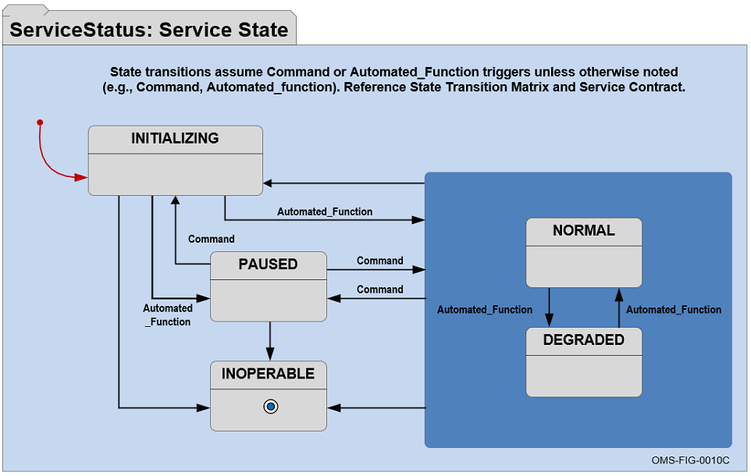
Figure 3.1-1 Service Status State Diagram
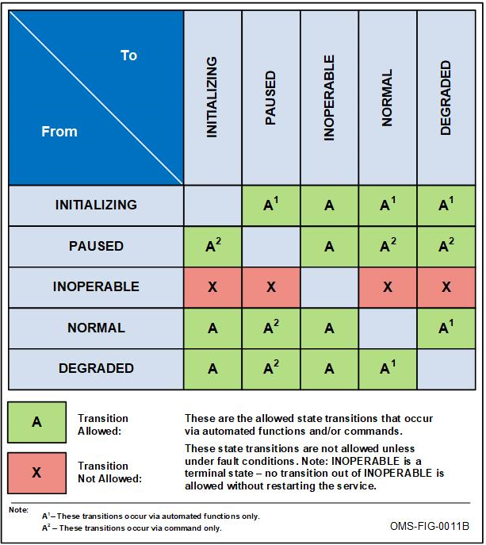
Figure 3.1-2 Allowed Service State Transitions

Service Status Sequence Diagram
Figure 3.1-3, Service Status Sequence Diagram, is the sequence diagram for Service Status. The sequence diagram shows both the periodic Service Status and the aperiodic Service Status Data Request functions. As the name implies, the communication pattern for the periodic Service Status function is a periodic publishing pattern. At the specified interval, the Service publishes the ServiceStatus message. This interval is defined in Section 3.1.1.3, Service Status Reporting Interval.
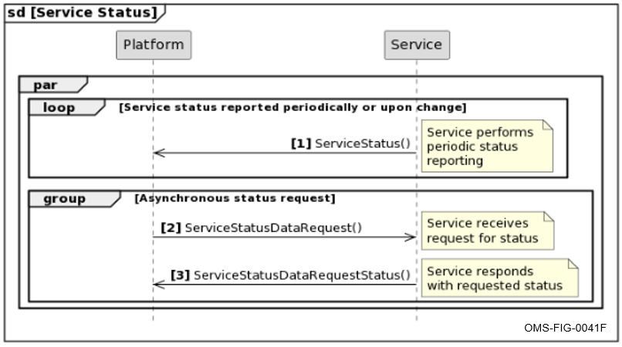
Figure 3.1-3 Service Status Sequence Diagram
The communication pattern for the aperiodic Service Status function is Request/Reply; wherein a request is received by the Service. The Service processes the request and sends a reply if appropriate per the Response Rules outlined in Figure 3.1-4, ServiceStatusDataRequest Response Rules. This is an on-time operation, meaning that there are no (long) time intervals between sending the request, the processing of the request, and sending the reply.
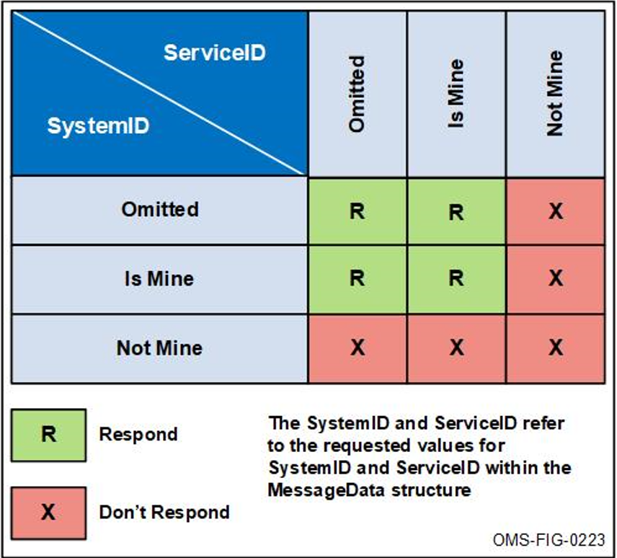
Figure 3.1-4 Service Status Data Request Response Rules

Service Status Post Conditions
This section indicates the possible states during function completion.
Service is running and is in any state (except INOPERABLE), typically NORMAL.

Service Status Error Handling
This section explains the behavior if errors and exceptions occur during the course of execution of this function.

Required Subsystem Functions
This section details the functions provided by OMS Subsystems. Every OMS Subsystem is required to provide these functions to ensure that all OMS Subsystems have a basic level of communication with one another. This section is required for Subsystems.

Subsystem Startup
This section is required for OMS Subsystems.

Subsystem Startup Description
This section describes the Subsystem startup function, which includes establishing network connection. Also refer to Section 2.2, Initialization, for additional details.

Subsystem Startup Preconditions
Once power has been applied to the Subsystem, the Subsystem can begin its initialization sequence. Network connection must be established to allow receipt and publication of messages.

Subsystem Startup Reporting Interval
This section indicates Subsystem specific modifiable configuration items that will be provided.
This section is not applicable for this function.

Subsystem Startup Inputs and Outputs
Table 3.2-1, Subsystem Startup Inputs and Outputs, identifies the inputs and outputs for the Subsystem Startup function.
Table 3.2-1 Subsystem Startup Inputs and Outputs
MP | IO | DE | Data Exchange Name | Data Exchange Information  (e.g., Topic Name for Messages or Protocol for Data Transfers) | LoM | P | Nominal Response Time or Nominal Periodic Rate | Max Response Time or Max Periodic Rate | Appendix C Mapping
Column Headings & Cell Abbreviations:
- MP=Message Primitive: S=Status-1; C/CS=Command-2; AR/ARS=ActionRequest-2; DR/DRS=DataRequest-2; D=Data-1; DRec=DataRecord-1
- I/O=Input/Output: I=Input; O=Output
- DE=Data Exchange: M=OMS Message; DT=Data Transfer; SS=Special Signal; SE=Security Exchange
- LoM=Level of Mandate: M=Mandatory; O=Optional
- P=Periodicity: A=Asynchronous; OD=On Demand; P=Periodic

Subsystem Startup Workflow and Orchestration
This section is used to detail the sequence of interactions required for the Subsystem Startup function.
Power has been applied to the Subsystem. Initialization begins. The Subsystem initializes its CAL connection. Once the CAL connection is initialized, this function can initiate additional functions.

Subsystem Startup Post Conditions
This section indicates the possible states during function completion.
Subsystem is running and is in any state (except SHUTDOWN), typically STANDBY or INITIALIZATION (awaiting SubsystemStateCommand(CommandedState=OPERATE) message) to continue.

Subsystem Startup Error Handling
This section explains the behavior if errors and exceptions occur during the course of execution of this function.

Subsystem Status
This section is required for OMS Subsystems.

Subsystem Status Description
This section describes the Subsystem status function. This OMS Subsystem reports Subsystem status periodically and aperiodically upon request. The periodic SubsystemStatus message is published at a configurable interval time; no other trigger is required. The periodic rate is discussed in Section 3.2.2.3, Subsystem Status Reporting Interval.
In addition to the periodic message, this Subsystem will reply to a received SubsystemStatusDataRequest message with a SubsystemStatusDataRequestStatus message, if the request is applicable to the Subsystem.

Subsystem Status Preconditions
The Subsystem must be up and running, and is initializing or initialized. Once the Subsystem in initialized, the Subsystem can be in any state, except SHUTDOWN.

Subsystem Status Reporting Interval
This section indicates Subsystem specific modifiable configuration items that will be provided.
Configuration parameter assignment for periodicity is configurable within the range of 1 to 600 seconds in 1 second increments.

Subsystem Status Inputs and Outputs
Table 3.2-2, Subsystem Status Inputs and Outputs, identifies the inputs and outputs for the Subsystem Status function.
Table 3.2-2 Subsystem Status Inputs and Outputs
MP | IO | DE | Data Exchange Name | Data Exchange Information  (e.g., Topic Name for Messages or Protocol for Data Transfers) | LoM | P | Nominal Response Time or Nominal Periodic Rate | Max Response Time or Max Periodic Rate | Appendix C Mapping
D | O | M | SubsystemStatus | SubsystemStatus | M | P
DR | I | M | SubsystemStatusDataRequest | SubsystemStatusDataRequest | M | A | N/A | N/A
DRS | O | M | SubsystemStatusDataRequestStatus | SubsystemStatusDataRequestStatus | M | OD
Column Headings & Cell Abbreviations:
- MP=Message Primitive: S=Status-1; C/CS=Command-2; AR/ARS=ActionRequest-2; DR/DRS=DataRequest-2; D=Data-1; DRec=DataRecord-1
- I/O=Input/Output: I=Input; O=Output
- DE=Data Exchange: M=OMS Message; DT=Data Transfer; SS=Special Signal; SE=Security Exchange
- LoM=Level of Mandate: M=Mandatory; O=Optional
- P=Periodicity: A=Asynchronous; OD=On Demand; P=Periodic

Subsystem Status Workflow and Orchestration
This section is used to detail the sequence of interactions required for the Subsystem Status function.

Allowed States and Transitions
Figure 3.2-1, Subsystem Status State Diagram, shows allowed states for reporting SubsystemStatus. Figure 3.2-2 Allowed Subsystem State Transitions, shows allowed states and transitions for this Subsystem.
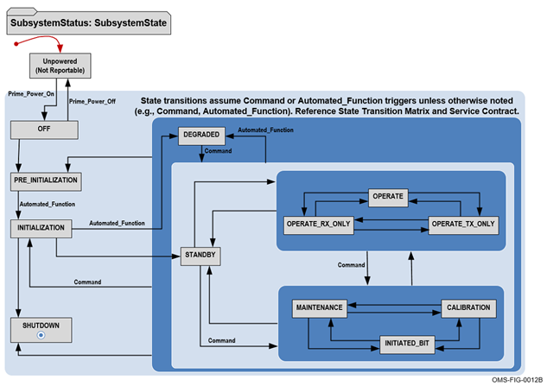
Figure 3.2-1 Subsystem Status State Diagram
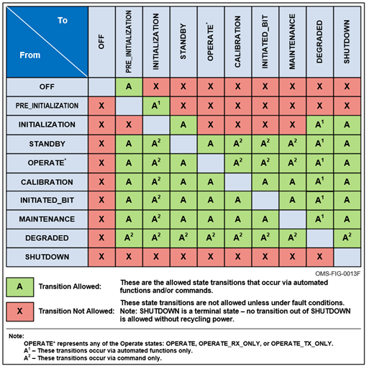
Figure 3.2-2 Allowed Subsystem State Transitions

Subsystem Status Sequence Diagram
Figure 3.2-3, Subsystem Status Sequence Diagram, is the sequence diagram for Subsystem Status. The sequence diagram shows both the periodic Subsystem Status and the aperiodic Subsystem Status functions. As the name implies, the communication pattern for the periodic Subsystem Status function is a periodic publishing pattern. At the specified interval, the Subsystem publishes the SubsystemStatus message. This interval is defined in Section 3.2.2.3, Subsystem Status Reporting Interval.
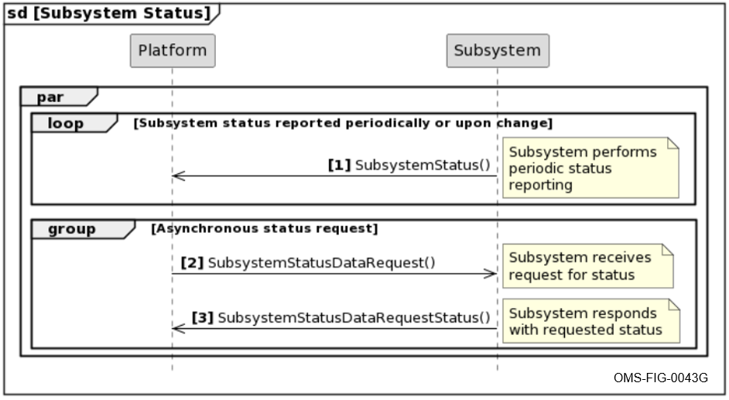
Figure 3.2-3 Subsystem Status Sequence Diagram
The communication pattern for the aperiodic Subsystem Status function is Request/Reply; wherein a request is received by the Subsystem. The Subsystem processes the request and sends a reply if appropriate per the Response Rules outlined in Table 3.2-4, SubsystemStatusDataRequest Response Rules. This is an on-time operation, meaning that there are no (long) time intervals between sending the request, the processing of the request, and sending the reply.
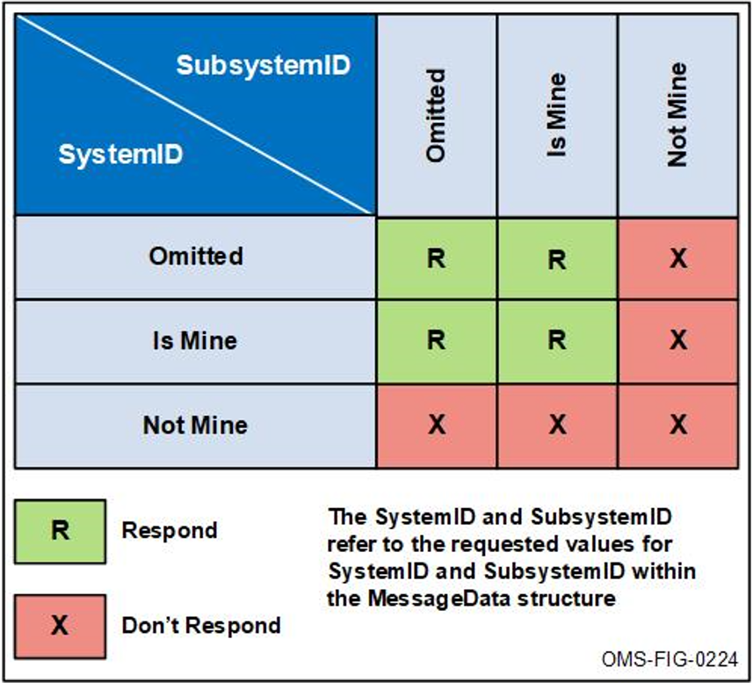
Figure 3.2-4 Subsystem Status Data Request Response Rules

Subsystem Status Post Conditions
This section indicates the possible states during function completion.
Subsystem is running and is in any state (except SHUTDOWN), typically OPERATE.

Subsystem Status Error Handling
This section explains the behavior if errors and exceptions occur during the course of execution of this function.

Subsystem State Command Processing
This section is only applicable for OMS Subsystems.

Subsystem State Command Processing Description
This section describes the Subsystem State Command Processing function.

Subsystem State Command Processing Preconditions
The Subsystem must be up and running, and is initialized. Once the Subsystem in initialized, the Subsystem can be in any state, except SHUTDOWN.

Subsystem State Command Processing Reporting Interval
This section indicates Subsystem specific modifiable configuration items that will be provided.
This section is not applicable for this function.

Subsystem State Command Processing Inputs and Outputs
Table 3.2-3, Subsystem State Command Processing Inputs and Outputs, identifies the inputs and outputs for the Subsystem State Command Processing function.
Table 3.2-3 Subsystem State Command Processing Inputs and Outputs
MP | IO | DE | Data Exchange Name | Data Exchange Information  (e.g., Topic Name for Messages or Protocol for Data Transfers) | LoM | P | Nominal Response Time or Nominal Periodic Rate | Max Response Time or Max Periodic Rate | Appendix C Mapping
C | I | M | SubsystemStateCommand | SubsystemStateCommand | M | A | N/A | N/A
CS | O | M | SubsystemStateCommandStatus | SubsystemStateCommandStatus | M | OD
Column Headings & Cell Abbreviations:
- MP=Message Primitive: S=Status-1; C/CS=Command-2; AR/ARS=ActionRequest-2; DR/DRS=DataRequest-2; D=Data-1; DRec=DataRecord-1
- I/O=Input/Output: I=Input; O=Output
- DE=Data Exchange: M=OMS Message; DT=Data Transfer; SS=Special Signal; SE=Security Exchange
- LoM=Level of Mandate: M=Mandatory; O=Optional
- P=Periodicity: A=Asynchronous; OD=On Demand; P=Periodic

Subsystem State Command Processing Workflow and Orchestration
This section is used to detail the sequence of interactions required for the Subsystem State Command Processing function.
Upon receipt of a SubsystemStateCommand with CommandedState=INITIATED_BIT, Subsystem Initiated BIT processing is handled in Section 3.2.4, Subsystem Built-In Test (BIT).
Upon receipt of a SubsystemStateCommand with CommandedState=CALIBRATION, Subsystem Calibration processing is handled in Section 3.2.5, Subsystem Calibration.
Upon receipt of a SubsystemStateCommand with CommandedState=SHUTDOWN, Subsystem shutdown processing is handled in Section 3.2.6, Subsystem Shutdown.
Otherwise, upon receipt of a SubsystemStateCommand, the Subsystem performs a state transition to the commanded state if it is able and allowed, or it rejects the command if a transition to the commanded state is not allowed as defined by Figure 3.2-3 Subsystem Status Sequence Diagram. The Subsystem responds with SubsystemStateCommandStatus in which the CommandProcessingState field is set to ACCEPTED or REJECTED.
While the Subsystem is processing the SubsystemStateCommand, the Subsystem Status function defined in Section 3.2.2, Subsystem Status, will publish SubsystemStatus showing the progress of the Subsystem state change.

Subsystem State Command Processing Post Conditions
This section indicates the possible states during function completion.
Subsystem transitions to the commanded state or remains in its current state due to transition rejection or failure.

Subsystem State Command Processing Error Handling
This section explains the behavior if errors and exceptions occur during the course of execution of this function.

Subsystem Built-In Test (BIT)
This section is only applicable for OMS Subsystems that support BIT processing.

Subsystem BIT Description
This section describes the Subsystem Built-In Test (BIT) function.

Subsystem BIT Preconditions
The Subsystem is up and running, and is initializing or initialized. The Subsystem can begin performing various BIT processing from any state, except SHUTDOWN.

Subsystem BIT Reporting Interval
This section indicates Subsystem specific modifiable configuration items that will be provided.

Subsystem BIT Inputs and Outputs
Table 3.2-4, Subsystem BIT Inputs and Outputs, identifies the inputs and outputs for the Subsystem BIT function.
Table 3.2-4 Subsystem BIT Inputs and Outputs
MP | IO | DE | Data Exchange Name | Data Exchange Information  (e.g., Topic Name for Messages or Protocol for Data Transfers) | LoM | P | Nominal Response Time or Nominal Periodic Rate | Max Response Time or Max Periodic Rate | Appendix C Mapping
Column Headings & Cell Abbreviations:
- MP=Message Primitive: S=Status-1; C/CS=Command-2; AR/ARS=ActionRequest-2; DR/DRS=DataRequest-2; D=Data-1; DRec=DataRecord-1
- I/O=Input/Output: I=Input; O=Output
- DE=Data Exchange: M=OMS Message; DT=Data Transfer; SS=Special Signal; SE=Security Exchange
- LoM=Level of Mandate: M=Mandatory; O=Optional
- P=Periodicity: A=Asynchronous; OD=On Demand; P=Periodic

Subsystem BIT Workflow and Orchestration
This section is used to detail the sequence of interactions required for the Subsystem BIT function.

Subsystem BIT Post Conditions
This section indicates the possible states during function completion.

Subsystem BIT Error Handling
This section explains the behavior if errors and exceptions occur during the course of execution of this function.

Subsystem Calibration
This section is only applicable for OMS Subsystems.

Subsystem Calibration Description
This section describes the Subsystem calibration function.

Subsystem Calibration Preconditions
The Subsystem is up and running, and is initialized. The Subsystem can begin its calibration sequence from any state, except SHUTDOWN.

Subsystem Calibration Reporting Interval
This section indicates Subsystem specific modifiable configuration items that will be provided.

Subsystem Calibration Inputs and Outputs
Table 3.2-5, Subsystem Calibration Inputs and Outputs, identifies the inputs and outputs for the Subsystem Calibration function.
Table 3.2-5 Subsystem Calibration Inputs and Outputs
MP | IO | DE | Data Exchange Name | Data Exchange Information  (e.g., Topic Name for Messages or Protocol for Data Transfers) | LoM | P | Nominal Response Time or Nominal Periodic Rate | Max Response Time or Max Periodic Rate | Appendix C Mapping
Column Headings & Cell Abbreviations:
- MP=Message Primitive: S=Status-1; C/CS=Command-2; AR/ARS=ActionRequest-2; DR/DRS=DataRequest-2; D=Data-1; DRec=DataRecord-1
- I/O=Input/Output: I=Input; O=Output
- DE=Data Exchange: M=OMS Message; DT=Data Transfer; SS=Special Signal; SE=Security Exchange
- LoM=Level of Mandate: M=Mandatory; O=Optional
- P=Periodicity: A=Asynchronous; OD=On Demand; P=Periodic

Subsystem Calibration Workflow and Orchestration
This section is used to detail the sequence of interactions required for the Subsystem Calibration function.

Subsystem Calibration Post Conditions
This section indicates the possible states during function completion.

Subsystem Calibration Error Handling
This section explains the behavior if errors and exceptions occur during the course of execution of this function.

Subsystem Shutdown
This section is only applicable for OMS Subsystems.

Subsystem Shutdown Description
This section describes the Subsystem shutdown function. Also refer to Section 2.4, Shutdown, for additional details.

Subsystem Shutdown Preconditions
The Subsystem is up and running, and is initialized. The Subsystem can begin its shutdown sequence from any state, except SHUTDOWN.

Subsystem Shutdown Reporting Interval
This section indicates Subsystem specific modifiable configuration items that will be provided.
This section is not applicable for this function.

Subsystem Shutdown Inputs and Outputs
Table 3.2-6, Subsystem Shutdown Inputs and Outputs, identifies the inputs and outputs for the Subsystem Shutdown function.
Table 3.2-6 Subsystem Shutdown Inputs and Outputs
MP | IO | DE | Data Exchange Name | Data Exchange Information  (e.g., Topic Name for Messages or Protocol for Data Transfers) | LoM | P | Nominal Response Time or Nominal Periodic Rate | Max Response Time or Max Periodic Rate | Appendix C Mapping
Column Headings & Cell Abbreviations:
- MP=Message Primitive: S=Status-1; C/CS=Command-2; AR/ARS=ActionRequest-2; DR/DRS=DataRequest-2; D=Data-1; DRec=DataRecord-1
- I/O=Input/Output: I=Input; O=Output
- DE=Data Exchange: M=OMS Message; DT=Data Transfer; SS=Special Signal; SE=Security Exchange
- LoM=Level of Mandate: M=Mandatory; O=Optional
- P=Periodicity: A=Asynchronous; OD=On Demand; P=Periodic

Subsystem Shutdown Workflow and Orchestration
This section is used to detail the sequence of interactions required for the Subsystem Shutdown function.
While the Subsystem is going through its shutdown process, the Subsystem Status function defined in Section 3.2.2, Subsystem Status, will publish SubsystemStatus showing the progress of the shutdown process until it completes with the last message occurrence showing SubsystemState set to SHUTDOWN.

Subsystem Shutdown Post Conditions
This section indicates the possible states during function completion.
Subsystem in the SHUTDOWN state and is no longer responding, awaiting power shutdown.

Subsystem Shutdown Error Handling
This section explains the behavior if errors and exceptions occur during the course of execution of this function.

Required Capability-related Functions
This section details the Capability-related functions provided by OMS Subsystems and OMS Services. A Subsystem or Service that provides a Capability is required to provide these functions to ensure that all Subsystems and Services have a basic level of communication with one another.

Position Information Processing
This section describes the Position Information Processing function that supports Capabilities.

Position Information Processing Description
This section describes the Position Information Processing function to subscribe to periodic PositionReport or PositionReportDetailed messages.

Position Information Processing Preconditions
The Subsystem has initialized and is in the STANDBY state or an Operational state (e.g., OPERATE), or the Service has initialized and is in the NORMAL state. Network connection must be established to allow receipt and publication of messages.

Position Information Processing Reporting Interval
This section indicates Service specific modifiable configuration items that will be provided.
This section is not applicable for this function.

Position Information Processing Inputs and Outputs
Table 3.3-1, Position Information Processing Inputs and Outputs, identifies the inputs and outputs for the Position Information Processing function.
Table 3.3-1 Position Information Processing Inputs and Outputs
MP | IO | DE | Data Exchange Name | Data Exchange Information  (e.g., Topic Name for Messages or Protocol for Data Transfers) | LoM | P | Nominal Response Time or Nominal Periodic Rate | Max Response Time or Max Periodic Rate | Appendix C Mapping
Column Headings & Cell Abbreviations:
- MP=Message Primitive: S=Status-1; C/CS=Command-2; AR/ARS=ActionRequest-2; DR/DRS=DataRequest-2; D=Data-1; DRec=DataRecord-1
- I/O=Input/Output: I=Input; O=Output
- DE=Data Exchange: M=OMS Message; DT=Data Transfer; SS=Special Signal; SE=Security Exchange
- LoM=Level of Mandate: M=Mandatory; O=Optional
- P=Periodicity: A=Asynchronous; OD=On Demand; P=Periodic

Position Information Processing Workflow and Orchestration
This section is used to detail the sequence of interactions required for the Position Information Processing function.
Upon receipt of a PositionReport or PositionReportDetailed message, the Subsystem or Service retains the position information for use by the Capability.

Position Information Processing Post Conditions
This section indicates the possible states during function completion.
This function will not cause a state change.

Position Information Processing Error Handling
This section explains the behavior if errors and exceptions occur during the course of execution of this function.

[CapabilityName] Capability-related Functions
This section describes the [CapabilityName] Capability-related functions.

[CapabilityName] Capability and Capability Status
This section describes the [CapabilityName] Capability and Capability Status function.
This function publishes [CapabilityName]Capability and [CapabilityName]CapabilityStatus messages.
Availability of Capabilities are initially DISABLED until they are enabled as defined in Section 3.3.2.2, [CapabilityName] Capability Enable/Disable function.

[CapabilityName] Capability and Capability Status Description
This section describes the Capability and Capability Status function, which publishes specific [CapabilityName]Capability and [CapabilityName]CapabilityStatus messages periodically.

[CapabilityName] Capability and Capability Status Preconditions
The Subsystem has initialized and is in the STANDBY state or an Operational state (e.g., OPERATE) or the Service has initialized and is in the NORMAL state.

[CapabilityName] Capability and Capability Status Reporting Interval
This section indicates Service specific modifiable configuration items that will be provided.
Configuration parameter assignment for periodicity is configurable within the range of 1 to 600 seconds in 1 second increments.

[CapabilityName] Capability and Capability Status Inputs and Outputs
Table 3.3-2, [CapabilityName] Capability and Capability Status Inputs and Outputs, identifies the inputs and outputs for the [CapabilityName] Capability and Capability Status function.
Table 3.3-2 [CapabilityName] Capability and Capability Status Inputs and Outputs
MP | IO | DE | Data Exchange Name | Data Exchange Information  (e.g., Topic Name for Messages or Protocol for Data Transfers) | LoM | P | Nominal Response Time or Nominal Periodic Rate | Max Response Time or Max Periodic Rate | Appendix C Mapping
Column Headings & Cell Abbreviations:
- MP=Message Primitive: S=Status-1; C/CS=Command-2; AR/ARS=ActionRequest-2; DR/DRS=DataRequest-2; D=Data-1; DRec=DataRecord-1
- I/O=Input/Output: I=Input; O=Output
- DE=Data Exchange: M=OMS Message; DT=Data Transfer; SS=Special Signal; SE=Security Exchange
- LoM=Level of Mandate: M=Mandatory; O=Optional
- P=Periodicity: A=Asynchronous; OD=On Demand; P=Periodic

[CapabilityName] Capability and Capability Status Workflow and Orchestration
This section is used to detail the sequence of interactions required for the [CapabilityName] Capability and Capability Status function.

[CapabilityName] Capability and Capability Status Post Conditions
This section indicates the possible states during function completion.

[CapabilityName] Capability and Capability Status Error Handling
This section explains the behavior if errors and exceptions occur during the course of execution of this function.

[CapabilityName] Capability Enable/Disable
This section describes the [CapabilityName] Capability Enable/Disable function.

[CapabilityName] Capability Enable/Disable Description
This section describes the [CapabilityName] Capability Enable/Disable function, which subscribes to [CapabilityName]SettingsCommand messages and publishes [CapabilityName]SettingsCommandStatus response messages.

[CapabilityName] Capability Enable/Disable Preconditions
The Subsystem has initialized and is in the STANDBY state or an Operational state (e.g., OPERATE) or the Service has initialized and is in the NORMAL state. Network connection must be established to allow receipt and publication of messages.

[CapabilityName] Capability Enable/Disable Reporting Interval
This section indicates Service specific modifiable configuration items that will be provided.
This is not applicable for this function.

[CapabilityName] Capability Enable/Disable Inputs and Outputs
Table 3.3-3, [CapabilityName] Capability Enable/Disable Inputs and Outputs, identifies the inputs and outputs for the [CapabilityName] Capability Enable/Disable Reporting function.
Table 3.3-3 [CapabilityName] Capability Enable/Disable Inputs and Outputs
MP | IO | DE | Data Exchange Name | Data Exchange Information  (e.g., Topic Name for Messages or Protocol for Data Transfers) | LoM | P | Nominal Response Time or Nominal Periodic Rate | Max Response Time or Max Periodic Rate | Appendix C Mapping
Column Headings & Cell Abbreviations:
- MP=Message Primitive: S=Status-1; C/CS=Command-2; AR/ARS=ActionRequest-2; DR/DRS=DataRequest-2; D=Data-1; DRec=DataRecord-1
- I/O=Input/Output: I=Input; O=Output
- DE=Data Exchange: M=OMS Message; DT=Data Transfer; SS=Special Signal; SE=Security Exchange
- LoM=Level of Mandate: M=Mandatory; O=Optional
- P=Periodicity: A=Asynchronous; OD=On Demand; P=Periodic

[CapabilityName] Capability Enable/Disable Workflow and Orchestration
This section is used to detail the sequence of interactions required for the [CapabilityName] Capability Enable/Disable function.

[CapabilityName] Capability Enable/Disable Post Conditions
This section indicates the possible states during function completion.

[CapabilityName] Capability Enable/Disable Error Handling
This section explains the behavior if errors and exceptions occur during the course of execution of this function.

[CapabilityName] Capability Operations
This section describes the [CapabilityName] Capability Operations function.

[CapabilityName] Capability Operations Description
This section describes the [CapabilityName] Capability Operations function that performs a Capability.

[CapabilityName] Capability Operations Preconditions
The Subsystem has initialized and is in the OPERATE state or the Service has initialized and is in the NORMAL state. Network connection must be established to allow receipt and publication of messages.

[CapabilityName] Capability Operations Reporting Interval
This section indicates Service specific modifiable configuration items that will be provided.

[CapabilityName] Capability Operations Inputs and Outputs
Table 3.3-4, [CapabilityName] Capability Operations Inputs and Outputs, identifies the inputs and outputs for the [CapabilityName] Capability Operations function.
Table 3.3-4 [CapabilityName] Capability Operations Inputs and Outputs
MP | IO | DE | Data Exchange Name | Data Exchange Information  (e.g., Topic Name for Messages or Protocol for Data Transfers) | LoM | P | Nominal Response Time or Nominal Periodic Rate | Max Response Time or Max Periodic Rate | Appendix C Mapping
Column Headings & Cell Abbreviations:
- MP=Message Primitive: S=Status-1; C/CS=Command-2; AR/ARS=ActionRequest-2; DR/DRS=DataRequest-2; D=Data-1; DRec=DataRecord-1
- I/O=Input/Output: I=Input; O=Output
- DE=Data Exchange: M=OMS Message; DT=Data Transfer; SS=Special Signal; SE=Security Exchange
- LoM=Level of Mandate: M=Mandatory; O=Optional
- P=Periodicity: A=Asynchronous; OD=On Demand; P=Periodic

[CapabilityName] Capability Operations Workflow and Orchestration
This section is used to detail the sequence of interactions required for the [CapabilityName] Capability Operations function.

[CapabilityName] Capability Operations Post Conditions
This section indicates the possible states during function completion.

[CapabilityName] Capability Operations Error Handling
This section explains the behavior if errors and exceptions occur during the course of execution of this function.

Specific Functions
In the following subsections, the specific functions provided by the Subsystem, Service, or Isolator, beyond the Required Functions discussed in earlier subsections of Section 3, are detailed.

[FunctionName]
This section details the specific function provided.

[FunctionName] Description
This section describes the specific function performed by the Service.

[FunctionName] Preconditions
This section indicates and describes the conditions that a requester of this operation must meet and the checks that have to be performed to assure optimal, secure and error-free execution and performance of this operation.

[FunctionName] Reporting Interval
This section indicates Service specific modifiable configuration items that will be provided.

[FunctionName] Inputs and Outputs
Table 3.4-1, [FunctionName] Inputs and Outputs, identifies the inputs and outputs for the [FunctionName] function.
Table 3.4-1 [FunctionName] Inputs and Outputs
MP | IO | DE | Data Exchange Name | Data Exchange Information  (e.g., Topic Name for Messages or Protocol for Data Transfers) | LoM | P | Nominal Response Time or Nominal Periodic Rate | Max Response Time or Max Periodic Rate | Appendix C Mapping
Column Headings & Cell Abbreviations:
- MP=Message Primitive: S=Status-1; C/CS=Command-2; AR/ARS=ActionRequest-2; DR/DRS=DataRequest-2; D=Data-1; DRec=DataRecord-1
- I/O=Input/Output: I=Input; O=Output
- DE=Data Exchange: M=OMS Message; DT=Data Transfer; SS=Special Signal; SE=Security Exchange
- LoM=Level of Mandate: M=Mandatory; O=Optional
- P=Periodicity: A=Asynchronous; OD=On Demand; P=Periodic

[FunctionName] Workflow and Orchestration
This section is used to detail the sequence of interactions required for the [FunctionName] function.

[FunctionName] Post Conditions
This section indicates the possible states during function completion.

[FunctionName] Error Handling
This section explains the behavior if errors and exceptions occur during the course of execution of this function.

Non-OMS Messages
This section summarizes the Non-OMS Messages used in the functions defined in Section 3 as shown in Table 4.0-1, Non-OMS Messages.
Table 4.0-1 Non-OMS Messages
Non-OMS Message Name | Description | Rationale

Change Request Identification
This section identifies the Change Request (CR) as applicable as shown in Table 5.0-1, Change Request Identification.
Table 5.0-1 Change Request Identification
CR# | Title | Date | Status | Status Date | Brief CR Description

Cybersecurity Posture
This section identifies the cybersecurity posture of the Subsystem, Service, or Isolator.

Cyber Survivability Attributes (CSAs)
This section identifies the CSAs applicable to the Subsystem, Service, or Isolator.

Prevent CSAs
This section identifies and documents the System Survivability Key Performance Parameters (KPPs) Prevent CSAs implementation for the Subsystem, Service, or Isolator. Table 6.1-1 identifies the System Survivability KPP Prevent CSAs applicable to the Subsystem, Service, or Isolator.
Table 6.1-1 Applicable System Survivability KPP Prevent CSAs
CSA-01 | CSA-02 | CSA-03 | CSA-04 | CSA-05 | CSA-06

Mitigate CSAs
This section identifies and documents the System Survivability KPP Mitigate CSAs implementation for the Subsystem, Service, or Isolator. Table 6.1-2 identifies the System Survivability KPP Mitigate CSAs applicable to the Subsystem, Service, or Isolator.
Table 6.1-2 Applicable System Survivability KPP Mitigate CSAs
CSA-07 | CSA-08

Recover CSA
This section identifies and documents the System Survivability KPP Recover CSA implementation for the Subsystem, Service, or Isolator.

Adapt CSA
This section identifies and documents the System Survivability KPP Adapt CSA implementation for the Subsystem, Service, or Isolator.

Security Addendum
Proprietary Notice: The Security Addendum reference in this section is a non-proprietary document. The Security Addendum may contain references to external documents that may be proprietary.
This section identifies the Security Addendum document(s).
- Appendix A Acronyms and Abbreviations
This section lists the abbreviations and acronyms used in this document not a copy of the OMS lexicon as shown in Table A.0-1, List of Acronyms and Abbreviation Definitions.
Table A.0-1 List of Acronyms and Abbreviation Definitions
Acronym/Abbreviation | Definition
ASB | Abstract Service Bus
CAL | Critical Abstraction Layer
CSA | Cyber Survivability Attribute
KPP | Key Performance Parameter
OACWG | Open Architecture Collaborative Working Group
OCE | Open Computing Environment
OMS | Open Mission Systems
SOAC | Supported Operational Attribute Configuration
UCI | Universal C2 Interface

- Appendix B Glossary
This section lists the terms used in this document as shown in Table B.0-1, List of Term Definitions.
Table B.0-1 List of Term Definitions
Term | Definition

- Appendix C Message Details
This appendix consists of one or more spreadsheet workbooks with a separate tab for each message use based on each function’s input and output messages.
This section also includes a table to document the usage of any ForeignKey and other user-defined index elements of the schema that are used by the Service.

