Universal Command and Control (C2) Interface (UCI)
Normalized Interface Specification (UNIS)

22 january 2026
Prepared By:
Open Architecture Collaborative Working Group (OACWG)

This page is intentionally left blank.

Abstract
Universal Command and Control (C2) Interface (UCI) is a messaging standard supporting communication for mission-level C2. UCI provides a common message definition for performing mission operations and enables C2 coordination across weapon systems and weapon system elements such as sensors, vehicles, data products, and software. UCI is defined by the UCI Standard, which is comprised of the UCI Standard Document, the UCI Normalized Interface Specification (UNIS) (i.e., this document), the UCI Schema, and the UCI Schema Style and Design Specification. This document provides a set of requirements for normalized UCI message primitive interface behaviors.
The Universal Command and Control (C2) Interface (UCI) Schema Style and Design Specification (OAM-SPC-001) (USSDS) provides additional guidance on the structure of each UCI Message.

This page is intentionally left blank.
Revision Record
Revision | Date | Description
A | 22 January 2026 | Initial public release

This page is intentionally left blank.

Table of Contents
1 Introduction 1
2 References 2
3 UCI Message Primitive Patterns Overview 3
4 Message Primitive Pattern Descriptions 4
4.1 Status-1 4
4.1.1 Status-1 Interaction Pattern 4
4.1.2 Status-1 Terminal State Behavior 5
4.2 Data-1 5
4.2.1 Data-1 Interaction Pattern 5
4.2.2 Data-1 Terminal State Behavior 6
4.3 DataRecord-1 6
4.3.1 DataRecord-1 Interaction Pattern 6
4.3.2 DataRecord-1 Terminal State Behavior 7
4.4 DataRequest-2 7
4.4.1 Data Request-2 Interaction Pattern 7
4.4.2 Data Request-2 Terminal State Behavior 8
4.5 ActionRequest-2 8
4.5.1 ActionRequest-2 Interaction Pattern 8
4.5.2 ActionRequest-2 Terminal State Behavior 8
4.6 Command-2 9
4.6.1 Command-2 Interaction Pattern 9
4.6.2 Command-2 Terminal State Behavior 9
5 Message Usage Descriptions 10
5.1 Data Record and List Management Interaction Patterns 10
5.1.1 DataRecordManagementRequest-3 Message Interaction Pattern 10
5.1.1.1 Examples of DataRecordManagementRequest-3 Message Interaction Pattern 11
5.1.1.2 Exemplars of DataRecordManagementRequest-3 Message Interaction Pattern 11
5.1.1.3 Template for DataRecordManagementRequest-3 Message Interaction Pattern 11
5.1.2 DataRecordListManagementRequest-3 Interaction Pattern 11
5.1.2.1 Examples of DataRecordListManagementRequest-3 Message Interaction Pattern 12
5.1.2.2 Exemplars of DataRecordListManagementRequest-3 Message Interaction Pattern 12
6 Acronyms and Abbreviations List 13

This page is intentionally left blank.

List of Figures
Figure 4.1-1 Status-1 Message Interaction Pattern 5
Figure 4.2-1 Data-1 Message Interaction Pattern 6
Figure 4.3-1 DataRecord-1 Message Interaction Pattern 6
Figure 4.4-1 DataRequest-2 Message Interaction Pattern 7
Figure 4.5-1 ActionRequest-2 Message Interaction Pattern 8
Figure 4.6-1 Command-2 Message Interaction Pattern 9
Figure 5.1-1 DataRecordManagementRequest-3 Message Interaction Pattern 10
Figure 5.1-2 DataRecordListManagementRequest-3 Message Interaction Pattern 12

This page is intentionally left blank.

List of Tables
Table 2.0-1 Referenced Documents 2
Table 3.0‑1 Message Primitive Patterns 3
Table 5.0-1 Acronyms 13

This page is intentionally left blank.

Introduction
Universal Command and Control (C2) Interface (UCI) is a messaging standard supporting communication for mission-level C2. UCI defines a set of messages intended to standardize interfaces between software services for C2, and these messages have been defined and validated as fit for purpose across a variety of mission behaviors and heterogeneous mission system implementations. Standardization of suitable behaviors is accomplished through Normalization.
Normalization of message behaviors and patterns, within UCI, is a benefit to the community as it increases reuse, simplifies integration, increases the ability for the Adopting Program to interact and communicate with other UCI-enabled platforms, and reduces the cost of implementation.

References
The documents listed in Table 2.0-1, Referenced Documents, are cited throughout this document. For dated references, only the revision cited applies. For undated references, the latest revision of the referenced document (including any addendums or corrigenda) applies.
Table 2.0-1 Referenced Documents
Document Number | Document Title | Revision | Date
OAC-STD-001 | Universal Command and Control (C2) Interface (UCI) Standard | I | 22 January 2026
OAC-STD-002 | Universal Command and Control (C2) Interface (UCI) Schema | E | 22 January 2026
OAC-SPC-001 | Universal Command and Control (C2) Interface (UCI) Schema Style and Design Specification | E | 22 January 2026

UCI Message Primitive Patterns Overview
UCI messages convey information between the different endpoints. Each message is assigned or mapped to one of six message primitive patterns. Messages are combined in specific ways called message primitive patterns which are designed to carry out different messaging tasks. There are six message primitive patterns: three single messages that provide data, data record(s), or status; and three paired messages requesting or commanding, and returning information. This section describes the message primitive patterns and describes how the messages in each primitive pattern interact. Refinements and additions to normalized interactions and behaviors will occur over time with a focus on proving greater interoperability amongst programs adopting UCI.
All six message primitive patterns are described in Table 3.0‑1, Message Primitive Patterns. Note that all message primitive patterns are named using the format “<PatternName>-n”, where n is the number of messages utilized in the pattern.
Table 3.0‑1 Message Primitive Patterns
Pattern Name | Description
Status-1 | Consists of a single message that contains status.
Data-1 | Consists of a single message that contains data.
DataRecord-1 | Consists of a single message that is similar to Data-1 but supports data record management.
DataRequest-2 | Consists of two messages where the first message requests data (uses the suffix *DataRequest) and the second message is a response that will contain the status of the request (QUEUED, PROCESSING, COMPLETED, FAILED, REJECTED) and when the request is completed it may include the data (uses the suffix *DataRequestStatus)
ActionRequest-2 | Consists of two messages where the first message requests an action (uses the suffix *Request) and the second message is a response that will contain the status of the request (QUEUED, PROCESSING, COMPLETED, FAILED, REJECTED) and when the action is completed it may include the requested data (uses the suffix *RequestStatus)
Command-2 | Consists of two messages where the first message commands an action (uses the suffix *Command) and the second message is a response with the status (RECEIVED, ACCEPTED, REJECTED, CANCELED) of the command and when the command is ACCEPTED it may return a resulting activity (uses the suffix *CommandStatus)

The following subsections describe each message primitive pattern and how the messages in the pattern interact.

Message Primitive Pattern Descriptions
The six primitive patterns are described below. Each pattern has a brief description along with an interaction pattern for the interface between the participants in the message exchange. Additionally, a discussion of terminal state behavior is provided; specifically, the terminal state behavior refers to the interface between the participants in the message exchange. Care should be taken when reviewing the interaction pattern. Primitive patterns that use two different messages address the message exchange between participants. In these cases, the interaction pattern flow is affected by the value of a particular field in the response message. UCI does not require a specific transport, so there can be no assumption that messages come in any order or that there is guaranteed delivery. The interaction patterns take this into account. Also, there is no design implication assumed with respect to the state machine of the requestee/commandee other than once a terminal state is reported, the sequence should end. In other words, a requester/commander can deem the sequence complete once a terminal state is reported and ignore any further responses.

Status-1
The Status-1 message primitive pattern consists of a single message sent from a producer to one or more consumers. This is very similar to the Data-1 and DataRecord-1 message primitive patterns. Typically, Status-1 primitive messages have a suffix of “Status”. However, there are cases where Status-1 messages do not have any specific nomenclature that can be used to identify it as a Status-1. Thus, a Status-1 message may be named anything that does not match any other primitive identifier.

Status-1 Interaction Pattern
There are two roles in the Status-1 message pattern: Producer and Consumer. The Producer is the UCI Component that initiates the sequence identified in Figure 4.1-1, Status-1 Message Interaction Pattern. The Consumer is the UCI Component that receives the message. Messages following the Status-1 message primitive pattern do not include an acknowledgement from the consumer(s) as part of the message exchange. The Status-1 pattern is akin to a “fire and forget” mechanism. As shown in Figure 4.1‑1, Status-1 messages take on two forms; the first is a message name ending with “Status” and the other is just a message name (that does not meet another naming convention for patterns denoted below).
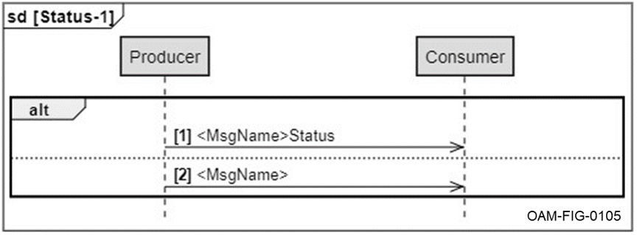
Figure 4.1-1 Status-1 Message Interaction Pattern
CERT UNIS-000076 [A UCI Component fulfilling a role identified in the Status-1 message interaction pattern shall follow the interaction pattern identified in the “Status-1 Message Interaction Pattern” figure.]

Status-1 Terminal State Behavior
When the Status-1 message is sent, that is the terminal state. This is a “fire and forget” where once sent, the sequence is complete.

Data-1
The Data-1 primitive pattern consists of a single message from a producer to one or more consumers. This is very similar to the Status-1 and DataRecord-1 message primitive patterns.

Data-1 Interaction Pattern
There are two roles in the Data-1 message pattern: Producer and Consumer. The Producer is the UCI Component that initiates the sequence identified in Figure 4.2-1, Data-1 Message Interaction Pattern. The Consumer is the UCI Component that receives the message. Messages following the Data-1 message primitive pattern do not include an acknowledgement from the consumer(s). The Data-1 pattern is expected to be used as a “fire and forget” mechanism.
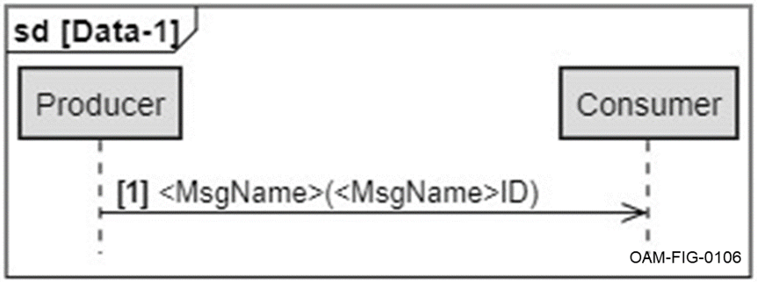
Figure 4.2-1 Data-1 Message Interaction Pattern
CERT UNIS-000081 [A UCI Component fulfilling a role identified in the Data‑1 message interaction pattern shall follow the interaction pattern identified in the “Data-1 Message Interaction Pattern” figure.]

Data-1 Terminal State Behavior
When the Data-1 message is sent, that is the terminal state. This is a “fire and forget” where once sent, the sequence is complete.

DataRecord-1
The DataRecord-1 primitive pattern includes a single message from a producer to one or more consumers. This is very similar to the Status-1 and Data-1 message primitive patterns.

DataRecord-1 Interaction Pattern
There are two roles in the DataRecord-1 message pattern: Producer and Consumer. The Producer is the UCI Component that initiates the sequence identified in Figure 4.3-1, DataRecord-1 Message Interaction Pattern. The Consumer is the UCI Component that receives the message. Messages following the DataRecord-1 primitive pattern do not include an acknowledgement from the consumer(s). The DataRecord-1 pattern is expected to be used as a “fire and forget” mechanism. The two flows shown in this diagram indicate mutually exclusive paths; one with <MsgName>DataRecord sent with the optional DataRecordInstanceID included, and one without. In the case where the DataRecordInstanceID is omitted, the flow acts in the same manner as the Data-1 message pattern.
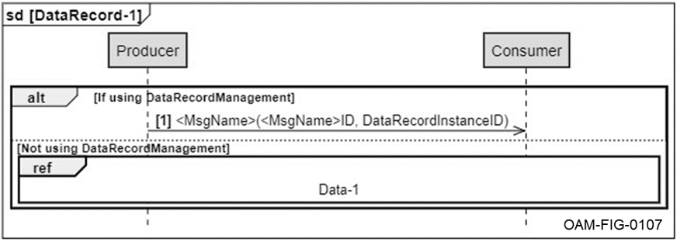
Figure 4.3-1 DataRecord-1 Message Interaction Pattern
CERT UNIS-000087 [A UCI Component fulfilling a role identified in the DataRecord-1 message interaction pattern shall follow the interaction pattern identified in the “DataRecord-1 Message Interaction Pattern” figure.]

DataRecord-1 Terminal State Behavior
When the DataRecord-1 message is sent, that is the terminal state. This is a “fire and forget” where once sent, the sequence is complete.

DataRequest-2
The DataRequest-2 primitive pattern is used to request data and to ensure that the requestee issues either an acknowledgement or the requested data per the response message. This primitive pattern includes two messages, a data request message from a requester to a requestee initiating the process, and a data request status message sent by the requestee providing a status or the requested data.

Data Request-2 Interaction Pattern
There are two roles in the DataRequest-2 message pattern: Requester and Requestee. The Requester is the UCI Component that initiates the sequence identified in Figure 4.4-1, DataRequest-2 Message Interaction Pattern. The Requestee is the UCI Component that receives the request and responds. The DataRequest-2 pattern is a send and response interaction. The Requester expects an acknowledgement from the Requestee.
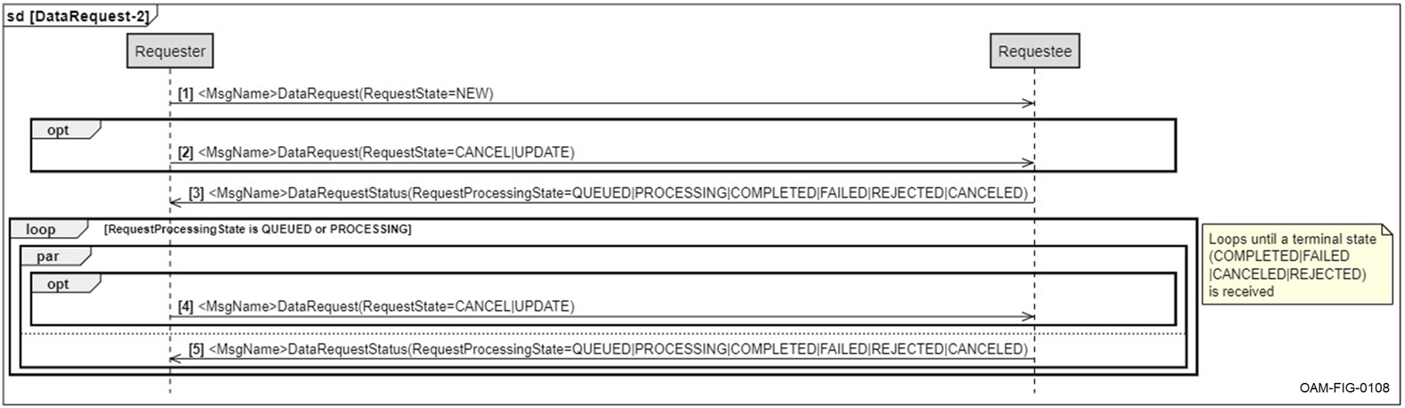
Figure 4.4-1 DataRequest-2 Message Interaction Pattern
CERT UNIS-000093 [A UCI Component fulfilling a role identified in the DataRequest-2 message interaction pattern shall follow the interaction pattern identified in the “DataRequest-2 Message Interaction Pattern” figure.]

Data Request-2 Terminal State Behavior
Once a request status message reporting a terminal state is received, the requester will ignore any further responses.

ActionRequest-2
The ActionRequest-2 primitive pattern is used to request a process be performed and to ensure that the requestee issues either an acknowledgement or a status. This primitive pattern includes two messages, an action request message from a requester to a requestee initiating the process and an acknowledgement message sent by the requestee providing a status.

ActionRequest-2 Interaction Pattern
There are two roles in the ActionRequest-2 message pattern: Requester and Requestee. The Requester is the UCI Component that initiates the sequence identified in Figure 4.5-1, ActionRequest-2 Message Interaction Pattern. The Requestee is the UCI Component that receives the request and responds. The ActionRequest-2 pattern is a send and response interaction. The Requester expects an acknowledgement from the Requestee.
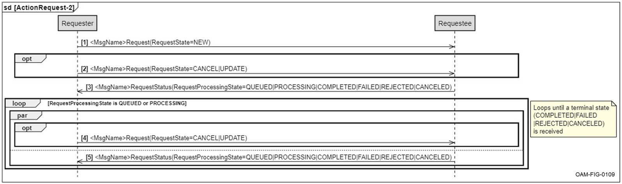
Figure 4.5-1 ActionRequest-2 Message Interaction Pattern
CERT UNIS-000099 [A UCI Component fulfilling a role identified in the ActionRequest-2 message interaction pattern shall follow the interaction pattern identified in the “ActionRequest-2 Message Interaction Pattern” figure.]

ActionRequest-2 Terminal State Behavior
Once a request status message reporting a terminal state is received, the requester will ignore any further responses.

Command-2
The Command-2 primitive pattern is used to command the performance of an activity and ensures the commandee issues either an acknowledgement or a status. This primitive pattern includes two messages, a command message from a commander to a commandee initiating the activity, and an acknowledgement message sent by the commandee providing a status.

Command-2 Interaction Pattern
There are two roles in the Command-2 message pattern: Commander and Commandee. The Commander is the UCI Component that initiates the sequence identified in Figure 4.6-1, Command-2 Message Interaction Pattern. The Commandee is the UCI Component that receives the command and responds. The Command-2 primitive pattern is a send and response interaction. The Commander expects an acknowledgement from the Commandee.
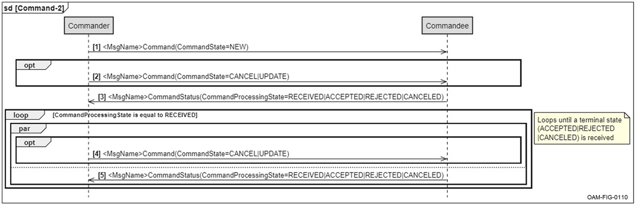
Figure 4.6-1 Command-2 Message Interaction Pattern
CERT UNIS-000105 [A UCI Component fulfilling a role identified in the Command-2 message interaction pattern shall follow the interaction pattern identified in the “Command-2 Message Interaction Pattern” figure.]

Command-2 Terminal State Behavior
Once a command status message reporting a terminal state is received, the commander will ignore any further responses.

Message Usage Descriptions
Message usage patterns are composed of a set of message primitive patterns and/or message group patterns. Those message usage patterns that have defined normalized behaviors are described in this section.

Data Record and List Management Interaction Patterns

DataRecordManagementRequest-3 Message Interaction Pattern
The DataRecordManagementRequest-3 message pattern involves three messages:
- <MsgName>
- DataRecordManagementRequest
- DataRecordManagementRequestStatus
The main message in this message pattern is an information message called <MsgName> that is published asynchronously and is defined as a DataRecord-1 message primitive pattern.
There are two additional messages in this pattern called DataRecordManagementRequest and DataRecordManagementRequestStatus that are defined as an ActionRequest-2 message primitive pattern.
Together, these three messages follow the pattern as shown in Figure 5.1-1, DataRecordManagementRequest-3 Message Interaction Pattern.
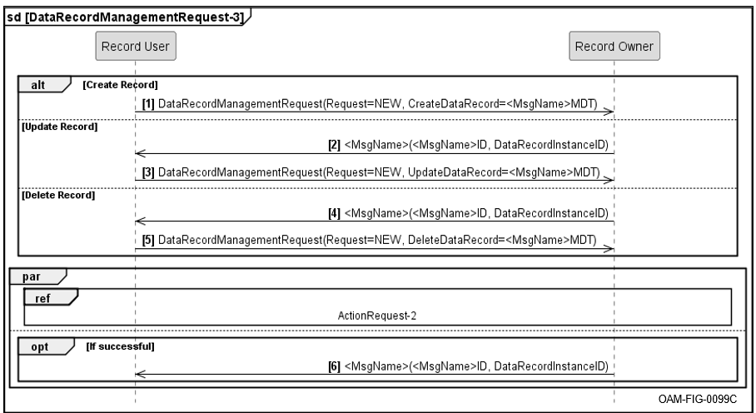
Figure 5.1-1 DataRecordManagementRequest-3 Message Interaction Pattern
CERT UNIS-000156 [A UCI Component fulfilling a role identified in the DataRecordManagementRequest-3 message interaction pattern shall follow the normalized behaviors identified in the “DataRecordManagementRequest-3 Message Interaction Pattern” figure.]

Examples of DataRecordManagementRequest-3 Message Interaction Pattern
There are many examples of this pattern that use the DataRecord-1 message primitive pattern along with an ActionRequest-2 message primitive pattern in the UCI Schema today as shown in the UCI Schema Style and Design Specification Section 5.1.4, DataRecord-1 Message Primitive Pattern.

Exemplars of DataRecordManagementRequest-3 Message Interaction Pattern
<To Be Supplied (TBS) in a future release.>

Template for DataRecordManagementRequest-3 Message Interaction Pattern
<To Be Supplied (TBS) in a future release.>

DataRecordListManagementRequest-3 Interaction Pattern
The Data Record List Management pattern is an extension of the DataRecord-1 pattern. It is designed to allow lists of data to be created and managed. Types created specifically for this pattern are described in the UCI Schema Style and Design Specification Section 4.3.1.5, Data Record List Types.
The DataRecordListManagementRequest-3 message pattern involves three messages:
- <MsgName>
- DataRecordListManagementRequest
- DataRecordListManagementRequestStatus
The main message in this message group pattern is an information message called <MsgName> that is published asynchronously and is defined as a DataRecord-1 message primitive.
There are two additional messages in this pattern called DataRecordListManagementRequest and DataRecordListManagementRequestStatus that are defined as an ActionRequest-2 message primitive pattern.
Together, these three messages follow the pattern as shown in Figure 5.1-2, DataRecordListManagementRequest-3 Message Interaction Pattern.
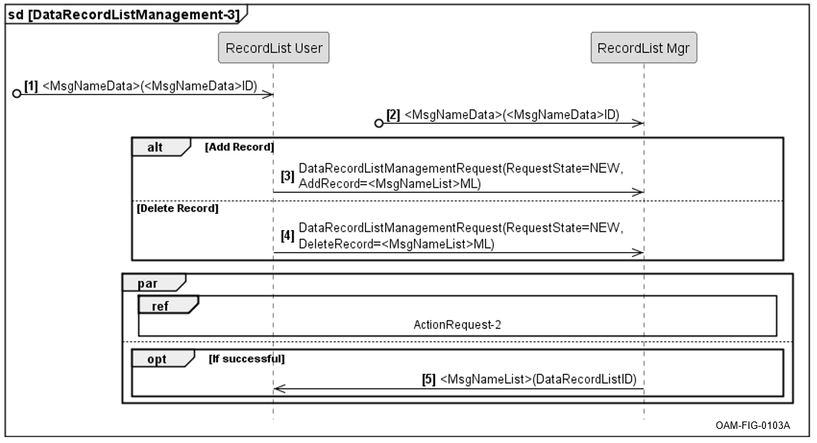
Figure 5.1-2 DataRecordListManagementRequest-3 Message Interaction Pattern
Messages 1 and 2 shown in Figure 5.1-2 are found messages. A found message is used when the originator of the message is undefined and unrepresented, but the lifelines must receive the message.
CERT UNIS-000190 [A UCI Component fulfilling a role identified in the DataRecordListManagementRequest-3 message interaction pattern shall follow the normalized behaviors identified in the “DataRecordListManagementRequest-3 Message Interaction Pattern” figure.]

Examples of DataRecordListManagementRequest-3 Message Interaction Pattern
Examples of this pattern include the ForeignKeyMap and ForeignKeyPair and the MessageTransmissionList and MessageTransmissionListEntry UCI messages.

Exemplars of DataRecordListManagementRequest-3 Message Interaction Pattern
<To Be Supplied (TBS) in a future release.>

Acronyms and Abbreviations List
Table 5.0-1 Acronyms
Acronym | Definition
C2 | Command and Control
CERT | Certification Requirement
OACWG | Open Architecture Collaborative Working Group
UCI | Universal C2 Interface
UNIS | UCI Normalized Interface Specification
USSDS | Universal Command and Control (C2) Interface (UCI) Schema Style and Design Specification

