Lab 3 - Building with Maven Tycho

The goal of this lab is to set up a build process for the application based on Maven Tycho.

Start by pointing Eclipse at the webapps/root/labs/lab-3 folder contained in the tutorial root. Import the projects into the workspace.

Make sure that there are no spaces in the path to this workspace. A bug in the Maven Tycho publishing process will cause problems if you have spaces in your path.

In this lab you will do the following:

- Build the bootstrapper application using using Tycho.

- Build the additional feature using Tycho.

Build the core application using using Tycho.

Prepare Maven and repositories for the lab.

Verify that Maven is correctly installed by entering mvn -version at a command prompt. Check that you get a valid response and that the version of Maven is 3.0 or greater.

If Maven is not correctly installed, you may need to install Maven 3 or configure your path so that it’s on your system path. An archive containing Maven 3 can be found in the webapps/root/maven-dist folder. You can also download it directly from the index page of this Tutorial's web server.

Create a release engineering project and build the bootstrapper bundle.

Note that we have modified the eclipse.product file to enable it to work with Maven and p2 repositories. Start-level and auto-start information has been added on the product Configuration page. Without this Maven Tycho will not create a proper config.ini file.

- Select File > New > Project.. from the main menu. Select General > Project from the list of wizards and click Next.

- On the first page of the wizard, enter com.example.app.releng as the Project name. Leave everything else as is and click Finish.

- Copy the file com.example.app.releng.pom.xml from the extra-files project into the new project. Rename it to pom.xml.

- Open this new pom.xml file. Locate the configuration element for the target-platform-configuration plugin. Comment out the environments that are not appropriate for your machine. Note that you may need to add _64 to the end of the arch element if you’re running a 64 bit JVM. This has been done for the Mac OS X environment already.

- Copy the file com.example.app.bootstrapper.pom.xml into the com.example.app.bootstrapper bundle. Rename it to pom.xml.

- We can now build the bootstrapper bundle. From a command prompt, move to the com.example.app.releng folder in your workspace. Enter mvn clean package and verify that the build completes successfully.

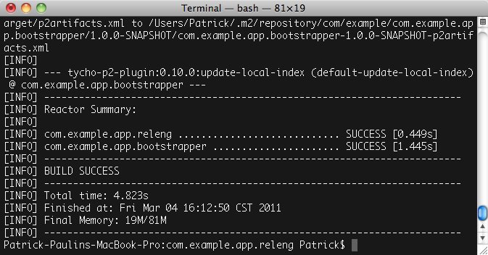
Add the test fragment to the build.

- Copy the file com.example.app.bootstrapper.test.pom.xml into the com.example.app.bootstrapper.test project and rename it to pom.xml.

- Open the parent pom.xml file in the com.example.app.releng project. Locate the modules element and add a new module sub-element that references the com.example.app.bootstrapper. test fragment.

- Re-run the build from the command line. The build should complete successfully and you should also see output indicating that the unit test ran successfully.

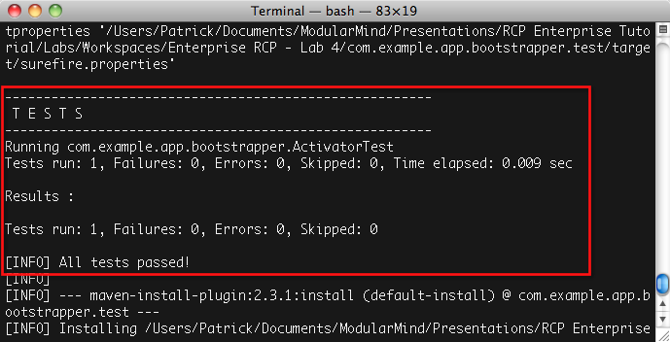
Add the feature to the build.

- Copy the file com.example.app.feature.pom.xml into the com.example.app.feature project and rename it to pom.xml.

- Open the parent pom.xml file in the com.example.app.releng project. Locate the modules element and add a new module sub-element that references the com.example.app.feature project.

- Re-run the build from the command line. The build should complete successfully and you should also see output indicating that the feature was built successfully.

Add the product to the build.

- Copy the file com.example.app.product.pom.xml into the com.example.app.product project and rename it to pom.xml.

- Open the eclipse.product file and enter com.example.app.bootstrapper.product.id into the ID field under General Information. This field is necessary for the Maven p2 director plugin to function properly.

- Open the parent pom.xml file in the com.example.app.releng project. Locate the modules element and add a new module sub-element that references the com.example.app.product project.

- Open the Application class in the com.example.app. bootstrapper bundle. Locate the line where the UPDATE_SITE_URL is declared (should be around line 87).

- We need to modify this variable because Tycho places the generated update site in a sub-folder of the project. Add /target/site to the end of the URL. (FIXME: Not necessary right now, and shouldn't we keep the environment variable like we did in lab-3?)

- Re-run the build from the command line. The build should complete successfully and you should also see output indicating that the product was built successfully.

Install and run bootstrapper.

- Refresh the com.example.app.product project and locate the target/products folder. In this folder is a zip archive containing the application.

- Extract this archive somewhere on your local machine.

- For Mac OS X users only, Maven Tycho does not create a properly configured eclipse.ini file. Locate the appropriate INI file in the extra-files project and copy it into the extracted application. Rename it to eclipse.ini.

In Finder, you will need to right click on the Eclipse application bundle and select Show Package Contents on the context menu. The INI file is located in the Contents/MacOS directory.

For those of you interested in why this is necessary, see the following bug report:

https://issues.sonatype.org/browse/TYCHO-595

- Launch the application if and note that you get an error. The perspective cannot be found because the update site has not been built yet. We’ll do that next.
Note: the application you just launched will not terminate properly. You'll need to use your platform's facilities for finding and terminating stray processes to end the application.
Build the additional feature using Tycho.

- Create a project called com.example.app.perspectives. releng. Copy the file com.example.app.perspectives. releng.pom.xml into the new project and rename it to pom.xml.

- Open the pom.xml file and locate the repository element. Modify the url sub-element so that it points to the local-p2-repository folder we created earlier.

- Copy the file com.example.app.perspectives.pom.xml into the com.example.app.perspectives project and rename it to pom.xml.

- Copy the file com.example.app.perspectives.feature. pom.xml into the com.example.app.perspectives.feature project and rename it to pom.xml.

- Copy the file com.example.app.perspectives.p2.pom.xml into the com.example.app.perspectives.p2 project and rename it to pom.xml.

- Before doing a build, we need to repair the site.xml file in the com.example.app.perspectives.p2 project. This file is modified when doing a PDE Build > Build Site command, and the change causes the Maven Tycho build process to fail.

To fix the problem, remove com.example.app.perspectives. feature from the list in the site.xml file and re-add it.

- In a terminal window, navigate to the com.example.app. perspectives.releng directory. Do a mvn clean package and the build should complete successfully.

- Refresh the com.example.app.perspectives.p2 project. You’ll see the update site has been created as both a folder and as an archive.

- Re-run the application. The new feature should be installed from the update site and the perspective should now appear. Delete the installed application. This lab is now complete.

