Lab 2 - Auto-updating an RCP application

The goal of this lab is to create a feature that will add functionality to our RCP application. The new feature will be automatically installed into the application using p2.

Start by pointing Eclipse at the webapps/root/labs/lab-2 folder contained in the tutorial root. Import the projects into the workspace.

In this lab you will do the following:

- Add p2 auto-update logic to the bootstrapper bundle.

- Create a feature that will add a perspective to our application.

- Publish the feature to an update site and install the feature into our application.

Add p2 auto-update logic to the bootstrapper bundle.

Add the p2 bundles and feature.

- Open the example.product file in the com.example.app. product project.

- On the Dependencies tab, add the org.eclipse.equinox.p2. user.ui feature. This will cause the p2 bundles to be incorporated into the product build.

- Select the org.eclipse.equinox.p2.user.ui feature in the list and click Properties. Enter 0.0.0 for in the Version field.

- Open the MANIFEST.MF file in the com.example.app. bootstrapper bundle.

- On the MANIFEST.MF tab, replace the Require-Bundle header with the following (keeping the leading spaces after the 1st line):

Require-Bundle: org.eclipse.ui,
org.eclipse.core.runtime,
org.apache.commons.codec,
org.apache.commons.httpclient,
org.eclipse.ecf,
org.eclipse.ecf.identity,
org.eclipse.ecf.filetransfer,
org.eclipse.ecf.provider.filetransfer,
org.eclipse.ecf.provider.filetransfer.httpclient,
org.eclipse.equinox.p2.artifact.repository,
org.eclipse.equinox.p2.core,
org.eclipse.equinox.p2.metadata,
org.eclipse.equinox.p2.metadata.repository,
org.eclipse.equinox.p2.operations,
org.eclipse.equinox.p2.repository,
org.eclipse.equinox.p2.repository.tools
Modify the Activator class to expose the BundleContext.

The p2 auto update code will need access to the BundleContext so that it can access OSGi services. To expose it, do the following:

- Open the Activator class in the com.example.app. bootstrapper bundle.

- Add a static variable called context of type BundleContext.

- Assign the variable in start. Set it to null in stop.

- Add a getContext static accessor method that returns the variable.

Modify the Application class.

- Open the Application class in the com.example.app. bootstrapper bundle.

- With a text editor, open the p2-auto-update.txt file in the extra-files folder. Copy the contents and paste them at the bottom of the Application class.

- There will be lots of compile errors because of missing imports. Right-click in the class and choose Source > Organize Imports from the context menu. There are a few imports with multiple suggestions. Choose java.net.URI, java.util.Collection, org.eclipse.jface.operation.IRunnableWithProgress, and java.net.URI.

- Finally, we need to initiate the auto update process in the start method (around line 54). Add the following code at the very beginning of the try block:

if (installNewFeature()) {
return IApplication.EXIT_RESTART;
}
Create a feature that will add a perspective to our application.

Create a bundle that contributes a perspective.

- Create a new Plug-in project called com.example.app. perspectives. On the second page of the wizard, make sure to select the Yes radio button for Would you like to create a rich client application? Click Next.

Note that we are not really going to create an RCP app here. This is just the easiest way to create a new bundle that contributes a perspective.

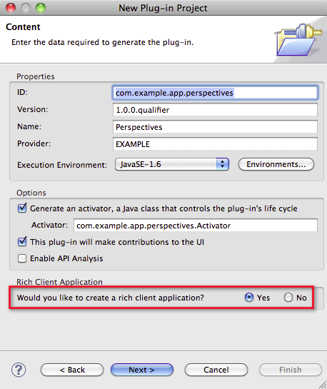

- On the third page of the wizard, select the RCP application with a view template. Click Finish.

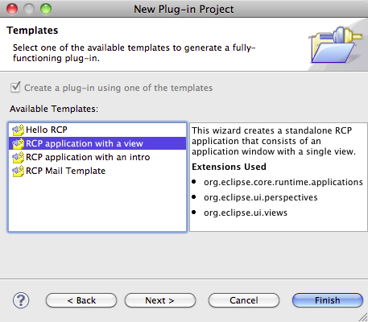

- In the new project, delete the following classes:

Application
ApplicationActionBarAdvisor
ApplicationWorkbenchAdvisor
ApplicationWorkbenchWindowAdvisor

- Open the manifest for the new project. Select the Extensions tab and remove the org.eclipse.core.runtime.applications extension.

Create a feature that will contribute the new functionality to our application.

- Create a new Feature project called com.example.app. perspectives.feature.

- On the second page of the wizard, select the com.example.app. perspectives bundle from the list. Click Finish.

Create an update site project that can be used to populate a p2 repository.

- Create a new project. Select Plug-in Development > Update Site Project from the wizard selection dialog. Click Next.

- Name the project com.example.app.perspectives.p2. Click Finish.

- In the site.xml file, add the com.example.app.perspectives. feature to the list.

Publish the feature to an update site and install the feature into our application.

Publish the feature.

- In the com.example.app.perspectives.p2 project, right click on the site.xml file and select PDE Tools > Build Site from the context menu. This will cause a p2 repository to be created inside the project.

The URL in the auto-update code is hard coded to reference the update site in this project. It will actually being served up via an HTTP URL by the Jetty server.

Modify product configuration file to include the perspective id.

- Open the eclipse.product file and switch to the Launching tab.

- Under Launching Arguments > VM Arguments, enter the following:

-DinitialWindowPerspectiveId=com.example.app.perspectives.perspective

Install the bootstrapper application so that it has valid p2 metadata.

- Export the application using the link in the example.product file. Make sure that the Generate metadata repository checkbox is selected. This is the key to making sure that the application is created with a valid p2 profile.

- In the Export dialog, enter example in the Root directory field. Also select a destination in the Directory field. Your Desktop would be a good destination.

- After the export is complete, you should have two folders in the destination directory, one containing the exported application and one called repository. You can ignore the repository folder.

The final step is to run the bootstrapper application. The auto update logic should discover and install the new feature. The contributed perspective should now appear.

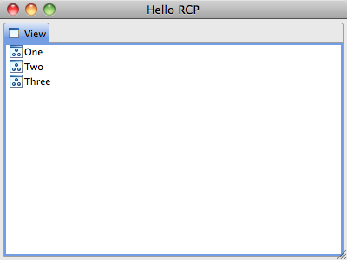

- Shut down the application and delete the example and repository folders. This lab is now complete.

