Lab 4 – Consuming your own builds

The goal of this lab is to build to a p2 repository that is then used for other downstream builds.

Start by pointing Eclipse at the webapps/root/labs/lab-4 folder contained in the tutorial root. Import the projects into the workspace.

In this lab you will do the following:

- Add a dependency on a non-visual feature.

- Build the non-visual feature and publish it to a p2 repository.

- Build the visual feature that consumes the new p2 repository.

- Put it all together.

Add a dependency on a non-visual feature.

A new “quad” has been added to the projects for this lab. The following projects make up the quad:

com.example.app.utility
com.example.app.utility.feature
com.example.app.utility.p2
com.example.app.utility.releng

These projects contain sample code and are set up to build correctly using Maven Tycho. We’ll now add a dependency from the com.example.app.perspectives quad to this one.

- Open the manifest for the com.example.app.perspectives bundle. On the Dependencies tab, add com.example.app. utility to this list or imported packages.

- Open the View class in the com.example.app.perspectives bundle. In the createPartControl method, insert this code at the beginning of the method:

Label label = new Label(parent, SWT.NONE);
int meaningOfLife = new MeaningFactory().getMeaningOfLife();
label.setText("Meaning of life = " + meaningOfLife);

- Test the code by clicking the link in the example.product file. You will get a warning message because the perspective and utility features are not included in the run configuration. You will also get some p2-related exceptions in the console. These can be ignored.

- Select Run > Run Configurations… from the main menu. Select the example.product run configuration and switch to the Plug-ins tab.

5. Place a check next to all of the bundles in the workspace. Then click the Add Required Plug-ins button. Click Run.

The application should run successfully and you should see the view with the new label.

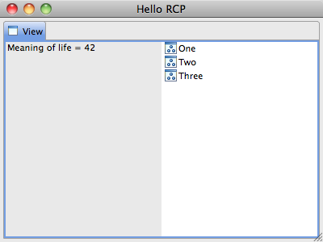

Build the non-visual feature and publish it to a p2 repository.

- From a terminal window, switch to the com.example.app. utility.releng project. Do a mvn clean package to build the non-visual feature.

- Refresh the com.example.app.utility.p2 project. The p2 repository can be found under the target/site folder.

Build the visual feature that consumes the new p2 repository.

  - Switch to the com.example.app.perspectives.releng project. Do a mvn clean package and notice that the build fails because the utility feature cannot be found.

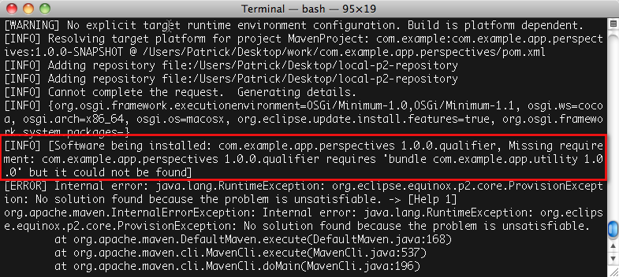

  - Open the pom.xml file in the com.example.app.perspectives. releng project. Add a repository element that points to the update site we generated earlier, like this:

<repository>
<id>utility-repository</id>
<layout>p2</layout>
<url>http://localhost:8080/labs/lab-4/com.example.app.utility.p2/target/site</url>
</repository>

- Re-run the build and it should now complete successfully. Refresh the com.example.app.perspectives.p2 project. The p2 repository can be found under the target/site folder.
Put it all together

We now have two update sites containing our two quads. Let’s install the bootstrapper application and verify that these two quads get installed as well.

The mechanism being used here is called a composite repository. This is a type of p2 repository that simply aggregates other p2 repositories by listing them in an XML file.

A composite repository allows us to pass a single repository URL to the bootstrapper application but reference multiple repositories behind the scenes.

      - The composite repository is stored in the com.example.app. deployment.p2 project. Examine the two XML files in the project and see how the repositories for the two quads are referenced.

      - Open the pom.xml file in the com.example.app.bootstrapper. releng project and comment out or delete the environments that are not appropriate.

      - In a terminal window, switch to the com.example.app. bootstrapper.releng directory and do a mvn clean package.

      - Locate the product archive generated by the build and extract it somewhere on your machine. If you’re running Mac OS X, remember to replace the INI file with one from the extra-files project.

      - Run the application and the two quads should get installed. The view should appear with content generated by the two quads working together.

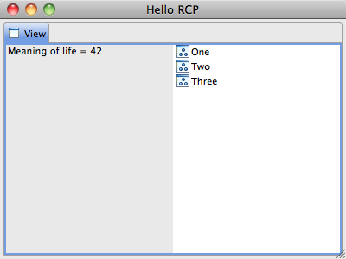

Congratulations! You’re done!

Again, if you have any questions or comments feel free to contact Dave or Patrick by email. And please feel free to introduce yourself if you see either of us walking around during the rest of the conference!

Short instructions for exercising lab-final projects

- Comment out environments in bootstrapper parent pom.
- Build utility quad.
- Build perspectives quad.
- Build bootstrapper quad.
- Install bootstrapper and run it.

