Accurate Fall Detection by Nine-axis IMU Sensor

Yuanzhong Yan1,2, Yongsheng Ou1,3,*

*Abstract*—Fall related injuries are a central problem for the elderly people, therefore many automated fall detectors have been developed. But prevalent methods are neither practical nor poor in accuracy. This paper proposes a novel fall detection algorithm using accelerometers, gyroscopes and magnetometers. In our study, we divide human activities into two categories: lying posture and no-lying posture. We assume that a lying posture is detected after falls. The proposed algorithm has three steps: quaternion Kalman filter, posture recognition, activity intensity analysis. The data is obtained by using nine-axial inertial measurement unit attached on the waist. Using the quaternion Kalman filer the system can obtain body's posture vectors measured in the frame of reference of the ground. The body's posture vectors include Euler angles, quaternion, acceleration. The Euler angles are used to determine the lying posture or no-lying posture. The quaternion and acceleration are used to analyze activity intensity when lying posture are detected. The proposed method features low computational cost and real-time response, in addition has a nice accuracy and convenient in detect falls.

Keywords—elderly; fall detect; euler angle; queternion Kalman filer; posture regconition; activity intensity

# Introduction

The World Health Organization reported that falls is the second leading cause of accidental or unintentional injury to death around the world in September 2016. About 10% to 15% falls will cause serious injuries in the elderly people, and more than 33% of the people aged over 65 have one fall per year [1][2]. Most elderly people are more willing to live at home alone. They can accept new technologies if it could support their independence and safety [5][6]. So, the reliable automated fall detection is very important to rescue the elderly people and avoid the badly prognosis [3][4].

The relevant factors of falls include the following three aspects: (1) environmental factors: when the ground is uneven, or have some obstacles, or is slip, (2) physical factors: it is widely held that aging is associated with a general decline in skeletal muscle function due to lose calcium and other minerals [7], (3) pathologic factors: some diseases cause syncope or asthenia, such as heart disease, high blood pressure.

Body attached wearable device which includes acceleration sensor and Gyro sensor have been used to detect human movement and especially falls. The placement of a wearable fall detector to optimize the location has been studied in some extent. The placement site on the waist has been suggested to be more efficient, since the acceleration signals are similar and evenly distributed between different fall types [8][9]. Furthermore, waist attached detector is located close to the body center of gravity providing reliable information on subject's posture and movements, with the exception of features of arms and legs [10].

Fall detection method commonly uses a motion sensor to detect a fall event, since accelerometer and gyroscope could provide linear and angular motion information directly. Some fall detection algorithms assume that the fall event has a large acceleration change, and uses a single tri-axial accelerometer to obtain object's accelerations in three direction which includes the influence of gravity. This method was accomplished using a single threshold determined by the fall-event data-set [11][12]. However, focusing only on large acceleration can result in many false positives detections from fall-like activities such as sitting down quickly. To solve this problem, Qian li uses two tri-axial accelerometers at chest and thigh, respectively. Qiang li and his research team [13] assume that falling is an unintentional translation to the static posture. By using both accelerometer-derived posture information and gyroscopes, the fall detection is more accurate than the others. However, it is not convenient for the elderly people to use two tri-axial accelerometers on the chest and thigh, respectively.

1. Yuanzhong Yan and Yongsheng Ou are with Guangdong Provincial Key Laboratory of Robotics and Intelligent System, Shenzhen Institutes of Advanced Technology, Chinese Academy of Sciences, 518055 Shenzhen, P.R.China
2. Yuanzhong Yan is with Shenzhen College of Advanced Technology, University of Chinese Academy of Science, 518055 Shenzhen, P.R.China*.*
3. Yongsheng Ou is with CAS Key Laboratory of Human-Machine Intelligence-Synergy Systems, Shenzhen Institutes of Advanced Technology, 51822 Shenzhen, P.R.China.

*Yongsheng Ou is the corresponding author. (ys.ou@siat.ac.cn)

This paper describes a new method to detect a fall event, we divide human activity into two postures: lying posture and no-lying posture. Our method assumes that a lying posture is detected after falls. To detect falls, our system has three steps: quaternion Kalman filter, posture recognition and activity intensity analysis. the nine-axial sensor (accelerometer, gyroscopes, magnetometers) based wearable device is mounted on human's waist. The fall detection system uses quaternion Kalman filter to get union quaternion, Euler angle and acceleration of human body. Our system can recognize lying posture and no-lying posture using yaw and pitch of the Euler angle. If a lying posture is detected, we can use the acceleration to analyze activity intensity and to determine whether the elderly people is falls. From our experiment result, the proposed algorithm is more accuracy than others algorithms [9][10][11][12][13]. the algorithm is low computationally. This method also can be embedded on a wearable device.

The rest of this paper is organized as follows. Section Ⅱ introduces the problem formulation. Section Ⅲ introduces the proposed fall detection method. Section Ⅳ discusses our fall detection solution. Section Ⅴ shows the result. Section Ⅵ concludes the work and gives suggestions for the future work.

# Problem formulation

It is difficult to obtain the fall-event data from the elderly people. The fall-event study involved the young performing simulated falls in a safe controlled environment. activities of daily living(ADL) is simulated by the young and the elderly people. Since it was also not appropriate for the elderly to simulated quickly sitting of activities of daily living.

## Data acquisition

Considering that the proposed method needs acceleration, angular velocity and geomagnetic to detect falls. A single 3-axis accelerometer can provide object's accelerations in three directions which includes the influence of gravity. A coordinate will be built when our fall detector is fixed on human's body. Gyroscope can offer angular velocity and obtain human posture information. A 3-axis magnetometer can detect magnetic strength in three directions, and it can also provide angular motion information in the horizontal plane. In the developed method, the sensor MPU-9250 is used to design the wearable fall detector as shown in Fig.1(a). The sensor MPU-9250 chip is a multi-chip module including a the 3-axis accelerometer, the 3-Axis gyroscope and 3-axis magnetometer. The MPU-9250 features three 16-bit analog-to-digital converters(ADCs) for digitizing the gyroscope outputs, three 16-bit ADCs for digitizing the accelerometer outputs and three 16-bit ADCs for digitizing the magnetometer outputs. The MPU-9250 can monitor angular velocity between ±2000°, acceleration within a range of ±16g, and magnetometer full-scale range of ±800mG. The sampling rate bandwidth should exceed the characteristic response of human movement [13]. the sampling rate of our fall detector is set to 120hz.

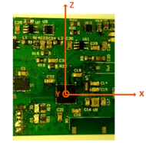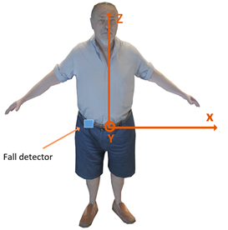

(a) (b)

Fig.1 (a) fall detector (b-system) (b)human model (R-system)

The wearable fall detector should be fast and accurate to detect the real fall-events, especially the real falls and fall-like activities. In order to get more effective fall data-sets and ADL data-sets, one question is that which position is more effective to reflect the human body falling down. Many researchers have done a lot of work to find the body location that can effectively reflect the fall-events. According to the study of Maarit kangas and other researcher [9][11][12] on the fall detection, we know that the waist is the most effective position to reflect the fall-event. The wearable sensor is attached on the waist as shown in Fig.1(b). Fall-like activities may affect the fall detector to make a wrong decision. The experiments should obtain more realistic simulated data, the following sections will introduce in details.

## The simulated fall and ADL study

The types of falls usually includes flat surface falls and inclined falls. In some special cases, it may occur vertical falls and falls with a seated posture. it is hard to record the real falls. In order to get fall-event data-sets, the simulated flat surface falls study involved 6 young healthy volunteers performing simulated falls in a special safe environment. Each subject performed four different types of falls in each of the four directions and each type was repeated four times. The four types of falls include forward falls, backward falls, and lateral falls right and right. These volunteers ranged in age from 23 to 28 years and height from 1.58 to 1.83m. In the inclined falls situation, as it is difficult for man to implement the fall tests from the stair, especially headlong down the stair after falling as shown in Fig.2(a). our experiment had to use puppets instead of our volunteer. However, we conduct four fall tests that head is on the top and foot is blow as shown in Fig.2(b), and use puppets to conduct other 16 times test. few methods have a good effect on inclined falls detection in the existing study. In the following Algorithm section, we show that our method is more prone to detecting falls in this inclined case. In other special falls, we are unlikely to use experiment to reproduce this case, these falls are great possibility caused by the disease.

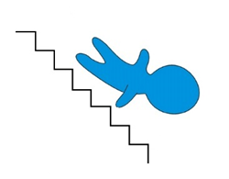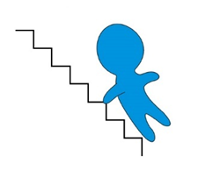

(a) (b)

Fig.2 (a) inclined falls 1 (b) inclined falls 2

Except for falls study, another study involved young volunteers and elderly subjects performing activities of daily living. To conduct these situation tests, the same 6 young healthy volunteers and 2 elderly volunteers (a 61 years old man and a 63 years old female) were monitored. Each ADL was conducted three times by these subjects. But some fall-like tests (quickly sitting down and standing up fast, walking down stair) were only conducted by young volunteers. Since it is not very appropriate for the elderly to conduct this situation.

Thus, the simulated fall and ADL study performed 16 types of activities as shown blow TABLE Ⅰ and TABLE Ⅱ.

TABLE Ⅰ ADL TYPES

|  |  |  |  |
| --- | --- | --- | --- |
| N | Types of ADL | Is fall-like? | subject |
| 1 | Sitting down | No | Young volunteer and the elderly |
| 2 | Standing up from armchair | No |
| 3 | bending | No |
| 4 | Sitting down fast | Yes | Young volunteer |
| 5 | Standing up fast | Yes |
| 6 | Walking flat | No | Young volunteer and the elderly |
| 7 | Walking up stair | No |
| 8 | Walking down stair | Yes |
| 9 | Lying bed | Yes |
| 10 | Standing up from bed | No |

TABLE Ⅱ FALL TYPES

|  |  |  |
| --- | --- | --- |
| N | Types of falls | subject |
| 1 | Forward falls | Young volunteer |
| 2 | Backward falls |
| 3 | Lateral falls right |
| 4 | Lateral falls left |
| 5 | Inclined falls 1 | Puppet |
| 6 | Inclined falls 2 | Young volunteer and puppet |

# Fall detection algorithm

Our fall detection method has three steps: quaternion Kalman filter, attitude recognition, activity intensity analysis. we have to build a reference coordinate system before we implement these three steps. The quaternion Kalman filter use a series of 9-axis inertial measurements obtained from the chip MPU-9250 over times and produces estimates of Euler angles and quaternion that tend to be more accurate than those based on a single acceleration measurement. Attitude recognition and activity intensity are used to detect fall-event.

It is necessary to define a suitable coordinate system to describe the motion of the elderly people. Our fall detect need to obtain the body posture and the acceleration in the direction of gravity, but the elderly motion data information collected by the IMU sensor is based on the sensor coordinates. In order to describe the motion information of human body, two coordinate systems are used. One coordinate system is fixed to the earth and is named R-system. The other coordinate system is fixed to the MPU-9250 IMU sensor and is referred to as a fall detector, and it is named b-system. The fall detector reflects the attitude of the body where the device installed. Fig.1 shows the two right-handed coordinate systems.

Although the gyroscope of the chip MPU9250 perform rather well with an uncorrected offset on the order of a few degrees per second. We have to do something about their drift. With some knowledge of flight control, the orientation of the airplane is often described by three consecutive rotations, the angular rotations are called the Euler angles. We also use this method to describe our fall detector. This explains why two coordinate systems are used. A unit quaternion provides a convenient mathematical notation for representing orientations and rotations of objects in three dimensions. Therefore, a union quaternion based extended Kalman filter (EKF) is developed for determining the orientation of a rigid body from the outputs of a sensor which is configured as the integration of a 3-axis gyro and an aiding system mechanized using a 3-axis accelerometer and a 3-axis magnetometer [14]. a rigid body refers to a fall detector in our method, and it also refers to waist of the old people being detected.

The state vector is composed of the union quaternion ${Qu}_{k}$, the tri-axis accelerometer and magnetometer bias vectors ${{}_{ }^{a}b}_{k},{{}_{ }^{m}b}_{k}$. The state transition vector equation is



which is simplified as:



where is the zero-mean white noise, $G$ is the angular velocity of b-system. $T_{s}$ is the IMU sensor sampling interval.

The measurement model is



which is simplified as:



where $C_{R}^{b}$ is the direction cosine matrix for the transformation from R-system to b-system. $A and M$ is the acceleration and geomagnetic of b-system, respectively. The accelerometer and magnetometer measurement vector is $a_{k},m_{k}$. the measurement noise is $ν_{k}$.

For the sake of reader's convenience, the EKF equations are summarized below [16].

* Compute the priori state estimate:



* Compute the priori error covariance matrix:



where the process noise covariance matrix



* Compute the Kalman gain:



where $F_{k+1}$ is the Jacobian matrix.

* Compute the posteriori state estimate:



* Compute the posteriori error covariance matrix:



On the basis of the above analysis, the IMU data reading from the sensor MPU-9250 chip will be processed from quaternion Kalman filter At first. And then if all values of the Euler angles within one second interval falls into the region specified in step 4 of Algorithm 1. It will detect a lying posture, otherwise, a no-lying posture is detected. If the detector detect human posture is lying posture. The detector will examine the posture change from no-lying posture to lying posture. To distinguish whether the posture change is intentional, the acceleration data $A_{v}$ of the previous 4 seconds along the gravity is applied. If the value of acceleration data within previous 4 seconds is satisfied with condition specified in step 10 of Algorithm 1. A fall event will be detected. The process is shown in algorithm 1 and introduced detailed explanations about the process in the following paragraphs.

Algorithm 1: The three steps fall detection process

$$1 A=\left\{a_{x},a_{y},a_{z}\right\},M=\left\{m_{x},m_{y},m_{z}\right\},G_{ }=\left\{g_{x},g_{y},g_{z}\right\},intervalNum=0$$

$Δ$ first step is quaternion Kalman filter, Euler angle $Ω=\{yaw,pitch,rol\}$

$$2 {Qu}_{ }=quaternion_Kalman_filter(A_{cc},M_{g},G_{yro})$$

$Δ$ turn quaternion to Euler angle

$$3. Ω=transform(Qu)$$

$Δ$ second step is attitude recognition, if all the values of yaw and pitch within one second interval is less than $45°$.lying posture is detected.

$$4 if \left|yaw\right|>40° ∪ \left|pitch\right| >40° then$$

$$5 intervalNum=intervalNum+1$$

$$6 else$$

$$7 intervalNum=0$$

$$8 endif$$

$$9 if intervalNum >120 then$$

$∆$ third step is activity intensity analysis, if ${Av}_{min}<0.4g$

$and {Av}_{max}>2.6g$, a fall-event is detected.

$10 { if Av}_{min}<0.4g∩{Av}_{max}>2.6g then$

$$11 return YES$$

$$12 else$$

$return NO$

### Lying posture and no-lying posture: it is hard to define what is a lying posture. Intuitively, the lying posture is the trunk close contact with the flat surface. In this paper, we can use the Euler angle to reflect the trunk posture. We got the most reasonable way to dectect a lying posture throgh a lot of fall experiments. The most resonable method is that whether the angle between the trunk and the vertical direction is always larger than the $40°$ within one second. For the sake of simplicity, we only consider the absolute pitch or yaw. If pitch angle or yaw angle is less than $40°$, a lying posture will be detected.

### Activity intensity: the dramatic changes in acceleration reflect the intensity of human motion. The fall detector be considered more about the acceleration in the direction of gravity. When the human body has a downward action, the vertical acceleration value will be less than gravity, and a speed deceleration exists when the body touches the ground. If a lying posture was detected, the larger the acceleration in the vertical direction, the greater the impact force of the body on the ground. Experiments show that it is very likely to detect falls when the minimum vertical acceleration is less than 0.4g and the maximum vertical acceleration is greater than 2.6g. We can obtain the acceleration along the direction of gravity from the quaternion and the acceleration based b-system (the sensor readings). The value is $A_{c}$ (including gravity)



Another fall detection algorithm only uses the threshold method. The resultant signal from 3-axis accelerometer at the waist was derived by taking the root-sum-of-squares of the three signals. The algorithm 2 is shown below.

Algorithm 2: Threshold method

$A_{cc}=\left\{a_{x},a_{y},a_{z}\right\}$

$Av=\sqrt{a_{x}^{2}+a_{y}^{2}+a_{z}^{2}}$

$∇$ threshold value is obtained by statistical method

$3 {if Av}_{min}<0.4g∩{Av}_{max}>3g then$

$$4 return YES$$

$$5 else$$

$$6 return NO$$

# Experimental study

Fig.3 and Fig.4 shows that the vertical acceleration and the posture of waist have different features. The fall-event and fall-like event have dramatic changes of accelerations. The maximum of vertical acceleration ${Av}_{max}$ and the minimum of the vertical acceleration ${Av}_{min}$ within four seconds interval are important parameters of describing and measuring the intensity of human activity. In this section, we evaluate the accuracy of our method by the posture recognition, the fall-like case study and the inclined falls.

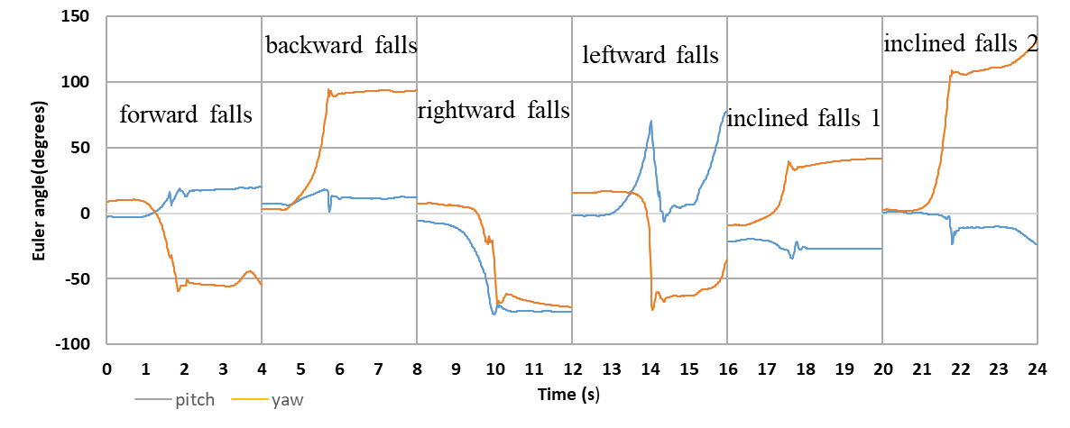

(a)

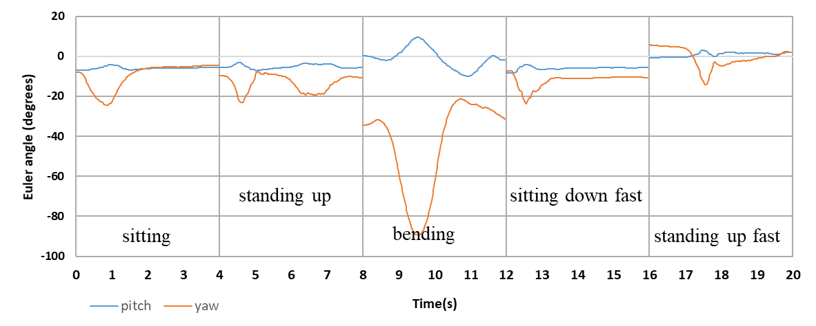

(b)

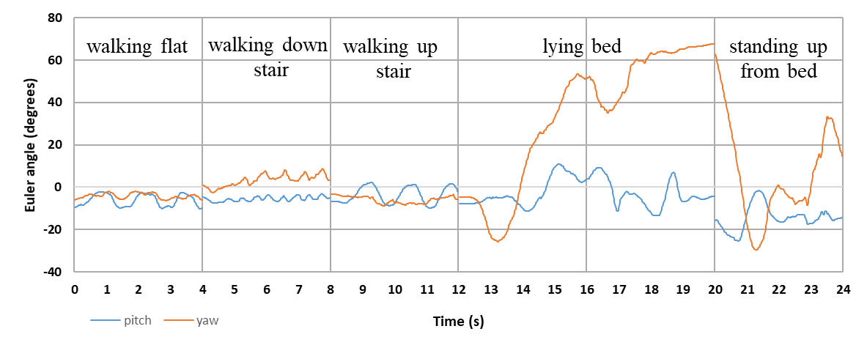

(c)

Fig.3 (a) typical Euler angles signal of waist for falls, (b) (c) typical Euler angles signal of waist for ADL

## Posture recognition

Different types of ADL have different body postures. Fig.3 shows 16 types of human postures. There is a noticeable change in the Euler angles of the flat surface falls, inclined fall 2 and lying bed. The body upright motion, like walking or sitting, has no dramatic changes in the Euler angles. We put the data of all the types of the falls and ADL to make a statistic as shown in the TABLE Ⅲ and TABLE Ⅳ. The tables show that maximum of absolute Euler angles (pitch and yaw) are less than 35° at most types of ADL and the maximum of absolute yaw or pitch are larger than $45°$ at flat falls. Therefore, the threshold value that used to recognize human posture is set at $40°$. When all the values of the pitch or yaw within one second interval are always larger than $40°$, a lying posture will be detected. The duration of one second is used to reduce the effects of noise interference. Because some motions also satisfy the regions specified in step 4 of Algorithm.1.

TABLE Ⅲ POSTURE FEATURES OF ADL

|  |  |  |  |
| --- | --- | --- | --- |
| **N** | **Types of ADL** | **|pitch|(max)** | **|yaw|(max)** |
| 1 | Sitting down | |pitch|<35° | |yaw|<35° |
| 2 | Standing up from armchair | |pitch|<35° | |yaw|<35° |
| 3 | bending | |pitch|<35° | 35°<yaw<90° |
| 4 | Sitting down fast | 0<pitch<35° | |yaw|<35° |
| 5 | Standing up fast | |pitch|<35° | |yaw|<35° |
| 6 | Walking flat | |pitch|<20° | |yaw|<20° |
| 7 | Walking up stair | |pitch|<20° | |yaw|<20° |
| 8 | Walking down stair | |pitch|<20° | |yaw|<20° |
| 9 | Lying bed | -- | 60<yaw<100° |
| 10 | Standing up from bed | -- | 60<yaw<100° |

TABLE Ⅳ POSTURE FEATURES OF FALLS

|  |  |  |  |
| --- | --- | --- | --- |
| **N** | **Types of falls** | **Pitch(max)** | **Yaw(max)** |
| 1 | Forward falls | -- | 45°<|yaw|<100° |
| 2 | Backward falls | -- | 45°<|yaw|<100° |
| 3 | Lateral falls right | 45°<|pitch|<100° | -- |
| 4 | Lateral falls left | 45°<|pitch|<100° | -- |
| 5 | Inclined falls 1 | -- | |yaw|>80° |
| 6 | Inclined falls 2 | -- | |yaw|>45° |

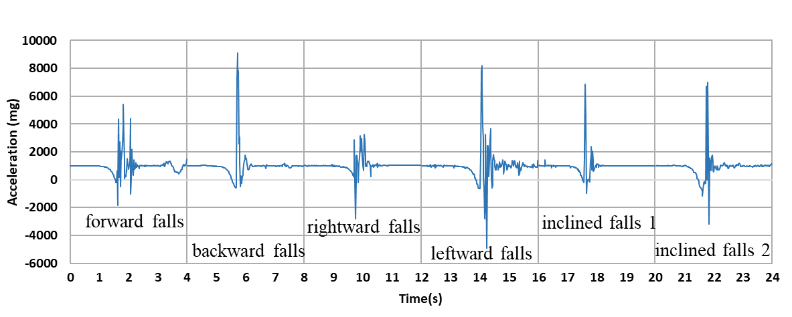

(a)

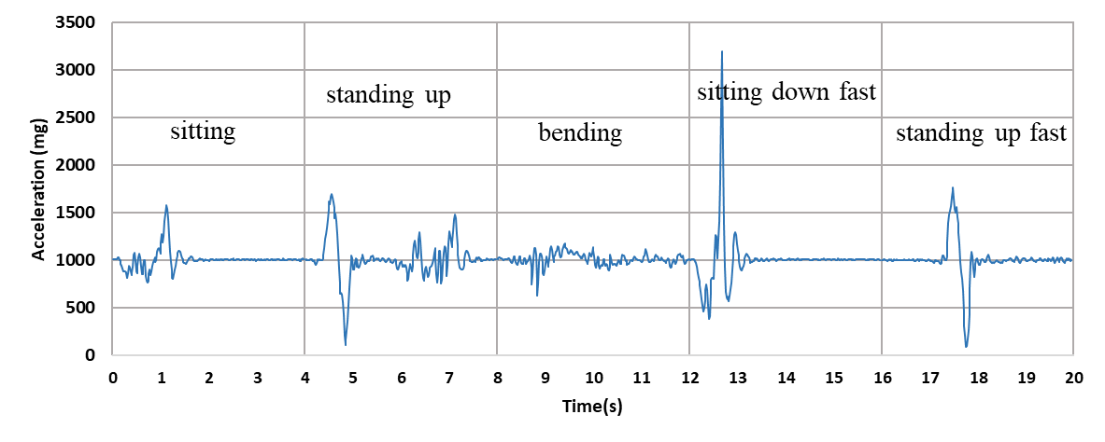

(b)

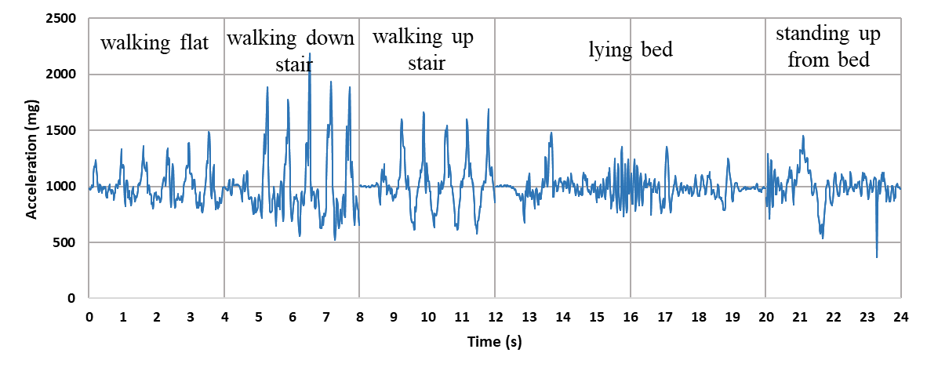

(c)

Fig.4 (a) typical feature of acceleration for all type of falls, (b)(c) typical feature of acceleration for all type of AD

## Fall-like case study

Bourke and the other researchers [12][15] use the algorithm2 to differentiate the falls from the ADL, besides the algorithm2 only uses acceleration to detect the fall-event. They assume that falls happen with large acceleration. However, the quickly sitting down motions or the other fall-like motions also feature large vertical acceleration. Our method adds a step of the posture recognition. Our first step is posture recognition. Although some fall-like motions have the large accelerations, they are still the no-lying posture, such as quickly sitting down and walking down stair. The first step in our algorithm can filter out some of fall-like situation. That is why our method works well than the others.

## Inclined falls

We have discussed that there are two forms about falling on the stair as shown in Fig.2. The first situation features large vertical acceleration and posture changes as shown in Fig.3(a) and Fig.4(a). Some existing fall detection systems [13] use the trunk inclination change to detect falls, and the others [11][12] use the large acceleration change to detect falls. Their methods and our method all work well. But in the second situation as shown in Fig.2(b), it may be very little vertical acceleration changes. Since the stair is steep, human body quickly touches the stairs after falling, and changes in human posture is not particularly evident than the other falls as shown in Fig.4(a). From our experiments, the minimum upper peaks and minimum peaks are 2.2g and 0.5g, respectively. It is hard to use acceleration or inclination changes to detect falls. But our method works better than the other algorithms.

## Computational complexity

The Kalman filter has a nice real-time characteristic. The computational complexity of the proposed method is not very high. The computation effort mainly goes into the calculation of the matrix of quaternion Kalman filter. The proposed algorithm also can work well in the 32-bit microcontrollers.

# Results

According to the analysis result of the experimental data as shown in Fig.5(a), the accuracy of the proposed fall detection algorithm has the same accuracy as the other methods [8][9][10][11][12] in detecting fall event from the activities of daily living except for fall-like case (quickly sitting down, quickly standing up from armchair and lying). But our method has a better performance in the detection of fall-like motion and inclined falls. Comparing our algorithm (algorithm 1) with the other researchers’ [13], the proposed detector can distinguish sitting down fast and quickly standing up from armchair from false falls. That is why the importance of the posture discrimination of our algorithm. Even the proposed method has some fault detections in lying and inclined fall 2 situation, it works better than the threshold method(algorithm2) as shown in Fig.5.

# Conclusion and future work

In this paper, we use nine-axis IMU sensor to detect falls from activities of daily living. The proposed method has three steps. The first step is to get the posture vector by the quaternion Kalman filter. The second step is to detect lying posture. The third step is to detect the activity intensity. The method divides human posture into two types: lying posture and no-lying posture. The system can obtain body’s posture vectors by the quaternion Kalman filter. Posture vectors include Euler angles, quaternion, acceleration. The Euler angles are used to determine the posture types. The quaternion and acceleration are used to analyze activity intensity when lying postures are detected. The algorithm has a real-time characteristic. The results have shown that our method can reduce incorrect detection rate. However, our method has some problems in lying bed and inclined fall 2. We haven’t implemented experiment on the vertical falls and other falls with a seated posture. In the quaternion Kalman filter step, we use geomagnetism to correct the horizontal direction. Our method does not consider the impacts of the environment on geomagnetism. These problems will be exploited in the future work.

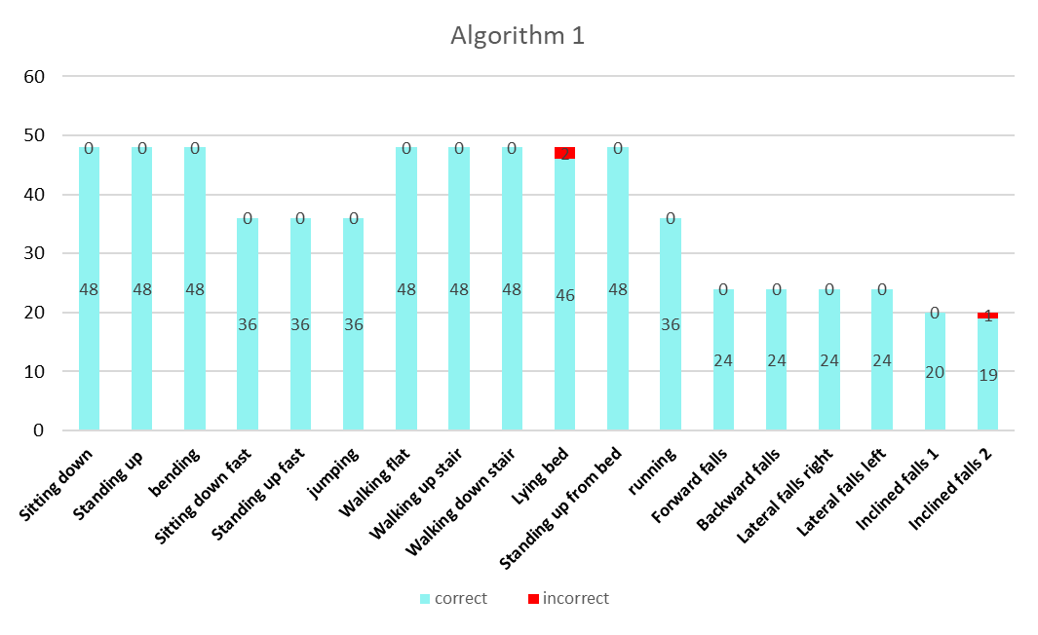

(a)

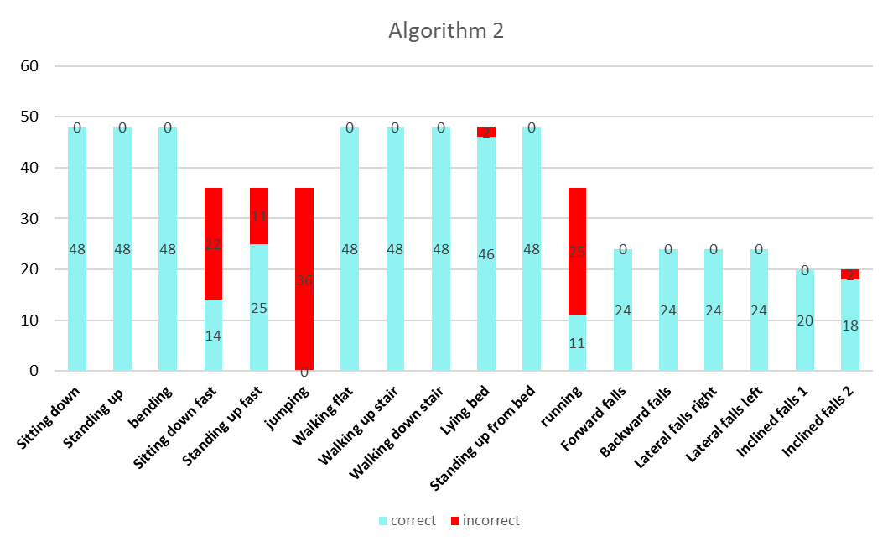

(b)

Fig.5 (a) Algorithm 1 performance (b)Algorithm 2 performance

##### Acknowledgment

This study was supported by the National High-Tech Research and Development Program of China (863 Program) (Grant No. 2015AA042303), the National Natural Science Foundation of China (Grants No. U1613210), the Shenzhen overseas innovation and entrepreneurship Research Program (KQCX2015033117354155), the Shenzhen Fundamental Research Programs (JCYJ20170413165528221, JCYJ2016428- 154842603).

##### References

1. N. Noury, "A smart sensor for the remote follow up of activity and fall detection of the elderly," 2nd Annual International IEEE-EMBS Special Topic Conference on Microtechnologies in Medicine and Biology. Proceedings (Cat. No.02EX578), Madison, WI, 2002, pp. 314-317.
2. Suhuai Luo and Qingmao Hu, "A dynamic motion pattern analysis approach to fall detection," IEEE International Workshop on Biomedical Circuits and Systems, 2004., 2004, pp. 1-5-8a
3. J. Y. Hwang, J. M. Kang, Y. W. Jang and H. C. Kim, "Development of novel algorithm and real-time monitoring ambulatory system using Bluetooth module for fall detection in the elderly," The 26th Annual International Conference of the IEEE Engineering in Medicine and Biology Society, San Francisco, CA, 2004, pp. 2204-2207.
4. B. Schölkopf, J. C. Platt, J. Shawe-Taylor, A. J. Smola and R. C. Willia-mson, "Estimating the Support of a High-Dimensional Distribution," in Neural Computation, vol. 13, no. 7, pp. 1443-1471, July 1 2001.
5. S.J. Brownsell, D.A. Bradley, R. Bragg, P.Catlin, J. Carlier "Do community alarm users want telecare?." Journal of Telemedicine and Telecare, Vol 6, Issue 4, 2000, pp.199-204.
6. Brownsell, Simon, S. Mark, Hawley. "Automatic fall detectors and the fear of falling." Journal of telemedicine and telecare, Vol 10, Issue 5, 2004, pp 262-266.
7. Lexell, Jan. "Ageing and human muscle: observations from Sweden." Canadian Journal of Applied Physiology, Vol 18, Issue 1, 1993, pp.2-18.
8. K Doughty, R Lewis, A Mcintosh "The design of a practical and reliable fall detector for community and institutional telecare." Journal of Telemedicine and Telecare, Vol 6, Issue 1_suppl, pp. 150 - 154
9. Maarit Kangas, Antti Konttila, Per Lindgren, Ilkka Winblad, Timo Jämsä, "Comparison of low-complexity fall detection algorithms for body attached accelerometers." Gait & posture Volume 28, Issue 2, 2008, pp 285-291.
10. M. J. Mathie, A. C. F. Coster, N. H. Lovell, B. G. Celler, "Accelerometry: Providing an integrated practical method for long-term ambulatory monitoring of human movement", Physiol. Meas., vol. 25, no. 2, 2004, pp. R1.
11. M. Kangas, A. Konttila, I. Winblad and T. Jamsa, "Determination of simple thresholds for accelerometry-based parameters for fall detection," 2007 29th Annual International Conference of the IEEE Engineering in Medicine and Biology Society, Lyon, 2007, pp. 1367-1370.
12. A.K. Bourke, J.V. O’Brien, G.M. Lyons, "Evaluation of threshold-based tri-axial accelerometer fall detection algorithm." Gait & Posture, Volume 26, Issue 2, 2007, pp. 194-199
13. Q. Li, J. A. Stankovic, M. A. Hanson, A. T. Barth, J. Lach and G. Zhou, "Accurate, Fast Fall Detection Using Gyroscopes and Accelerometer-Derived Posture Information," 2009 Sixth International Workshop on Wearable and Implantable Body Sensor Networks, Berkeley, CA, 2009, pp. 138-143.
14. A. M. Sabatini, "Quaternion-based extended Kalman filter for determ-ining orientation by inertial and magnetic sensing," in IEEE Transactions on Biomedical Engineering, vol. 53, no. 7, pp. 1346-1356, July 2006.
15. J. Chen, K. Kwong, D. Chang, J. Luk and R. Bajcsy, "Wearable Sensors for Reliable Fall Detection," 2005 IEEE Engineering in Medicine and Biology 27th Annual Conference, Shanghai, 2005, pp. 3551-3554.
16. P. S. Maybeck, Stochastic models, estimation, and control. New York: Academic press, 1979.