SACHA BARBER
F# in Finance, Final Exam Project

Contents
Contents 2
1. The General Idea 3
2. The Overall Structure 3
3. Deep Dive Into Demo App 3
3.1 BioCSharp.Interfaces 3
3.1.1 The Interfaces 3
3.2 BioCSharp 3
3.2.1 BioMorphs 3
3.2.2 Controls 3
3.3 SachaBarberFSharpGeneticAlgorithm 3
3.3.1 Initialisation 3
3.3.2 The App Startup 3
3.3.3 ViewModels General Approach 3
3.3.4 MainWindowViewModel 3
4. Conclusion 3

The General Idea
For my final piece of course work for the F# In Finance course, I decided to try and include a broad cross section of the techniques included in the course. To this end I have tried to include the following areas:
- Deedle usage
- CSVTypeProvider usage
- Other type provider usage
- F# charting
- Functional F#
- OOP F#
- Interop with C#
I think I have done fairly ok in my usage of these things, and I have also included a few other things for fun such as:
- Reactive Extensions (RX)
- F# Async workflow
- Inversion Of Control (IOC) container
- Log4net
- WPF app

The Overall Structure
When you open the Visual Studio solution (VS2013) you should see something like this:
BioCSharp
This is a C# Dll that is used from the main F# SachaBarberFSharpGeneticAlgorithm application
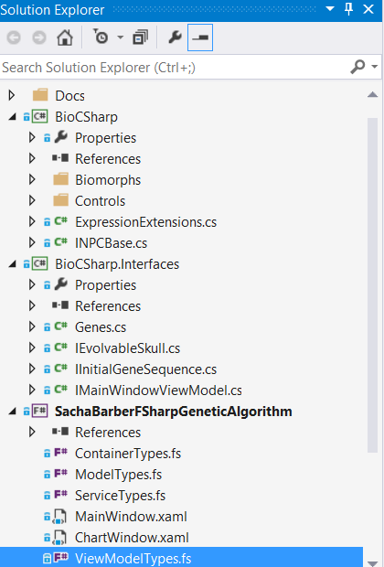
BioCSharp.Interfaces
This is C# Dll that provides common interfaces that are used by both the BioCSharp Dll and the main F# SachaBarberFSharpGeneticAlgorithm application
SachaBarberFSharpGeneticAlgorithm
This is main F# application. It is this one that forms the main basis for my submission. This is the one that has the main window in it.

What Does The Demo App Do?
The demo app I have decided to create is a Genetic Algorithm that will try and create an elite population of cartoon’ish skulls.
The running app will look something like this:
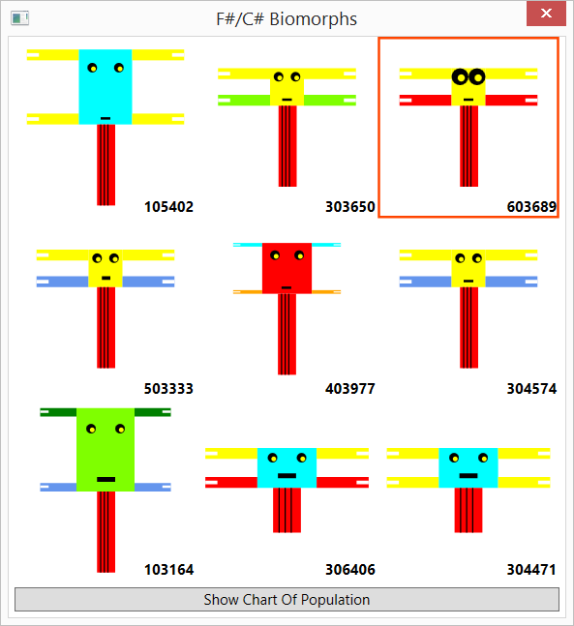
Where it can be seen that we have a population of cartoon ‘ish skulls each with different bones/head/eyes

The Algorithm
Need to grab the screen shot of how the algorithm works from codeproject
Need to grab the screen shot of how the algorithm works from codeproject
Need to grab the screen shot of how the algorithm works from codeproject
Need to grab the screen shot of how the algorithm works from codeproject

The Gene Sequence
There are a total of 9 genes describing the genotype of the organism, which are held in a static class in the BioCSharp.Interfaces.Genes class.
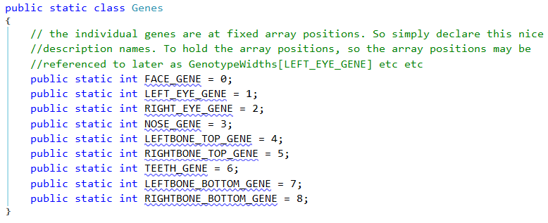

The Initial Population
The initial population is meant to come from a CSV file called “InitialPopulation.csv” within the main SachaBarberFSharpGeneticAlgorithm F# project. Depending on the App.Config “InitialPopulationLoadingStrategy” value, this CSV file will be read with Deedle of the CSVTypeProvider for F#

The Population Count
The initial population is expected to be EXACTLY 9, so if the user tries to amend the count of the “InitialPopulation.csv” file within the main SachaBarberFSharpGeneticAlgorithm F# project, that should result in a error being shown something like this:
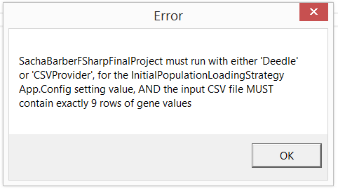

How Is The Population Scored
Each organism of the population is scored, such that an overall dominant one may be found. So how does the scoring work? Well for this simple GA, we treat each gene roughly as some rectangle type shape that has a width/height/colour. So we simple add up all the overall areas of the gene sequences for the organism, and add on any bonuses it may hold.
Bonuses are available for:
- Preferred eye colour
- Preferred gene colour

How Is A New Population Created
There is a cross over point picked, and up to that point some of the genes will come from the parent, and after that point will come from the other parent. Then some random genes are mutated (have new values assigned). This is how a new population is created in this demo app

Deep Dive Into Demo App
This section will talk about the individual projects/items within the projects in a bit more detail, though for the best understanding you will still need to read the code

BioCSharp.Interfaces
This project is a C# Dll, that is used by both the BioCSharp C# project and the main SachaBarberFSharpGeneticAlgorithm F# project.

The Interfaces
The actual interfaces/classes this project contains are listed below:
File name | Description
Genes.cs | Static class holding the int values representing the gene numbers
IEvolvableSkull.cs | Defines interface to dictate what an organism in the population can do
IInitialGeneSequence.cs | Defines interface to dictate what initial gene sequence will look like
IMainWindowViewModel.cs | Defines interface that will be implemented by MainWindowViewModel

BioCSharp

BioMorphs

Controls

SachaBarberFSharpGeneticAlgorithm

Initialisation

Deedle

CSVTypeProvider

The App Startup

Log4Net

XAMLTypeProvider

ViewModels General Approach

Attached DP To Locate VM

IOC For VM Services

MainWindowViewModel

Conclusion
I have had quite a bit of fun working on this final piece of course work. I think I have done reasonable job of trying to showcase some of the stuff we learnt on the course in this demo app. One area where I do think F# is severely crippled compared to other .NET languages is in the tooling. Even forgetting how much of a pain it is to try and create a standard WPF Window, just consider something basic like try to re-order a file in the Visual Studio IDE. You have to locate the file and move it up/down one at a time.
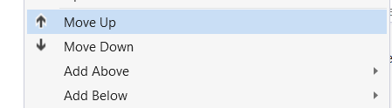

I understand why we have this, it is to make use think about our types a bit more clearly before we start. This mechanism though, really? This takes ages and I think it is absolutely retarded personally.
That said I have really enjoyed working with F#, and creating what I would consider to be a proper application, even if it is a small one. I just wish the tooling was a lot better.

