Dart:
Question 1:
import 'dart:io';

void main() {
print('=== Restaurant Bill Splitter ===\n');
// Get user input
double billAmount = getBillAmount();
int numberOfPeople = getNumberOfPeople();
double tipPercentage = getTipPercentage();
// Calculate amounts
double tipAmount = billAmount * (tipPercentage / 100);
double totalAmount = billAmount + tipAmount;
double amountPerPerson = totalAmount / numberOfPeople;
// Display results
displayResults(billAmount, tipAmount, totalAmount, amountPerPerson, numberOfPeople, tipPercentage);
}

double getBillAmount() {
while (true) {
stdout.write('Enter the total bill amount: ₹');
String? input = stdin.readLineSync();

if (input != null) {
double? amount = double.tryParse(input);
if (amount != null && amount > 0) {
return amount;
}
}
print('Please enter a valid positive number.');
}
}

int getNumberOfPeople() {
while (true) {
stdout.write('Enter the number of people: ');
String? input = stdin.readLineSync();

if (input != null) {
int? people = int.tryParse(input);
if (people != null && people > 0) {
return people;
}
}
print('Please enter a valid positive integer.');
}
}

double getTipPercentage() {
while (true) {
stdout.write('Enter the tip percentage (e.g., 15 for 15%): ');
String? input = stdin.readLineSync();

if (input != null) {
double? percentage = double.tryParse(input);
if (percentage != null && percentage >= 0) {
return percentage;
}
}
print('Please enter a valid non-negative number.');
}
}

void displayResults(double billAmount, double tipAmount, double totalAmount,
double amountPerPerson, int numberOfPeople, double tipPercentage) {
print('\n=== BILL SUMMARY ===');
print('Original Bill Amount: ₹${billAmount.toStringAsFixed(2)}');
print('Tip (${tipPercentage.toStringAsFixed(1)}%): ₹${tipAmount.toStringAsFixed(2)}');
print('Total Amount (including tip): ₹${totalAmount.toStringAsFixed(2)}');
print('Number of People: $numberOfPeople');
print('Amount per Person: ₹${amountPerPerson.toStringAsFixed(2)}');
print('==================');
}

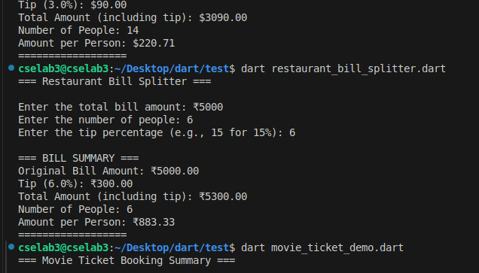
5.movie booking summary
void main() {
print('=== Movie Ticket Booking Summary ===\n');
// Sample booking data
List<Map<String, dynamic>> bookings = [
{
'movieName': 'Avengers: Endgame',
'ticketsBooked': 4,
'pricePerTicket': 250.0,
},
{
'movieName': 'Spider-Man: No Way Home',
'ticketsBooked': 2,
'pricePerTicket': 300.0,
},
{
'movieName': 'RRR',
'ticketsBooked': 6,
'pricePerTicket': 200.0,
},
{
'movieName': 'KGF Chapter 2',
'ticketsBooked': 3,
'pricePerTicket': 280.0,
}
];
// Display booking summary
displayBookingSummary(bookings);
}

void displayBookingSummary(List<Map<String, dynamic>> bookings) {
print('=== BOOKING SUMMARY ===');
print('=' * 60);
double grandTotal = 0.0;
for (int i = 0; i < bookings.length; i++) {
Map<String, dynamic> booking = bookings[i];

String movieName = booking['movieName'];
int ticketsBooked = booking['ticketsBooked'];
double pricePerTicket = booking['pricePerTicket'];
double totalCost = ticketsBooked * pricePerTicket;

grandTotal += totalCost;

print('\nBooking ${i + 1}:');
print(' Movie Name: $movieName');
print(' Number of Tickets: $ticketsBooked');
print(' Price per Ticket: ₹${pricePerTicket.toStringAsFixed(2)}');
print(' Total Cost: ₹${totalCost.toStringAsFixed(2)}');
print('-' * 40);
}
print('\n🎬 GRAND TOTAL EARNED: ₹${grandTotal.toStringAsFixed(2)} 🎬');
print('=' * 60);
}

