DesktopDock
A floating dock for the apps, folders and web pages you use most

DesktopDock is a small strip that floats above your desktop and stays on top of other windows. Drag a browser tab or a program onto it and it is pinned there; click a tile and it opens. It keeps everything it knows in a single plain text file that sits next to the program, so there is nothing hidden away in the registry and nothing to uninstall.
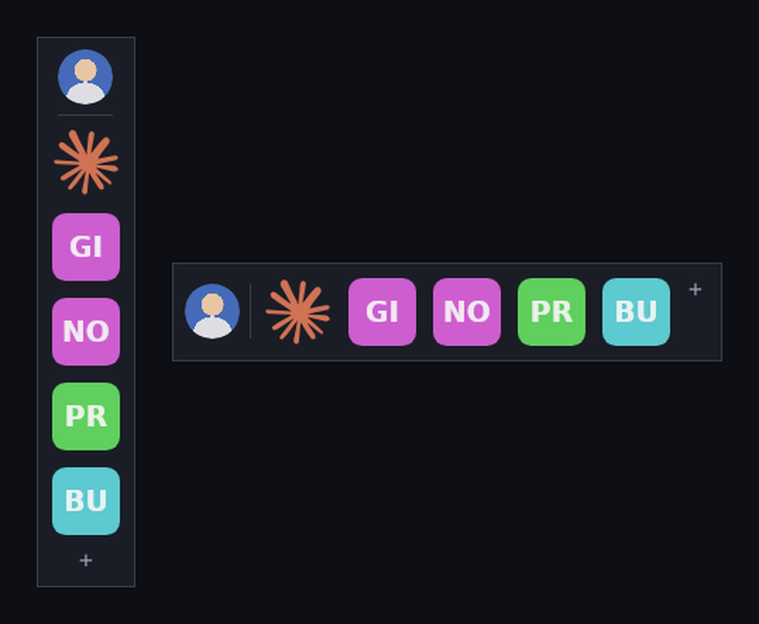
The dock, standing upright on the left and lying flat on the right

Getting started

Starting it for the first time
- Put DesktopDock.exe in a folder of its own. It writes its settings file beside itself, so give it somewhere to live rather than leaving it in Downloads.
- Double-click DesktopDock.exe.
- Windows may show “Windows protected your PC”. Choose More info, then Run anyway. This appears for any program that has not been code-signed; it is not a sign that anything is wrong.
- The dock appears near the top-left of your screen, empty and waiting.


A brand new dock, before anything is pinned to it

If the program will not start
The small download needs the Microsoft .NET 8 Runtime, a free one-time install from Microsoft. If DesktopDock closes immediately or Windows offers to find the missing component online, install the runtime from dotnet.microsoft.com/download/dotnet/8.0 and try again. The larger self-contained download has the runtime built in and needs nothing.

Pinning things to the dock
There are three ways to add something. Dragging is the quickest.
To pin this | Do this
A web page | Drag the tab out of Chrome, Edge or Firefox and drop it anywhere on the dock
A program | Drag its .exe, its desktop shortcut, or its Start-menu tile onto the dock
A folder or document | Drag it in from File Explorer
Something you just copied | Point at the dock and press Ctrl+V
Anything, by browsing | Click the + at the end of the dock and choose Add link, Add app or file, or Add folder

The dock works out a sensible name and picture for whatever you drop. Both can be changed afterwards, so do not worry if a name comes out longer than you would like.
Dropping something that is already pinned does nothing, so you cannot end up with the same tile twice.

Everyday use
What you want | How
Open something | Click its tile once
See what a tile is | Rest the pointer on it and its name and address appear
Change the order | Drag a tile along the dock and let go where you want it
Move the dock | Drag any empty part of it, or drag the round picture at the end
Keep it from moving | Turn on Lock position in the menu
Get to the settings | Right-click anywhere on the dock, or click the +
Close the dock | Right-click it and choose Quit DesktopDock

The dock has no title bar and does not appear on the taskbar, which is what lets it sit quietly above everything else. That also means the only way to close it is the Quit item in its menu.

Changing a single tile
Right-click any tile for the things you can do to it.
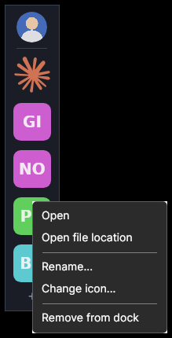
The menu for one tile
Item | What it does
Open | The same as clicking the tile
Open file location | Opens File Explorer with the file selected. Folders open directly
Copy link | For web pages: puts the address on the clipboard
Rename | Changes the name shown under the tile and in its tooltip
Change icon | Pick any picture on your PC to use instead of the automatic one
Reset icon | Throws away the custom picture and works the icon out again
Remove from dock | Unpins it. The program or file itself is untouched

Removing a tile only removes the shortcut. Nothing is deleted from your PC.

The dock menu
Right-click an empty part of the dock, or click the +, for everything else.
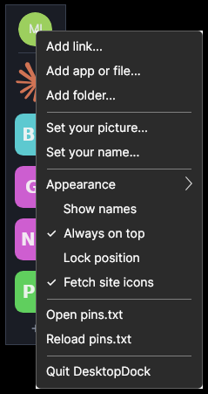
The main menu
Item | What it does
Add link / app or file / folder | Pin something by browsing for it instead of dragging
Set your picture | Choose the photo shown at the head of the dock
Set your name | Used for your initials when no photo is set
Appearance | Upright or flat, tile size from 32 to 80 pixels, and how see-through the dock is
Show names | Puts each tile's name underneath it
Always on top | Whether the dock stays above other windows. On by default
Lock position | Stops the dock and its tiles being dragged by accident
Fetch site icons | Whether web pages may download their icon. Turn off to stop all network use
Start with Windows | Runs the dock automatically when you sign in
Open pins.txt | Opens the settings file in your text editor
Reload pins.txt | Re-reads that file after you have edited it by hand
Quit DesktopDock | Closes the dock

Your picture
The round tile at the head of the dock is yours. Click it to choose a photo from your PC, and it will be cropped to a circle for you. Until you set one, the dock shows your initials if you have entered a name, or a plain silhouette if you have not.
The picture is also a handle: drag it to move the dock around the screen.

How tiles get their pictures
- Programs, folders and documents borrow the icon Windows already shows for them, so they look exactly as they do in the Start menu or File Explorer.
- Web pages use the site's own icon, downloaded once and then kept in an icons folder next to the program.
- Pictures show a small version of the picture itself.
- Anything else gets its initials on a coloured tile. The colour is worked out from the name, so it stays the same every time.

If a site has no icon, or you are working offline, the initials tile is used instead and the dock quietly tries again another time. Change any icon yourself with Change icon on the tile's menu.

Your settings file
Everything the dock remembers lives in pins.txt, in the same folder as DesktopDock.exe. It is an ordinary text file, meant to be read and edited. Choose Open pins.txt from the menu to see it, and Reload pins.txt after you save your changes.
[settings]
x = 1180
y = 220
orientation = vertical
icon_size = 48
opacity = 0.96
always_on_top = true
locked = false
show_labels = false
fetch_favicons = true
profile_pic = C:\Users\me\Pictures\me.jpg
profile_name = Michael

[pins]
link | Claude | https://claude.ai |
app | Notepad | C:\Windows\notepad.exe |
folder | Projects | C:\Users\me\Projects |
file | Budget | C:\Users\me\budget.xlsx |
Each pin is written as type | name | what it opens | icon. The type is app, file, folder or link. The last column is optional and holds the picture you chose with Change icon; left empty, the dock works the icon out itself.
Because everything is in that one folder, DesktopDock is portable. Copy the folder to a USB stick or another PC and your dock arrives exactly as you left it, with the same pins in the same order. It is also worth copying somewhere safe now and then, the same as any other settings you would rather not rebuild.

Starting with Windows
Turn on Start with Windows in the menu and the dock will be waiting for you each time you sign in. Turning it off again removes the entry. If you move DesktopDock.exe to a different folder afterwards, switch the setting off and on again so it points at the new location.

If something is not right
What you see | What to do
“Windows protected your PC” when starting | Choose More info, then Run anyway. Expected for any program that is not code-signed
It closes straight away | Install the Microsoft .NET 8 Runtime, or use the larger self-contained download
A drop does not add anything | Drop onto the dark body of the dock rather than the very edge. As a fallback, copy the address and press Ctrl+V over the dock
A web page shows initials, not its icon | The site has no icon, or you were offline. Check that Fetch site icons is ticked, or set one with Change icon
The dock will not move | Lock position is on. Turn it off in the menu
A tile does nothing when clicked | Whatever it points at has been moved, renamed or deleted. Remove the tile and pin it again
The dock is off the edge of the screen | Close it, open pins.txt, set x and y to something small such as 80, and start it again
Your pins have gone | Check that pins.txt is still beside the program. The dock creates a fresh, empty one if it cannot find it

The dock sends nothing anywhere. The only time it uses the network is to fetch the small icon belonging to a web page you have pinned, and Fetch site icons turns even that off.

Quick reference
Action | Result
Click a tile | Opens it
Drag a tile | Moves it along the dock
Right-click a tile | Rename, change icon, remove
Drag the dock body | Moves the dock
Right-click the dock | The main menu
Click + | The main menu
Ctrl+V | Pins the address or path on the clipboard
Drop a tab or file | Pins it

