1. Bash script to provision AWS ec2.

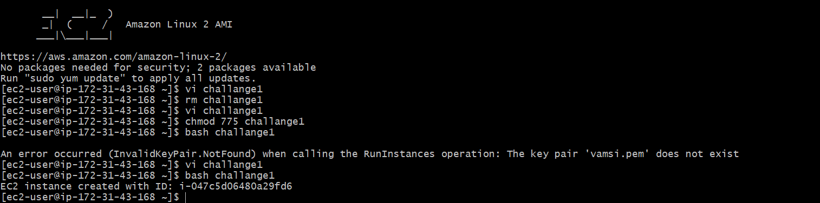

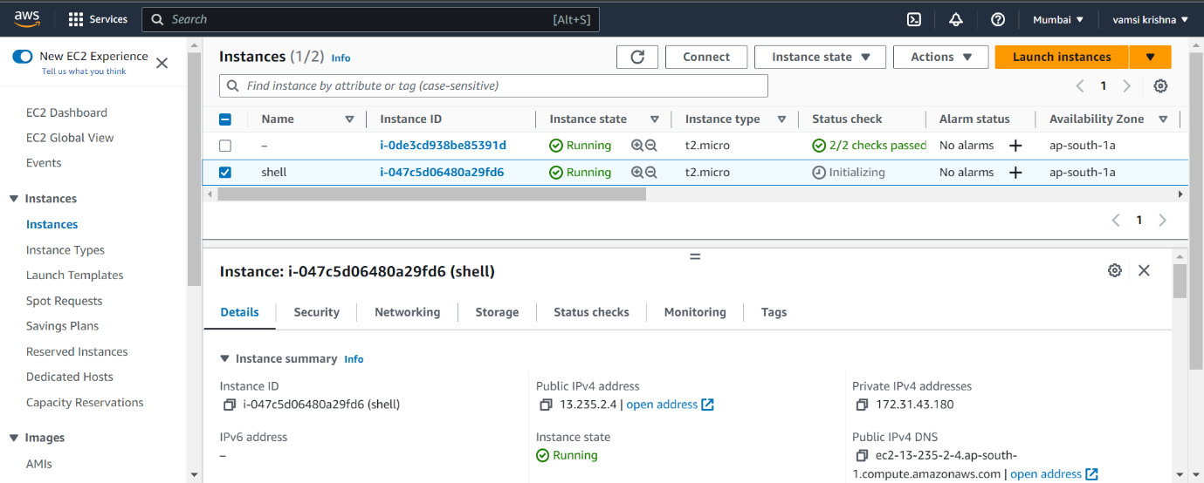

1. Bash script to find the files with the extension .txt and delete the files.

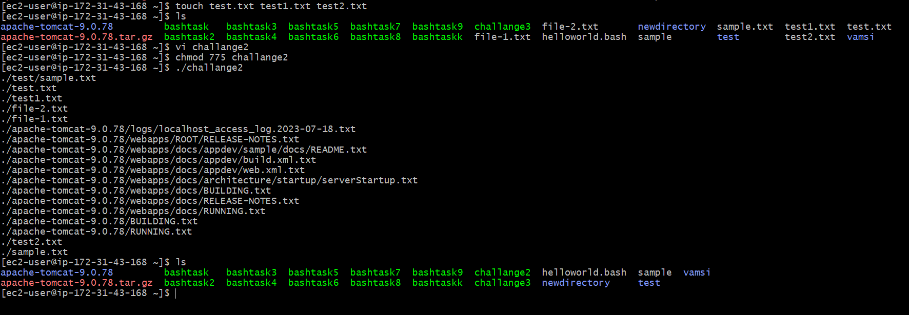

1. Bash script to install nginx and run on port number 80.

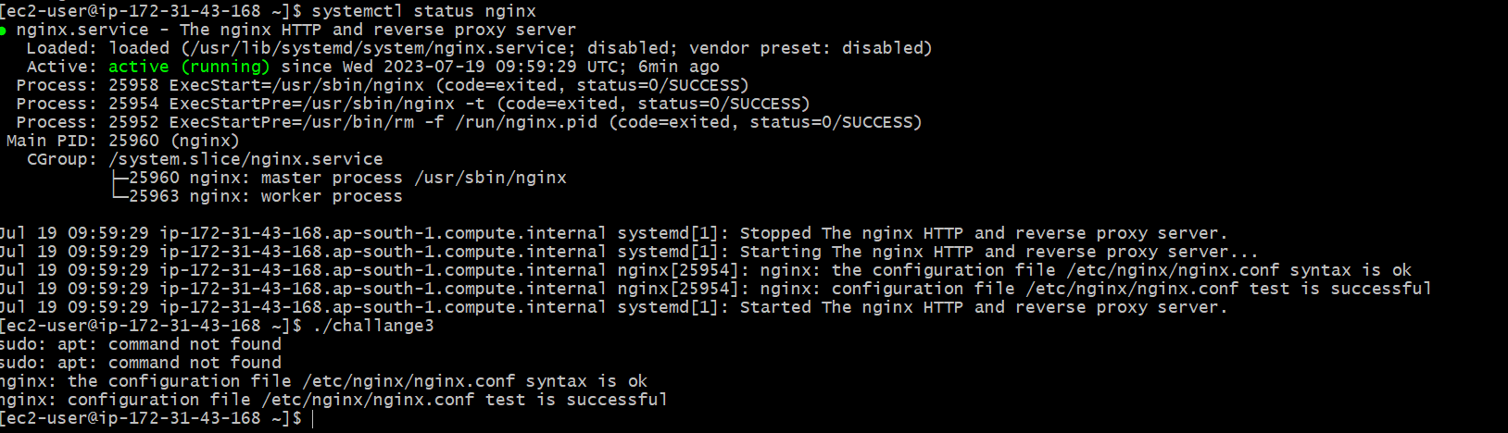

1. Bash script to install httpd and run on port number 81.



