Error pattern analysis: phoneme-to-text decoder
Project: homophone-aware phoneme-to-text decoding for lip-reading Date: 22 July 2026 Model: Llama-3.2-3B with low-rank adapters, trained on clean phonemes Decoding: beam search width 5 Evaluation set: 949 validation sentences, deduplicated against training
Structured to follow the P2T Three-Stage Error Analysis Framework.

Scope
This report analyses the errors remaining after fine-tuning the decoder on clean phoneme transcriptions. The model gets 873 of 949 sentences exactly right and fails on 76. A second model, trained on the same data but with some of its input phonemes deliberately corrupted, is analysed in a separate report; no number here refers to it.
Two framework activities fall outside what this component can be measured on. Viseme analysis asks which sounds look alike on the lips, which is a property of the visual front-end upstream of us. Our decoder receives phonemes already transcribed and produces text, so a viseme grouping explains none of its errors. Severity assessment is included below at category level, though a fully defensible version would annotate all 76 failures individually.
The failure sample is 76 rows. Several breakdowns rest on counts in single digits, and those are flagged where they occur.

Stage 1: Conventional evaluation
Alignment is by Levenshtein distance at word, character and phoneme level.
Metric | Value
Phoneme error rate | 1.75%
Word error rate | 2.09%
Character error rate | 0.98%
Exact sentence match | 91.99%

Phoneme error rate on failing rows alone rises to 19.26%, against 0% on the 873 correct rows.
As the framework sets out, these numbers say how much and stay silent on what. Two models with identical phoneme error rates can fail in entirely different ways, and the remaining stages exist to separate those cases.

Stage 2: Phoneme error pattern analysis

Substitution, insertion and deletion
Level | Reference units | Substitutions | Insertions | Deletions | Error rate
Word, overall | 5,214 | 87 | 13 | 11 | 2.13%
Word, homophone rows | 3,995 | 57 | 8 | 9 | 1.85%
Word, non-homophone rows | 1,219 | 30 | 5 | 2 | 3.04%
Character, overall | 26,345 | 116 | 67 | 78 | 0.99%
Character, homophone rows | 19,751 | 74 | 35 | 60 | 0.86%
Character, non-homophone rows | 6,594 | 42 | 32 | 18 | 1.40%

At word level, 87 of 111 errors are substitutions (78%). The dominant behaviour is picking the wrong word while keeping sentence structure intact.
At character level the balance flips. Insertions and deletions total 145 against 116 substitutions, and 95 of those 145 sit in homophone rows. That signature comes from splitting or merging a word, which forces the character alignment to insert or delete a space and shifts everything after it.
Non-homophone sentences score worse on every line. This runs against the expectation that homophones are the harder case, and it has now appeared in four consecutive runs. We have no explanation and are treating it as open.

Confusion matrix
A confusion matrix records, for every sound the model got wrong, which sound it produced instead. Reference sounds run down the rows and predicted sounds across the columns, so each filled cell is one type of substitution and its number is how often that substitution happened. The figure below covers the 76 failing sentences, with vowels grouped in the upper-left block and consonants in the lower-right, separated by the red lines.
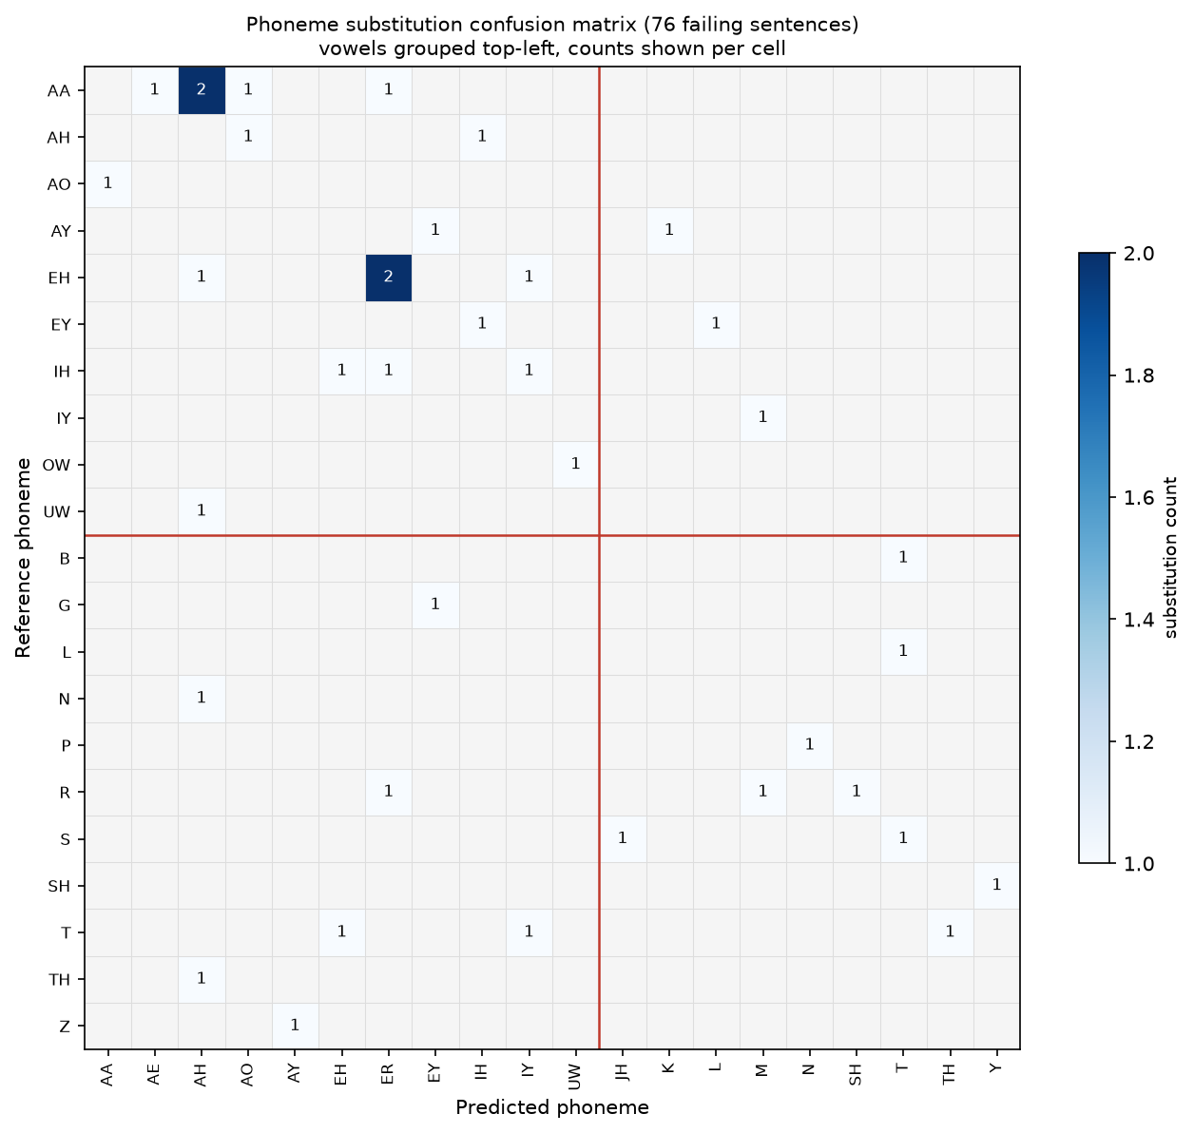
Phoneme substitution confusion matrix across the 76 failing sentences. Vowels are grouped top-left and consonants bottom-right. Only two cells reach a count of 2; every other confusion happened once.
The matrix holds 38 substitutions spread across 36 distinct cells. Only two cells reach a count of two, AA replaced by AH and EH replaced by ER. Every other cell holds a single event. Thirty-six distinct confusions from 38 substitutions means the errors do not repeat: the model does not confuse one particular sound for another in a consistent way that could be corrected with a targeted rule. The sample is small enough that a systematic pattern could still emerge at larger scale, so this describes the current data without ruling that out.
The density sits in the upper-left block, where a vowel was replaced by another vowel. That accounts for 19 of the 38 substitutions, exactly half, and is the clearest signal in the analysis that the model's weak point is vowel quality rather than consonants. This proportion does not depend on how often each sound appears, so it is more stable than the per-sound rates below. Six substitutions replace a consonant with a vowel and three replace a vowel with a consonant, and the rest stay within the consonants.
For completeness: an earlier version of this matrix was computed incorrectly. It joined each phoneme sequence into one unbroken string before aligning, which made it compare individual letters and produce meaningless pairs such as the letter A against the letter E. That computation has been replaced by the sound-level matrix shown here, and any earlier figure built from it should be disregarded.

Phoneme-class analysis
The table below counts, for each reference sound, how many times it was substituted and how often it appears across all 949 sentences, giving a corpus-wide error rate in the same form as the parallel prompting study. Sounds are ordered by substitution count, since that is the more stable ordering at these low error volumes.
Sound | Substitutions | Occurrences across 949 sentences | Rate | Replacements seen
AA (as in "father") | 5 | 379 | 1.3% | AH, AE, AO, ER
EH (as in "bed") | 4 | 519 | 0.8% | ER, AH, IY
R | 3 | 829 | 0.4% | ER, M, SH
IH (as in "sit") | 3 | 1,138 | 0.3% | EH, ER, IY
T | 3 | 1,540 | 0.2% | EH, IY, TH
EY (as in "say") | 2 | 263 | 0.8% | IH, L
AY (as in "my") | 2 | 407 | 0.5% | EY, K
AH (as in "cup") | 2 | 1,702 | 0.1% | AO, IH

Every rate sits below 1.4%, which is expected for a model that gets 92% of sentences exactly right. The two sounds substituted most often are the vowels AA and EH, and both are open or open-mid, meaning the jaw sits low when they are produced. This is consistent with the vowel-to-vowel pattern in the confusion matrix above, which is the stronger evidence since it does not depend on occurrence counts.
Read as a rate alone, this table is noisy at these volumes. A sound substituted once can show a higher rate than AA purely because it is rare: TH, for instance, appears 64 times with one substitution, giving a 1.6% rate off a single event. The substitution count is the reliable column; the rate is context for it.
The replacement column shows the same dispersion as the matrix. AA is replaced by four different vowels across its five substitutions, and EH by three across its four, so where a sound fails more than once it tends to fail in a different direction each time.
Grouping substitutions by articulatory feature, where place is where in the mouth a sound forms, manner is how it is produced, and voicing is whether the vocal cords vibrate:
Group | Substitutions | Place kept | Manner kept | Voicing kept
All failing rows | 38 | 44.7% | 47.4% | 26.3%
Homophone rows | 27 | 51.9% | 51.9% | 25.9%
Non-homophone rows | 11 | 27.3% | 36.4% | 27.3%

Voicing is preserved least often at 26%, which suggests voicing errors tend to miss by a full articulatory step. Homophone rows preserve place and manner about half the time while non-homophone rows preserve them less often, which is consistent with errors in homophone sentences being closer to the target than errors elsewhere. The non-homophone figures rest on 11 substitutions, so this difference is suggestive rather than established.

Are the errors systematic?
The framework distinguishes systematic confusions, which suggest a targeted fix, from random ones, which are harder to diagnose. Weighting the phoneme error rate by articulatory similarity answers this: a weighted rate far below the unweighted one would mean errors clustered among neighbouring sounds.
Group | n | Phoneme error rate | Weighted | Ratio
Overall | 949 | 1.75% | 1.63% | 0.930
Homophone rows | 672 | 1.48% | 1.37% | 0.928
Non-homophone rows | 277 | 2.52% | 2.36% | 0.935
Failing rows only | 76 | 19.26% | 17.92% | 0.930

The ratio holds at 0.93 across every group. Weighting by articulatory similarity moves the total by 7%, which points toward errors that are not concentrated among neighbouring sounds. The confusion matrix points the same way, with 36 distinct pairs from 38 events. The two measurements are consistent with each other, though both rest on the same small set of substitutions and are not fully independent evidence. The parallel prompting-based study on this same corpus, run by another member of the group, reported the weighted rate well below the unweighted one, which would indicate clustered errors; the difference from our result may reflect the different approach, the far larger error count in that study, or both. On our data a sound-aware rescoring pass would have limited material to work with.
The AA to AH confusion illustrates why. Those two vowels share place and manner, so a correction working from articulatory features cannot separate them. Only length distinguishes them, and length is the dimension the model loses.

Stage 3: Hierarchical error analysis
Each failing sentence was classified using the target text, the predicted text, and pronunciation dictionary lookups for both. Methodology follows the framework's Option 2 for lexical analysis and Option 3 for contextual analysis, with semantic similarity scoring for Option 4. Option 5, classification by a language model, is built but has not been run.

3.1 Lexical analysis
All four lexical error types named in the framework appear in our output.
Framework type | Our category | n | Share | Example
Homophone ambiguity | Homophone substitution | 34 | 44.7% | PINT to PAINT
Incorrect word selection | Semantic substitution | 8 | 10.5% | RARITY to RETIREMENT
Out of vocabulary | Invented spelling | 17 | 22.4% | SQUIRREL to SQUWAREL
Out of vocabulary | Rare word substitution | 3 | 3.9% | SAXIFRAGE to SAXOPHONE FRAGMENT
Incorrect segmentation | Word boundary error | 5 | 6.6% | ROPES to ROPE S
Beyond framework | Number formatting | 5 | 6.6% | SIX to 6
Beyond framework | Truncation | 3 | 3.9% | final word dropped
Beyond framework | Suffix addition | 1 | 1.3% | SHIP to SHIPPING

Homophone and incorrect-word-selection cases are two ends of one phenomenon and together account for 42 of 76 failures (55%). Which of the two a case lands in depends on a similarity threshold with no principled value.
Dictionary coverage supports the out-of-vocabulary reading: 56 predictions contain a word the pronunciation dictionary lacks against 34 in the targets, so the model invents unknown words more often than it meets them. Nothing constrains the decoder to produce real words.
Reliability of these labels. The categories in the table above were assigned by an automatic rule. To check that rule, one of us read 26 of the 76 failing sentences by hand, without seeing the automatic label, and assigned a category independently. This manual review is referred to as the manual audit throughout this report. The two labels disagreed on twelve of the 26 sentences, which is 46%.
The disagreements run in one direction: the automatic rule over-assigns homophone ambiguity, because its test of whether two words share half their sounds catches cases that are homophones in no linguistic sense. FORTNIGHT becoming NIGHT is a dropped syllable, OLYMPIC becoming OLYMPICS is an added plural, FLOURISH becoming FLURRY is a collapsed syllable. Three further cases the rule labelled invented spellings or incorrect word selection were word segmentation problems underneath. Genuine homophone ambiguity therefore sits below the 44.7% in the table and segmentation well above its 6.6%. This is the framework's own argument for manual annotation as the most defensible option, and the audit here is a partial version of it, covering 26 of the 76 failures rather than all of them.

3.2 Contextual analysis
The grammar checker looks for tense inconsistency, agreement errors and word-order problems, specifically flagging cases where a possessive word such as THEIR or YOUR appears in a position only its sound-alike counterpart could fill.
It fired zero times across all 85 substitutions.
The four genuine homophone substitutions in the whole evaluation set are TO for TOO, AD for ADD, BY for BUY, and LLOYD for LOYD. None involves a possessive pronoun, so the detector had nothing to catch. It works and should stay armed for larger runs; this corpus lacks the confusion it targets. The other 81 substitutions fall outside exact-homophone lookup and are the segmentation, suffix and dictionary-coverage problems described above.
The detector found no contextual errors of the framework's type in this output. This reflects both the model producing mostly well-formed sentences and the detector covering only the closed-class possessive case, so it should be read as an absence of that specific error type rather than a guarantee of full grammaticality.

3.3 Semantic analysis
Semantic similarity scoring compares meaning through contextual language embeddings, so two sentences can score highly even when their words differ. Measured on the 76 failing rows:
Statistic | Value
Mean | 0.884
Median | 0.905
Scoring 0.90 or above | 40 of 76 (52.6%)
Scoring 0.70 or above | 75 of 76 (98.7%)
Scoring below 0.50 | 0 of 76

Meaning is largely preserved even on failures. Homophone and non-homophone rows score within one point of each other, at 0.886 and 0.880.
The framework notes that semantic similarity alone is insufficient, since a meaning reversal can still score highly. That caution applies here. Our high scores establish an absence of wholesale semantic drift; they cannot by themselves rule out a reversal, and the manual audit is what confirms none occurred.

3.4 Severity assessment
Severity is assigned per category against the framework's four levels. The assignment works at category level; per-row annotation would be the more defensible form if required.
Severity | Categories | Rows | Share
Low | Number formatting, word boundary error, suffix addition | 11 | 14.5%
Medium | Homophone substitution, invented spelling | 51 | 67.1%
High | Incorrect word selection, rare word substitution, truncation | 14 | 18.4%
Critical | None | 0 | 0%

Low covers cases where meaning survives intact and a reader recovers the intended text without effort, such as SIX rendered as 6 or ROPES split into ROPE S. Medium covers an incorrect lexical choice inside an understandable sentence, matching the framework's own example of there becoming their. High covers substantial meaning change, such as RARITY becoming RETIREMENT or a dropped final word.
The mapping from category to severity is a judgement applied uniformly to each category, so individual rows within a category may warrant a different level on closer reading. The table should be read at that resolution.
No row was classified critical. The framework defines critical by consequence, such as a medical negation reversing, and this corpus is broadcast television content where no output is likely to carry safety risk. Severity in a safety-critical deployment would need reassessing against that domain.
The semantic scores are consistent with this distribution. No row falls below 0.50 and only one below 0.70, which places most of the failure mass at the low and medium end and agrees with the 82% classified Low or Medium here.

Outputs: correction recommendations
Rank | Issue | Evidence | Direction
1 | Word segmentation | The most common mechanism found in the hand review of 26 failures | Handle compounds on the target side, or penalise mid-word spaces during decoding
2 | Number formatting | 5 failing sentences; 17 predictions across all 949 contain a digit | Convert digits and spelled-out numbers to one form before scoring
3 | Rare and proper nouns | 56 predictions contain a word absent from the pronunciation dictionary | Extend dictionary coverage through the existing fallback
4 | Invented spellings | 17 failing sentences (22.4% of failures) | Constrain generation to real words
5 | Open vowel confusion | Half of all phoneme substitutions (19 of 38) are vowel-to-vowel; AA and EH are the most-substituted sounds | Needs acoustic-side work; not addressable at the text stage
6 | Suffix additions | 1 clear case in the failure set, with related cases seen in the hand review | Same constraint as rank 4
7 | Casing artefacts | 932 of 949 predictions carry an uppercase word | Cosmetic; normalise case before computing character error rate
8 | Exact homophones | 4 of the 85 substitutions | Choose a single canonical spelling at training time

Ranks 3, 4 and 6 share a cause: the decoder can emit any token sequence with nothing requiring a real word. Constraining generation to a known vocabulary addresses all three at once and is the single change with the widest reach. Ranks 1 and 2 are post-processing fixes needing no retraining. Rank 5 is the only finding pointing at the model itself, and Stage 2 concluded twice that a feature-aware correction cannot fix it.

Caveats and outstanding work
The confusion matrix figure replaces an earlier, incorrectly computed version. Any figure or table produced before this report that shows single-letter confusion pairs comes from that earlier version and should be set aside.
Severity was assigned one level per category. Annotating each of the 76 failures individually would make the severity breakdown defensible under the framework's most rigorous option, its manual-annotation route.
Classification by a language model, the framework's fifth Stage 3 option, is implemented but has not been run. Running it would give an independent second opinion on the 46% disagreement rate the hand review found.
The automatic lexical labels disagreed with the hand review on 46% of the 26 audited sentences, always by over-assigning homophone ambiguity, so the Stage 3.1 category shares are approximate and the manual review corrects their direction.
The two tools used to count substitutions report slightly different totals, 85 and 87, because they normalise text differently before aligning. The difference does not change any conclusion.
The corpus carries no speaker identifiers, so the same speakers may appear in training and evaluation. If they do, scores are optimistic by an unknown amount.
All numbers come from the validation split. The held-out test set of 1,243 sentences remains untouched and available for final reporting.

