P2T LoRA Decoder — 5,000-Row Fine-Tuning Run
Detailed Run Report, including Error Pattern Analysis (Stage 2 + Stage 3)
11 July 2026

1. Run Configuration
Setting | Value
Base model | meta-llama/Llama-3.2-3B (4-bit QLoRA, frozen base)
Adapter | LoRA — r=8, alpha=16, dropout=0.1, target modules: q_proj/k_proj/v_proj/o_proj
Training objective | Plain cross-entropy (contrastive mechanism disabled — see dryrun.py)
Data selection | 5,000 rows sampled directly from the full LRS2 corpus (CPT_N_TOTAL=5000), unstratified — no deliberate homophone/non-homophone balancing
Train / validation split | 4,000 / 1,000 (80/20, random, seed 42)
Homophone share of sample | 791 / 1,000 validation rows (79.1%) — reflects the corpus's natural proportion, not an artificial balance
Epochs | 2 (default)
Batch size / grad accumulation | 2 / 2 (effective batch 4)
Learning rate | 2e-4, linear warmup + decay
Checkpoint location | p2t_lora_checkpoints/

This is a preliminary, reduced-scale run (5,000 of 48,164 corpus rows, ~10%) — a checkpoint on the way to the full stratified run (37,374 homophone + 10,790 non-homophone rows), not the final thesis result.

2. Core Metrics
Subset | N | WER | CER | BLEU-4 | Exact Match
Overall | 1000 | 19.96% | 11.50% | 0.673 | 41.20%
Homophone | 791 | 19.26% | 11.30% | 0.682 | 41.85%
Non-Homophone | 209 | 23.86% | 12.52% | 0.604 | 38.76%

For reference, the small 200-row validation run (done first, purely to confirm the real-GPU pipeline worked end to end) scored WER 77.86% / EM 5.0% overall — the 25x jump in usable training data (200 → 5,000 rows) takes WER from 77.86% to 19.96% and EM from 5.0% to 41.2%. Directionally, this is exactly what should happen with more data; it is not yet evidence about the homophone-vs-non-homophone question specifically.

3. Error Pattern Analysis — Stage 2 (Substitution Classification)
Every WER substitution error is classified as Homophone (exact CMU-dict phonetic match), Near-homophone (phoneme edit distance ≥1), or Other (phonetically unrelated).
Subset | Homophone | Near-homophone | Other
Overall (n=987 substitutions) | 2.6% | 13.5% | 83.9%
Homophone-containing sentences (n=791) | 3.3% | 14.2% | 82.6%
Non-homophone sentences (n=196) | 0.0% | 10.7% | 89.3%

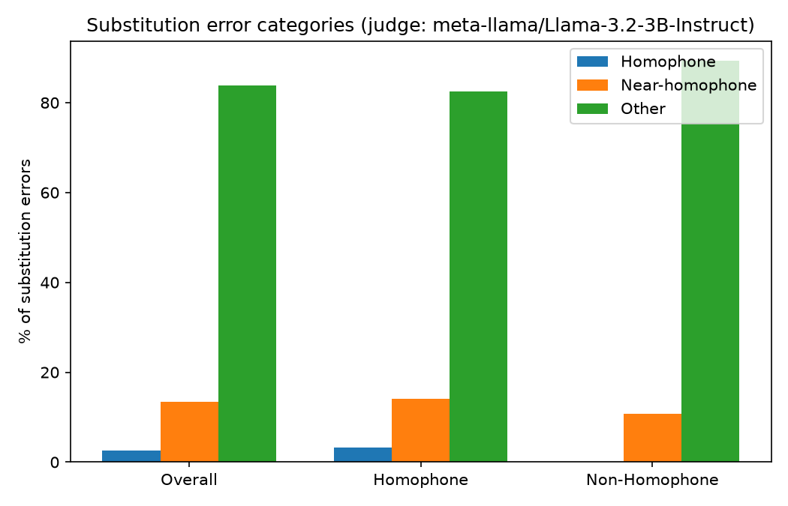
Figure 1 — substitution error categories, Overall / Homophone / Non-Homophone (p2t_lora_checkpoints/error_report.png).

Headline: only 17.4% of substitution errors on homophone-containing sentences are phonetically explainable at all (Homophone + Near-homophone combined). The remaining ~83% of errors, in both subsets, are unrelated word swaps — consistent with an undertrained model (5,000 of 48,164 rows) rather than a homophone-specific weakness. This should be re-measured once the full-corpus run exists.

4. Error Pattern Analysis — Stage 3 (Category Resolution)
Every Homophone/Near-homophone substitution from Stage 2 (159 total) was further classified into one of the framework's four top-level categories — Phonological, Lexical, Contextual, Semantic — first via a grammar-based check (Option 3, cheap, catches only a narrow closed-class-word pattern), then via an LLM judge (Option 5) for anything Option 3 left unresolved.
Category | Count | % of resolved (159)
Lexical | 151 | 95.0%
Phonological | 6 | 3.8%
Contextual | 2 | 1.3%
Semantic | 0 | 0.0%

Resolution method | Count
Option 3 (grammar) | 2
Option 5 (LLM judge) | 157

Judge model: meta-llama/Llama-3.2-3B-Instruct (4-bit). This is a deliberate departure from the framework's own suggested "cheap" judge model — a documented empirical test earlier in this project (see llm_judge.py) found the small stand-in model (Qwen2.5-0.5B-Instruct) defaults to labelling every case "Semantic" regardless of the actual error, including on the framework's own worked examples. The 3B instruct model used here shows genuine discrimination between categories (zero "Semantic" calls here, versus the small model's 100% "Semantic" rate on a 4-case smoke test) — the larger judge was necessary, not optional, for this stage to be trustworthy.
Reading: when the model does produce a phonetically-related error, it is almost always picking the wrong specific word that happens to sound similar (Lexical) — not garbling individual sounds (Phonological, 3.8%) or misreading grammatical structure (Contextual, 1.3%). Combined with Section 3, the overall picture at this data scale is: mostly unrelated substitutions (83.9%), and on the smaller slice that is phonetically related, mostly a lexical/word-choice mix-up rather than a deeper phonetic or grammatical confusion.

5. Worked Examples
Homophone (Stage 2), THERE ↔ THEIR:
Reference: “THEIR INJURIES CAN BE LIFE CHANGING” → Prediction: “THERE INJURIES CAN BE LIFECHANGING”
Stage 3: Lexical / Homophone (Option 5) — “the words ‘their’ and ‘there’ are used interchangeably... resulting in a change in meaning.”

Homophone (Stage 2), THERE ↔ THEIR, resolved differently:
Reference: “THERE IS NO AIR SO THERE IS NO SOUND” → Prediction: “THERE IS NO AIR SO THEIR IS NO SOUND”
Stage 3: Contextual / closed_class_dependency_mismatch (Option 3, grammar) — “THEIR” is grammatically restricted to a possessive role, but the parser needs it here as a subject, a role only “THERE” can fill.

Near-homophone (Stage 2), CHOCK → CHECK:
Reference: “AND OUR GREEN ROOM IS CHOCK FULL OF BEAUTIFUL FACES TONIGHT” → Prediction: “...CHECK FULL OF BEAUTIFUL FADES TONIGHT”
Stage 3: Phonological / Homophone (Option 5) — treated as a sound-driven confusion despite the sentence also containing an unrelated FACES→FADES swap (see Section 6, limitation 2).

Other (unrelated substitution), LANCASHIRE → LANCASTER:
Reference: “I COME FROM LANCASHIRE” → Prediction: “I COME FROM LANCASTER” — phonetically unrelated place names, not classified past Stage 2.

6. Limitations and Caveats
- Scale: 5,000 of 48,164 corpus rows (~10%), 2 epochs. Not the thesis's final result — a checkpoint confirming the pipeline and giving an early read.
- Unstratified sampling: this run deliberately skipped the homophone/non-homophone balancing the full run will use (CPT_N_HOMOPHONE / CPT_N_NON_HOMOPHONE), so it is not directly comparable to the original small-scale (200-row) stratified validation run.
- No held-out test set: validation here is the same 20% split used throughout; there's no separate test set yet (a standing project caveat, not new to this run).
- Multi-error sentences and the LLM judge: classify_error() (Stage 3 Option 5) prompts with the full reference/prediction sentence pair, not the specific word pair. When a sentence has more than one substitution error, the same judge response can be attributed to more than one substitution in that sentence — seen directly in this run's data (the “a”→“an” and “lots”→“lotts” substitutions, from the same sentence pair, received an identical explanation clearly written about “a/an” only). This affects individual explanation text more than the aggregate category counts, but is worth fixing (pass the specific word pair into the judge prompt) before quoting individual Stage 3 explanations in the thesis.
- Contrastive training mechanism is disabled for this run (see dryrun.py's module docstring) — these results say nothing about whether contrastive/hard-negative training would change the homophone-vs-non-homophone gap.

7. Next Steps
- Run the full stratified corpus (37,374 homophone + 10,790 non-homophone rows) — the actual thesis-reportable result.
- Re-run this same Stage 2/3 analysis on the full run's predictions.csv once it exists, for a like-for-like comparison against this preliminary read.
- Fix classify_error()'s prompt to take the specific word pair, not just the full sentence, before quoting Stage 3 explanations directly.
- Build the three-way comparison table: Mira (Llama-3.1-8B, prompting-only) vs. our zero-shot baseline (Llama-3.2-3B, prompting-only) vs. this fine-tuned run, once the full-corpus numbers exist.
- Revisit re-enabling contrastive training (with the near-homophone negative-source fix already designed) once the plain fine-tuned baseline is established on the full corpus.

