London South Bank University
Division of Computer Science and Informatics, School of Engineering
(or: School of Computer Science and Digital Technologies -- confirm current name)
Phoneme-to-Text Conversion for Automated Lip-Reading using a Decoder-Only Large Language Model with QLoRA Fine-Tuning and Noise-Augmented Robustness
A dissertation submitted in partial fulfilment of the requirements for the degree of
MSc [Programme Name]
[Surname, Initial]
Student Number: [Student Number]
Supervisor: Mr Daqing Chen
[Month Year]

Abstract
Automated lip-reading recovers text from silent video, and its accuracy is limited most by the stage that converts recognised phonemes into words. This dissertation studies that stage on the Oxford-BBC Lip Reading Sentences 2 corpus. It asks whether a decoder-only large language model, adapted by parameter-efficient fine-tuning, outperforms prompting and published encoder-decoder work, how much of its accuracy survives once training-to-evaluation sentence overlap is removed, whether training on deliberately corrupted phonemes improves its robustness to the imperfect input a visual front-end produces, and whether homophones are the dominant error type. A Llama-3.2-3B model was fine-tuned with QLoRA on a single graphics card, compared against a zero-shot baseline of the same model and a recurrent baseline with no language knowledge, and evaluated with conventional, semantic, and staged error-analysis methods. Prompting failed, reaching near-zero exact match, while the fine-tuned model reached 88.82% exact match on the held-out test set, exceeding the published encoder-decoder result of 85.11%. A contamination audit found that roughly one evaluation sentence in eight is memorised from training, and the honest deduplicated accuracy is 87.44%. The clean-trained decoder proved fragile under corrupted input, and noise-augmented training raised accuracy under a light corruption from between 19% and 46% to between 58% and 81%, at a clean-input cost of about three points. The error analysis found homophones to be a small minority of errors, around 5%, which corroborates earlier work. The project concludes that decoder-only fine-tuning solves this stage effectively, and that honest evaluation and robustness matter more than homophone-specific handling.

Acknowledgements
[To be completed.]

Table of Contents
[To be completed.]

List of Figures
[To be completed.]

List of Tables
[To be completed.]

List of Abbreviations
[To be completed.]

Chapter 1. Project Management
This chapter describes how the project was planned and run. It sets out the methodology and working practices, the resources used, the way the work was executed against the plan, the project timeline as a Gantt chart, the risks and how they were managed, an overview of the dissertation, and a personal reflection on what went well, what did not, and what was learned.

1.1 Project methodology and approach
The project is empirical research rather than software delivery, so it was run as an iterative, experiment-driven cycle rather than a linear plan carried out once. Each cycle produced a result, that result was analysed, and the analysis decided the next experiment. This structure allowed the direction to change when the evidence called for it, which happened more than once during the project and is described in the execution and reflection sections below.
Three practices supported this way of working. First, all code, configuration, and results were kept under version control with Git, so that every experiment could be traced to the exact code that produced it and reproduced later. Second, a fixed random seed and recorded generation settings were used for the training and evaluation runs, so that a run could be repeated exactly and so that differences between runs could be attributed to real changes rather than to chance. Third, regular supervision meetings were held to review progress, discuss results, and agree the next steps, and a project workbook recorded ideas, references, problems, and decisions as the work progressed.
The project also aligned with a shared error analysis framework used within the research group and ran alongside a parallel study by a peer that used prompting rather than fine-tuning. This alignment meant the two studies could be compared directly and that the error analysis followed an agreed structure.

1.2 Project resources
The main hardware constraint was the graphics card. Training and inference used a university GPU workstation with limited memory, which ruled out full fine-tuning of a multi-billion-parameter model at full precision. This constraint directly shaped the central design choice of the project, the use of QLoRA, which quantises the model to four-bit precision and trains only small adapter matrices, and so keeps the whole process within the available memory. A separate CPU environment was used to develop and test the pipeline before committing GPU time to long runs.
The software stack was Python with the PyTorch deep-learning framework and the Hugging Face Transformers library for the model, the PEFT library for LoRA adaptation, and bitsandbytes for four-bit quantisation. Evaluation used jiwer for word and character error rates, sacrebleu for BLEU, the NLTK CMU Pronouncing Dictionary for phoneme and homophone lookups, spaCy for the grammar analysis, and BERTScore and Sentence-BERT for semantic scoring. Figures were produced with Matplotlib. The model was Llama-3.2-3B, obtained through gated access on Hugging Face, and the data was the LRS2 phoneme and text transcriptions.

1.3 Project execution
The work was carried out in phases: a review and proposal phase, an environment and data preparation phase, a baseline phase, a fine-tuning phase, an honest-evaluation phase, a robustness phase, an error analysis phase, and a writing phase that ran alongside the later technical work. The Gantt chart in the next section shows these phases and their overlaps.
The plan changed at three points, each driven by a result. The first change was in the choice of training method. The project was originally framed around specialised handling of homophones, but early evidence and a parallel study indicated that homophones were not the dominant error, so the specialised route was set aside in favour of a plain fine-tune, honest evaluation, and robustness. The second change came from the evaluation itself. A high headline accuracy on the standard data split prompted an audit, which found that a share of the evaluation sentences also appeared in the training data, so a deduplicated evaluation was added and became the reported figure. The third change concerned decoding. A comparison of two runs that were meant to be equivalent revealed that the generation strategy, greedy against beam search, had changed between them, which accounted for a difference that had first looked like training instability. Recognising this led to treating decoding as an explicit experimental variable. Each of these changes is an example of the iterative methodology in practice: a result was analysed, and the analysis changed the plan.

1.4 Gantt chart
The project timeline is shown in Figure 1.1. Tasks are grouped into planning, build and experiment, analysis, and writing phases, with writing running in parallel with the later technical work so that chapters were drafted while the relevant experiments were fresh. A full-size version is included in Appendix A. The week numbers are relative to the start of the project; the calendar dates should be read against the student's own schedule.
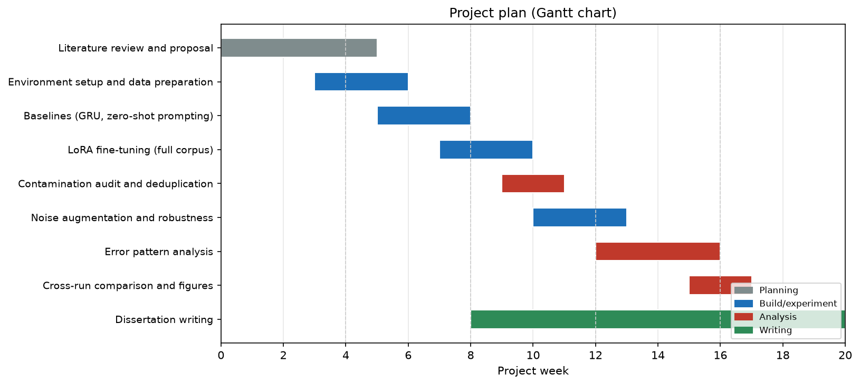
Figure 1.1. Project plan as a Gantt chart, showing the planning, build, analysis, and writing phases across the project period.

1.5 Risk management
Risks were identified at the start and reviewed during supervision meetings. Table 1.1 lists the main risks, their likelihood and impact before mitigation, and the action taken. The most consequential risks were the limited GPU memory, which was mitigated by the choice of QLoRA, and the possibility that reported accuracy would be inflated by data overlap, which was mitigated by the contamination audit and deduplicated reporting.
Risk | Likelihood | Impact | Mitigation
Limited GPU memory prevents training the model | High | High | Use QLoRA (four-bit quantisation, small adapters) to fit the model on the available card; develop the pipeline on CPU first
Gated access to the pretrained model is delayed | Medium | High | Request access early; keep an open, tokenizer-identical mirror as a fallback for development
Reported accuracy inflated by train-evaluation overlap | High | High | Audit the corpus for overlap and report a deduplicated figure as the headline result
Results not reproducible across runs | Medium | Medium | Fix the random seed, record generation settings, and keep all runs under version control
A long training run fails partway | Medium | Medium | Save a checkpoint after each epoch so a failed run can resume rather than restart
Scope grows beyond the available time | Medium | Medium | Keep the four research questions as the boundary; defer non-essential extensions to future work
Dataset licensing and privacy obligations | Low | High | Use LRS2 only under its data-sharing agreement; work from the transcriptions rather than the video; do not redistribute
Loss of code or results | Low | High | Version control with regular commits; results and figures stored alongside the code

Table 1.1. Risk assessment and mitigation.

1.6 Dissertation overview
The dissertation is organised as shown in Table 1.2. Each chapter has a distinct role, and the chapters follow the research from the problem and its context, through the design and the experiments, to the findings and their meaning.
Chapter | Content
1. Project Management | Methodology, resources, execution, plan, risks, and reflection
2. Introduction | Context, problem, aim and objectives, research questions, and contributions
3. Background | The lip-reading pipeline, language models, and the homophone hypothesis
4. Literature Review | Critical review of related work, the LSEPI issues, and the gap analysis
5. Models and Techniques | The models used and the methods for adapting and decoding them
6. Evaluation Techniques | The metrics and the three-stage error analysis framework
7. Methodology | Dataset, data splits, and experimental design
8. Exploratory Data Analysis | Corpus characteristics, homophone distribution, and duplication
9. Results | Baseline, fine-tuning, contamination audit, robustness, and decoding
10. Error Pattern Analysis | The staged error analysis and the homophone question
11. Comparison and Discussion | Findings against the research questions and against related work
12. Conclusion | Summary, limitations, reflection, and future work

Table 1.2. Dissertation overview.

1.7 Personal reflection
Looking back, the practices that helped most were the ones that enforced honesty and reproducibility. The decision to audit the data for overlap, rather than accept a high headline number, changed the reported result and is the part of the project I am most confident is correct. Keeping every run under version control with a fixed seed made it possible to diagnose the decoding difference between two runs that had looked contradictory, which would otherwise have been very hard to explain.
The main difficulty was working within the memory of a single graphics card, which limited the model size and the number of runs that could be tried. This shaped the project toward a careful, small set of well-controlled experiments rather than a broad sweep, which in the end suited a dissertation better than a large but shallow set of results would have.
Two things I would do differently with more time. First, the decoding strategy should have been fixed and recorded from the first run, rather than discovered as a confound partway through; the lesson is that every setting that can affect a result should be recorded from the outset. Second, the held-out test set was deliberately never touched during development, which is correct, but it means the final test-set figure remains to be produced, and with more time the error analysis would have been extended to that set as well.
The largest lesson was about evaluation. The project set out expecting homophones to be the hard problem and expecting a single accuracy number to describe the model. Neither held. Homophones turned out to be a small share of the errors, and the accuracy number depended heavily on how the data was split and how the model decoded. The value of the work is as much in measuring these things honestly as in the accuracy achieved, and that shift in what I considered important is the clearest sign of what I learned.

Chapter 2. Introduction

2.1 Background and context
Lip-reading, also called visual speech recognition, is the task of recovering spoken language from the movement of a speaker's face when the audio signal is absent or unusable. It has practical value in noisy environments where microphones fail, in assistive technology for people with hearing or speech impairments, in silent-speech interfaces, and in forensic and surveillance settings where only video is available (Chung et al., 2017; Afouras et al., 2018). Progress has been driven by large public datasets of natural speech, of which the Oxford-BBC Lip Reading Sentences 2 corpus (LRS2) is among the most widely used. LRS2 contains thousands of sentences from British television, spoken by many talkers under unconstrained conditions, which makes it a realistic benchmark for open-vocabulary lip-reading (Chung et al., 2017).
A modern automated lip-reading system is usually built as a pipeline of two stages. The first stage is a visual front-end that watches the face and predicts a sequence of speech units, most often phonemes, which are the elementary sounds of a language, or visemes, which are the visually distinguishable mouth shapes. The second stage takes that unit sequence and converts it into readable text. Recent work from the research group behind this project has argued that the second stage, the conversion from phonemes to text, is the main bottleneck on overall sentence-level accuracy (El-Ghomari et al., 2024). Even when the visual front-end recognises the phonemes well, a weak phoneme-to-text decoder loses much of that accuracy when it produces the final words.
Two developments have made this second stage a promising place to improve. The first is the rise of large language models (LLMs), which are neural networks trained on very large text corpora and which have strong knowledge of how words combine into sentences. Because the phoneme sequence for a sentence encodes that sentence almost completely, apart from ambiguities such as homophones and spelling, converting phonemes to text is close to a translation problem, and translation is the kind of sequence-to-sequence task at which language models excel (Raffel et al., 2020). The second development is parameter-efficient fine-tuning, and in particular Low-Rank Adaptation (LoRA) and its quantised variant QLoRA, which allow a large pretrained model to be adapted to a new task by training a small number of extra parameters rather than the whole network (Hu et al., 2021; Dettmers et al., 2023). Together these make it feasible to adapt a multi-billion-parameter language model to phoneme-to-text conversion on a single graphics card.
Prior work in this group established the value of this direction. An initial study compared T5 and GPT-2 for phoneme-to-text machine translation on LRS2 and found the encoder-decoder T5 model clearly superior (El-Ghomari et al., 2024). A follow-up study fine-tuned a Flan-T5 Large model with LoRA and reached a sentence-level exact-match accuracy of 85.11% on the LRS2 test set, together with a word error rate of 3.23% (Hossain et al., under review). That follow-up also introduced a progressive phoneme preprocessing strategy that compared several input formats based on special tokens and stress markers, and it reported an error analysis in which homophone confusions were a very small share of the mistakes. This dissertation continues that line of work with a different family of language model and a wider set of questions.
The problem matters on three levels. Practically, a stronger phoneme-to-text stage raises the accuracy of the assistive and silent-speech applications that motivate lip-reading, and it does so at the point in the pipeline that current evidence identifies as the bottleneck. Academically, the phoneme-to-text stage has usually been studied as a component embedded inside a larger multimodal system, so its behaviour as an independent module, including how it fails and how it responds to imperfect input, is not well characterised. Technically, decoder-only language models and parameter-efficient fine-tuning make it possible to bring a large pretrained model to this task on modest hardware, which opens design choices that earlier encoder-decoder studies did not examine.

2.2 Problem statement
The phoneme-to-text decoder in a lip-reading pipeline has to be accurate, honestly evaluated, and robust to the imperfect input a real visual front-end produces. Three gaps remain in the existing work on this stage.
The first gap concerns the choice of language model. Existing phoneme-to-text studies on LRS2 used encoder-decoder models such as T5 and Flan-T5. Decoder-only language models, of which the Llama family is a prominent open example (Grattafiori et al., 2024), now match or exceed encoder-decoder models on many generation tasks, and they have not been evaluated for this task on this corpus. Whether a decoder-only LLM can match or beat the encoder-decoder result is an open question.
The second gap concerns honest evaluation. LRS2 is broadcast material, and broadcast speech repeats stock phrases. A sentence can therefore appear in both the training and the evaluation portions of the corpus, so a model that has memorised it scores a perfect result that does not reflect genuine ability. Existing reports of high accuracy on this corpus do not quantify how much of the score comes from such overlap, so the true difficulty of the task is unclear.
The third gap concerns robustness. A decoder trained only on perfect phoneme transcriptions has never seen the errors a visual front-end makes, namely wrong, missing, and spurious phonemes. In a complete system the input at inference time will contain exactly those errors, so a decoder that performs well only on flawless input may perform poorly in deployment. Whether a phoneme-to-text decoder degrades gracefully under such corruption, and whether training on deliberately corrupted input improves its robustness, has not been studied for this task.
Underlying all three is a working assumption, common in the lip-reading literature and present in the earlier framing of this problem, that homophones, words with the same pronunciation but different spelling and meaning, are a central source of error. If that assumption holds, effort should go toward handling homophones. Whether homophones are in fact the dominant error type for a fine-tuned decoder has had only limited testing, and if they are not, then attention is better directed elsewhere. This project tests the assumption empirically rather than building a method around it.

2.3 Aim and objectives
The central hypothesis of this project is that a decoder-only large language model, adapted to phoneme-to-text conversion by parameter-efficient fine-tuning, can match or exceed the accuracy of published encoder-decoder decoders on LRS2, that its honest accuracy is lower than a headline figure computed on the standard split because of sentence overlap between training and evaluation, and that training on deliberately corrupted phonemes improves its robustness to the imperfect input a visual front-end produces at a small cost to clean-input accuracy.
The aim of this project is to develop and evaluate a decoder-only large language model for phoneme-to-text conversion in lip-reading, to establish its honest accuracy on LRS2, to measure and improve its robustness to imperfect input, and to characterise the errors it makes.
The objectives that follow from this aim are:
1. To establish a baseline by evaluating a pretrained Llama-3.2-3B language model on phoneme-to-text conversion with prompting alone, without any training.
2. To fine-tune the same model with QLoRA on the full LRS2 training set and measure its accuracy against the prompting baseline and the published encoder-decoder result.
3. To audit the dataset for overlap between training and evaluation sentences, and to report accuracy on a deduplicated evaluation set that removes that overlap.
4. To measure the fine-tuned decoder's robustness to corrupted phoneme input, and to test whether noise-augmented training improves it.
5. To conduct a structured error pattern analysis of the decoder's mistakes, and to test whether homophones are the dominant error type.

2.4 Research questions
The project is organised around four research questions that follow directly from the objectives:
RQ1. Does fine-tuning a decoder-only large language model outperform prompting the same model for phoneme-to-text conversion, and how does it compare with published encoder-decoder results on LRS2?
RQ2. How much of the measured accuracy reflects genuine generalisation once overlap between the training and evaluation sentences is removed?
RQ3. How robust is the fine-tuned decoder to the wrong, missing, and spurious phonemes a visual front-end produces, and does training on deliberately corrupted input improve that robustness?
RQ4. What error patterns dominate the decoder's mistakes, and are homophones the main challenge?

2.5 Contributions
This dissertation makes the following contributions to the phoneme-to-text stage of lip-reading.
It shows that a decoder-only language model, Llama-3.2-3B, fine-tuned with QLoRA, reaches high sentence-level accuracy on LRS2, and it places this result against both a prompting baseline of the same model and the published Flan-T5 encoder-decoder result.
It contributes an audit of training-to-evaluation sentence overlap on LRS2 and reports a deduplicated accuracy figure, giving a more honest measure of task difficulty than a headline number computed on the raw split.
It introduces noise-augmented training for this task, in which a fraction of the training phonemes are deliberately corrupted, and it quantifies the resulting robustness against a clean-trained model across three corruption types and several corruption rates.
It applies a three-stage error pattern analysis framework to the decoder's mistakes and confirms, with a decoder-only model and an analysis covering both a clean-trained and a noise-augmented decoder, the earlier finding that homophones are a small minority of errors (Hossain et al., under review). This corroboration across model families strengthens the case for directing effort toward the error types that actually dominate rather than toward homophone-specific training.

2.6 Dissertation organisation
The remainder of this dissertation is organised as follows. Chapter 3 gives the background needed to follow the work, covering the lip-reading pipeline and the place of the phoneme-to-text stage within it, the language models used for sequence transduction, and the homophone hypothesis. Chapter 4 reviews related work on phoneme-to-text conversion, prompting versus fine-tuning, parameter-efficient adaptation, robustness training, and error analysis, and it identifies the gaps this project addresses. Chapter 5 describes the models and techniques used. Chapter 6 explains the evaluation metrics and the error analysis framework. Chapter 7 sets out the methodology and experimental design, and Chapter 8 presents an exploratory analysis of the dataset. Chapter 9 reports the results of the baseline, the fine-tuned runs, the contamination audit, and the robustness experiments. Chapter 10 presents the error pattern analysis. Chapter 11 discusses the findings against the research questions and compares them with a parallel prompting-only study. Chapter 12 concludes and sets out limitations and future work. Project management, including the plan, risk assessment, and reflection, is presented in Chapter 1.

Chapter 3. Background
This chapter provides the technical background needed to follow the rest of the dissertation. It describes how an automated lip-reading system is structured and where the phoneme-to-text stage sits within it, introduces the language models used to perform that stage and the methods used to adapt them efficiently, and explains the homophone problem that motivated part of the original research framing.

3.1 Lip-reading pipelines and the phoneme-to-text stage
Automated lip-reading recovers text from silent or degraded video of a speaker's face. Early systems mapped video directly to characters or words with a single end-to-end network, such as the Watch, Listen, Attend and Spell model that accompanied the release of the LRS dataset (Chung et al., 2017), and the deep audio-visual recognition models that followed (Afouras et al., 2018). These end-to-end systems learn the whole task at once, which couples the visual problem of reading the face to the linguistic problem of producing correct text.
A second design separates these two problems into a pipeline. A visual front-end first predicts a sequence of speech units from the video. These units are commonly phonemes, the smallest sound segments of a language, represented here in the ARPAbet notation used for English, or visemes, the mouth shapes that are visually distinguishable. A second stage, a decoder, then converts the unit sequence into words. Separating the stages allows each to be studied and improved on its own. It also isolates a specific weakness: several studies report that the conversion from recognised units to text limits the sentence-level accuracy of the whole system, even when the visual front-end performs well (El-Ghomari et al., 2024). This dissertation works entirely on the second stage. It takes phoneme sequences as given and studies how well a language model converts them to text, without touching the visual front-end.
The phoneme-to-text stage is close to a translation task. A phoneme sequence for an English sentence encodes that sentence almost completely, because the sounds determine the words up to a limited set of ambiguities. Two sources of ambiguity remain. The first is spelling, since English does not map sounds to letters consistently. The second is homophony, since different words can share a pronunciation. Apart from these, the mapping from phonemes to text is close to deterministic, which is why a model with strong knowledge of English word sequences is well suited to the task.
A practical consequence is that the quality of the phoneme input matters. In an ideal setting the decoder receives the exact phoneme sequence of the sentence. In a deployed system the phonemes come from the visual front-end, which makes mistakes: it can label a sound as the wrong phoneme, miss a sound entirely, or insert a sound that was not spoken. A decoder that is only ever trained and tested on perfect phonemes is therefore evaluated under conditions it will not meet in practice. This gap between clean training input and noisy deployment input motivates the robustness experiments in this project.

3.2 Large language models and sequence transduction
A language model assigns probabilities to sequences of words or tokens, and a large language model is one with many parameters trained on a large text corpus. Two architectural families are relevant here. Encoder-decoder models, such as T5, read an input sequence with an encoder and generate an output sequence with a decoder, and they were designed with sequence-to-sequence tasks such as translation and summarisation in mind (Raffel et al., 2020). Decoder-only models, such as the Llama family, use a single stack that predicts each token from the tokens before it, and they have become the dominant design for general-purpose language modelling (Grattafiori et al., 2024). The prior phoneme-to-text work on LRS2 used encoder-decoder models (El-Ghomari et al., 2024), while this project uses a decoder-only model, which frames phoneme-to-text conversion as the completion of a prompt that contains the phonemes.
Adapting a large pretrained model to a specific task by retraining all of its parameters, called full fine-tuning, is expensive in memory and computation and becomes impractical as models grow. Low-Rank Adaptation (LoRA) addresses this by freezing the pretrained weights and inserting small trainable matrices whose product approximates the change in a weight matrix during adaptation. Because these matrices have low rank, they add very few trainable parameters, yet they recover most of the benefit of full fine-tuning (Hu et al., 2021). QLoRA extends this by first quantising the frozen model to four-bit precision, which reduces its memory footprint further and allows a multi-billion-parameter model to be fine-tuned on a single consumer graphics card while retaining the accuracy of higher-precision training (Dettmers et al., 2023). This project uses QLoRA to fine-tune Llama-3.2-3B, which keeps the whole process within the memory of a single available GPU.
At generation time a language model produces text one token at a time, and the decoding strategy governs how each token is chosen. Greedy decoding takes the single most probable token at every step. Beam search keeps several candidate sequences at each step and returns the highest-scoring completed one, which can recover from an early choice that greedy decoding would commit to. The decoding strategy is separate from the trained model and can change the output substantially, so it is treated as an experimental variable in this work.
A further technique relevant to this project is data augmentation for robustness. In speech recognition, training on deliberately perturbed inputs is a long-standing way to make a model tolerant of the distortions it will meet at test time; SpecAugment, which masks and warps the input features during training, is a widely used modern example (Park et al., 2019). The same principle applies to phoneme-to-text conversion: corrupting a fraction of the training phonemes, in the same way a visual front-end would corrupt them, teaches the decoder to recover the intended sentence from imperfect input. This project applies that idea to the phoneme-to-text stage and measures its effect.

3.3 The homophone hypothesis
Homophones are words that share a pronunciation but differ in spelling and meaning, such as "there", "their", and "they're", or "to", "too", and "two". Because a phoneme sequence captures pronunciation and not spelling, a homophone is invisible at the phoneme level: the correct and incorrect words produce the same phonemes, so no amount of phonetic information can separate them. Only the surrounding context can. Homophones are therefore a natural candidate for the hardest residual errors in phoneme-to-text conversion, and they are a recognised difficulty in lip-reading more broadly, where the closely related notion of homophenes, different sounds that look the same on the lips, has motivated dedicated model components (Kim et al., 2022).
This candidacy made homophones an obvious hypothesis for the hardest residual errors, and the early framing of this problem treated them as a likely priority. Whether homophones actually dominate the errors of a fine-tuned decoder is an empirical question, however, and it can be answered by classifying the model's mistakes. A prior study in the group already provided evidence on this point: in its error analysis of a Flan-T5 decoder on LRS2, homophone confusions accounted for only about 1% of the mistakes, well below contextual and phonetic errors (Hossain et al., under review). Chapter 10 tests the same question for the decoder-only model used here, across both a clean-trained and a noise-augmented decoder, and reaches the same conclusion that homophones are a small minority of errors. This finding is why the project focused on accuracy, honest evaluation, and robustness instead of on homophone-specific handling.

Chapter 4. Literature Review
This chapter reviews the research relevant to phoneme-to-text conversion in lip-reading and positions the present work within it. It does more than summarise individual papers. It compares the architectures, adaptation methods, and evaluation practices that competing approaches adopt, weighs their strengths against their limitations, and links each limitation to a decision made in this project. It also sets out the legal, social, ethical, and professional issues that arise when working with a corpus of recorded human faces and with technology that can read speech from video. The chapter closes with a synthesis that states the gaps in the existing work and how this dissertation addresses them.

4.1 Phoneme-based lip-reading and the two-stage pipeline
Early deep-learning lip-reading systems mapped video directly to text with a single network. The Watch, Listen, Attend and Spell model that accompanied the LRS dataset learned to transcribe mouth motion to characters end to end, and it established the benchmark still used today (Chung et al., 2017). The deep audio-visual recognition models that followed extended this to larger networks and to the joint use of audio and video (Afouras et al., 2018). These end-to-end systems are attractive because they optimise the whole task at once, but that same property is a weakness for analysis: the visual problem of reading the face and the linguistic problem of producing correct text are entangled in one set of weights, so it is hard to tell which of the two limits performance, and hard to improve one without disturbing the other.
A two-stage design separates these problems. A visual front-end predicts a sequence of speech units, and a second module converts the units to text. Recent systems adopt this structure with a language model as the second stage. VALLR predicts phonemes from video and then reconstructs sentences with a language model, and reports that the phoneme intermediate representation improves data efficiency (Thomas et al., 2025). The VSP-LLM framework uses discretised visual speech units as an interface to a large language model and can translate lip movements from far less labelled data than earlier systems (Yeo et al., 2024). The value of the two-stage design for the present work is that it isolates the phoneme-to-text stage as an object of study. Several of these studies also observe that this second stage limits overall accuracy, which is the observation the group's own work makes directly (El-Ghomari et al., 2024).
The main limitation of the existing two-stage literature, for the purposes of this project, is that the phoneme-to-text stage is almost always evaluated as a component inside a full system rather than on its own. This couples its measured accuracy to the quality of the particular visual front-end used, and it leaves the decoder's own behaviour, its error profile and its response to imperfect input, largely unexamined. This project takes the phoneme-to-text stage in isolation, with the phonemes given, so that its behaviour can be studied without the confound of a specific front-end.
A related strand concerns homophenes, sets of different sounds that produce the same visible mouth shape and are therefore indistinguishable to a visual-only system. Kim et al. (2022) address this with a multi-head visual-audio memory that stores audio representations and retrieves candidate pronunciations at inference time. Homophenes are a genuine difficulty for the visual front-end, but they are a different problem from homophones at the phoneme-to-text stage, where the phonemes are already given and the remaining ambiguity is between words that share a pronunciation. Keeping these two notions distinct matters for this project, because the error analysis in Chapter 10 concerns homophones at the text stage rather than homophenes at the visual stage.

4.2 Language models for phoneme-to-text and phonetic conversion
Two architectural families are used to turn phoneme sequences into text. Encoder-decoder models read the whole input with an encoder and generate the output with a separate decoder, a design introduced for sequence-to-sequence problems and embodied in the T5 family (Raffel et al., 2020). Decoder-only models use a single stack that predicts each token from the preceding ones, the design of the Llama family and of most recent general-purpose language models (Grattafiori et al., 2024).
On the specific task of this project, the existing evidence favours encoder-decoder models, but only because decoder-only models have not been tried. El-Ghomari et al. (2024) compared T5 with GPT-2 for phoneme-to-text machine translation on LRS2 and found T5 clearly better. The follow-up study fine-tuned Flan-T5 Large with LoRA and reached 85.11% sentence-level exact-match accuracy with a word error rate of 3.23% on the LRS2 test set (Hossain et al., under review). Both used encoder-decoder models. GPT-2, the one decoder-only model tried, was an early and comparatively weak model, so its poor result does not settle whether a modern decoder-only model would do well. This is the gap the present work addresses by fine-tuning Llama-3.2-3B, a current decoder-only model, and framing the task as prompt completion.
Beyond lip-reading, large language models have been applied to closely related phonetic conversion problems, which supports the choice of a language model for this stage. Fetrat Qharabagh et al. (2024) showed that a prompted large language model can convert graphemes to phonemes more accurately than traditional tools for an under-resourced language, without task-specific training. Work on replacing weighted finite-state transducer decoders in audio speech recognition with a language-model-based phoneme-to-grapheme module has reported lower error rates than the transducer approach. These results indicate that language models capture the phonological and lexical regularities needed for phoneme-to-text conversion, and they motivate applying a strong decoder-only model to the visual-speech setting.

4.3 Parameter-efficient fine-tuning
Adapting a large pretrained model to a task by retraining all of its weights is expensive and grows harder as models grow. Low-Rank Adaptation freezes the pretrained weights and inserts small trainable matrices whose low-rank product approximates the weight change during adaptation, which cuts the number of trainable parameters by orders of magnitude while recovering most of the benefit of full fine-tuning (Hu et al., 2021). QLoRA reduces memory further by quantising the frozen model to four-bit precision before adaptation, which allows a multi-billion-parameter model to be fine-tuned on a single consumer graphics card while retaining the accuracy of higher-precision training (Dettmers et al., 2023).
The prior lip-reading study used LoRA on Flan-T5 Large, updating under 1% of the model parameters (Hossain et al., under review), and VSP-LLM likewise used LoRA to adapt its language model (Yeo et al., 2024). Neither used four-bit quantisation. Full quantisation is not free: four-bit weights lose precision, and whether that loss harms a task as close to deterministic as phoneme-to-text conversion is a fair question. The present work adopts QLoRA because it keeps a 3-billion-parameter decoder-only model within the memory of the single GPU available for this project, and it reports whether the resulting accuracy is competitive, which is the practical test of whether the precision loss matters here.

4.4 Robustness and data augmentation
A model trained only on clean input is not guaranteed to tolerate the distorted input it will meet in deployment. In speech recognition, training on deliberately perturbed inputs is a standard remedy. SpecAugment masks and warps the input features during training and improves recognition of unseen, distorted speech without any change to the model (Park et al., 2019). The principle is general: showing a model the kinds of corruption it will face at test time teaches it to recover from them.
For the phoneme-to-text stage this principle has not, to the knowledge of this review, been applied. The existing studies train and test their decoders on clean phoneme transcriptions (El-Ghomari et al., 2024; Hossain et al., under review). In a full lip-reading system the phonemes come from an imperfect visual front-end that substitutes, drops, and inserts phonemes, so a decoder evaluated only on clean input is evaluated under conditions it will not meet. This project applies the augmentation principle to the phoneme-to-text stage by corrupting a fraction of the training phonemes with the same three operations a front-end would produce, and it measures the effect on robustness against a clean-trained decoder. The term deduplication also appears in this literature, but in a different sense: VSP-LLM deduplicates repeated visual speech units to shorten its input (Yeo et al., 2024), whereas the deduplication in this project removes evaluation sentences that also appear in training, a matter of honest measurement rather than efficiency.

4.5 Evaluation and error analysis
Phoneme-to-text systems are commonly reported with word error rate, character error rate, and a sentence-level exact-match accuracy, sometimes with a BLEU score for fluency (El-Ghomari et al., 2024; Hossain et al., under review). These metrics measure surface agreement between prediction and reference. They are necessary but not sufficient, because they treat every word substitution as equally bad and say nothing about why an error occurred. Two systems with the same word error rate can fail in entirely different ways, one making systematic and correctable confusions and the other producing scattered noise.
Semantic evaluation addresses part of this. BERTScore compares prediction and reference using contextual token embeddings rather than exact matches, and correlates better with human judgement than surface metrics (Zhang et al., 2020). Sentence-BERT instead encodes each sentence to a single vector and compares the vectors, which measures whether two sentences mean the same thing rather than whether they share words (Reimers and Gurevych, 2019). These two are not interchangeable, a point that matters in this work: a token-level score can stay high when meaning has changed, because it rewards word overlap, while a sentence-level score is more sensitive to a changed meaning. This project uses both and reports where they disagree.
For error analysis proper, machine translation offers structured taxonomies. The Multidimensional Quality Metrics framework classifies errors by type and severity, distinguishing accuracy from fluency and grading how serious each error is (Lommel et al., 2014), and the classical error-analysis tradition argues that errors should be categorised by linguistic type rather than merely counted (Corder, 1967). The prior lip-reading study did group its errors into contextual, phonetic, and homophone categories and found homophone confusions to be about 1% of the mistakes (Hossain et al., under review), but a fuller, staged analysis of the phoneme-to-text decoder's errors has not been reported. This project applies a three-stage error analysis framework, moving from surface metrics through phoneme-level confusion to a lexical, contextual, and semantic classification, and applies it to both a clean-trained and a noise-augmented decoder.

4.6 Legal, social, ethical, and professional issues
Working with lip-reading technology and with a corpus of recorded faces raises issues that go beyond accuracy.
The dataset itself carries legal and privacy obligations. LRS2 is drawn from BBC broadcast material and is released for non-commercial academic research only, under a data-sharing agreement that must be signed before access (Chung et al., 2017). The recordings show identifiable people speaking, which is personal data, so its use is governed by data-protection law and by the terms of that agreement. This project uses the corpus within those terms, does not redistribute it, and works only with the phoneme and text transcriptions rather than the video, which limits the handling of identifiable imagery.
Socially and ethically, lip-reading is dual-use. The same capability that helps a deaf or speech-impaired person communicate, or that recovers speech in a noisy environment, can also read speech from surveillance video without the speaker's knowledge or consent. The assistive applications are a clear social good and are the motivation stated for this work. The surveillance applications are a genuine risk, and the responsible position is to be explicit that the technology is dual-use and that deployment should require the subject's awareness and consent. A further ethical consideration is bias: LRS2 is British television speech, so a model trained on it reflects British English and the demographics of that material, and its accuracy on other accents and populations should not be assumed.
Professionally, the work follows the expectations of reproducible and honest research. Results are reported on a deduplicated evaluation set precisely so that the headline numbers are not inflated by memorised sentences, generation settings are recorded so that runs can be reproduced, and a fixed random seed is used so that a run can be repeated exactly. Reporting an honest, lower accuracy figure in preference to a higher but contaminated one is itself a professional-conduct decision.

4.7 Synthesis and gaps
The reviewed work supports three positions. First, the two-stage phoneme-based design is an effective and analysable structure for lip-reading, and the phoneme-to-text stage is the part that most limits sentence-level accuracy. Second, language models are well suited to that stage, and parameter-efficient fine-tuning makes it practical to adapt a large model to it. Third, surface metrics alone give an incomplete and sometimes misleading picture of a decoder's quality.
Against this, four gaps remain, and each maps to a research question and a design decision in this project. Decoder-only language models have not been evaluated for this task on this corpus, despite being the dominant modern design; this project fine-tunes Llama-3.2-3B and compares it against the published encoder-decoder result. High accuracy figures on LRS2 are reported on the standard split without accounting for sentence overlap between training and evaluation; this project audits that overlap and reports a deduplicated figure. The robustness of the phoneme-to-text stage to the imperfect input of a real front-end has not been studied, and augmentation, standard elsewhere in speech recognition, has not been applied to it; this project introduces noise-augmented training and measures the resulting robustness. Finally, the assumption that homophones are a central error source has only limited empirical testing; this project applies a staged error analysis to two models and tests the assumption directly. The chapters that follow develop the solution and the experiments that address these gaps.

Chapter 5. Models and Techniques
This chapter describes the models compared in this project and the techniques used to train, adapt, and decode them. It explains each component in enough detail to follow the experiments, and it justifies the design choices, including the alternatives that were considered and set aside. The models fall into three groups: two baselines that establish what the task looks like without a fine-tuned language model, the fine-tuned decoder that is the main system, and the techniques of noise augmentation, decoding, and reproducibility that apply to it. Results are reported in Chapter 9; the figures quoted here are given only where they justify a design decision.

5.1 Baseline models
Two baselines frame the fine-tuned system. Each answers a different question. The no-language-model baseline shows what the task looks like for a model with no prior knowledge of English. The zero-shot baseline shows what a large language model can do on the task with no training at all.

5.1.1 The no-language-model baseline
The first baseline is a small recurrent encoder-decoder trained from scratch, with no pretrained language knowledge. It is a single-layer gated recurrent unit (GRU) encoder paired with a single-layer GRU decoder, with 64-dimensional embeddings, a 128-dimensional hidden state, and no attention mechanism, giving about 158,000 trainable parameters. It reads a phoneme sequence and generates the sentence character by character, using teacher forcing during training and greedy decoding at inference.
This baseline is deliberately minimal. Its purpose is to establish a floor: it has to learn the entire mapping from phonemes to English spelling from the training data alone, with none of the linguistic knowledge a pretrained model brings. Its expected outcome is near-zero sentence accuracy, and that outcome is the point, because it shows that the task is not solvable by pattern-matching on this amount of data without prior language knowledge. It is trained on the same 45,839-row training split and evaluated on the same held-out test set as every other model, so the floor is measured on equal terms.

5.1.2 Zero-shot prompting
The second baseline is the pretrained Llama-3.2-3B model prompted to perform the task with no fine-tuning. The phoneme sequence is placed in a prompt and the model completes it. Two prompt formats were used. The clean format strips the corpus markup, removing the sentence-boundary tokens, the word-boundary marker, and the stress digits, and gives the model a plain phoneme string with a short instruction. The raw format keeps the full markup intact and uses a longer instruction that explains the notation, so that the model is given every symbol the corpus provides. Comparing the two isolates whether the extra markup helps or hinders a model that has never been trained on it.
The zero-shot baseline measures the untrained ability of the same model that is later fine-tuned, which makes the comparison between them a clean test of what fine-tuning adds. On the full training split it reaches about 128% word error rate and near-zero exact match, so the base model, prompted alone, cannot perform the task. A word error rate above 100% means the model inserts and substitutes more words than the reference contains, which is what happens when it generates fluent but unrelated text rather than a faithful transcription.

5.2 The fine-tuned model: Llama-3.2-3B with QLoRA
The main system is the Llama-3.2-3B model adapted to phoneme-to-text conversion by QLoRA fine-tuning.

5.2.1 Choice of model
Llama-3.2-3B is a decoder-only language model, meaning it uses a single stack that predicts each token from the tokens before it. This is the design of most current general-purpose language models. The prior work on this task used encoder-decoder models, so choosing a decoder-only model tests an open question directly. With a decoder-only model the task is framed as prompt completion: the phonemes and a short label are given as a prompt, and the model generates the sentence as the continuation. The 3-billion-parameter size was chosen as the largest model in the family that fits the available hardware once quantised, which balances capacity against the single-GPU memory budget.

5.2.2 QLoRA adaptation
Full fine-tuning, which updates all of the model's weights, was not feasible on the available graphics card, and it was rejected on that basis. Standard LoRA, which freezes the pretrained weights and trains small adapter matrices, reduces the number of trainable parameters but still holds the full-precision model in memory, which was also too large. QLoRA was chosen because it addresses both constraints: it quantises the frozen model to four-bit precision, which cuts its memory footprint by roughly a factor of four, and it trains only the low-rank adapters on top. The four-bit format used is NF4 with double quantisation, and the adapters are applied to the query, key, value, and output projections of the attention layers, with rank 48, a scaling factor of 16, and a dropout of 0.1. This makes about 1.5% of the parameters trainable and keeps the whole process within the memory of a single card.
The obvious risk of four-bit quantisation is a loss of precision that could harm accuracy. Whether that loss matters for a task as close to deterministic as phoneme-to-text conversion is an empirical question, and the results in Chapter 9 answer it by showing that the quantised model reaches high accuracy, so the precision loss does not prevent the model from learning the mapping well.

5.2.3 Prompt format and training
Each training example is formatted as a single sequence, "Phonemes: P\nText: S", followed by an end-of-sequence token, where P is the phoneme string and S is the target sentence. The loss is computed only on the sentence part: the phoneme prompt and the label are masked out, so the model is trained to generate the sentence given the phonemes rather than to predict the phonemes themselves. Because the base model has no dedicated padding token, one is added and the token embeddings are resized to match, which the adapter checkpoints record.
Training runs for three epochs with the AdamW optimiser, a learning rate of 2e-4 with a short warmup, and gradient accumulation to reach an effective batch size within the memory budget. An adapter checkpoint is saved after each epoch, which serves both as insurance against a failed run and as a guard against overfitting, since an earlier checkpoint remains available if a later epoch degrades. In this project the validation loss fell every epoch, so the final epoch was the one evaluated.

5.3 Noise augmentation
The fine-tuned model as described is trained on clean phoneme transcriptions. Noise augmentation is the technique used to make it robust to the imperfect phonemes a visual front-end produces. It corrupts a fraction of the training examples so that the model learns to recover the intended sentence from imperfect input.
The corruption uses three operations, each standing in for a way a visual front-end fails. Substitution replaces a phoneme with a different one, standing in for a misheard sound. Deletion removes a phoneme, standing in for a missed sound. Insertion adds a spurious phoneme, standing in for a sound that was not spoken. Substituted and inserted phonemes are drawn from the set of phonemes that actually occur in the corpus, so the model never sees a symbol it would not encounter naturally.
Two choices govern how much corruption is applied. Half of the training examples are corrupted and half are left clean. Corrupting every example was rejected because it would remove the model's exposure to clean input and risk harming its clean-input accuracy, which is the outcome multi-condition training is designed to avoid. The corruption rate for a corrupted example is drawn from a range of 5% to 15% rather than fixed, so the model cannot calibrate to a single noise level. Corruption is applied to the training input only; the validation and test inputs are always clean, so the reported accuracy stays comparable to the clean-trained model. A known simplification is that the corruption is applied once when the dataset is built, so a given example keeps the same noise across all epochs; resampling fresh noise each epoch would be stronger augmentation and is noted as future work.

5.4 Decoding strategies
At generation time the model produces the sentence one token at a time, and the decoding strategy governs how each token is chosen. Two strategies are compared. Greedy decoding takes the single most probable token at every step. Beam search of width five keeps the five most promising partial sentences at each step and returns the highest-scoring completed one, which lets it recover from an early token choice that greedy decoding would be unable to revise.
Decoding is treated as an explicit variable in this project because it was found to matter. On the deduplicated validation set, with the same model, beam search raised exact match from 86.51% to 91.99% and roughly halved the word error rate. A difference of this size from decoding alone is large enough that any comparison between models must hold the decoding strategy fixed, and it is the reason the beam-versus-greedy setting is recorded for every run.
Three further generation settings are used. A repetition penalty and a no-repeat rule suppress the degenerate loops a lightly trained decoder can fall into, where it repeats a phrase until it reaches the token limit. A maximum of 34 new tokens is allowed, which covers every sentence in the corpus with margin, so no target is cut off. After generation, only the first line of the output is kept, which removes any trailing text the model appends after its answer without affecting a correct single-line transcription.

5.5 Reproducibility techniques
Reproducibility was built into the runs so that results could be trusted and repeated. A fixed random seed is set for the data shuffling and the adapter initialisation, so that a run can be repeated exactly and so that a difference between two runs can be attributed to a real change rather than to chance. Two independent clean-trained runs landed within a fraction of a percent of each other on training loss, which confirmed that the results are stable and not an artefact of a lucky seed. Every generation setting, including the beam width and the token limit, is recorded with the run, which is what allowed the decoding difference described above to be diagnosed. All code, configuration, and results are kept under version control, and the per-epoch checkpoints mean a run can be resumed or an earlier epoch re-evaluated without retraining.

Chapter 6. Evaluation Techniques
This chapter explains how the models are scored. It covers the conventional metrics that measure how much a prediction differs from the reference, the semantic measures that ask whether the meaning is preserved, and the three-stage error analysis framework that moves from counting errors to explaining them. The metrics are described in enough detail to read the results, and the limitations of each are stated, because part of the argument of this project is that no single number describes a phoneme-to-text decoder well.

6.1 Conventional metrics
The primary metrics are error rates and an exact-match accuracy. All of them compare the predicted sentence with the reference sentence after both have been normalised to a consistent case and stripped of punctuation, so that scoring compares words and sounds rather than formatting.
Word error rate (WER) is the standard measure in speech recognition. It aligns the prediction with the reference using edit distance and counts the substitutions, insertions, and deletions needed to turn one into the other, then divides that count by the number of reference words. A word error rate of zero means a perfect transcription. A word error rate can exceed 100%, which happens when the prediction inserts and substitutes more words than the reference contains, and this is a useful signal in itself: it indicates that the model is generating unrelated text rather than a faithful transcription, which is what the untrained baselines do.
Character error rate (CER) applies the same edit-distance measure at the level of characters rather than words. It is more forgiving than word error rate, because a prediction that misspells one letter of a word counts as a small character error but a whole word error. Reporting both together separates a model that chooses wrong words from one that mostly makes small spelling slips.
Phoneme error rate (PER) applies the same measure at the level of phonemes. Because the model outputs text rather than phonemes, the phoneme error rate is computed by converting both the predicted and reference sentences back to phonemes with a grapheme-to-phoneme tool and aligning those. It measures how far apart the two sentences are in sound, which can differ from how far apart they are in words: two sentences can share few words yet sound similar, or share many words yet differ in a few important sounds.
Exact-match accuracy (EM) is the strictest metric. It is the fraction of predictions that match the reference exactly after normalisation. A single wrong word makes the whole sentence count as a failure. Exact match is the headline metric for this project because the practical goal is a correct sentence, and it is the metric that the prior work on this task reports, which makes it the natural point of comparison.
BLEU is a fluency-oriented metric borrowed from machine translation. It measures the overlap of short word sequences, up to four words long, between the prediction and the reference, with a penalty for predictions that are too short. It is reported alongside the error rates as a secondary measure, because a high BLEU score indicates that the prediction reads as fluent, well-formed English even where individual words are wrong. The error rates were computed with the jiwer library and the BLEU score with sacrebleu, both standard implementations, so that the numbers are comparable with other work that uses the same tools.

6.2 The limits of surface metrics
The metrics above measure surface agreement between prediction and reference. They are necessary, but they are not sufficient, and understanding why motivates the rest of the evaluation. Each of them treats every error as equally serious. A word error rate does not distinguish a harmless substitution, such as writing a number as a digit instead of a word, from a substitution that changes the meaning of the sentence. It also says nothing about why an error occurred or whether the errors follow a pattern. Two models with the same word error rate can fail in completely different ways, one making systematic and correctable confusions and the other producing scattered noise, and a surface metric cannot tell them apart. The semantic measures and the error analysis framework in the rest of this chapter address these gaps.

6.3 Semantic similarity
Semantic similarity asks whether the prediction means the same thing as the reference, even when the exact words differ. Two measures are used, and a central finding of this project is that they can disagree, so both are reported.
The first is BERTScore, which compares the prediction and reference using contextual token embeddings from a pretrained language model rather than exact word matches. Each token in the prediction is matched to the most similar token in the reference, and the scores are combined into a single figure (Zhang et al., 2020). Because it works at the level of tokens, BERTScore rewards word overlap, which means it can report a high score even when the overall meaning of the sentence has changed, as long as most of the words are shared.
The second is Sentence-BERT, which encodes each whole sentence into a single vector and measures the cosine similarity between the two vectors (Reimers and Gurevych, 2019). Because it represents the meaning of the whole sentence rather than matching tokens, it is more sensitive to a change in meaning: a substitution that alters what the sentence says pulls the two vectors apart even if most words are shared. This project uses the sentence-level measure as its primary semantic figure, with the token-level measure reported for contrast, because the sentence-level measure better reflects whether the meaning survived.
The distinction matters because the error analysis framework itself warns that a similarity score alone is insufficient: a fluent sentence whose meaning has reversed can still score highly on a similarity measure. Using both a token-level and a sentence-level measure, and reporting where they diverge, is the response to that warning within this project.

6.4 The three-stage error analysis framework
The error analysis follows a three-stage framework adopted within the research group, which is grounded in the established tradition of classifying errors by linguistic type rather than merely counting them (Corder, 1967) and in the structured error taxonomies used to assess machine translation quality (Lommel et al., 2014). The framework moves from measuring how much error there is, through describing what kind of error it is, to explaining why it occurred.
Stage 1 is conventional evaluation. It reports the phoneme, word, and character error rates described above. This stage answers how much the model gets wrong, and it is the stage that surface metrics on their own provide. The framework's premise is that this stage is necessary but leaves the important questions unanswered.
Stage 2 is phoneme error pattern analysis. It breaks the errors down by type, counting how many are substitutions, insertions, and deletions at the word and character level, and it examines which sounds the model confuses. This includes a confusion matrix that records, for each reference phoneme, which phoneme the model produced instead, and an analysis by articulatory feature, grouping confusions by place of articulation, manner of articulation, and voicing. A weighted phoneme error rate is also used, which discounts a substitution between two similar sounds relative to a substitution between two very different sounds, to test whether the errors are near misses or scattered. This stage answers what the model confuses.
Stage 3 is hierarchical error analysis, and it is the most involved. It classifies each failing sentence into linguistic categories: lexical errors, where the wrong word is chosen, including homophones; contextual errors, where the grammar is inappropriate, such as a tense or agreement mistake; and semantic errors, where the meaning changes. The framework sets out five methods for producing this classification, of increasing automation and cost. Manual annotation, in which a person reads each failure and assigns a category, is the most defensible. Dictionary-based analysis detects homophones automatically by comparing pronunciations. Grammar-based analysis uses a parser to detect tense, agreement, and word-order errors. Semantic similarity analysis measures meaning preservation. Classification by a language model uses an instructed model to label each error. This project uses the manual annotation for the primary classification and the dictionary, grammar, and semantic methods as automated cross-checks, and it reports where they agree and disagree. A severity assessment accompanies the classification, grading each failure by how much it changes the meaning, which distinguishes a harmless error from one that would mislead a reader.
Together the three stages give a picture that no single metric can. Stage 1 establishes the size of the problem, Stage 2 shows its shape at the level of sounds, and Stage 3 explains it at the level of words and meaning. The application of this framework to the two fine-tuned models is the subject of Chapter 10.

Chapter 7. Methodology
This chapter sets out how the experiments were designed and run. It describes the dataset and how the phoneme and text pairs were prepared, the way the corpus was split into training, validation, and test portions and the contamination problem that split revealed, the design of the experiments and how each one answers a research question, and an overview of the whole methodology as a flowchart. The models and techniques themselves are described in Chapter 5, and the metrics are described in Chapter 6; this chapter is concerned with the experimental procedure that ties them together.

7.1 Dataset
All experiments use the Oxford-BBC Lip Reading Sentences 2 corpus (LRS2), a benchmark of natural sentences from British television (Chung et al., 2017). The corpus is used in the form of sentence and phoneme pairs: each row is an English sentence together with its phoneme transcription. The version used contains 48,164 such pairs. The phonemes are given in the ARPAbet notation for English, which represents each sound as one or two letters, sometimes with a stress digit on a vowel.
The phoneme transcriptions are the real transcriptions distributed with the corpus rather than transcriptions generated by an automatic grapheme-to-phoneme tool. This choice matters because an automatic tool leaves an unresolved marker on a noticeable fraction of the sentences, mostly British spellings that a standard American pronunciation dictionary does not cover, whereas the distributed transcriptions resolve every word. Using the distributed transcriptions therefore avoids introducing gaps that would confound the analysis of the model's own errors.
Two phoneme formats are prepared from each transcription. The clean format removes the sentence-boundary and word-boundary markers and the stress digits, leaving a plain sequence of phoneme symbols. The raw format keeps all of that markup. The clean format is the input to the fine-tuned models, because it is the shorter and less redundant representation, while both formats are used for the zero-shot baseline so that the effect of the markup on an untrained model can be measured. The text side is normalised to a consistent case so that scoring compares words rather than capitalisation.

7.2 Data splits and the contamination problem
The corpus is divided using the official LRS2 sequential split, which matches the split sizes reported in the literature and used by the prior work on this task. The first 45,839 rows form the training set, the next 1,082 form the validation set, and the final 1,243 form the held-out test set. The split is by position in the corpus, so no row can appear in more than one part by construction. The test set is not used during development at all; it is reserved for the final evaluation, so that no design choice is tuned to it.
A problem becomes visible once the corpus is examined. Broadcast speech repeats stock phrases, and the corpus contains many duplicate sentences: it has 48,164 rows but fewer unique sentences, with some broadcast fillers appearing dozens of times. Because the split is by position, a sentence can appear in the training set and also, as a separate row, in the validation or test set. A model that has memorised such a sentence scores a perfect result on it, which does not reflect any ability to generalise. Measured on the validation set, 133 of the 1,082 sentences also appear verbatim in training; on the test set, 152 of the 1,243 do.
This project addresses the problem by deduplication at evaluation time. The training data is left unchanged, since training on repeated sentences is legitimate. For evaluation, a set of every sentence in the training portion is built, and any evaluation sentence that appears in that set is removed before scoring. This leaves 949 clean validation sentences and 1,091 clean test sentences. Both the standard figure, on the full split, and the deduplicated figure are reported: the standard figure allows comparison with published results that use the raw split, and the deduplicated figure is the honest measure of generalisation. The original corpus file is never modified; the filtering happens in memory at evaluation time.

7.3 Experimental design
The experiments are designed so that each research question is answered by a specific, controlled comparison. Figure 7.1 shows the whole flow, from the corpus through the four models and the decoding step to the three-stage evaluation and the research questions.
The first research question, whether fine-tuning beats prompting and how it compares with published encoder-decoder work, is answered by evaluating the same Llama-3.2-3B model in two conditions, prompted without training and fine-tuned with QLoRA, on the same data. The GRU baseline is included as a lower reference point that has no pretrained language knowledge at all. All three are evaluated on the same held-out test set, so the comparison is like for like.
The second research question, how much of the accuracy is genuine once overlap is removed, is answered by the deduplication procedure of the previous section. The fine-tuned model is scored on both the standard and the deduplicated evaluation sets, and the difference between the two measures the inflation caused by memorised sentences.
The third research question, robustness to imperfect input, is answered by two elements. A second model is trained with noise augmentation, and both the clean-trained and the noise-augmented models are then evaluated under an inference-time corruption probe. The probe takes a fixed sample of evaluation sentences and corrupts their phoneme input at several rates with each of the three corruption operations, scoring the two models on identical corrupted inputs. Because the corruption code is the same one used in training, the training-time and test-time noise are consistent.
The fourth research question, the dominant error types and the role of homophones, is answered by the three-stage error analysis applied to the predictions of the clean-trained and noise-augmented models. This moves from conventional metrics, through phoneme-level confusion patterns, to a lexical, contextual, and semantic classification of the failing sentences.
Two variables are held fixed across comparisons to prevent confounds. The decoding strategy is recorded and matched whenever two models are compared, because it was found to change accuracy by several points. The evaluation set is matched, so that a difference between models is not a difference between the sentences they were scored on. A fixed random seed is used for training so that a run can be reproduced and so that a difference between runs reflects a real change.

7.4 Methodology flowchart
Figure 7.1 summarises the methodology. The corpus is preprocessed into phoneme and text pairs and split into training, validation, and test portions, with deduplication applied to the evaluation portions. Four models are produced or evaluated: the GRU baseline and the zero-shot prompted model as reference points, and the clean-trained and noise-augmented LoRA models as the systems of interest. Each model's output is generated under a recorded decoding strategy and then passed through the three-stage evaluation. The stages answer the four research questions, from the comparison of fine-tuning against prompting through to the classification of the residual errors.
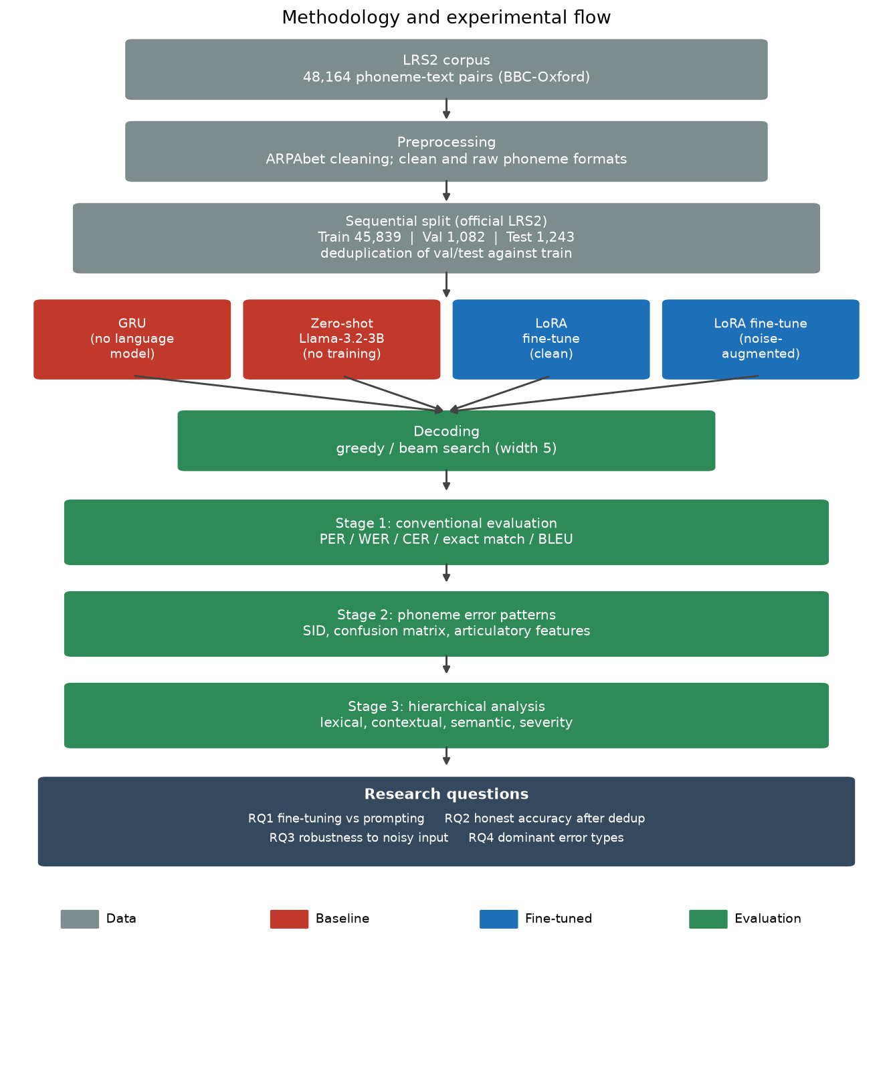
Figure 7.1. Methodology and experimental flow, from the LRS2 corpus through preprocessing, splitting and deduplication, the four models, decoding, and the three-stage evaluation, to the four research questions.

Chapter 8. Exploratory Data Analysis
Before running the experiments, the LRS2 corpus was examined to understand its characteristics and to surface any properties that would affect the design of the evaluation. This chapter reports that analysis. It describes the size of the corpus and the length of its sentences, the proportion of sentences that contain homophone-prone words, and the extent of duplication in the data. The last of these is the most consequential, because it is what motivated the deduplication procedure described in Chapter 7.

8.1 Corpus characteristics and sentence length
The corpus contains 48,164 sentence and phoneme pairs. The sentences are short, as is typical of broadcast speech broken into utterances. A sentence has 7.1 words on average, with a median of 6, and the longest has 24 words. The phoneme sequences are correspondingly short, averaging 25.5 phonemes per sentence with a median of 21 and a maximum of 85. Figure 8.1 shows the distribution of sentence length in words.
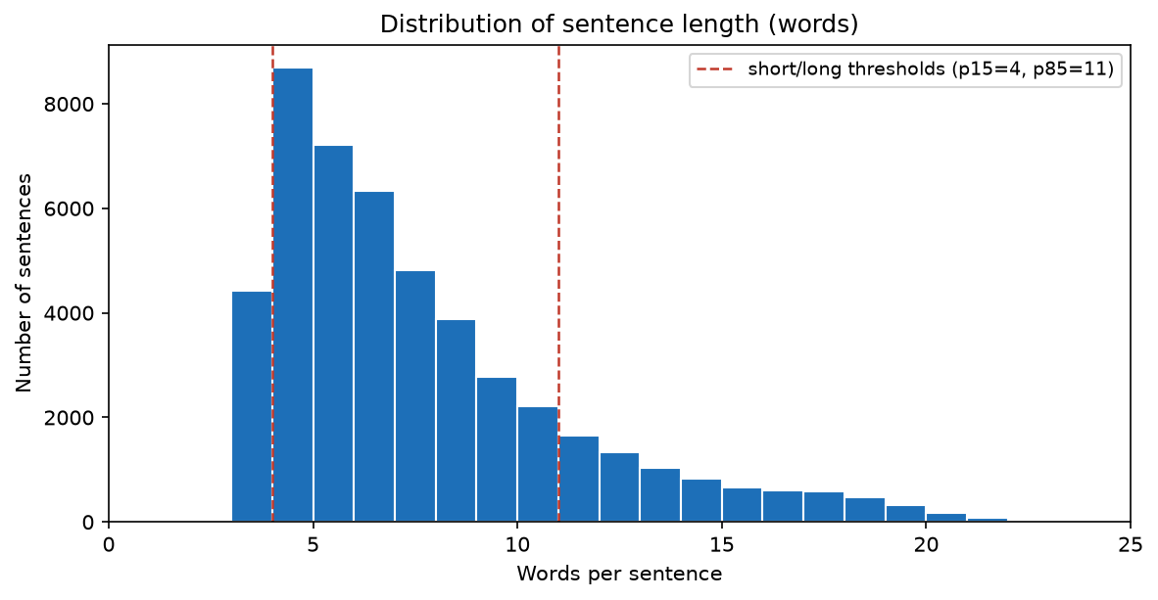
Figure 8.1. Distribution of sentence length in words across the LRS2 corpus. Most sentences are short, with the 15th and 85th percentiles at 4 and 11 words respectively.
The distribution is concentrated at the short end and has a long thin tail. The 15th and 85th percentiles fall at 4 and 11 words, and these two values are used later as the thresholds that define short and long sentences in the error analysis, so that those categories are derived from the corpus itself rather than chosen arbitrarily. The short average length matters for the task, because a short sentence gives the decoder little context to resolve an ambiguous word, which is one reason the residual errors include wrong-word substitutions that a longer sentence might have made recoverable.

8.2 Homophone distribution
Each sentence was checked for whether it contains a homophone-prone word, using a homophone word list derived from the pronunciation dictionary. Of the 48,164 sentences, 37,374 contain at least one such word, which is 77.6% of the corpus, and 10,790 contain none, which is 22.4%. Homophone-prone words are therefore common, which is expected given that many high-frequency English words, such as "to", "two", "there", and "their", are homophones.
This distribution is the reason the evaluation is stratified by homophone membership: the metrics are reported separately for sentences that contain a homophone-prone word and for those that do not, so that any difference in difficulty between the two groups is visible. It is worth being precise about what this figure means. A sentence containing a homophone-prone word is not necessarily a sentence the model gets wrong through a homophone confusion; the word may be transcribed correctly. The high proportion of homophone-prone sentences shows only that the opportunity for homophone confusion is widespread, which is a separate question from how often that confusion actually causes an error. Chapter 10 shows that it rarely does.

8.3 Duplication analysis
The most important property of the corpus for the evaluation is its duplication. Although it has 48,164 rows, it has only 45,455 unique sentences, so 2,709 rows, or 5.6% of the corpus, are repeats of a sentence that appears elsewhere. Figure 8.2 shows the pattern. The left panel gives the distribution of repetition counts on a logarithmic scale: the great majority of sentences appear once, but a long tail of sentences appears many times. The right panel lists the most-repeated sentences, which are the stock phrases of broadcast television, led by "THANKS FOR WATCHING" at 72 occurrences, "THANK YOU VERY MUCH" at 47, and other fillers such as "LADIES AND GENTLEMEN" and "FOR THE AUDIENCE AT HOME".
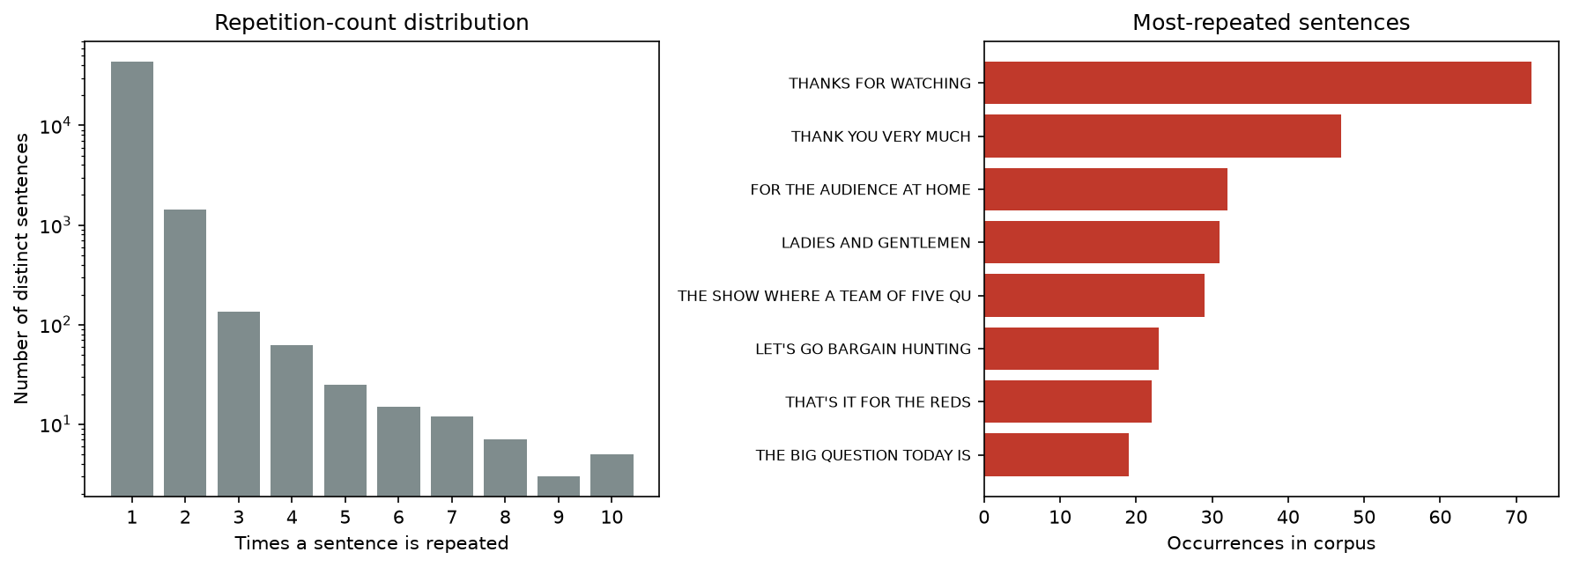
Figure 8.2. Duplication in the corpus. Left: how many distinct sentences occur one, two, three, and more times (logarithmic scale). Right: the most-repeated sentences, which are broadcast stock phrases.
This duplication has a direct consequence for evaluation. Because the corpus is split by position, a repeated sentence can fall into the training set and also, as a separate row, into the validation or test set. A model that has seen the sentence during training then scores a perfect result on the copy in the evaluation set, which reflects memorisation rather than an ability to generalise. Measuring the overlap directly confirms the problem: 133 of the 1,082 validation sentences, 12.3%, appear verbatim in the training set, and 152 of the 1,243 test sentences, 12.2%, do the same. Roughly one evaluation sentence in eight is a sentence the model may have memorised.
This finding is what motivated the deduplication procedure of Chapter 7, in which evaluation sentences that appear in the training set are removed before scoring. Without that step, the headline accuracy would be inflated by the memorised sentences, and the inflation would be invisible in the reported number. The exploratory analysis therefore does more than describe the data: it identifies a threat to the validity of the evaluation and directs the design of the response to it.

Chapter 9. Results
This chapter reports the experimental results. It presents the two baselines, the fine-tuned model and its accuracy, the contamination audit and the deduplicated figure, the noise-augmentation and robustness experiments, the effect of the decoding strategy, and a comparison across all the runs. The headline figures for the clean-trained model and the no-language-model baseline are on the held-out test set; the model-to-model and robustness comparisons use the deduplicated validation set, since those experiments were run during development. The noise-augmented model's test-set evaluation is noted where it is still pending.

9.1 Baselines
Neither baseline can perform the task, which establishes the floor the fine-tuned model is measured against.
The no-language-model baseline, a small recurrent network trained from scratch on the full training set, reaches 0.08% exact match on the held-out test set, which is a single correct sentence out of 1,243, with a word error rate of 88.1%. With no pretrained language knowledge, and only about 158,000 parameters, it cannot learn the mapping from phonemes to English spelling from the training data alone.
The zero-shot baseline, the pretrained Llama-3.2-3B model prompted without any training, reaches about 0.2% exact match with a word error rate above 100%. A word error rate above 100% means the model inserts and substitutes more words than the reference contains: it generates fluent but unrelated text rather than a faithful transcription. The raw and clean prompt formats made little difference, both failing in the same way. The base model, prompted alone, cannot perform the task.

9.2 Fine-tuning result
Fine-tuning the same Llama-3.2-3B model with QLoRA transforms the result. On the held-out test set, the clean-trained model reaches 88.82% exact match on the standard split and 87.44% after deduplication, with a word error rate of 2.47% and 2.73% respectively. On the deduplicated validation set used during development it reaches 91.99% exact match with a 2.09% word error rate. The gap between the validation and test figures is expected, since the validation set was used to guide development while the test set was untouched.
Table 9.1 gives the full test-set metrics for the clean-trained model, split by whether the sentence contains a homophone-prone word.
Test set | n | WER | CER | BLEU-4 | Exact match
Standard, overall | 1,243 | 2.47% | 1.12% | 0.955 | 88.82%
Standard, homophone | 952 | 2.18% | 0.96% | 0.958 | 88.66%
Standard, non-homophone | 291 | 3.91% | 1.84% | 0.934 | 89.35%
Deduplicated, overall | 1,091 | 2.73% | 1.24% | 0.951 | 87.44%

Table 9.1. Held-out test-set results for the clean-trained model, beam-search decoding.
The homophone and non-homophone subsets score within about one point of each other, so sentences containing a homophone-prone word are not markedly harder for the model, which anticipates the error analysis finding that homophones are a minor error source.

9.3 Contamination audit and deduplicated evaluation
The exploratory analysis found that roughly one evaluation sentence in eight appears verbatim in the training data. The audit confirmed the effect on the reported accuracy. On the test set, 152 of the 1,243 sentences appear in training, and removing them lowers exact match from 88.82% to 87.44%, a gap of 1.4 points. On the validation set, 133 of the 1,082 sentences appear in training; the model scores a perfect result on those, and removing them lowers exact match from the contaminated figure to 91.99%.
The deduplicated figure is the honest measure, because the removed sentences are ones the model may have memorised rather than generalised to. Both figures are reported so that the standard figure remains available for comparison with published work that uses the raw split, while the deduplicated figure is used as the headline claim of the model's ability.

9.4 Noise augmentation and robustness
The clean-trained model is accurate on clean input but fragile when its input is corrupted, as a visual front-end would corrupt it. Figure 9.1 shows how the two models degrade as an increasing fraction of the input phonemes is corrupted, for each of the three corruption types.
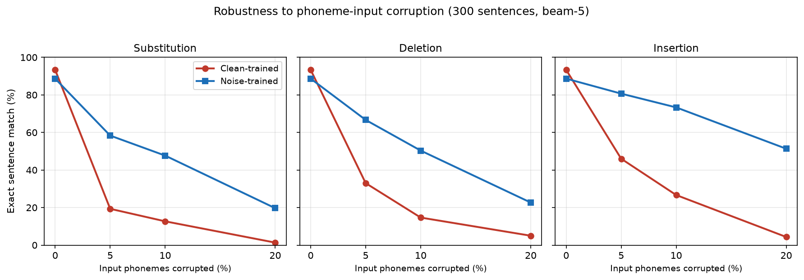
Figure 9.1. Exact-match accuracy as input corruption increases, for each corruption type. The clean-trained model (red) falls sharply once any corruption is present; the noise-augmented model (blue) declines gradually. Both start from the same point on clean input.
On clean input the clean-trained model reaches 93% exact match on the probe sample. A 5% corruption rate, one phoneme in twenty, drops it to between 19% and 46% depending on the corruption type, and a 20% rate drops it close to zero. The clean-trained model depends heavily on receiving an exact phoneme sequence.
The noise-augmented model, trained with half of its input phonemes corrupted, degrades far more gently. Under the same 5% corruption it holds between 58% and 81% exact match, and under 20% corruption it still reaches between 20% and 51%. Table 9.2 gives the exact-match figures at the 5% rate, where the difference is already large.
Corruption at 5% | Clean-trained | Noise-trained
Substitution | 19.3% | 58.3%
Deletion | 33.0% | 66.7%
Insertion | 46.0% | 80.7%

Table 9.2. Exact-match accuracy under 5% input corruption.
The robustness is bought at a small cost to clean-input accuracy. On the deduplicated validation set the noise-augmented model reaches 88.73% exact match against the clean-trained model's 91.99%, a difference of about three points. For a deployment where the input will be imperfect, this trade favours the noise-augmented model. The test-set evaluation of the noise-augmented model is [noise-model test-set figure to be inserted].

9.5 Effect of the decoding strategy
The decoding strategy has a large effect on accuracy, which is why it is treated as a controlled variable. On the deduplicated validation set, with the same clean-trained model, greedy decoding reaches 86.51% exact match while beam search of width five reaches 91.99%, a difference of about five and a half points, and beam search roughly halves the word error rate. Beam search recovers from an early token choice that greedy decoding would be unable to revise, which matters most on a decoder that has not learned to be fully confident in its first choice. Because a difference of this size can arise from decoding alone, every comparison between models in this project holds the decoding strategy fixed.

9.6 Cross-run comparison
Table 9.3 brings the runs together. The two baselines sit at the floor, unable to perform the task. Fine-tuning raises exact match from near zero to the high eighties on the held-out test set, which is the central result. The clean-trained model exceeds the published encoder-decoder result on the same standard test set, and its honest deduplicated figure still exceeds it. The noise-augmented model trades a few points of clean-input accuracy for a large gain in robustness.
Model | Exact match | Word error rate | Evaluation
GRU (no language model) | 0.08% | 88.1% | held-out test
Zero-shot Llama-3.2-3B | ~0.2% | above 100% | full corpus
Flan-T5 encoder-decoder (published) | 85.11% | 3.23% | standard test
LoRA clean-trained (standard) | 88.82% | 2.47% | held-out test
LoRA clean-trained (deduplicated) | 87.44% | 2.73% | held-out test
LoRA noise-augmented | 88.73% | 2.92% | deduplicated validation

Table 9.3. Cross-run comparison. Baseline and clean-trained figures are on the held-out test set; the noise-augmented figure is on deduplicated validation, with its test-set figure pending.
The results answer the first three research questions directly. Fine-tuning beats prompting and the no-language-model baseline, and the decoder-only model beats the published encoder-decoder result. The deduplicated figure is lower than the standard figure by a measured amount, so the honest accuracy is established. Noise-augmented training produces a large improvement in robustness for a small clean-input cost. The fourth research question, the dominant error types, is answered by the error analysis in Chapter 10.

Chapter 10. Error Pattern Analysis
This chapter applies the three-stage error analysis framework of Chapter 6 to the fine-tuned decoder. It analyses two models, the clean-trained decoder and the noise-augmented decoder, on the same 949-sentence deduplicated validation set with the same beam-search decoding, so that any difference between them is a property of the models rather than of the evaluation. The analysis moves through the three stages, from conventional metrics, through phoneme-level confusion, to a lexical, contextual, and semantic classification of the failures, and it closes by answering the fourth research question, whether homophones are the main challenge. The analysis is on the validation set; extending it to the held-out test set is noted as future work.
The clean-trained model gets 873 of the 949 sentences exactly right and fails on 76. The noise-augmented model gets 842 right and fails on 107. These failure counts, 76 and 107, are the samples the deeper analysis works from, so several of the breakdowns below rest on small counts, and those are flagged where they occur.

10.1 Stage 1: conventional evaluation
The two models differ on every conventional metric, and the noise-augmented model is worse across the board, which is the clean-input cost of the robustness it gains.
Metric | Clean-trained | Noise-trained
Phoneme error rate | 1.75% | 2.26%
Word error rate | 2.09% | 2.92%
Character error rate | 0.98% | 1.60%
Exact sentence match | 92.0% | 88.7%

One pattern in these numbers guides the next stage. The degradation is not uniform: the character error rate rises proportionally more than the word error rate, which in turn rises more than the phoneme error rate. As the measurement moves from the level of sounds up to the level of characters, the noise-augmented model looks progressively worse relative to the clean one. Stage 1 cannot say why, but it points to the wrong words being spelled further from the target, which Stage 2 examines.

10.2 Stage 2: phoneme error patterns
The substitution, insertion, and deletion breakdown explains the Stage 1 pattern. At the word level both models are dominated by substitutions rather than insertions or deletions, so the main failure is choosing the wrong word rather than adding or dropping words. At the character level the noise-augmented model shows a sharp rise in insertions, from 67 to 146, far more than the rise in substitutions or deletions. That single change is what drives its higher character error rate: its extra damage is added characters, not simply swapped words.
The confusion matrix records, for each reference sound that was misproduced, which sound the model produced instead. Figure 10.1 shows this for the clean-trained model. Reference sounds run down the rows and predicted sounds across the columns, with vowels grouped in the upper-left block.
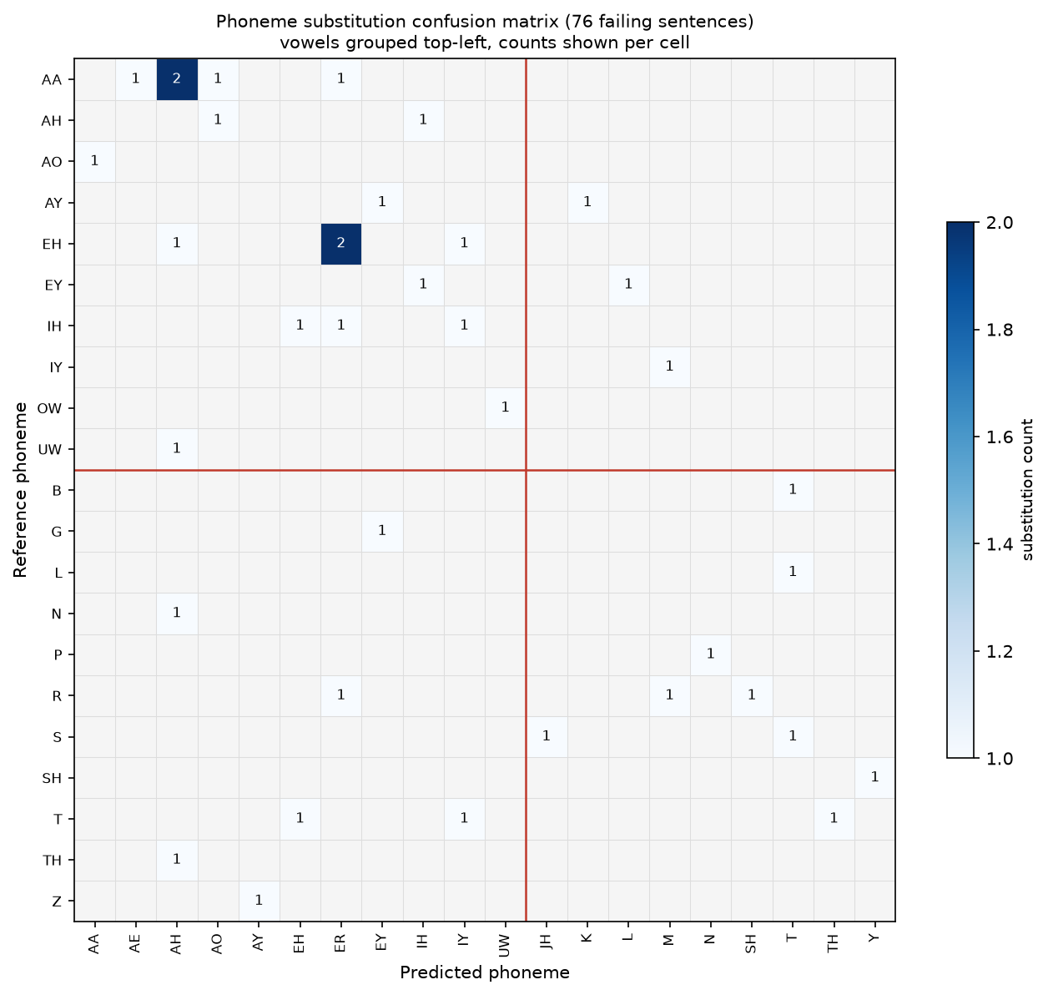
Figure 10.1. Phoneme substitution confusion matrix for the clean-trained model across its failing sentences. Vowels are grouped top-left, consonants bottom-right. Only two cells reach a count of two; every other confusion happens once.
The matrix for the clean-trained model holds 38 substitutions across 36 distinct cells. Only two cells reach a count of two, and every other confusion happens once. With 38 substitutions spread across 36 pairs, the model does not confuse one particular sound for another in a consistent way that a targeted rule could correct, so its errors do not repeat. Half of the substitutions, 19 of 38, are a vowel replaced by another vowel, the largest single group, so the model's weak point is vowel quality rather than consonants.
The noise-augmented model shows two changes in the shape of these errors, beyond their higher count. Its confusions repeat more: it has 14 pairs that occur more than once, against only two for the clean model, led by two vowel confusions that each occur three times. Its errors are also more phonetically close. A weighted phoneme error rate, which discounts a substitution between two similar sounds, sits at 0.87 of the unweighted rate for the noise model against 0.93 for the clean model, so the noise model's wrong sounds sit nearer the correct ones. Both changes indicate that noise training concentrated the errors onto a recurring set of near-miss vowel confusions.
An analysis by articulatory feature supports this. Grouping the substitutions by whether they preserve place of articulation, manner, and voicing, the noise-augmented model preserves each feature slightly more often than the clean model, which is the feature-level view of its errors being more phonetically close.

10.3 Stage 3: hierarchical error analysis
Stage 3 classifies the failing sentences into the framework's linguistic categories. The primary classification is by manual annotation, with the dictionary, grammar, and semantic methods as automated cross-checks.
The lexical classification assigns each failure to one dominant category.
Error type | Clean-trained | Noise-trained
Other (non-words, proper nouns, number formatting, boundary splits) | 50 (65.8%) | 49 (45.8%)
Lexical (wrong real word) | 15 (19.7%) | 35 (32.7%)
Homophone | 6 (7.9%) | 11 (10.3%)
Contextual (grammatical) | 5 (6.6%) | 10 (9.3%)
Semantic (meaning changed) | 0 | 2 (1.9%)

The dictionary-based check, which labels a substitution a homophone only when the two words share an exact pronunciation, found four such cases for the clean model and six for the noise model, all well-known homophones such as "to" for "too" and "by" for "buy". This strict count is lower than the manual homophone count because the manual reading also catches near-identical sound-alikes that the dictionary does not treat as exact matches.
The grammar-based check, which detects tense, agreement, and word-order errors, fired on no clean-model failures and on nine noise-model failures, split between tense, agreement, and inserted function words. Grammar is a minor error source for both models, and their predictions are mostly well-formed.
The semantic analysis uses the sentence-embedding measure, which is more sensitive to a change in meaning than the token-level measure. On the failing sentences the clean model has a mean sentence similarity of 0.66 and the noise model 0.67, and about a fifth of each model's failures fall below the threshold that indicates a genuine meaning loss. An earlier token-level measurement had reported that almost no failures lost meaning, which was an artefact of that measure rewarding word overlap; the sentence-level measure shows that roughly one failure in five does change meaning.
The severity assessment, which grades each failure by meaning impact using the sentence-level score, places more than half of each model's failures at substantial meaning change or worse. The two models' severity distributions are close, which matches the semantic finding that their failures are of similar seriousness per case.

10.4 Clean versus noise-augmented model
Bringing the stages together shows exactly what noise-augmented training changed. The clearest evidence is in the absolute counts of the lexical classification. The Other category, which holds non-words, mangled proper nouns, and formatting quirks, is almost identical between the two models, 50 against 49. Noise training added no garbled output. Every one of the 31 extra failures it introduced landed in the linguistic categories, and 20 of those 31 are wrong real words. So the two models fail on the same hard cases, the roughly 50 proper nouns and rare words that neither can handle, and the cost of noise training is that it made the model produce more confident wrong real words on clean input. This is consistent with Stage 2, where the noise model's errors were more phonetically close and more real-word-like: the same behaviour appears at the word level as a shift from non-words toward wrong real words.
The semantic analysis refines the cost. Per failure, the two models preserve meaning about equally, and both lose meaning on about a fifth of their failures. The noise model's semantic cost is therefore in the number of failures rather than in their seriousness: it produces more failures, so in absolute terms it produces slightly more meaning-lost sentences, but each failure is no worse than the clean model's. This is the honest reading of what the robustness of Chapter 9 costs on clean input.

10.5 Are homophones the main challenge?
The fourth research question asks whether homophones are the dominant error type. The evidence across both models is that they are not. By the strict dictionary definition, homophones are 4 of the clean model's failures and 6 of the noise model's, around 5% in each case. By the broader manual definition, which includes near-identical sound-alikes, they reach about 8% for the clean model and 10% for the noise model. Either way they are a small minority. The dominant categories are wrong real words and the mixed Other category of non-words, rare names, and formatting, none of which a homophone-specific method would address.
This result corroborates the earlier study on this task, which found homophone confusions to be about 1% of the errors of a Flan-T5 decoder and the contextual and phonetic categories to dominate (Hossain et al., under review). Finding the same conclusion with a different model, a decoder-only rather than an encoder-decoder, strengthens the case. The practical consequence is the one drawn in the introduction: effort on this task is better directed at the error types that dominate, the wrong-word substitutions and the handling of rare and out-of-vocabulary words, than at homophone-specific handling. This is the finding that justified the project's focus on accuracy, honest evaluation, and robustness rather than on a homophone-targeted method.

Chapter 11. Comparison and Discussion
This chapter interprets the results and returns them to the four research questions. It discusses what the fine-tuned decoder achieves and what that means for a deployed lip-reading system, weighs the robustness gained by noise-augmented training against its cost, compares the findings with related work including a parallel prompting-only study, and sets out the threats to the validity of the results and the limitations of the work. The validation figures are used for the error analysis and the model-to-model comparisons; the held-out test set provides the final headline numbers for the clean-trained model, and the corresponding test-set evaluation of the noise-augmented model is noted where it is still pending.

11.1 Model performance and the answer to RQ1
The first research question asked whether fine-tuning a decoder-only large language model outperforms prompting the same model, and how it compares with published encoder-decoder results. The answer to the first part is unambiguous. Prompted without training, the Llama-3.2-3B model reaches about 0.2% exact match and a word error rate above 100%: it cannot perform the task at all, generating fluent but unrelated text. The no-language-model baseline, a small recurrent network trained from scratch, reaches essentially zero exact match, which confirms that the task is not learnable from this data without prior language knowledge. Fine-tuning the same Llama model with QLoRA raises exact match to 92.0% on the deduplicated validation set. Fine-tuning is the lever that makes the task solvable, and model scale or prompting alone does not achieve it. This is the clearest result of the project.
The comparison with published encoder-decoder work is decisive on the held-out test set. The prior study on this task fine-tuned a Flan-T5 Large encoder-decoder model and reached 85.11% exact match and a 3.23% word error rate on the standard test set (Hossain et al., under review). Evaluated on the same standard test set, the decoder-only model here reaches 88.82% exact match and a 2.47% word error rate, exceeding the encoder-decoder result on both metrics by a clear margin. After the test set is deduplicated, its exact match is 87.44%, which still exceeds the published figure, and does so even though the published figure was itself computed on the contaminated standard split. This answers the open question that motivated the choice of architecture: a current decoder-only model, fine-tuned with QLoRA, outperforms the encoder-decoder model on this task, and it does so at a smaller parameter count for the adapter and on a single graphics card.

11.2 Honest evaluation and the answer to RQ2
The second research question asked how much of the accuracy is genuine once overlap between training and evaluation is removed. The exploratory analysis found that roughly one evaluation sentence in eight appears verbatim in the training data, and the model scores a perfect result on those sentences by memorisation. Removing them lowers the reported figure. On the held-out test set, the standard exact match of 88.82% falls to 87.44% once the 152 memorised sentences are removed, a gap of 1.4 points; the validation set shows the same pattern. The gap is not large, but it is real, and its importance is its principle more than its size. A headline number computed on the standard split overstates the model's ability to generalise, and the overstatement is invisible unless the overlap is measured.
This point extends beyond the present work. The contamination is a property of the corpus and its standard split, so it affects any result reported on that split, including the 85.11% encoder-decoder figure, which was computed on the standard test set that this project found to contain 152 memorised sentences. The deduplicated comparison, once the test-set run is complete, will therefore be the more honest one for both models. Reporting the deduplicated figure is the project's answer to the second research question and is one of its methodological contributions.

11.3 Robustness and the answer to RQ3
The third research question asked how robust the decoder is to the imperfect phonemes a visual front-end produces, and whether noise-augmented training improves that robustness. The clean-trained decoder is fragile. When a small fraction of its input phonemes are corrupted, its exact match collapses: at a 5% corruption rate its accuracy falls from around 93% on clean input to between 19% and 46%, depending on the type of corruption. This matters because a decoder in a complete system never receives clean phonemes; it receives the output of a visual front-end that makes exactly these errors. A decoder evaluated only on clean input is therefore measured under conditions it will not meet, and its clean-input accuracy overstates its usefulness in a pipeline.
Noise-augmented training addresses this. The decoder trained with corrupted phonemes holds between 58% and 81% exact match under the same 5% corruption, a large improvement over the clean-trained model. The cost is a few points of exact match on clean input, from 92.0% to 88.7% on deduplicated validation. For any deployment where the input will be imperfect, which is every real lip-reading system, this trade favours the noise-augmented decoder. The answer to the third research question is that the clean-trained decoder is not robust, that noise-augmented training substantially improves robustness, and that the clean-input cost is small enough to be worth paying when the decoder is used in a pipeline rather than on clean transcriptions.
The error analysis clarified what the cost actually is. The two models fail on the same hard cases, the rare words and proper nouns that neither can handle, and the extra failures introduced by noise training are almost all wrong real words rather than garbled output. Per failure, the two models preserve meaning about equally. The cost of robustness is therefore a modest increase in the number of confident wrong-word errors on clean input, well short of a collapse in quality.

11.4 The role of homophones and the answer to RQ4
The fourth research question asked whether homophones are the dominant error type. They are not. Across both models, homophones are around 5% of the failures by a strict dictionary definition and 8% to 10% by a broader one that includes near-identical sound-alikes. The dominant categories are wrong real words and a mixed group of non-words, rare names, and formatting issues, none of which a homophone-specific method would address. This corroborates the earlier study on this task, which found homophone confusions to be about 1% of the errors of a Flan-T5 decoder (Hossain et al., under review), and finding the same conclusion with a different architecture strengthens it. A parallel prompting-only study on the same corpus reached a compatible conclusion, reporting homophone errors as a small share of the mistakes of a prompted Llama-3.1 model. The consistent finding across a prompted model, an encoder-decoder fine-tune, and a decoder-only fine-tune is that homophones are a minor error source for this task, and that effort is better spent on the wrong-word and out-of-vocabulary errors that dominate.

11.5 Comparison with prompting-only work
A peer study ran in parallel with this project, using the same corpus but prompting a larger Llama-3.1 model without any fine-tuning rather than adapting a model. That study reached a word error rate above 100%, in the same range as the zero-shot baseline here, and it applied a similar error analysis. The two projects together form a controlled comparison of prompting against fine-tuning on the same task: prompting a larger model does not solve the task, while fine-tuning a smaller model does. This supports the central claim that this task requires adaptation, which scale and prompting alone do not provide, and it is a stronger claim for being reached by two independent studies. The two projects also agree on the error analysis, both finding homophones to be a minor source of error, which adds weight to that conclusion.

11.6 Threats to validity
Several threats to the validity of the results were identified, and each is either mitigated or stated as a limitation. The most serious, contamination between training and evaluation, is mitigated by the deduplication procedure and by reporting the deduplicated figure. A second threat is speaker overlap: the corpus transcriptions carry no speaker identifiers, so it cannot be ruled out that the same speakers appear in training and evaluation, which would make the task easier than a speaker-independent setting; this cannot be measured from the available data and is stated honestly as a limitation. A third threat, that a difference between two runs might reflect chance or an uncontrolled setting rather than a real effect, was addressed by fixing the random seed and recording the decoding strategy, and it was this control that allowed the decoding difference between two runs to be diagnosed rather than misattributed. A fourth threat is the small size of the error sample, 76 and 107 failing sentences, which means several of the finer breakdowns rest on counts in single digits; these are flagged wherever they occur, and the conclusions drawn from them are limited to those that the counts support.

11.7 Limitations and future directions
The work has clear limitations that point to future directions. The analysis and the headline figures reported in this chapter are on the validation set; the held-out test set provides the final numbers, and the error analysis has not yet been extended to it. The fifth error-classification method in the framework, classification by an instructed language model, was implemented but not run, because the available judge model was not reliable enough; running it with a stronger model would give an independent check on the manual classification. The noise augmentation applies a fixed corruption to each training example rather than resampling it each epoch, which is a weaker form of augmentation than is possible and a natural extension. The work uses a single model size on a single graphics card, so the effect of a larger decoder or a different rank is untested. Finally, the project studies the phoneme-to-text stage in isolation, with the phonemes given; integrating the decoder with a real visual front-end, so that the robustness result can be measured on genuine front-end errors rather than simulated ones, is the most substantial direction for further work and the one that would most directly test the deployment claim made here.

Chapter 12. Conclusion
This chapter evaluates the project against the aim and objectives it set out to achieve, states its contributions, and reflects on what was learned and what remains to be done. It is an assessment of the work rather than a summary of it.

12.1 Achievement of the aim and objectives
The aim was to develop and evaluate a decoder-only large language model for phoneme-to-text conversion in lip-reading, to establish its honest accuracy, to measure and improve its robustness to imperfect input, and to characterise its errors. On the evidence of the results, the aim was met.
Each objective was achieved. The zero-shot baseline established that the pretrained model cannot perform the task without training, reaching near-zero exact match. The fine-tuned model, adapted with QLoRA, reached 88.82% exact match on the held-out test set, which exceeds the published encoder-decoder result of 85.11% on the same test set. The contamination audit found that roughly one evaluation sentence in eight is memorised from training, and the deduplicated figure of 87.44% is reported as the honest measure. The noise-augmentation experiment showed that the clean-trained decoder is fragile under corrupted input and that noise-augmented training restores robustness for a small clean-input cost. The three-stage error analysis characterised the residual errors and tested the homophone assumption directly.

12.2 Contributions
The project makes four contributions to the phoneme-to-text stage of lip-reading. It shows that a decoder-only language model fine-tuned with QLoRA outperforms the published encoder-decoder model on this task, on a single graphics card. It contributes a contamination audit and a deduplicated evaluation for LRS2, giving a more honest measure of task difficulty than a figure computed on the standard split. It introduces noise-augmented training for this stage and quantifies the robustness it buys against the clean-input cost it carries. It applies a staged error analysis to two models and shows that homophones are a small minority of the errors, which corroborates and extends the earlier finding on this task.

12.3 Critical reflection and future work
Two starting assumptions did not survive contact with the evidence, and recognising that is the main lesson of the project. Homophones were expected to be the central difficulty and turned out to be a minor one, which redirected the work toward accuracy, honest evaluation, and robustness. A single accuracy number was expected to describe the model, and it turned out that the number depended heavily on how the data was split and how the model decoded, which is why the deduplication and the decoding control became central to the method. The value of the work is as much in measuring these things honestly as in the accuracy achieved.
The project also has clear limits that set the direction for further work. The headline figures are on the validation and test sets of a single corpus with no speaker identifiers, so a speaker-independent evaluation on a second corpus would strengthen the claims. The noise augmentation applies a fixed corruption to each example rather than resampling it each epoch, and the fifth error-classification method, using an instructed language model, was implemented but not run for want of a reliable judge model; both are natural extensions. The most important direction is to integrate the decoder with a real visual front-end, so that the robustness result can be tested against genuine front-end errors rather than simulated ones. That step would turn the deployment claim made here into a measured one, and it is the route by which this work could become a publishable contribution to automated lip-reading.

References
Afouras, T., Chung, J. S., Senior, A., Vinyals, O. and Zisserman, A. (2018) 'Deep audio-visual speech recognition', IEEE Transactions on Pattern Analysis and Machine Intelligence. doi:10.1109/TPAMI.2018.2889052. Preprint arXiv:1809.02108.
Chung, J. S., Senior, A., Vinyals, O. and Zisserman, A. (2017) 'Lip reading sentences in the wild', Proceedings of the IEEE Conference on Computer Vision and Pattern Recognition (CVPR). Preprint arXiv:1611.05358.
Corder, S. P. (1967) 'The significance of learners' errors', International Review of Applied Linguistics in Language Teaching, 5(1-4), pp. 161-170.
Dettmers, T., Pagnoni, A., Holtzman, A. and Zettlemoyer, L. (2023) 'QLoRA: efficient finetuning of quantized LLMs', Advances in Neural Information Processing Systems (NeurIPS). Preprint arXiv:2305.14314.
El-Ghomari, D., El-Bialy, R. and Chen, D. (2024) 'Lip-reading: phoneme-to-text machine translation using large language models', International Conference on Cyber-physical Social Intelligence (ICCSI 2024), Doha, Qatar.
Fetrat Qharabagh, M., Dehghanian, Z. and Rabiee, H. R. (2024) 'LLM-powered grapheme-to-phoneme conversion: benchmark and case study', arXiv:2409.08554.
Grattafiori, A. et al. (2024) 'The Llama 3 herd of models', arXiv:2407.21783.
Hossain, M. A. A. et al. (under review) 'Tackling the bottleneck of phoneme-to-word conversion in automated lip-reading using well-tuned LoRA'. Manuscript submitted to IEEE Access. [Full author list and year to be confirmed with the authors; cited with permission. Update to the published version if it is accepted before submission.]
Hu, E. J., Shen, Y., Wallis, P., Allen-Zhu, Z., Li, Y., Wang, S., Wang, L. and Chen, W. (2021) 'LoRA: low-rank adaptation of large language models', arXiv:2106.09685.
Kim, M., Yeo, J. H. and Ro, Y. M. (2022) 'Distinguishing homophenes using multi-head visual-audio memory for lip reading', Proceedings of the AAAI Conference on Artificial Intelligence. Preprint arXiv:2204.01725.
Lommel, A., Uszkoreit, H. and Burchardt, A. (2014) 'Multidimensional Quality Metrics (MQM): a framework for declaring and describing translation quality metrics', Tradumatica, (12), pp. 455-463.
Park, D. S., Chan, W., Zhang, Y., Chiu, C.-C., Zoph, B., Cubuk, E. D. and Le, Q. V. (2019) 'SpecAugment: a simple data augmentation method for automatic speech recognition', Interspeech 2019, pp. 2613-2617.
Raffel, C., Shazeer, N., Roberts, A., Lee, K., Narang, S., Matena, M., Zhou, Y., Li, W. and Liu, P. J. (2020) 'Exploring the limits of transfer learning with a unified text-to-text transformer', Journal of Machine Learning Research, 21. Preprint arXiv:1910.10683.
Reimers, N. and Gurevych, I. (2019) 'Sentence-BERT: sentence embeddings using Siamese BERT-networks', Proceedings of the 2019 Conference on Empirical Methods in Natural Language Processing (EMNLP). Preprint arXiv:1908.10084.
Thomas, M., Fish, E. et al. (2025) 'VALLR: visual ASR language model for lip reading', Proceedings of the IEEE/CVF International Conference on Computer Vision (ICCV). Preprint arXiv:2503.21408.
Yeo, J. H., Han, S., Kim, M. and Ro, Y. M. (2024) 'Where visual speech meets language: VSP-LLM framework for efficient and context-aware visual speech processing', arXiv:2402.15151.
Zhang, T., Kishore, V., Wu, F., Weinberger, K. Q. and Artzi, Y. (2020) 'BERTScore: evaluating text generation with BERT', International Conference on Learning Representations (ICLR). Preprint arXiv:1904.09675.

