Error pattern analysis: noise-augmented phoneme-to-text decoder
Project: homophone-aware phoneme-to-text decoding for lip-reading Date: 23 July 2026 Model: Llama-3.2-3B with low-rank adapters, trained with noise-augmented phonemes Decoding: beam search width 5 Evaluation set: 949 validation sentences, deduplicated against training
Structured to follow the P2T Three-Stage Error Analysis Framework. Read alongside the clean-model report, since the purpose here is to show what noise-augmented training changed about the character of the errors, beyond their count.

Scope
This model was trained with half of its input phonemes deliberately corrupted, a robustness technique measured separately in the noise-augmentation report. On clean validation it gets 842 of 949 sentences exactly right and fails on 107, against the clean-trained model's 873 right and 76 wrong. Every comparison below uses the same 949 rows and the same beam-search decoding for both models, so the differences are real properties of the two models rather than of the evaluation.
The failure sample is 107 rows, larger than the clean model's 76 but still small. Several breakdowns rest on counts in single digits, and those are flagged where they occur.

Stage 1: Conventional evaluation
Metric | Clean-trained | Noise-trained | Change
Phoneme error rate | 1.75% | 2.26% | ×1.29
Word error rate | 2.09% | 2.92% | ×1.39
Character error rate | 0.98% | 1.60% | ×1.64
Exact sentence match | 92.0% | 88.7% | −3.3 points

The noise-trained model is worse on every conventional metric, which is the clean-input cost of the robustness it gains. One pattern is worth carrying forward: the degradation is not uniform across the three error rates. Character error rate rises the most, word error rate less, and phoneme error rate least. As the measurement moves from the sound level up to the character level, the noise model looks progressively worse relative to the clean one.
The framework's point about Stage 1 is that these numbers say how much and stay silent on what. A character error rate that climbs faster than the phoneme error rate hints that the noise model's wrong words are spelled further from the target, but Stage 1 cannot say whether that comes from wrong words, added material, or a different kind of confusion. Stage 2 answers that.

Stage 2: Phoneme error pattern analysis

Substitution, insertion and deletion
Count | Clean-trained | Noise-trained | Change
Word substitutions | 87 | 120 | ×1.4
Word insertions | 13 | 25 | ×1.9
Word deletions | 11 | 7 | ×0.6
Character substitutions | 116 | 161 | ×1.4
Character insertions | 67 | 146 | ×2.2
Character deletions | 78 | 110 | ×1.4

This resolves the Stage 1 hint. Character insertions more than doubled, while substitutions and deletions grew only about 1.4 times. That single row is what drove the disproportionate character error rate. The noise model's extra damage is added material, characters and words that the target does not contain, more than it is wrong words swapped one for one. Word deletions actually fell, so the model adds rather than drops.

Confusion matrix
The confusion matrix records, for every sound the model got wrong, which sound it produced instead. Reference sounds run down the rows and predicted sounds across the columns, with vowels grouped in the upper-left block.
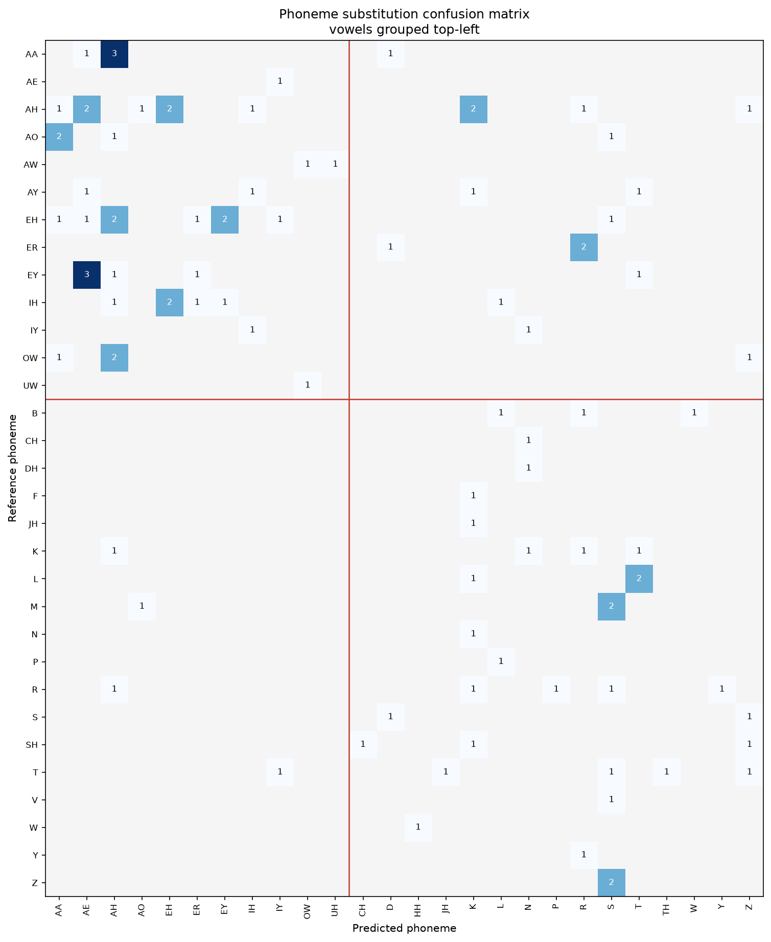
Phoneme substitution confusion matrix for the noise-trained model across its 107 failing sentences. Vowels are grouped top-left, consonants bottom-right.
 | Clean-trained | Noise-trained
Phoneme substitutions | 38 | 97
Distinct confusion pairs | 36 | 81
Repeated pairs | 2 | 14
Vowel-to-vowel share | 50% | 43%

Two changes in the shape of the errors, beyond the higher count.
The errors became more systematic. The clean model repeated almost no confusion, 2 of its 36 pairs. The noise model repeats 14, led by AA becoming AH three times and EY becoming AE three times, with a cluster of AH confusions behind them. Noise training concentrated the errors onto a recurring set of vowel confusions rather than scattering them across single events. The most-substituted sound is now AH with 11 substitutions, against 2 in the clean model.
The errors also stay vowel-dominated. Vowel-to-vowel substitutions are 42 of the 97, the largest single group, the same weak spot the clean model showed. Even the sounds that fail most often fail toward a neighbouring vowel.

Phoneme-class analysis
Substitution counts and corpus-wide rates for the most-substituted sounds:
Sound | Substitutions | Occurrences across 949 sentences | Rate
AH (as in "cup") | 11 | 1,702 | 0.6%
EH (as in "bed") | 9 | 519 | 1.7%
IH (as in "sit") | 6 | 1,138 | 0.5%
EY (as in "say") | 6 | 263 | 2.3%
T | 5 | 1,540 | 0.3%
R | 5 | 829 | 0.6%
AA (as in "father") | 5 | 379 | 1.3%

Every rate stays low, under 2.3%, which is expected for a model that gets 89% of sentences exactly right. The most-substituted sounds are vowels, and the highest rates belong to open and open-mid vowels, the same finding as the clean model but on more errors so the pattern is better supported here.
Grouping substitutions by articulatory feature, where place is where in the mouth a sound forms, manner is how it is produced, and voicing is whether the vocal cords vibrate:
Feature preserved | Clean-trained | Noise-trained
Place | 45% | 46%
Manner | 47% | 51%
Voicing | 26% | 33%

The noise model preserves each feature slightly more often, which is the feature view of the errors being more phonetically close.

Are the errors systematic?
Weighting the phoneme error rate by articulatory similarity tests whether the errors cluster among neighbouring sounds. A weighted rate far below the unweighted one would mean near misses a sound-aware correction could repair.
 | Clean-trained | Noise-trained
Weighted-over-raw ratio | 0.93 | 0.87

The noise model's ratio is lower, so weighting by similarity discounts its errors more. Its substitutions sit nearer the correct sound than the clean model's did. This moves the noise model toward what the parallel prompting study found and away from the clean model's scattered profile. Combined with the 14 repeated pairs, the picture is consistent: noise training made the sound-level errors both closer and more repeated, the two marks of a more systematic error pattern.

Stage 3: Hierarchical error analysis
Stage 3 was carried out through four of the framework's five options. Option 1 is manual annotation, Option 2 dictionary-based homophone detection, Option 3 grammar analysis, and Option 4 semantic similarity. Option 5, classification by a language model, was not run; it needs a capable instruct-tuned judge model.

3.1 Lexical analysis (Option 1, manual annotation)
Each failing prediction was annotated against the framework's five categories: Homophone, Lexical (wrong word selection), Contextual (grammatically inappropriate), Semantic (meaning changed), and Other (uncategorised).
Error type | Clean-trained | Noise-trained
Other | 50 (65.8%) | 49 (45.8%)
Lexical | 15 (19.7%) | 35 (32.7%)
Homophone | 6 (7.9%) | 11 (10.3%)
Contextual | 5 (6.6%) | 10 (9.3%)
Semantic | 0 (0.0%) | 2 (1.9%)
Total | 76 | 107

This is the central finding of the whole comparison, and it is clearest in the absolute counts. The Other category, which holds non-words, mangled proper nouns, boundary splits and number formatting, is almost identical between the two models, 50 against 49. Noise training added no garbled output. Every one of the 31 extra failures it introduced landed in the linguistic categories, and 20 of those 31 are Lexical, wrong but real words.
So the two models fail on the same hard cases in the same way, the roughly 50 proper nouns and rare words and formatting quirks that neither can handle. The cost of noise training is specifically that it made the model produce more confident wrong real words on clean input. Trained to recover a valid word from corrupted phonemes, it sometimes commits to a plausible but incorrect word when the input is clean, where the clean model would have produced the same garble or gotten it right. This matches Stage 2 exactly: the sound-level errors got more real-word-like, and here at the word level they show up as Lexical rather than Other.
The dictionary method in the next section could only detect homophones, lumping everything else into one bucket. This manual annotation is what separates the linguistic error types, which is its purpose in the framework.

3.2 Contextual analysis (Options 2 and 3)
Option 2, dictionary-based lexical analysis, looks every word substitution up in the CMU pronouncing dictionary and labels it a homophone when the two words share an identical pronunciation. It found 6 of 120 word substitutions (5.0%) are exact homophones: khan to con, baron to barron, knot to not, to to two, lloyd to loyd, and by to buy. True homophones are a small fraction, the same finding as every run. This strict count is lower than the manual annotation's 11, because the manual pass also caught near-identical sound-alikes the dictionary does not treat as exact matches.
Option 3, grammar-based context analysis, used spaCy to detect tense, agreement and word-order errors. LanguageTool, the framework's other named tool, needs a Java runtime that is not installed, so spaCy was used, which the framework lists as an accepted alternative. It flagged 9 of 107 failing sentences: 4 tense (face to faced, unfold to unfolded), 3 article or auxiliary (through antibody to through an antibody), and 2 agreement (upset to upsets, rocket to rockets). Grammar is a minor error source and the predictions are mostly well-formed, the same as the clean model.

3.3 Semantic analysis (Option 4)
Semantic similarity was measured two ways. The token-level method (BERTScore) was run first, then the framework's literal method, sentence embeddings with a cosine similarity, which encodes each sentence to one vector.
Method | Mean | ≥ 0.90 | < 0.50
BERTScore (token-level) | 0.877 | 42% | 0%
Sentence embeddings (framework's method) | 0.674 | 18% | 19%

The two methods disagree substantially, and the exact one is more discriminating. BERTScore reported that nothing fell below 0.50, so meaning looked fully preserved. Sentence embeddings put 19% of failures below 0.50. The extremes confirm the sentence-embedding method reads meaning correctly: its lowest scores are genuine meaning losses (ISLAM ALLOWS POLYGAMY becoming EL SALVADOR LOWS POLICY at 0.02), and its highest are the cases where meaning truly survives (SIX becoming 6, the article insertion, the agreement fix, all above 0.97). This is the framework's own Option 4 warning confirmed on real data: a token-overlap score stays high while meaning changes.
Comparing the two models on the exact method:
Sentence-embedding cosine | Clean-trained | Noise-trained
Mean | 0.662 | 0.674
< 0.50 (meaning lost) | 22% | 19%

The two models' failures are about equal in meaning quality. The noise model's mean is marginally higher and its share of meaning-lost failures marginally lower, so per failure it preserves meaning about as well as the clean model. Its semantic cost sits in the count of failures: both models lose meaning on about a fifth of their failures, but the noise model has more failures, so in absolute terms it produces 20 meaning-lost sentences against the clean model's 17.

3.4 Severity assessment
Severity was assigned by meaning impact, using the per-row sentence-embedding scores, since the framework defines severity by consequence and a semantic score measures exactly that. Bands: Low is a score at or above 0.90 (meaning preserved), Medium is 0.70 to 0.90 (minor drift), High is 0.50 to 0.70 (substantial change), and meaning-lost is below 0.50.
Severity | Clean-trained | Noise-trained
Low | 24% | 18%
Medium | 18% | 30%
High | 36% | 34%
Meaning lost | 22% | 19%

Both models carry substantial High and meaning-lost mass, roughly half of each model's failures. The two distributions are close, consistent with 3.3: per failure the two models are about equally severe, and the noise model's cost is the larger number of failures. A caution the framework itself raises applies here: a similarity score cannot detect a fluent meaning reversal, so this method cannot rule out the framework's true Critical category on its own, and severity in a safety-critical deployment would need human review. This corpus is broadcast television with no safety-consequential output.
An earlier severity table built on BERTScore was far more lenient, putting almost everything at Low or Medium. That was an artifact of the token-level method overstating meaning preservation, corrected here by the exact method.

Framework option coverage
Stage 3 option | Status for this model
1. Manual annotation | Done, all 107 failures annotated
2. Dictionary homophone | Done
3. Grammar context (spaCy) | Done
4. Semantic similarity (sentence embeddings) | Done
5. LLM classification | Not run, needs a capable judge model

Correction recommendations
The noise model's failures point to the same fixes as the clean model, with one shift in emphasis. Because noise training moved errors from garble toward wrong real words, constraining generation to real words would help less here than it would for the clean model; the wrong words are already real. The open-vowel confusion is more pronounced and more repeated, so it is the clearer target.
Rank | Issue | Direction
1 | Open-vowel confusion, now repeated (AA, EH, EY) | Needs acoustic-side work; not addressable at the text stage
2 | Wrong real-word substitutions (Lexical, 33% of failures) | A stronger language-model prior or context rescoring
3 | Word segmentation and boundary errors | Handle compounds on the target side, or penalise mid-word spaces
4 | Rare and proper nouns | Extend dictionary coverage
5 | Number formatting | Normalise digits and number words before scoring

Caveats
The failure sample is 107 rows, and several tables rest on counts below ten.
The manual annotation was done by reading each pair and assigning one dominant category, using a fixed precedence saved with the results. The annotator was an automated reader rather than a human, which sits between the framework's Option 1 and its Option 5, and the boundaries between Lexical, Homophone and Semantic are fuzzy on a handful of rows. A human pass could shift the borderline calls.
Sentence-embedding cosine runs on a different scale from BERTScore F1, and short sentences pull it down, so the band cutoffs are not absolute. The reliable signals are the relative comparison between the two models, which is near-parity, and the verified extremes.
The corpus carries no speaker identifiers, so the same speakers may appear in training and evaluation. If they do, scores are optimistic by an unknown amount.
All numbers come from the validation split. The held-out 1,243-row test set remains untouched and available for final reporting.

Reproduction
Derived from the beam-5 predictions on the 949-row deduplicated validation set, in this directory. Stage tables are summary.json, stage2_confusion_pairs.csv, stage2_per_phoneme.csv, and the Stage 3 option files. Semantic scoring used BERTScore with DeBERTa-base-MNLI and sentence embeddings with all-MiniLM-L6-v2. Grammar analysis used spaCy en_core_web_sm. No GPU required for any analysis step.

